Replicalm
A plain-speech description of what this is, what it does, and how it relates to the NCALM workflow described in the Estrada-Belli et al. 2025 supplementary material.
Benjamin Jay Britton, 2026

What it is
Replicalm is a set of Python tools that turns a raw airborne lidar point cloud into a bare-earth elevation model — a picture of the ground with the trees and buildings taken out. It is built to follow the method that NCALM used to process the G-LiHT surveys of the Maya lowlands, but using only software that is free and open.
The reason for building it is simple. The published method depends on commercial software — TerraScan for the classification, Golden Surfer for the interpolation and rasterization. If you do not have those licenses, you cannot reproduce the published results, and you cannot apply the same processing to new data. Replicalm is an attempt to close that gap.

What it does
You give it a point cloud and it gives you back a ground surface. In between it does five things:
1. Reads the survey. Lidar tiles are large — a single G-LiHT tile can be two gigabytes. Replicalm processes a whole tile at once on a machine with the memory for it, and can fall back to one-kilometer blocks with a ten-meter overlap where memory is short. That choice changes nothing about the result; it only changes how the work is divided.
2. Sorts the returns into ground and not-ground. This is the hard part. Each laser pulse may bounce off a leaf, a branch, a rooftop, and finally the soil. The software has to decide which returns are the floor. Replicalm uses a filter called SMRF, which works by sliding a shape across the data and asking which points sit close enough to the lowest surface to be ground.
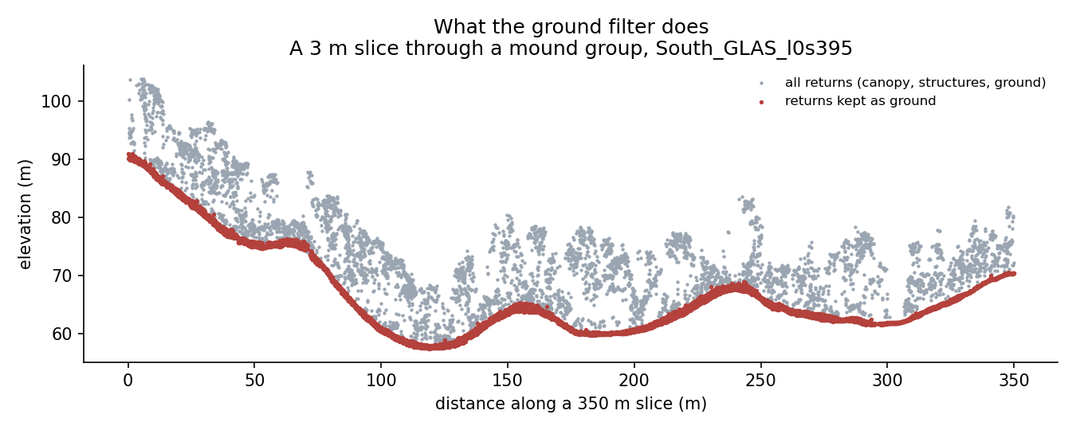
A slice through a mound group, showing all returns and the ones kept as ground
A three-meter-wide slice cut through a mound group, seen from the side. The gray dots are every laser return — canopy above, ground below. The red dots are the ones the filter decided were the floor. The whole job is drawing that red line correctly, including where the ground is steep.
3. Removes obvious errors. A few returns land below the real ground — reflections, birds, noise in the sensor. These are flagged so they do not drag the surface down into a pit.
4. Fills in the gaps between the ground points. Ground returns are scattered irregularly; a map needs a value at every cell of a regular grid. Replicalm uses kriging, a statistical interpolation method, falling back to a simpler distance-weighted average where the mathematics becomes unstable.
5. Tidies the edges. Cells around the outside of the surveyed area are calculated from data on one side only, so they are unreliable and get trimmed. Small holes inside the covered area get filled. Areas with no data are set to black, and nothing inside the data area is allowed to be black, so that a hole can never be mistaken for terrain or the other way round.
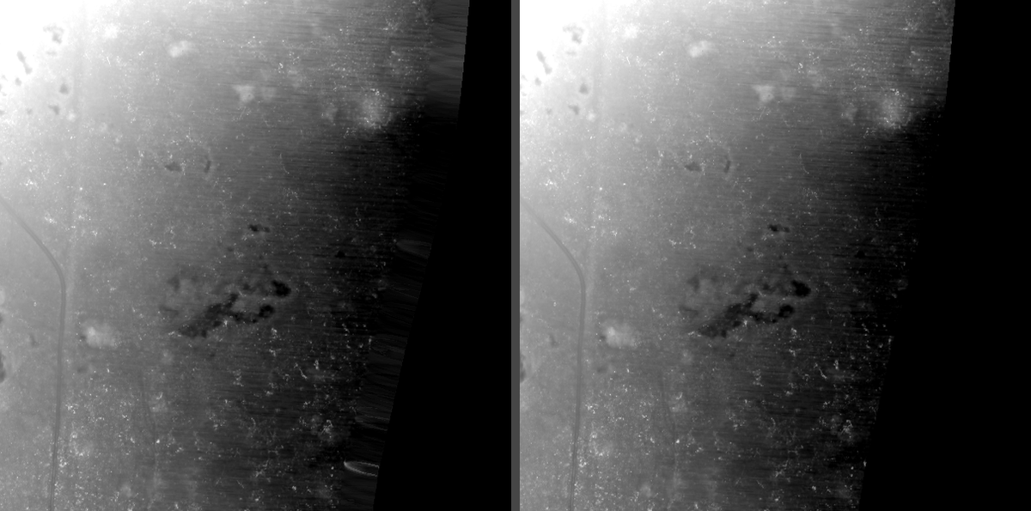
The edge of the surveyed area, before and after tidying
The eastern edge of the flight line. On the left, the raw surface: the ragged comb along the boundary is cells calculated from data on one side only, which can be wrong by several meters. On the right, the same area after trimming.
6. Makes the picture. A bare-earth elevation model is a grid of numbers. What an archaeologist actually reads is a shaded image, and the one used here is G1 — four relief visualizations blended together, the recipe published as Table 3 of Britton et al. 2025. Replicalm calls that recipe rather than copying it, so there is only one definition of it and this software cannot drift away from it.

Three ways to run it
The same pipeline runs in three forms.
Baseline follows the published method as closely as the translation allows. It is what the software does unless told otherwise, and what everything else is measured against.
Clear adds one step. Some laser pulses stop on low vegetation — scrub, brush, a root mass — instead of reaching the soil, and the ground filter accepts them. In the elevation model they become small bumps a few centimeters high, and in the shaded image they appear as a fine speckle across otherwise flat ground: clutter that an archaeologist has to learn to discount. Clear removes returns that stand more than 20 cm above the ground immediately around them, which catches most of that vegetation. It also removes some genuine ground with it, so the edges of platforms come out very slightly softer.
Deep takes Clear and sets the map's cell size from the survey's own point spacing instead of fixing it in advance. Where ground returns average one every half meter, a third-of-a-meter cell resolves what the data holds; a sparser survey gets a coarser grid and a denser one a finer grid. Deep is aimed at getting the most out of a given point cloud rather than at matching what the commercial workflow produced — a different goal, not a better score at the same one.
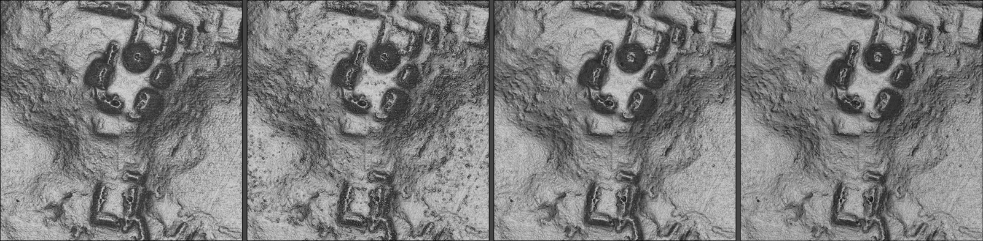
The same ground under four treatments
The Pixoyal group. From left: the original commercial workflow; Replicalm's baseline, where the speckle on the open ground is vegetation the filter let through; Clear, with it removed; and Deep, on a finer grid. The four have been matched for overall brightness so the comparison is about what they show rather than how light they are.

What you get
Two products, from one run:
The elevation model — a single-band GeoTIFF of ground heights in meters. Zero means no data, and nothing inside the surveyed area is ever exactly zero, so a hole can never be mistaken for terrain. Beside it, a small JSON file recording the settings used, how many cells were interpolated across gaps, and how far the edge was trimmed.
It used to carry a second layer marking where the data was real. That layer was removed: it repeated what the elevations already said, and a second layer is quietly dropped by many format conversions, which is the sort of silent loss the whole black-means-nothing convention exists to prevent.
The G1 image — a three-channel picture of the same ground, plus the five individual visualizations it is blended from (sky-view factor, positive openness, slope, multi-directional hillshade and the archaeological VAT blend). This step is optional. It needs one extra component, the Relief Visualization Toolbox, and a run that only wants elevations does not have to install it.

The tools it uses
Everything is free and open:
- PDAL reads point clouds and runs the ground filter.
- GDAL reads and writes the map files and handles coordinate systems.
- NumPy and SciPy do the kriging and the arithmetic.
- Relief Visualization Toolbox produces the shading the G1 image is blended
from. Apache-licensed, from the Slovenian Academy of Sciences and the University of Ljubljana. Needed only for the picture, not for the elevations.
- QGIS and CloudCompare are useful for looking at results but are not
required by the pipeline.

Running it
Three ways, all doing the same work:
- A command line, for scripting a survey: point it at a cloud, name an
output folder, add --g1 if the image is wanted.
- A Python call, for building it into something larger.
- A desktop application — planned, and partly built. It is a small window:
choose a point cloud, choose an output folder, set the cell size, tick a box for the image, press Run. A progress log shows each stage as it happens, because a full tile takes minutes and a window that may or may not be working is worse than a slow one that says what it is doing.
The desktop version is packaged as an installer carrying its own copy of Python and the geospatial libraries, so nothing needs to be installed or configured first and it cannot collide with other software already on the machine. That costs about four gigabytes on disk and buys a program that runs where nothing has been set up. The packaged build has been tested end to end: it processes a tile and writes a correctly projected elevation model using only its own bundled components.
Nothing in the chain needs TerraScan or Surfer.

How it compares to the published method

What is the same
The overall shape of the workflow is the same, and several numbers are taken directly from the source and not changed:
- height-above-ground limits of −0.5 m and 600 m
- the near-ground band of ±0.2 m, written to class 8
- exporting only the ground and near-ground classes
- LAS version 1.2 output
- a twenty-meter kriging search radius as the maximum

What is similar but not identical
The ground filter. This is the largest difference and it cannot be avoided. The published method uses TerraScan's "Classify Ground", which builds a triangulated surface and grows it upward — an approach with four settings: window size, maximum terrain angle, iteration angle and iteration distance. No free tool implements that algorithm with those settings. Replicalm uses SMRF instead, which does the same job by different means and has different knobs.
The settings were translated by reasoning about what each one controls. The source's 9° iteration angle becomes a slope tolerance of 0.1584, which is the tangent of 9°. That is a defensible translation, not an equivalence, and the result was checked against reference surfaces produced by the original workflow rather than assumed to be right.
Interpolation. Both krige. The published method uses Golden Surfer; Replicalm uses its own implementation. The search radius is the source's twenty meters as an upper limit, but it is scaled down where the points are densely packed, because a wide search on dense data makes the mathematics unstable.

What is different
Two passes became one. The source runs its ground classification twice, the second pass refining the first. SMRF has no refining mode — each run starts over — so a second pass simply redoes the work with a steeper tolerance. Measured across seven areas, running it twice changed nothing and doubled the time, so Replicalm runs one pass. This is a real departure from the source and is recorded as such.
The elevation tolerance is tighter. The source allows a point to sit three meters below the surface and still count as ground. Carried across directly, that setting lets in almost anything: it produced four times the error of a half-meter tolerance. Replicalm uses 0.5 m. The source's figure describes TerraScan's behavior, not SMRF's.
There is one setting the source could not have. SMRF works on its own internal grid, and TerraScan has no equivalent. Left at one meter while producing a half-meter map, it turns steep slopes into staircases. Tying it to the output cell size removes most of that.
The output grid is declared rather than derived. The original products have cells of 0.500042 by 0.499988 meters on origins that are multiples of nothing, which means neighboring tiles do not line up without resampling. Replicalm puts cell edges on whole multiples of the cell size, so tiles join exactly and a re-run reproduces the previous result. For direct comparison against an original product, it can adopt that product's grid instead.
Noise removal is reduced. The source's workflow includes a low-point filter. Tested here, one of the two filters available removed no points at all, on flat and steep ground alike, so it is switched off by default with that measurement recorded. The other removes a fraction of a percent and its effect varies by tile.

How well it works
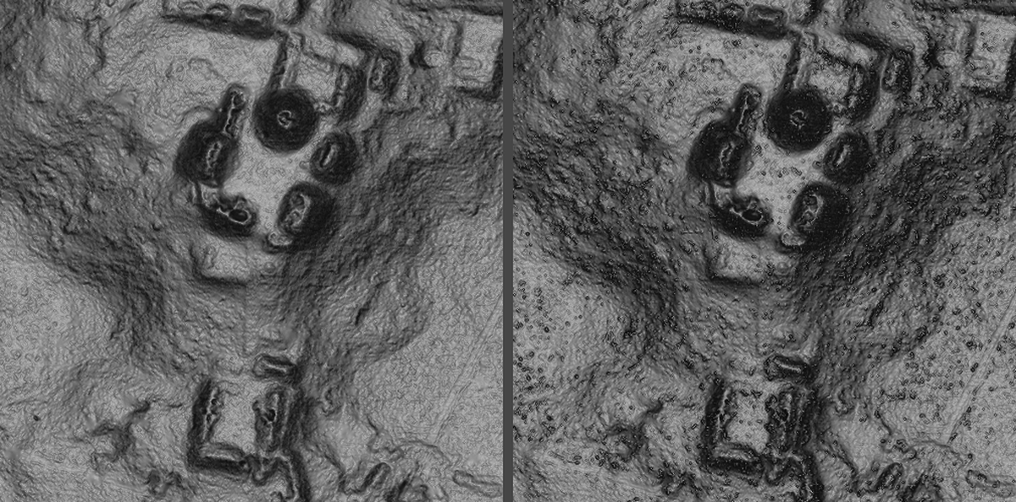
The original workflow and Replicalm over the same mound group
The same ground, same point cloud, same visualization recipe. On the left, the surface from the original commercial workflow. On the right, Replicalm.
Tested on South_GLAS_l0s395, a tile with known structures, against the reference surface from the original workflow:
- Half the cells agree to within 1.5 millimeters.
- Across the whole tile the root-mean-square difference is 6 centimeters.
- On flat ground, fewer than one cell in ten thousand differs by more than half
a meter.
- On slopes steeper than thirty degrees, about one cell in forty-five does.
- Platforms, plazas, range structures and looter trenches read clearly in the
resulting visualization.
The remaining disagreement is almost entirely on steep ground. Below ten degrees of slope the two surfaces are effectively the same; above thirty degrees they are not. Slopes above ten degrees make up about 15% of this tile but carry about 98% of the large differences.

What is not settled
Three things are recorded in docs/open_observations.md rather than glossed:
- One comparison on a steep window produced a much larger difference than any
other setting has explained. The cause was attributed twice and both attributions turned out to be wrong. One candidate remains untested.
- The outlier filter helps on one tile and hurts on another, and it is not known
what distinguishes them.
- Results obtained before 20 September 2026 were measured on sample areas that
turned out to contain almost no steep ground, which is where the differences live. Those results should be treated as untested rather than as established.

The settings, as locked on 20 September 2026
setting | value
ground filter | SMRF, one pass
slope tolerance | 0.1584 (tangent of 9°)
elevation tolerance | 0.5 m
filter working grid | 0.5 m
low-point filter (ELM) | off — removed nothing when tested
outlier filter | on — effect varies by tile
kriging search radius | scaled to point density, never above 20 m
neighbors per cell | 16

These are recorded in code as well as in this table, and the software will refuse a production run if the configuration has drifted from them.

