Replicalm

What it is, why it exists, and how it compares to TerraScan and Golden Surfer at reproducing the NCALM method
Benjamin Jay Britton, September 2026

What it is
Replicalm is a software tool that turns raw airborne lidar point clouds into bare-earth elevation models and archaeological relief visualizations. It reproduces the processing workflow that NCALM used on the G-LiHT surveys of the Maya lowlands, as documented in the supplementary materials of Estrada-Belli et al. 2025.
It runs on free and open software throughout: PDAL for point-cloud handling and ground classification, GDAL for coordinate systems and raster output, NumPy and SciPy for the interpolation, and the Relief Visualization Toolbox for the optional image step. It is MIT licensed.

Why it exists
The published method depends on two commercial products: TerraScan for ground classification, and Golden Software Surfer for interpolation and rasterization. Together these represent several thousand dollars of licensing before a single tile is processed.
That creates two problems for the field. Published results cannot be independently reproduced by anyone without those licenses — which is most researchers, most students, and most institutions outside well-funded programs. And the method cannot be applied to new surveys by those same people, so the data accumulating from lidar campaigns can only be processed by those who can pay to process it.
Replicalm closes that gap. The method is the same method; the tools underneath it are ones anyone can install.

What it is useful for
The immediate use is processing G-LiHT and comparable airborne lidar over archaeological landscapes: producing a ground surface with vegetation removed, and from it the shaded relief images in which platforms, plazas, causeways, terraces and looter trenches become legible.
Beyond that, three things make it useful as infrastructure rather than as a one-off script:
Every run records its own settings. A configuration file is written beside each output, so any raster can be traced back to the parameters that produced it. The tool refuses to run silently under settings that differ from the validated baseline — it says so.
The output grid is declared rather than derived. Neighboring tiles land on the same lattice and mosaic without resampling, and rerunning reproduces the previous result exactly.
Parameters are measured, not inherited. Each setting in the baseline carries the measurement that chose it, recorded in the code beside the value.

How it works
Given a point cloud, five stages:
1. Classify ground. Decide which returns are the soil and which are canopy, structures or brush. This is the hard part and the part that determines everything after it. 2. Remove outliers. Flag returns that cannot be ground. 3. Measure height above ground and apply the source method's cuts, including its near-ground class band. 4. Interpolate the scattered ground returns onto a regular grid by ordinary kriging. 5. Finish the raster — fill enclosed gaps, trim the unreliable fringe where cells were calculated from data on one side only, and write it so that no data is unambiguous.
An optional sixth stage produces the G1 relief composite from the finished surface.

Three configurations
The same pipeline runs in three forms, which differ in how hard they work at removing what is not ground and at matching the grid to the data.
Baseline reproduces the source method as closely as the translation allows. It is the configuration against which everything else is measured, and it is what the software runs unless told otherwise.
Clear adds one step: it removes ground returns that stand more than 0.20 m above the local ground surface. These are overwhelmingly low vegetation — scrub, brush, root mass — that stopped the laser pulse before it reached the soil. In the baseline they survive into the elevation model and appear in the image as a fine speckle across otherwise flat ground.
Deep takes Clear and adds a cell size derived from the survey's own point density rather than fixed in advance. Where ground returns average one every 0.46 m, as they do here, a 0.33 m cell resolves what the data contains; on a sparser survey the same rule produces a coarser grid, and on a denser one a finer grid. Deep is aimed at getting the most out of a given point cloud rather than at matching what the commercial workflow produced.

How it compares to TerraScan and Golden Surfer

What cannot be ported, only translated
TerraScan's "Classify Ground" implements progressive TIN densification after Axelsson (2000). The source method drives it with four parameters: a 70 m window, an 88° maximum terrain angle, iteration angles of 9° and 12° on two successive passes, and a 3 m iteration distance.
No free tool implements that algorithm with that parameter surface. PDAL offers SMRF (Pingel et al. 2013), a morphological filter; PMF (Zhang et al. 2003); and CSF (Zhang et al. 2016), a cloth simulation. None of them has a terrain angle or an iteration angle. ArcGIS Pro's equivalent offers three presets and exposes none of the four.
So the classification stage is a translation, not a port, and any claim that it has been replicated exactly would be false. Angles were converted to slope tolerances by taking their tangent — tan 9° = 0.1584 — and the translation was then checked against reference surfaces produced by the original workflow rather than assumed correct.
Golden Surfer's kriging is likewise proprietary. The source specifies a 20 m search radius and says nothing about the variogram model, its parameters, or the maximum number of points per solve. Those had to be chosen and are recorded.

What is carried over unchanged
The height-above-ground cuts at −0.5 m and 600 m, the ±0.2 m near-ground class 8 band, ground-only export, LAS 1.2 output, and a 20 m kriging search radius as the maximum.
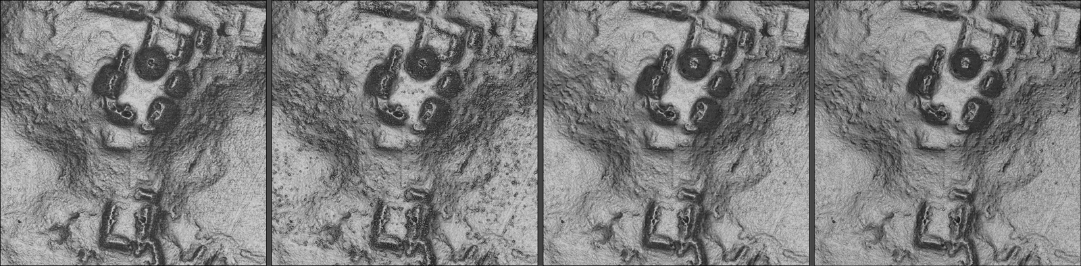
The Pixoyal group under four treatments
The Pixoyal group on South_GLAS_l0s395, same point cloud and same visualization recipe throughout. From left: the original TerraScan and Surfer workflow; Replicalm's baseline, where the speckle on the plaza floors is residual low vegetation the ground filter accepted; Clear, with that vegetation removed; and Deep, which adds a cell size derived from the measured point density. The four panels have been tone-matched to a common median, because the visualization recipe normalizes each raster by its own extremes and the untreated panels differ in overall brightness for reasons that have nothing to do with the surfaces.

How closely the output agrees
Measured on South_GLAS_l0s395, a tile containing known structures, against the reference surface produced by the original commercial workflow, over the 12.29 million cells both deliver:
measure | value
median difference | 1.5 mm
RMSE, whole tile | 0.0601 m
cells more than 0.5 m apart, below 5° slope | 0.09%
between 5° and 10° | 0.17%
between 10° and 20° | 0.39%
between 20° and 30° | 1.01%
above 30° | 2.25%
coverage delivered | 99.56%

Half the surface agrees to within a millimeter and a half. The disagreement is concentrated almost entirely on steep ground: 97.7% of all error above half a meter sits on slopes steeper than 10°, which are 15.5% of the tile.

Where the two approaches genuinely differ
Ground classification is where the real difference lies. TerraScan rejects low vegetation more completely than a translated SMRF pass does. Comparing against TerraScan's own classification, which the delivered clouds carry, 3.88% of the returns Replicalm calls ground were explicitly rejected by the original workflow — and at the cells where that shows up visually as speckle on flat ground, the figure is 12.2% against 0.8% on clean ground.
Replicalm's Clear rule recovers 92.5% of that without TerraScan, by demoting returns that stand more than 0.20 m above the local ground floor. It removes 17.75% of ground returns to do what TerraScan does by removing 3.88%, so it takes genuine returns with the clutter, and platform edges come out slightly softer as a result.
Deep uses the same classification and differs downstream, in the grid. On the measures that do not reference the commercial output, the three configurations separate like this:
 | baseline | Clear | Deep
predicts held-out ground returns (MAE) | 0.0512 m | 0.0439 m | 0.0439 m
returns left below the surface | 8.11% | 4.80% | 2.27%
rasterized fold residual, median | 0.0872 m | 0.0803 m | 0.0787 m
output grid | 0.50 m | 0.50 m | 0.33 m

Two of those rows need reading carefully. The first is identical for Clear and Deep because that test predicts at point locations and never touches the raster, so it cannot see cell size at all. The second improves partly for a reason unrelated to quality: a coarser cell averages over more ground, so returns at the low end of a cell fall beneath its single value.
The third row is the one with the grid inside the measurement — whole blocks of returns withheld, the surface built without them, then sampled where those returns actually are. By that measure Deep is 2.0% better than Clear, which is real and small. Its larger practical benefit is that slope and sky-view factor are computed on a finer grid, so breaklines render without stair-stepping at cell boundaries.
Interpolation differs in how the neighborhood is chosen. The source fixes the search radius at 20 m. Replicalm scales it to the measured point density, with 20 m as the ceiling, because a fixed radius means different things at different densities — at high density it packs the neighborhood so tightly that the kriging system loses rank.
The output grid differs by design. The reference products have cells of 0.500042 × 0.499988 m on origins that are multiples of nothing, so neighboring tiles do not align without resampling. Replicalm puts cell edges on whole multiples of the cell size. It also derives the cell size from measured ground density rather than fixing it, since a survey at one return per square meter cannot support a 0.5 m raster and one at sixteen is wasted on it.
Tiling differs for reasons that are not methodological. The source works in 1 km tiles because a whole transect will not fit in memory on modest hardware. Replicalm's interpolation is internally chunked, so it processes whole extents by default, with tiling available where classification memory still demands it.

Comparing Replicalm with the commercial workflow
This is worth careful consideration, because the two are not aimed at the same thing and a single verdict would misrepresent both.
On elevation agreement over ordinary terrain the two are equivalent. The median difference is smaller than the sensor's own precision.
On steep ground they differ, and the difference is one of approach. The commercial workflow produces a smoother surface there. Replicalm's baseline carries more texture, some of which is real micro-relief and some of which is residual vegetation. Clear removes the vegetation and keeps most of the micro-relief.
Deep optimizes for something different, and is therefore not on the same scale. Baseline and Clear are aimed at replication: they are measured against the commercial output and judged by how closely they match it. Deep is aimed at getting the most out of the point cloud, and is measured against the returns themselves — how well the surface predicts measurements it was not built from, and whether it leaves returns stranded beneath it.
Those are different objectives, and a configuration optimized for one will score differently under the other by construction. A surface tuned to the point cloud may well diverge further from the commercial output, and that divergence is not evidence of error in either direction. Which of the two is the better representation of the ground cannot be settled by comparing them to each other. It requires ground truth — surveyed control points, or excavated profiles — which neither workflow has here.
What can be said now is narrower and worth stating plainly. On the measures that reference only the point cloud, Clear predicts held-out ground returns 13% more accurately than the baseline and leaves roughly half as many returns beneath the surface. Deep matches Clear on prediction and improves the rasterized fold residual by a further 2.0% while rendering on a finer grid. All of these are early results from a single tile.
On reproducibility Replicalm is better, and not marginally. Settings are recorded per run, the grid is deterministic, and a configuration that has drifted from the validated baseline stops the run rather than quietly producing something different.
On cost the comparison is not close.

Status
The processing pipeline is complete and validated.
Baseline is the locked configuration. Every parameter in it carries the measurement that chose it, and the software refuses to run silently under settings that differ from it.
Clear is validated on windows it was not developed against, and is available as a setting rather than as the default. Making it the default is a change to the locked baseline, which is a decision to be taken deliberately.
Deep is an early result. It has been built and measured on one window of one tile, and its cell-size rule rests on a single density measurement. That the rule should track point spacing is physically sensible and one measurement is not a law; a survey of markedly different density should be measured before the rule is trusted on it.

The application
A Windows installer, Replicalm-1.0.0-setup.exe, installs a Windows executable with user selections for the point cloud to be processed, the output folder, the cell size in meters per pixel, an optional suite of RVT-based visualizations, and optional retention of the classified ground-filtered point cloud. A progress bar indicates how far along the run is, and a message window reports the details of the processing as it happens.
Replicalm-1.0.0-setup.exe is 1.15 GB and takes about 4 GB installed. It carries its own copies of Python, PDAL, GDAL and PROJ, so nothing needs to be installed or configured on the target machine beforehand, and it cannot collide with software already there. Both the installer and the program it installs have been run and produce correct output.
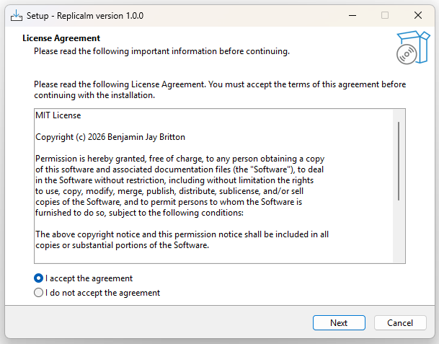
Replicalm v1.0 installer
Replicalm v1.0 installer
Replicalm-1.0.0-setup.exe is a standard Windows installer, 1,180,522 KB, compatible with 64-bit Windows 10 and 11. It needs no prerequisites: Python and the geospatial libraries travel inside it. The MIT license is presented for acceptance at the second step, and the third-party components — PDAL, GDAL, PROJ, NumPy, SciPy and the Relief Visualization Toolbox — are installed with their own license texts alongside. Installation offers a choice of folder, creates Start Menu entries and an optional desktop shortcut, and configures the bundled environment for wherever it has been placed.
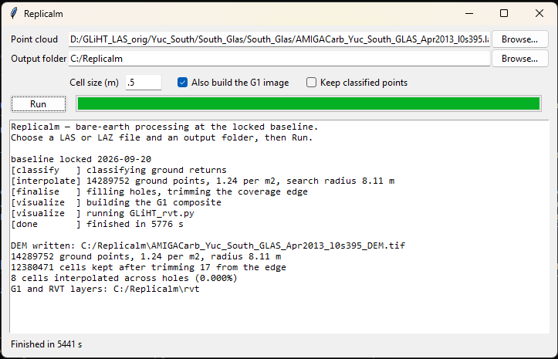
Replicalm User Interface
Replicalm User Interface
The whole program is one window. The two file selections are the only required input; everything else has a working default. The message pane below reports each stage as it completes — how many ground returns were classified, their density, the search radius chosen, how many cells survived the edge trim, and how many were interpolated across gaps. The run shown processed a complete G-LiHT flight strip of 14.3 million ground returns, including the full visualization suite, in about ninety-six minutes.
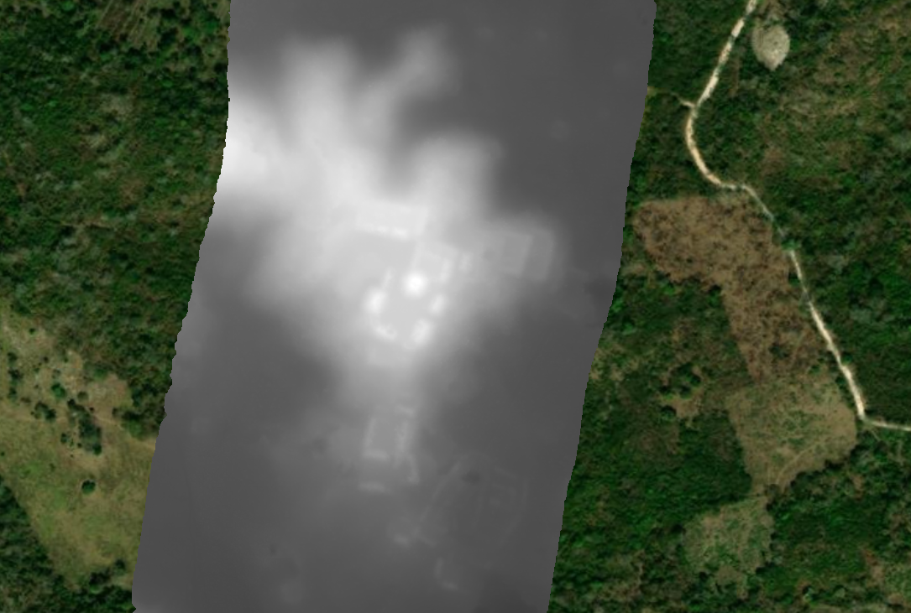
Replicalm GeoTIFF DEM file
Replicalm GeoTIFF DEM file
The primary output, shown here draped over satellite imagery in a GIS. The elevation model carries its coordinate system, so it lands in the right place without any manual positioning — the flight strip sits exactly where the survey flew it. Brighter is higher. Even in this plain grayscale rendering the architecture is visible: the raised platforms of the site core show as pale rectangles against the surrounding terrain.
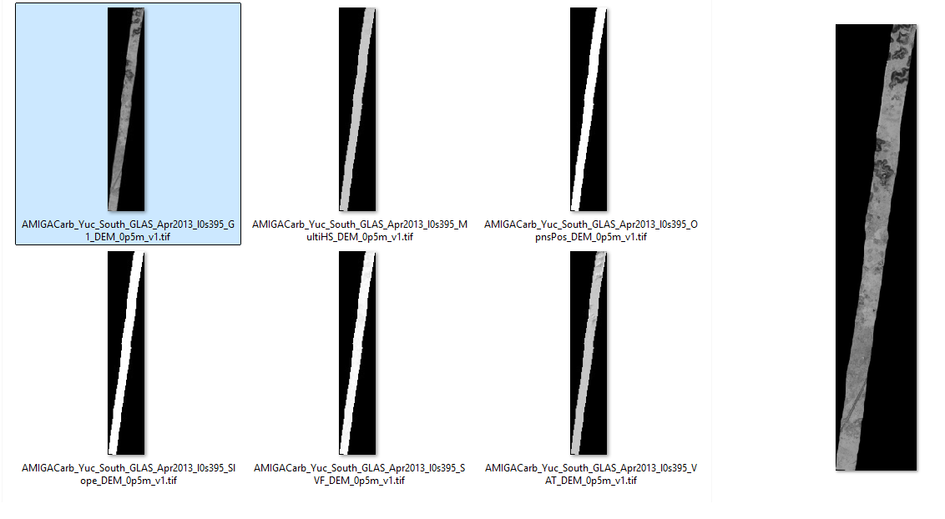
Replicalm visualization products
Replicalm visualization products
With the visualization option selected, six rasters are produced alongside the elevation model: the G1 composite, and the five individual analyses it is blended from — multi-directional hillshade, positive openness, slope, sky-view factor, and the VAT archaeological blend. Each is a separately usable product; they are listed here as they appear in the output folder. The narrow diagonal form of each is the flight strip itself, with no data either side of it.
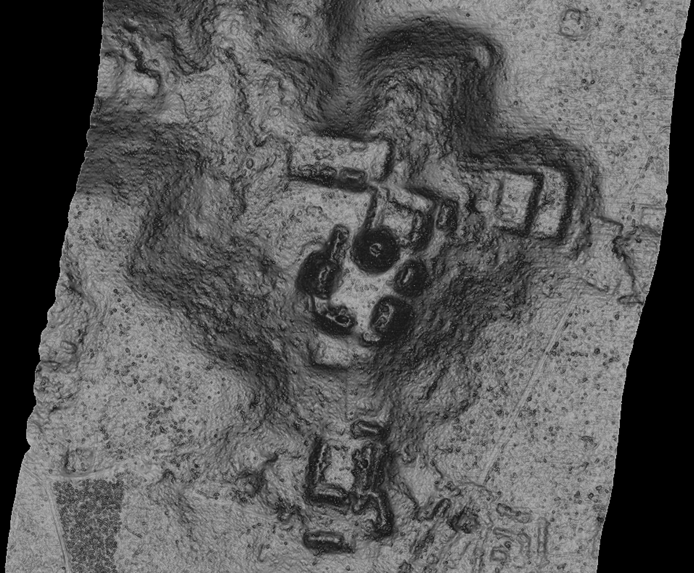
Replicalm.exe G1 visualization
Replicalm.exe G1 visualization
The G1 composite at full resolution over the site core, produced end to end by the installed program from the raw point cloud. Platforms, plazas, range structures, the circular feature at the center of the group and the causeway running south are all legible. The fine speckle across the open ground is residual low vegetation, which the Clear configuration removes.
— Benjamin Jay Britton, 2026

