LABORATORY EXERCISE 9

SEARCH AND FILTERING SYSTEM

Learning Objectives
By the end of this laboratory exercise, students should be able to:
- Implement client-side search filtering using jQuery for dynamic user experience.
- Develop server-side search functionality using CodeIgniter's database queries.
- Create a responsive search interface using Bootstrap components.
- Integrate AJAX techniques to display search results without page reload.
- Understand the differences between client-side and server-side search approaches.

Prerequisite student experiences and knowledge
Before starting this exercise, students should have:
- Completed Laboratory Exercise 8 (Real-time Notifications with jQuery).
- Solid understanding of CodeIgniter's MVC architecture and database operations.
- Proficiency in writing jQuery and JavaScript code for DOM manipulation.
- Experience with AJAX requests and handling JSON responses.
- Familiarity with Bootstrap form components and grid system.
- Knowledge of SQL queries, particularly LIKE operators for search functionality.

Background
An effective search system is crucial for any Learning Management System (LMS) to help users quickly find relevant courses and content. This exercise focuses on implementing a dual-approach search system: client-side filtering for immediate feedback and server-side searching for comprehensive results. jQuery provides the tools for dynamic client-side filtering, while CodeIgniter's database class enables efficient server-side search using SQL LIKE queries. The combination creates a seamless user experience where search results update in real-time without page refreshes, enhancing the overall usability of the application.

Materials/Resources
- Personal Computer with Internet Access
- XAMPP/WAMP/LAMP server installed
- CodeIgniter Framework
- Visual Studio Code or any code editor
- Git and GitHub Account
- Web Browser (Chrome, Firefox, etc.)
Laboratory Activity
Step 1: Project Setup
- Open your existing ITE311-LASTNAME CodeIgniter project.
- Ensure your database has a courses table with sample data for testing search functionality.
- Verify that your course listing page is functional from previous exercises.

Step 2: Create Search Controller Method
- Navigate to your Course.php controller in app/Controllers/.
- Add a new method named search():
  - This method should accept GET or POST requests with a search term parameter.
  - Use CodeIgniter's Query Builder to search the courses table using LIKE queries.
  - Return the results as JSON for AJAX requests or render a view for regular requests.
- Implement the search logic
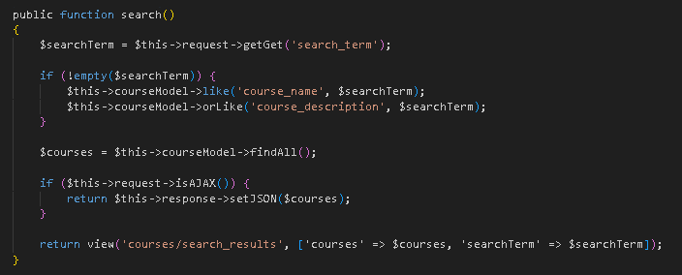

Step 3: Add Search Route
- Open app/Config/Routes.php.
- Add routes for the search functionality:
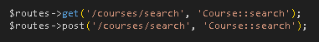

Step 4: Create Search Interface
- Modify your courses view file (app/Views/courses/index.php).
- Add a search form with Bootstrap styling
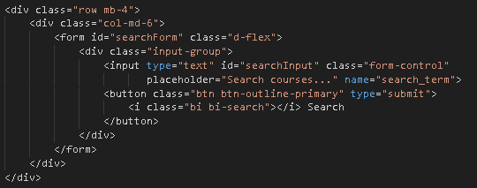

Step 5: Implement Client-Side Filtering with jQuery
- Add jQuery script for instant client-side filtering
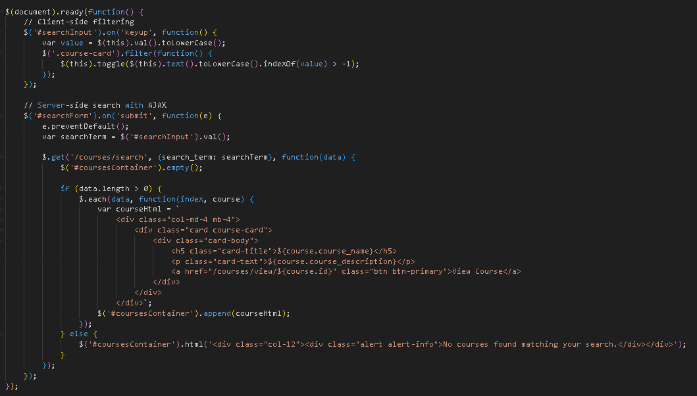

Step 6: Update Courses View Structure
- Modify your courses listing to work with the search functionality
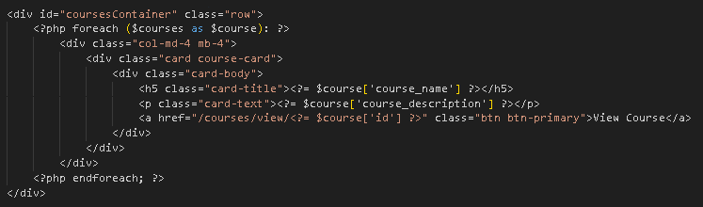
- To simulate real-time updates, you can set an interval to fetch notifications every 60 seconds (optional advanced task).

Step 7: Test the Search Functionality
- Load the courses page in your browser.
- Test the client-side filtering by typing in the search box courses should filter instantly.
- Test the server-side search by submitting the form results should load via AJAX without page refresh.
- Verify that both empty search results and successful searches display appropriate messages.

Step 9: Push to GitHub
- Stage and commit your search functionality
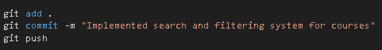

Output / Results
- Screenshot of the courses page with the search interface implemented.
- Screenshot showing filtered courses during client-side search.
- Screenshot of browser Developer Tools Network tab showing AJAX request to server-side search.
- Screenshot of search results displaying when no courses match the search term.
- Screenshot of GitHub repository with the latest commit.

QUESTIONS:
- What are the advantages and limitations of client-side filtering compared to server-side search?

Client-side filtering provides instant results because all data is already loaded in the browser, which reduces server load and creates a smooth experience for small datasets. However, it is limited by the amount of data a browser can handle, exposes all data to users, and lacks advanced search features. In contrast, server-side search can efficiently handle large datasets, support complex queries such as full-text search, and protect sensitive information, though it requires network requests, increases server load, and is more complex to implement.

- How does using AJAX for search improve the user experience compared to traditional form submission?

Using AJAX improves the user experience by updating search results without requiring a full page reload, creating a faster and more interactive interface. It also supports features such as live or “search as you type” results and preserves the user's place on the page. Traditional form submission reloads the entire page, making the process slower and more disruptive to the user’s workflow.

- What security considerations should be taken when implementing search functionality with user input?

When implementing search functionality, it is important to protect against SQL injection by using parameterized queries, prevent XSS by escaping any displayed user input, and validate or limit input size to avoid abuse. Additional security measures include applying rate limiting to prevent automated attacks and ensuring that search results or error messages do not expose sensitive information or internal system details.

Output / Results
In conclusion, securing search functionality is essential for maintaining both the safety and integrity of an application. Because search fields accept direct user input, they become a common target for attacks such as SQL injection and cross-site scripting, making it crucial to use parameterized queries and proper output escaping. Beyond these core protections, developers should enforce strict input validation and size limits to prevent attackers from overloading the system or injecting harmful payloads. Implementing rate limiting further helps safeguard the server from automated attacks or brute-force attempts that could degrade performance. Finally, ensuring that search results and error messages reveal no sensitive information or internal system details protects against unintended data exposure. By combining these measures, developers can create search features that are not only functional and efficient but also resilient against security threats.

Conclusion

