LABORATORY EXERCISE 3
WHILE AND FOR LOOP: NUMBER SEQUENCE GENERATOR

Learning Objectives
- Understand how the while loop iterates as long as a specified condition is true.
- Write simple programs that use while loops for repetitive tasks.
- Understand the role of initialization, condition, and iteration expressions in a for loop.
- Write for loops to iterate over various values and perform specific tasks.
- Analyze and create C++ programs using loops to solve real-world problems.
- Develop code using loops to calculate sums, products, and other mathematical operations.

Prerequisite student experiences and knowledge
Prerequisite student experiences and knowledge play a vital role in shaping the effectiveness and appropriateness of a learning experience. Before embarking on a specific course or program, it is essential to assess the background of prospective students. This includes their prior educational experiences, relevant skills, and knowledge levels. Prerequisites help ensure learners have the foundational understanding and abilities necessary to engage with the course material effectively. It's particularly important in technical subjects like computer programming, where understanding basic programming concepts might be required before delving into more advanced topics. By setting clear prerequisites, educational institutions, and instructors can create a learning environment that promotes comprehension, participation, and overall success while

Background
In the realm of programming, while and for loops are invaluable tools. The while loop repeatedly executes a block of code as long as a specified condition remains true, making it ideal for situations where the number of repetitions isn't known in advance. On the other hand, the for loop, characterized by its initialization, condition, and update phases, is best suited for tasks where you know precisely how many times you want to repeat a set of instructions. Mastering these loops is fundamental in programming, as they empower you to automate repetitive tasks and solve a wide array of problems, whether building basic counting programs or tackling complex simulations. Understanding when and how to use while and for loops is a fundamental skill for any budding programmer.

Materials/Resources
- PC/Internet
- Pen
- DevC++
- Web Browser (Internet Explorer, Mozilla, Google Chrome, Etc.)
- Word-processing program

Laboratory Activity
Sample Problem: WHILE LOOP
- Open DevC++, select File > New > Project
- Select Console Application, type the name SampleWhile, then press OK.
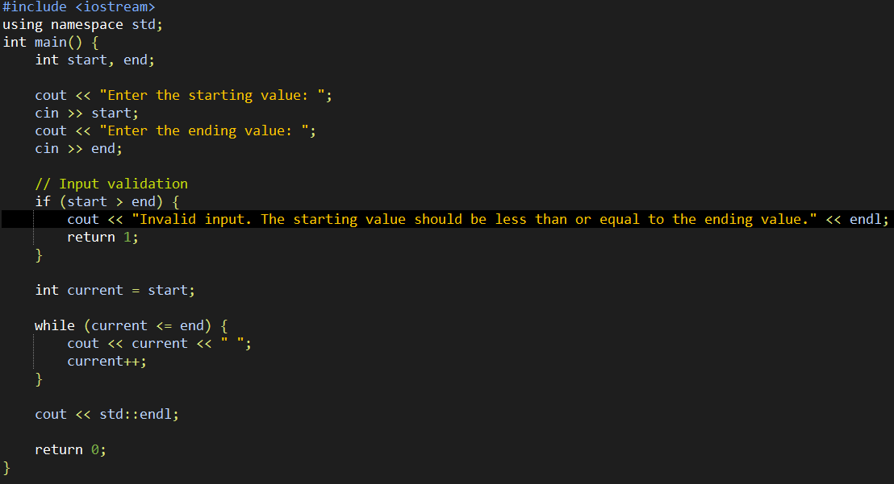
In this program, the while loop generates a sequence of numbers from the start to the end values and prints each number on the screen. The loop continues until the current value reaches or exceeds the end value. The program includes input validation to ensure that the start value is less than or equal to the end value.
- Then, declare the syntax below.
- The result must be similar to the image below.

Sample Problem: FOR LOOP
- Open DevC++, select File > New > Project
- Select Console Application, type the name SampleFOR, then press OK.
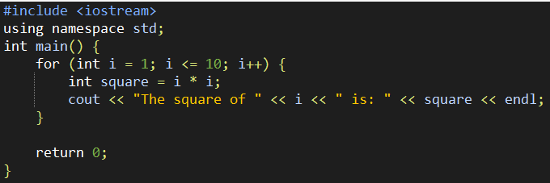
This program initializes a for loop from i = 1 to i = 10. Inside the loop, it calculates the square of the current value of i and then displays the result using std::cout. When you run this program, it will print the square of numbers from 1 to 10.
- Then, declare the syntax below.
- The result must be similar to the image below.

Problems: Number Sequence Generator
Instruction: Write a C++ program that generates and displays two number sequences: one using a while loop and the other using a for loop. The program should include the following steps:
- Prompt the user to enter the sequence's starting, ending, and step values. Let's call these values start, end, and step.
- Check if the input is valid (i.e., the start is less than or equal to the end, and the step is a positive value). If the input is invalid, display an error message and ask the user to enter valid values. Repeat this step until valid inputs are provided.
- Generate and display the number sequence using a while loop. The sequence should start at the start, increment by step in each step, and stop when it reaches or exceeds the end.
- Generate and display the number sequence using a for loop with the same conditions as in step 3.
- Ask the user if they want to generate another sequence. If yes, repeat the process. If not, exit the program.
Sample Result:
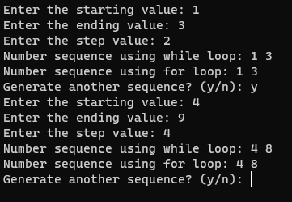
Question
- In the given C++ program, two loops, a while loop and a for loop, are used to iterate over number sequences. Explain the key differences between these two types of loops in terms of structure, syntax, and use cases.
* In the given C++ program two loops a while loop and a for loop, are used to iterate over number sequences explain the key differences between these two types of loops in terms of structure, syntax, and use cases.

- Compare the advantages and disadvantages of using each loop type in this context.
* while loop when you need flexibility in loop control and the number of iterations is uncertain. Choose a for loop when you have a known number of iterations and want a more concise and readable loop structure. Properly managing loop conditions is essential to avoid infinite loops and ensure the correct behavior of your program.

- Provide a flowchart diagram of the problem, number sequence generator.

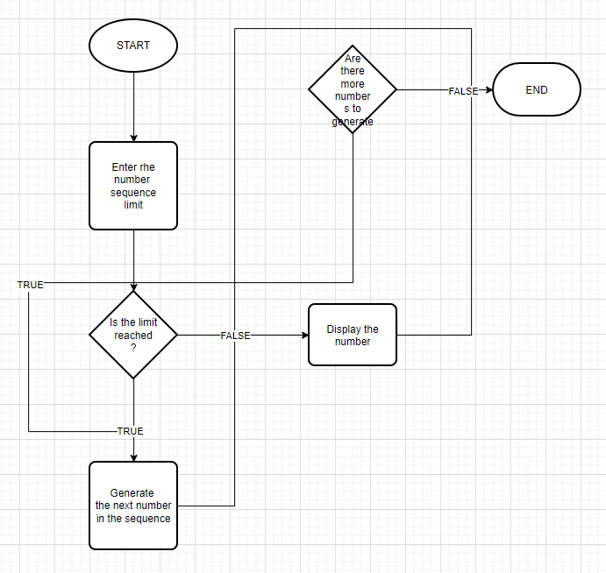

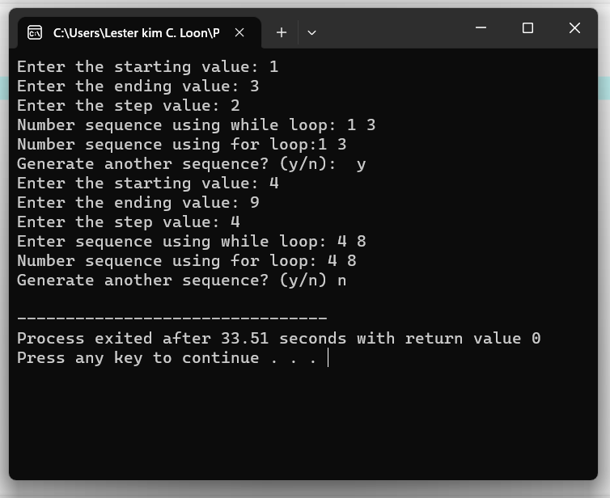
Output / Results

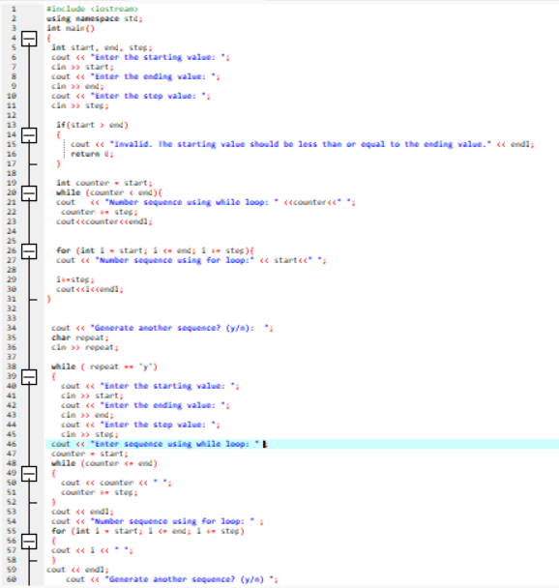

Conclusion
Choose Based on Context: The choice between while and for loops depends on the specific use case. If you need to repeat a block of code based on a condition, use a while loop. If you need to iterate over a sequence, use a for loop.
Readability and Simplicity: In cases where both while and for loops can be used, consider readability. For loops are generally more readable and are preferred when iterating over sequences. They make the code more expressive and easier to understand.
Avoiding Infinite Loops: When using while loops,always ensure that the loop will eventually reach a false condition to prevent infinite loops. Properly initializing and updating loop control variables is crucial to avoid unintended infinite iterations.

