AI Agent User Guide
Date: 2026-06-22

Overview
This guide explains how to use the AI Agent module in the dashboard: Status, Agents, Settings, and Chat Test.

Navigation
Open the dashboard and go to: AI Agent
Tabs: Status, Agents, Settings, Chat Test

Status (Live Status)
Use Status to monitor each AI agent and see whether it is currently connected.
What “Connected” means
An AI agent is Connected when it is enabled and there is an active widget conversation being served by AI for that agent’s group.
Summary cards
- Connected: agents currently serving an active widget conversation
- Disconnected: paused agents or no active widget conversation
- Average response time: average across recent runs (if available)
- Token usage: token usage across recent runs (if available)
Agent cards
Each agent card shows status, status detail, last activity, basic metrics, and a Reconnect action for offline agents.

Figure 1. AI Agent Status page
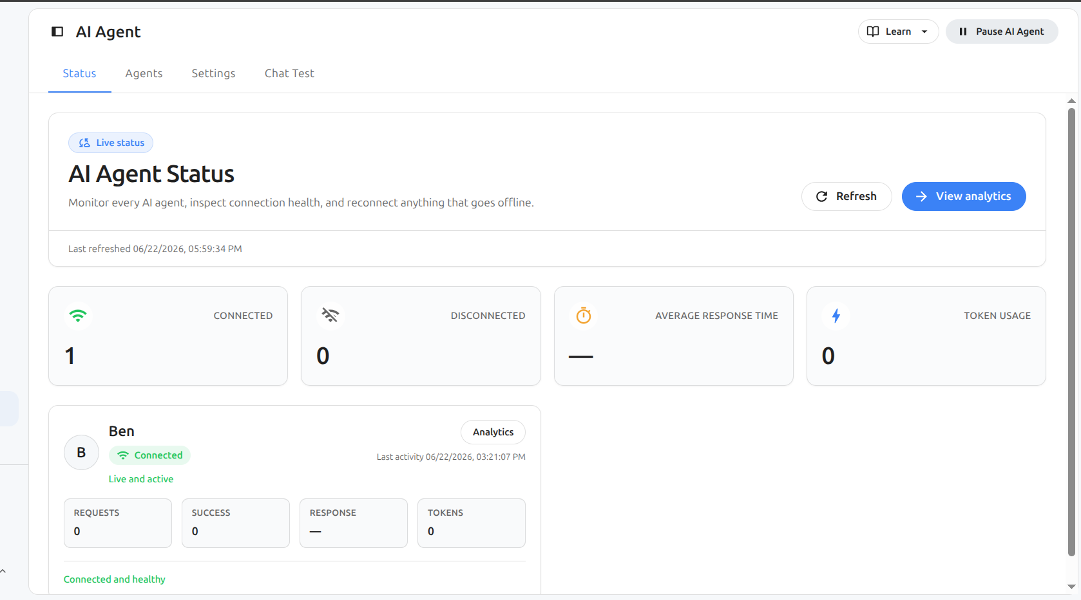

Figure 2. AI Agent list (Agents tab)
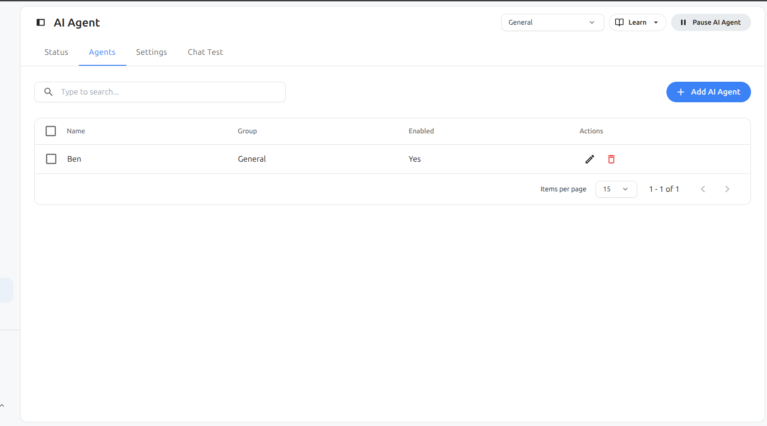

Figure 3. AI Agent settings panels
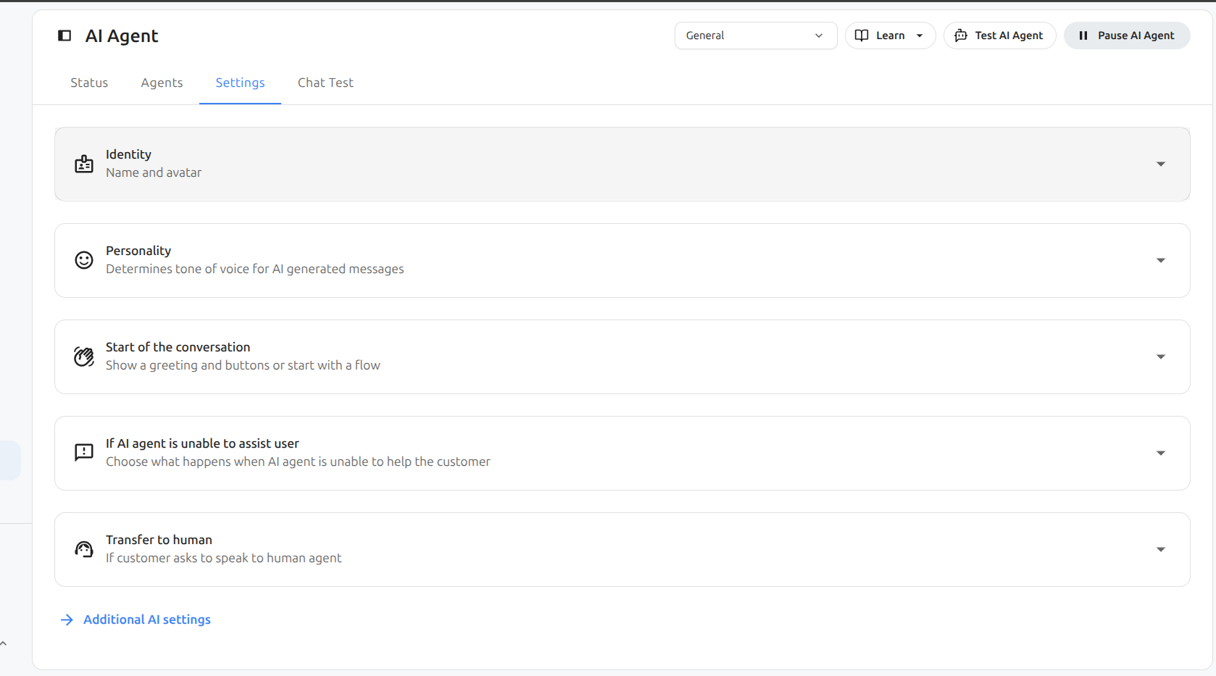

Figure 4. Chat Test with preview sidebar
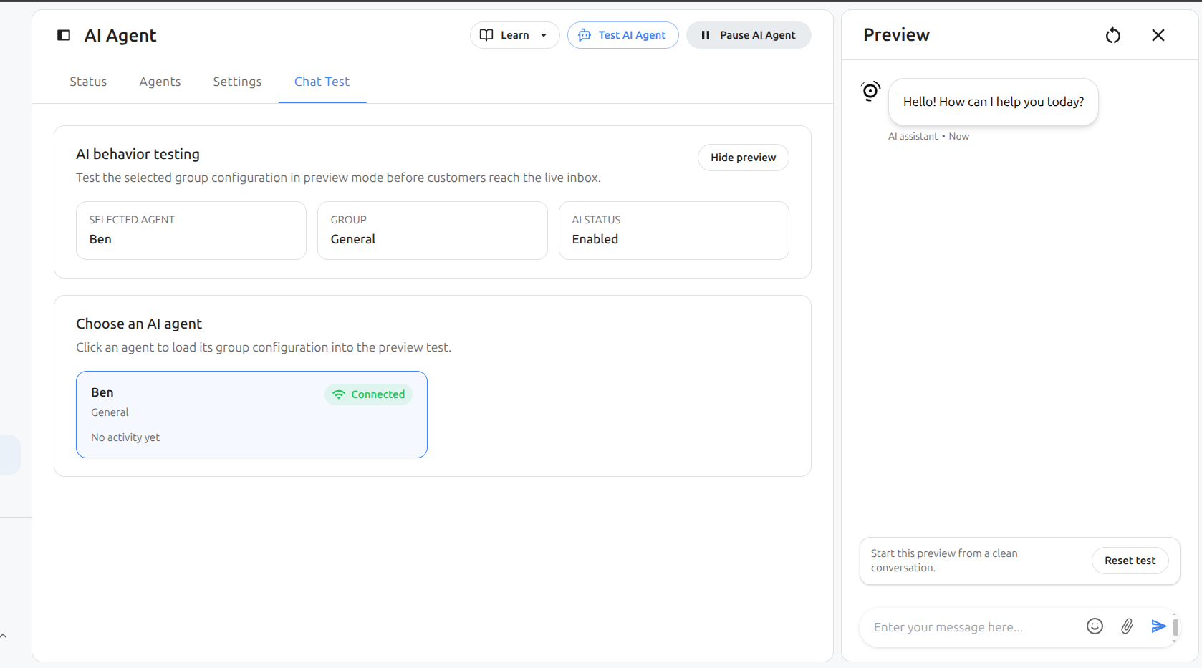

Agents (Create and Manage)
1. Go to AI Agent > Agents
2. Click Add AI Agent
3. Enter the agent name and assign a group if applicable
4. Save

Settings (Behavior Configuration)
Settings can be Global or Group-specific.
Identity
Configure the agent name and avatar shown to customers.
Personality
Choose a tone of voice for AI generated messages.
Start of the conversation (Greeting)
Choose Basic greeting or start with a Flow.
If AI agent is unable to assist user
Add an optional instruction for fallback behavior.
Transfer to human
Choose Basic transfer or Custom instruction.

Chat Test (Preview Mode)
Use Chat Test to test behavior without touching the live inbox flow.
1. Open AI Agent > Chat Test
2. Click an agent card to load its group configuration
3. Use Reset test to start from a clean conversation

Troubleshooting
Disconnected while enabled can be normal if no active widget conversation exists.
If settings do not appear, confirm the correct group scope and click Save.

