**Version 1.1**

**Preparation: Subnet Sub-Interface Test for IP Schema Change**

1. Go to <https://github.com/benjimmie/FW-refresh.git>
2. Go select **Code | Download ZIP**

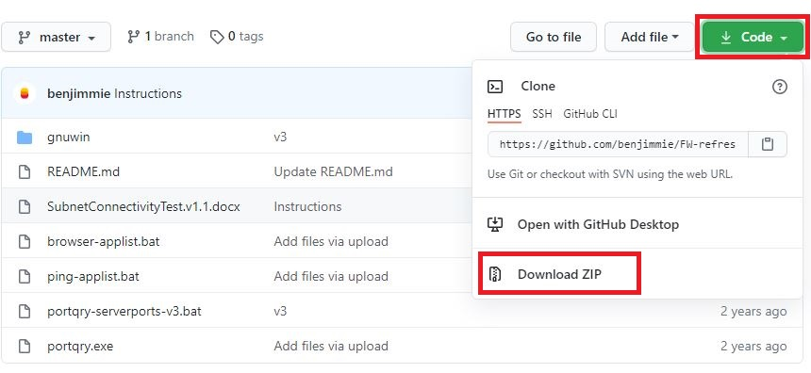

1. Extract the **FW-refresh-master.zip** to your desktop

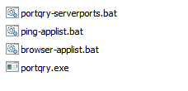

1. Add the txt files found in the attachments in the ticket [**applist.txt, serverports.txt & pinglist.txt**] to the folder. If you did not get it, contact the Project Manager, and they will email it to you.

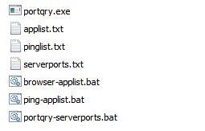

1. Test needs to be performed from each of the various user subnets in the sites. Typically;

**Section 0: Run Test prior to migration to establish benchmark**

1. Connect laptop to LAN. Get dynamic IP.
2. Run the scripts before the change as benchmark. Note what works and fails.
3. All batch scripts can be ran at once.

**Section 1: Basic Network Test – DHCP/Clearpass/DNS**

1. Connect laptop to LAN. Set Static IP of new subnet.
2. Outlook & skype is OK.
3. Run the scripts to test. Note the results.
4. All batch scripts can be run at once.

**Section 2: Ping & Application Connectivity Ping – DNS/Proxy/Server Connectivity**

**Steps:**

1. Double-Click **ping-applist.bat**



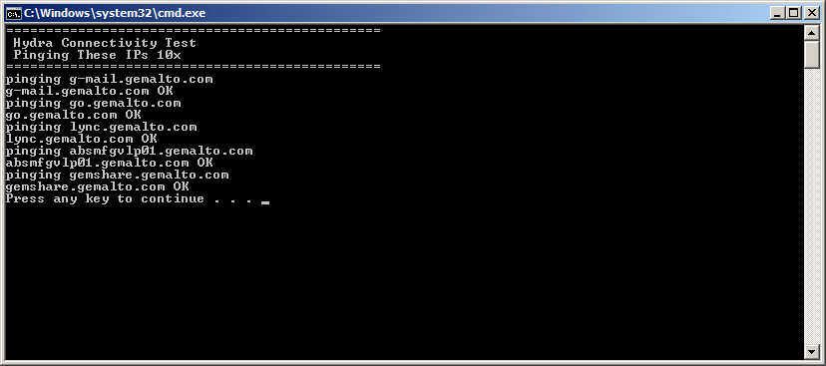

1. Note which ping tests are OK and which test are NOK. The typical ping window is suppressed to make it easier to read as we’re pinging multiple servers at a time 10x.
2. Double-click **browser-applist.bat**



1. Check the default web browser tabs that were launched to see if the sites displays properly

