1. Project 1 budget is limited to $35 (BOM only).
2. PCB must be 2 layer. PCBs will be built by JLCPCB. Check their website for specifications and design constraints. Size is limited to 100 mm x 100 mm. If the size exceeds the limit, then cost of PCB becomes significantly higher and your available budget for the BOM will accordingly reduce.
3. Passives: R and C should not be included in the BOM, if they are available in the kits below:
   1. Limit resistors to 0805 package from the kit, Digikey part# RESKIT0805RS-ND
   2. Limit Capacitors to 0805 package from the kit, Digikey part# 399-12004-ND
4. If the R or C components cannot be found in the kits and their value is critical to the design (i.e., cannot be changed) then they can be included in the BOM after discussion and approval by the instructor.
5. It is recommended to use LM317 linear regulator and the MC33063ADR switching regulators in your design. You have used the same components in the regulator lab and you should be familiar with them. If you need different specifications (e.g., higher current), then select other ICs.
   1. Other regulators stocked in ETG from previous semesters ~200 on hand. Good for breadboarding prototypes
      1. LM317MTGOS-ND: TO-220 packaging, ADJ/500mA
      2. AS7805AT-E1DI-ND: TO-220 packaging, 5V/1A
6. ETG stocks op-amps LMC660 SOIC packages (Digikey part number: LMC660CM/NOPB-ND) and LM324 (Digikey part number: 296-18447-1-ND). I recommend using these op-amps if you need them for your project and if the specifications are suitable for your design.
   1. DIP versions of both and the TLO82 are also available.
7. Your board should run from a 12VDC, 1A wall wart power supply.
   1. Include barrel jack receptacle Digi-Key Part Number CP-002A-ND on your board for power entry.
      1. Alternative you can use ED10561-ND if you need to power the board from another source such as a lab bench top power supply.
   2. If you require another voltage, then you need to create that using a buck, boost, or inverting regulators.
   3. If 12V, 1A is not suited for your project, then we need to discuss and come up with a suitable solution.
8. Prepare the BOM as a .XLSX file generated from a Digikey cart.
   1. Make sure to exclude Market Place items from your BOM.
      1. This screen shot shows how to use Digikey filter tool to select components.

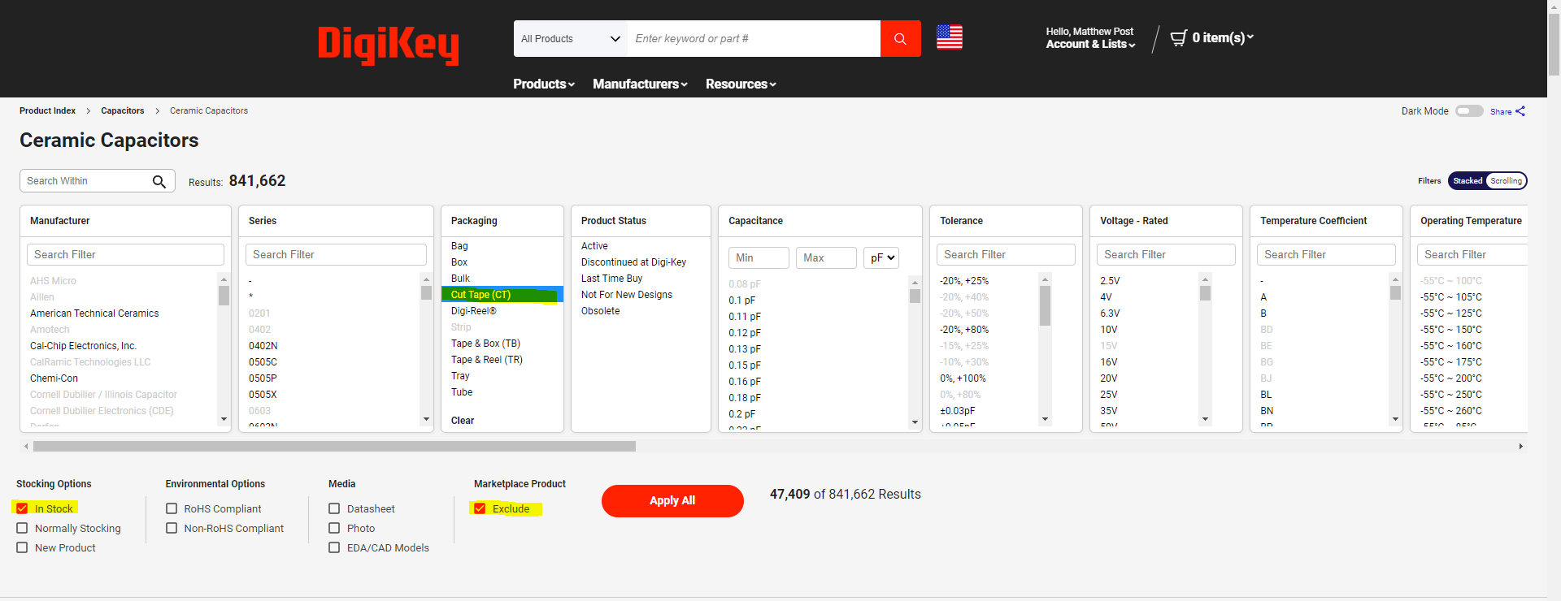

* 1. Make sure Digikey has sufficient components in stock. Sufficient means more than you need such that there are very little chance of components being out of stock by the time order is placed.
  2. Components CAN NOT be in Reel or Digi-Reel packaging.
     1. You can filter by Cut Tape
  3. If a component is not very expensive and you are within the budget, then make sure you include spares in the quantities listed in the BOM. For example, if you need quantity one of a particular IC and the overall cost of the BOM will not exceed $35, then change the quantity to 2.
     1. Certain components are very low cost. Example, for passives such as resistor or capacitor, there is no price difference between buying 1 or 10.
  4. Put your first initial and last name in the Customer Reference field.
  5. Save your BOM with file name: LastNameFirstName.xlsx and submit on Canvas.

1. PCB design suggestions
   1. Use “hand solder” pads in KiCAD whenever available.
   2. It is also good when hand soldering to extend the pads on IC’s a little to make soldering easier.
   3. Avoid BGA and QFN packages if possible. ETG does have a heat gun to reflow but results may vary
   4. Do not blindly assume footprints/symbols in KiCAD or online are correct. It’s best to always make your own based off the datasheet but at the very least compare the provided ones with a datasheet to make sure pinouts and dimensions are correct.
   5. Always run ERC’s and DRC’s when finishing a schematic or PCB. Do NOT ignore errors – fix them!
2. “Tag” your boards to make them easily identifiable and it’s just good practice as well. Find a suitable corner of PCB and add first name initial and last name, date(mm,yyyy), revision number, and a title to the silkscreen layer. KiCAD also can easily pull in images to add to the silkscreen as well.
3. Prepare a zip folder with fabrication files.
   1. These include Gerber and drill files.
   2. Check your files with a viewer.
   3. Make sure you upload them to JLC to make sure everything is in order.
   4. Submit your fabrication files on Canvas. Name the file LastNameFirstName.zip
4. Failure to follow instructions that results in an incomplete project is the responsibility of the student and will results in loss of points of the project.