# Play-Doh Controller Iterations

**Overview and Purpose:**

Students will prototype one-button controllers using Play-Doh and Makey Makey GO, to play a one-button game. Through experimenting with the controller, students change, redesign, and iterate on their design to find the best controller tactics.

This lesson is ideal as a lead in to designing with TinkerCAD.

**Objectives:**

*Specify skills/information that will be learned*

* Prototype and test a technology
* Use Makey Makey GO to control a game
* Iterate on a design, improve a design based on testing and experimentation
* Use shapes to build controllers that is intuitive for users
* Incorporate visual design elements of game into the controller for a cohesive visual design

**Materials Needed:**

* Play-Doh (1-3 colors per student)
* Makey Makey GO (1 per student)
* Chromebook with Scratch
* One-button scratch game (through repository, or create your own!)
* Alligator clips (1 per controller)

***Other Resources:***

*(websites, videos, books, etc.)*

* A good one-button scratch game - <https://scratch.mit.edu/projects/91959305/>
* Makey Makey GO setup instructions: <http://makeymakey.com/how-to/go/>
* TinkerCad: <https://www.tinkercad.com/>

**Information:**

*Give and/or demonstration necessary information*

1. As technologists, we can use technologies to extend our experience of the world and control other things. If I wanted to dig a hole, what would I want to use to do it? (A shovel) To get the job done, what do I want a shovel to look like? What features does a good shovel have?
2. So the best designed tools are suited to the job we want to do. When we play games, we also want tools that fit what we do. In most games, we need to use some kind of controller to play. A controller is a tool, where we use our hands to control what happens in the game.
3. Show some examples of game controllers. They can look like many things. What kind of games might you play with some of these? Some controllers fit many games, and some only play one game.

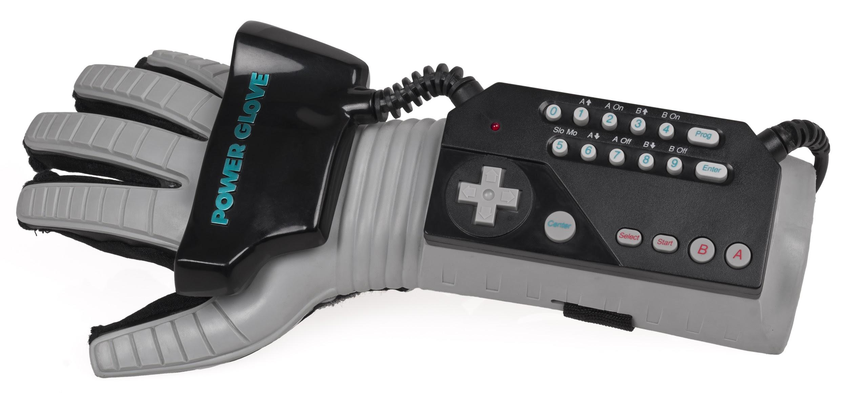

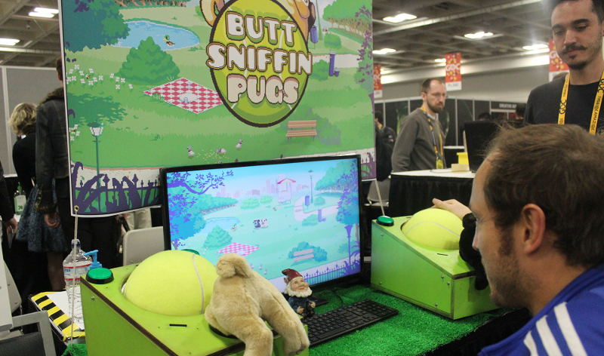

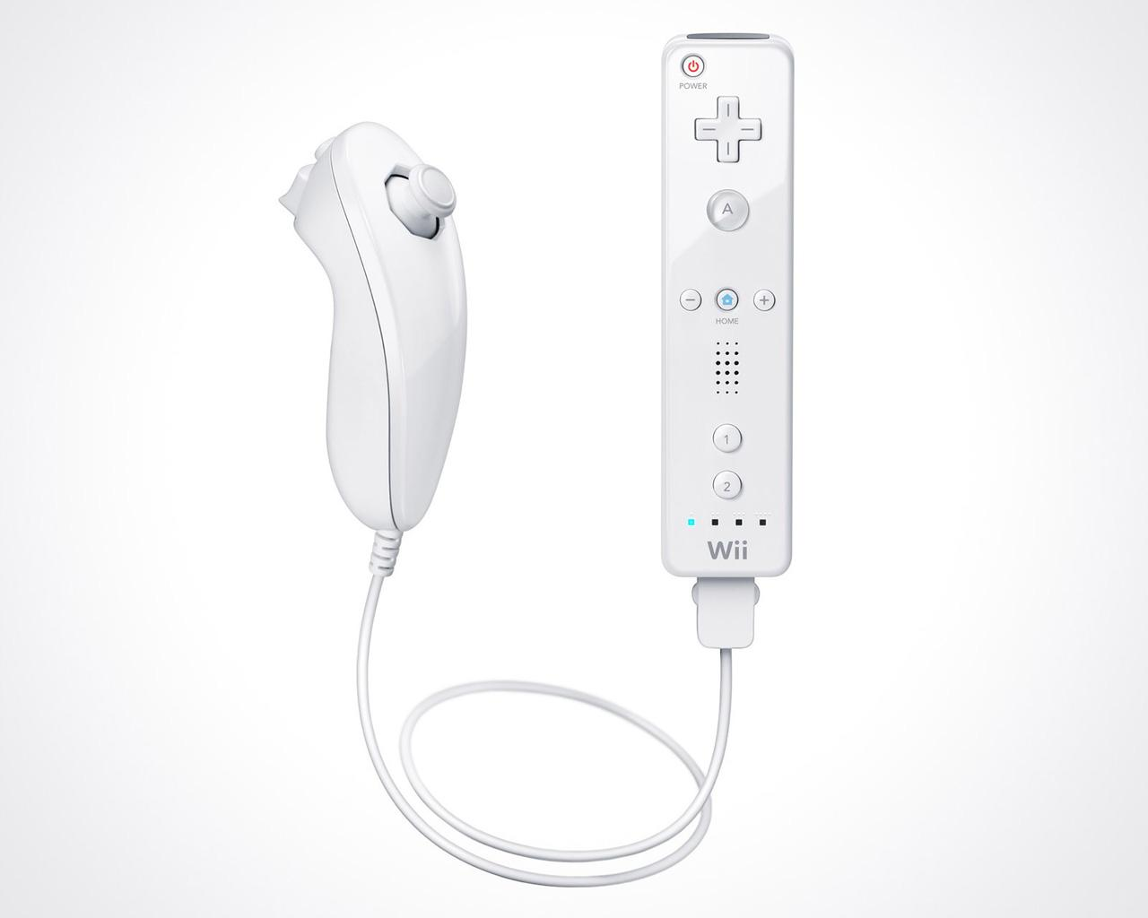

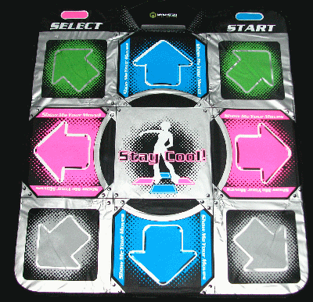

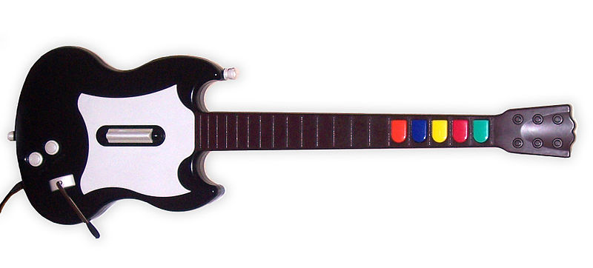

-

1. Today, you’re going to make a controller for this game. This game only has one button, so the player needs to be able to know where to press and how in order to play. Great controllers can be used without explaining - in the controllers above, you pick it up and can easily figure out how to use it.

***Verification*:**

*Steps to check for student understanding*

1. (Make a ball of play-doh, plug into Makey Makey GO to demonstrate that it works) Could this be my game controller if I plug it into the computer? How would I use it? Can a player guess that?
2. What’s one way I could make my controller better?
3. Using the Makey Makey tool, we can plug in anything that conducts electricity. Play-Doh conducts electricity because it contains water and salt, but conductive materials can also be metal, foods, or even our own bodies. What are some other things that we could use as controllers with Makey Makey?

***Activity*:**

*Describe activity that will reinforce the lesson*

1. Plug in and test the Makey Makey GO, and set up the Scratch game. Students should try to play the game without a controller (in 1 Button Tank, use space to play with the keyboard). Try to guide the following questions:
   1. How does the game work? Does a player need to hold the button for a long time? Press it very quickly in succession?
   2. What does the game look like? What would a controller that looks like this game be? What colors might it be? Could it look like a real world object?
   3. How do you win this game? Could a certain design of controller make a player more successful? Make it more challenging? Make it funny or strange to play and watch the game?
2. When kids understand the game, give them play-doh and have them build a button they would press to play that game.
3. When the initial design is ready to test, Plug the alligator clip into the play-doh no more than half an inch from the surface (where the player would touch). Have kids play the game using the controller. Does the controller work? Would another design make the controller more reliable? Less play-doh, different shape?
4. Have two kids switch and play each other’s game. When switching, the two partners aren’t allowed to explain their controller to each other. A usable controller should make sense without any explanation.
5. Ask, did your partner figure out how to use the controller? Partners, what did you like about the other controller? What’s one way they could make it easier to use?
6. Switch back and edit your controller based on feedback.
7. Trade controllers again with new partners. Again, no explanations allowed - is this controller better? What elements make it better?
8. Which controller designs look most like the game? (In 1 Button Tank, for instance, kids could build a button that looks like the tank) Does the visual design add to the experience of playing? If time, have kids add visual elements to fit the theme of the game.

**Notes**

Play-Doh is conductive, but a lot of times the alligator clip needs to be fairly close to the surface to make contact when touched. If a controller isn’t working, try adjusting the position of the clip closer to the surface. If that doesn’t work, test the alligator clip by placing the clip end against your hand directly. Next, try recalibrating the Makey Makey GO. Encourage kids to make one element that shows the player where to press for best results - i.e., a big red dot on your blue play-doh circle would probably suggest to a player that they should touch there (which is where your alligator clip is located).