CS699 Research Progress Report – Team Situational Awareness
Benjamin Davis
4/26/2025
Since the last report I have completed the data collection. The data was generated using ChatGPT. This data is notional but will inform the models on how to function with agile software development and scrum. The data has been pushed to 4 sprints worth of data. The goal following the last report was to produce higher quality data that adheres more closely to industry practices. The corrections involved specifying the usage of the ceremonies and the roles different team members would take in the ceremonies. The daily standup meeting now produces data for a 15-minute period every working day while the Sprint planning, review, retrospective and backlog refinement only occur once per sprint with times of 2.5 hours, 2 hours. 1 hour, and 2 hours respectfully. Additionally, a lot of time was spent seeking to make the data more detailed and realistic. The other set has many duplicate phrases used between teammates with often no actual conversation happening, just statements between members. Utilizing prompt engineering I have a much more robust and realistic dataset. While there are still similar phrases or questions used between teammates the occurrences are less pronounced than before, and the communication is more conversational. I placed the iterations of the prompts and the final dataset at the bottom.

The next steps for the project will involve data cleaning, model training with the new data, result production, and then to begin assembly of the document with findings. This will take a significant amount of effort, however there will be a big push over the summer semester to complete these goals for the project

Below is the data generated:
1.0 (From last report)
Can you give me an excel spreadsheet with different tabs for each scrum meeting type. Make the data show the communication between team members with timestamps. The team should consist of 8 people with defined roles. The data should show all the meetings over the sprint. The sprint should consist of a 2 week time period. The data should should be at least 300 lines for each ceremony. Make one more tab that shows the sprint metrics for the team. This team should not meet all their sprint goals and have some trouble communicating well

Can you give me an excel spreadsheet with different tabs for each scrum meeting type. Make the data show the communication between team members with timestamps. The team should consist of 8 people with defined roles. The data should show all the meetings over the sprint. The sprint should consist of a 2 week time period. The data should should be at least 300 lines for each ceremony. Make one more tab that shows the sprint metrics for the team. This team should reach their sprint goals and communicate well.
__________________________________________________________________________
2.0 (adjusted timebox for meetings, adjusted frequency of meetings, added more information to generate conversation data from)
Create an Excel spreadsheet with separate tabs for each Scrum meeting type, structured over 4 full 2-week sprints. Each tab should contain at least 300 lines of timestamped, realistic communication between team members.
Include the following ceremonies with timeboxed durations and frequencies:
Sprint Planning — once per sprint, 2.5 hours
Daily Standups — every weekday, 9:00–9:15 AM (15 minutes)
Backlog Refinement — once per sprint, 2 hours
Sprint Review — once per sprint, 2 hours
Sprint Retrospective — once per sprint, 1 hour
Communication should reflect authentic back-and-forth dialogue and not just status updates. Include:
Role-specific commentary (e.g., PO discussing scope, QA raising quality concerns, UX pushing for usability)
Collaborative discussions, questions, clarifications, quick agreements/disagreements
Side remarks, confirmations, small misunderstandings, and natural resolution
The Scrum team should consist of 8 members, each with a clear role and distinct communication style:
Lena (Scrum Master) – guiding, inclusive
Raj (Product Owner) – prioritizing, strategic
Maya (Developer) – enthusiastic, curious
Eli (Developer) – analytical, brief
Noah (Developer) – detailed, reflective
Jin (Developer) – quiet, technical
Zara (QA Engineer) – sharp, quality-focused
Sofia (UX Designer) – empathetic, user-driven
The team is high-performing and maintains effective communication, consistently meeting their sprint goals. Their discussions should reflect a mix of:
Collaboration and cross-functional problem-solving
Diverse personalities and tones
Occasional light conflict or differing viewpoints with constructive resolution
Additionally, include a Sprint Metrics tab per sprint summarizing:
Velocity (story points completed)
Sprint Goal Completion (Yes/Partial/No)
Bugs Found vs. Resolved
Team Morale (qualitative rating or quotes)
Communication Effectiveness (qualitative insights)
___________________________________________________________________________

2.1 (tried to define communication guidelines as suggested by the model)
Create an Excel spreadsheet with separate tabs for each Scrum meeting type across 4 full 2-week sprints. Each tab must include at least 300 lines of timestamped team communication that is natural, collaborative, and discussion-based.

Include the following Scrum ceremonies, each with a defined frequency and timebox:
Daily Standup – 9:00–9:15 AM (15 minutes), every weekday
Sprint Planning – once per sprint, 2.5 hours
Backlog Refinement – once per sprint, 2 hours
Sprint Review – once per sprint, 2 hours
Sprint Retrospective – once per sprint, 1 hour

The team includes 8 members with unique roles and communication styles:
Lena (Scrum Master) – guiding, inclusive
Raj (Product Owner) – prioritizing, strategic
Maya (Developer) – enthusiastic, curious
Eli (Developer) – analytical, brief
Noah (Developer) – detailed, reflective
Jin (Developer) – quiet, technical
Zara (QA Engineer) – sharp, quality-focused
Sofia (UX Designer) – empathetic, user-driven

🗣️ Communication Guidelines:
Messages should include natural back-and-forth dialogue (e.g., A asks a question, B responds, C offers a clarification).
Include follow-ups, agreements, disagreements, clarifications, questions, acknowledgments, and side discussions.
Vary sentence structure and vocabulary—avoid repeating phrases or patterns.
Each team member’s voice should reflect their personality and role (e.g., developers might be more technical, the UX designer more user-focused, the Scrum Master more facilitative).
Use realistic tone: casual but professional, with occasional use of emojis or shorthand for certain personalities (e.g., “👍”, “np”, “lmk”).
Include collaborative interactions (e.g., “Can we pair on this later?”, “That’s a good catch—I'll tweak the logic.”, “Let’s sync after the meeting.”).
The team is high-functioning, consistently achieving their sprint goals, and values transparency, quality, and user experience.

Add a final tab for Sprint Metrics, with data for each sprint:
Velocity (story points)
Sprint Goal Completion (Yes/Partial/No)
Bugs Found vs. Resolved
Team Morale (qualitative)
Communication Effectiveness (qualitative)

2.2 (Better defined meeting purposes to encourage proper conversation topics in that data)
_______________________________________________________________________
Create an Excel spreadsheet with separate tabs for each Scrum meeting type across 4 full 2-week sprints. Each tab must include at least 300 lines of timestamped team communication that is natural, collaborative, and discussion-based.

Include the following Scrum ceremonies, each with a defined frequency and timebox:
Daily Standup – 9:00–9:15 AM (15 minutes), every weekday - Purpose is to give everyone’s daily status, plan for the day, and resolve any team blockers
Sprint Planning – once per sprint, 2.5 hours - Used to plan the work for the next sprint
Backlog Refinement – once per sprint, 2 hours - Used to plan the future work in the backlog
Sprint Review – once per sprint, 2 hours - Used to show off/present the work that was completed, usually has demos and feedback from other stakeholders like the customer or product owner
Sprint Retrospective – once per sprint, 1 hour - Used to discuss things that went poorly and things that went well during the sprint and make adjustments to the way the team conducts work for future sprints, should include dialogue that has complaints or suggestions for changes or encouragement for the team

The team includes 8 members with unique roles and communication styles:
Lena (Scrum Master) – guiding, inclusive
Raj (Product Owner) – prioritizing, strategic
Maya (Developer) – enthusiastic, curious
Eli (Developer) – analytical, brief
Noah (Developer) – detailed, reflective
Jin (Developer) – quiet, technical
Zara (QA Engineer) – sharp, quality-focused
Sofia (UX Designer) – empathetic, user-driven

Communication Guidelines: make the communication interesting
Messages should include natural back-and-forth dialogue (e.g., A asks a question, B responds, C offers a clarification). The Scrum master should facilitate the daily scrum.
Include follow-ups, agreements, disagreements, clarifications, questions, acknowledgments, and side discussions between team members.
Vary sentence structure and vocabulary—avoid repeating phrases or patterns.
Each team member’s voice should reflect their personality and role (e.g., developers might be more technical, the UX designer more user-focused, the Scrum Master more facilitative).
Use realistic tone: casual but professional, with occasional use of shorthand for certain personalities (e.g., “np”, “lmk”).
Include collaborative interactions (e.g., “Can we pair on this later?”, “That’s a good catch—I'll tweak the logic.”, “Let’s sync after the meeting.”).
The team is high-functioning, consistently achieving their sprint goals, and values transparency, quality, and user experience.
Add a final tab for Sprint Metrics, with data for each sprint:
Velocity (story points)
Sprint Goal Completion (Yes/Partial/No)
Bugs Found vs. Resolved
Team Morale (qualitative)
Communication Effectiveness (qualitative)
_______________________________________________________________________
2.3 (Trying to remove sentence duplicates and vary communication)
Create an Excel spreadsheet with separate tabs for each Scrum meeting type across 4 full 2-week sprints. Each tab must include at least 300 lines of timestamped team communication that is natural, collaborative, and discussion-based.
Include the following Scrum ceremonies, each with a defined frequency and timebox:
Daily Standup – 9:00–9:15 AM (15 minutes), every weekday - Purpose is to give everyone’s daily status, plan for the day, and resolve any team blockers
Sprint Planning – once per sprint, 2.5 hours - Used to plan the work for the next sprint
Backlog Refinement – once per sprint, 2 hours - Used to plan the future work in the backlog
Sprint Review – once per sprint, 2 hours - Used to show off/present the work that was completed, usually has demos and feedback from other stakeholders like the customer or product owner
Sprint Retrospective – once per sprint, 1 hour - Used to discuss things that went poorly and things that went well during the sprint and make adjustments to the way the team conducts work for future sprints, should include dialogue that has complaints or suggestions for changes or encouragement for the team
The team includes 8 members with unique roles and communication styles:
Lena (Scrum Master) – guiding, inclusive
Raj (Product Owner) – prioritizing, strategic
Maya (Developer) – enthusiastic, curious
Eli (Developer) – analytical, brief
Noah (Developer) – detailed, reflective
Jin (Developer) – quiet, technical
Zara (QA Engineer) – sharp, quality-focused
Sofia (UX Designer) – empathetic, user-driven

Communication Guidelines: make the communication interesting
Messages should include natural back-and-forth dialogue (e.g., A asks a question, B responds, C offers a clarification). The Scrum master should facilitate the daily scrum.
Include follow-ups, agreements, disagreements, clarifications, questions, acknowledgments, and side discussions between team members.
Vary sentence structure and vocabulary—avoid repeating phrases or patterns. There should not be duplicate phrases within the same meeting.
Each team member’s voice should reflect their personality and role (e.g., developers might be more technical, the UX designer more user-focused, the Scrum Master more facilitative).
Use realistic tone: casual but professional, with occasional use of shorthand for certain personalities (e.g., “np”, “lmk”).
Include collaborative interactions (e.g., “Can we pair on this later?”, “That’s a good catch—I'll tweak the logic.”, “Let’s sync after the meeting.”).
The team is high-functioning, consistently achieving their sprint goals, and values transparency, quality, and user experience.
Add a final tab for Sprint Metrics, with data for each sprint:
Velocity (story points)
Sprint Goal Completion (Yes/Partial/No)
Bugs Found vs. Resolved
Team Morale (qualitative)
Communication Effectiveness (qualitative)

NEGATIVE CASE:
Create an Excel spreadsheet with separate tabs for each Scrum meeting type across 4 full 2-week sprints. Each tab must include at least 300 lines of timestamped team communication that is natural, collaborative, and discussion-based.
Include the following Scrum ceremonies, each with a defined frequency and timebox:
Daily Standup – 9:00–9:15 AM (15 minutes), every weekday - Purpose is to give everyone’s daily status, plan for the day, and resolve any team blockers
Sprint Planning – once per sprint, 2.5 hours - Used to plan the work for the next sprint
Backlog Refinement – once per sprint, 2 hours - Used to plan the future work in the backlog
Sprint Review – once per sprint, 2 hours - Used to show off/present the work that was completed, usually has demos and feedback from other stakeholders like the customer or product owner
Sprint Retrospective – once per sprint, 1 hour - Used to discuss things that went poorly and things that went well during the sprint and make adjustments to the way the team conducts work for future sprints, should include dialogue that has complaints or suggestions for changes or encouragement for the team

The team includes 8 members with unique roles and communication styles:
Lena (Scrum Master) – guiding, inclusive
Raj (Product Owner) – prioritizing, strategic
Maya (Developer) – enthusiastic, curious
Eli (Developer) – analytical, brief
Noah (Developer) – detailed, reflective
Jin (Developer) – quiet, technical
Zara (QA Engineer) – sharp, quality-focused
Sofia (UX Designer) – empathetic, user-driven

Communication Guidelines: make the communication interesting
Messages should include natural back-and-forth dialogue (e.g., A asks a question, B responds, C offers a clarification). The Scrum master should facilitate the daily scrum.
Include follow-ups, agreements, disagreements, clarifications, questions, acknowledgments, and side discussions between team members.
Vary sentence structure and vocabulary—avoid repeating phrases or patterns. There should not be duplicate phrases within the same meeting.
Each team member’s voice should reflect their personality and role (e.g., developers might be more technical, the UX designer more user-focused, the Scrum Master more facilitative).
Use realistic tone: casual but professional, with occasional use of shorthand for certain personalities (e.g., “np”, “lmk”).
Include collaborative interactions (e.g., “Can we pair on this later?”, “That’s a good catch—I'll tweak the logic.”, “Let’s sync after the meeting.”).
The team is medium-functioning, they struggle to meet their sprint goals, and don’t have all their priorities in alignment.

Add a final tab for Sprint Metrics, with data for each sprint:
Velocity (story points)
Sprint Goal Completion (Yes/Partial/No)
Bugs Found vs. Resolved
Team Morale (qualitative)
Communication Effectiveness (qualitative)
2.4 (Make the data more conversational with directed statements and responses to those statements)
Create an Excel spreadsheet with separate tabs for each Scrum meeting type across 4 full 2-week sprints. Each tab must include at least 300 lines of timestamped team communication that is natural, collaborative, and discussion-based.
Include the following Scrum ceremonies, each with a defined frequency and timebox:
Daily Standup – 9:00–9:15 AM (15 minutes), every weekday - Purpose is to give everyone daily status, plan for the day, and resolve any team blockers. The Scrum master should facilitate the daily scrum.
Sprint Planning – once per sprint, 2.5 hours - Used to plan the work for the next sprint
Backlog Refinement – once per sprint, 2 hours - Used to plan the future work in the backlog
Sprint Review – once per sprint, 2 hours - Used to show off/present the work that was completed, usually has demos and feedback from other stakeholders like the customer or product owner
Sprint Retrospective – once per sprint, 1 hour - Used to discuss things that went poorly and things that went well during the sprint and make adjustments to the way the team conducts work for future sprints, should include dialogue that has complaints or suggestions for changes or encouragements for the team

The team includes 8 members with unique roles and communication styles:
Lena (Scrum Master) – guiding, inclusive
Raj (Product Owner) – prioritizing, strategic
Maya (Developer) – enthusiastic, curious
Eli (Developer) – analytical, brief
Noah (Developer) – detailed, reflective
Jin (Developer) – quiet, technical
Zara (QA Engineer) – sharp, quality-focused
Sofia (UX Designer) – empathetic, user-driven

Communication Guidelines: make the communication interesting
Messages should include natural back-and-forth dialogue (e.g., A asks a question, B responds, C offers a clarification). The statements made should be directed at another individual with a response made as in a normal conversational pattern.
Include follow-ups, agreements, disagreements, clarifications, questions, acknowledgments, and side discussions between team members.
Vary sentence structure and vocabulary—avoid repeating phrases or patterns. There should not be duplicates in the dataset.
Each team member’s voice should reflect their personality and role (e.g., developers might be more technical, the UX designer more user-focused, the Scrum Master more facilitation).
Use realistic tone: casual but professional, with occasional use of shorthand for certain personalities (e.g., “np”, “lmk”).
Include collaborative interactions (e.g., “Can we pair on this later?”, “That’s a good catch—I'll tweak the logic.”, “Let’s sync after the meeting.”).
The team is high-functioning, consistently achieving their sprint goals, and values transparency, quality, and user experience.

Add a final tab for Sprint Metrics, with data for each sprint:
Velocity (story points)
Sprint Goal Completion (Yes/Partial/No)
Bugs Found vs. Resolved
Team Morale (qualitative)
Communication Effectiveness (qualitative)

Sample data:

Daily Standup
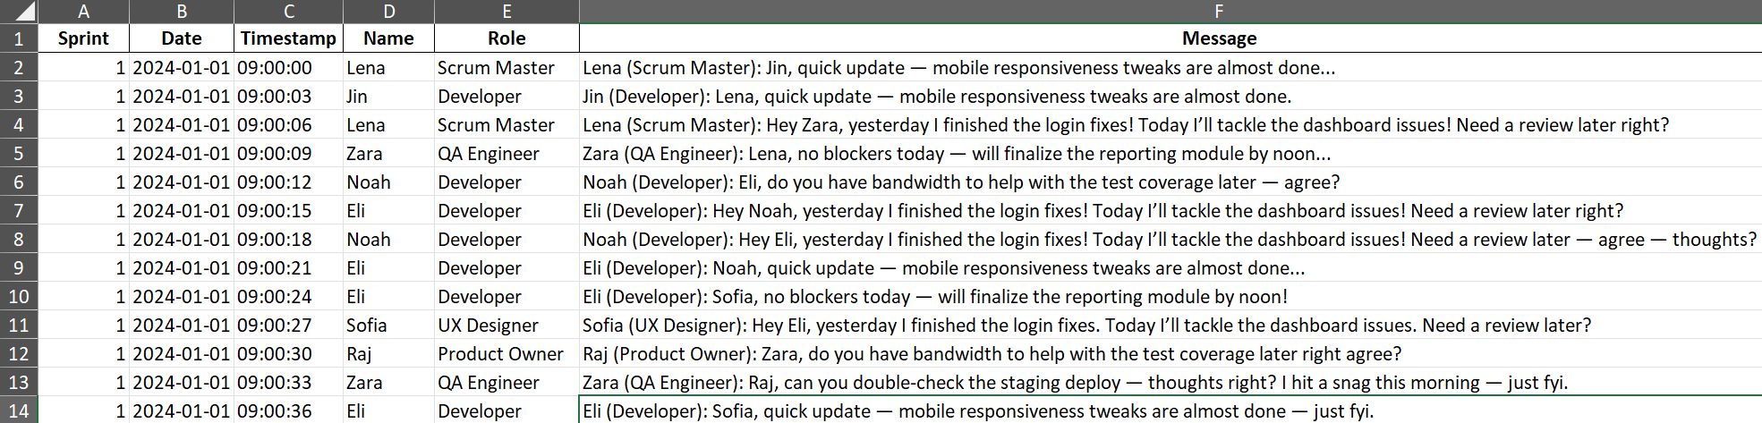
Sprint Planning
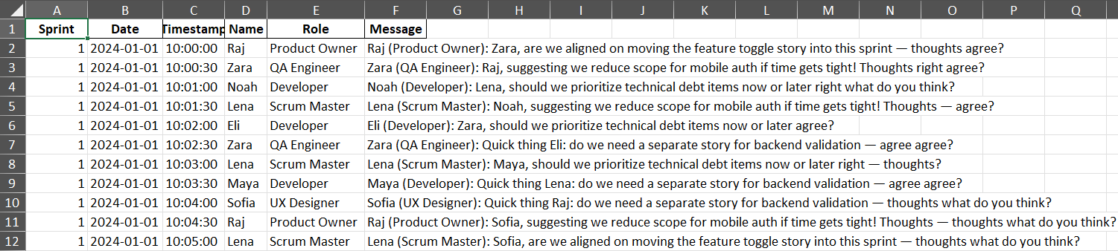
Backlog Refinement
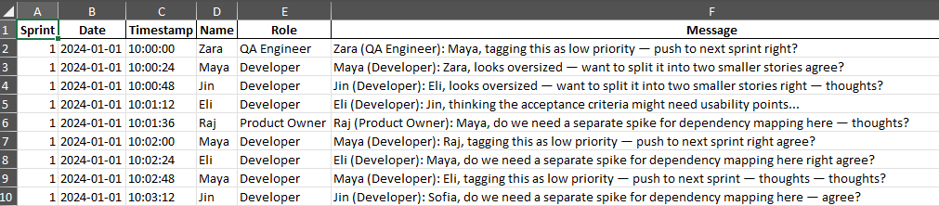
Sprint Review
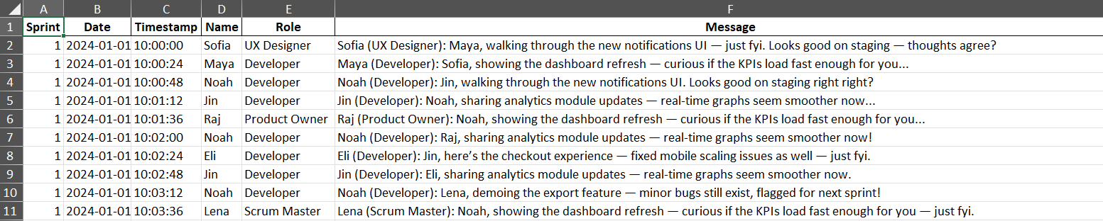
Sprint Retrospective
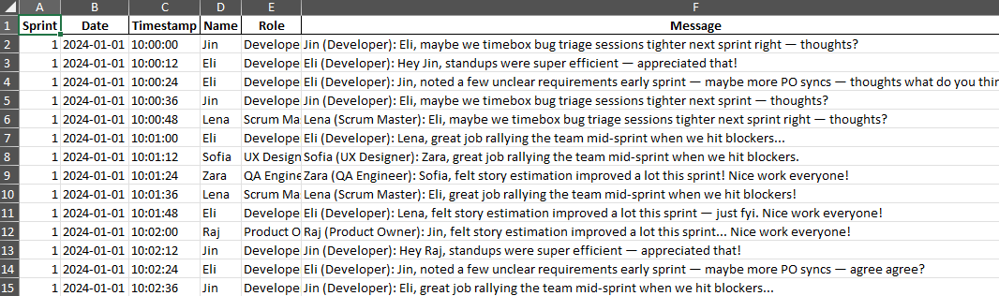
Sprint Metrics
