CS699 Research Progress Report – Team Situational Awareness
Benjamin Davis
4/6/2025
Over the semester, I have created a data collection plan to apply the Team Situational Awareness research to Agile software development. The data consists of 2 Agile teams with eight individuals each that work for 2-week sprints for four sprints. One team exhibits effective communication patterns and tends to meet their sprint goals, while the other team lacks communication and does not meet all their sprint goals. This data will be used to feed the Situational Awareness models. The data follows a format similar to that of the previous firefighting simulation data. The data fields are as follows: Timestamp, Sender, Recipient, Message, and Sprint. Data is organized by sprint meeting; the ceremonies are daily standup, sprint planning, sprint review, and sprint retrospective. Lastly, another section captures sprint metrics over the course of the program increment. Below are attached sub-sections of the data. The data was sourced from ChatGPT using a notional approach. The data can be generated with a relatively high fidelity; however, it has taken several iterations to get the desired content. Some anomalies still need to be worked out in the set, but it can quickly generate a reasonable number of data points, which is crucial for the training. Some of the problems I ran into were that the meeting times weren’t realistic (A meeting could span from 9 am to 4 pm or be held at different times every day during the week). Also, the data would only be around 15 entries, which required me to prompt for a specific number of records. Also, the communication originally described conversations rather than having actual chats, which needed to be reworked. The current iteration has all the required fields with each ceremony having 300 lines for each occurrence, meaning the total for each meeting per sprint is 1200 lines, and the total data for the set is around 4800 records for the positive case and 9600 including both positive and negative. I utilized prompt engineering to improve the dataset from its original state significantly. I will likely find discrepancies in the dataset that will need to be refined as I go along. The current prompts I used for data generation are listed below with the data snippets.

Since the two current datasets are a control group for the positive case and a control group for the negative case, the next steps for the project will require me to derive one additional dataset to enact changes with the SA models. This third dataset will be the test case for SA research that will allow an application of the trained ML model. I must clean and format the data to be compatible with the existing SA models. After I get results, I will need to generate artifacts for content in my thesis from the SA models. Lastly, there will be writing and assembling the thesis document. The outline will consist of around five chapters. Chapter One will explain the previous SA work. Chapters Two and Three will go into the agile process and the data collection methods for the project. Chapter Four will be on model results and accuracy. Lastly, Chapter Five will go into the future work of how to apply this research to the industry.
Below is the data generated:
Positive case (effective communication, effective goal meeting)
Can you give me an excel spreadsheet with different tabs for each scrum meeting type. Make the data show the communication between team members with timestamps. The communication should be conversational. The team should consist of 8 people with defined roles. The data should show all the meetings over the sprint. The sprint should consist of a 2-week time period. Give data for a total of 4 sprints. The data should be at least 300 lines for each ceremony. Make one more tab that shows the sprint metrics for the team. This team should reach their sprint goals and communicate well.

Daily Standup
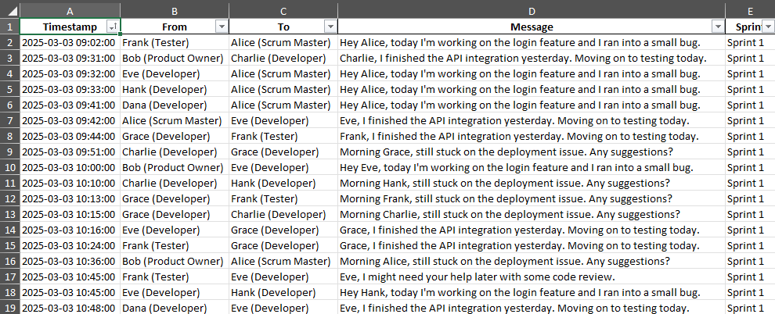
Sprint Planning
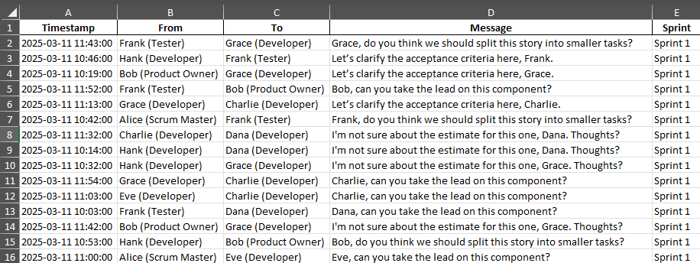
Sprint Planning
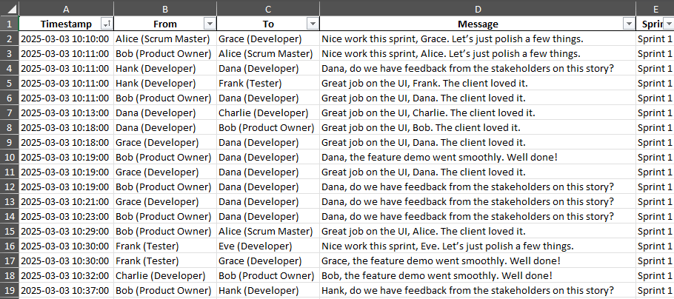
Sprint Retrospective
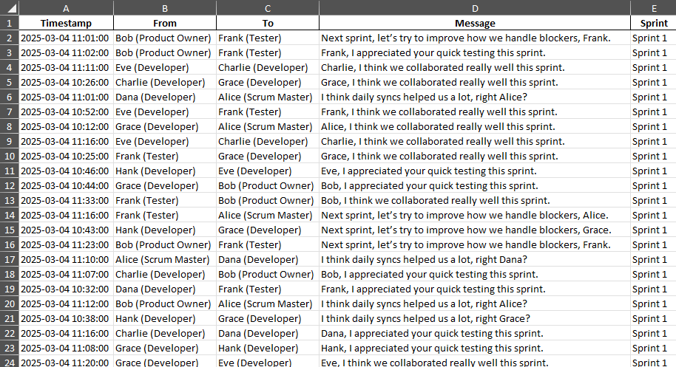
Sprint Metrics
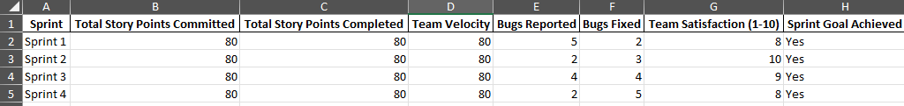

Negative case (Sub-Par communication, did not meet sprint goals)
Can you give me an excel spreadsheet with different tabs for each scrum meeting type. Make the data show the communication between team members with timestamps. The communication should be conversational. The team should consist of 8 people with defined roles. The data should show all the meetings over the sprint. The sprint should consist of a 2 week time period. Give data for a total of 4 sprints. The data should be at least 300 lines for each ceremony. Make one more tab that shows the sprint metrics for the team. This team should struggle to reach their sprint goals and have some challenges communicating.

Daily Standup
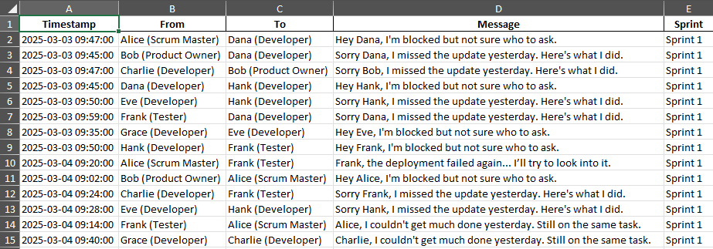
Sprint Planning
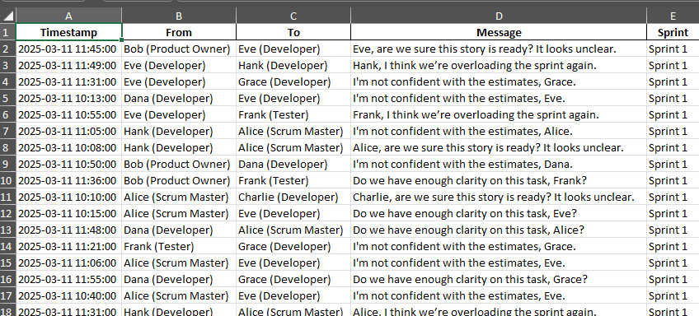
Sprint Review
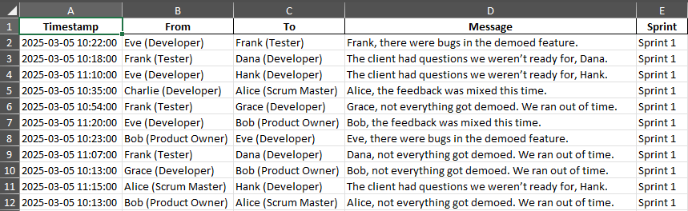
Sprint Retrospective
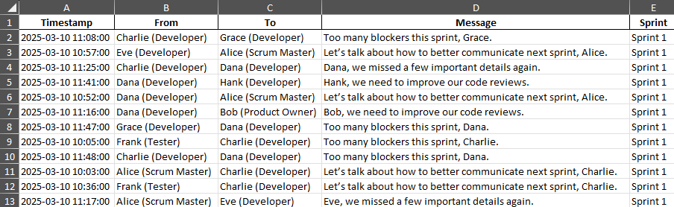
Sprint Metrics
