**jason**

Position: supervisor

Department: it



------------------------------

**Alice**

Position: staff

Department: IT

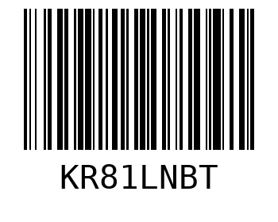

------------------------------

**Bob**

Position: technician

Department: IT



------------------------------

**Charlie**

Position: analyst

Department: IT



------------------------------