**Final project**

**Goal**: In Stage 2’s Lynda video, you learned how to make a calculator in the laptop. Here, this project requires you to make a calculator app for mobile devices.

**Requirements:**

1. Your mobile calculator must have all the functionalities as shown in the laptop one.
2. You must design a UI (User Interface) to enable these functionalities of the calculator app.
3. You must include the following four Android permissions: INTERNET, ACCESS_FINE_LOCATION, CAMERA, SEND_SMS
4. You must store the results of using the calculator into the network hosts. Use any free network host to host your data; In your app, you must have one button to display all these results retrieved from the network hosts.

**Submit your work:**   
  
Use screen shots to 1) show the UI of the app; 2) show the functionalities of the mobile calculator app; 3) demonstrate that your app could store and retrieve the results from the Internet hosts. Rename this word doc with your embedded screen shots as Lastname_Firstname_FinalProject.docx. Zip it all up with a complete copy of your project. Name the Zip file: Lastname_Firstname_FinalProject.zip. Submit your archive with the Bb assignment mechanism.

Screenshots below:

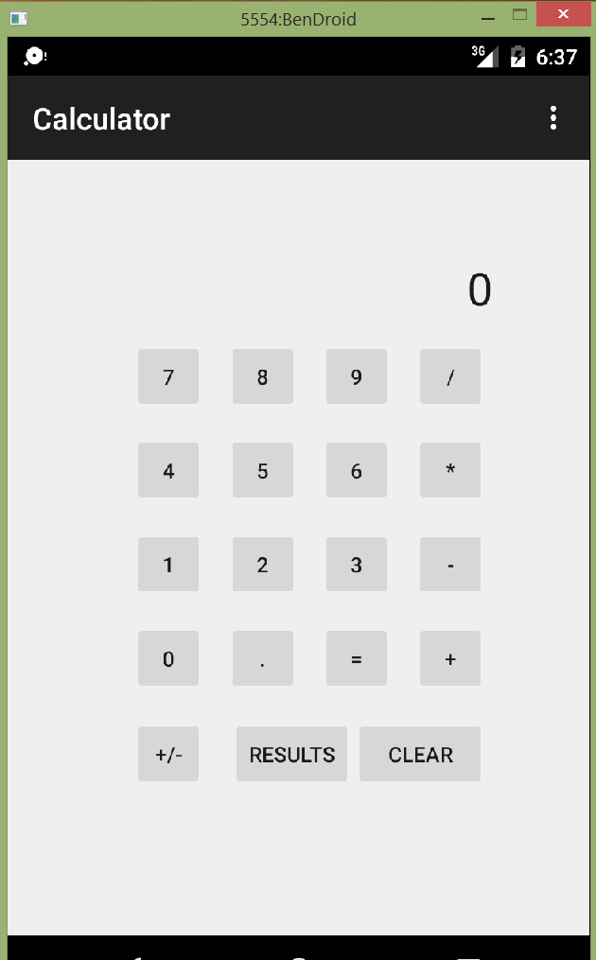

This is our basic calculator UI. We have buttons for the numbers 0-9 along with decimal and sign change buttons. This calculator can do addition, multiplication, subtraction and division. The Clear button resets all calculation variables to 0/null so we can start with fresh operands and operations. The Results button shows us what our past results of using the calculator are.

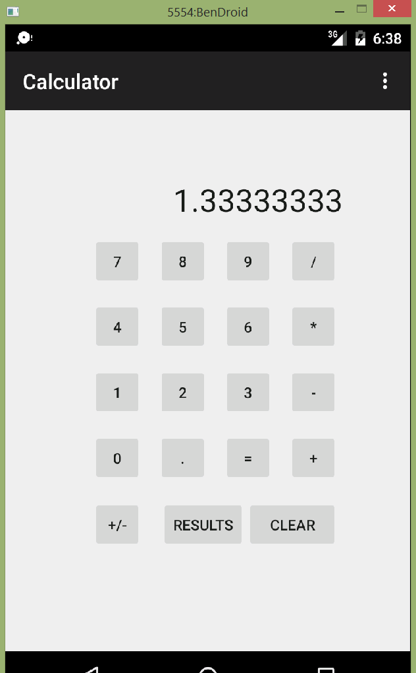

The df format is used to limit results to 8 decimal places. Once the = operator is clicked the results are sent to the cloud. The result shown is now in the variable preValue so we can enter a new operation and a new currValue to perform additional operations on our prior results.

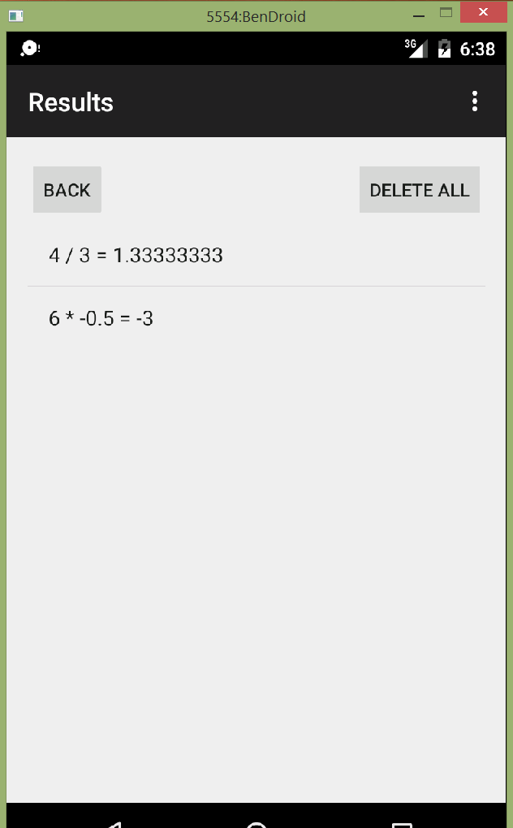

Clicking Results brings us to this new activity which shows all results in a ListView. The results come from a NoSQL datastore on Parse.com. They are passed via query to ParseObject into an ArrayList which is then rendered via the ListView.

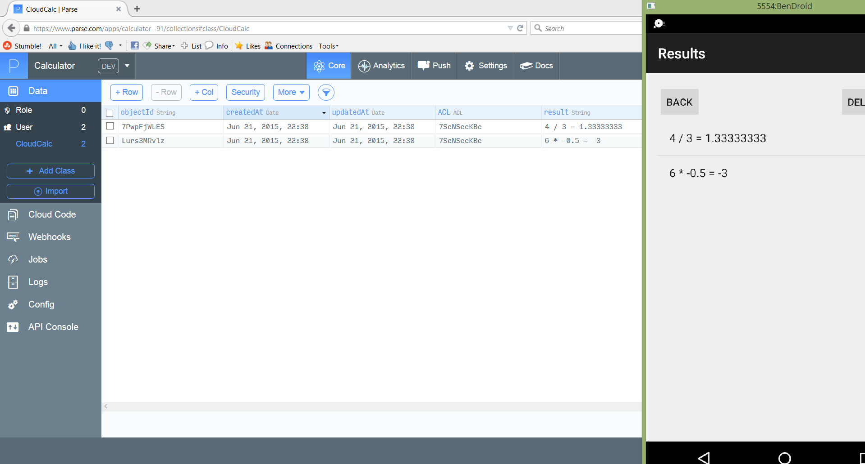

Here we can see the results on both the Results screen in the calculator app as well as on the parse.com dashboard. The Results screen also gives us the ability to clear all results from both the device’s screen and the cloud.

