Results

# Results

## Simulation A

The descriptive results for all 288 conditions in Simulation A are reported in the appendix (TODO).

### Outcome: Estimation bias (MSE)

**Descriptive statistics.**

**ANOVA.** We used a 4 × 2 × 3 × 4 × 3 factorial Type I ANOVA (with estimation bias as an outcome and number of participants, number of timepoints per participant, missingness type, compliance, and the simulated fixed autoregressive effect) to assess which of the manipulated factors had a considerable influence on estimation bias. The results from every simulation run (i. e., 1,000 results per condition = 288,000 rows) were combined into a single dataset for the analysis. Given the very large sample size (which would make any difference significant) and the exploratory character of the analysis, *p*-values and significance thresholds were not used make inferences. Instead, we used a threshold of 0.14 for the partial $ω^{2}$, indicating a large effect size (Field, Miles, and Field 2012). The partial $ω^{2}$ was chosen as the less biased alternative to partial $η^{2}$ (Okada 2013). The results and effect sizes are reported in Table FJ.

Four main effects above the effect size threshold of 0.14 were found: the main effect of missingness type ( $ω^{2}$ = 0.73), compliance ( $ω^{2}$ = 0.63), the number of timepoints per participant ( $ω^{2}$ = 0.26), and the simulated fixed slope ( $ω^{2}$ = 0.14). Furthermore, the interaction between the missingness type and compliance ( $ω^{2}$ = 0.54) had an effect size above the cut-off.

The main effects of missingness type and compliance are visualised in Figure BG and Figure BH (respectively), while the interaction between missingness type and compliance are depicted in Figure BK.

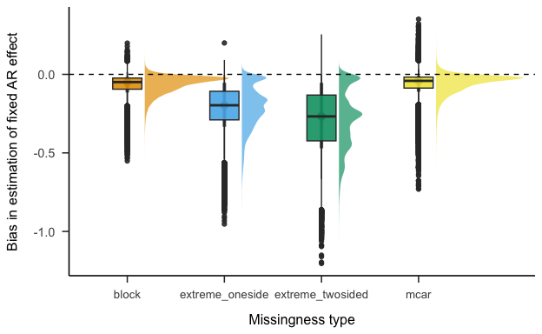

The effect of compliance on the bias in estimation of the fixed slopes.

Figure BG shows that while the underestimation of the fixed slopes is fairly low (although still considerable) when the observations are missing completely at random or in block, it becomes severe when only the most extreme values (both at one side and at both sides) are missing. SOMETHING ABOUT JANNE’S PAPER! Additionally, the underestimation of the fixed slopes becomes more severe as the compliance gets lower.

The average estimation bias when compliance is 0.8 (which is very close to the average compliance of ESM studies in psychology) is -0.13. As a consequence, many estimates of inertia in psychological research could be seriously downward biased. Furthermore, the estimates are slightly biased even when compliance is 1 (i. e., there are no missing data; average bias: -0.04). This is in line with the findings about estimation biased caused by person-mean centering in multilevel autoregressive models (Hamaker and Grasman 2015).

Zooming in on the interaction between compliance and missingness type (Figure BK) suggests that the effect of compliance on estimation bias is dramatically more severe for the two conditions in which the most extreme values of the process were set as missing (as compared to the other two conditions, i. e., data MCAR and missing in blocks). In the worst-case scenario (low compliance of 0.4; the most extreme values at both sides missing), the average estimation bias was -0.48). Given that the average simulated fixed slope was 0.5, these results imply that even rather large autocorrelations can be estimated as close to 0 in studies with the combination of low compliance and a non-random missingness pattern. At the same time, the results about data MCAR and missing in blocks are encouraging. Even in a low-compliance (0.4) condition, the average estimation bias was -0.08 for the former and -0.09) for the latter.

The average estimation bias for all combinations of missingness type and compliance (averaged over all values of the number of participants, timepoints per participant and simulated fixed slope) is reported in Table XD.

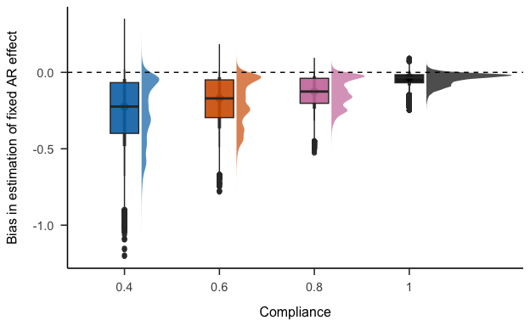

The effect of missingness type on the bias in estimation of the fixed slopes.

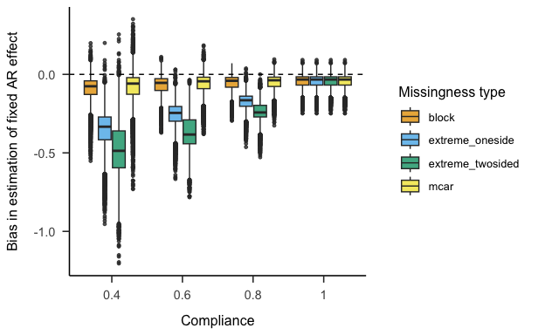

The effect of the interaction between missingness type and compliance on the bias in estimation of the fixed slopes.

### Outcome: Standard error

**Descriptive statistics.**

**ANOVA.**

### Outcome: Statistical power

### Outcome: Bias in person-mean estimation

Field, Andy, Jeremy Miles, and Zoë Field. 2012. “Discovering Statistics Using r (2012).” *Great Britain: Sage Publications, Ltd* 958.

Hamaker, Ellen L., and Raoul P. P. P. Grasman. 2015. “To Center or Not to Center? Investigating Inertia with a Multilevel Autoregressive Model.” *Frontiers in Psychology* 5 (January). <https://doi.org/10.3389/fpsyg.2014.01492>.

Okada, Kensuke. 2013. “Is Omega Squared Less Biased? A Comparison of Three Major Effect Size Indices in One-Way ANOVA.” *Behaviormetrika* 40 (2): 129147.