# Introduction

In recent years, the focus in diverse subfields of psychology has been shifting towards complexity, dynamics and within-person perspective (Hamaker, 2012). Among other things, this shift has been facilitated by the growing availability of smartphones and wearables. These devices allow researchers to use the Experience sampling method (ESM) to collect intensive longitudinal data with a high level of ecological validity (Myin-Germeys et al., 2018). Intensive longitudinal data consist of severeal repeated measurements per day, nested within individual participants (Larson & Csikszentmihalyi, 2014). The use of intensive longitudinal data considerably broadens the extent of research questions psychological researchers can investigate and statistical analyses they can conduct. Importantly, the multilevel structure of intensive longitudinal data allows scientists to investigate both within-person dynamic processes and the individual differences therein between persons (Wright & Zimmermann, 2019). One of the new research avenues that emerged with the growing popularity of intensive longitudinal data is the study of affect dynamics (for an overview, see Houben et al., 2015). The dynamic affect measures make use of the structure of intensive longitudinal data to take the fluctuating nature of affect/emotions into account.

Apart from dynamic measures such as emotional variance or instability, inertia emerged as a parameter that can contribute to the knowledge about emotion regulation (Kuppens & Verduyn, 2017). Usually, inertia is operationalised as autoregression in ESM psychological research. The autoregressive (AR) parameter quantifies the degree to which the value of a process at time *t* is influenced by the lagged variable (i. e., the process value at a previous time point; usually, *t-1*). In other words, the AR parameter allows researchers to approximate to what degree the intensity of an emotion/affect is carried onto the intensity of the emotional experience at the subsequent time point (for the same emotion), and to what degree the process is influenced by other factors. The part of the process value that is not explained by the lagged variable is assumed to be caused by *innovation*: the ensemble of (both within- and between-person factors) that have influenced the process at a given time point (Ariens et al., 2020). Inertia is usually modelled using the multilevel autoregressive (MLAR) model (Koval et al., 2021). Usually, the MLAR model has two levels: the within-person Level 1, in which the intra-person autoregressive process is modelled, and the between-person Level 2, in which the individual differences in the autoregressive parameter and intercept are modelled. A more detailed description of the MLAR model is provided in the Methods section of the present thesis.

### Emotional inertia and psychological well-being

Although some degree of inertia is to be expected in human emotional experiences, a high level of emotional inertia (i. e., a high temporal persistence of emotional states) has been linked to psychological maladjustment (Kuppens et al., 2010). A negative emotion process with a high inertia can get caught in a self-reinforced feedback loop (also called *critical slowing down,* Leemput 2014). This causes the process to be partially resistant to both external influences and inner processes, including emotional regulation (Koval et al., 2015).

The evidence about the association between emotional inertia and the well-being/psychopathology spectrum has grown steadily over the last two decades. A recent meta-analysis indicated an association between emotional inertia (of both positive and negative emotions) and psychological well-being/psychopathology (Houben et al., 2015). More specifically, higher emotional inertia has been linked to lower well-being and higher ocurrence of depressive symptoms (Brose et al., 2015), bipolar disorder (Mneimne et al., 2018), and lower response of depression and anxiety symptoms to cognitive-behavioral therapy (Bosley et al., 2019).

However, a recent study has demonstrated that when the affect intensity (i.e., the mean of the affective process) is taken into account in the multiple regression model, the dynamic measures such as inertia, instability and variability no longer meaningfully contribute to the prediction of well-being and psychopathology (Dejonckheere, 2019). Similarly, recent empirical studies did not find a significant association between inertia and depression/anxiety symptoms (Bosley et al., 2019) and borderline personality disorder (Houben & Kuppens, 2020) when the mean intensity of affect was included in the regression model. One reason for this is the statistical overlap between the emotion intensity (i. e., the process mean), inertia, and the other dynamic measures (Bos et al., 2019; Koval et al., 2013).

### Problems with the estimation of inertia

In addition to the statistical overlap between dynamic measures, another reason for the limited contribution of inertia to the prediction of psychopathology/well-being is the fact that the current ways of estimating emotional inertia from ESM data do not provide sufficient estimation precision. Wenzel & Brose (2022) show that the neglect of estimating the reliability of inertia leads to an attenuation of its relation to depressive symptoms. When reliability is taken into account via multilevel dynamic structural equation modelling and inertia is modelled as latent, the inertia of negative affect contributes to the prediction of depressive symptoms even when the emotion mean is included in the model (Wenzel & Brose, 2022). Furthermore, measurement decisions (such as the choice of items comprising the positive/negative affect composite measures), which are often made ad hoc in ESM research (Cloos et al., 2022), can lead to very different estimates of inertia.

More generally, low estimation precision will lead to the attenuation of the meaningful associations between inertia and other psychological constructs. Several simulation studies investigated the effect of varying parameters (such as the number of participants and the number of observations per participant) and assumption violations on measures related to the estimation precision of the MLAR(1) model. In the following sub-chapter, the evidence from simulation studies will be summarised.

### Evidence from simulation studies

Jongerling et al. (2015) investigated the effect of modelling innovation variance as fixed (identical for all participants) instead of random. They found that modelling innovation as fixed when it differs across participants leads to a considerable bias in the estimation of the fixed AR effect. There is an upward bias (overestimation) present when the correlation between the individual AR effects and individual innovation variances is positive, and vice versa. Additionally, Jongerling et al. point out that using the person-means to center the lagged predictor variable leads to a downward bias in the estimation of the fixed AR effect. The effect of person-mean centering the predictor on the estimation performance of the MLAR model was further studied by Hamaker & Grasman (2015). Their simulation study confirmed that person-mean centering leads to an underestimation of the fixed autoregressive effect, especially when the number of time points per participant *(T.obs)* is low. Still, they recommend using person-mean centering when one is interested in the effect of a between-person predictor on inertia.

In their simulation study comparing the maximum likelihood and Bayesian approaches to estimating the MLAR model, Krone et al. (2016) show that the two estimation procedures have a very similar performance. Furthermore, a higher *T.obs* leads to more precise estimates, while the effect of *N* on the estimation performance is small. They also show that a higher variance of the random AR effects leads to a worse estimation precision and that the estimation bias gets smaller when the real fixed AR effect increases. Liu (2017) assessed how violating the normality of the random AR effect distribution influences the estimation performance of the MLAR model. The different distributions of the random AR effects were found to only have a small effect on the estimation performance.

While the simulation studies mentioned above provide an extensive body of evidence about the statistical properties of the MLAR model under different conditions, several questions remain unanswered. One of them is the effect of missing observations on estimation performance. The presence of missing values in an intensive longitudinal dataset decreases the number of observations per participant (or, more specifically, the number of observation-pairs that can be used for the estimation of the model). As such, it can be expected that lower compliance (i. e., lower proportion of ESM beeps that the given participant answered) will make estimation bias more severe. Additionally, different patterns of missingness might have different consequences on the estimation performance. Ji et al. (2018) show that the presence of data missing completely at random (MCAR), missing at random (MAR) and not missing at random (MNAR) leads to a considerable bias in point estimated of cross-lagged and autoregressive parameters in vector autoregressive models when list-wise deletion is used. However, no similar evidence is available about the MLAR(1) model.

As such, the goal of the present thesis is to investigate whether compliance (i. e., the inverse of the proportion of missing data within each participant of an ESM study) and the different patterns of missingness have an effect on estimation bias, variability, and statistical power of the multilevel AR(1) model. Additionally, the number of participants *(N),* number of time points per participant *(T.obs),* the simulated fixed AR effect ($β_{10}$) and the variance of the random slopes/AR effects ($σ_{ν1}$) will be manipulated. More details about the simulation study are provided in the Methods section. In the remainder of the Introduction, I will present the available evidence about compliance in ESM studies to argue that the presence of missing data should not be ignored when investigating the estimation performance of multilevel autoregressive models.

### Compliance and missing data in ESM studies

Due to the nature of intensive longitudinal data collection in psychology, the presence of missing data in the datasets is more of a rule than an exception. In their meta-analysis of 477 published ESM studies (with total *N* of 677,536), Wrzus and Nebauer (2022) found the average compliance to be 79.19% (*SD* = 13.64%). Importantly, both within-person, momentary factors (e. g., a participant might be less likely to answer an ESM beep during social situations, compared to when they are alone) and between-person factors could influence compliance.

On the study design level, compliance is usually higher in studies that provide financial incentives to participants (Vachon et al., 2019; Wrzus & Neubauer, 2022), while increasing the questionnaire length is associated with lower compliance (Eisele et al., 2020). On the other hand, sampling frequency (i. e., the number of ‘beeps’ per day) was not found to be associated with compliance in both an experimental study (Eisele et al., 2020) and a large-scale meta-analysis (Wrzus & Neubauer, 2022).

The evidence about participant characteristics associated with compliance is more ambiguous. While some studies found men to have lower compliance than women (Rintala et al., 2019; Vachon et al., 2019), the meta-analysis by Wrzus & Nebauer (2022) found the evidence for gender differences in compliance to be limited. Psychotic disorders appear to be associated with lower compliance (Vachon et al., 2019), and participants with depression tend to have higher compliance (Rintala et al., 2019). Additionally, Rintala et al. (2019) report that participants with higher overall positive affect and lower overall negative affect tend to have higher compliance. Furthermore, higher compliance was found to be associated with lower overall activity stress, lower event unpleasantness, feeling less physically tired/unwell, and using less alcohol (Rintala et al., 2020). The evidence regarding the momentary factors of compliance is similarly limited. While Rintala (2019) found some momentary measures (higher positive affect, feeling less disturbed by the ESM beep, and using tobacco) to be associated with higher compliance they conclude that the majority of the momentary factors are not correlated with compliance. Even though the evidence is limited, we can expect both within- and between-person differences in compliance to arise from a complex interaction of study design, sample characteristics and momentary.

To summarise the introductory part: I have introduced the application of the multilevel autoregressive model to operationalise inertia in ESM research, summarised the simulation studies about the statistical properties of the multilevel autoregressive model, and introduced the evidence about compliance in ESM research. In the rest of the thesis, I will describe the design, results and implications of two Monte Carlo simulation studies I conducted to address the knowledge gap about the effect of missing data on the estimation performance of the multilevel autoregressive model.

# Methods

## Multilevel AR(1) model

In this subchapter, I will describe the mathematical basis and assumptions of the first-order multilevel autoregressive model with random intercepts and random autoregressive effects, which will be the focus of the simulation part of the thesis. The notation used by Lafit et al. (2020) will be adhered to throughout the thesis.

The MLAR model consists of two levels: the within-person Level 1 and the between-person Level 2. At Level 1, described by Equation (Lafit et al., 2020), each participant’s first-order autoregressive process is modelled: The person-specific autoregressive parameter (inertia) $γ_{1i}$ quantifies to what degree the process value $esm_{it}$ of participant *i* at time *t* depends on the lagged process value $esm_{i,t−1}$. The person-specific intercept $γ_{0i}$ represents the expected process value $esm_{it}$ when the lagged variable $esm_{i,t−1}$ equals 0 (Jongerling et al., 2015). Following the recommendations by Hamaker & Grasman (2015), the predictor (lagged variable) in the simulation will be person-mean centered. The innovation $ϵ_{it}$ (i.e., residuals, the part of the process variance that is not explained by the lagged variable $esm_{i,t−1}$) is assumed to be independent and coming from a normal distribution with mean of 0 and variance $σ_{e}^{2}$ (Lafit et al., 2020). The model used in the present thesis assumes that the innovation variance is identical for all participants.

In the multilevel AR(1) model, the person-specific autoregressive effects $γ_{1i}$ and the person-specific intercepts $γ_{0i}$ are allowed to vary between participants. The Level 2 of the MLAR(1) model describes this between-person variability. The Level 2 is defined in Equation . Each person-specific autoregressive effect $γ_{1i}$ is a sum of a fixed effect $β_{10}$ and a person-specific random effect $ν_{1i}$. The random effects $ν_{1i}$ themselves come from a normal distribution with mean of 0 and variance $σ_{ν1}^{2}$ (Lafit et al., 2020). The same holds for the person-specific intercepts $γ_{0i}$: they are a sum of a fixed effect $β_{00}$ and a random effect $ν_{0i}$ that comes from *N*(0, $σ_{ν0}^{2}$).

### Assumptions of the MLAR(1) model

In this part, the assumptions of the MLAR(1) model and the way they were taken into account in the present simulation study will be explained.

**Stationarity.** The MLAR(1) model is used to model stable processes in which no temporal trends (i. e., changes in the process mean over time) are present. As such, it assumes weak stationarity: the (person-specific) process mean, innovation variance, and autoregressive parameter are assumed to not change through the time series (Rovine & Walls, 2006). For this reason, the person-specific autoregressive effects $γ_{1i}$ are assumed to be bounded by -1 and 1, as autoregressive effects larger than 1 (or lower than -1) cause a change in the process mean (Krone et al., 2016).

**Equally spaced measurements.** The time-periods that elapsed between each pair of consecutive measurement occasions are assumed to be equal in the following simulation study. Importantly, this means that no night gaps were assumed in the simulations. In real-life ESM data, the lagged value of the last ESM observation of each day is usually set as missing to account for the fact that the gap between the last night ESM beep and the first morning beep is much larger than the time-gap between the other ESM observations.

## Simulation study

The goal of the present exploratory simulation study is to assess the effects of four different patterns of missing data (data missing completely random, data missing in blocks, and two patterns of data missing dependent on process value) on estimation performance/bias, standard error and statistical power for the estimation of the fixed autoregressive effect in the MLAR(1) model. No apriori hypotheses were tested.

### Simulation procedure

The study followed the general principles of the Monte Carlo simulation procedure described by Lane & Hennes (2018).

**Simulation conditions.** Two simulation studies, Simulation A and Simulation B, were carried out to investigate the research questions. In Simulation A, no random autoregressive effects were simulated and estimated (i.e., each subject’s time-series in the simulation had the same simulated autoregressive effect, and only fixed autoregressive effects were estimated). In Simulation B, random autoregressive effects were simulated and estimated (with the random effects variance set to either 0.05 or 0.1). Both random and fixed intercepts were estimated in Simulations A and B.

Simulation A followed a 4 × 2 × 3 × 4 × 3 factorial design (yielding 288 simulation conditions in total), and Simulation B followed a 4 × 2 × 2 × 4 × 2 × 2 design (256 conditions in total). Each of the conditions was simulated in 1,000 simulation runs. As such, 544,000 datasets were generated (and the same number of models was estimated) in this simulation study. The manipulated variables are listed in Table , and the parameters that remained fixed throughout all simulation conditions are reported in Table .

Manipulated parameter

Simulation A

Simulation B

Values of the manipulated parameters used in the two simulation studies

Missingness pattern

MCAR, block, extreme-onesided, extreme-twosided

MCAR, block, extreme-onesided, extreme-twosided

Simulated fixed AR effect

0.3, 0.5, 0.7

0.3, 0.7

Variance of random AR effects

* 0.05, 0.1
* Compliance
* 0.4, 0.6, 0.8, 1
* 0.4, 0.6, 0.8, 1
* Number of participants (N)
* 20, 50
* 20, 50
* Timepoints per participant (T.obs)
* 20, 50, 100
* 50, 100

Simulation parameter

Simulation A

Simulation B

Parameters used for the two simulation studies.

Fixed intercept

0

0

Variance of random intercepts

3

3

Innovation variance

3

3

Correlation between random intercepts and random slopes

0

0

Significance threshold

0.05

0.05

Simulation runs per condition

1000

1000

**Data generation.** First, for each of the simulation conditions (i.e., combination of the parameters listed below), 1,000 synthetic datasets were generated. Each dataset contained observations from *N* simulated participants. A temporally dependent time-series of length *T.obs* was generated as nested within each simulated participant via a recursive equation. Additionally, for each time-series, a burn-in period with 1,000 observation was generated and later discarded. The within-person error (innovation) vector $ϵ_{i}$ was generated from a N(0, $σ$) distribution with $σ$ set to 3 in all simulations. The fixed intercept $β_{00}$ was set to 0 across all conditions. The random intercepts $ν_{0i}$ for each simulated time-series were sampled from a *N*(0, 3) distribution in both studies. In Simulation A, only fixed autoregressive effects $β_{10}$ were simulated and manipulated, while both fixed and random autoregressive effects $ν_{1}i$ were included in Simulation B. For an overview of the values of all manipulated simulation parameters, please refer to Table .

Each time-series was then generated using Equation . The initial value was generated as a sum of the person-specific intercept $γ_{0i}$ and the innovation $ϵ_{ij}$, and the following observations were calculated by multiplying the value of the time-series at *t-1* by the person-specific autoregressive effect $γ_{1i}$ and adding the person-specific intercept $γ_{0i}$ and the innovation $ϵ_{ij}$. Subsequently, after removing the burn-in datapoints, the first-order lagged version of the time-series was generated, setting the first lagged value as missing.

The non-manipulated simulation parameters ($β_{00},σ_{ν0},σ,ρ_{ν}$) were set following a simulation design from Hamaker & Grasman (2015).

**Introduction of missing values.** Secondly, missing data were introduced to each of the generated datasets according to the missing data pattern and compliance of the given simulation condition. Four different missingness patterns were introduced to the data: a) data missing completely at random (MCAR); b) data missing in blocks of consecutive observations; c) lowest (100%-compliance) observations set as missing, and d) highest and lowest (100%-compliance)/2 observations set as missing.

Each of these missingness patterns corresponds to a hypothetical scenario in an ESM study. The MCAR pattern assumes that the participants miss responding to beeps randomly, and each beep has the same probability of being missed, regardless on any other factors (e.g., whether the previous beep was missed, or the intensity of the emotion measured by ESM). When there is a block of missing data present, all missing observations follow each other. Neither the start nor the endpoint of the missing block depend on the intensity of the emotion. This can correspond to a situation where a participant misses a series of beeps because they are attending a social event. For patterns c) and d), the missingness is dependent on the value of the process itself. The missingness pattern c) can represent a situation in which a participant does not respond to an ESM measure of a positive mood because they are not feeling well enough, while pattern d) can correspond to a situation in which a participant misses an ESM beep when they either do not feel well enough, or they feel too good to respond to ESM beep.

It can be expected that the different missingness patterns will differ in their effects on the simulation outcomes (estimation bias, standard error, power). This is because with identical proportion of missing data, datasets with different missingness patterns will have different proportions of effective observation-pairs (i.e., proportion of timepoints for which both the observation at t and the observation at t-1 are not missing) used to estimate the autoregressive effect. Figure illustrates the four different missingness patterns on the same ESM time-series.

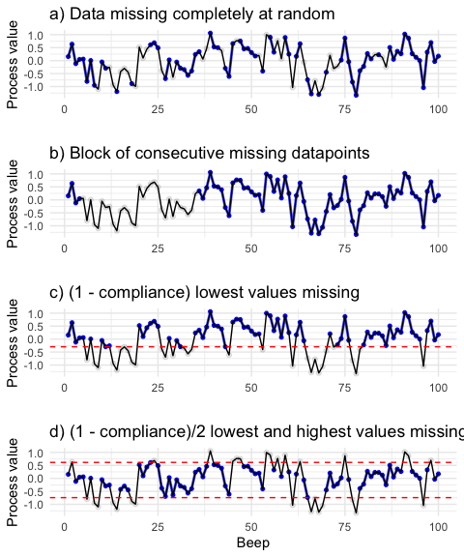

Illustration of the four different missingness pattern used in the simulation study. The blue dots represent observed datapoints, while the light gray dots represent missing values.

**Fitting a multilevel autoregressive model.** After missing values were introduced to the data, a MLAR(1) model was fitted to each of the simulated datasets using the *lme* function from the *nlme* R package (Pinheiro et al., 2022) with the value of the time-series at *t* as the outcome, the lagged *(t-1)* value of the time-series as the predictor, and the participant number as the grouping variable. We then extracted relevant parameters from the models that converged successfully. Missing values were treated by list-wise deletion. The restricted maximum log-likelihood method with the Broyden-Fletcher-Goldfarb-Shanno optimization algorithm was used to estimate the model.

The predictor (lagged) variable was person-mean centered (i. e., each individual participant’s observed mean of the ESM process was subtracted from the value of the lagged variable at each timepoint). Although person-mean centering results in an underestimation of the autoregressive effect (Hamaker & Grasman, 2015), it allows for a clearer interpretation of the within-person effects in multilevel models (Enders & Tofighi, 2007; Hamaker & Muthén, 2020).

**Simulation outcomes.** Estimation bias (MSE), the standard error of the estimation, and the statistical power to estimate the fixed autoregressive effect $β_{10}$ were the focal outcomes of the study. Additionally, we examined the effect of the manipulated variables on the proportion of models that successfully converged and the bias in the estimation of the person-mean used for centering of the predictor (lagged) variable.

Estimation bias was computed as the difference between the real (simulated) fixed autoregressive effect $β_{10}$ and the estimated fixed autoregressive effect $\hat{β_{10}}$ in each simulation run. As such, the dataset with estimation bias contained 1,000 rows per simulation condition.

Standard error (SE) and statistical power were calculated for each simulation condition (i.e., 1 row per condition). Statistical power was calculated as the proportion of simulation runs (within the given simulation condition) in which the p-value for the estimated fixed autoregressive effect $\hat{β_{10}}$ was below the significance threshold ( $α$ = 0.05) and the number of simulation runs that converged successfully.

The bias in the estimation of the person-mean of the time-series was computed as the average difference between the real process mean $μ_{i}$ and the observed person-mean $\hat{μ_{i}}$ (computed after the missing data were introduced).

**Manipulated simulation parameters.** Apart from the four different missingness patterns (described above), the following parameters were manipulated in both Simulation A and Simulation B: The number of participants of each simulated study *(N)*, the number of ESM observations within each participant *(T.obs)*, the compliance rate (i.e., the proportion of timepoints that are not missing for each participant), and the simulated autoregressive effect. Furthermore, in Simulation B, the variance of the random autoregressive effects was manipulated. The values of the manipulated variables were set considering realistic research questions in psychological research. The values of the manipulated variables for both studies are reported in Table .

### Reproducibility and code/data availability

The simulations were conducted in R version 4.2.1 (R Core Team, 2021). The study was conducted with emphasis on reproducibility of the results (Pawel et al., 2022). As such, we provide all data (simulation results) used for the reported analyses, as well as the full reproducible R code for the simulations (including the custom functions created for the purposes of the study), and the code used to generate the plots and result tables (available at [https://github.com/benjsimsa/AR-missing-simulations)](https://github.com/benjsimsa/AR-missing-simulations) The repository also includes a *sessionInfo* document that lists the versions of the packages used for the study. The present thesis was written using R Markdown (Allaire et al., 2022).

Additionally, the *renv* R package (Ushey, 2022) was used to set up a reproducible R environment and improve reproducibility by creating a project-local package library. For reproducible file referencing, the R package *here* (Müller, 2020) was used. For more information about the custom functions, simulation code, and the structure of the GitHub repository itself, please refer to the file README.md in the repository.

# Results

## Simulation A

The descriptive results for all 288 conditions included in Simulation A are reported in the appendix (TODO).

### Outcome: Estimation bias (MSE)

**ANOVA.** We used a 4 × 2 × 3 × 4 × 3 factorial Type I ANOVA (with estimation bias as an outcome and number of participants, number of time points per participant, missingness type, compliance, and the simulated fixed autoregressive effect, as well as their two-ways interactions, as predictors) to assess which of the manipulated factors had a considerable influence on estimation bias. The results from every simulation run (i. e., 1,000 results per condition = 288,000 rows) were combined into a single dataset for the analysis. Given the very large sample size (which would make even negligible differences significant) and the exploratory character of the analysis, *p*-values and significance thresholds were not used make inferences. Instead, we used a threshold of 0.14 for the partial $ω^{2}$, indicating a large effect size (Field et al., 2012). This cutoff will be used for all ANOVA results throughout the Results section. The partial $ω^{2}$ was chosen as the less biased alternative to partial $η^{2}$ (Okada, 2013). The results and effect sizes are reported in Table .

Four main effects above the effect size threshold of 0.14 were found: the main effect of missingness type ( $ω^{2}$ = 0.73), compliance ( $ω_{p}^{2}$ = 0.63), the number of time points per participant ( $ω_{p}^{2}$ = 0.26), and the simulated fixed slope ( $ω_{p}^{2}$ = 0.14). Furthermore, the interaction between the missingness type and compliance ( $ω_{p}^{2}$ = 0.54) had an effect size above the cut-off.

The main effects of missingness type and compliance are visualised in Figure and Figure (respectively), while the interaction between missingness type and compliance is depicted in Figure .

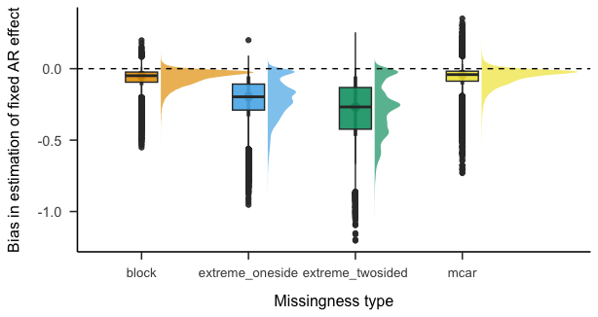

The effect of compliance on the bias in estimation of the fixed slopes.

Figure shows that while the underestimation of the fixed slopes is fairly low (although still considerable) when the observations are missing completely at random or in block, it becomes severe when only the most extreme values (both at one side and at both sides) are missing. Additionally, the underestimation of the fixed slopes becomes more severe as the compliance gets lower.

The average estimation bias when compliance is 0.8 (i.e., roughly the average compliance of ESM studies in psychology) is -0.13. As a consequence, many estimates of emotional inertia in psychological research could be seriously downward biased. Furthermore, the estimates are slightly biased even when compliance is 1 (i. e., there are no missing data; average bias: -0.04). This is in line with the findings about estimation bias caused by person-mean centering in multilevel autoregressive models (Hamaker & Grasman, 2015).

Zooming in on the interaction between compliance and missingness type (Figure ) suggests that the effect of compliance on estimation bias is dramatically more severe for the two conditions in which the most extreme values of the process were set as missing (as compared to the other two conditions, i. e., data MCAR and missing in blocks). In the worst-case scenario (low compliance of 0.4; the most extreme values at both sides missing), the average estimation bias was -0.48. Given that the average simulated fixed slope was 0.5, these results imply that even rather large autocorrelations can be estimated as close to 0 in studies in which the compliance is low and the missingness pattern is non-random. At the same time, the results concerning data MCAR and missing in blocks are encouraging. Even in a low-compliance (0.4) condition, the average estimation bias was -0.08 for the former and -0.09 for the latter.

The average estimation bias for all combinations of missingness type and compliance (averaged over the different values of the number of participants, time points per participant and simulated fixed slope) is reported in Table .

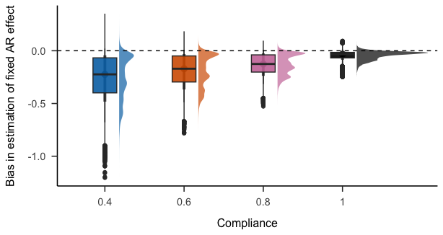

The effect of missingness type on the bias in estimation of the fixed slopes.

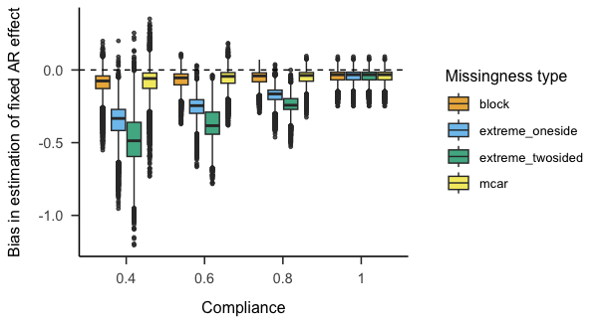

The effect of the interaction between missingness type and compliance on the bias in estimation of the fixed slopes.

### Outcome: Standard error

**Descriptive statistics.** The average standard errors for the different combinations of number of participants, time points per participant and compliance are reported in Table .

**ANOVA.** To examine the effect of the manipulated parameters on the standard error of the estimation of the fixed slopes, we combined the results for each condition (1,000 simulation runs) into a single row. As such, the dataset used for the following analyses had 288 rows in total. A a 4 × 2 × 3 × 4 × 3 factorial Type I ANOVA was used to analyse the data. The full ANOVA results and effect sizes are reported in Table .

The main effects of the number of participants ( $ω_{p}^{2}$ = 0.68), number of time points per participant ( $ω_{p}^{2}$ = 0.68) and compliance ( $ω_{p}^{2}$ = 0.66) crossed the cut-off for effect size.

Additionally, the interaction between the number of time points per participant and compliance ( $ω_{p}^{2}$ = 0.28), number of participants and time points per participants ( $ω_{p}^{2}$ = 0.07), and between the number of participants and compliance ( $ω_{p}^{2}$ = 0.22) was found.

Figure depicts the interaction between the number of time points per participant and compliance, while Figure shows the interaction between the number of participants and compliance.

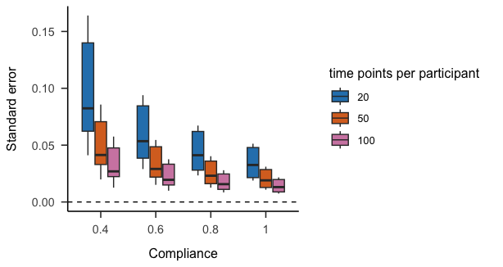

The effect of the interaction between number of time points and compliance on standard error of estimation of the fixed slopes. Simulation A.

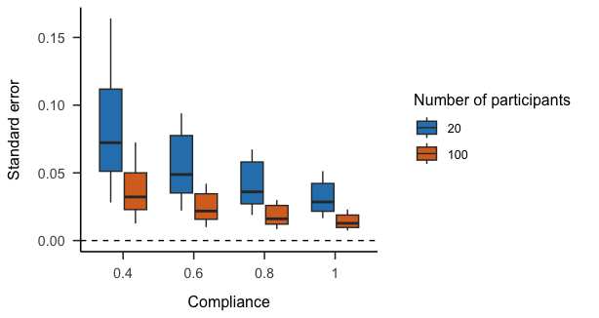

The effect of the interaction between number of participants and compliance on standard error of estimation of the fixed slopes. Simulation A.

### Outcome: Statistical power

**Descriptive statistics.** The statistical power for each combination of the manipulated parameters is reported in Table (BIG TABLE TODO). As an illustration, the effects of compliance, missingness type, the number of participants and the number of time points per participant when the simulated fixed slope is 0.3 are visualised in Figure . Consistent with the results about estimation bias, statistical power is the lowest in the two conditions with the most extreme datapoints missing. For the conditions with data missing completely at random and data missing in consecutive blocks, power is very high even when the compliance is low for most conditions (except for the two conditions with T = 20).

A peculiar pattern is worth pointing out in the plot: in the two conditions with T = 20 and the most extreme data missing at both sides (green dashed line), the statistical power is higher when compliance is 0.4 compared to when compliance is 0.6. This counterintuitive result is likely due to the fact that the underestimation is the most severe when the most extreme values at both sides are missing. As such, some of the estimates of the fixed slope will be negative, and their magnitude will be large enough for them to reach statistical significance.

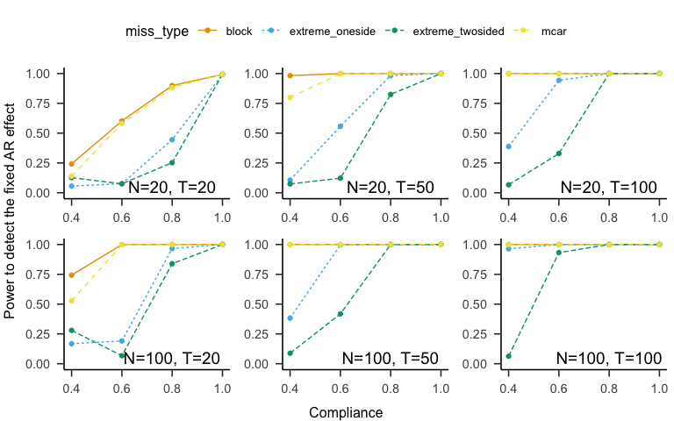

Simulation A. Statistical power to detect the fixed slope for all combinations of compliance, missingness type, number of participants and time points per participant when the simulated fixed slope is 0.3.

**ANOVA.** A 4 × 2 × 3 × 4 × 3 factorial Type I ANOVA was used to analyse the effect of the manipulated parameters (288 conditions in total) on statistical power. The results are reported in Table .

Four main effect above the cut-off for the effect size were found: the effect of compliance ( $ω_{p}^{2}$ = 0.43), of missingness type ( $ω_{p}^{2}$ = 0.36), simulated fixed slope ( $ω_{p}^{2}$ = 0.18), and the effect of the number of time points per participant ( $ω_{p}^{2}$ = 0.17).

## Simulation B

In Simulation B, random AR effects were included both in the data generating procedure and in the estimated models. The variance of random AR effects ($σ_{ν1}^{2}$) was manipulated as an additional simulation factor (2 values: 0.05 and 0.1). For an overview of all manipulated and fixed simulation parameters, please refer to Table . The descriptive results for all 256 simulation conditions are reported in the appendix (Big table TODO).

### Outcome: Estimation bias

To evaluate the effect of the number of participants, number of time points per participant, missingness type, compliance, the variance of random AR effects, and the simulated fixed autoregressive effect on the bias in the estimation of the fixed AR effect in Simulation B, a 4 × 2 × 2 × 4 × 2 × 2 factorial Type I ANOVA was used. The results from every simulation run (256 conditions * 1000 runs per condition) were combined into a single dataset. An identical inference criterion ( $ω_{p}^{2}$ $≥$ 0.14) as in the analysis of Simulation A was used. The ANOVA results are listed in Table .

Interestingly, compared to the results from Simulation A (see Table ), the effect of *T.obs* on estimation bias ( $ω^{2}$ = 0.03) is much smaller and does not reach the effect size threshold. The three main effects that do reach the cut-off in Simulation B are the effect of missingness type ( $ω_{p}^{2}$ = 0.65), compliance ( $ω_{p}^{2}$ = 0.48), and the real fixed AR effect ( $ω_{p}^{2}$ = 0.46). The only interaction that reached the cut-off was the interaction between missingness type and compliance ( $ω_{p}^{2}$ = 0.45). The interaction is visualised in Figure . The pattern of the interaction is very similar to the pattern of the interaction between missingness type and compliance in Simulation A (see Figure ). Interestingly, when compared to the results of Simulation A, the average estimation bias is slightly worse for the MCAR and block missingness types and slightly less severe for the two conditions with the extreme values missing (compare Table and Table ). However, the overall conclusion remains the same as in Simulation A: there is a considerable downward estimation bias that becomes more severe the lower the compliance rate is, and it is most severe for the condition in which the most extreme data at both sides are missing.

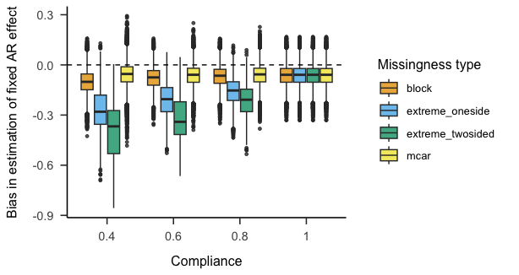

Simulation B: The effect of the interaction between missingness type and compliance on the bias in estimation of the fixed slopes.

### Outcome: Standard error

**ANOVA.** The results of the 4 × 2 × 2 × 4 × 2 × 2 factorial ANOVA used to assess the influence of the manipulated factor on the standard error are reported in Table . Compared to Simulation A, more main effects of the manipulated factors crossed the effect-size cut-off: the effect of number of participants ( $ω_{p}^{2}$ = 0.93), compliance ( $ω_{p}^{2}$ = 0.53), number of time points per participant ( $ω_{p}^{2}$ = 0.33), and the value of the simulated fixed AR effect ( $ω_{p}^{2}$ = 0.28). Additionally, the interaction between compliance and the number of time points per participant ( $ω_{p}^{2}$ = 0.18) crossed the threshold.

Figure illustrates the main effect of *N* (as the most important factor) on standard error, while Figure shows the interaction between compliance and *T.obs*. While the results are comparable to Simulation A, the SE is slightly higher for the same *N/T.obs* combinations in Simulation B.

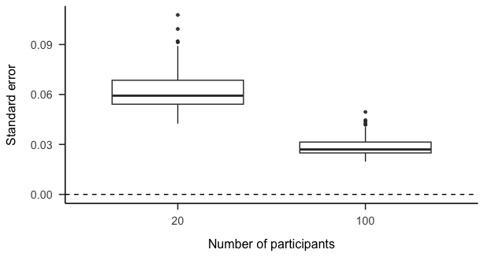

The effect of the number of participants on the standard error of estimation of the fixed slopes. Simulation B.

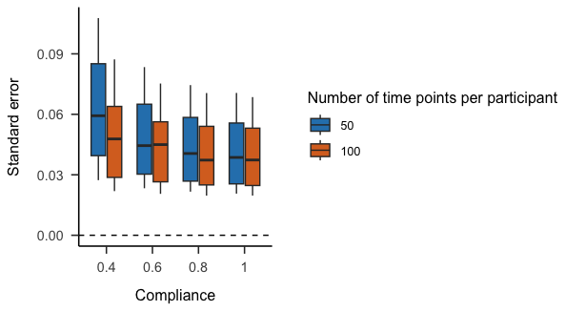

The effect of the interaction between number of time points per participant and compliance on standard error of estimation of the fixed slopes. Simulation B.

### Outcome: Statistical power

**Descriptive statistics.** The statistical power for each combination of the manipulated parameters in Simulation B is reported in Table (BIG TABLE TODO SIM2). The effects of compliance, missingness type, the number of participants and the number of time points per participant when the simulated fixed slope is 0.3 are shown in Figure . For the sake of clarity, only the results for simulation conditions in which the $σ_{ν1}^{2}=0.1$ are visualised.

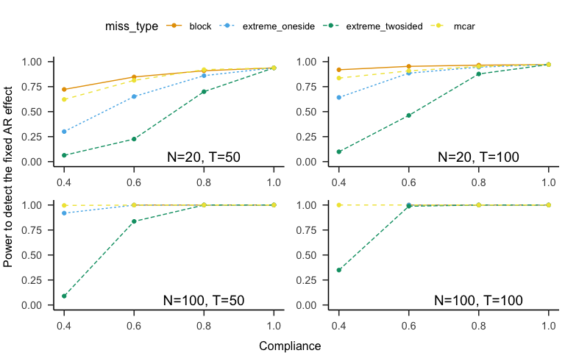

Simulation B. Statistical power to detect the fixed AR effect for the 4 combinations of compliance, missingness type, number of participants and time points per participant when the simulated fixed slope is 0.3 and the variance of random AR effects is 0.1.

**ANOVA.** A 4 × 2 × 2 × 4 × 2 × 2 factorial Type I ANOVA was used to analyse the effect of the manipulated parameters on statistical power. The results are reported in Table .

Missignness type ( $ω_{p}^{2}$ = 0.4) together with compliance ( $ω_{p}^{2}$ = 0.38) were the two main effects with the largest influence on the statistical power to detect the fixed AR effect. The value of the simulated AR effect has a large effect ( $ω_{p}^{2}$ = 0.3) as well. Three interactions crossed the effect size threshold: *missingness type*compliance* ( $ω_{p}^{2}$ = 0.41), *missingness type*simulated fixed AR* ( $ω_{p}^{2}$ = 0.23), and *compliance*simulated fixed AR* ( $ω_{p}^{2}$ = 0.23).

# Discussion

We conducted two Monte Carlo simulation studies to address a gap in knowledge about the influence of missing data on the estimation performance of the multilevel autoregressive model. In Simulation A, we only estimated and simulated fixed autoregressive effects (together with both fixed and random intercepts), while in Simulation B, both fixed and random autoregressive effects were simulated and estimated. Three outcomes were evaluated in both simulations: the estimation bias, standard error of the simulations, and statistical power. Four values of compliance and four missingness patterns (data MCAR, data missing in a block of consecutive observations, the highest values missing, and the highest and lowest values missing) were varied across the simulations. The other manipulated factors included the number of participants, the number of time points per participant, the simulated value of the fixed AR effect, and the variance of the random AR effects.

The two parameters related to missing data (compliance and missingness pattern) emerged as very important factors influencing all three outcomes. In both simulations, missingness type and compliance (and the interaction between the two) were the factors with the largest effect on the bias in the estimation of the fixed AR effect. Similarly, both missingness type and compliance had a strong influence on the statistical power to detect the fixed AR effect in both simulations. With regards to the standard error of the simulation results, compliance was found to have a very large effect (more so in Simulation A than in Simulation B), while the effect of missingness type was only moderate.

Our results corroborate the conclusions about the importance of the number of time points per participant for precise estimation of the autoregressive effects (Hamaker & Grasman, 2015; Krone et al., 2016). In general, the estimation bias became considerably less severe as the ESM time-series length per participant increased. *T.obs* also had a large effect on statistical power. However, our simulations show that the context of missingness matters: when the compliance is low and the data are missing MCAR or in blocks, the underestimation of the fixed AR effect caused by the missing data (and the negative consequences for statistical power) becomes less severe very quickly as *T.obs* increases. On the other hand, when the missingness is dependent on the value of the process itself (i. e., the most extreme observations are missing), increasing compliance appears to be more important for estimation precision and statistical power than the length of the time-series. In other words, it can be said that the presence of missing data exacerbates Nickell’s bias (Nickell, 1981) - an estimation bias introduced by person-mean centering in multilevel models.

While Krone et al. (2016) found that estimation bias becomes smaller as the simulated fixed AR effect becomes larger, we found an opposite pattern: estimation bias was larger as the simulated fixed AR effect became larger.

Overall, there was always some degree of estimation bias present in the simulations, ranging from very severe (when *T.obs* and compliance were low, and the missingness of data was dependent on the process value) to mild (when compliance was high and the data were missing either MCAR or in block). This bias in estimation might be one of the driving forces behind the low value added by estimates of emotional inertia to the prediction of psychopathology and well–being, pointed out by Dejonckheere et al. (2019). Additionally, while the simulation studies did not explicitly assess the bias in the estimation of individual autoregressive effects, the results suggest that some individual differences in inertia estimates might not be caused by real differences in inertia, but due to the bias caused by missingness: for two individual participants with an identical real autoregressive parameter but different compliance and missingness patterns, the inertia estimates can vary considerably.

Our results have several implications for the design choices in psychological research using the multilevel autoregressive model to estimate emotional inertia. First, in line with previous simulation studies, we recommend for researchers to focus on increasing *T.obs* rather than *N* in order to increase the statistical power and the precision of the inertia estimates. In other words, for optimal statistical performance, it is more effective to make the data collection period longer (or schedule more beeps per day) than to collect data from more participants. Secondly, while the time-series length is important, researchers should aim to design their ESM studies in a way that will make compliance as high as possible. According to recent evidence about compliance in ESM studies, these design choices include providing financial incentives to participants (Wrzus & Neubauer, 2022) and including less items in ESM questionnaires (Eisele et al., 2020). Furthermore, the results suggest that the potential presence of missing data should be accounted for in power analyses for ESM studies. In an ideal case, a researcher should have an idea about what the average compliance in their study could be and what missingness patterns might be present in the data. Of course, this is not entirely feasible, as it might be difficult to estimate the average compliance, and real-life ESM data will likely include a mixture of different missing data patterns, both at the within- and between-person level. Still, to avoid overestimating statistical power for planned studies, it is advisable to include several different missing data scenarios in the power simulations as a sensitivity check.

### Directions for future research

The present thesis provides evidence about estimation bias being made more severe by lower compliance and by patterns of missingness that depend on the process value itself. Nonetheless, the insight into the mechanisms driving this bias remains limited. Several plausible explanations of the bias arise. First, the estimation bias was the most severe when the most extreme observations at both ends of the ESM process distribution were missing. This finding can be linked to the evidence about tails (i. e., the extreme ends) of distributions containing the most information about the scale of the distribution (Zheng & Gastwirth, 2002). However, further investigation is needed to provide more understanding about whether the tails also provide crucial information about the autoregressive effect.

Secondly, the different bias values for different missingness patterns could be partly caused by the fact that the number of “effective” observation-pairs (i. e., pairs of current and lagged values where both values are not missing) used to estimate the autoregressive parameters differs between the missignness patterns. For example, the number of effective observation-pairs will be larger when the data are MCAR than when they are missing in a block. However, the results of the present thesis seem to contradict this explanation. On the one hand, estimation bias was found to be very similar when data are MCAR and missing in blocks (although the two missingness patterns come with a very different number of observation-pairs). On the other hand, the estimation bias was much larger for the conditions with the most extreme values set as missing, compared to the condition with data MCAR (even though the number of effective observation-pairs is generally higher for the “extreme” conditions than when data are MCAR). As such, this explanation of estimation bias appears to be less plausible than the explanation described in the previous paragraph.

### Limitations

First, while the two simulation studies include a wide range of scenarios and parameter combinations, our results are far from comprehensive, and they largely depend on the simulation parameters that were not varied. However, the reproducible code available from the GitHub repository (<https://github.com/benjsimsa/AR-missing-simulations>) provides a sufficient framework for an interested reader to rerun the analyses with different parameters and modify the code to better fit the peculiarities of their specific study sample and research questions.

Furthermore, the results depend on several assumptions, which were problematised as being too simplistic in previous research. We assumed that the innovation variance $σ$ was identical for all the participants, and that the random intercepts (and random slopes in Simulation B) came from a normal distribution. Additionally, we only focused on normally distributed affective processes. While a normal distribution can be assumed for ESM measures of positive emotions, negative affective processes are usually heavily right-skewed in the general population (Haslbeck et al., 2022). Additionally, we assumed that the analysed ESM time-series are measured without any error; however, recent evidence shows that this is very often not the case in real-world research (Dejonckheere et al., 2022; Schuurman & Hamaker, 2019), and unreliability can lead to further attenuation of the estimated parameters (Wenzel & Brose, 2022). While person-mean centering was carried out using observed means in the simulations we conducted, different ways of person-mean centering, such as using latent person-means, might be more appropriate (Gistelinck et al., 2021). Another assumption of the present simulations that is unlikely to hold in real-world data is the homogeneity of compliances and missing data patterns within each simulated dataset. In the real world, it can be expected for different missingness patterns to be present in the data at both the between- and within-person level.

Finally, although we took steps to make the simulations reproducible by making all code and results publicly available, using R packages *here* and *renv*, and reporting the sessionInfo for every simulation, a large number of packages with many dependencies were used, which might be detrimental to reproducibility in the long term.

# References

Allaire, J., Xie, Y., McPherson, J., Luraschi, J., Ushey, K., Atkins, A., Wickham, H., Cheng, J., Chang, W., & Iannone, R. (2022). *Rmarkdown: Dynamic documents for r*. <https://github.com/rstudio/rmarkdown>

Ariens, S., Ceulemans, E., & Adolf, J. K. (2020). Time series analysis of intensive longitudinal data in psychosomatic research: A methodological overview. *Journal of Psychosomatic Research*, *137*, 110191. <https://doi.org/10.1016/j.jpsychores.2020.110191>

Bos, E. H., Jonge, P., & Cox, R. F. A. (2019). Affective variability in depression: Revisiting the inertiainstability paradox. *British Journal of Psychology*, *110*(4), 814–827. <https://doi.org/10.1111/bjop.12372>

Bosley, H. G., Soyster, P. D., & Fisher, A. J. (2019). Affect Dynamics as Predictors of Symptom Severity and Treatment Response in Mood and Anxiety Disorders: Evidence for Specificity. *Journal for Person-Oriented Research*, *5*(2), 101–113. <https://doi.org/10.17505/jpor.2019.09>

Brose, A., Schmiedek, F., Koval, P., & Kuppens, P. (2015). Emotional inertia contributes to depressive symptoms beyond perseverative thinking. *Cognition and Emotion*, *29*(3), 527–538. <https://doi.org/10.1080/02699931.2014.916252>

Cloos, L. J. R., Kuppens, P., & Ceulemans, E. (2022). *Development, Validation, and Comparison of Self-Report Measures for Positive and Negative Affect in Intensive Longitudinal Research*. <https://doi.org/10.31234/osf.io/5j7c6>

Dejonckheere, E. (2019). Complex affect dynamics add limited information to the prediction of psychological well-being. *Nature Human Behaviour*, *3*, 17.

Dejonckheere, E., Demeyer, F., Geusens, B., Piot, M., Tuerlinckx, F., Verdonck, S., & Mestdagh, M. (2022). Assessing the reliability of single-item momentary affective measurements in experience sampling. *Psychological Assessment*. <https://doi.org/10.1037/pas0001178>

Eisele, G., Vachon, H., Lafit, G., Kuppens, P., Houben, M., Myin-Germeys, I., & Viechtbauer, W. (2020). The Effects of Sampling Frequency and Questionnaire Length on Perceived Burden, Compliance, and Careless Responding in Experience Sampling Data in a Student Population. *Assessment*, *29(2)*, 16.

Enders, C. K., & Tofighi, D. (2007). Centering predictor variables in cross-sectional multilevel models: A new look at an old issue. *Psychological Methods*, *12*(2), 121–138. <https://doi.org/10.1037/1082-989X.12.2.121>

Field, A., Miles, J., & Field, Z. (2012). Discovering statistics using r (2012). *Great Britain: Sage Publications, Ltd*, *958*.

Gistelinck, F., Loeys, T., & Flamant, N. (2021). Multilevel Autoregressive Models when the Number of Time Points is Small. *Structural Equation Modeling: A Multidisciplinary Journal*, *28*(1), 15–27. <https://doi.org/10.1080/10705511.2020.1753517>

Hamaker, E. L. (2012). *Why researchers should think" within-person": A paradigmatic rationale.*

Hamaker, E. L., & Grasman, R. P. P. P. (2015). To center or not to center? Investigating inertia with a multilevel autoregressive model. *Frontiers in Psychology*, *5*. <https://doi.org/10.3389/fpsyg.2014.01492>

Hamaker, E. L., & Muthén, B. (2020). The fixed versus random effects debate and how it relates to centering in multilevel modeling. *Psychological Methods*, *25*(3), 365–379. <https://doi.org/10.1037/met0000239>

Haslbeck, J. M. B., Ryan, O., & Dablander, F. (2022). *Multimodality and Skewness in Emotion Time Series*. <https://doi.org/10.31234/osf.io/qudr6>

Houben, M., & Kuppens, P. (2020). Emotion Dynamics and the Association With Depressive Features and Borderline Personality Disorder Traits: Unique, Specific, and Prospective Relationships. *Clinical Psychological Science*, *8*(2), 226–239. <https://doi.org/10.1177/2167702619871962>

Houben, M., Van Den Noortgate, W., & Kuppens, P. (2015). The relation between short-term emotion dynamics and psychological well-being: A meta-analysis. *Psychological Bulletin*, *141*(4), 901.

Ji, L., Chow, S.-M., Schermerhorn, A. C., Jacobson, N. C., & Cummings, E. M. (2018). Handling Missing Data in the Modeling of Intensive Longitudinal Data. *Structural Equation Modeling: A Multidisciplinary Journal*, *25*(5), 715–736. <https://doi.org/10.1080/10705511.2017.1417046>

Jongerling, J., Laurenceau, J.-P., & Hamaker, E. L. (2015). A Multilevel AR(1) Model: Allowing for Inter-Individual Differences in Trait-Scores, Inertia, and Innovation Variance. *Multivariate Behavioral Research*, *50*(3), 334–349. <https://doi.org/10.1080/00273171.2014.1003772>

Koval, P., Burnett, P. T., & Zheng, Y. (2021). *Emotional Inertia: On the Conservation of Emotional Momentum* (C. E. Waugh & P. Kuppens, Eds.; pp. 63–94). Springer International Publishing. <https://doi.org/10.1007/978-3-030-82965-0_4>

Koval, P., Butler, E. A., Hollenstein, T., Lanteigne, D., & Kuppens, P. (2015). Emotion regulation and the temporal dynamics of emotions: Effects of cognitive reappraisal and expressive suppression on emotional inertia. *Cognition and Emotion*, *29*(5), 831–851. <https://doi.org/10.1080/02699931.2014.948388>

Koval, P., Pe, M. L., Meers, K., & Kuppens, P. (2013). Affect dynamics in relation to depressive symptoms: Variable, unstable or inert? *Emotion*, *13*(6), 1132–1141. <https://doi.org/10.1037/a0033579>

Krone, T., Albers, C. J., & Timmerman, M. E. (2016). Comparison of Estimation Procedures for Multilevel AR(1) Models. *Frontiers in Psychology*, *7*. <https://doi.org/10.3389/fpsyg.2016.00486>

Kuppens, P., Allen, N. B., & Sheeber, L. B. (2010). Emotional Inertia and Psychological Maladjustment. *Psychological Science*, *21*(7), 984–991. <https://doi.org/10.1177/0956797610372634>

Kuppens, P., & Verduyn, P. (2017). Emotion dynamics. *Current Opinion in Psychology*, *17*, 22–26. <https://doi.org/10.1016/j.copsyc.2017.06.004>

Lafit, G., Adolf, J., Dejonckheere, E., Myin-Germeys, I., Viechtbauer, W., & Ceulemans, E. (2020). *Selection of the Number of Participants in Intensive Longitudinal Studies: A User-friendly Shiny App and Tutorial to Perform Power Analysis in Multilevel Regression Models that Account for Temporal Dependencies*. <https://doi.org/10.31234/osf.io/dq6ky>

Lane, S. P., & Hennes, E. P. (2018). Power struggles: Estimating sample size for multilevel relationships research. *Journal of Social and Personal Relationships*, *35*(1), 7–31. <https://doi.org/10.1177/0265407517710342>

Larson, R., & Csikszentmihalyi, M. (2014). *The experience sampling method* (p. 2134). Springer.

Leemput, I. A. van de, Wichers, M., Cramer, A. O. J., Borsboom, D., Tuerlinckx, F., Kuppens, P., Nes, E. H. van, Viechtbauer, W., Giltay, E. J., Aggen, S. H., Derom, C., Jacobs, N., Kendler, K. S., Maas, H. L. J. van der, Neale, M. C., Peeters, F., Thiery, E., Zachar, P., & Scheffer, M. (2014). Critical slowing down as early warning for the onset and termination of depression. *Proceedings of the National Academy of Sciences*, *111*(1), 87–92. <https://doi.org/10.1073/pnas.1312114110>

Liu, S. (2017). Person-specific versus multilevel autoregressive models: Accuracy in parameter estimates at the population and individual levels. *British Journal of Mathematical and Statistical Psychology*, *70*(3), 480–498. <https://doi.org/10.1111/bmsp.12096>

Mneimne, M., Fleeson, W., Arnold, E. M., & Furr, R. M. (2018). Differentiating the everyday emotion dynamics of borderline personality disorder from major depressive disorder and bipolar disorder. *Personality Disorders: Theory, Research, and Treatment*, *9*(2), 192–196. <https://doi.org/10.1037/per0000255>

Müller, K. (2020). *Here: A simpler way to find your files*. <https://CRAN.R-project.org/package=here>

Myin-Germeys, I., Kasanova, Z., Vaessen, T., Vachon, H., Kirtley, O., Viechtbauer, W., & Reininghaus, U. (2018). Experience sampling methodology in mental health research: new insights and technical developments. *World Psychiatry*, *17*(2), 123–132. <https://doi.org/10.1002/wps.20513>

Nickell, S. (1981). Biases in dynamic models with fixed effects. *Econometrica*, *49*(6), 1417. <https://doi.org/10.2307/1911408>

Okada, K. (2013). Is omega squared less biased? A comparison of three major effect size indices in one-way ANOVA. *Behaviormetrika*, *40*(2), 129147.

Pawel, S., Kook, L., & Reeve, K. (2022). *Pitfalls and potentials in simulation studies*. <http://arxiv.org/abs/2203.13076>

Pinheiro, J., Bates, D., DebRoy, S., Sarkar, D., Heisterkamp, S., Van Willigen, B., Ranke, J., Team, R. C., & Team, M. R. C. (2022). *Package ‘nlme’*.

R Core Team. (2021). *R: A language and environment for statistical computing*. R Foundation for Statistical Computing. <https://www.R-project.org/>

Rintala, A., Wampers, M., Myin-Germeys, I., & Viechtbauer, W. (2019). Response compliance and predictors thereof in studies using the experience sampling method. *Psychological Assessment*, *31*(2), 226–235. <https://doi.org/10.1037/pas0000662>

Rintala, A., Wampers, M., Myin-Germeys, I., & Viechtbauer, W. (2020). Momentary predictors of compliance in studies using the experience sampling method. *Psychiatry Research*, *286*, 112896. <https://doi.org/10.1016/j.psychres.2020.112896>

Rovine, M. J., & Walls, T. A. (2006). Multilevel autoregressive modeling of interindividual differences in the stability of a process. *Models for Intensive Longitudinal Data*, 124147.

Schuurman, N. K., & Hamaker, E. L. (2019). Measurement error and person-specific reliability in multilevel autoregressive modeling. *Psychological Methods*, *24*(1), 70–91. <https://doi.org/10.1037/met0000188>

Ushey, K. (2022). *Renv: Project environments*. <https://CRAN.R-project.org/package=renv>

Vachon, H., Viechtbauer, W., Rintala, A., & Myin-Germeys, I. (2019). Compliance and Retention With the Experience Sampling Method Over the Continuum of Severe Mental Disorders: Meta-Analysis and Recommendations. *Journal of Medical Internet Research*, *21*(12), e14475. <https://doi.org/10.2196/14475>

Wenzel, M., & Brose, A. (2022). Addressing measurement issues in affect dynamic research: Modeling emotional inertia’s reliability to improve its predictive validity of depressive symptoms. *Emotion*. <https://doi.org/10.1037/emo0001108>

Wright, A. G. C., & Zimmermann, J. (2019). Applied ambulatory assessment: Integrating idiographic and nomothetic principles of measurement. *Psychological Assessment*, *31*(12), 1467–1480. <https://doi.org/10.1037/pas0000685>

Wrzus, C., & Neubauer, A. B. (2022). Ecological Momentary Assessment: A Meta-Analysis on Designs, Samples, and Compliance Across Research Fields. *Assessment*, 1–22. <https://doi.org/10.1177/10731911211067538>

Zheng, G., & Gastwirth, J. (2002). Do tails of symmetric distributions contain more fisher information about the scale parameter? *Sankhyā: The Indian Journal of Statistics, Series B*, 289300.