Seasonal Autoregressive Integrated Moving Acerage (SARIMA) Analysis and Predicition of Seasonal Weather Patterns in the Four Corners Region of the United Steates

Ben Karabinus

8/12/2021

## Problem Statement

In the past decades there has been a noticeable increase in the volatility of weather patterns in the Western United States. In particular, the four corners region (Arizona, Colorado, New Mexico and Utah) have experienced prolonged drought, monsoon rainfall, and a noticeable increase in the intensity and duration of heat waves. To better understand seasonal weather patterns in the region this report focuses on a time-series analysis of mean monthly temperature, total monthly precipitation and total monthly snowfall in the period between January 1, 1970 and December 31, 2019. Time-series analysis was carried using a Seasonal Autregressive Integrated Moving Average (SARIMA) model. The primary research questions addressed are as follows:

* Is there a noticeable trend in monthly mean temperature, total monthly precipitation, or total monthly snowfall?
* What does the trend in any or all of these measures tell us about weather patterns in the previous 5 decades?
* Is the SARIMA model an effective means of visualizng and predicting mean monthly temperature, total monthly precipitation and total monthly snowfall in the four corners region of the United States.

## Data Collection

Data for the analysis was sourced from the GLobal Historical Climatology Network (GHCN). The GHCN is an integrated database of daily climate summaries from land surface weather stations across the globe. The data contain records from more than 100,000 stations in 180 countries and territories. All records are subject to a common suite of quality assurance reviews to miantain accuracy though uniformity of reporting stndards. All GHCN records include but are not limited too the following daily variables:

* Daily maximum and Daily minimum temperatue
* Total daily precipitation
* Total daily snowfall

### US Collection of GHCN Data

Daily weather records from the United States are compiled from a dozen separate datasets archived at the Nation Centers of Environmental Information (NCEI), a branch of the National Oceanic and Atmospheric Administration (NOAA). NCEI is responsible fo hosting and providing access to one of the most significant stores of environmental data in existence with over 37 petabytes of oceanic, atmospheric and geophyscical data (National Centers for Environmental Information, 2019).

### Variables Included in the Model

* Average daily temperature (Degrees Farenheight)
* Total Daily precipitation (Inches)
* Total Daily Snowfall (Inches)

For more detailed information on each of the variables listed above pleas see the data dictionary (Appendix A)

## Data Set Features and Data Preparation

### Data Set Summary

The data used in this report were observed at weather stations in four major cities located in the southwestern United States, specifically (Phoenix, Arizona), (Denver, Colorado), (Albequerque,New Mexico) and (Salt Lake City, Utah). Data was collected via land-based weather stations at major airports in each city with the exception being data collected in Denver, Colorado. Weather observations for Denver were collected using a land-based weather station located in the Sand Creek Open Space in the Denver Central Park Region in the Northwest corner of the city. Data for each city where downloaded as seperate comma seperated (csv) files. Exploration of the features of the data, data cleansing and initial visualization were carried out using the “DataExplorer” package available in R.

### Data Discovery and Cleansing Process

Prior to conducting time-series analysis

#### Summary statistics for each data set

# Albuquerque  
summary(ABQ)

## STATION NAME   
## USW00023050:18262 ALBUQUERQUE INTERNATIONAL AIRPORT, NM US:18262   
##   
##   
##   
##   
##   
##   
## DATE PRCP SNOW TAVG   
## 1970-01-01: 1 Min. :0.0000 Min. : 0.00000 Min. : 0.00   
## 1970-01-02: 1 1st Qu.:0.0000 1st Qu.: 0.00000 1st Qu.:45.00   
## 1970-01-03: 1 Median :0.0000 Median : 0.00000 Median :60.00   
## 1970-01-04: 1 Mean :0.0247 Mean : 0.02759 Mean :58.94   
## 1970-01-05: 1 3rd Qu.:0.0000 3rd Qu.: 0.00000 3rd Qu.:74.00   
## 1970-01-06: 1 Max. :1.9200 Max. :11.30000 Max. :89.00   
## (Other) :18256 NA's :251 NA's :13120   
## TMAX TMIN   
## Min. : 6.00 Min. :-17.00   
## 1st Qu.: 56.00 1st Qu.: 31.00   
## Median : 72.00 Median : 44.00   
## Mean : 70.55 Mean : 44.35   
## 3rd Qu.: 86.00 3rd Qu.: 59.00   
## Max. :107.00 Max. : 78.00   
##

# Denver   
summary(DEN)

## STATION NAME DATE   
## USW00023062:18262 DENVER CENTRAL PARK, CO US:18262 1970-01-01: 1   
## 1970-01-02: 1   
## 1970-01-03: 1   
## 1970-01-04: 1   
## 1970-01-05: 1   
## 1970-01-06: 1   
## (Other) :18256   
## PRCP SNOW TAVG TMAX   
## Min. :0.0000 Min. : 0.0000 Mode:logical Min. : -9.0   
## 1st Qu.:0.0000 1st Qu.: 0.0000 NA's:18262 1st Qu.: 50.0   
## Median :0.0000 Median : 0.0000 Median : 66.0   
## Mean :0.0423 Mean : 0.1497 Mean : 64.8   
## 3rd Qu.:0.0000 3rd Qu.: 0.0000 3rd Qu.: 81.0   
## Max. :6.4700 Max. :23.6000 Max. :104.0   
## NA's :1 NA's :19   
## TMIN   
## Min. :-25.00   
## 1st Qu.: 25.00   
## Median : 36.00   
## Mean : 36.95   
## 3rd Qu.: 52.00   
## Max. : 72.00   
## NA's :6

# Phoenix  
summary(PHX)

## STATION NAME LATITUDE   
## USW00023183:18262 PHOENIX AIRPORT, AZ US:18262 Min. :33.43   
## 1st Qu.:33.43   
## Median :33.43   
## Mean :33.43   
## 3rd Qu.:33.43   
## Max. :33.43   
##   
## LONGITUDE ELEVATION DATE PRCP   
## Min. :-112 Min. :337.4 1970-01-01: 1 Min. :0.00000   
## 1st Qu.:-112 1st Qu.:337.4 1970-01-02: 1 1st Qu.:0.00000   
## Median :-112 Median :337.4 1970-01-03: 1 Median :0.00000   
## Mean :-112 Mean :337.4 1970-01-04: 1 Mean :0.02078   
## 3rd Qu.:-112 3rd Qu.:337.4 1970-01-05: 1 3rd Qu.:0.00000   
## Max. :-112 Max. :337.4 1970-01-06: 1 Max. :3.30000   
## (Other) :18256   
## SNOW TAVG TMAX TMIN   
## Min. :0.0 Min. : 0.00 Min. : 43.00 Min. :19.00   
## 1st Qu.:0.0 1st Qu.: 63.00 1st Qu.: 73.00 1st Qu.:50.00   
## Median :0.0 Median : 77.00 Median : 88.00 Median :62.00   
## Mean :0.0 Mean : 76.44 Mean : 86.88 Mean :62.71   
## 3rd Qu.:0.0 3rd Qu.: 91.00 3rd Qu.:101.00 3rd Qu.:76.00   
## Max. :0.2 Max. :106.00 Max. :122.00 Max. :96.00   
## NA's :7255 NA's :13128

# Salt Lake City   
summary(SLC)

## STATION NAME   
## USW00024127:18262 SALT LAKE CITY INTERNATIONAL AIRPORT, UT US:18262   
##   
##   
##   
##   
##   
##   
## DATE PRCP SNOW TAVG   
## 1970-01-01: 1 Min. :0.00000 Min. : 0.000 Min. : 0.00   
## 1970-01-02: 1 1st Qu.:0.00000 1st Qu.: 0.000 1st Qu.:40.00   
## 1970-01-03: 1 Median :0.00000 Median : 0.000 Median :54.00   
## 1970-01-04: 1 Mean :0.04391 Mean : 0.155 Mean :54.98   
## 1970-01-05: 1 3rd Qu.:0.01000 3rd Qu.: 0.000 3rd Qu.:72.00   
## 1970-01-06: 1 Max. :2.27000 Max. :13.800 Max. :92.00   
## (Other) :18256 NA's :8 NA's :13119   
## TMAX TMIN   
## Min. : 2.00 Min. :-15.00   
## 1st Qu.: 47.00 1st Qu.: 30.00   
## Median : 63.00 Median : 41.00   
## Mean : 64.35 Mean : 41.97   
## 3rd Qu.: 83.00 3rd Qu.: 56.00   
## Max. :107.00 Max. : 81.00   
##

#### Structure of Each Data Set (Number of Observations and Variable Type)

# Albuquerque  
str(ABQ)

## 'data.frame': 18262 obs. of 8 variables:  
## $ STATION: Factor w/ 1 level "USW00023050": 1 1 1 1 1 1 1 1 1 1 ...  
## $ NAME : Factor w/ 1 level "ALBUQUERQUE INTERNATIONAL AIRPORT, NM US": 1 1 1 1 1 1 1 1 1 1 ...  
## $ DATE : Factor w/ 18262 levels "1970-01-01","1970-01-02",..: 1 2 3 4 5 6 7 8 9 10 ...  
## $ PRCP : num 0 0 0 0 0 0 0 0 0 0 ...  
## $ SNOW : num 0 0 0 0 0 0 0 0 0 0 ...  
## $ TAVG : int NA NA NA NA NA NA NA NA NA NA ...  
## $ TMAX : int 35 31 33 31 35 31 35 41 44 53 ...  
## $ TMIN : int 17 8 6 10 10 4 3 16 14 29 ...

# Denver  
str(DEN)

## 'data.frame': 18262 obs. of 8 variables:  
## $ STATION: Factor w/ 1 level "USW00023062": 1 1 1 1 1 1 1 1 1 1 ...  
## $ NAME : Factor w/ 1 level "DENVER CENTRAL PARK, CO US": 1 1 1 1 1 1 1 1 1 1 ...  
## $ DATE : Factor w/ 18262 levels "1970-01-01","1970-01-02",..: 1 2 3 4 5 6 7 8 9 10 ...  
## $ PRCP : num 0 0 0 0.02 0.04 0 0 0 0 0 ...  
## $ SNOW : num 0 0 0 0.3 0.6 0 0 0 0 0 ...  
## $ TAVG : logi NA NA NA NA NA NA ...  
## $ TMAX : int 28 30 30 33 14 22 23 22 38 52 ...  
## $ TMIN : int 10 10 3 1 -6 -10 -5 -8 1 23 ...

# Phoenix  
str(PHX)

## 'data.frame': 18262 obs. of 11 variables:  
## $ STATION : Factor w/ 1 level "USW00023183": 1 1 1 1 1 1 1 1 1 1 ...  
## $ NAME : Factor w/ 1 level "PHOENIX AIRPORT, AZ US": 1 1 1 1 1 1 1 1 1 1 ...  
## $ LATITUDE : num 33.4 33.4 33.4 33.4 33.4 ...  
## $ LONGITUDE: num -112 -112 -112 -112 -112 ...  
## $ ELEVATION: num 337 337 337 337 337 ...  
## $ DATE : Factor w/ 18262 levels "1970-01-01","1970-01-02",..: 1 2 3 4 5 6 7 8 9 10 ...  
## $ PRCP : num 0 0 0 0 0 0 0 0 0 0 ...  
## $ SNOW : num 0 0 0 0 0 0 0 0 0 0 ...  
## $ TAVG : int NA NA NA NA NA NA NA NA NA NA ...  
## $ TMAX : int 57 55 59 61 58 59 61 67 68 64 ...  
## $ TMIN : int 31 31 26 35 28 28 33 32 42 37 ...

## 'data.frame': 18262 obs. of 8 variables:  
## $ STATION: Factor w/ 1 level "USW00024127": 1 1 1 1 1 1 1 1 1 1 ...  
## $ NAME : Factor w/ 1 level "SALT LAKE CITY INTERNATIONAL AIRPORT, UT US": 1 1 1 1 1 1 1 1 1 1 ...  
## $ DATE : Factor w/ 18262 levels "1970-01-01","1970-01-02",..: 1 2 3 4 5 6 7 8 9 10 ...  
## $ PRCP : num 0 0 0 0 0 0 0 0 0 0.2 ...  
## $ SNOW : num 0 0 0 0 0 0 0 0 0 0.7 ...  
## $ TAVG : int NA NA NA NA NA NA NA NA NA NA ...  
## $ TMAX : int 26 25 30 30 27 26 25 29 43 44 ...  
## $ TMIN : int 6 8 12 11 10 7 6 8 24 34 ...

#### Visualize Missing Values From Each Dataset

# Albuquerque  
plot_missing(ABQ, title = "Albuquerque", group=c("No Missing Values"=0,   
 "PCT Missing Values"= 1))

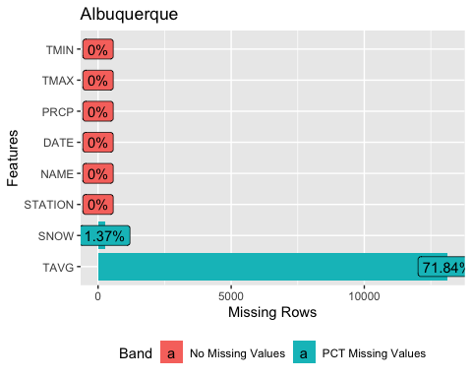

# Denver  
plot_missing(DEN, title = "Denver", group=c("No Missing Values"=0,   
 "PCT Missing Values"= 1))

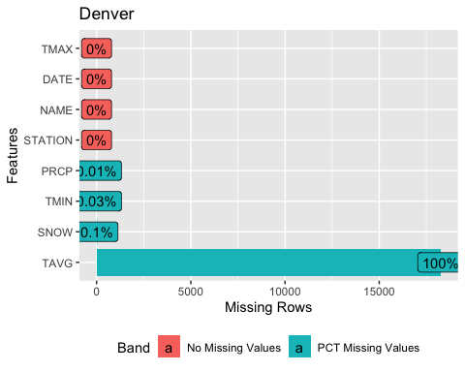

# Phoenix  
plot_missing(PHX, title = "Phoenix", group=c("No Missing Values"=0,  
 "PCT Missing Values"= 1))

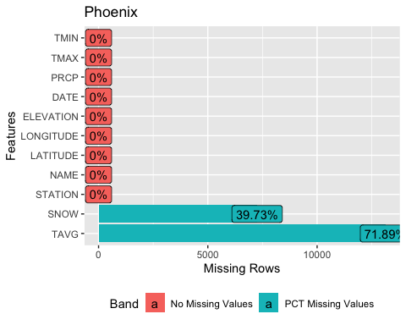

# Salt Lake City   
plot_missing(SLC, title = "Salt Lake City ", group=c("No Missing Values"=0,   
 "PCT Missing Values"= 1))

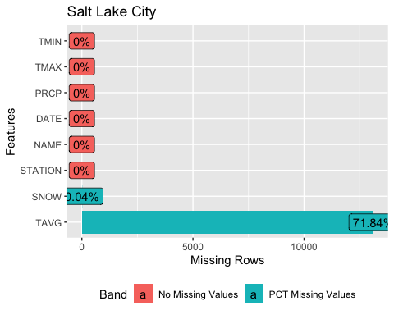

#### Replace Misssing Values

The above graphs shows that each of the data sets are missing observations for one or more values. To avoid the effects of outliers in the missing values for TMIN, TMAX, PRCP and SNOW will be replaced with the median value for each of the respective values. According GHCN Daily TAVG is calculated by taking the mean of value for daily observations of TMAX and TMIN and rounding up to the nearest integer, That is daily . Therefore, missing values for TAVG will be replaced using this formula.

# replace missing values in ABQ  
# replace NA's in the SNOW column with the median snowfall   
ABQ$SNOW[is.na(ABQ$SNOW)] <- median(ABQ$SNOW, na.rm = T)  
# replace the missing values for TAVG  
ABQTEMP <- data.frame(ABQ$TMAX, ABQ$TMIN)  
ind <- which(is.na(ABQ), arr.ind=TRUE)  
# all temperatures are given as whole numbers in dataset so round the mean  
ABQ[ind] <- ceiling(rowMeans(ABQTEMP, na.rm=TRUE)[ind[,1]])  
#check to ensure replacement   
profile_missing(ABQ)

## feature num_missing pct_missing  
## 1 STATION 0 0  
## 2 NAME 0 0  
## 3 DATE 0 0  
## 4 PRCP 0 0  
## 5 SNOW 0 0  
## 6 TAVG 0 0  
## 7 TMAX 0 0  
## 8 TMIN 0 0

## feature num_missing pct_missing  
## 1 STATION 0 0  
## 2 NAME 0 0  
## 3 DATE 0 0  
## 4 PRCP 0 0  
## 5 SNOW 0 0  
## 6 TAVG 0 0  
## 7 TMAX 0 0  
## 8 TMIN 0 0

## feature num_missing pct_missing  
## 1 STATION 0 0  
## 2 NAME 0 0  
## 3 LATITUDE 0 0  
## 4 LONGITUDE 0 0  
## 5 ELEVATION 0 0  
## 6 DATE 0 0  
## 7 PRCP 0 0  
## 8 SNOW 0 0  
## 9 TAVG 0 0  
## 10 TMAX 0 0  
## 11 TMIN 0 0

## feature num_missing pct_missing  
## 1 STATION 0 0  
## 2 NAME 0 0  
## 3 DATE 0 0  
## 4 PRCP 0 0  
## 5 SNOW 0 0  
## 6 TAVG 0 0  
## 7 TMAX 0 0  
## 8 TMIN 0 0

#### Preparing Data for Time Series Analysis

# transform date column from factor to date data type in each data set  
ABQ <- transform(ABQ, DATE = as.Date(DATE))  
DEN <- transform(DEN, DATE = as.Date(DATE))  
PHX <- transform(PHX, DATE = as.Date(DATE))  
SLC <- transform(SLC, DATE = as.Date(DATE))  
#verify changes   
ABQ_DELTA <- sapply(ABQ, class)  
DEN_DELTA <- sapply(DEN, class)  
PHX_DELTA <- sapply(PHX, class)  
SLC_DELTA <- sapply(SLC, class)

ABQ_DELTA

## STATION NAME DATE PRCP SNOW TAVG TMAX   
## "factor" "factor" "Date" "numeric" "numeric" "numeric" "integer"   
## TMIN   
## "integer"

## STATION NAME DATE PRCP SNOW TAVG TMAX   
## "factor" "factor" "Date" "numeric" "numeric" "numeric" "numeric"   
## TMIN   
## "numeric"

## STATION NAME LATITUDE LONGITUDE ELEVATION DATE PRCP   
## "factor" "factor" "numeric" "numeric" "numeric" "Date" "numeric"   
## SNOW TAVG TMAX TMIN   
## "numeric" "numeric" "integer" "integer"

## STATION NAME DATE PRCP SNOW TAVG TMAX   
## "factor" "factor" "Date" "numeric" "numeric" "numeric" "integer"   
## TMIN   
## "integer"

#### Aggregate Data for Analysis of Monthly Values

# Albuquerque  
# create column month year to aggregate data for time series   
ABQ$MONTH_YEAR <- floor_date(ABQ$DATE,"month")  
# create aggregated dataset using MONTH_YEAR COLUMN  
ABQ_AGG <- ABQ %>%  
 group_by(MONTH_YEAR)%>%  
 dplyr::summarize(Monthly_Avg_Temp = mean(TAVG),  
 Monthly_Rainfall=sum(PRCP), Monthly_Snowfall=sum(SNOW)) %>%  
 as.data.frame()  
head(ABQ_AGG)

## MONTH_YEAR Monthly_Avg_Temp Monthly_Rainfall Monthly_Snowfall  
## 1 1970-01-01 34.74194 0.00 0.0  
## 2 1970-02-01 43.14286 0.27 2.7  
## 3 1970-03-01 44.22581 0.42 3.3  
## 4 1970-04-01 52.76667 0.05 0.0  
## 5 1970-05-01 66.35484 0.33 0.0  
## 6 1970-06-01 72.83333 0.40 0.0

# Phoenix   
# create column month year to aggregate data for time series   
PHX$MONTH_YEAR <- floor_date(PHX$DATE,"month")  
# create aggregated dataset using MONTH_YEAR COLUMN  
PHX_AGG <- PHX %>%  
 group_by(MONTH_YEAR)%>%  
 dplyr::summarize(Monthly_Avg_Temp = mean(TAVG),  
 Monthly_Rainfall=sum(PRCP), Monthly_Snowfall=sum(SNOW)) %>%  
 as.data.frame()

# Salt Lake City   
# create column month year to aggregate data for time series   
SLC$MONTH_YEAR <- floor_date(SLC$DATE,"month")  
# create aggregated dataset using MONTH_YEAR COLUMN  
SLC_AGG <- SLC %>%  
 group_by(MONTH_YEAR)%>%  
 dplyr::summarize(Monthly_Avg_Temp = mean(TAVG),  
 Monthly_Rainfall=sum(PRCP), Monthly_Snowfall=sum(SNOW)) %>%  
 as.data.frame()

### Time Series Analysis Using Seasonal Autoregressive Integrated Moving Average SARIMA Model

#### What is a SARIMA Model?

A SARIMA model is the seasonal flavor of the autoregressive integrated moving average (ARIMA) model. ARIMA and SARIMA models are a statistical technique used to analyze times series data and in certain cases predict future values. The goal of autoregressive models is to predict future values of the target variable by regressing against past observations of the variable. That is lagged values of the target variable are used as independent variables “x’s” in the regression equation (Yiu, 2020). Seasonal autoregressive models are used to perform similar analysis while accounting for any seasonality obesrved in the time series being analyzed. ARIMA and SARIMA models also incorporate differencing “I” to correct for data that is not stationary and moving average “MA” to include errors in previous predictions as a parameter in the model. To better understand the method a brief summary of each component is given below.

#### Autoregressive (p)

Considering an observed value “Y” to be a linear function of it’s past observations a simple representation of the regression equation is as follows.

By tweaking this equation we can attemmt to predict future values of Y.

The above equation represents whats commonly referred to as an AR(1) model. An autoregressive model using a single lag to predict future values of Y, the outcome.

#### Integrated (d)

When conducting times series analysis an important step is ensuring that time series data is stationary. Stationary time series data has a more stable mean and variance. That is the mean and variance of the data are consistent over time leading to a more robust model. Performing one or more differencing steps on time series data helps to ensure stationarity. In ARIMA and SARIMA modeling this step can be performed as follows.

#### Moving Average (q)

Moving avaerage(MA) is similar to the auto regresive step in that it uses past values (lags) to predict future outcomes. The difference is that the MA method uses previous error terms in the regression model as parameters for predicting future values. Error terms or “E” represent random deviations between values of the target variable fitted by the model and actual observations at each lag.

For a simple moving average model the above equation can then be modified to include the average of “Y.” Thus errors at each lag push the average of Y in the positive or negative direction adjusting the moving average of Y.

#### Seasonal (PDQ)[Seasonality]

When constructing an ARIMA model it’s important to note the presence of cyclical or predictable patterns in the data being analyzed. Many times these patterns represent seasonality. If you wanted to model the sale of baseball tickets on a monthly basis you would notice a sharp decrease to zero tickets sold between the months of February and March. That’s becuse this is the offseason for baseball. The offseason begins and ends at roughly the same time every year. So when using an ARIMA model we should account for this seasonality by adding seasonal parameters to the model. Using the auto.arima function in R approximates the seasonal parameters of an ARIMA model helping to account for seasonality and improve model performance. An abstraction of a SARIMA model and it’s parameters as output by the auto.ariam function is given below.

### Preparing to Model the Data Using SARIMA

The first step when using the auto.arima function in R is to tranform the data being analyzed into a "time series object.Time series objects will be created for mean mothly temperature, total monthly precipation (inches) and total monthly snowfall (inches) for each of the four locations being analyzed.

# create time series objects for mean monthly temperature   
ABQ_TS_TEMP <- ts(ABQ_AGG[, 2], start= c(1970,1), end= c(2019,12), frequency = 12)  
DEN_TS_TEMP <- ts(DEN_AGG[, 2], start= c(1970,1), end= c(2019,12), frequency = 12)  
PHX_TS_TEMP <- ts(PHX_AGG[, 2], start= c(1970,1), end= c(2019,12), frequency = 12)  
SLC_TS_TEMP <- ts(SLC_AGG[, 2], start= c(1970,1), end= c(2019,12), frequency = 12)  
# create time series objects for total monthly precipitation   
ABQ_TS_PRCP <- ts(ABQ_AGG[, 3], start=c(1970, 1), end=c(2019,12), frequency=12)  
DEN_TS_PRCP <- ts(DEN_AGG[, 3], start=c(1970, 1), end=c(2019,12), frequency=12)  
PHX_TS_PRCP <- ts(PHX_AGG[, 3], start=c(1970, 1), end=c(2019,12), frequency=12)  
SLC_TS_PRCP <- ts(SLC_AGG[, 3], start=c(1970, 1), end=c(2019,12), frequency=12)  
# create time series objects for total monthly snowfall   
ABQ_TS_SNOW <- ts(ABQ_AGG[, 4], start=c(1970,1), end=c(2019,12), frequency=12)  
DEN_TS_SNOW <- ts(DEN_AGG[, 4], start=c(1970,1), end=c(2019,12), frequency=12)  
PHX_TS_SNOW <- ts(PHX_AGG[, 4], start=c(1970,1), end=c(2019,12), frequency=12)  
SLC_TS_SNOW <- ts(SLC_AGG[, 4], start=c(1970,1), end=c(2019,12), frequency=12)

#### Test That the Time Series Data Are Stationary

Time series may be considered stationary if they have no significant trend, constant variance over time and a constant autocorrelation structure over time (Zach, 2021). One mehtod of testing whether times series data are stationary in R is the to use the adf.test function from the tseries library. The adf.test function performs an augmented Dickey-Fuller test on the specified time series object. The augmented Dickey-Fuller Test gives the following null hypothesis, alternate hypothesis and confidence level.

$$H_o: \space The \space time \space series \space is \space non-stationary.$$

$$H_A: \space the \space time \space series \space is \space stationary$$

# perform the ADF test for ABQ  
adf.test(ABQ_TS_TEMP)

## Warning in adf.test(ABQ_TS_TEMP): p-value smaller than printed p-value

##   
## Augmented Dickey-Fuller Test  
##   
## data: ABQ_TS_TEMP  
## Dickey-Fuller = -15.857, Lag order = 8, p-value = 0.01  
## alternative hypothesis: stationary

## Warning in adf.test(ABQ_TS_PRCP): p-value smaller than printed p-value

##   
## Augmented Dickey-Fuller Test  
##   
## data: ABQ_TS_PRCP  
## Dickey-Fuller = -10.292, Lag order = 8, p-value = 0.01  
## alternative hypothesis: stationary

## Warning in adf.test(ABQ_TS_SNOW): p-value smaller than printed p-value

##   
## Augmented Dickey-Fuller Test  
##   
## data: ABQ_TS_SNOW  
## Dickey-Fuller = -11.235, Lag order = 8, p-value = 0.01  
## alternative hypothesis: stationary

## Warning in adf.test(DEN_TS_TEMP): p-value smaller than printed p-value

##   
## Augmented Dickey-Fuller Test  
##   
## data: DEN_TS_TEMP  
## Dickey-Fuller = -14.942, Lag order = 8, p-value = 0.01  
## alternative hypothesis: stationary

## Warning in adf.test(DEN_TS_PRCP): p-value smaller than printed p-value

##   
## Augmented Dickey-Fuller Test  
##   
## data: DEN_TS_PRCP  
## Dickey-Fuller = -10.397, Lag order = 8, p-value = 0.01  
## alternative hypothesis: stationary

## Warning in adf.test(DEN_TS_SNOW): p-value smaller than printed p-value

##   
## Augmented Dickey-Fuller Test  
##   
## data: DEN_TS_SNOW  
## Dickey-Fuller = -12.049, Lag order = 8, p-value = 0.01  
## alternative hypothesis: stationary

## Warning in adf.test(PHX_TS_TEMP): p-value smaller than printed p-value

##   
## Augmented Dickey-Fuller Test  
##   
## data: PHX_TS_TEMP  
## Dickey-Fuller = -15.134, Lag order = 8, p-value = 0.01  
## alternative hypothesis: stationary

## Warning in adf.test(PHX_TS_PRCP): p-value smaller than printed p-value

##   
## Augmented Dickey-Fuller Test  
##   
## data: PHX_TS_PRCP  
## Dickey-Fuller = -8.9584, Lag order = 8, p-value = 0.01  
## alternative hypothesis: stationary

## Warning in adf.test(PHX_TS_SNOW): p-value smaller than printed p-value

##   
## Augmented Dickey-Fuller Test  
##   
## data: PHX_TS_SNOW  
## Dickey-Fuller = -8.1445, Lag order = 8, p-value = 0.01  
## alternative hypothesis: stationary

## Warning in adf.test(SLC_TS_TEMP): p-value smaller than printed p-value

##   
## Augmented Dickey-Fuller Test  
##   
## data: SLC_TS_TEMP  
## Dickey-Fuller = -18.359, Lag order = 8, p-value = 0.01  
## alternative hypothesis: stationary

## Warning in adf.test(SLC_TS_PRCP): p-value smaller than printed p-value

##   
## Augmented Dickey-Fuller Test  
##   
## data: SLC_TS_PRCP  
## Dickey-Fuller = -9.3255, Lag order = 8, p-value = 0.01  
## alternative hypothesis: stationary

## Warning in adf.test(SLC_TS_SNOW): p-value smaller than printed p-value

##   
## Augmented Dickey-Fuller Test  
##   
## data: SLC_TS_SNOW  
## Dickey-Fuller = -13.065, Lag order = 8, p-value = 0.01  
## alternative hypothesis: stationary

#### Visualize the Data

An important step in time series analysis is to visually inspect the data. Time series visualization allows for further assessment of whether the data are stationary, decomposition of time series attributes and ispection for anomalies in the data.

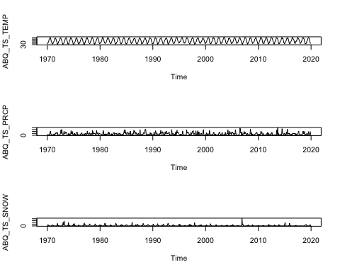

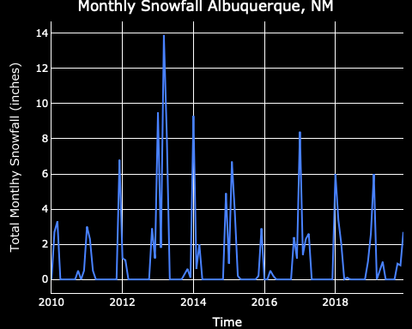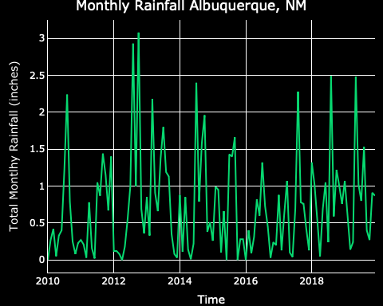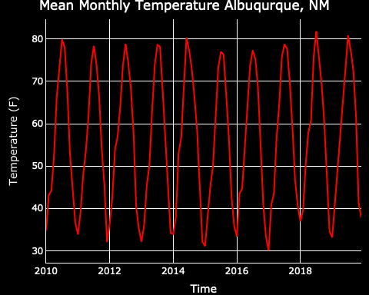

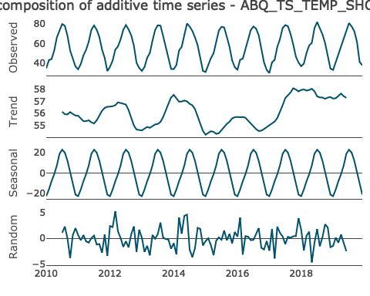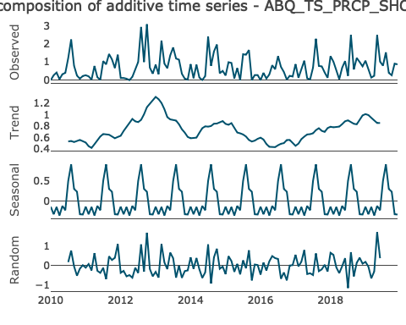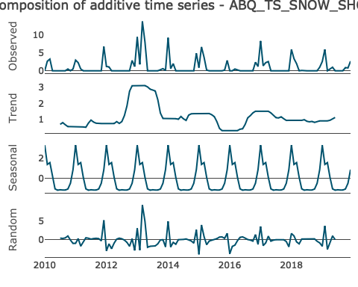

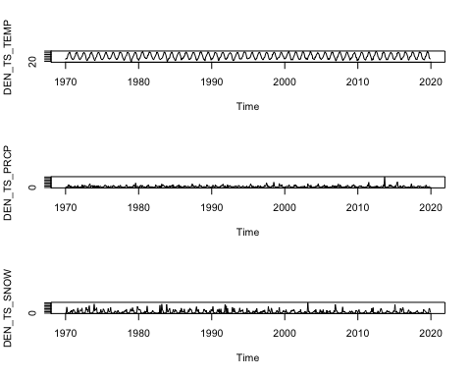

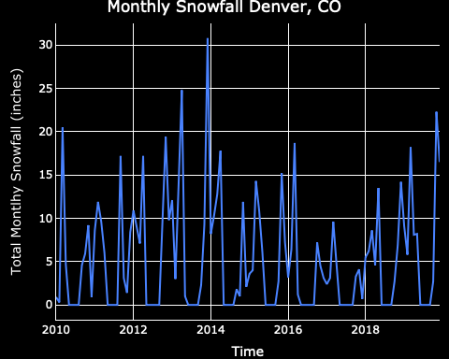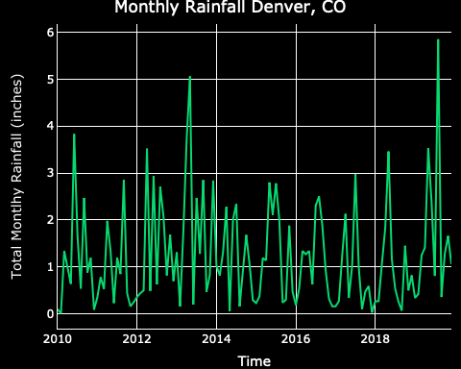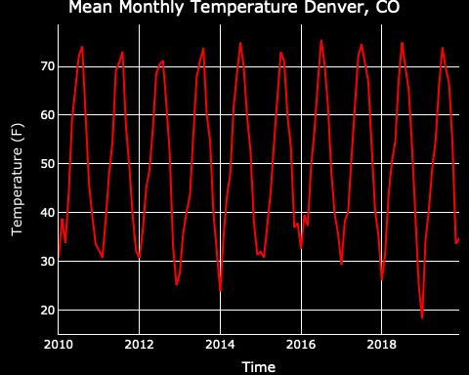

par(mfrow=c(1,3))  
ts_decompose(DEN_TS_TEMP_SHORT)

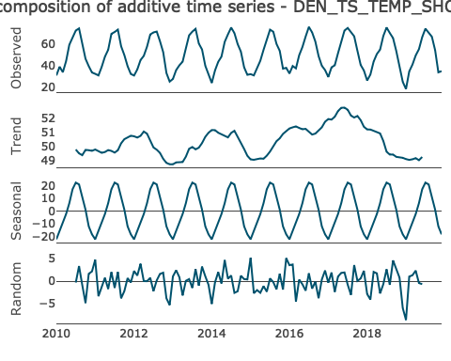

ts_decompose(DEN_TS_PRCP_SHORT)

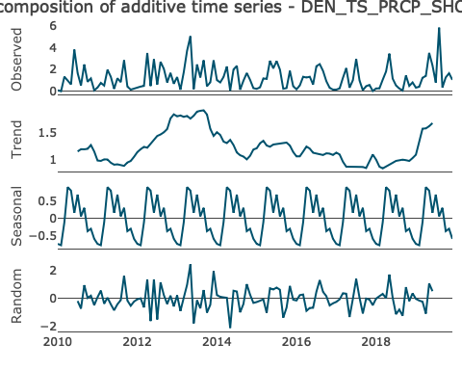

ts_decompose(DEN_TS_SNOW_SHORT)

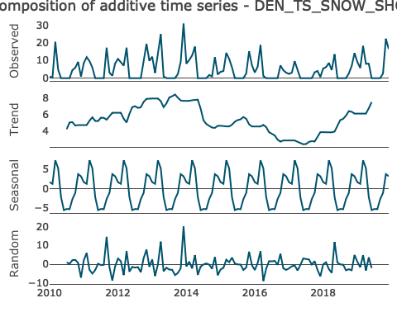

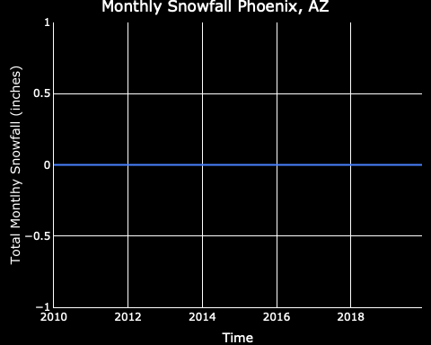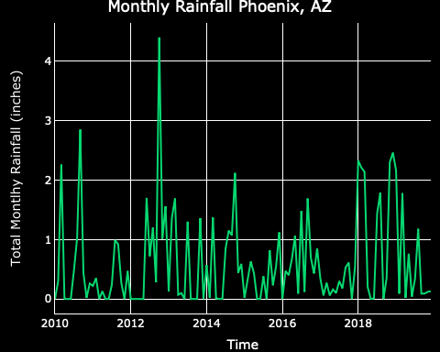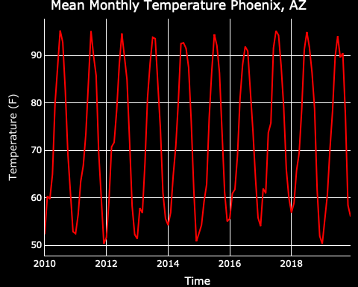

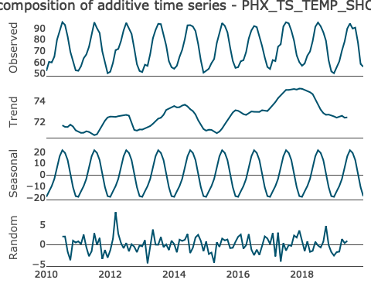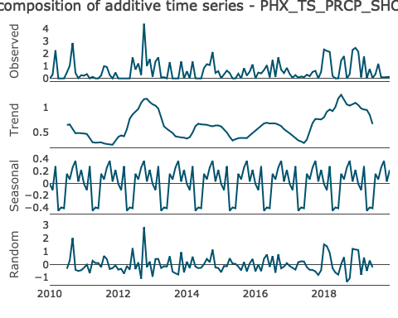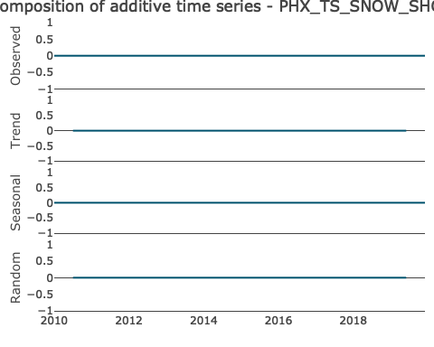

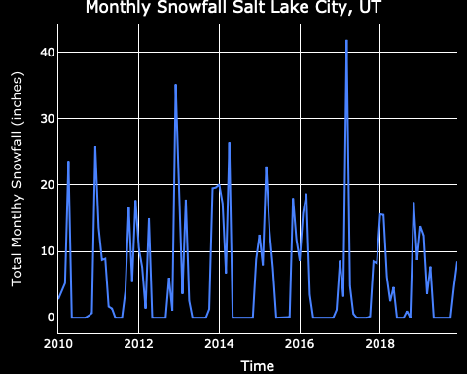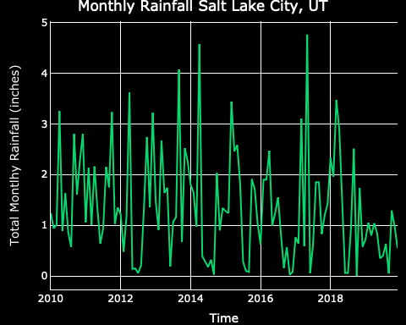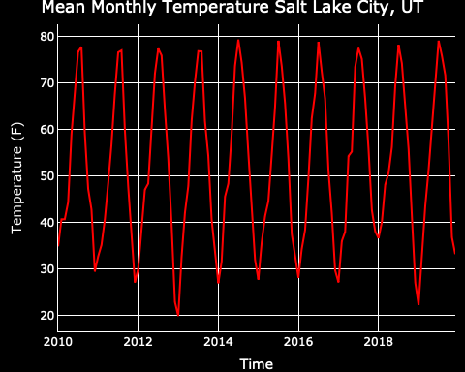

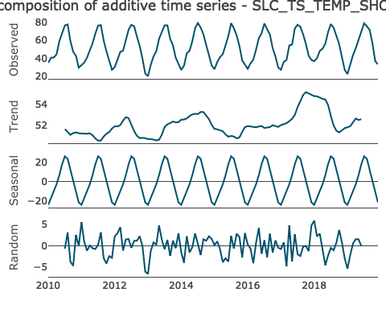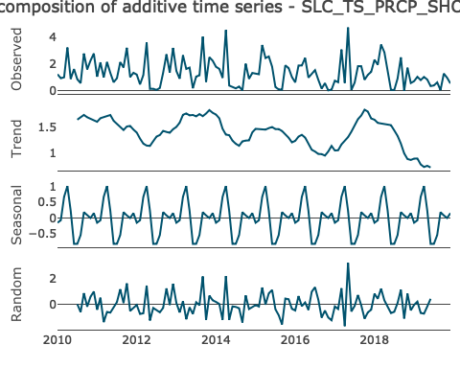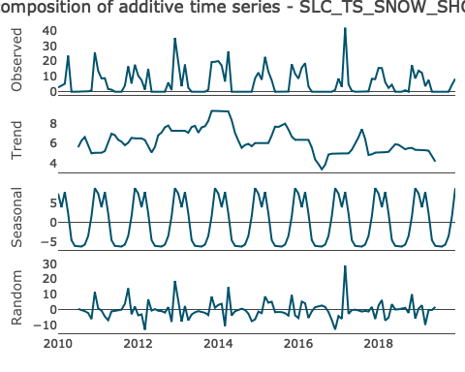

#### Create the SARIMA MODEL for Each Time Series

# summary of ABQ_TEMP_MODEL  
ABQ_TEMP_MODEL

## Series: ABQ_TS_TEMP   
## ARIMA(0,0,0)(0,1,1)[12]   
##   
## Coefficients:  
## sma1  
## -0.8789  
## s.e. 0.0206  
##   
## sigma^2 estimated as 6.562: log likelihood=-1395.81  
## AIC=2795.62 AICc=2795.64 BIC=2804.37

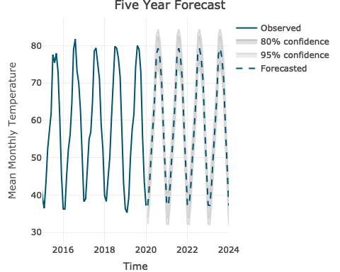

# summary of ABQ_PRCP_MODEL  
ABQ_PRCP_MODEL

## Series: ABQ_TS_PRCP   
## ARIMA(0,0,2)(2,0,0)[12] with non-zero mean   
##   
## Coefficients:  
## ma1 ma2 sar1 sar2 mean  
## 0.0868 0.0821 0.1825 0.2092 0.7480  
## s.e. 0.0419 0.0422 0.0401 0.0412 0.0535  
##   
## sigma^2 estimated as 0.4876: log likelihood=-634.26  
## AIC=1280.53 AICc=1280.67 BIC=1306.91

## Point Forecast Lo 80 Hi 80 Lo 95 Hi 95  
## Jan 2020 0.6553223 -0.23958421 1.550229 -0.7133191 2.023964  
## Feb 2020 0.6223902 -0.27588264 1.520663 -0.7513996 1.996180  
## Mar 2020 0.6258954 -0.27537937 1.527170 -0.7524854 2.004276  
## Apr 2020 0.6393342 -0.26194054 1.540609 -0.7390466 2.017715  
## May 2020 0.5239220 -0.37735272 1.425197 -0.8544587 1.902303  
## Jun 2020 0.7606930 -0.14058177 1.661968 -0.6176878 2.139074  
## Jul 2020 1.2732392 0.37196452 2.174514 -0.1051415 2.651620  
## Aug 2020 0.7322432 -0.16903155 1.633518 -0.6461376 2.110624  
## Sep 2020 0.7128794 -0.18839532 1.614154 -0.6655013 2.091260  
## Oct 2020 0.9790246 0.07774990 1.880299 -0.3993561 2.357405  
## Nov 2020 0.8181752 -0.08309958 1.719450 -0.5602056 2.196556  
## Dec 2020 0.6122808 -0.28899396 1.513556 -0.7661000 1.990662  
## Jan 2021 0.6834003 -0.23255117 1.599352 -0.7174266 2.084227  
## Feb 2021 0.6732062 -0.24285500 1.589267 -0.7277885 2.074201  
## Mar 2021 0.7219651 -0.19419423 1.638124 -0.6791797 2.123110  
## Apr 2021 0.7829976 -0.13316174 1.699157 -0.6181472 2.184142  
## May 2021 0.6008409 -0.31531846 1.517000 -0.8003039 2.001986  
## Jun 2021 0.6084830 -0.30767638 1.524642 -0.7926618 2.009628  
## Jul 2021 1.0953409 0.17918158 2.011500 -0.3058039 2.496486  
## Aug 2021 0.6786083 -0.23755104 1.594768 -0.7225365 2.079753  
## Sep 2021 0.6792589 -0.23690046 1.595418 -0.7218859 2.080404  
## Oct 2021 0.7571179 -0.15904140 1.673277 -0.6440269 2.158263  
## Nov 2021 1.0206645 0.10450515 1.936824 -0.3804803 2.421809  
## Dec 2021 0.6295184 -0.28664094 1.545678 -0.7716264 2.030663  
## Jan 2022 0.7168356 -0.22467919 1.658350 -0.7230870 2.156758  
## Feb 2022 0.7080854 -0.23361791 1.649789 -0.7321255 2.148296  
## Mar 2022 0.7177168 -0.22415520 1.659589 -0.7227521 2.158186  
## Apr 2022 0.7316662 -0.21020574 1.673538 -0.7088027 2.172135  
## May 2022 0.6742784 -0.26759355 1.616150 -0.7661905 2.114747  
## Jun 2022 0.7252089 -0.21666306 1.667081 -0.7152600 2.165678  
## Jul 2022 0.9212881 -0.02058393 1.863160 -0.5191808 2.361757  
## Aug 2022 0.7320541 -0.20981793 1.673926 -0.7084148 2.172523  
## Sep 2022 0.7281216 -0.21375038 1.669994 -0.7123473 2.168590  
## Oct 2022 0.7980116 -0.14386042 1.739884 -0.6424573 2.238480  
## Nov 2022 0.8124544 -0.12941763 1.754326 -0.6280145 2.252923  
## Dec 2022 0.6979977 -0.24387424 1.639870 -0.7424712 2.138467  
## Jan 2023 0.7288115 -0.21594522 1.673568 -0.7160692 2.173692  
## Feb 2023 0.7250820 -0.21969651 1.669860 -0.7198320 2.169996  
## Mar 2023 0.7370407 -0.20775723 1.681839 -0.7079030 2.181984  
## Apr 2023 0.7523552 -0.19244271 1.697153 -0.6925885 2.197299  
## May 2023 0.7037726 -0.24102525 1.648571 -0.7411710 2.148716  
## Jun 2023 0.7146658 -0.23013207 1.659464 -0.7302779 2.159610  
## Jul 2023 0.8523061 -0.09249177 1.797104 -0.5926376 2.297250  
## Aug 2023 0.7305862 -0.21421167 1.675384 -0.7143575 2.175530  
## Sep 2023 0.7300047 -0.21479320 1.674803 -0.7149390 2.174948  
## Oct 2023 0.7590482 -0.18574969 1.703846 -0.6858955 2.203992  
## Nov 2023 0.8168216 -0.12797629 1.761619 -0.6281221 2.261765  
## Dec 2023 0.7141009 -0.23069695 1.658899 -0.7308427 2.159045  
## Jan 2024 0.7379922 -0.20863794 1.684622 -0.7097537 2.185738  
## Feb 2024 0.7354809 -0.21116302 1.682125 -0.7122860 2.183248  
## Mar 2024 0.7396783 -0.20697798 1.686335 -0.7081075 2.187464  
## Apr 2024 0.7453915 -0.20126480 1.692048 -0.7023944 2.193177  
## May 2024 0.7245193 -0.22213702 1.671176 -0.7232666 2.172305  
## Jun 2024 0.7371625 -0.20949372 1.683819 -0.7106233 2.184948  
## Jul 2024 0.8033032 -0.14335307 1.749959 -0.6444826 2.251089  
## Aug 2024 0.7415000 -0.20515630 1.688156 -0.7062859 2.189286  
## Sep 2024 0.7405711 -0.20608515 1.687227 -0.7072147 2.188357  
## Oct 2024 0.7604933 -0.18616299 1.707150 -0.6872925 2.208279  
## Nov 2024 0.7740580 -0.17259824 1.720714 -0.6737278 2.221844  
## Dec 2024 0.7313665 -0.21528978 1.678023 -0.7164193 2.179152

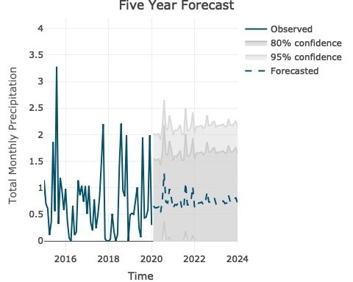

# summary of ABQ_SNOW_MODEL  
ABQ_SNOW_MODEL

## Series: ABQ_TS_SNOW   
## ARIMA(4,1,0)(1,0,0)[12]   
##   
## Coefficients:  
## ar1 ar2 ar3 ar4 sar1  
## -0.6366 -0.3806 -0.2412 -0.1423 0.1908  
## s.e. 0.0428 0.0504 0.0485 0.0407 0.0434  
##   
## sigma^2 estimated as 4.258: log likelihood=-1281.81  
## AIC=2575.61 AICc=2575.76 BIC=2601.99

## Point Forecast Lo 80 Hi 80 Lo 95 Hi 95  
## Jan 2020 1.3223920 -1.321975 3.966759 -2.721818 5.366602  
## Feb 2020 1.6418834 -1.171652 4.455419 -2.661048 5.944815  
## Mar 2020 0.9099168 -2.084955 3.904789 -3.670345 5.490179  
## Apr 2020 1.2235282 -1.929971 4.377027 -3.599333 6.046389  
## May 2020 0.8551434 -2.458311 4.168597 -4.212347 5.922634  
## Jun 2020 0.9678735 -2.568884 4.504631 -4.441130 6.376877  
## Jul 2020 0.9508102 -2.748843 4.650464 -4.707321 6.608942  
## Aug 2020 0.9629919 -2.895781 4.821765 -4.938493 6.864476  
## Sep 2020 0.9869618 -3.022806 4.996730 -5.145449 7.119373  
## Oct 2020 0.9551404 -3.201519 5.111800 -5.401921 7.312202  
## Nov 2020 1.7288363 -2.574333 6.032005 -4.852293 8.309965  
## Dec 2020 1.0399044 -3.401601 5.481409 -5.752791 7.832600  
## Jan 2021 1.2174675 -3.505372 5.940307 -6.005493 8.440428  
## Feb 2021 1.2801877 -3.613999 6.174374 -6.204824 8.765200  
## Mar 2021 1.1378264 -3.925265 6.200918 -6.605504 8.881157  
## Apr 2021 1.1986370 -4.026438 6.423712 -6.792426 9.189700  
## May 2021 1.1281172 -4.255135 6.511370 -7.104857 9.361091  
## Jun 2021 1.1498087 -4.397097 6.696715 -7.333452 9.633069  
## Jul 2021 1.1466785 -4.552480 6.845837 -7.569432 9.862789  
## Aug 2021 1.1487708 -4.699164 6.996705 -7.794873 10.092415  
## Sep 2021 1.1534332 -4.839332 7.146199 -8.011711 10.318577  
## Oct 2021 1.1473371 -4.987033 7.281707 -8.234372 10.529046  
## Nov 2021 1.2949532 -4.978549 7.568455 -8.299540 10.889446  
## Dec 2021 1.1635357 -5.245552 7.572623 -8.638317 10.965389  
## Jan 2022 1.1973894 -5.364499 7.759278 -8.838153 11.232932  
## Feb 2022 1.2093625 -5.489235 7.907960 -9.035258 11.453983  
## Mar 2022 1.1822020 -5.650863 8.015267 -9.268069 11.632473  
## Apr 2022 1.1938048 -5.770914 8.158523 -9.457813 11.845422  
## May 2022 1.1803524 -5.913737 8.274442 -9.669122 12.029827  
## Jun 2022 1.1844888 -6.038158 8.407136 -9.861597 12.230575  
## Jul 2022 1.1838924 -6.164047 8.531832 -10.053812 12.421597  
## Aug 2022 1.1842913 -6.286915 8.655498 -10.241933 12.610515  
## Sep 2022 1.1851809 -6.407252 8.777613 -10.426443 12.796804  
## Oct 2022 1.1840180 -6.527765 8.895801 -10.610137 12.978173  
## Nov 2022 1.2121782 -6.617251 9.041607 -10.761900 13.186257  
## Dec 2022 1.1871081 -6.758141 9.132357 -10.964102 13.338318  
## Jan 2023 1.1935662 -6.868947 9.256080 -11.136984 13.524116  
## Feb 2023 1.1958503 -6.980291 9.371992 -11.308479 13.700179  
## Mar 2023 1.1906690 -7.097621 9.478959 -11.485177 13.866515  
## Apr 2023 1.1928824 -7.206024 9.591789 -11.652137 14.037902  
## May 2023 1.1903161 -7.317795 9.698427 -11.821716 14.202349  
## Jun 2023 1.1911052 -7.425067 9.807278 -11.986194 14.368404  
## Jul 2023 1.1909915 -7.531740 9.913723 -12.149276 14.531259  
## Aug 2023 1.1910676 -7.636949 10.019085 -12.310219 14.692354  
## Sep 2023 1.1912373 -7.740818 10.123292 -12.469162 14.851636  
## Oct 2023 1.1910154 -7.843884 10.225915 -12.626671 15.008702  
## Nov 2023 1.1963875 -7.940218 10.332993 -12.776845 15.169620  
## Dec 2023 1.1916049 -8.045573 10.428783 -12.935440 15.318650  
## Jan 2024 1.1928369 -8.144342 10.530016 -13.087147 15.472820  
## Feb 2024 1.1932726 -8.242525 10.629071 -13.237535 15.624081  
## Mar 2024 1.1922842 -8.341126 10.725694 -13.387808 15.772376  
## Apr 2024 1.1927065 -8.437320 10.822733 -13.535148 15.920561  
## May 2024 1.1922169 -8.533471 10.917904 -13.681939 16.066372  
## Jun 2024 1.1923674 -8.628090 11.012825 -13.826726 16.211461  
## Jul 2024 1.1923457 -8.721948 11.106639 -13.970258 16.354950  
## Aug 2024 1.1923602 -8.814892 11.199613 -14.112411 16.497132  
## Sep 2024 1.1923926 -8.906962 11.291747 -14.253237 16.638022  
## Oct 2024 1.1923503 -8.998274 11.382975 -14.392865 16.777566  
## Nov 2024 1.1933751 -9.087713 11.474463 -14.530192 16.916942  
## Dec 2024 1.1924628 -9.178297 11.563223 -14.668246 17.053171

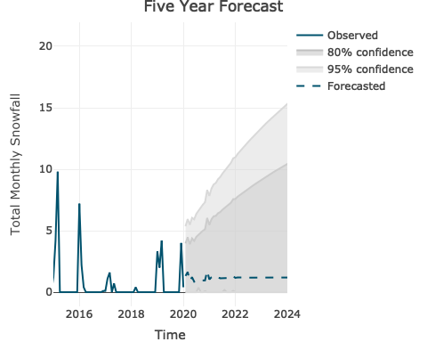

# summary of DEN_TEMP_MODEL  
DEN_TEMP_MODEL

## Series: DEN_TS_TEMP   
## ARIMA(1,0,0)(2,1,0)[12]   
##   
## Coefficients:  
## ar1 sar1 sar2  
## 0.2085 -0.5684 -0.3709  
## s.e. 0.0404 0.0390 0.0391  
##   
## sigma^2 estimated as 14.46: log likelihood=-1621.12  
## AIC=3250.23 AICc=3250.3 BIC=3267.74

## Point Forecast Lo 80 Hi 80 Lo 95 Hi 95  
## Jan 2020 37.23837 33.95552 40.52123 32.21769 42.25906  
## Feb 2020 42.58499 39.30214 45.86784 37.56430 47.60568  
## Mar 2020 50.74947 47.46662 54.03232 45.72878 55.77016  
## Apr 2020 57.67002 54.38716 60.95287 52.64933 62.69071  
## May 2020 65.75930 62.47645 69.04216 60.73861 70.77999  
## Jun 2020 77.58888 74.30603 80.87173 72.56819 82.60957  
## Jul 2020 79.27305 75.99019 82.55590 74.25236 84.29374  
## Aug 2020 76.79466 73.51180 80.07751 71.77397 81.81535  
## Sep 2020 71.16605 67.88320 74.44890 66.14536 76.18674  
## Oct 2020 58.78522 55.50236 62.06807 53.76453 63.80591  
## Nov 2020 46.27841 42.99556 49.56126 41.25772 51.29910  
## Dec 2020 37.33927 34.05642 40.62213 32.31858 42.35996  
## Jan 2021 37.23837 33.93153 40.54522 32.18098 42.29577  
## Feb 2021 42.58499 39.27814 45.89184 37.52760 47.64238  
## Mar 2021 50.74947 47.44262 54.05632 45.69208 55.80686  
## Apr 2021 57.67002 54.36317 60.97687 52.61263 62.72741  
## May 2021 65.75930 62.45245 69.06615 60.70191 70.81669  
## Jun 2021 77.58888 74.28203 80.89573 72.53149 82.64627  
## Jul 2021 79.27305 75.96620 82.57990 74.21566 84.33044  
## Aug 2021 76.79466 73.48781 80.10151 71.73727 81.85205  
## Sep 2021 71.16605 67.85920 74.47290 66.10866 76.22344  
## Oct 2021 58.78522 55.47837 62.09207 53.72783 63.84261  
## Nov 2021 46.27841 42.97156 49.58526 41.22102 51.33580  
## Dec 2021 37.33927 34.03242 40.64612 32.28188 42.39666  
## Jan 2022 37.23837 33.90770 40.56905 32.14455 42.33220  
## Feb 2022 42.58499 39.25432 45.91566 37.49116 47.67882  
## Mar 2022 50.74947 47.41880 54.08014 45.65564 55.84330  
## Apr 2022 57.67002 54.33934 61.00069 52.57619 62.76384  
## May 2022 65.75930 62.42863 69.08998 60.66548 70.85313  
## Jun 2022 77.58888 74.25821 80.91955 72.49505 82.68271  
## Jul 2022 79.27305 75.94237 82.60372 74.17922 84.36687  
## Aug 2022 76.79466 73.46398 80.12533 71.70083 81.88848  
## Sep 2022 71.16605 67.83538 74.49672 66.07222 76.25988  
## Oct 2022 58.78522 55.45454 62.11589 53.69139 63.87904  
## Nov 2022 46.27841 42.94774 49.60909 41.18458 51.37224  
## Dec 2022 37.33927 34.00860 40.66995 32.24545 42.43310  
## Jan 2023 37.23837 33.88405 40.59270 32.10837 42.36838  
## Feb 2023 42.58499 39.23066 45.93932 37.45499 47.71499  
## Mar 2023 50.74947 47.39514 54.10380 45.61947 55.87947  
## Apr 2023 57.67002 54.31569 61.02435 52.54001 62.80002  
## May 2023 65.75930 62.40497 69.11363 60.62930 70.88931  
## Jun 2023 77.58888 74.23455 80.94321 72.45888 82.71888  
## Jul 2023 79.27305 75.91872 82.62738 74.14304 84.40305  
## Aug 2023 76.79466 73.44033 80.14899 71.66465 81.92466  
## Sep 2023 71.16605 67.81172 74.52038 66.03605 76.29605  
## Oct 2023 58.78522 55.43089 62.13955 53.65521 63.91522  
## Nov 2023 46.27841 42.92408 49.63274 41.14841 51.40842  
## Dec 2023 37.33927 33.98494 40.69360 32.20927 42.46928  
## Jan 2024 37.23837 33.86056 40.61619 32.07245 42.40430  
## Feb 2024 42.58499 39.20717 45.96281 37.41906 47.75092  
## Mar 2024 50.74947 47.37165 54.12729 45.58354 55.91540  
## Apr 2024 57.67002 54.29220 61.04784 52.50409 62.83594  
## May 2024 65.75930 62.38148 69.13712 60.59338 70.92523  
## Jun 2024 77.58888 74.21106 80.96670 72.42295 82.75481  
## Jul 2024 79.27305 75.89523 82.65087 74.10712 84.43898  
## Aug 2024 76.79466 73.41684 80.17248 71.62873 81.96058  
## Sep 2024 71.16605 67.78823 74.54387 66.00012 76.33198  
## Oct 2024 58.78522 55.40740 62.16304 53.61929 63.95114  
## Nov 2024 46.27841 42.90059 49.65623 41.11248 51.44434  
## Dec 2024 37.33927 33.96146 40.71709 32.17335 42.50520



# summary of DEN_PRCP_MODEL  
DEN_PRCP_MODEL

## Series: DEN_TS_PRCP   
## ARIMA(0,0,2)(2,0,0)[12] with non-zero mean   
##   
## Coefficients:  
## ma1 ma2 sar1 sar2 mean  
## 0.0633 0.0659 0.2345 0.1138 1.2803  
## s.e. 0.0418 0.0418 0.0407 0.0422 0.0834  
##   
## sigma^2 estimated as 1.443: log likelihood=-959.49  
## AIC=1930.97 AICc=1931.11 BIC=1957.35

## Point Forecast Lo 80 Hi 80 Lo 95 Hi 95  
## Jan 2020 0.6553223 -0.23958421 1.550229 -0.7133191 2.023964  
## Feb 2020 0.6223902 -0.27588264 1.520663 -0.7513996 1.996180  
## Mar 2020 0.6258954 -0.27537937 1.527170 -0.7524854 2.004276  
## Apr 2020 0.6393342 -0.26194054 1.540609 -0.7390466 2.017715  
## May 2020 0.5239220 -0.37735272 1.425197 -0.8544587 1.902303  
## Jun 2020 0.7606930 -0.14058177 1.661968 -0.6176878 2.139074  
## Jul 2020 1.2732392 0.37196452 2.174514 -0.1051415 2.651620  
## Aug 2020 0.7322432 -0.16903155 1.633518 -0.6461376 2.110624  
## Sep 2020 0.7128794 -0.18839532 1.614154 -0.6655013 2.091260  
## Oct 2020 0.9790246 0.07774990 1.880299 -0.3993561 2.357405  
## Nov 2020 0.8181752 -0.08309958 1.719450 -0.5602056 2.196556  
## Dec 2020 0.6122808 -0.28899396 1.513556 -0.7661000 1.990662  
## Jan 2021 0.6834003 -0.23255117 1.599352 -0.7174266 2.084227  
## Feb 2021 0.6732062 -0.24285500 1.589267 -0.7277885 2.074201  
## Mar 2021 0.7219651 -0.19419423 1.638124 -0.6791797 2.123110  
## Apr 2021 0.7829976 -0.13316174 1.699157 -0.6181472 2.184142  
## May 2021 0.6008409 -0.31531846 1.517000 -0.8003039 2.001986  
## Jun 2021 0.6084830 -0.30767638 1.524642 -0.7926618 2.009628  
## Jul 2021 1.0953409 0.17918158 2.011500 -0.3058039 2.496486  
## Aug 2021 0.6786083 -0.23755104 1.594768 -0.7225365 2.079753  
## Sep 2021 0.6792589 -0.23690046 1.595418 -0.7218859 2.080404  
## Oct 2021 0.7571179 -0.15904140 1.673277 -0.6440269 2.158263  
## Nov 2021 1.0206645 0.10450515 1.936824 -0.3804803 2.421809  
## Dec 2021 0.6295184 -0.28664094 1.545678 -0.7716264 2.030663  
## Jan 2022 0.7168356 -0.22467919 1.658350 -0.7230870 2.156758  
## Feb 2022 0.7080854 -0.23361791 1.649789 -0.7321255 2.148296  
## Mar 2022 0.7177168 -0.22415520 1.659589 -0.7227521 2.158186  
## Apr 2022 0.7316662 -0.21020574 1.673538 -0.7088027 2.172135  
## May 2022 0.6742784 -0.26759355 1.616150 -0.7661905 2.114747  
## Jun 2022 0.7252089 -0.21666306 1.667081 -0.7152600 2.165678  
## Jul 2022 0.9212881 -0.02058393 1.863160 -0.5191808 2.361757  
## Aug 2022 0.7320541 -0.20981793 1.673926 -0.7084148 2.172523  
## Sep 2022 0.7281216 -0.21375038 1.669994 -0.7123473 2.168590  
## Oct 2022 0.7980116 -0.14386042 1.739884 -0.6424573 2.238480  
## Nov 2022 0.8124544 -0.12941763 1.754326 -0.6280145 2.252923  
## Dec 2022 0.6979977 -0.24387424 1.639870 -0.7424712 2.138467  
## Jan 2023 0.7288115 -0.21594522 1.673568 -0.7160692 2.173692  
## Feb 2023 0.7250820 -0.21969651 1.669860 -0.7198320 2.169996  
## Mar 2023 0.7370407 -0.20775723 1.681839 -0.7079030 2.181984  
## Apr 2023 0.7523552 -0.19244271 1.697153 -0.6925885 2.197299  
## May 2023 0.7037726 -0.24102525 1.648571 -0.7411710 2.148716  
## Jun 2023 0.7146658 -0.23013207 1.659464 -0.7302779 2.159610  
## Jul 2023 0.8523061 -0.09249177 1.797104 -0.5926376 2.297250  
## Aug 2023 0.7305862 -0.21421167 1.675384 -0.7143575 2.175530  
## Sep 2023 0.7300047 -0.21479320 1.674803 -0.7149390 2.174948  
## Oct 2023 0.7590482 -0.18574969 1.703846 -0.6858955 2.203992  
## Nov 2023 0.8168216 -0.12797629 1.761619 -0.6281221 2.261765  
## Dec 2023 0.7141009 -0.23069695 1.658899 -0.7308427 2.159045  
## Jan 2024 0.7379922 -0.20863794 1.684622 -0.7097537 2.185738  
## Feb 2024 0.7354809 -0.21116302 1.682125 -0.7122860 2.183248  
## Mar 2024 0.7396783 -0.20697798 1.686335 -0.7081075 2.187464  
## Apr 2024 0.7453915 -0.20126480 1.692048 -0.7023944 2.193177  
## May 2024 0.7245193 -0.22213702 1.671176 -0.7232666 2.172305  
## Jun 2024 0.7371625 -0.20949372 1.683819 -0.7106233 2.184948  
## Jul 2024 0.8033032 -0.14335307 1.749959 -0.6444826 2.251089  
## Aug 2024 0.7415000 -0.20515630 1.688156 -0.7062859 2.189286  
## Sep 2024 0.7405711 -0.20608515 1.687227 -0.7072147 2.188357  
## Oct 2024 0.7604933 -0.18616299 1.707150 -0.6872925 2.208279  
## Nov 2024 0.7740580 -0.17259824 1.720714 -0.6737278 2.221844  
## Dec 2024 0.7313665 -0.21528978 1.678023 -0.7164193 2.179152



## Series: DEN_TS_SNOW   
## ARIMA(3,1,2)   
##   
## Coefficients:  
## ar1 ar2 ar3 ma1 ma2  
## 0.9724 -0.0853 -0.1945 -1.7707 0.7739  
## s.e. 0.0556 0.0575 0.0411 0.0414 0.0413  
##   
## sigma^2 estimated as 33.19: log likelihood=-1898.66  
## AIC=3809.31 AICc=3809.46 BIC=3835.69  
##   
## Training set error measures:  
## ME RMSE MAE MPE MAPE MASE ACF1  
## Training set -0.2281976 5.732596 4.174309 NaN Inf 1.039687 -0.02976723

## Point Forecast Lo 80 Hi 80 Lo 95 Hi 95  
## Jan 2020 3.328138 -4.055490 10.711766 -7.964147 14.62042  
## Feb 2020 1.450503 -6.081754 8.982760 -10.069090 12.97010  
## Mar 2020 1.790604 -5.788513 9.369721 -9.800655 13.38186  
## Apr 2020 2.120360 -5.493009 9.733728 -9.523282 13.76400  
## May 2020 2.777162 -4.906839 10.461162 -8.974503 14.52883  
## Jun 2020 3.321560 -4.439310 11.082430 -8.547666 15.19079  
## Jul 2020 3.730786 -4.071959 11.533532 -8.202483 15.66406  
## Aug 2020 3.954555 -3.862133 11.771242 -8.000037 15.90915  
## Sep 2020 4.031375 -3.786747 11.849496 -7.925410 15.98816  
## Oct 2020 4.007408 -3.811068 11.825884 -7.949920 15.96474  
## Nov 2020 3.934035 -3.886979 11.755049 -8.027174 15.89524  
## Dec 2020 3.849793 -3.974896 11.674482 -8.117036 15.81662  
## Jan 2021 3.778795 -4.049127 11.606717 -8.192979 15.75057  
## Feb 2021 3.731211 -4.098846 11.561269 -8.243828 15.70625  
## Mar 2021 3.707379 -4.123847 11.538605 -8.269447 15.68421  
## Apr 2021 3.702070 -4.129738 11.533877 -8.275647 15.67979  
## May 2021 3.708193 -4.123919 11.540305 -8.269988 15.68637  
## Jun 2021 3.719235 -4.113077 11.551547 -8.259252 15.69772  
## Jul 2021 3.730482 -4.102011 11.562975 -8.248282 15.70925  
## Aug 2021 3.739286 -4.093413 11.571986 -8.239793 15.71837  
## Sep 2021 3.744741 -4.088213 11.577695 -8.234728 15.72421  
## Oct 2021 3.747107 -4.086155 11.580369 -8.232834 15.72705  
## Nov 2021 3.747230 -4.086386 11.580846 -8.233251 15.72771  
## Dec 2021 3.746087 -4.087911 11.580086 -8.234979 15.72715  
## Jan 2022 3.744505 -4.089889 11.578899 -8.237166 15.72618  
## Feb 2022 3.743041 -4.091749 11.577831 -8.239236 15.72532  
## Mar 2022 3.741974 -4.093205 11.577153 -8.240899 15.72485  
## Apr 2022 3.741369 -4.094191 11.576928 -8.242085 15.72482  
## May 2022 3.741156 -4.094775 11.577088 -8.242867 15.72518  
## Jun 2022 3.741209 -4.095089 11.577507 -8.243375 15.72579  
## Jul 2022 3.741395 -4.095266 11.578057 -8.243744 15.72653  
## Aug 2022 3.741614 -4.095409 11.578637 -8.244079 15.72731  
## Sep 2022 3.741800 -4.095585 11.579186 -8.244447 15.72805  
## Oct 2022 3.741926 -4.095823 11.579676 -8.244876 15.72873  
## Nov 2022 3.741991 -4.096123 11.580105 -8.245370 15.72935  
## Dec 2022 3.742006 -4.096473 11.580486 -8.245913 15.72993  
## Jan 2023 3.741992 -4.096854 11.580837 -8.246488 15.73047  
## Feb 2023 3.741963 -4.097249 11.581175 -8.247077 15.73100  
## Mar 2023 3.741934 -4.097645 11.581513 -8.247667 15.73153  
## Apr 2023 3.741911 -4.098034 11.581856 -8.248251 15.73207  
## May 2023 3.741896 -4.098415 11.582208 -8.248826 15.73262  
## Jun 2023 3.741890 -4.098788 11.582567 -8.249392 15.73317  
## Jul 2023 3.741889 -4.099154 11.582933 -8.249952 15.73373  
## Aug 2023 3.741892 -4.099518 11.583302 -8.250509 15.73429  
## Sep 2023 3.741896 -4.099879 11.583672 -8.251065 15.73486  
## Oct 2023 3.741900 -4.100241 11.584041 -8.251620 15.73542  
## Nov 2023 3.741903 -4.100604 11.584410 -8.252177 15.73598  
## Dec 2023 3.741904 -4.100969 11.584778 -8.252735 15.73654  
## Jan 2024 3.741905 -4.101334 11.585144 -8.253294 15.73710  
## Feb 2024 3.741905 -4.101700 11.585510 -8.253853 15.73766  
## Mar 2024 3.741904 -4.102066 11.585875 -8.254413 15.73822  
## Apr 2024 3.741904 -4.102433 11.586240 -8.254974 15.73878  
## May 2024 3.741903 -4.102799 11.586606 -8.255534 15.73934  
## Jun 2024 3.741903 -4.103165 11.586971 -8.256093 15.73990  
## Jul 2024 3.741903 -4.103531 11.587337 -8.256653 15.74046  
## Aug 2024 3.741903 -4.103897 11.587703 -8.257212 15.74102  
## Sep 2024 3.741903 -4.104263 11.588068 -8.257772 15.74158  
## Oct 2024 3.741903 -4.104628 11.588434 -8.258331 15.74214  
## Nov 2024 3.741903 -4.104994 11.588800 -8.258890 15.74270  
## Dec 2024 3.741903 -4.105359 11.589166 -8.259449 15.74326

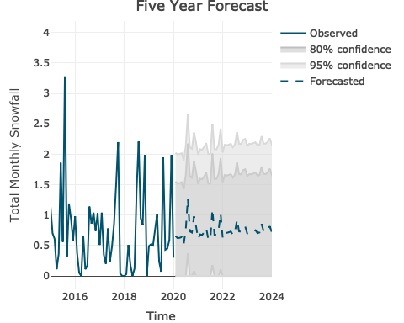

summary(PHX_TEMP_MODEL)

## Series: PHX_TS_TEMP   
## ARIMA(1,0,1)(0,1,1)[12]   
##   
## Coefficients:  
## ar1 ma1 sma1  
## 0.8697 -0.7030 -0.8868  
## s.e. 0.0808 0.1141 0.0317  
##   
## sigma^2 estimated as 6.478: log likelihood=-1391.36  
## AIC=2790.72 AICc=2790.79 BIC=2808.23  
##   
## Training set error measures:  
## ME RMSE MAE MPE MAPE MASE  
## Training set 0.3073631 2.513271 1.960212 0.3108707 2.743017 0.7300289  
## ACF1  
## Training set 0.02888133

## Point Forecast Lo 80 Hi 80 Lo 95 Hi 95  
## Jan 2020 56.63883 53.37691 59.90075 51.65016 61.62751  
## Feb 2020 59.86623 56.55929 63.17318 54.80870 64.92377  
## Mar 2020 67.41168 64.07109 70.75228 62.30268 72.52068  
## Apr 2020 74.38979 71.02396 77.75562 69.24220 79.53738  
## May 2020 81.51991 78.13512 84.90470 76.34332 86.69649  
## Jun 2020 92.89006 89.49100 96.28912 87.69164 98.08847  
## Jul 2020 95.80719 92.39738 99.21701 90.59233 101.02206  
## Aug 2020 94.43930 91.02137 97.85723 89.21203 99.66657  
## Sep 2020 89.26543 85.84138 92.68948 84.02879 94.50207  
## Oct 2020 77.53284 74.10417 80.96152 72.28913 82.77656  
## Nov 2020 65.71843 62.28626 69.15060 60.46937 70.96748  
## Dec 2020 55.96952 52.53470 59.40433 50.71642 61.22261  
## Jan 2021 56.81519 53.34613 60.28425 51.50972 62.12065  
## Feb 2021 60.01961 56.54671 63.49252 54.70826 65.33096  
## Mar 2021 67.54508 64.06927 71.02089 62.22928 72.86087  
## Apr 2021 74.50581 71.02780 77.98382 69.18665 79.82496  
## May 2021 81.62081 78.14114 85.10048 76.29911 86.94250  
## Jun 2021 92.97781 89.49689 96.45874 87.65420 98.30143  
## Jul 2021 95.88352 92.40164 99.36539 90.55845 101.20859  
## Aug 2021 94.50568 91.02309 97.98828 89.17952 99.83185  
## Sep 2021 89.32316 85.84003 92.80630 83.99617 94.65016  
## Oct 2021 77.58306 74.09951 81.06660 72.25543 82.91068  
## Nov 2021 65.76210 62.27824 69.24595 60.43400 71.09020  
## Dec 2021 56.00750 52.52340 59.49159 50.67904 61.33596  
## Jan 2022 56.84822 53.34074 60.35569 51.48400 62.21243  
## Feb 2022 60.04834 56.53966 63.55702 54.68227 65.41441  
## Mar 2022 67.57006 64.06047 71.07966 62.20260 72.93753  
## Apr 2022 74.52754 71.01725 78.03783 69.15901 79.89606  
## May 2022 81.63971 78.12890 85.15052 76.27038 87.00903  
## Jun 2022 92.99425 89.48304 96.50546 87.62432 98.36418  
## Jul 2022 95.89781 92.38630 99.40932 90.52742 101.26820  
## Aug 2022 94.51812 91.00638 98.02985 89.14738 99.88885  
## Sep 2022 89.33398 85.82207 92.84588 83.96298 94.70497  
## Oct 2022 77.59246 74.08042 81.10450 72.22126 82.96365  
## Nov 2022 65.77028 62.25814 69.28241 60.39893 71.14162  
## Dec 2022 56.01461 52.50240 59.52682 50.64315 61.38607  
## Jan 2023 56.85440 53.32072 60.38808 51.45011 62.25870  
## Feb 2023 60.05372 56.51916 63.58828 54.64808 65.45936  
## Mar 2023 67.57474 64.03952 71.10997 62.16809 72.98140  
## Apr 2023 74.53161 70.99588 78.06734 69.12418 79.93904  
## May 2023 81.64325 78.10714 85.17935 76.23524 87.05125  
## Jun 2023 92.99733 89.46094 96.53372 87.58888 98.40577  
## Jul 2023 95.90049 92.36388 99.43710 90.49171 101.30927  
## Aug 2023 94.52044 90.98367 98.05722 89.11141 99.92947  
## Sep 2023 89.33600 85.79910 92.87290 83.92678 94.74522  
## Oct 2023 77.59422 74.05723 81.13121 72.18486 83.00359  
## Nov 2023 65.77181 62.23474 69.30887 60.36234 71.18128  
## Dec 2023 56.01594 52.47883 59.55306 50.60639 61.42550  
## Jan 2024 56.85556 53.29744 60.41369 51.41388 62.29725  
## Feb 2024 60.05473 56.49578 63.61367 54.61179 65.49766  
## Mar 2024 67.57562 64.01606 71.13518 62.13174 73.01950  
## Apr 2024 74.53237 70.97234 78.09240 69.08777 79.97697  
## May 2024 81.64391 78.08353 85.20430 76.19877 87.08905  
## Jun 2024 92.99791 89.43725 96.55856 87.55236 98.44345  
## Jul 2024 95.90099 92.34014 99.46185 90.45513 101.34685  
## Aug 2024 94.52088 90.95987 98.08189 89.07479 99.96697  
## Sep 2024 89.33638 85.77526 92.89750 83.89011 94.78265  
## Oct 2024 77.59455 74.03334 81.15576 72.14815 83.04095  
## Nov 2024 65.77210 62.21082 69.33337 60.32559 71.21860  
## Dec 2024 56.01619 52.45486 59.57752 50.56961 61.46277

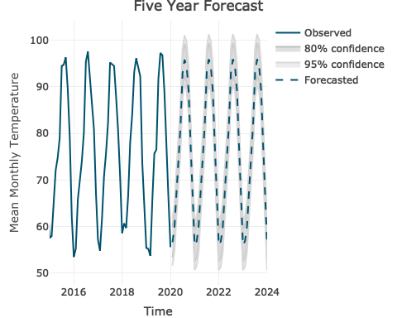

summary(PHX_PRCP_MODEL)

## Series: PHX_TS_PRCP   
## ARIMA(0,0,1)(2,0,0)[12] with non-zero mean   
##   
## Coefficients:  
## ma1 sar1 sar2 mean  
## 0.1171 0.0472 0.1386 0.6312  
## s.e. 0.0407 0.0407 0.0421 0.0452  
##   
## sigma^2 estimated as 0.6664: log likelihood=-727.87  
## AIC=1465.75 AICc=1465.85 BIC=1487.73  
##   
## Training set error measures:  
## ME RMSE MAE MPE MAPE MASE  
## Training set 0.0009709305 0.8136339 0.585541 -Inf Inf 0.8071127  
## ACF1  
## Training set 0.0002778747

## Point Forecast Lo 80 Hi 80 Lo 95 Hi 95  
## Jan 2020 0.5798413 -0.4663656 1.626048 -1.0201941 2.179877  
## Feb 2020 0.6705072 -0.3828475 1.723862 -0.9404598 2.281474  
## Mar 2020 0.5336917 -0.5196631 1.587046 -1.0772754 2.144659  
## Apr 2020 0.5182402 -0.5351146 1.571595 -1.0927269 2.129207  
## May 2020 0.5187120 -0.5346427 1.572067 -1.0922550 2.129679  
## Jun 2020 0.5139933 -0.5393614 1.567348 -1.0969737 2.124960  
## Jul 2020 0.6190045 -0.4343502 1.672359 -0.9919626 2.229972  
## Aug 2020 0.7331526 -0.3202021 1.786507 -0.8778145 2.344120  
## Sep 2020 0.5853693 -0.4679855 1.638724 -1.0255978 2.196336  
## Oct 2020 1.2552694 0.2019146 2.308624 -0.3556977 2.866236  
## Nov 2020 0.6356278 -0.4177269 1.688983 -0.9753393 2.246595  
## Dec 2020 0.5733499 -0.4800049 1.626705 -1.0376172 2.184317  
## Jan 2021 0.6438859 -0.4106250 1.698397 -0.9688494 2.256621  
## Feb 2021 0.7936483 -0.2608785 1.848175 -0.8191113 2.406408  
## Mar 2021 0.5807435 -0.4737833 1.635270 -1.0320161 2.193503  
## Apr 2021 0.5509176 -0.5036092 1.605444 -1.0618420 2.163677  
## May 2021 0.5523254 -0.5022014 1.606852 -1.0604342 2.165085  
## Jun 2021 0.5382471 -0.5162797 1.592774 -1.0745125 2.151007  
## Jul 2021 0.5667568 -0.4877700 1.621284 -1.0460027 2.179516  
## Aug 2021 0.5818421 -0.4726847 1.636369 -1.0309175 2.194602  
## Sep 2021 0.5762542 -0.4782726 1.630781 -1.0365054 2.189014  
## Oct 2021 0.5732257 -0.4813011 1.627752 -1.0395339 2.185985  
## Nov 2021 0.7587489 -0.2957779 1.813276 -0.8540107 2.371508  
## Dec 2021 0.6380374 -0.4164894 1.692564 -0.9747222 2.250797  
## Jan 2022 0.6247170 -0.4400461 1.689480 -1.0036977 2.253132  
## Feb 2022 0.6443462 -0.4205566 1.709249 -0.9842821 2.272974  
## Mar 2022 0.6153432 -0.4495596 1.680246 -1.0132851 2.243971  
## Apr 2022 0.6117949 -0.4531079 1.676698 -1.0168334 2.240423  
## May 2022 0.6119267 -0.4529761 1.676830 -1.0167016 2.240555  
## Jun 2022 0.6106086 -0.4542942 1.675511 -1.0180197 2.239237  
## Jul 2022 0.6265038 -0.4383990 1.691407 -1.0021245 2.255132  
## Aug 2022 0.6430316 -0.4218712 1.707934 -0.9855967 2.271660  
## Sep 2022 0.6222916 -0.4426112 1.687194 -1.0063367 2.250920  
## Oct 2022 0.7149676 -0.3499352 1.779870 -0.9136607 2.343596  
## Nov 2022 0.6378666 -0.4270362 1.702769 -0.9907617 2.266495  
## Dec 2022 0.6235416 -0.4413612 1.688444 -1.0050867 2.252170  
## Jan 2023 0.6326863 -0.4323058 1.697678 -0.9960786 2.261451  
## Feb 2023 0.6543630 -0.4106303 1.719356 -0.9744037 2.283130  
## Mar 2023 0.6234952 -0.4414982 1.688488 -1.0052716 2.252262  
## Apr 2023 0.6191952 -0.4457982 1.684188 -1.0095716 2.247962  
## May 2023 0.6193965 -0.4455969 1.684390 -1.0093703 2.248163  
## Jun 2023 0.6173836 -0.4476097 1.682377 -1.0113831 2.246150  
## Jul 2023 0.6220839 -0.4429095 1.687077 -1.0066829 2.250851  
## Aug 2023 0.6249539 -0.4400394 1.689947 -1.0038128 2.253721  
## Sep 2023 0.6232010 -0.4417923 1.688194 -1.0055657 2.251968  
## Oct 2023 0.6271545 -0.4378388 1.692148 -1.0016122 2.255921  
## Nov 2023 0.6492217 -0.4157716 1.714215 -0.9795450 2.277988  
## Dec 2023 0.6318205 -0.4331729 1.696814 -0.9969463 2.260587  
## Jan 2024 0.6304063 -0.4347952 1.695608 -0.9986788 2.259491  
## Feb 2024 0.6341489 -0.4310554 1.699353 -0.9949405 2.263238  
## Mar 2024 0.6286738 -0.4365305 1.693878 -1.0004156 2.257763  
## Apr 2024 0.6279793 -0.4372251 1.693184 -1.0011102 2.257069  
## May 2024 0.6280071 -0.4371973 1.693211 -1.0010824 2.257097  
## Jun 2024 0.6277294 -0.4374749 1.692934 -1.0013600 2.256819  
## Jul 2024 0.6301536 -0.4350507 1.695358 -0.9989359 2.259243  
## Aug 2024 0.6325791 -0.4326253 1.697783 -0.9965104 2.261669  
## Sep 2024 0.6296227 -0.4355816 1.694827 -0.9994668 2.258712  
## Oct 2024 0.6426501 -0.4225543 1.707854 -0.9864394 2.271740  
## Nov 2024 0.6330086 -0.4321958 1.698213 -0.9960809 2.262098  
## Dec 2024 0.6302026 -0.4350017 1.695407 -0.9988868 2.259292

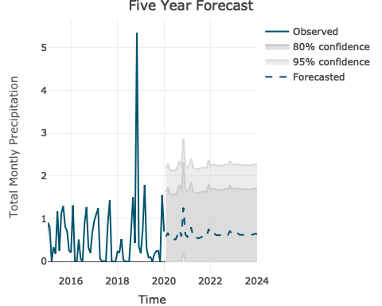

summary(SLC_TEMP_MODEL)

## Series: SLC_TS_TEMP   
## ARIMA(1,0,0)(2,1,0)[12]   
##   
## Coefficients:  
## ar1 sar1 sar2  
## 0.2713 -0.6424 -0.3172  
## s.e. 0.0400 0.0394 0.0394  
##   
## sigma^2 estimated as 13.39: log likelihood=-1598.62  
## AIC=3205.25 AICc=3205.32 BIC=3222.76  
##   
## Training set error measures:  
## ME RMSE MAE MPE MAPE MASE  
## Training set 0.08769661 3.613625 2.788469 -0.5184753 6.426822 0.7931266  
## ACF1  
## Training set 0.0005458417

# forecast using the SLC_TEMP_MODEL  
SLC_TEMP_CAST <- forecast(SLC_TEMP_MODEL, h=60)  
SLC_TEMP_CAST

## Point Forecast Lo 80 Hi 80 Lo 95 Hi 95  
## Jan 2020 32.28086 27.59082 36.97091 25.10806 39.45367  
## Feb 2020 37.99000 33.13046 42.84953 30.55798 45.42201  
## Mar 2020 46.05970 41.18793 50.93147 38.60897 53.51043  
## Apr 2020 52.89801 48.02534 57.77068 45.44590 60.35012  
## May 2020 61.27392 56.40118 66.14666 53.82171 68.72613  
## Jun 2020 74.26572 69.39298 79.13846 66.81351 81.71794  
## Jul 2020 83.46664 78.59390 88.33939 76.01443 90.91886  
## Aug 2020 79.82749 74.95475 84.70023 72.37528 87.27971  
## Sep 2020 68.59646 63.72372 73.46920 61.14424 76.04867  
## Oct 2020 50.07017 45.19743 54.94291 42.61795 57.52238  
## Nov 2020 41.88424 37.01150 46.75698 34.43202 49.33645  
## Dec 2020 32.46365 27.59091 37.33639 25.01143 39.91587  
## Jan 2021 33.40639 28.25303 38.55976 25.52500 41.28779  
## Feb 2021 37.26712 32.09370 42.44053 29.35506 45.17917  
## Mar 2021 44.87837 39.70348 50.05325 36.96406 52.79267  
## Apr 2021 53.62597 48.45097 58.80097 45.71150 61.54044  
## May 2021 60.94704 55.77203 66.12204 53.03255 68.86152  
## Jun 2021 73.55181 68.37681 78.72681 65.63732 81.46630  
## Jul 2021 82.96761 77.79261 88.14262 75.05313 90.88210  
## Aug 2021 79.40979 74.23478 84.58479 71.49530 87.32427  
## Sep 2021 69.11024 63.93524 74.28524 61.19575 77.02473  
## Oct 2021 49.60581 44.43081 54.78082 41.69133 57.52030  
## Nov 2021 40.31967 35.14466 45.49467 32.40518 48.23415  
## Dec 2021 32.46385 27.28884 37.63885 24.54936 40.37833  
## Jan 2022 32.03151 26.43727 37.62576 23.47585 40.58718  
## Feb 2022 36.65838 31.03452 42.28224 28.05743 45.25933  
## Mar 2022 44.51314 38.88710 50.13917 35.90886 53.11741  
## Apr 2022 53.04268 47.41649 58.66888 44.43816 61.64720  
## May 2022 59.94453 54.31832 65.57073 51.33999 68.54907  
## Jun 2022 72.92160 67.29539 78.54780 64.31706 81.52614  
## Jul 2022 82.94572 77.31951 88.57193 74.34118 91.55026  
## Aug 2022 79.87608 74.24987 85.50229 71.27154 88.48062  
## Sep 2022 68.51699 62.89078 74.14320 59.91245 77.12153  
## Oct 2022 48.66415 43.03794 54.29036 40.05961 57.26869  
## Nov 2022 40.93845 35.31224 46.56465 32.33391 49.54299  
## Dec 2022 32.77712 27.15091 38.40332 24.17258 41.38166  
## Jan 2023 32.55764 26.27629 38.83900 22.95114 42.16414  
## Feb 2023 37.27871 30.95183 43.60559 27.60258 46.95484  
## Mar 2023 45.12248 38.79226 51.45270 35.44124 54.80371  
## Apr 2023 53.18644 46.85598 59.51691 43.50483 62.86805  
## May 2023 60.69219 54.36170 67.02267 51.01055 70.37382  
## Jun 2023 73.55288 67.22240 79.88336 63.87124 83.23452  
## Jul 2023 83.11808 76.78760 89.44856 73.43644 92.79972  
## Aug 2023 79.70906 73.37857 86.03954 70.02742 89.39069  
## Sep 2023 68.73509 62.40461 75.06557 59.05345 78.41673  
## Oct 2023 49.41633 43.08585 55.74681 39.73469 59.09797  
## Nov 2023 41.03727 34.70679 47.36776 31.35563 50.71891  
## Dec 2023 32.57582 26.24534 38.90631 22.89419 42.25746  
## Jan 2024 32.65581 25.94673 39.36489 22.39516 42.91647  
## Feb 2024 37.07334 30.33724 43.80944 26.77136 47.37531  
## Mar 2024 44.84692 38.10884 51.58500 34.54191 55.15193  
## Apr 2024 53.27912 46.54089 60.01735 42.97389 63.58436  
## May 2024 60.52993 53.79169 67.26817 50.22468 70.83518  
## Jun 2024 73.34728 66.60904 80.08552 63.04203 83.65253  
## Jul 2024 83.01431 76.27607 89.75255 72.70906 93.31956  
## Aug 2024 79.66843 72.93019 86.40667 69.36318 89.97368  
## Sep 2024 68.78318 62.04494 75.52142 58.47793 79.08843  
## Oct 2024 49.23187 42.49363 55.97011 38.92662 59.53712  
## Nov 2024 40.77751 34.03927 47.51575 30.47226 51.08276  
## Dec 2024 32.60575 25.86751 39.34399 22.30050 42.91100

SLC_TEMP_CAST$lower<-apply(SLC_TEMP_CAST$lower, 2, function(x) ifelse(x < 0,0, x))  
plt <- plot_forecast(SLC_TEMP_CAST, title = "Five Year Forecast",   
 Ytitle = "Mean Monthly Temperature",  
 Xtitle = "Time") %>% layout(  
 xaxis = list(range=c(2015, 2024))  
)  
plt

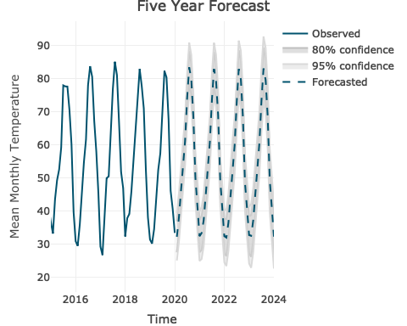

summary(SLC_PRCP_MODEL)

## Series: SLC_TS_PRCP   
## ARIMA(0,0,2)(2,0,0)[12] with non-zero mean   
##   
## Coefficients:  
## ma1 ma2 sar1 sar2 mean  
## 0.0992 0.0644 0.1200 0.2225 1.3433  
## s.e. 0.0427 0.0413 0.0409 0.0410 0.0676  
##   
## sigma^2 estimated as 0.9138: log likelihood=-822.58  
## AIC=1657.16 AICc=1657.3 BIC=1683.54  
##   
## Training set error measures:  
## ME RMSE MAE MPE MAPE MASE  
## Training set -0.003096505 0.951948 0.728056 -Inf Inf 0.7655113  
## ACF1  
## Training set -0.003142553

## Point Forecast Lo 80 Hi 80 Lo 95 Hi 95  
## Jan 2020 1.3207779 0.095692302 2.545863 -0.55282884 3.194385  
## Feb 2020 1.3006836 0.069581710 2.531786 -0.58212429 3.183492  
## Mar 2020 1.9325774 0.698948731 3.166206 0.04590516 3.819250  
## Apr 2020 1.7222880 0.488659348 2.955917 -0.16438422 3.608960  
## May 2020 1.6172792 0.383650521 2.850908 -0.26939305 3.503951  
## Jun 2020 0.9123293 -0.321299406 2.145958 -0.97434298 2.799001  
## Jul 2020 0.9746879 -0.258940796 2.208317 -0.91198437 2.861360  
## Aug 2020 1.0532638 -0.180364838 2.286892 -0.83340841 2.939936  
## Sep 2020 1.0692557 -0.164372950 2.302884 -0.81741652 2.955928  
## Oct 2020 1.4982512 0.264622488 2.731880 -0.38842108 3.384923  
## Nov 2020 1.2594851 0.025856452 2.493114 -0.62718712 3.146157  
## Dec 2020 1.3636505 0.130021860 2.597279 -0.52302171 3.250323  
## Jan 2021 1.4333295 0.190966923 2.675692 -0.46670012 3.333359  
## Feb 2021 1.3196707 0.077222358 2.562119 -0.58049005 3.219831  
## Mar 2021 1.9962539 0.753769468 3.238738 0.09603795 3.896470  
## Apr 2021 1.8575397 0.615055293 3.100024 -0.04267623 3.757756  
## May 2021 1.9183577 0.675873307 3.160842 0.01814179 3.818574  
## Jun 2021 1.0260860 -0.216398431 2.268570 -0.87412995 2.926302  
## Jul 2021 1.0914196 -0.151064767 2.333904 -0.80879629 2.991636  
## Aug 2021 1.1186511 -0.123833289 2.361136 -0.78156481 3.018867  
## Sep 2021 1.3564140 0.113929604 2.598898 -0.54380192 3.256630  
## Oct 2021 1.1720659 -0.070418556 2.414550 -0.72815008 3.072282  
## Nov 2021 1.2947009 0.052216489 2.537185 -0.60551503 3.194917  
## Dec 2021 1.4095516 0.167067228 2.652036 -0.49066429 3.309768  
## Jan 2022 1.3491157 0.073185263 2.625046 -0.60225152 3.300483  
## Feb 2022 1.3310017 0.054746249 2.607257 -0.62086255 3.282866  
## Mar 2022 1.5528087 0.276416382 2.829201 -0.39926490 3.504882  
## Apr 2022 1.4893699 0.212977559 2.765762 -0.46270372 3.441443  
## May 2022 1.4733065 0.196914143 2.749699 -0.47876714 3.425380  
## Jun 2022 1.2093544 -0.067037949 2.485747 -0.74271923 3.161428  
## Jul 2022 1.2310712 -0.045321127 2.507464 -0.72100241 3.183145  
## Aug 2022 1.2518226 -0.024569703 2.528215 -0.70025099 3.203896  
## Sep 2022 1.2839209 0.007528623 2.560313 -0.66815266 3.235995  
## Oct 2022 1.3572412 0.080848877 2.633634 -0.59483241 3.309315  
## Nov 2022 1.3188380 0.042445632 2.595230 -0.63323565 3.270912  
## Dec 2022 1.3558004 0.079408059 2.632193 -0.59627322 3.307874  
## Jan 2023 1.3640490 0.085870123 2.642228 -0.59075690 3.318855  
## Feb 2023 1.3365863 0.058389817 2.614783 -0.61824652 3.291419  
## Mar 2023 1.5137467 0.235542837 2.791951 -0.44109742 3.468591  
## Apr 2023 1.4752687 0.197064836 2.753473 -0.47957542 3.430113  
## May 2023 1.4868721 0.208668262 2.765076 -0.46797199 3.441716  
## Jun 2023 1.2566634 -0.021540438 2.534867 -0.69818069 3.211508  
## Jul 2023 1.2738066 -0.004397300 2.552010 -0.68103755 3.228651  
## Aug 2023 1.2823563 0.004152460 2.560560 -0.67248779 3.237200  
## Sep 2023 1.3391100 0.060906169 2.617314 -0.61573409 3.293954  
## Oct 2023 1.3068948 0.028690980 2.585099 -0.64794927 3.261739  
## Nov 2023 1.3295706 0.051366708 2.607774 -0.62527355 3.284415  
## Dec 2023 1.3595610 0.081357111 2.637765 -0.59528314 3.314405  
## Jan 2024 1.3471045 0.066835823 2.627373 -0.61089748 3.305106  
## Feb 2024 1.3397777 0.059488715 2.620067 -0.61825534 3.297811  
## Mar 2024 1.4103941 0.130096541 2.690692 -0.54765204 3.368440  
## Apr 2024 1.3916606 0.111363039 2.671958 -0.56638555 3.349707  
## May 2024 1.3894794 0.109181866 2.669777 -0.56856672 3.347526  
## Jun 2024 1.3031183 0.022820745 2.583416 -0.65492784 3.261164  
## Jul 2024 1.3100080 0.029710403 2.590306 -0.64803818 3.268054  
## Aug 2024 1.3156513 0.035353747 2.595949 -0.64239484 3.273697  
## Sep 2024 1.3296055 0.049307939 2.609903 -0.62844065 3.287652  
## Oct 2024 1.3420518 0.061754231 2.622349 -0.61599435 3.300098  
## Nov 2024 1.3362292 0.055931669 2.616527 -0.62181692 3.294275  
## Dec 2024 1.3480531 0.067755518 2.628351 -0.60999307 3.306099

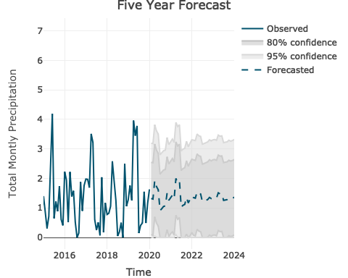

summary(SLC_SNOW_MODEL)

## Series: SLC_TS_SNOW   
## ARIMA(1,0,0)(2,0,0)[12] with non-zero mean   
##   
## Coefficients:  
## ar1 sar1 sar2 mean  
## 0.1314 0.2674 0.3209 4.7125  
## s.e. 0.0446 0.0396 0.0404 0.6701  
##   
## sigma^2 estimated as 37.76: log likelihood=-1941.02  
## AIC=3892.05 AICc=3892.15 BIC=3914.03  
##   
## Training set error measures:  
## ME RMSE MAE MPE MAPE MASE ACF1  
## Training set -0.0161987 6.124065 3.953661 -Inf Inf 0.9385355 -0.003045899

## Point Forecast Lo 80 Hi 80 Lo 95 Hi 95  
## Jan 2020 6.097223 -1.7773752 13.971821 -5.945936 18.14038  
## Feb 2020 10.155847 2.2136003 18.098093 -1.990771 22.30246  
## Mar 2020 8.159159 0.2157501 16.102568 -3.989236 20.30755  
## Apr 2020 2.441105 -5.5023240 10.384534 -9.707321 14.58953  
## May 2020 1.939713 -6.0037157 9.883143 -10.208713 14.08814  
## Jun 2020 1.939891 -6.0035376 9.883321 -10.208535 14.08832  
## Jul 2020 1.939915 -6.0035143 9.883344 -10.208512 14.08834  
## Aug 2020 1.939918 -6.0035112 9.883347 -10.208509 14.08834  
## Sep 2020 1.939918 -6.0035108 9.883348 -10.208508 14.08834  
## Oct 2020 1.939918 -6.0035107 9.883348 -10.208508 14.08834  
## Nov 2020 5.213411 -2.7300179 13.156840 -6.935015 17.36184  
## Dec 2020 6.897882 -1.0455468 14.841311 -5.250544 19.04631  
## Jan 2021 5.688534 -2.5293418 13.906410 -6.879622 18.25669  
## Feb 2021 9.116560 0.8940287 17.339091 -3.458716 21.69184  
## Mar 2021 7.555676 -0.6669351 15.778288 -5.019723 20.13108  
## Apr 2021 2.656966 -5.5656469 10.879579 -9.918435 15.23237  
## May 2021 2.458690 -5.7639225 10.681303 -10.116711 15.03409  
## Jun 2021 2.458738 -5.7638749 10.681351 -10.116663 15.03414  
## Jul 2021 2.458744 -5.7638687 10.681357 -10.116657 15.03415  
## Aug 2021 2.458745 -5.7638678 10.681358 -10.116656 15.03415  
## Sep 2021 2.458745 -5.7638677 10.681358 -10.116656 15.03415  
## Oct 2021 2.458745 -5.7638677 10.681358 -10.116656 15.03415  
## Nov 2021 6.607394 -1.6152189 14.830007 -5.968007 19.18279  
## Dec 2021 4.651166 -3.5714470 12.873779 -7.924235 17.22657  
## Jan 2022 5.417891 -3.3662253 14.202007 -8.016255 18.85204  
## Feb 2022 7.637113 -1.1563772 16.430603 -5.811370 21.08560  
## Mar 2022 6.578925 -2.2147270 15.372577 -6.869805 20.02766  
## Apr 2022 3.433864 -5.3597911 12.227518 -10.014871 16.88260  
## May 2022 3.219940 -5.5737151 12.013595 -10.228795 16.66867  
## Jun 2022 3.220010 -5.5736452 12.013664 -10.228725 16.66874  
## Jul 2022 3.220019 -5.5736360 12.013674 -10.228716 16.66875  
## Aug 2022 3.220020 -5.5736348 12.013675 -10.228715 16.66875  
## Sep 2022 3.220020 -5.5736347 12.013675 -10.228714 16.66875  
## Oct 2022 3.220020 -5.5736346 12.013675 -10.228714 16.66875  
## Nov 2022 5.380024 -3.4136306 14.173679 -8.068710 18.82876  
## Dec 2022 5.397379 -3.3962756 14.191034 -8.051355 18.84611  
## Jan 2023 5.214360 -3.7066959 14.135417 -8.429218 18.85794  
## Feb 2023 6.907933 -2.0153054 15.831172 -6.738983 20.55485  
## Mar 2023 6.124039 -2.7992376 15.047315 -7.522935 19.77101  
## Apr 2023 3.710913 -5.2123645 12.634190 -9.936062 17.35789  
## May 2023 3.590073 -5.3332042 12.513350 -10.056902 17.23705  
## Jun 2023 3.590107 -5.3331702 12.513384 -10.056868 17.23708  
## Jul 2023 3.590111 -5.3331658 12.513388 -10.056863 17.23709  
## Aug 2023 3.590112 -5.3331652 12.513389 -10.056863 17.23709  
## Sep 2023 3.590112 -5.3331651 12.513389 -10.056863 17.23709  
## Oct 2023 3.590112 -5.3331651 12.513389 -10.056863 17.23709  
## Nov 2023 5.499094 -3.4241835 14.422371 -8.147881 19.14607  
## Dec 2023 4.875985 -4.0472918 13.799262 -8.770989 18.52296  
## Jan 2024 5.073078 -3.9583397 14.104495 -8.739283 18.88544  
## Feb 2024 6.238164 -2.7951080 15.271436 -7.577033 20.05336  
## Mar 2024 5.688943 -3.3443613 14.722247 -8.126304 19.50419  
## Apr 2024 4.034314 -4.9989911 13.067618 -9.780934 17.84956  
## May 2024 3.933348 -5.0999571 12.966652 -9.881900 17.74859  
## Jun 2024 3.933379 -5.0999256 12.966684 -9.881868 17.74863  
## Jul 2024 3.933383 -5.0999215 12.966688 -9.881864 17.74863  
## Aug 2024 3.933384 -5.0999210 12.966688 -9.881864 17.74863  
## Sep 2024 3.933384 -5.0999209 12.966689 -9.881864 17.74863  
## Oct 2024 3.933384 -5.0999209 12.966689 -9.881864 17.74863  
## Nov 2024 5.137078 -3.8962270 14.170382 -8.678170 18.95233  
## Dec 2024 4.975998 -4.0573066 14.009303 -8.839249 18.79125

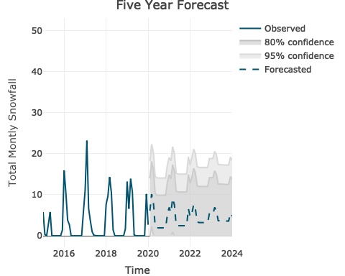

### Conclusion