Ben Karabinus

Professor Segall

CIS 3145

13 November 2019

Chapter 22 Exercise 3 Output

**Step 3 Output:**

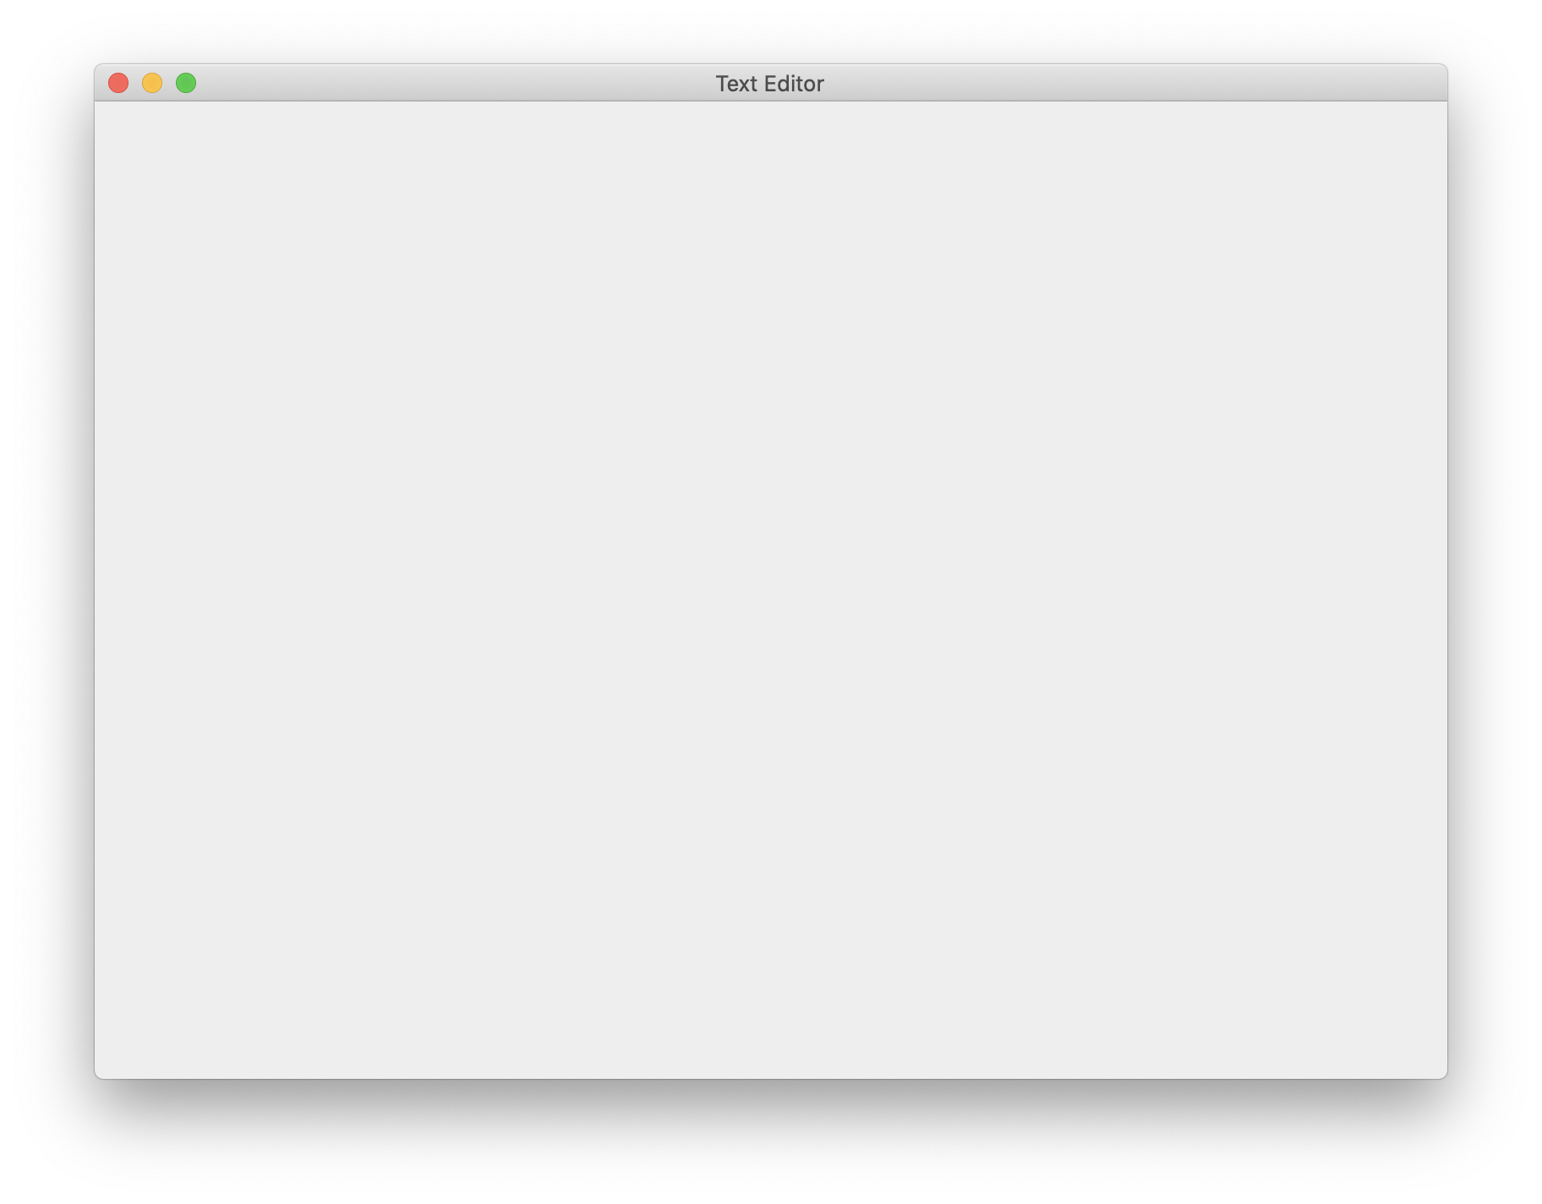

**Step 7 Output:**

Window

The Console

100.0|200.0|20,000.000|600.000

300.0|400.0|120,000.000|1,400.000

100.0|50.0|5,000.000|300.000

100.0|75.0|7,500.000|350.000

4.0|4.0|16.000|16.000

The file was saved!

100.0|200.0|20,000.000|600.000

300.0|400.0|120,000.000|1,400.000

100.0|50.0|5,000.000|300.000

100.0|75.0|7,500.000|350.000

4.0|4.0|16.000|16.000

**Step 12 Output:**

**Step 14 Output:**

