|  |  |
| --- | --- |
| **Project Case** |  |
| COMP7116  Computer Vision |
| **Computer Science** | **E192-COMP7116-BO01-00** |
| ***Valid on*** *Even Semester Year 2018/2019* | **Revision 00** |

1. Seluruh kelompok tidak diperkenankan untuk:

*The whole group is not allowed to:*

* + - Melihat sebagian atau seluruh proyek kelompok lain,

*Seeing a part or the whole project from other groups*

* + - Menyadur sebagian maupun seluruh proyek dari buku,

*Adapted a part or the whole project from the book*

* + - Mendownload sebagian maupun seluruh proyek dari internet,

*Downloading a part or the whole project from the internet,*

* + - Mengerjakan soal yang tidak sesuai dengan tema yang ada di soal proyek,

*Working with another theme which is not in accordance with the existing theme in the matter of the project,*

* + - Melakukan tindakan kecurangan lainnya,

*Committing other dishonest actions,*

* + - Secara sengaja maupun tidak sengaja melakukan segala tindakan kelalaian yang menyebabkan hasil karyanya berhasil dicontek oleh orang lain / kelompok lain.

*Accidentally or intentionally conduct any failure action that cause the results of the project was copied by someone else / other groups.*

1. Jika kelompok terbukti melakukan tindakan seperti yang dijelaskan butir 1 di atas, maka **nilai kelompok** yang melakukan kecurangan (menyontek maupun dicontek) akan di – **NOL** – kan.

*If the group is proved to the actions described in point 1 above, the score of the group which committed dishonest acts (cheating or being cheated) will be “Zero”*

1. Perhatikan jadwal pengumpulan proyek, segala jenis pengumpulan proyek di luar jadwal tidak dilayani.

*Pay attention to the submission schedule for the project, all kinds of submission outside the project schedule will not be accepted*

1. Jangan lupa untuk melihat kriteria penilaian proyek yang ditempel di papan pengumuman, atau tanya asisten anda.

*Don’t forget to look at the project assessment criteria that posted on the announcement board, or ask your teaching assistant.*

1. Persentase penilaiaan untuk matakuliah ini adalah sebagai berikut:

*Marking percentage for this subject is described as follows:*

|  |  |  |
| --- | --- | --- |
| **Tugas Mandiri**  *Assignment* | **Proyek**  *Project* | **UAP**  *Final Exam* |
| 40% | 60% | - |

1. Software yang digunakan pada matakuliah ini adalah sebagai berikut:

*Software will be used in this subject are described as follows:*

|  |
| --- |
| **Software**  *Software* |
| Microsoft Visual Studio Code  Python 3.6  Scipy  OpenCV 3.4.5 |

## Ekstensi file yang harus disertakan dalam pengumpulan tugas mandiri dan proyek untuk matakuliah ini adalah sebagai berikut:

*File extensions should be included in assignment and project collection for this subject are described as follows:*

|  |  |
| --- | --- |
| **Tugas Mandiri**  *Assignment* | **Proyek**  *Project* |
| PY | PY |

## Soal

*Case*

**Boogle**

**Boogle** is a new company that focuses on developing application with **Artificial Intelligence** concept,especially **Computer Vision**. **Boogle** wants to add a new computer vision feature to some applications which are already developed. This feature will allow the applications to detect and recognize every user based on **profile** **image** with **single face** which have been uploaded to the developed applications. Therefore, as a programmer in **Boogle**, you are asked to create that feature using **Python programming language** and **OpenCv Library**.

* **Dataset Description**

The given dataset contains **training dataset** consisting of **2,572 profile images** of **1**,**151 users** that already uploaded from the applications that already developed by **Boogle** and **testing images** consisting of **5** **random user**’**s profile images**.

* **Get Training Images Classes**

The directories of the **given training dataset** will be stored into a **list** containing the **names of directories**. This list will also be used as the **labels** of the training images.

* **Get Training Images Path**

The **path of training images** will be stored into a **list** of **image path** and **image classes id**.

* **Get Training Images Data**

The **image data** will be stored into a **list** of **images**.

* **Detect Faces and Filter**

**Faces** inside the **training** **images** will be **detected** and stored into a **list** of **images**. The **position** and **size** of the **detected faces** will also be stored into a **list** of **rectangles**. You also need to **filter** the training images if there are **no face or more than one face detected**.

* **Training Data**

The list of **face images** which are already detected will be used to train **face recognition classifier**.

* **Get Training Images Path**

The **path of testing images** will be stored into a **list** of **image path**.

* **Get Testing Images Data**

The **chosen testing images** will be **loaded** and **stored**.

* **Detect Faces and Filter the Testing Images**

**Faces** inside the **testing** **images** will be **detected** and stored into a **list** of **images**. The **position** and **size** of the **detected faces** will also be stored into a **list** of **rectangles**. You also need to **filter** the testing images if there are **no face or more than one face detected**.

* **Predict Testing Images**

The **list** of **testing images** will be **predicted** to **produce** the **prediction results** based on the **trained** **classifier** above.

* **Draw Prediction Results**

The **prediction results** which consist of the **predicted** **names** of the **users** will be **drawn** to every **testing image**. The **rectangle** **around the face** **stored** in the previous step will also be **drawn** together.

* **Combine Testing Image**

**List** of **testing images** that has been drawn will be **combined** onto a **single image**.

* **Show Result**

The **testing images** that have been **drawn** and **combined** will be **shown**.

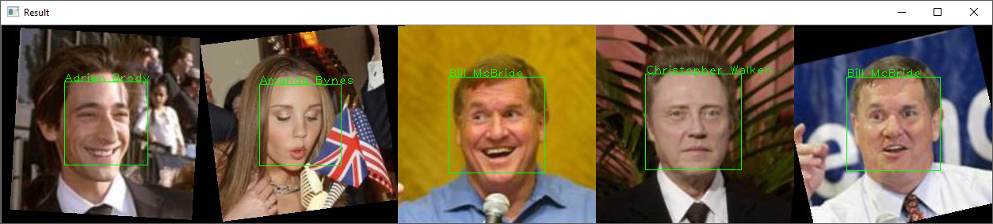

**Guidelines:**

1. **All** the **steps mentioned in the case** should be **put** in the **corresponding function** in the **template**. **All codes written** **outside** the **corresponding function** will **not be marked**.
2. Do not **modify** or **erase** **any** **codes** in the **template**.

**Reference:**

* + - The dataset is obtained from Kaggle dataset that was created and maintained by researcher at the University of Massachusetts, Amherst (https://www.kaggle.com/jessicali9530/lfw-dataset/home). The dataset has been modified for the purpose of this case.