Raytracing algorithm
Leonid Benkevitch, Igor Sokolov

Introduction
Solar radioastronomy deals with electromagnetic waves traveling in the media with non-uniformly distributed index of refraction. The ray trajectories in solar corona are far from straight lines for the frequencies below ~200 MHz. In order to simulate a radiotelescope solar image one needs to calculate the trajectories of the rays that make up the sun pixel image. In this work a raytracing algorithm is presented. It allows to calculate ray trajectories in space plasmas with specified density distribution.
In order to find an electromagnetic ray trajectory in non-uniform plasma one needs to know the distribution of index of refraction $n\left(r,ω\right)$, which is the square root of dielectric permittivity$ϵ$:
$n=\sqrt{ϵ}$ | (1)
Here r is the position vector: $r=\left\|x,y,z\right\|$in Cartesian coordinates, and is angular frequency of the wave. The index of refraction can be calculated from the plasma density distribution $ρ\left(r\right)$. For plasma,
$ϵ=1−\frac{ω_{p}^{2}}{ω^{2}}$ | (2)
where $ω_{p}$is the plasma frequency:
$ω_{p}=\sqrt{\frac{4πe^{2}n_{e}}{m_{e}}}$ | (3)

The plasma density $ρ=m_{p}n_{e}$ at which the electromagnetic wave frequency equals the plasma frequency is called the critical density $ρ_{cr}$. For the critical density the plasma dielectric constant and hence index of refraction are zero. The dielectric constant depends on density as follows:
$ϵ=1−\frac{ω_{p}^{2}}{ω^{2}}=1−\frac{4πn_{e}e^{2}}{m_{e}ω^{2}}=1−\frac{1}{\frac{m_{e}ω^{2}}{4πn_{e}e^{2}}}=1−\frac{m_{p}n_{e}}{\frac{m_{p}m_{e}ω^{2}}{4πe^{2}}}=1−\frac{ρ}{ρ_{cr}}$.
Thus, the dielectric permittivity can be expressed via the critical density,
$ϵ=1−\frac{ρ}{ρ_{cr}}$ | (4)

and the gradient of dielectric permittivity is rendered as
$∇ϵ=−\frac{∇ρ}{ρ_{cr}}$ | (5)
The gradient of the index of refraction can be expressed through the permittivity as
$∇n=∇\sqrt{ϵ}=\frac{∇ϵ}{2\sqrt{ϵ}}$ | (6)

The relative gradient of the index of refraction, which will be required for the algorithm further, is:
$\frac{∇n}{n}=\frac{∇ϵ}{2n\sqrt{ϵ}}=\frac{∇ϵ}{2\sqrt{ϵ}\sqrt{ϵ}}=\frac{∇ϵ}{2ϵ}$,
or
$\frac{∇n}{n}=\frac{∇ϵ}{2ϵ}$ | (7)

Equation for ray trajectory
For electromagnetic wave ray trajectories the Lagrange principle cannot be applied. However, there exists an analogous Fermat principle. It states that the light ray will choose the path along which the index of refraction reaches minimum values, or
$δ\int_{P_{1}}^{P_{2}}{nds}=0$ | (8)

where means variation. The integrand can be transformed so that it had a Lagrangian form. Introduce a parameter . The parametric trajectory equation then is$x=x\left(τ\right);y=y\left(τ\right);z=z\left(τ\right)$.
Notice that here the is a time-like variable, but it is not time. Then the ray path element squared is
${ds}^{2}={dx}^{2}+{dy}^{2}+{dz}^{2}=\left(\frac{{dx}^{2}}{dτ^{2}}+\frac{{dx}^{2}}{dτ^{2}}+\frac{{dx}^{2}}{dτ^{2}}\right)dτ^{2}=\left(\overset{˙}{x^{2}}+\overset{˙}{y^{2}}+\overset{˙}{z^{2}}\right)dτ^{2}$ | (9)
or
$ds=\sqrt{\overset{˙}{r}⋅\overset{˙}{r}}dτ$ | (10)
Substitute ds into the Fermat integral (8):
$δ\int_{P_{1}}^{P_{2}}{n\sqrt{\overset{˙}{r}⋅\overset{˙}{r}}}dt=0$ | (11)
Now the integrand has the Lagrangian format,
$L=L\left(r,\overset{˙}{r},τ\right)=n\left(r\right)\sqrt{\overset{˙}{r}⋅\overset{˙}{r}}$ | (12)
and we can utilize the Euler-Lagrange method to find the differential equation of the ray trajectory satisfying the variation minimum condition. The minimum of the variation is reached at the solution to the Euler-Lagrange equation:
$\frac{d}{dτ}\left(\frac{∂L}{∂\overset{˙}{r}}\right)−\frac{∂L}{∂r}=0$ | (13)
Find the partial derivatives to substitute into the equation.
$\frac{∂L}{∂\overset{˙}{r}}=n\left(r\right)\frac{∂}{∂\overset{˙}{r}}{\left(\overset{˙}{r}⋅\overset{˙}{r}\right)}^{1/2}=\frac{n\left(r\right)\frac{dr}{dτ}}{\sqrt{\frac{dr}{dτ}⋅\frac{dr}{dτ}}}=\frac{n\left(r\right)dr}{\sqrt{\frac{dr}{dτ}⋅\frac{dr}{dτ}}dτ}=n\left(r\right)\frac{dr}{ds}$, | (14)
$\frac{∂L}{∂r}=\frac{∂n\left(r\right)}{∂r}\sqrt{\overset{˙}{r}⋅\overset{˙}{r}}=∇n\sqrt{\overset{˙}{r}⋅\overset{˙}{r}}=∇n\frac{ds}{dτ}$. | (15)
Substituting the derivatives from (14) and (15) in (13) yields the equation for the ray trajectory
$\frac{d}{ds}\left(n\frac{dr}{ds}\right)−∇n=0$. | (16)
Reduce it to a more convenient form. Notice that in Cartesian coordinates
$\frac{dn}{ds}=\frac{∂n}{∂x}\frac{dx}{ds}+\frac{∂n}{∂y}\frac{dy}{ds}+\frac{∂n}{∂z}\frac{dz}{ds}=∇n⋅\frac{dr}{ds}$, | (17)

therefore the first term on the LHS of (16) can be rendered as
$\frac{d}{ds}\left(n\frac{dr}{ds}\right)=\frac{dr}{ds}\left(\frac{dr}{ds}⋅∇n\right)+n\frac{d^{2}r}{ds^{2}}$ | (18)

Using the identity $B\left(A⋅C\right)−C\left(A⋅B\right)=A×\left(B×C\right)$, make conversion

$\frac{dr}{ds}\left(\frac{dr}{ds}⋅∇n\right)=∇n\left(\frac{dr}{ds}⋅\frac{dr}{ds}\right)+\frac{dr}{ds}×\left(\frac{dr}{ds}×∇n\right)=∇n+\frac{dr}{ds}×\left(\frac{dr}{ds}×∇n\right)$

and substitute the RHS in (16):
$\frac{d}{ds}\left(n\frac{dr}{ds}\right)−∇n=∇n+\frac{dr}{ds}×\left(\frac{dr}{ds}×∇n\right)+n\frac{d^{2}r}{ds^{2}}−∇n=0$, whence
$−\frac{dr}{ds}×\left(∇n×\frac{dr}{ds}\right)+n\frac{d^{2}r}{ds^{2}}=0$.

Dividing the latter by n yields the result as a system of 3 differential equation of the second order. This system describes the position vector$r$of a ray traveling in a medium with arbitrary distribution of the index of refraction.
$\frac{d^{2}r}{{ds}^{2}}=\frac{dr}{ds}×\left(\frac{∇n}{n}×\frac{dr}{ds}\right)$ | (19)

The raytracing algorithm developed here is based on Eq. (19).
In order to represent the system in the form of 6 equations of the first order, introduce the vector of ray direction, $v={dr}/{ds}$. The system now has 6 variables, 3 components of the position vector r and 3 components of the direction vector v:

$\frac{dr}{ds}=v$ | (20a)
$\frac{dv}{ds}=v×\left(\frac{∇n}{n}×v\right)$ | (20b)

The quantity$v^{2}$is obviously conserved along the ray path and it is always 1:
$v^{2}={\left(\frac{dr}{ds}\right)}^{2}=\frac{dx^{2}+dy^{2}+dz^{2}}{ds^{2}}={\left(\frac{ds}{ds}\right)}^{2}=1$ | (21)

Modified Boris' algorithm
The calculation of a ray trajectory is based on an original algorithm developed as a modification of the Boris' implementation of the explicit Crank-Nicholson scheme for calculation of charged particle motion in magnetic field (see [1]). The Boris' CYLRAD algorithm ensures conservation of the velocity squared $v^{2}$. In our algorithm we use ray direction (or slope)$v={dr}/{ds}$, where${ds}^{2}={dx}^{2}+{dy}^{2}+{dz}^{2}$, instead of a particle velocity$v={dr}/{dt}$, and ray curvature $Ω$instead of magnetic field B. Analogously, the square of direction vector$v^{2}=1$is also conserved in the course of numerical integration.
A “leapfrog” difference scheme is used, where the half-step points are used in calculations. Suppose a ray at a particular moment has its end position$r_{0}$and direction$v_{0}$. The scheme below provides formulae to calculate its successive position $r_{1}$ and direction $v_{1}$after the step $ds$. The variables subscripted with the ½ are intermediate and they are related to the middle of the step ${ds}/2$. Note that the density and its gradient calculation is performed only once for each step at the step middle point so the$\frac{∇n}{n}$ratio is attributed to the grid point (i+1/2). The raytracing algorithm has five steps:
1.$r_{1/2}=r_{0}+v_{0}\frac{ds}{2}$ | (22a)
2.$Ω_{0}={\left(\frac{∇n}{n}\right)}_{\frac{1}{2}}×v_{0}\frac{ds}{2}$ | (22b)
3.$Ω_{1/2}={\left(\frac{∇n}{n}\right)}_{\frac{1}{2}}×\left(v_{0}+v_{0}×Ω_{0}\right)\frac{ds}{2}$ | (22c)
4.$v_{1}=v_{0}+\frac{2}{1+{\left|Ω_{1/2}\right|}^{2}}\left(v_{0}+v_{0}×Ω_{1/2}\right)×Ω_{1/2}$ | (22d)
5.$r_{1}=r_{1/2}+v_{1}\frac{ds}{2}$ | (22e)

The derivation of raytracing algorithm (22) is provided below.
In (22b) denote
$Ω=\frac{∇n}{n}×v$ | (23)
to rewrite it as
$\frac{dv}{ds}=v×Ω$. | (24)
In order to build a difference scheme consider a discrete grid whose points with respect to some i-th position are numbered as ... (i-1), (i-1/2), (i), (i+1/2), (i+1),... and so forth. We subscribe a variable with 0 if its value is taken at i-th point, with (½) for (i+1/2)-th point, and with 1 for (i+1)-th point. Thus differential Eq. (24) can be approximated by differences as
$\frac{v_{1}−v_{0}}{ds}=v_{1/2}×Ω$. | (25)
Since we do not know $v_{1/2}$, it can be approximated by the mean of $v_{1}$and$v_{0}$as
$\frac{v_{1}−v_{0}}{ds}=\frac{1}{2}\left(v_{1}+v_{0}\right)×Ω$, or

$v_{1}−v_{0}=\left(v_{1}+v_{0}\right)×Ω\frac{ds}{2}$ | (26)
Eq. (26) has the form of implicit Crank-Nicholson scheme. Convert this scheme into the explicit form where $v_{1}$is expressed via$v_{0}$. To do this we first derive one useful relationship from (26). Multiply (as scalar product) both sides of Eq. (26) by$Ω$:
$v_{1}⋅Ω−v_{0}⋅Ω=\left(v_{1}+v_{0}\right)×Ω⋅Ω\frac{ds}{2}$.
The mixed product on the right hand side can be reformed according to the identity $A×B⋅C=A⋅B×C$to show it is identical to zero because of the cross-product of two equal vectors:
$v_{1}⋅Ω−v_{0}⋅Ω=\left(v_{1}+v_{0}\right)⋅Ω×Ω\frac{ds}{2}=0$.
Hence the property
$v_{1}⋅Ω=v_{0}⋅Ω$, | (27)

which will be used later in this derivation. Now substitute$v_{1}$from Eq. (26)into itself:
$v_{1}=v_{0}+\left(v_{1}+v_{0}\right)×Ω\frac{ds}{2}=v_{0}+\left(v_{0}+\left(v_{1}+v_{0}\right)×Ω\frac{ds}{2}+v_{0}\right)×Ω\frac{ds}{2}$; it gives
$v_{1}=v_{0}+2v_{0}×Ω\frac{ds}{2}+\left(\left(v_{1}+v_{0}\right)×Ω\frac{ds}{2}\right)×Ω\frac{ds}{2}$. | (28)

Replace$v_{0}$in Eq. (28) by the identical expression
$v_{0}=v_{0}\left(1+{\left(Ω\frac{ds}{2}\right)}^{2}−{\left(Ω\frac{ds}{2}\right)}^{2}\right)$:
$v_{1}=v_{0}\left(1+{\left(Ω\frac{ds}{2}\right)}^{2}−{\left(Ω\frac{ds}{2}\right)}^{2}\right)+2v_{0}×Ω\frac{ds}{2}+\left(\left(v_{1}+v_{0}\right)×Ω\frac{ds}{2}\right)×Ω\frac{ds}{2}$,
then expand it:
$v_{1}=v_{0}+v_{0}{\left(Ω\frac{ds}{2}\right)}^{2}−v_{0}{\left(Ω\frac{ds}{2}\right)}^{2}+2v_{0}×Ω\frac{ds}{2}+\left(\left(v_{1}+v_{0}\right)×Ω\frac{ds}{2}\right)×Ω\frac{ds}{2}$;
$v_{1}=v_{0}+v_{0}{\left(Ω\frac{ds}{2}\right)}^{2}−v_{0}{\left(Ω\frac{ds}{2}\right)}^{2}+2v_{0}×Ω\frac{ds}{2}+\left(v_{1}×Ω\frac{ds}{2}\right)×Ω\frac{ds}{2}+\left(v_{0}×Ω\frac{ds}{2}\right)×Ω\frac{ds}{2}$ | (29)

Using the identity
$\left(C×B\right)×A=B\left(A⋅C\right)−C\left(A⋅B\right)$ | (30)

one of the terms on the RHS in (29) can be transformed as follows:
$\left(v_{1}×Ω\frac{ds}{2}\right)×Ω\frac{ds}{2}=Ω\left(Ω⋅v_{1}\right)\frac{{ds}^{2}}{4}−v_{1}{\left(Ω\frac{ds}{2}\right)}^{2}$.
After its substitution in Eq. (29) we get:
$v_{1}=v_{0}+v_{0}{\left(Ω\frac{ds}{2}\right)}^{2}−v_{0}{\left(Ω\frac{ds}{2}\right)}^{2}+2v_{0}×Ω\frac{ds}{2}+Ω\left(Ω⋅v_{1}\right)\frac{{ds}^{2}}{4}−v_{1}{\left(Ω\frac{ds}{2}\right)}^{2}+\left(v_{0}×Ω\frac{ds}{2}\right)×Ω\frac{ds}{2}$
Using property (27) replace$Ω⋅v_{1}$with$Ω⋅v_{0}$, then use the identity (30) to merge two terms into one:
$Ω\left(Ω⋅v_{0}\right)\frac{{ds}^{2}}{4}−v_{0}{\left(Ω\frac{ds}{2}\right)}^{2}=\left(v_{0}×Ω\frac{ds}{2}\right)×Ω\frac{ds}{2}$.
After rearranging the terms this results in
$v_{1}+v_{1}{\left(Ω\frac{ds}{2}\right)}^{2}=v_{0}+v_{0}{\left(Ω\frac{ds}{2}\right)}^{2}+2v_{0}×Ω\frac{ds}{2}+2\left(v_{0}×Ω\frac{ds}{2}\right)×Ω\frac{ds}{2}$, or
$v_{1}\left(1+{\left(Ω\frac{ds}{2}\right)}^{2}\right)=v_{0}\left(1+{\left(Ω\frac{ds}{2}\right)}^{2}\right)+2v_{0}×Ω\frac{ds}{2}+2\left(v_{0}×Ω\frac{ds}{2}\right)×Ω\frac{ds}{2}$ | (31)
Dividing both sides by $1+{\left(Ω\frac{ds}{2}\right)}^{2}$yields the final explicit difference scheme
$v_{1}=v_{0}+\frac{2}{1+{\left(Ω\frac{ds}{2}\right)}^{2}}\left(v_{0}+v_{0}×Ω\frac{ds}{2}\right)×Ω\frac{ds}{2}$. | (32)

The latter is called the Boris' scheme, implemented as step 4 of the algorithm (Eq. (22d)).
So far the$Ω$has been left without a subscript intentionally. Although we get the values for dielectric permittivity$ϵ$and its gradient$∇ϵ$at the (i+1/2)-th grid points, the calculated$Ω$can be related to the i-th point because we have the direction vector$v$at the i-th point:
$Ω_{0}=\frac{{∇n}_{1/2}}{n_{1/2}}×v_{0}=\frac{{∇ϵ}_{1/2}}{2ϵ_{1/2}}×v_{0}$ | (33)

In order to advance$v$by one-half of the step, use difference scheme for Eq. (20b):
$\frac{v_{1/2}−v_{0}}{{ds}/2}=v_{0}×Ω_{0}$.
Expressing$v_{1/2}$via$v_{0}$yields
$v_{1/2}=v_{0}+v_{0}×Ω_{0}\frac{ds}{2}$,
and after substitution it into (28) we arrive at the$Ω$half-step approximation
$Ω_{1/2}=\frac{{∇n}_{1/2}}{n_{1/2}}×\left(v_{0}+v_{0}×Ω_{0}\frac{ds}{2}\right)$. | (34)

This is actually step 3 of the algorithm (Eq. (22c)), where the half-step advance is made on the$Ω_{0}$.
In order to make the algorithm faster we should reduce the number of multiplications. Notice that all occurrences of$Ω$in RHS of Eqs. (32) and (34) have the multiplier$\frac{ds}{2}$. Therefore it is expedient to include it in the$Ω_{0}$and$Ω_{1/2}$calculations in steps 2 and 3 of the algorithm (Eqs. (22b), (22c)). This last change completes the algorithm derivation.

Precision control
The algorithm maintains the precision of trajectory calculation. Before making an algorithm step, the current ray curvature$κ$is calculated:
$κ=\frac{∇n}{n}×v$ | (35)
The curvature by definition is the inverse of the curvature radius,$κ=1/R$, therefore the tolerance Tol expressed as a product$κds$,
$Tol=κds=\frac{ds}{R}=\frac{1}{R/{ds}}$ | (36)
has the meaning of inverse number of the steps per one radian of curvature, which is a convenient measure of the calculation precision. For example, the tolerance of 0.1 means that at least 10 steps per one radian of ray curvature is required. If$κds$is greater than the tolerance Tol, the step ds is corrected.
The ds value that makes the$κds$exactly equal Tol is, of course,$ds={Tol}/κ$. However, to ensure the precision is better than the Tol and the new step ds' is less than the previous one, the following correction is used:
${ds}^{}=\frac{Tol}{2κ}ds$ | (37)
In the used leap-frog scheme the plasma dielectric permittivity and the gradient are available at the middle-step points only, and the curvature is calculated within a half-step distance ds/2 as${\left(κ{ds}/2\right)}^{2}$. In the program implementation, to reduce the number of floating-point calculations its approximation is calculated using the identity${\left(u×v\right)}^{2}=u^{2}v^{2}−{\left(u⋅v\right)}^{2}$, reduced due to the condition $v^{2}=1$to${\left(u×v\right)}^{2}=u^{2}−{\left(u⋅v\right)}^{2}$. The index of refraction n is replaced by the dielectric permittivity$ϵ$according to Eq. (7):
${\left(κ\frac{ds}{2}\right)}^{2}={\left(\frac{ds}{2}\left(\frac{∇n_{1/2}}{n_{1/2}}\right)×v_{0}\right)}^{2}={\left(\frac{ds}{2}\left(\frac{∇ϵ_{1/2}}{2ϵ_{1/2}}\right)×v_{0}\right)}^{2}={\left(\frac{ds}{2}\right)}^{2}\left[{\left(\frac{∇ϵ_{1/2}}{2ϵ_{1/2}}\right)}^{2}−{\left(\frac{∇ϵ_{1/2}}{2ϵ_{1/2}}⋅v_{0}\right)}^{2}\right]$, or
${\left(κ\frac{ds}{2}\right)}^{2}={\left(\frac{ds}{2}\right)}^{2}\left[{\left(\frac{∇ϵ_{1/2}}{2ϵ_{1/2}}\right)}^{2}−{\left(\frac{∇ϵ_{1/2}}{2ϵ_{1/2}}⋅v_{0}\right)}^{2}\right]$ | (38)

This formula uses the values that have already been calculated by that point of the program and uses no vector values thus accelerating the algorithm.
Prior to making the algorithmic step the program checks if
${\left(κ\frac{ds}{2}\right)}^{2}<{Tol}^{2}$. | (39)

If this condition is true, the ray position and direction are advanced by one step by the analog of the Boris' algorithm. Otherwise the step is reduced as shown in (37).

Adaptive control of step size
The raytracing algorithm as it is implemented works on many rays that comprise a beam. Typically, the beam of rays is required to simulate a multi-pixel image. During one call to the program each ray is tested for accuracy and correctness, and only those rays that passed the tests are processed with the Boris's algorithm to calculate new positions and directions. Another portion of the rays, those that are too steep, are switched to the opposite parabola branches (this method is described later). On return they also have new position and direction vectors.
The rest are the rays whose step sizes are too large to secure the specified precision. The step size for them is shortened by applying formula (37). After the step reduction no processing is made on these rays during the current call. The rays with reduced step sizes are thus processed at the next call, during which their positions and directions would be advanced by one step (provided that they meet the precision and correctness criteria).
The subroutine that provides the plasma density and density gradient at each call also provides the desired new step size ${ds}_{new}$for each ray. After the positions and directions for the rays are advanced by the current step sizes, the algorithm increases the steps towards the${ds}_{new}$. It however cannot be fulfilled in one move. The ${ds}_{new}$can be greater than the current ds by orders of magnitude, and near the critical surface a simple assignment like $ds={ds}_{new}$would almost inevitably lead to the ray penetration past the critical surface. Therefore the algorithm uses a special method of gradual increase of the step size. It is based on solving a non-linear difference equation which outputs the increased ds' from the current ds and the desired${ds}_{new}$.
Consider a difference equation associating two variables, input x and output y, specified at grid nodes ... (i-1), (i), (i+1), (i+2) ... and so on:
$y_{i+1}=\left(2−{y_{i}}/{x_{i}}\right)y_{i}$ | (40)

For constant input$x_{i}=X$the solution to Eq. (40) can be shown to be stable for any initial condition on the output variable$y_{0}$between 0 and X:
$y_{0}∈\left[0..2X\right]$ | (41)
Specifying$y_{0}$beyond interval (41) makes the solution unstable and is not used here.
In this case the solution to Eq. (40)$y_{i}$always converges to the value X. Here the useful property of Eq. (40) is that for a small (compared to X) initial condition$y_{0}$the solution behaves similar to growing exponential function $e^{t}$, while for large values of$y_{0}$, i.e. closer to the X, it grows slower and slower similar to the decaying exponent$Xe^{−t}$, which converges to X. This is illustrated in Fig. 1.
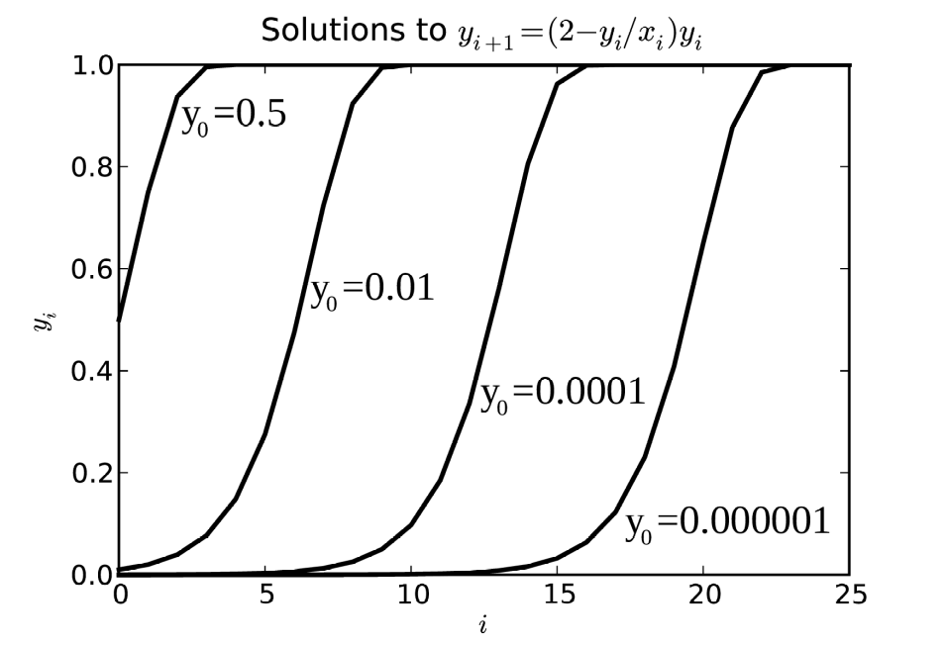

Figure 1. Solutions to the non-linear difference equation (40) for four different initial conditions$y_{0}$. The input variable is constant:$x_{i}=1.$The solutions always converge to $x_{i}=X=1$.

Notice that reasonably large initial values for$y_{0}$ ensure fast convergence: 10 steps for$y_{0}=0.01X$, and even 3 steps for $y_{0}=0.5X$to 1% of the range [0..1].
The step ds is incremented using the Eq. (40) as the algorithm
${ds}^{}=\left(2−{ds}/{{ds}_{new}}\right)ds$. | (42)
When ds is small compared to ${ds}_{new}$, each next step value of${ds}^{}$is almost$2ds$, so the ds grows in a geometrical progression. However, as ds approaches${ds}_{new}$, its growth rate becomes slower. These features ensure fast and yet smooth adjustment of the ds in several steps up to the specified${ds}_{new}$value.

Correctness control
Correctness of the ray path computation is violated if at some step the ray penetrates the critical
surface. This condition can arise for very steep rays, incident almost normally on the critical
surface. This is usually prevented before the step is made. A too steep ray is approximated by a parabola and it is then switched to the symmetrical point on the opposite branch of the parabola. Thus no ray can penetrate the critical surface.
At each moment the algorithm has current values of the dielectric permittivity$ϵ_{1/2}$and its gradient$∇ϵ_{1/2}$. If the ray at next step can occasionally trespass the border then the next value of permittivity $ϵ_{3/2}$should become negative. Therefore, the algorithm must use a criterion for positive$ϵ_{3/2}$based on predictions of the next value of$ϵ_{1/2}$. The prediction here uses a linear mechanism.
The $ϵ_{3/2}$is positive if$ϵ_{1/2}$> 0 and
$\frac{ϵ_{3/2}}{ϵ_{1/2}}>0$. | (43)
Replace both numerator and denominator of (43) by the linear cuts of their Taylor series:
$\frac{ϵ_{3/2}}{ϵ_{1/2}}=\frac{ϵ_{0}+v_{0}⋅∇ϵ_{1/2}\frac{3ds}{2}}{ϵ_{0}+v_{0}⋅∇ϵ_{1/2}\frac{ds}{2}}=\frac{ϵ_{0}+v_{0}⋅∇ϵ_{1/2}\frac{ds}{2}+v_{0}⋅∇ϵ_{1/2}ds}{ϵ_{0}+v_{0}⋅∇ϵ_{1/2}\frac{ds}{2}}=1+\frac{v_{0}⋅∇ϵ_{1/2}}{ϵ_{0}+v_{0}⋅∇ϵ_{1/2}\frac{ds}{2}}ds>0$
Rearrange:
$ds\frac{v_{0}⋅∇ϵ_{1/2}}{ϵ_{0}+v_{0}⋅∇ϵ_{1/2}\frac{ds}{2}}>−1$;
$ds\left(v_{0}⋅∇ϵ_{1/2}\right)>−ϵ_{0}−v_{0}⋅∇ϵ_{1/2}\frac{ds}{2}$.
Divide both sides by $ϵ_{0}$:
$ds\left(v_{0}⋅\frac{∇ϵ_{1/2}}{ϵ_{0}}\right)>−1−\left(v_{0}⋅\frac{∇ϵ_{1/2}}{ϵ_{0}}\right)\frac{ds}{2}$;
$\frac{3}{2}ds\left(v_{0}⋅\frac{∇ϵ_{1/2}}{ϵ_{0}}\right)>−1$.
Finally we get the correctness criterion :
$\frac{ds}{2}\left(v_{0}⋅\frac{∇ϵ_{1/2}}{ϵ_{0}}\right)>−\frac{1}{3}$. | (44)
If this inequality is true, the next step is safe. If not, the ray is so close to the critical surface and so steep that previous decreases of the step size did not help avoid its penetration past the critical surface. If this is the case, another method is employed.

Parabola switching
Suppose the ray is close to the critical surface, the algorithmic step ds has already been decreased down to the specified absolute minimum step, and yet the next step will penetrate the critical surface. In this case the algorithm performs the procedure of its reflection. Provided the step is small enough, the dielectric permittivity gradient can be considered constant along the ray path. In the medium with$∇ϵ=const$electromagnetic rays have parabolic trajectories, which will be shown further. Knowing the parameters of the parabola, the algorithm calculates the position and direction vectors of the ray on the opposite branch of the parabola. The ray is switched to the opposite parabolic trajectory branch so that instead of approaching the critical surface it starts departing it.
Consider a simple 2-dimensional case of a ray traveling in XY-plane, where the dielectric permittivity changes linearly from = 1 at the origin of coordinates down to = 0 at some distance L along the X axis, so that
$ϵ=1−\frac{x}{L}$ | (45)
This situation is shown in Fig. 2. We shall derive the equation for the ray trajectory going through an arbitrary point$\left(x_{0},y_{0}\right)$. The equation set for the ray trajectory (16) in the two-dimensional geometry consists of two equations. The dielectric permittivity changes in the X direction only, so does the index of refraction n, therefore its gradient along the Y axis is zero:
$∇_{y}n=\frac{∂n}{∂y}=0$,
and from the E.-L. equation for the y
$−∇_{y}n=\frac{d}{ds}\left(n\frac{dy}{ds}\right)=0$
one can see that
$n\frac{dy}{ds}=const$. | (46)

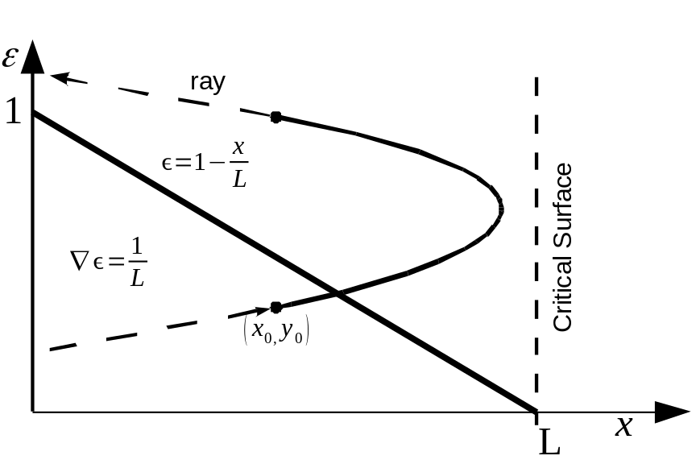

Figure 2. In a medium with linearly changing dielectric permittivity electromagnetic rays have parabolic trajectories.
Denote the values of n and at the point$\left(x_{0},y_{0}\right)$as$n_{0}=\sqrt{ϵ_{0}}$. To find constant (46) at the point$\left(x_{0},y_{0}\right)$notice that the direction vector v can be expressed as
$v=\left\|\frac{dx}{ds};\frac{dy}{ds}\right\|=\left\|cosα;sinα\right\|$, | (47)
where is the angle between the ray direction v and the $−∇ϵ$, which is the X axis here (See Fig. 3). Hence
$n\frac{dy}{ds}=n_{0}sinα$, or
$\frac{dy}{ds}=\frac{n_{0}}{n}sinα$ | (48)
Now find the relationship between the differentials dx and dy.
$\frac{{dx}^{2}}{{ds}^{2}}+\frac{{dy}^{2}}{{ds}^{2}}=1$, | (49)

whence$\frac{{dx}^{2}}{{ds}^{2}}=1−\frac{{dy}^{2}}{{ds}^{2}}=1−\frac{n_{0}^{2}}{n^{2}}\sin^{2}α$ and
$\frac{dx}{ds}=\sqrt{1−\frac{n_{0}^{2}}{n^{2}}\sin^{2}α}=\frac{\sqrt{n^{2}−n_{0}^{2}sinα}}{n}$ | (50)
From (48) and (50) find the ratio
$\frac{dx}{dy}=\frac{dx}{ds}÷\frac{dy}{ds}=\frac{\sqrt{n^{2}−n_{0}^{2}sinα}}{n_{0}sinα}$. | (51)
This yields the differential equation associating dx and dy:
$\frac{dx}{\sqrt{ϵ−ϵ_{0}\sin^{2}α}}=\frac{dy}{\sqrt{ϵ_{0}}sinα}$ | (52)
The linearly changing can be represented through linear terms of its Taylor expansion near the point$\left(x_{0},y_{0}\right)$as
$ϵ\left(r\right)=ϵ_{0}+\left(r−r_{0}\right)⋅∇ϵ_{0}$ | (53)
Notice that the gradient in (53) has the x component only:
$∇ϵ_{0}=∇_{x}ϵ_{0}=d{ϵ_{0}}/{dx}=ϵ_{0}^{}$, | (54)
which we denote as $ϵ_{0}^{}$. The expression (53) becomes a scalar$ϵ\left(x\right)=ϵ_{0}+\left(x−x_{0}\right)ϵ_{0}^{}$, and the expression in the left hand side denominator is converted as
$ϵ−ϵ_{0}\sin^{2}α=ϵ_{0}+ϵ_{0}^{}\left(x−x_{0}\right)−ϵ_{0}\sin^{2}α=ϵ_{0}^{}x+ϵ_{0}^{}x_{0}−ϵ_{0}\cos^{2}α$ | (55)
Using (55) equation (52) can be integrated as follows:
$\int_{x_{0}}^{x}{\frac{dx}{\sqrt{ϵ_{0}^{}x+ϵ_{0}^{}x_{0}−ϵ_{0}\cos^{2}α}}}=\int_{y_{0}}^{y}{\frac{dy}{\sqrt{ϵ_{0}}sinα}}$ | (56)
Its solution, the ray trajectory equation, is the equation of parabola:
$x=x_{0}−\frac{ϵ_{0}}{ϵ_{0}^{}}\cos^{2}α+\frac{1}{ϵ_{0}^{}}{\left(\sqrt{ϵ_{0}}cosα+\frac{ϵ_{0}^{}}{2\sqrt{ϵ_{0}}sinα}\left(y−y_{0}\right)\right)}^{2}$ | (57)

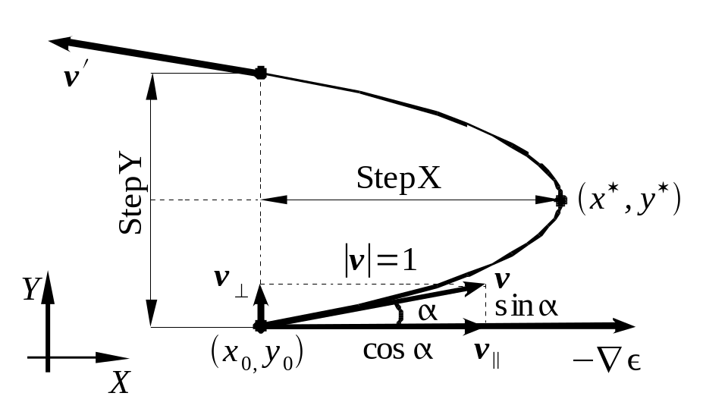

Figure 3. Parabola parameters.
The coordinates of the parabola extremum,$\left(x^{✶},y^{✶}\right)$, can be found from the equation ${dx}/{dy}=0$, where x is the right hand side of equation (57). It yields:
$y^{✶}=y_{0}−\frac{2ϵ_{0}}{ϵ_{0}^{}}cosαsinα$ | (58)
$x^{✶}=x_{0}−\frac{ϵ_{0}}{ϵ_{0}^{}}\cos^{2}α$ | (59)
As seen in Fig. 3, after the parabola reflection the ray starts its trip from the symmetric point at the opposite parabola branch, whose coordinates are obviously$\left(x_{0},y_{0}+2\left(y^{✶}−y_{0}\right)\right)$. Denote the increment along the Y axis as$\vec{StepY}$, then after the switching the new position vector$r^{}$will be
$r^{}=r+\vec{StepY}$. | (60)
The increment length is
$StepY=2\left(y^{✶}−y_{0}\right)=−\frac{4ϵ_{0}}{ϵ_{0}^{}}cosαsinα$. | (61)
Find its direction. In the situation of arbitrary ray direction the X axis has the direction of $−∇ϵ$. The Y axis lies in the plane formed by the vectors$−∇ϵ$and v. Decompose the direction vector v into two vectors, parallel to the axes. The$v_{∥}$is directed along $−∇ϵ$and the X axis, and the $v_{}$is directed along the Y axis:
$v=v_{∥}+v_{}$. | (62)
Notice that since$\left|v\right|=1$its projections have lengths
$\begin{aligned}\left|v_{∥}\right|=cosα \\ \left|v_{⊥}\right|=sinα\end{aligned}$ | (63)
where is the angle between the$−∇ϵ$and v. In the coordinates related to these vectors,
$\vec{\text{StepY}}=−4\frac{ϵ}{∇ϵ}cosαsinα\frac{v_{⊥}}{\left|v_{⊥}\right|}=−4\frac{ϵ}{∇ϵ}cosαv_{⊥}$ | (64)
In order to find$cosα$consider the scalar product
$v⋅∇ϵ=\left|v\right|\left|∇ϵ\right|cosα=\left|v_{∥}\right|\left|∇ϵ\right|$, | (65)
whence the length of $v_{∥}$, or cos , is
$cosα=\left|v_{∥}\right|=\frac{v⋅\left(−∇ϵ\right)}{\left|∇ϵ\right|}$ | (66)
Then the vector step to the opposite parabolic branch is
$\vec{\text{StepY}}=4ϵ\left(−\frac{v⋅∇ϵ}{{\left|∇ϵ\right|}^{2}}\right)v_{⊥}$. | (67)
Consider the parenthesized expression in (67). It is convenient to denote it as a variable $Lcosα$so as to use later. From equation (45) the hypothetical distance along$−∇ϵ$from the point with $ϵ=1$ to the critical surface, L, is
$L=\frac{1}{\left|∇ϵ\right|}$, | (68)
so
$Lcosα=\frac{cosα}{\left|∇ϵ\right|}$ | (69)
Then using cos from Eq. (66) the$Lcosα$can be rendered as
$Lcosα=−\frac{v⋅∇ϵ}{{\left|∇ϵ\right|}^{2}}$. | (70)
Having this notation one can rewrite equation (67) for the step vector as
$\vec{\text{StepY}}=4ϵLcosαv_{⊥}$. | (71)
The ray direction v should also be changed as shown in Fig. 3. The new direction vector$v^{}$is calculated through the geometrical considerations described in Fig. 4:
$v^{}=v−2v_{∥}$ | (72)
To obtain the vector value of $v_{∥}$, the $\left|v_{∥}\right|$should be multiplied by the unity vector along the X axis, which is$−\frac{∇ϵ}{\left|∇ϵ\right|}$. This yields the result:
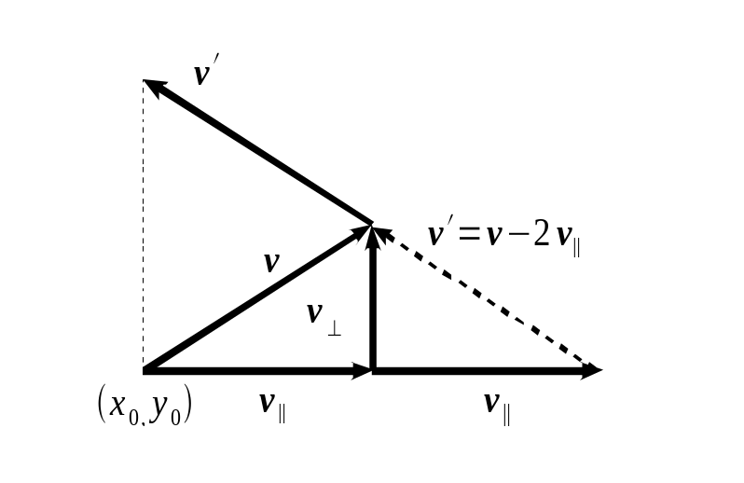

Figure 4. The ray direction$v^{}$at the opposite branch of the parabola after reflection.

$v_{∥}=\frac{\left(v⋅∇ϵ\right)}{{\left|∇ϵ\right|}^{2}}∇ϵ$, | (73)
or with the introduced notation (70),
$v_{∥}=Lcosα∇ϵ$. | (74)
An important application of the raytracing algorithm is calculation of the ray intensity via integration of the volumetric emissivity as well as calculation of the absorption along the ray path. The integration is performed at each algorithmic step and uses the current step length ds. However, in case of the parabolic switching/reflection the ray is terminated at some point and invoked at another. The omitted parabolic path should be included in the integration process as a special step, where the ds is changed for the parabola segment length $L_{p}$. Unfortunately, direct calculation of the parabola length leads to very complex algebra, so the parabolic trajectory segment should be approximated by straight parabola chords. In Fig. 5 these segments are shown as AC and CB. Obviously, the sum of their lengths is equal
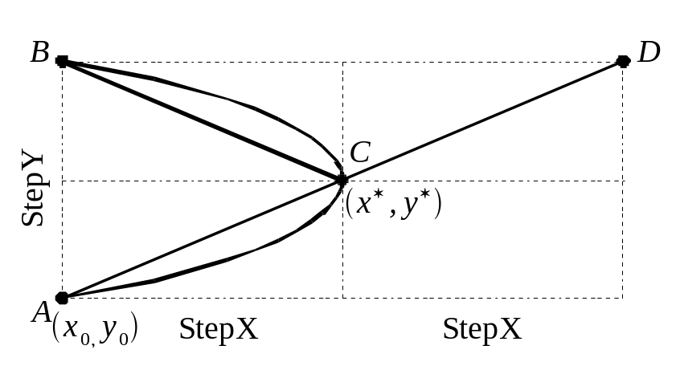

Figure 5. The length of parabolic segment ACB can be approximated by the straight line segments AC and CB, which are the parabolic chords. The sum of their lengths equals that of the line segment AD.
to the length of straight segment AD. In order to calculate the$\left|AD\right|$one should know the distance from the switching point$\left(x_{0},y_{0}\right)$to the parabola extremum$\left(x^{✶},y^{✶}\right)$along the X axis or, in general case, along the$−∇ϵ$. Denote this distance as StepX. From Equation (59) we have
$StepX=\frac{−ϵ}{\left|∇ϵ\right|}\cos^{2}α$ | (75)
The vector representation requires multiplying StepX by the unity vector directed along the$−∇ϵ$:
$\vec{\text{StepX}}=\frac{−ϵ}{\left|∇ϵ\right|}\cos^{2}α\frac{−∇ϵ}{\left|∇ϵ\right|}=ϵ\left(\frac{\cos^{2}α}{{\left|∇ϵ\right|}^{2}}\right)∇ϵ$ | (76)
From Eq. (59) one can see that (76) can be written as
$\vec{\text{StepX}}=ϵ{\left(Lcosα\right)}^{2}∇ϵ$ | (77)
whence we get the final formula for the StepX length:
$StepX=ϵ{\left(Lcosα\right)}^{2}\left|∇ϵ\right|$ | (78)
The length of the parabola segment$L_{p}$along which the integration can be performed is approximated by the expression
$L_{p}=\left|AC\right|+\left|CB\right|=\left|AD\right|=\sqrt{{\left(2StepX\right)}^{2}+{StepY}^{2}}$. | (79)

Algorithm testing and validation
The algorithm of raytracing has been implemented in the form of programs written in Fortran 90 and C languages. As an example of the algorithm validation, the ray trajectories in a medium with simple dielectric permittivity distribution have been obtained numerically using the algorithm and compared with the exact solutions for this medium.
Consider a hypothetic medium where the dielectric permittivity linearly falls off along the X axis starting from 1 at x = 0 down to 0 at some distance L. , as given by Eq. (45). The ray trajectories in such a medium are shown to be parabolas described by Eq. (57). We choose the distance L = 100 conditional units (they may be solar radii, for example), and set the point $r_{0}$from where the rays start traveling at the coordinate origin (0,0,0). Then the ray equation (57) takes the form

$x=L\cos^{2}α−L{\left(cosα−\frac{1}{2Lsinα}y\right)}^{2}$, | (80)
where is the angle of incidence with respect to the critical surface at x = L. The results of comparison are presented in Fig. 6. Four angles were selected:$1^{o},{10}^{o},{30}^{o},\text{and}{60}^{o}.$The exact solutions (80) are plotted in black; the ray traces created by the raytracing algorithm are plotted over them. The colored curves completely hide the black ones, so one can conclude the numerical solutions are essentially precise.
In Fig. 7 the differences between the numerical and exact solutions are more discernible because only a short piece of the trajectory in the vicinity of the parabola focus is shown.

Figure 6. Comparison of the numerically simulated ray trajectories for several angles of incidence$1^{o},{10}^{o},{30}^{o},\text{and}{60}^{o}$with the exact ray traces. The simulated curves completely overlap the exact parabolic solutions, plotted in black, so that the parabolas are not visible.
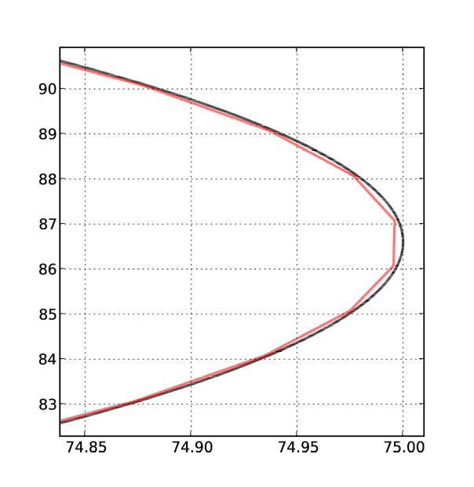

Figure 7. A closer view on a ray trajectory from the raytracing algorithm (red, segmented line) and the exact ray trajectory (black, smooth line). A short piece of the trace near the reflection point x = 75 is shown. Notice the scale on the axes.

Examples of algorithm applications
The algorithm has been applied for solar studies and shown good results. In the numerical experiments presented here the coronal electron density distribution is approximated by the inverse squares law:
$N_{e}=\frac{2×{10}^{−8}}{r^{2}}{\text{cm}}^{−3}$ | (81)
where r is distance from the center of the sun, and$N_{e}$is the electron number density in ${\text{cm}}^{−3}$. Figs. (8), (9), and (10) give the ray trajectories in SGI XZ-plane at the frequencies 10 MHz, 20 MHz, and 40MHz, respectively. The observation point is located at the earth, which is not shown.
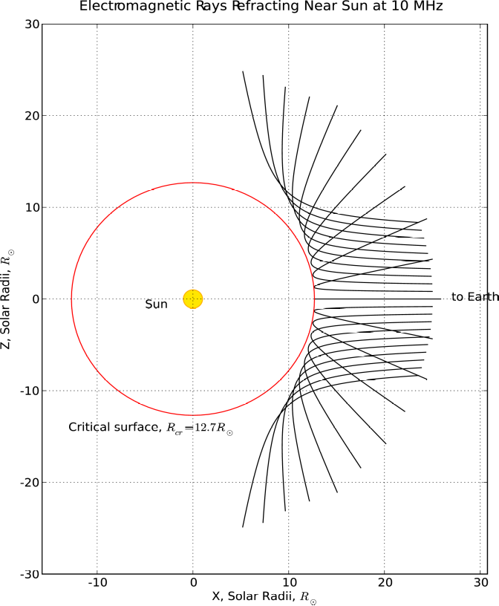

Figure 8. The electromagnetic ray traces at 10 MHz.

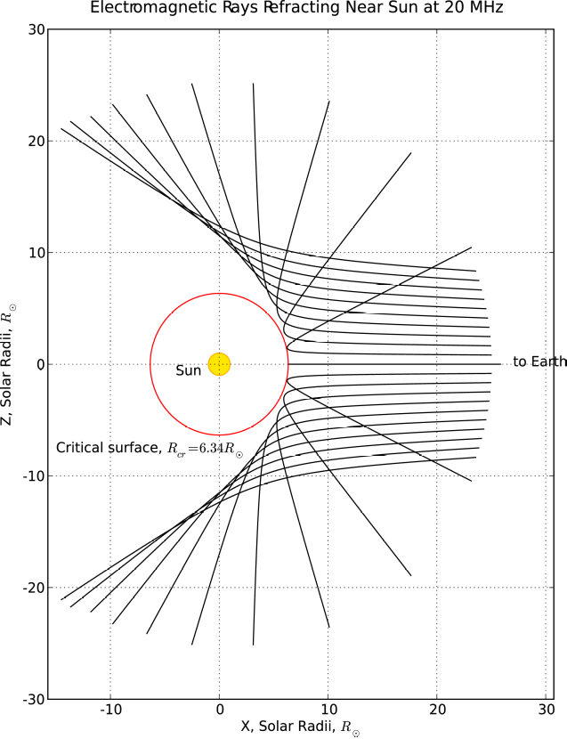

Figure 9. The electromagnetic ray traces at 20 MHz.
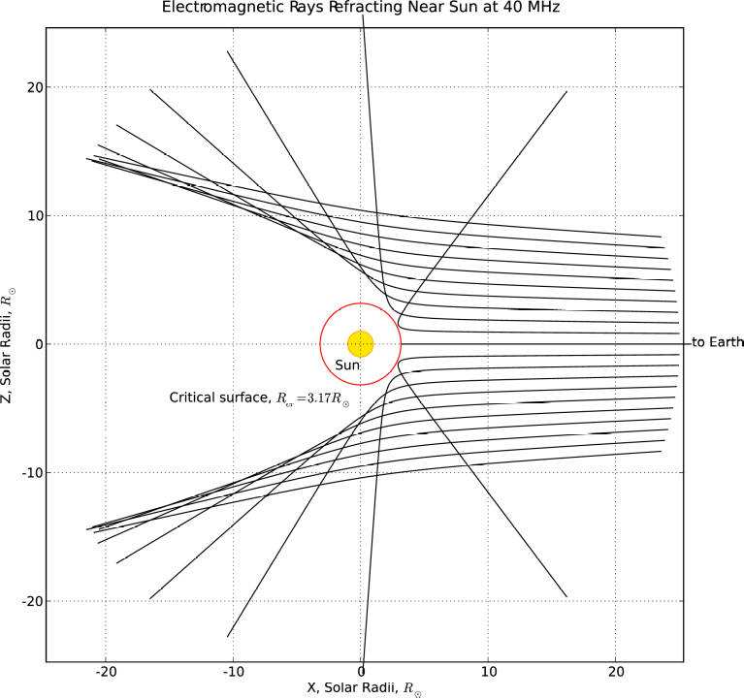

Figure 10. The electromagnetic ray traces at 40 MHz.

References
1. Hockney, R. W., and J. W. Eastwood, Computer simulation using particles, McGraw-Hill, 1980.

