1. **Find RACE result**

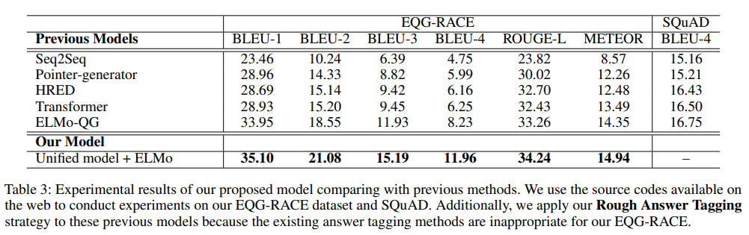

1. **Make model better than previous**

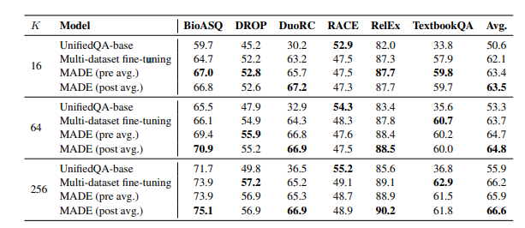

BERT-based Distractor Generation (BDG) parallel masked-LM multi-task training

https://github.com/voidful/BDG

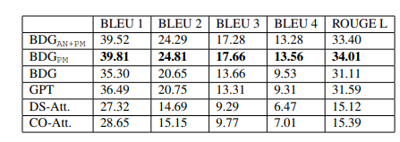

* Split paragraph
* Find most important sentences
* Select sentences
* Check grammar
* Check keyword
* get hint
* generate answer from hint

1. **eval**