**Servo Controller**

[servo_control]

*servo.h*

The servo control component uses a position value to output a 1-2ms pulse for the control of servos.

It must be driven by a 100MHz clock signal (sys_clk) to output with proper timing. The component is wrapped by a port, which presents an Avalon MM-Slave interface.

In the system, two of these components are mapped at <0xff200070> and <0xff200080>.

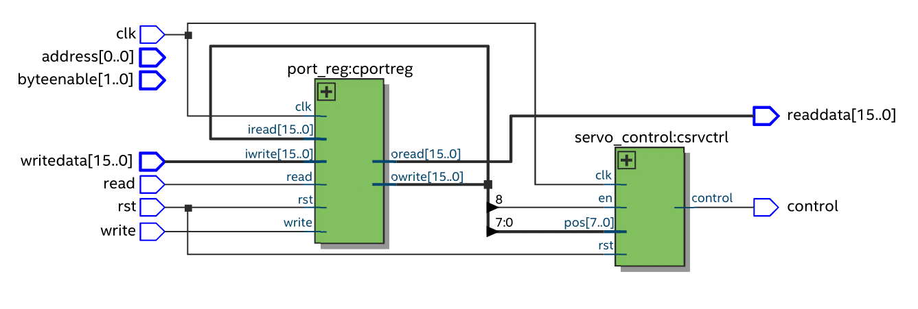

**Operation:**

The component uses a prescaler to slow down the clock to 200 cycles per ms, and a counter to keep track of the time. The count is reset at the end of the period. The output is set high if the count < (pos + 200).

**C library:**

All functions accessed through the *servo.h* header. Call *init_servo()* before using the library, then all functions will be available as members of SERVO.

**Register Map:**

|  |  |  |
| --- | --- | --- |
| 15 - 9 | 8 | 7 - 0 |
| Res. | EN | POS [7:0] |
|  | rw | rw |

Bits 15:9: Reserved

Bit 8: **EN**: Component enable

Active-high enable

Bits 7:0: **POS[7:0]**: Servo position

Values from 0-200 set the position of the servo (-90° to 90°)

Values above 200 (0xc8) cause the component to reset