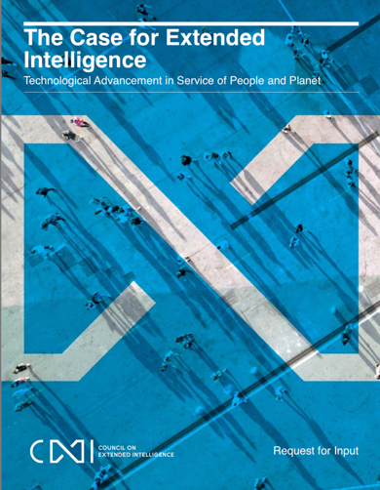

Participatory Design

A design approach intended to enable large-scale social participation. Like the well-known revelation : **« You are not ‘in’ the traffic, you ‘are’ the traffic !«** Participatory design considers all agents and agencies in the social and technical infrastructures to act as knowledgeable contributors of both problems and solutions. Therefore, a new kind of Data Agency is needed to capture the participants’ knowledge in technical decision-making processes.

Data Agency

Modern communication and computation infrastructure allows human participants to register their interest on continuous basis and at a massive scale. Information captured using these existing infrastructure can be used to make informed decisions. More importantly, protecting and utilizing the basic rights and benefits for all participants is a critical goal of the design of such data agency.

Enlightened Metrics

Decisions are often driven by chosen metrics. Unlike monolithic metrics such GDP and personal wealthy, modern data agencies, allowing real-time and fine-grained massive data collection, allowing a new kind of metrics to be computed. The ability to choose a diverse range of metrics and having objective data sources to assess the metrics in real-time would afford different guided paths to fullfil the needs and objectives of organizations at scale with sensible feedback and goal tracking.

Background

In a world where material actions are governed by Artificial Intelligence technologies, a higher level of intelligence must prevail. Instead of focusing on the artificial, materialistic aspects of intelligence, the governing rules should be an Extention of Humanistic Intent. Technologies should be extensions of humanity, not the other way around. Henceforth, a developmental paradigm should shift from pursuing outward artificial gratification to return to the origin of realizing humanistic concerns.

Who created CXI?

The IEEE Standards Association (the world’s largest technical standard creator, including Wifi 802.11 and 4G/5G Communication Protocols) and the MIT Media Lab invited policy makers, technologists, and thought leaders to form the global Council on Extended Intelligence (CXI).

What does CXI plan to do?

CXI intend to proliferate a new paradigm of technology decision-making, by promoting the study of “Participatory Design”. A new design methodology based on emerging, egalitarian data agencies that affords anyone, everywhere, to obtain access to latest data content and open source data processing tools. It also promotes an “Enlightened Metrics” approach, allowing organizational decisions to avoid lock-in on single-minded success factors such as GDP growth, but allow multi-scale social considerations, such as United Nation’s Sustainable Development Goals.

CXI in ASIA

Council on Extended Intelligence (CXI): an organization formed by global key-opinion-leaders to foster international collaboration on ethically-aligned technology development and socially responsible data agencies. It aims to create a permanent communication hub in Asia, potentially located in Bali, Indonesia.

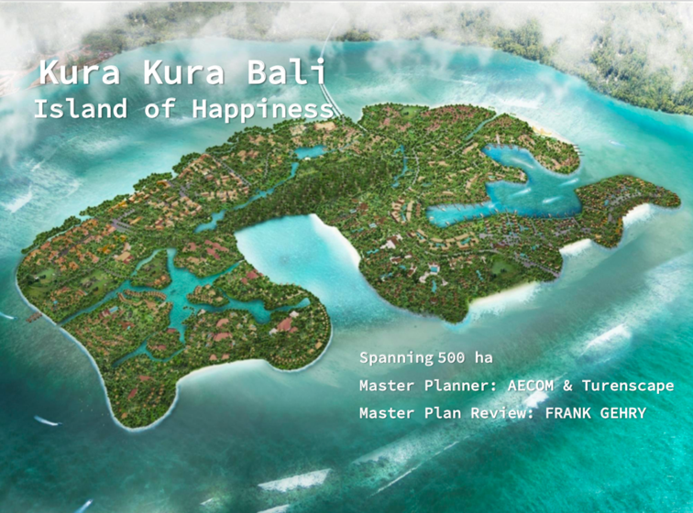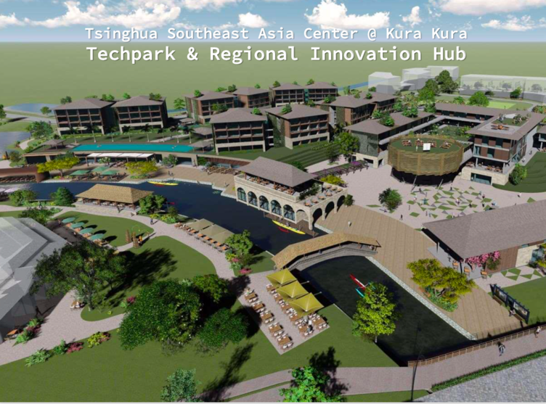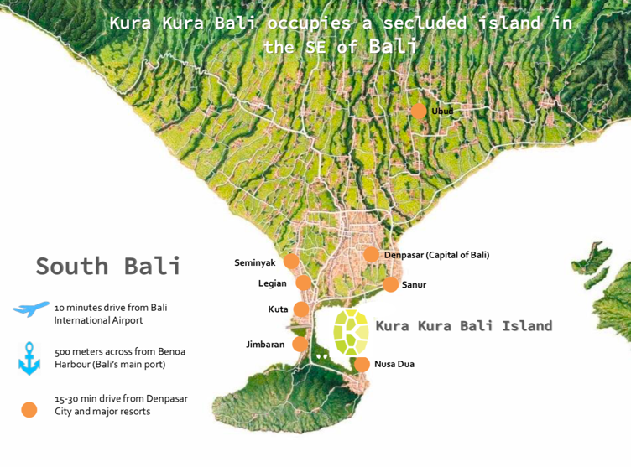

Information about CXI

More detailed information about CXI in general can be found on the following website:

<http://globalcxi.org>

For a full list of CXI members, please see:

https://globalcxi.org/#members

Some images of this presentation came from:

DRAFT INFO for Councilon Extended Intelligence (CXI) 23/7/2019

CXI-Asia Location

CXI-Asian plans to co-locate with Tsinghua South East Asian campus on Kura-Kura Island. A location where learning activities and confereces can be conveniently conducted.

What will CXI-Asia do?

CXI-Asia will launch the following activities :

1. Participation Models
   1. Summits for Global Thought Leaders
      1. Digital/Data Curriculum Standards for future citizens
      2. Coaching Circles for organization development
      3. Environmental Data Collection and Solutions
   2. Residential/Rotational Programs
      1. Designers in Residence Program
      2. Long-term Co-living Space for Digital Innovators
      3. Collaborate with other international locations to create exchange/rotational Thought-Leader Residential Programs.
2. Data Agencies:
   1. Computational Thinking Curriculum for the masses: Teaching young people AI-compatible math fundamentals
   2. New Data Standards: Blockchain and Spatial Web (Web 3.0)
   3. Technology Development for Secure Data Sharing Infrastructures
3. Identifying Meaningful Success Factors:
   1. Workshops for Policy Makers: Teach government officers to use existing public data sources to formulate useful indicators for policy success
   2. Create a long-term joint research institute for Happiness Index, so that general public, data scientists and policy makers can participate in the shaping of data-driven policies for public good.

Why CXI in Bali, Indonesia?

Bali, Indonesia, is known as the Island of Happiness and has been a major hub for digital momads. It is ideally suited to be a model of humanistic technology demonstration center. Knowing that Kura Kura island and Tsinghua South East Asian Center will be dedicated to draw brain trusts and global influencers to Bali, CXI is interested in joining force with Indonesian thought leaders and local industries to demonstrate the power and effects of participatory design and practice the use of modern, egalitarian data agencies.

Who of CXI-Asia

CXI-Asia will be lead by Andre Uhl, a member of the CXI Leadership board. Lili Xu of MIT U-Lab, and Ben Koo of Tsinghua Unviersity will also support this operation.