Android Learning Resource

Software Setup:

Java:

* Verify that you have java. In windows type ‘java -version’ in cmd window (I am using Windows machine)

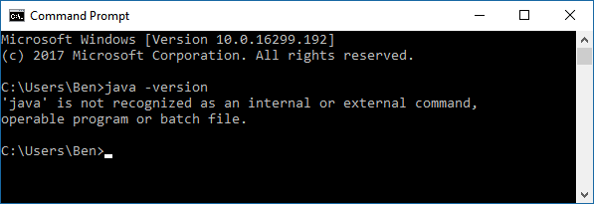

* If there is no java in the machine, then download Java Development Kit
* from  <http://www.oracle.com/technetwork/java/javase/downloads/index.html> and install and verify again.

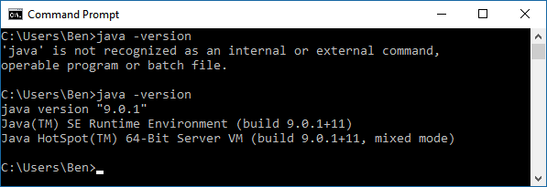

Android Studio

* Download and Install Android Studio (<https://developer.android.com/studio/install.html>)
* Can use free udacity course for installation help. [https://classroom.udacity.com/courses/ud808/lessons/4216368924/concepts/43072785890923#](https://classroom.udacity.com/courses/ud808/lessons/4216368924/concepts/43072785890923)
* For version control with GIT, the resource at <http://wii.logdown.com/posts/2013/11/15/android-studio-git-tutorial> will be helpful specially if you are new to Android Studio (AS) and you want integration of GIT within AS.

Time Requirements:

|  |  |  |
| --- | --- | --- |
| Lesson | Hours | Cummulative |
| 1 | 2 | 2 |
| 2 | 2 | 4 |
| 3 | 3 | 7 |
| 4 | 2.5 | 9.5 |
| 5. Intends | 3 | 12.5 |
| 6. Lifecycle | 2 | 14.5 |
| 7. Preference | 3 | 17.5 |
| 8. Storing Data in SQLite | 3 | 20.5 |
| 9. Content Providers | 2 | 22.5 |
| 10. Building Content Provider | 4 | 26.5 |
| 11. Backgrounnd Tasks | 4 | 30.5 |
| 12. Completinngg the UI | 2 | 32.5 |
| 13. Polishing the UI | .3 | 33 |
| 14. Challenge Course Wrap Up | .05 | 33 |

My Log:

Started 1/11/2018

1/11 Day 01: Reviewed Email and other Materials

1/12 Day 02: Started Setup and Started Lecture. Familiarize yourself with Android Studio.

1/13 Day 03: More Lectures and Started Exercise

* Learned GIT in Android Studio.
* Completed Exercises
  + T01.01, T01.02, T01.03
  + S01.01, S01.02

1/14 Day 04: Break

1/15 Day 05: Started Lesson 3. Completed T02.01

1/16 Day 06: Completed T02.02-T02.03

1/17 Day 07: More lecture still at Lesson 3

Completed Exercises

T02.04-05

1/18 Day 08: Completed T02.06. S02.01, S02.02, and S02.03 completed.

Gave a feed back on a lesson:

// TODO (8) Create a method that will get the user's preferred location and execute your new AsyncTask and call it loadWeatherData

Updated log.

1/19 Day 09: Started Lesson 4. Completed T03.01

1/20 Day 10: Continued Lesson 4. Started T03.02

1/21 Day 11: Found the length of course and created ‘Time Requirements’

1/22 Day 12: Continued Lesson 4. Completed T03.02, T03.03, T03.04, T03.05, T03.07

1/23 Day 13: Started S03.01

1/24 Day 14: Continued S03.01. Complete S03.01. Update Log.

1/25 Day 15

1/26 Day 16

1/27 Day 17

1/28 Day 18

1/29 Day 19 Completed Exercise T04b.01 T04b.02 T04b.03 Updated log

Common Trouble Shoot:

The build error with R. Go to tool, Android and Sync the project.