Reported swallowing difficulties among US adults aged 65 years and older in 2022 and 2025 a repeated cross sectional analysis by stroke history
  - National Health Interview Survey analysis with age standardization and exploratory sensitivity analyses
Cinja Huber¹, Gero Lueg², Anel Karisik^{3,4}, Sriramya Lapa⁵, Anne Jung¹, Orhan Aktas¹, Michael Gliem¹, Paul Muhle⁶, Sonja Suntrup-Krueger⁶, Rainer Dziewas⁷, Bendix Labeit¹
¹ Department of Neurology, Medical Faculty, University Hospital Duesseldorf, Duesseldorf, Germany.
² Department of Geriatric Medicine, Marien Hospital Herne, Ruhr University Bochum, Herne, Germany.
³ Department of Neurology, Medical University of Innsbruck, Innsbruck, Austria
⁴ VASCage-Centre on Clinical Stroke Research, Innsbruck, Austria
⁵ Department of Neurology, Medical Faculty, University Hospital Frankfurt, Frankfurt, Germany
⁶ Department of Neurology, University Hospital Muenster, Muenster, Germany.
⁷ Department of Neurology and Neurorehabilitation, Klinikum Osnabrueck, Osnabrueck, Germany.
Corresponding author: Bendix Labeit. Department of Neurology, Medical Faculty and University Hospital Duesseldorf, Moorenstraße 5, 40225, Duesseldorf, Germany. Email: benlabeit@gmail.com

Abstract
Background: Population surveys can characterize swallowing symptoms outside clinical settings, but comparisons require attention to survey design and reporting. We compared reported swallowing difficulties among US adults aged 65 years and older in 2022 and 2025 and examined differences by stroke history.
Methods: We analyzed National Health Interview Survey public-use Sample Adult files using survey weights and design-based variance estimation. The primary outcome was reported swallowing difficulty during the preceding 12 months. Prevalences were directly standardized to the US 2000 population aged 65 years and older. We estimated 2025-minus-2022 differences and the difference between changes in the stroke-history and no-stroke groups. Exploratory analyses included age and sex adjustment, restriction to confirmed self-responses, interview-period restriction, and extreme missing-outcome assumptions.
Results: Valid primary responses were available for 8,485 adults in 2022 and 8,223 in 2025. Age-standardized prevalence was 7.77% versus 8.35%, respectively, a difference of 0.57 percentage points (95% confidence interval [CI], −0.40 to 1.55). Among respondents with stroke history, prevalence was 14.15% versus 20.43%, a difference of 6.27 points (95% CI, 1.08 to 11.47); the additive interaction was 6.05 points (95% CI, 0.77 to 11.33). The stroke-group difference remained positive after age and sex adjustment but decreased to 4.53 points (95% CI, −0.42 to 9.48) when restricted to confirmed self-responses. The 2025 collection interruption and asymmetric response-status classification limit comparability.
Conclusions: The overall comparison did not establish a clear prevalence difference. A larger increase was observed among respondents with stroke history, but its magnitude and precision were sensitive to response-status restriction. These findings concern reported symptoms and warrant further surveillance; they do not establish a change in clinically confirmed dysphagia or individual outcomes.

Introduction
Swallowing difficulties are relevant to population health because they occur beyond hospitals and specialist clinics. In the 2012 National Health Interview Survey (NHIS), approximately 4.0% of US adults reported a swallowing problem during the preceding year, and relatively few affected respondents sought professional care. A subsequent comparison of NHIS 2012 and 2022 reported an increase in all-adult prevalence from 4.02% to 5.91%. Whether a similar difference is apparent in more recent survey years, particularly among older adults, requires separate assessment. [1,2]
Estimates among community-dwelling older adults vary with symptom definitions, recall periods, sampling and assessment methods. Reviews show considerable heterogeneity, making pooled prevalence an imperfect benchmark for an individual survey. A US National Health and Aging Trends Study (NHATS) analysis reported annual weighted prevalence between 8.7% and 10.2% across 11 rounds, with symptoms often reported intermittently. Such observations support repeated surveillance while cautioning against interpreting separate cross-sectional estimates as individual deterioration or recovery. [3–5]
Stroke history identifies a clinically important subgroup. However, swallowing abnormalities identified during acute stroke admission differ from symptoms reported later by community-dwelling survivors. Acute-stroke estimates vary markedly between screening, clinical examination and instrumental assessment, and swallowing function can change after the acute event. Clinical guidance emphasizes recognition and assessment of post-stroke dysphagia, but population-survey symptom questions neither establish a diagnosis nor identify the cause of the reported problem. [6–8]
We compared the prevalence of reported swallowing difficulties in NHIS 2022 and 2025 among adults aged 65 years and older, using a common age standard. Secondary objectives were to characterize substantial difficulty and prolonged symptoms and assess whether the year difference varied by reported stroke history. Additional exploratory analyses examined age and sex adjustment and restriction to confirmed self-responses. The focus was a population comparison between two survey years, without attributing differences to calendar year, stroke, or treatment as causal exposures.

Methods
Study design and population. We conducted a repeated cross-sectional analysis of the 2022 and 2025 NHIS public-use Sample Adult files. NHIS samples the civilian noninstitutionalized US population. Adults with known age of at least 65 years were eligible; the highest public-use age value represents 85 years or older. The full adult survey design was constructed before restricting analyses to older-adult domains. The two files provide distinct cross-sectional observations and do not support individual longitudinal follow-up. [9,10]
Survey comparability. The swallowing items and stroke-history item had matching wording, universes and response codes. Nevertheless, a new sampling design began in 2025, and survey operations were disrupted by a lapse in federal appropriations. Collection was paused from October 1 through November 16 and restarted on November 18. October and November sample interviewing was delayed; the December sample was fielded in January 2026 and excluded from the 2025 file. The annual file therefore contains 11 sample months with adjusted weights. The altered end-of-year interview-quarter code was retained in the annual analysis rather than treated as missing. [10–12]
Outcomes and subgroup definition. The primary outcome was a positive response to VSLSWYR_A, which asks about swallowing problems during the previous 12 months and gives examples involving food, pills and liquids. Secondary outcomes were reporting “a lot” of difficulty (VSLSWDIF_A=2) and symptoms on at least 180 days (VSLSWDYS_A=6). These were population outcomes: respondents without swallowing problems were classified as negative, whereas missing severity or duration among affected respondents remained missing. Duration categories were not treated as exact continuous measurements. Stroke history indicated a reported previous diagnosis by a doctor or other health professional (STREV_A=1); timing and attribution of swallowing symptoms to stroke were unavailable. [11,12]
Analysis planning and missing data. The original plan was recorded after codebook review and inspection of unweighted cell counts, before weighted outcome estimates and inferential comparisons. It was not externally preregistered. Endpoint-specific complete cases were analyzed; unknown stroke status excluded respondents only from stroke-group comparisons. Refused, unknown and not-ascertained responses were not recoded as negative. Sensitivity bounds assigned all missing primary outcomes to negative or positive responses, both identically across years and under opposing assumptions. These are deliberately extreme scenarios rather than missing-at-random imputations.
Survey estimation and standardization. Analyses used R 4.6.0 and survey 4.5, with Taylor linearization, annual adult weights and the public-use strata and primary sampling units. Following NCHS guidance for public-use cross-year comparisons, weights and design identifiers were retained unchanged when files were concatenated. All domains were derived from the full survey design. Direct standardization used ages 65–74, 75–84 and 85 years or older, weighted by corresponding US 2000 standard-population counts normalized within ages 65 and older: 0.522495, 0.354796 and 0.122709. Standardized prevalences are comparative indexes; crude weighted prevalences additionally describe each year's population distribution. [10,13,14]
Contrasts and uncertainty. The primary contrast was the 2025-minus-2022 age-standardized prevalence difference among all older adults. Prevalence confidence intervals used logit-transformed delta-method standard errors and t critical values; differences used linear contrasts and the full covariance matrix of the jointly estimated year-by-age domain means. Degrees of freedom reflected the relevant survey domain. Additive interaction was defined as the stroke-group year difference minus the no-stroke-group year difference. This descriptive difference-in-differences contrast was not interpreted as a causal difference-in-differences design.
Secondary comparisons and quality checks. Stroke-group, secondary-outcome, interaction and sensitivity analyses were exploratory, without multiplicity adjustment. Interaction estimation required at least 30 valid observations, 10 events and 10 nonevents in each year-by-stroke-by-age cell, with adequate design degrees of freedom. Sparse secondary-outcome cells were flagged rather than interpreted as reliable negative findings. Record and event counts were checked against codebooks; standardized estimates were independently reproduced from age-specific means, and covariance estimates were checked against saturated survey models. These checks do not constitute a complete NCHS publication-reliability assessment. Reporting was informed by STROBE. [15]
Interview-period sensitivity. We repeated primary-outcome comparisons within interview quarters 1–3, using the full survey design and annual weights. This explored the influence of the disrupted end-of-year period. It did not recalibrate nonresponse weights for the restricted interval and should not be interpreted as a fully seasonally adjusted annual comparison. [10]
Post-hoc adjustment. After the original results were inspected, an addendum specified exploratory survey-weighted logistic models with quasibinomial variance. The overall model included year, age group and sex; the stroke model additionally included stroke history and its interaction with year. Marginal predictions used the same fixed hypothetical reference in every year and subgroup: US 2000 age weights crossed with 50% male and 50% female within each age group. Adjusted levels consequently describe this reference population. Differences and additive interactions used analytic gradients, the full coefficient covariance and model-based residual survey degrees of freedom. Numerical gradients and model predictions were independently checked.
Self-response sensitivity. Public proxy indicators changed between years. A conservative 2022 definition required the sample adult to be available (AVAIL_A=1) with PROXY_A outside its question universe; other ambiguous combinations were excluded. In 2025, PROXYFLAG_A=2 identified self-response. Direct age standardization and age-and-sex-adjusted models were repeated in these domains. This restriction changes the represented population toward adults able to respond themselves, and its asymmetric classification may exclude some true self-responses in 2022. It is a sensitivity analysis, not a correction establishing that proxy responses are erroneous. [11,12]

Results
Study sample. The adult files contained 27,651 records in 2022 and 24,215 in 2025, including 8,771 and 8,468 adults aged 65 years or older. Valid primary responses were available for 8,485 and 8,223, with 653 and 689 positive responses, respectively. Primary-outcome missingness was 286/8,771 (3.26%) and 245/8,468 (2.89%) unweighted, corresponding to weighted proportions of 3.64% and 3.06%. Valid stroke-group analyses included 671 respondents in 2022 and 590 in 2025, with 98 and 108 positive responses. The corresponding no-stroke denominators were 7,796 and 7,615.
Overall prevalence. Crude weighted prevalence was 7.61% in 2022 and 8.14% in 2025. After age standardization, prevalence was 7.77% (95% CI, 7.13–8.47) and 8.35% (95% CI, 7.67–9.08), respectively. The difference was 0.57 percentage points (95% CI, −0.40 to 1.55; P=.248). The interval was compatible with a small decrease or an increase; the result does not establish equivalence between years.
Stroke-history comparison. Age-standardized prevalence among respondents with stroke history was 14.15% (95% CI, 11.24–17.67) in 2022 and 20.43% (95% CI, 16.64–24.81) in 2025. The difference was 6.27 percentage points (95% CI, 1.08–11.47; P=.018). Among respondents without stroke history, prevalence was 7.19% and 7.41%, a difference of 0.22 points (95% CI, −0.73 to 1.18). The additive interaction was 6.05 points (95% CI, 0.77–11.33; P=.025), indicating a larger estimated year difference in the stroke-history group on the absolute scale.
Secondary outcomes. Overall age-standardized prevalence of substantial difficulty was 1.49% in 2022 and 1.43% in 2025, a difference of −0.05 points (95% CI, −0.48 to 0.38). Symptoms on at least 180 days were reported by 2.12% and 2.48%, a difference of 0.37 points (95% CI, −0.18 to 0.92). Corresponding stroke-group differences were 2.16 points for substantial difficulty (95% CI, −0.49 to 4.80) and 1.06 points for prolonged symptoms (95% CI, −2.70 to 4.83). Sparse age-specific cells made these subgroup estimates fragile; no secondary-outcome interaction tests were performed.
Interview-period and missing-outcome sensitivities. Restricting to quarters 1–3 produced an overall difference of 0.43 points (95% CI, −0.65 to 1.51) and a stroke-group difference of 5.72 points (95% CI, 0.08–11.37). Assigning every missing outcome to negative responses in both years yielded a stroke-group difference of 6.18 points (95% CI, 1.18–11.18); assigning all to positive responses yielded 5.16 points (95% CI, −0.27 to 10.58). Opposing assignments across years produced stroke-group point differences from 1.27 to 10.06 points. These scenarios demonstrate dependence on missingness assumptions rather than identifying a preferred estimate.
Additional age and sex adjustment. Adjusted marginal differences were 0.52 points overall (95% CI, −0.44 to 1.48), 5.84 points in the stroke-history group (95% CI, 0.80–10.88), and 0.18 points without stroke history (95% CI, −0.77 to 1.12). The adjusted additive interaction was 5.66 points (95% CI, 0.52–10.80). Six respondents with valid outcomes in 2025 lacked usable sex information and were excluded from these models.
Restriction to confirmed self-responses. The primary-outcome domain decreased to 8,175 respondents in 2022 and 7,944 in 2025; stroke-group denominators were 614 and 532. Age-standardized stroke-group prevalence was 13.52% and 18.05%, a difference of 4.53 points (95% CI, −0.42 to 9.48). The additive interaction decreased to 4.15 points (95% CI, −0.92 to 9.23). Combining self-response restriction with age and sex adjustment yielded a stroke-group difference of 4.05 points (95% CI, −0.78 to 8.88) and an interaction of 3.80 points (95% CI, −1.17 to 8.77). These intervals include both no difference and appreciable increases.

Discussion
This comparison found no clear overall difference in reported swallowing difficulties among older US adults between 2022 and 2025. A larger increase was observed among respondents with stroke history than among those without it. That contrast persisted after additional age and sex adjustment, but became smaller and less precise when analyses were restricted to confirmed self-responses. The combined evidence supports further investigation of the stroke-history subgroup while limiting claims about a consistent population change across alternative analytic populations.
The findings extend an established NHIS research framework. Previous work documented an all-adult increase between 2012 and 2022, but the current older-adult comparison does not demonstrate that this earlier pattern continued uniformly after 2022. Differences in age range, standardization and calendar interval prevent direct numerical substitution. Earlier analyses also crossed the 2019 NHIS redesign. Two observed years identify a between-year difference, not a continuous trajectory or the timing of a change. [1,2,9]
The overall estimates are broadly within the range of reported symptoms in recent US older-adult survey research, including NHATS, but these sources should not be combined into a single prevalence series. Community studies from Japan, the United Kingdom and Korea used different questionnaires or clinical screening, age distributions and exclusions. The UK questionnaire study, for example, excluded participants with a history of neurological disease. Reviews' wide ranges and marked heterogeneity reinforce the importance of matching the measurement and target population when interpreting prevalence. [3–5,16–18]
The stroke-history finding is clinically relevant but cannot be interpreted as an increase in acute post-stroke dysphagia. NHIS respondents are survivors living outside institutions, with unknown time since stroke, stroke severity and recurrence. Symptoms may predate stroke or have another cause. Acute-stroke studies use bedside or instrumental assessments and commonly report higher frequencies; longitudinal clinical observations also show that diet recovery and residual swallowing abnormalities need not coincide. The survey therefore complements clinical surveillance without measuring the same outcome or population. [6–8]
The response-status analysis is particularly informative because restrictions on who can answer may change the composition of a stroke-survivor sample. The decrease in the point estimate after excluding proxy and ambiguous responses could reflect differences in health, functional ability, reporting or classification. It cannot establish that proxy reports inflated the original result. The strict 2022 harmonization also differs from the direct 2025 flag. A confidence interval crossing zero after restriction does not prove absence of a difference; conversely, the primary interval excluding zero does not establish robustness to all plausible selection mechanisms. [11,12]
Reported symptoms matter even without diagnostic confirmation. NHIS 2022 analyses linked swallowing complaints with functional limitations, while NHATS analyses found associations with psychosocial health, food insecurity and being homebound. These studies provide context for potential service needs, although they are observational and some use overlapping source populations. Prospective community evidence links clinically assessed swallowing impairment with subsequent respiratory infection. Such findings justify attention to symptom burden but should not be treated as complications demonstrated in the present respondents. [19–22]
Care access remains a separate issue. Previous NHIS work identified disparities in reported swallowing problems and treatment, and a 2012/2022 comparison did not establish a corresponding clear improvement in treatment access. Our analysis did not test care utilization, treatment effectiveness or policy effects. Consequently, the stroke-group difference cannot be attributed to reduced access, inadequate rehabilitation or a specific policy. Those explanations require studies with appropriately measured exposures and temporal information. [23,24]
Several limitations constrain inference. The single symptom question does not distinguish oropharyngeal from esophageal disorders, identify aspiration, or establish clinical severity. Validation of a multi-item instrument such as EAT-10 does not validate the NHIS item. Twelve-month recall, recognition of symptoms and proxy observation may affect reporting. Missing outcomes were handled transparently, but neither complete-case analysis nor extreme bounds remove selection bias. Exclusion of institutionalized adults is particularly relevant to older people with severe disability, and weighting cannot guarantee correction of all differential nonresponse. [9,10,25]
The 2025 collection interruption creates an additional comparability limitation. Adjusted annual weights, the delayed October and November samples, and the absence of the December sample do not recreate uninterrupted collection. Interview-period restriction gave a similar directional stroke-group estimate, but used annual weights and did not address all participation or seasonal effects. Age standardization and the exploratory sex-adjusted models address selected compositional differences, not unmeasured changes in morbidity or reporting. Multiple exploratory comparisons, modest stroke-group event counts and fragile secondary cells further favor cautious interpretation over isolated significance claims. [10]
Strengths include a population-based sampling framework, identical outcome coding, explicit preservation of the public-use survey design, a common age standard and reproducible covariance calculations. Distinguishing the original plan from post-hoc extensions makes the evidential status of the analyses transparent. Future work could assess additional survey waves, clinically characterized community stroke cohorts and consistent response-status measures. Such work would help distinguish persistent symptom changes from differences in survey participation and survivor composition.

Conclusion
Reported swallowing difficulties did not show a clearly established overall prevalence difference among US adults aged 65 years and older between 2022 and 2025. A larger increase was observed among respondents with stroke history, with attenuation and wider uncertainty under confirmed-self-response restriction. The findings support continued surveillance of swallowing symptoms in older stroke survivors while requiring caution about survey comparability, reporting differences and any inference concerning clinically confirmed dysphagia.

Data availability
The original public-use Sample Adult CSV files and documentation are available from CDC/NCHS for NHIS 2022 and 2025. The accompanying reproducibility package contains copies of the downloaded source tables, source URLs and checksums, variable mappings, analysis plans, R scripts, numerical results and English-language figures. A separate literature record documents the targeted narrative search, verified references and evidence summaries. The literature search was not a systematic review. Public repository details are supplied with the final project materials. [9,10]

Funding
Bendix Labeit's salary was supported by the Deutsche Forschungsgemeinschaft (DFG, German Research Foundation), project number 529859742, under the Walter Benjamin Programme.

Competing interests
C.H. has received travel expenses from Phagenesis Ltd and from the German Society for Dysphagia (DGD).
G.L. has received honoraria from Bristol Myers Squibb, has received travel expenses from German Dysphagia Society (DGD) and German Geriatric Society (DGG), and receives additional funding through the Advanced Clinician Scientist Program of Ruhr University Bochum.
S.L. has received honoraria and travel grants for lectures and conferences from the German Society for Clinical Neurophysiology and Functional Imaging (DGKN), Phagenesis Ltd, the United European Gastroenterology (UEG), the German Stroke Society (DSG), argenx, AbbVie, and Merck, and serves as a consultant for Phagenesis Ltd.
A.J. has received a travel grant from the German Dysphagia Society (DGD) and honoraria for lectures from the German Society for Clinical Neurophysiology and Functional Imaging (DGKN) and Phagenesis Ltd.
O.A. has received personal fees from Alexion, Amgen, AstraZeneca, Roche, Sanofi, and UCB.
M.G. receives speaking fees from Novartis, Pfizer, Daiichi Sankyo, and Johnson & Johnson.
P.M. has received honoraria for lectures from Nestlé Health Science, Phagenesis Ltd, and Alexion Pharma.
S.S.-K. has received honoraria from Phagenesis Ltd, and served as unpaid Congress President 2024 of the European Society for Swallowing Disorders (ESSD).
R.D. is a former advisory board member of Phagenesis Ltd, serves as unpaid President of the European Society for Swallowing Disorders (ESSD) and has received consulting fees from Danone, Johnson and Johnson and Argenx.
B.L. has received research funding from the Deutsche Forschungsgemeinschaft (DFG, German Research Foundation), Clexio Bioscience Ltd, the Medical Faculty of the University of Münster, and the Gesellschaft von Freunden und Förderern der Heinrich-Heine-Universität Düsseldorf e.V.; scientific prizes from the German Geriatric Society (DGG) in conjunction with the Rolf and Hubertine Schiffbauer Foundation and the German Neurological Society (DGN); and honoraria and/or travel grants for lectures and conferences from the German Society for Clinical Neurophysiology and Functional Imaging (DGKN), the European Stroke Organization (ESO), the Society for Clinical Nutrition and Metabolism (ESPEN), Phagenesis Ltd, the German Society for Neurology (DGN), the European Society for Swallowing Disorders (ESSD), the United European Gastroenterology (UEG), the University of Strasbourg, the German Society for Muscular Dystrophy (DGM), the German Society for Nutritional Medicine (DGEM), the German Society for Internal Medicine (DGIM), the German Stroke Society (DSG), the University of Zurich, the Confederation of European Otorhinolaryngology – Head and Neck Surgery (CEORL-HNS), CONGRES ORPHEO, the Deutsche Interdisziplinäre Vereinigung für Intensiv- und Notfallmedizin (DIVI), the DGG, Novartis, and Danone.

References
1. Bhattacharyya N. The prevalence of dysphagia among adults in the United States. Otolaryngology--head and neck surgery : official journal of American Academy of Otolaryngology-Head and Neck Surgery. 2014;151:765–9. https://doi.org/10.1177/0194599814549156
2. Hong I, Bae S, Lee HK, Bonilha HS. Prevalence of Dysphonia and Dysphagia Among Adults in the United States in 2012 and 2022. American journal of speech-language pathology. 2024;33:1868–79. https://doi.org/10.1044/2024_AJSLP-23-00407
3. Madhavan A, LaGorio LA, Crary MA, Dahl WJ, Carnaby GD. Prevalence of and Risk Factors for Dysphagia in the Community Dwelling Elderly: A Systematic Review. The journal of nutrition, health & aging. 2016;20:806–15. https://doi.org/10.1007/s12603-016-0712-3
4. Rech RS, de Goulart BNG, Dos Santos KW, Marcolino MAZ, Hilgert JB. Frequency and associated factors for swallowing impairment in community-dwelling older persons: a systematic review and meta-analysis. Aging clinical and experimental research. 2022;34:2945–61. https://doi.org/10.1007/s40520-022-02258-x
5. Namasivayam-MacDonald A, Werbeloff M, Shune S. Prevalence and Predictors of Self-Reported Swallowing Difficulties in Community-Dwelling Older Adults: A Population-Based Study from the National Health and Aging Trends Study (NHATS). Dysphagia. 2026;41:127–37. https://doi.org/10.1007/s00455-025-10860-0
6. Martino R, Foley N, Bhogal S, Diamant N, Speechley M, Teasell R. Dysphagia after stroke: incidence, diagnosis, and pulmonary complications. Stroke. 2005;36:2756–63. https://doi.org/10.1161/01.STR.0000190056.76543.eb
7. Mann G, Hankey GJ, Cameron D. Swallowing function after stroke: prognosis and prognostic factors at 6 months. Stroke. 1999;30:744–8. https://doi.org/10.1161/01.str.30.4.744
8. Dziewas R, Michou E, Trapl-Grundschober M, Lal A, Arsava EM, Bath PM, et al. European Stroke Organisation and European Society for Swallowing Disorders guideline for the diagnosis and treatment of post-stroke dysphagia. European stroke journal. 2021;6:LXXXIX–CXV. https://doi.org/10.1177/23969873211039721
9. National Center for Health Statistics. National Health Interview Survey, 2022 survey description [Internet]. Centers for Disease Control and Prevention; 2023. https://ftp.cdc.gov/pub/Health_Statistics/NCHS/Dataset_Documentation/NHIS/2022/srvydesc-508.pdf
10. National Center for Health Statistics. National Health Interview Survey, 2025 survey description [Internet]. Centers for Disease Control and Prevention; 2026. https://ftp.cdc.gov/pub/Health_Statistics/NCHS/Dataset_Documentation/NHIS/2025/srvydesc-508.pdf
11. National Center for Health Statistics. 2022 National Health Interview Survey: Codebook for Sample Adult File [Internet]. Centers for Disease Control and Prevention; 2023. https://ftp.cdc.gov/pub/Health_Statistics/NCHS/Dataset_Documentation/NHIS/2022/adult-codebook.pdf
12. National Center for Health Statistics. 2025 National Health Interview Survey: Codebook for Sample Adult File [Internet]. Centers for Disease Control and Prevention; 2026. https://ftp.cdc.gov/pub/Health_Statistics/NCHS/Dataset_Documentation/NHIS/2025/adult-codebook.pdf
13. Lumley T. Analysis of Complex Survey Samples. Journal of Statistical Software [Internet]. 2004;9. https://doi.org/10.18637/jss.v009.i08
14. National Center for Health Statistics. Age adjustment - Health, United States [Internet]. 2026 [cited 2026 Nov 6]. https://www.cdc.gov/nchs/hus/sources-definitions/age-adjustment.htm. Accessed 6 Nov 2026
15. von Elm E, Altman DG, Egger M, Pocock SJ, Gøtzsche PC, Vandenbroucke JP, et al. The Strengthening the Reporting of Observational Studies in Epidemiology (STROBE) statement: guidelines for reporting observational studies. PLoS medicine. 2007;4:e296. https://doi.org/10.1371/journal.pmed.0040296
16. Kawashima K, Motohashi Y, Fujishima I. Prevalence of dysphagia among community-dwelling elderly individuals as estimated using a questionnaire for dysphagia screening. Dysphagia. 2004;19:266–71. https://doi.org/10.1007/s00455-004-0013-6
17. Holland G, Jayasekeran V, Pendleton N, Horan M, Jones M, Hamdy S. Prevalence and symptom profiling of oropharyngeal dysphagia in a community dwelling of an elderly population: a self-reporting questionnaire survey. Diseases of the esophagus : official journal of the International Society for Diseases of the Esophagus. 2011;24:476–80. https://doi.org/10.1111/j.1442-2050.2011.01182.x
18. Yang EJ, Kim MH, Lim J, Paik N-J. Oropharyngeal Dysphagia in a community-based elderly cohort: the korean longitudinal study on health and aging. Journal of Korean medical science. 2013;28:1534–9. https://doi.org/10.3346/jkms.2013.28.10.1534
19. Hong I, Norman RS, Woo H-S, Jin Y, Reistetter TA. Dysphagia and Functional Limitations Among Adults in the United States: Findings from the 2022 National Health Interview Survey. Dysphagia. 2024;39:1042–51. https://doi.org/10.1007/s00455-024-10680-8
20. Leiman DA, Jones HN, North R, Porter Starr KN, Pieper CF, Cohen SM. Self-Reported Dysphagia and Psychosocial Health Among Community-Dwelling Older Adults: Results of a National Study. Journal of general internal medicine. 2023;38:3329–38. https://doi.org/10.1007/s11606-023-08232-1
21. Jones HN, Leiman DA, Porter Starr KN, North R, Pieper CF, Robison RD, et al. Dysphagia in Older Adults is Associated With Food Insecurity and Being Homebound. Journal of applied gerontology : the official journal of the Southern Gerontological Society. 2023;42:1993–2002. https://doi.org/10.1177/07334648231177568
22. Serra-Prat M, Palomera M, Gomez C, Sar-Shalom D, Saiz A, Montoya JG, et al. Oropharyngeal dysphagia as a risk factor for malnutrition and lower respiratory tract infection in independently living older persons: a population-based prospective study. Age and ageing. 2012;41:376–81. https://doi.org/10.1093/ageing/afs006
23. Zheng M, Zhou S, Hur K, Chambers T, O’Dell K, Johns M. Disparities in the prevalence of self-reported dysphagia and treatment among U.S. adults. American journal of otolaryngology. 2023;44:103774. https://doi.org/10.1016/j.amjoto.2022.103774
24. Zhao R, He L, Albert SW, Li A, Rameau A. Dysphagia Care in the United States: Examining the Impact of the Affordable Care Act on Access to Care. Otolaryngology--head and neck surgery : official journal of American Academy of Otolaryngology-Head and Neck Surgery. 2025;173:162–70. https://doi.org/10.1002/ohn.1239
25. Belafsky PC, Mouadeb DA, Rees CJ, Pryor JC, Postma GN, Allen J, et al. Validity and reliability of the Eating Assessment Tool (EAT-10). The Annals of otology, rhinology, and laryngology. 2008;117:919–24. https://doi.org/10.1177/000348940811701210

Table 1 Sample inclusion and primary outcome counts
Sample or outcome | 2022 n | 2025 n
All Sample Adult records | 27,651 | 24,215
Unknown age | 64 | 60
Adults aged 65 years or older | 8,771 | 8,468
Valid primary outcome | 8,485 | 8,223
Reported swallowing problems | 653 | 689
Missing primary outcome | 286 | 245
Reported stroke history among adults 65+ | 702 | 615
Unknown stroke status among adults 65+ | 18 | 22
Stroke history with valid primary outcome | 671 | 590
No stroke history with valid primary outcome | 7,796 | 7,615
All counts are unweighted. Outcome-specific missing responses are excluded from prevalence estimation. Unknown stroke status affects subgroup analyses but does not exclude a valid response from the overall analysis.

Table 2 Primary age standardized prevalence and between year differences
Population | 2022 prevalence %  95% CI | 2025 prevalence %  95% CI | Difference pp  95% CI
All adults 65+ | 7.77 (7.13 to 8.47) | 8.35 (7.67 to 9.08) | 0.57 (−0.40 to 1.55)
Stroke history | 14.15 (11.24 to 17.67) | 20.43 (16.64 to 24.81) | 6.27 (1.08 to 11.47)
No stroke history | 7.19 (6.55 to 7.89) | 7.41 (6.76 to 8.12) | 0.22 (−0.73 to 1.18)
CI, confidence interval; pp, percentage points. Differences are 2025 minus 2022. Direct age standardization uses the US 2000 population within ages 65 years and older. Intervals account for weights, strata, clusters and covariance of the joint estimates. The overall population includes unknown stroke status and overlaps both subgroups. Subgroup analyses are exploratory and intervals are not adjusted for multiplicity.

Table 3 Primary outcome comparisons across four analysis methods
Method | Population | 2022 % | 2025 % | Difference pp  95% CI
Direct age standardization | All adults 65+ | 7.77 | 8.35 | 0.57 (−0.40 to 1.55)
Direct age standardization | Stroke history | 14.15 | 20.43 | 6.27 (1.08 to 11.47)
Direct age standardization | No stroke history | 7.19 | 7.41 | 0.22 (−0.73 to 1.18)
Age and sex adjustment | All adults 65+ | 7.76 | 8.28 | 0.52 (−0.44 to 1.48)
Age and sex adjustment | Stroke history | 13.95 | 19.79 | 5.84 (0.80 to 10.88)
Age and sex adjustment | No stroke history | 7.15 | 7.33 | 0.18 (−0.77 to 1.12)
Self-response only  Age standardization | All adults 65+ | 7.26 | 7.78 | 0.52 (−0.39 to 1.43)
Self-response only  Age standardization | Stroke history | 13.52 | 18.05 | 4.53 (−0.42 to 9.48)
Self-response only  Age standardization | No stroke history | 6.72 | 7.10 | 0.38 (−0.55 to 1.30)
Self-response only  Age and sex adjustment | All adults 65+ | 7.29 | 7.68 | 0.39 (−0.52 to 1.30)
Self-response only  Age and sex adjustment | Stroke history | 13.43 | 17.48 | 4.05 (−0.78 to 8.88)
Self-response only  Age and sex adjustment | No stroke history | 6.74 | 6.99 | 0.25 (−0.67 to 1.17)
CI, confidence interval; pp, percentage points. Model-adjusted estimates use the US 2000 age standard crossed with a fixed 50:50 male:female distribution, a hypothetical reference population. Self-response restriction uses conservative year-specific classifications and changes the target population. The additional methods were specified after inspection of the original results; all are exploratory and unadjusted for multiplicity. Small changes in denominators for adjusted models reflect missing sex information. These analyses do not remove the 2025 collection-interruption limitation.

Figure legends

Figure 1
Swallowing problems among adults aged 65 years and older, NHIS 2022 and 2025.
Points indicate survey-weighted, directly age-standardized prevalence estimates of reported swallowing problems during the past 12 months; horizontal lines indicate 95% confidence intervals. Estimates are shown for all adults aged 65 years and older and for groups with and without a reported history of stroke. Displayed event/denominator counts are unweighted: 653/8,485 and 689/8,223 overall in 2022 and 2025, respectively; 98/671 and 108/590 among those with a history of stroke; and 552/7,796 and 580/7,615 among those without a history of stroke. Percentages are weighted and age-standardized and therefore do not equal the ratios of these raw counts. The overall population includes people with unknown stroke status and overlaps with both subgroups. Missing primary-outcome responses are excluded on an outcome-specific basis. Subgroup comparisons are exploratory. The survey years represent repeated cross-sections, not individual trajectories. See the shared methods and limitations below.

Figure 2
Absolute prevalence differences between 2025 and 2022 by outcome and history of stroke.
Points indicate differences in age-standardized prevalence in percentage points (2025 minus 2022); horizontal lines indicate design-based 95% confidence intervals. Positive values indicate higher prevalence in 2025; the vertical zero line denotes no between-year difference. The primary outcome is swallowing problems during the past 12 months. Secondary outcomes are substantial swallowing difficulty (the response “a lot” to the question about the amount of difficulty swallowing) and swallowing problems lasting at least 180 days during the past 12 months. Both secondary prevalence estimates refer to the entire respective population with a valid outcome status, not only to participants reporting swallowing problems. Valid negative responses to the primary question are coded as 0 for the secondary population indicators; missing follow-up responses among participants reporting problems remain missing. Open circles identify the two fragile contrasts in the stroke group: substantial difficulty and duration of at least 180 days. At least one underlying year-by-age cell contains fewer than ten events. This flag is a project-specific rule and does not constitute an official assessment under the NCHS Data Presentation Standards. Secondary outcomes and subgroup analyses are exploratory, and confidence intervals are not adjusted for multiple comparisons. See the shared methods and limitations below.

Figure 3
Sensitivity of the between-year comparison of swallowing problems to survey period and missing responses.
Age-standardized prevalence differences (2025 minus 2022, percentage points) with 95% confidence intervals are shown for all adults aged 65 years and older and for those with a reported history of stroke. The primary analysis of valid primary-outcome responses is compared with restriction to quarters 1–3 and with two opposing extreme assumptions about missing primary-outcome responses. In the lower-bound scenario, all missing responses are treated as yes in 2022 and no in 2025; the upper-bound scenario makes the reverse assignment. The quarterly analysis uses annual weights without additional recalibration and is an exploratory robustness check rather than a fully seasonally adjusted annual comparison. Confidence intervals for the extreme scenarios quantify sampling uncertainty conditional on the specified assignment; they do not form a joint confidence band covering all possible missing-response mechanisms. The scenarios are not plausibility-weighted imputations. They address only missing primary-outcome responses among participants with known age and, where applicable, known stroke status; they do not address unknown age or stroke status, or complete interview nonparticipation. See the shared methods and limitations below.

Figure 4
Stroke-group prevalence differences across the primary and post-hoc analyses.
Points and horizontal lines show absolute differences in reported 12-month swallowing-problem prevalence (2025 minus 2022, percentage points) and design-based 95% confidence intervals among adults aged 65 years and older with a reported history of stroke. Direct age-standardized estimates use the projected U.S. 2000 standard population in the age groups 65-74, 75-84 and 85 years or older. Model-based adjusted estimates additionally standardize to a fixed 50:50 male:female distribution within age groups using a survey-weighted logistic model with survey year, stroke history, year-by-stroke interaction, age group and sex. These marginal levels refer to a hypothetical balanced-sex population. Self-response restriction uses conservative year-specific harmonization and excludes proxy and unknown respondent status; it changes the target population. All models retain the original survey weights, strata and clusters. Added analyses were specified after examination of the original results, and all subgroup and sensitivity comparisons are exploratory without multiplicity adjustment. The data are repeated cross-sections and do not establish individual change or causality.

Shared methods and source statement
The target population is the civilian noninstitutionalized population of the United States aged 65 years and older. Estimates account for the final annual weights (WTFA_A), strata (PSTRAT), and clusters (PPSU) in the NHIS public-use files. The survey design was specified using all adult records, followed by domain analyses. Public-use design identifiers and annual weights were retained without modification for between-year comparisons, as specified in CDC documentation. Variances were estimated by Taylor linearization using the survey package in R. Direct age standardization used the projected 2000 U.S. standard population in the age groups 65–74, 75–84, and ≥85 years, normalized within the population aged 65 years and older (standard population counts: 18,135,514; 12,314,793; and 4,259,173). Standardized prevalence estimates are comparative indices rather than directly observed population proportions. Prevalence intervals are two-sided 95% t-based intervals calculated on the logit scale using the delta method and back-transformed. Intervals for differences use linear contrasts of the full covariance matrix and t quantiles with degrees of freedom from the respective analytic domain.
Findings are based on self- or proxy-reports and do not represent clinically confirmed dysphagia. A history of stroke denotes a report of having previously been told by a health professional that the participant had a stroke; its timing and any causal relationship with swallowing problems are unknown. The 2025 annual file contains 11 sample months with adjusted annual weights following interruptions and shifts in data collection; the December sample month is absent. The sample design also changed in 2025. These differences limit comparability despite consistent question wording. The primary comparison concerns the between-year difference among all adults aged 65 years and older; secondary outcomes, subgroups, and sensitivity analyses are exploratory. Findings do not establish individual change, causal effects, or a continuous temporal trend.
Data source: National Center for Health Statistics, National Health Interview Survey, 2022 and 2025 public-use data; authors’ calculations. Analyses, interpretations, and conclusions do not represent positions of NCHS.

Figure 1
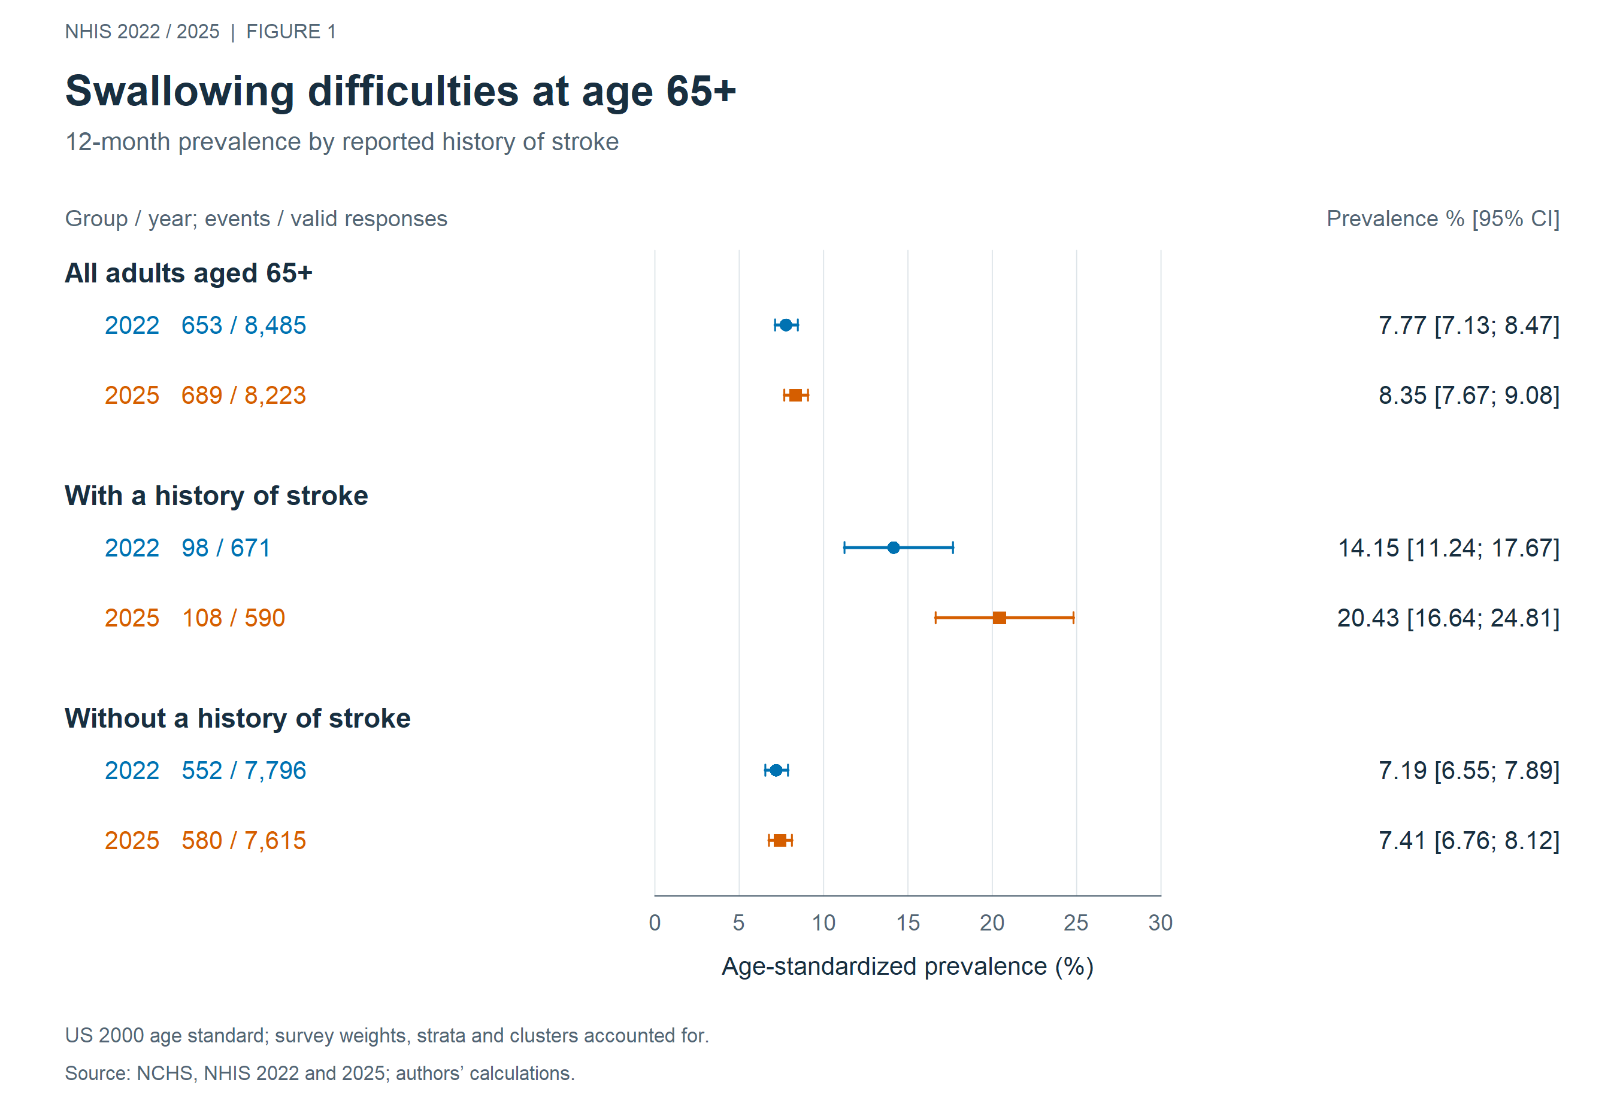

Figure 2
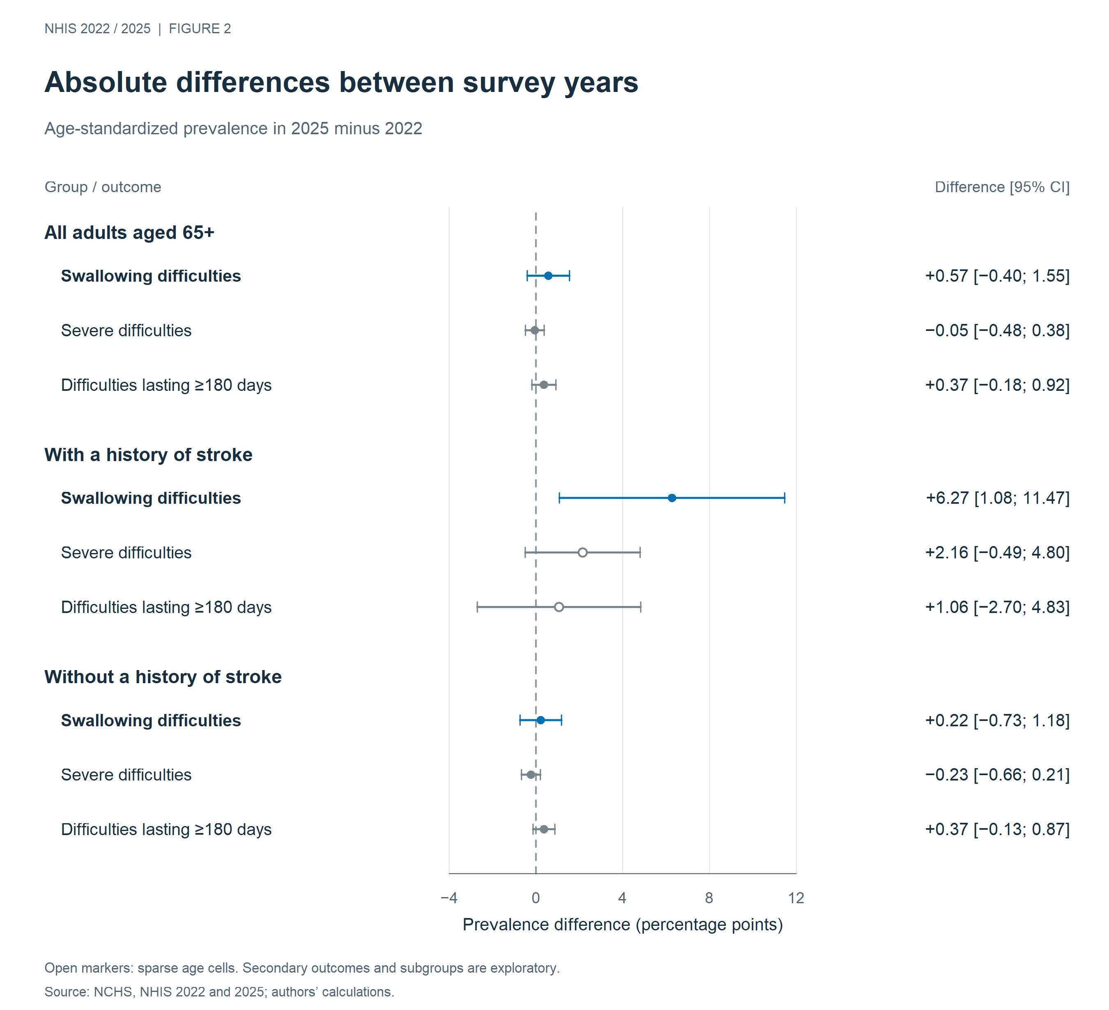

Figure 3
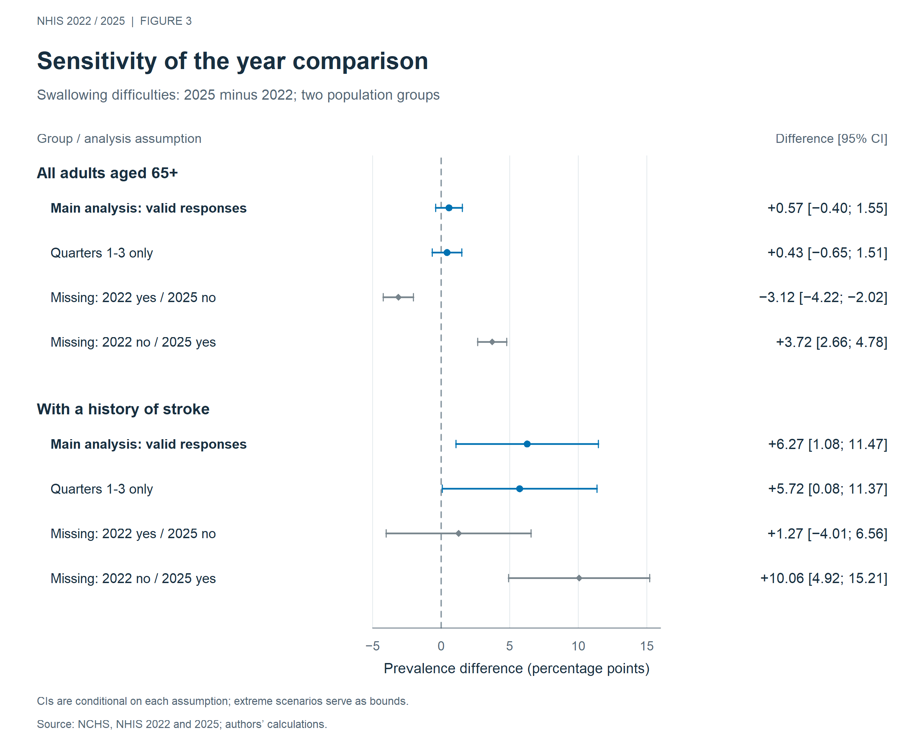

Figure 4


