Lower Overall Prevalence of Swallowing Difficulties in US Adults but Higher Estimates Among Stroke Survivors

Abstract
We compared reported swallowing difficulties between 2022 and 2025 across all US adults, followed by a separate analysis of adults with stroke history. We analyzed National Health Interview Survey Sample Adult files using survey weights and design-based variance estimation. The primary outcome was reported swallowing difficulty during the preceding 12 months. We reported crude prevalence and prevalence standardized to the projected US 2000 adult age distribution. Supporting analyses examined sex adjustment, self-response restriction, interview period and missing outcomes. Valid primary responses were available for 26,490 adults in 2022 and 23,441 in 2025, including 959 and 862 with stroke history. Overall age-standardized prevalence decreased from 6.11% to 5.18%, a difference of −0.93 percentage points (95% confidence interval [CI], −1.43 to −0.42). Crude prevalence decreased from 6.18% to 5.43%. Among adults with stroke history, age-standardized prevalence was 12.49% and 21.15%, respectively, a difference of 8.66 points (95% CI, −1.03 to 18.35). This estimate was imprecise because of sparse younger stroke cells. The stroke-group difference decreased to 4.03 points (95% CI, −5.59 to 13.64) with self-response restriction, whereas the overall decrease persisted. Reported swallowing difficulties were less common in the overall adult population in 2025. Higher stroke-group point estimates warrant further surveillance but were imprecise and sensitive to response-status restriction. The 2025 collection interruption and different response-status measures limit comparability. These findings concern reported symptoms rather than clinically confirmed dysphagia or individual change.
Keywords Swallowing difficulties; Adults; Stroke; National Health Interview Survey; Prevalence; Population survey

Introduction
Swallowing difficulties occur across adulthood and can remain unrecognized outside clinical settings. In the 2012 National Health Interview Survey (NHIS), approximately 4.0% of US adults reported a swallowing problem during the preceding year, and relatively few affected respondents sought professional care. A subsequent comparison of NHIS 2012 and 2022 reported an increase in all-adult prevalence from 4.02% to 5.91%. Whether reported swallowing difficulties were more common in 2025 than in 2022 is therefore relevant to population surveillance. [1, 2]
Population estimates depend on the age range, symptom definition, recall period and method of assessment. Reviews of community-dwelling older adults show substantial heterogeneity, while a US National Health and Aging Trends Study (NHATS) analysis reported annual weighted prevalence between 8.7% and 10.2% across 11 rounds, with symptoms often reported intermittently. Age-specific studies provide useful context, but their estimates cannot substitute for prevalence in the full adult population. Separate cross-sectional surveys also cannot establish individual deterioration or recovery. [3–5]
Adults with a history of stroke are a clinically important population for a separate analysis. Swallowing abnormalities identified during acute stroke admission differ from symptoms reported later by community-dwelling survivors. Acute-stroke estimates vary between screening, clinical examination and instrumental assessment, and swallowing function can change after the acute event. Clinical guidance emphasizes recognition and assessment of post-stroke dysphagia, but a population-survey symptom question neither establishes a diagnosis nor identifies the cause of the reported problem. [6–8]
Our primary analysis compared the prevalence of reported swallowing difficulties between NHIS 2022 and 2025 across all adults aged 18 years or older, followed by a separate analysis of adults reporting a stroke history. We reported crude prevalence and comparisons standardized to a common adult age distribution. Supporting analyses examined adults without stroke history, substantial difficulty, prolonged symptoms and the sensitivity of comparisons to sex adjustment, response status, interview period and missing outcomes. The study was designed to describe population differences between two survey years, not to determine their causes.

Methods
Study design and population. We analyzed the 2022 and 2025 NHIS public-use Sample Adult files as repeated cross-sectional surveys of the civilian noninstitutionalized US population. Analyses included adults with known age of at least 18 years; the highest public-use age value represents 85 years or older. The full adult survey design was constructed before applying analytical domain restrictions. The files provide separate cross-sectional observations and do not support individual longitudinal follow-up. [9, 10]
Survey comparability. The swallowing items and stroke-history item had matching wording, universes and response codes. Nevertheless, a new sampling design began in 2025, and survey operations were disrupted by a lapse in federal appropriations. Collection was paused from October 1 through November 16 and restarted on November 18. October and November sample interviewing was delayed; the December sample was fielded in January 2026 and excluded from the 2025 file. The annual file therefore contains 11 sample months with adjusted weights. The altered end-of-year interview-quarter code was retained in the annual analysis rather than treated as missing. [10–12]
Outcomes and stroke history. The primary outcome was a positive response to VSLSWYR_A, which asks about swallowing problems during the preceding 12 months and gives examples involving food, pills and liquids. Secondary outcomes were reporting “a lot” of difficulty (VSLSWDIF_A=2) and symptoms on at least 180 days (VSLSWDYS_A=6). These were population outcomes: respondents without swallowing problems were classified as negative, whereas missing severity or duration among affected respondents remained missing. Duration categories were not treated as exact continuous measurements. Stroke history indicated a reported previous diagnosis by a doctor or other health professional (STREV_A=1). Stroke timing and the attribution of swallowing symptoms to stroke were unavailable. [11, 12]
Analysis planning and missing data. The analysis plan was revised on November 8, 2026, to make the overall adult comparison and the separate stroke-history analysis the central questions. This revision followed an earlier analysis restricted to adults aged 65 years or older and inspection of unweighted adult feasibility counts; it preceded inspection of weighted all-adult outcome estimates. The revised plan and its checksum are retained with the study materials. The study was not externally preregistered. Endpoint-specific complete cases were analyzed. Unknown stroke status excluded respondents only from stroke-group comparisons. Refused, unknown and not-ascertained responses were not recoded as negative. Sensitivity scenarios assigned all missing primary outcomes to negative or positive responses, both identically across years and under opposing assumptions; these were extreme assignments rather than missing-at-random imputations.
Survey estimation and standardization. Analyses used R 4.6.0 and survey 4.5, with Taylor linearization, annual adult weights and the public-use strata and primary sampling units. Following NCHS guidance for public-use cross-year comparisons, weights and design identifiers were retained unchanged when files were concatenated. All domains were derived from the full survey design. Direct standardization used five age groups: 18–44, 45–64, 65–74, 75–84 and 85 years or older. Corresponding projected US 2000 population counts were normalized within ages 18 and older and applied identically in both years and all stroke groups. These standardized prevalences describe a common reference population; they do not represent the actual age distribution of stroke survivors. Crude weighted estimates additionally describe each year's observed population distribution. [10, 13, 14]
Contrasts and uncertainty. The principal temporal contrast was the 2025-minus-2022 age-standardized prevalence difference, first in the overall adult population and then separately among adults with stroke history. Crude differences were reported alongside it. Prevalence intervals used logit-transformed delta-method standard errors and t critical values; difference intervals used linear contrasts and the full covariance matrix of jointly estimated year-by-age domain means. Degrees of freedom reflected the relevant survey domain. A supporting additive interaction compared the stroke-group year difference with the no-stroke-group year difference. This descriptive contrast was not interpreted as a causal difference-in-differences design. All confidence intervals and P values are nominal, without multiplicity adjustment.
Precision and quality checks. We reported unweighted denominators and event counts and flagged contributing year-by-age cells with fewer than 30 valid observations, fewer than 10 events or fewer than 10 nonevents, as well as relative standard errors greater than 30%. Central estimates were retained when flagged, with explicit qualification of their uncertainty. Secondary outcomes and supporting comparisons were exploratory. Record and event counts were checked against codebooks. Standardized estimates were independently reproduced from age-specific weighted means, and covariance estimates were checked against saturated survey models and an independent calculation from primary-sampling-unit totals. These checks do not constitute a complete NCHS publication-reliability assessment. Reporting was informed by STROBE. [15]
Interview-period sensitivity. We repeated primary-outcome comparisons within interview quarters 1–3, using the full survey design and annual weights. This explored the influence of the disrupted end-of-year period. It did not recalibrate nonresponse weights for the restricted interval and should not be interpreted as a fully seasonally adjusted annual comparison. [10]
Additional sex adjustment. Survey-weighted logistic regression with quasibinomial variance provided an additional adjustment for sex. Separate models for the overall population and each stroke-history group included year, age group and sex. A joint model for the supporting interaction allowed year, age-group and sex associations to differ by stroke history. Marginal predictions used the same fixed hypothetical reference: US 2000 adult age weights crossed with 50% male and 50% female within each age group. Differences and additive interactions used analytic gradients, the full coefficient covariance and residual survey degrees of freedom. Numerical gradients and model predictions were independently checked. These model-based margins require the specified relationships between year, age group and sex and differ from direct standardization of age-specific means.
Self-response sensitivity. Public proxy indicators changed between years. A conservative 2022 definition required the sample adult to be available (AVAIL_A=1) with PROXY_A outside its question universe; other ambiguous combinations were excluded. In 2025, PROXYFLAG_A=2 identified self-response. Direct standardization and age-and-sex-adjusted models were repeated in these domains. This restriction changes the represented population toward adults able to respond themselves. Differences in how self- and proxy responses were identified may exclude some true self-responses in 2022 and complicate comparison between years. The analysis does not establish that proxy responses are erroneous. [11, 12]
Generative AI assistance. ChatGPT (OpenAI) assisted with drafting analysis code, manuscript text and figure layouts, and with formatting. Statistical estimates were produced by the R scripts; numerical validation procedures are described above.

Results
Study sample. The source files contained 27,651 adults in 2022 and 24,215 in 2025. Excluding 64 and 60 records with unknown age left 27,587 and 24,155 eligible adults. Valid primary responses were available for 26,490 and 23,441, with 1,716 and 1,463 positive responses, respectively. Primary-outcome missingness was 1,097/27,587 (3.98%) in 2022 and 714/24,155 (2.96%) in 2025, unweighted. Stroke-group analyses included 959 and 862 valid responses, with 140 and 157 positive responses. Corresponding no-stroke denominators were 25,496 and 22,551. Sample inclusion and response counts are shown in Table 1.
Table 1 Sample inclusion and primary outcome counts
Sample or outcome | 2022 | 2025
Original adult records | 27,651 | 24,215
Excluded for unknown age | 64 | 60
Eligible adults with known age | 27,587 | 24,155
Valid primary responses | 26,490 | 23,441
Missing primary responses | 1,097 | 714
Positive primary responses | 1,716 | 1,463
Stroke history among eligible adults | 1,008 | 902
Valid stroke-group responses | 959 | 862
Positive stroke-group responses | 140 | 157
Unknown stroke history among eligible adults | 38 | 34
Valid no-stroke responses | 25,496 | 22,551
Positive no-stroke responses | 1,569 | 1,305
All counts are unweighted. Positive responses indicate reported swallowing difficulties during the preceding 12 months. Unknown stroke status affects stroke-group analyses but does not exclude an otherwise valid response from the overall analysis. Outcome-specific missing responses are excluded from prevalence estimation.
Overall adult prevalence. Crude weighted prevalence was 6.18% in 2022 and 5.43% in 2025, a difference of −0.75 percentage points (95% CI, −1.24 to −0.25). Age-standardized prevalence was 6.11% (95% CI, 5.75 to 6.48) and 5.18% (95% CI, 4.84 to 5.54), respectively. The principal difference was −0.93 points (95% CI, −1.43 to −0.42; P<.001), indicating lower reported symptom prevalence in 2025.
Separate stroke-history analysis. Among adults with stroke history, crude weighted prevalence was 14.02% in 2022 and 19.22% in 2025, a difference of 5.20 points (95% CI, 0.89 to 9.52). Age-standardized prevalence was 12.49% (95% CI, 7.88 to 19.23) and 21.15% (95% CI, 14.30 to 30.12), respectively. The principal standardized difference was 8.66 points (95% CI, −1.03 to 18.35; P=.080). Its interval included no difference and a large increase, and the estimate was flagged for sparse contributing age cells. Among adults without stroke history, standardized prevalence decreased from 5.91% to 4.88%, a difference of −1.03 points (95% CI, −1.53 to −0.53). The supporting additive interaction was 9.69 points (95% CI, 0.02 to 19.37; P=.049), with the same sparse-cell qualification. Primary estimates are shown in Table 2 and Fig. 1.
Table 2 Primary prevalence and between-year differences
Population | Method | 2022 prevalence % (95% CI) | 2025 prevalence % (95% CI) | Difference pp (95% CI)
All adults | Crude | 6.18 (5.84 to 6.54) | 5.43 (5.09 to 5.80) | −0.75 (−1.24 to −0.25)
All adults | Age standardized | 6.11 (5.75 to 6.48) | 5.18 (4.84 to 5.54) | −0.93 (−1.43 to −0.42)
Stroke history | Crude | 14.02 (11.52 to 16.96) | 19.22 (16.09 to 22.80) | 5.20 (0.89 to 9.52)
Stroke history | Age standardized | 12.49 (7.88 to 19.23) | 21.15 (14.30 to 30.12) | 8.66 (−1.03 to 18.35)
No stroke history | Crude | 5.94 (5.60 to 6.29) | 5.04 (4.71 to 5.39) | −0.89 (−1.38 to −0.41)
No stroke history | Age standardized | 5.91 (5.56 to 6.28) | 4.88 (4.55 to 5.23) | −1.03 (−1.53 to −0.53)
CI, confidence interval; pp, percentage points. Differences are 2025 minus 2022. Direct age standardization uses the projected US 2000 adult population with five age groups and full survey covariance. Crude estimates describe each year’s weighted population. The standardized stroke estimate is flagged because a contributing age cell has fewer than ten events. The overall and stroke-history comparisons are central; no-stroke estimates support interpretation. Intervals are nominal without multiplicity adjustment.
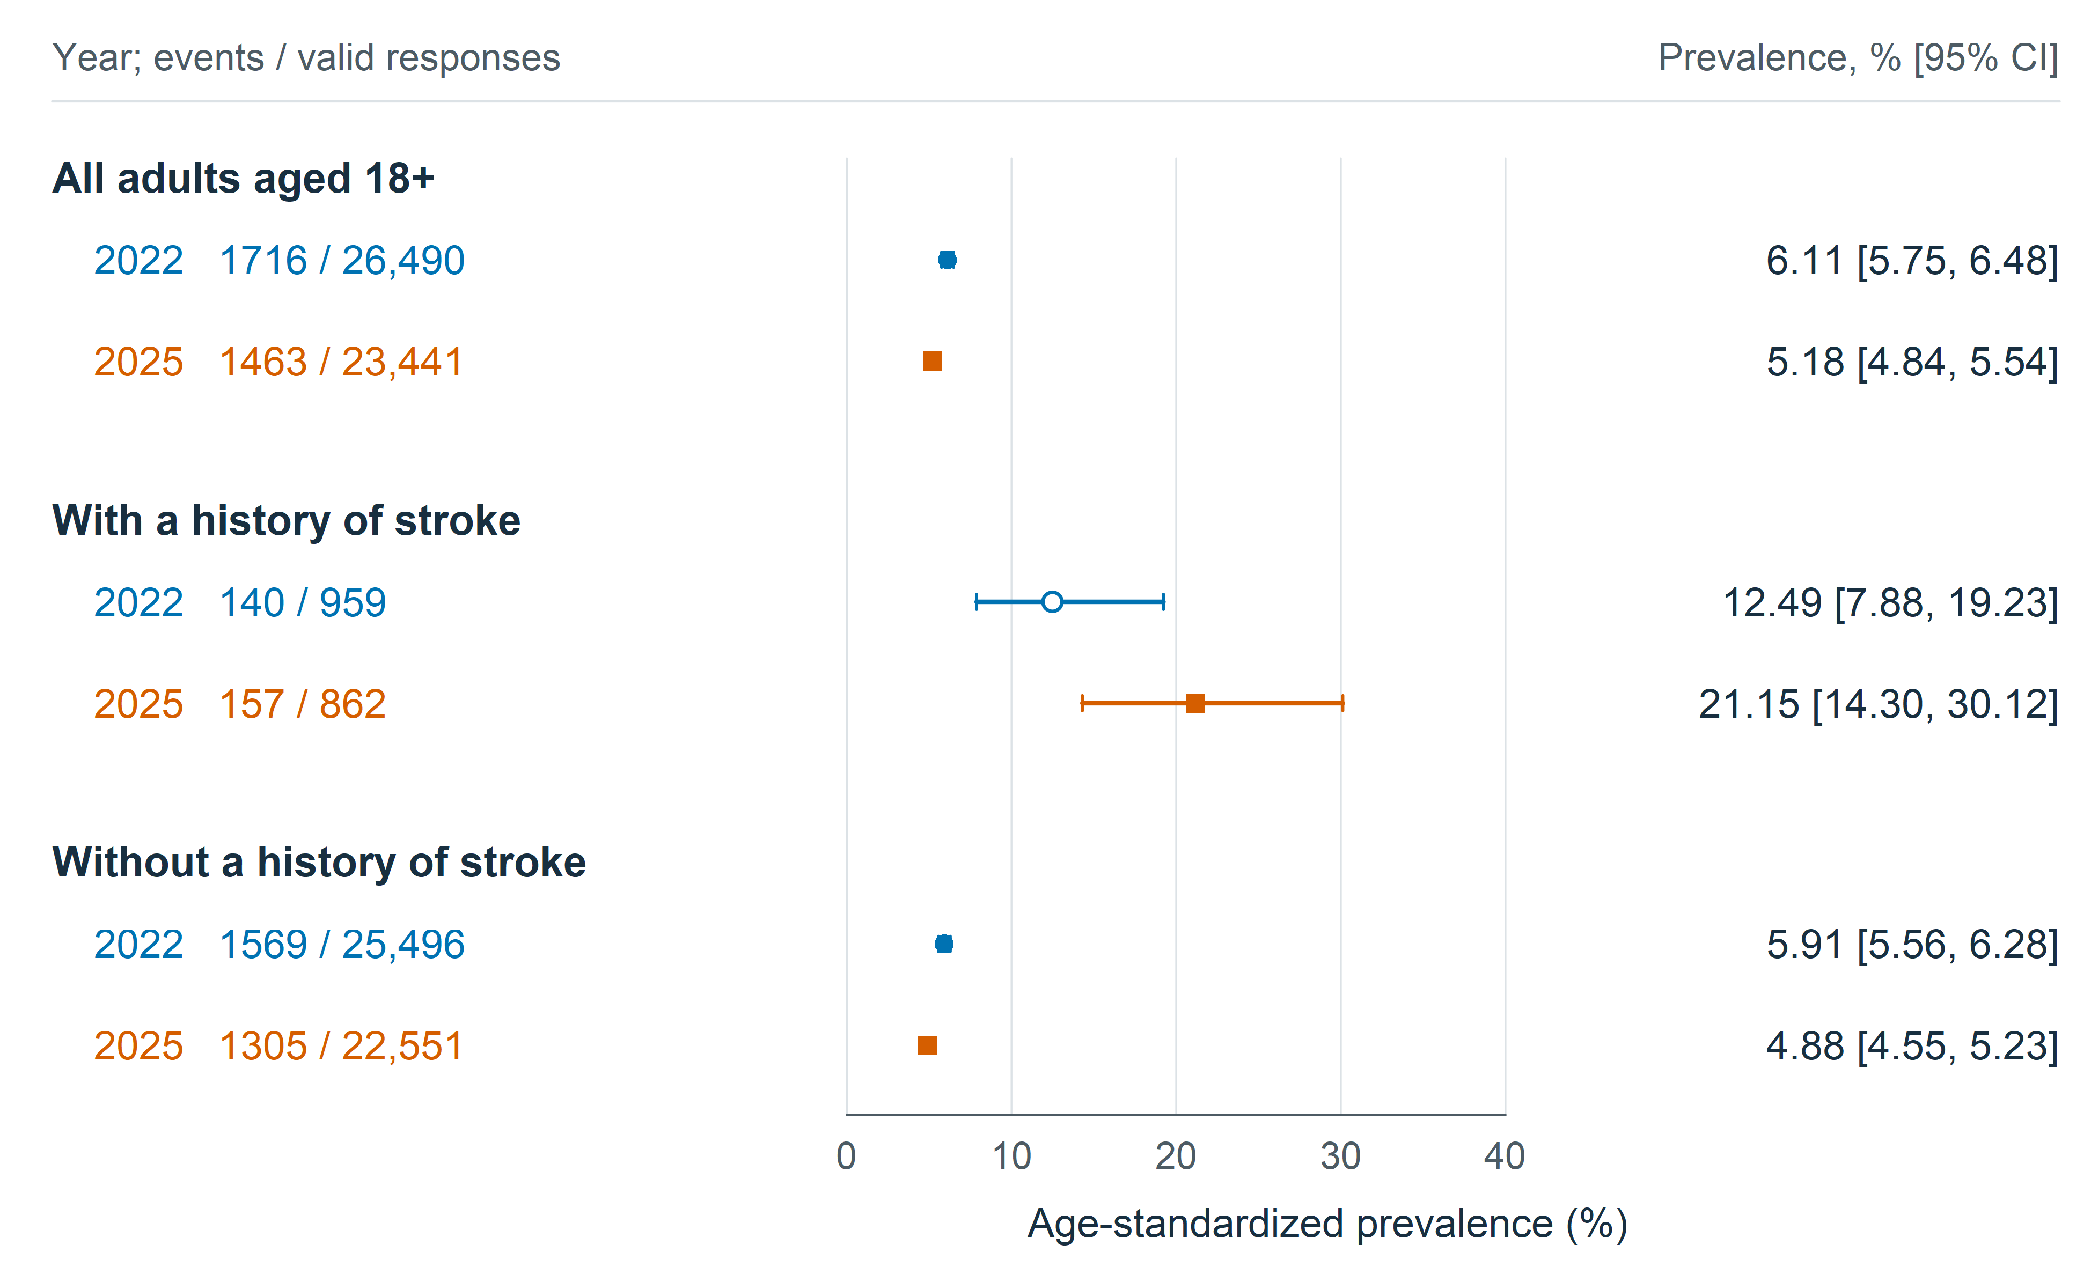
Fig. 1 Reported swallowing difficulties among US adults aged 18 years and older in 2022 and 2025. Points indicate survey-weighted prevalence standardized to the projected US 2000 adult age distribution; horizontal lines indicate 95% confidence intervals. Circles denote 2022 and squares denote 2025. Event counts and valid-response denominators are unweighted and therefore do not reproduce weighted percentages. Open markers identify estimates flagged for sparse contributing age cells or high relative standard error. The overall population and the separate stroke-history population are the central analyses; the no-stroke comparison is supporting. The overall group includes unknown stroke status and overlaps both stroke-history groups. Standardized estimates use a common reference age distribution, rather than the actual distribution of stroke survivors. Source: National Health Interview Survey public-use data
Secondary outcomes. Overall age-standardized prevalence of substantial difficulty decreased from 1.35% to 0.95%, a difference of −0.40 points (95% CI, −0.62 to −0.18). Prolonged symptoms were reported by 1.04% and 1.14%, respectively, a difference of 0.10 points (95% CI, −0.12 to 0.32). Stroke-group differences were 4.47 points for substantial difficulty (95% CI, −1.05 to 9.98) and 7.12 points for prolonged symptoms (95% CI, −0.63 to 14.87). Sparse contributing stroke cells and wide intervals limited the precision of these estimates (Fig. 2).
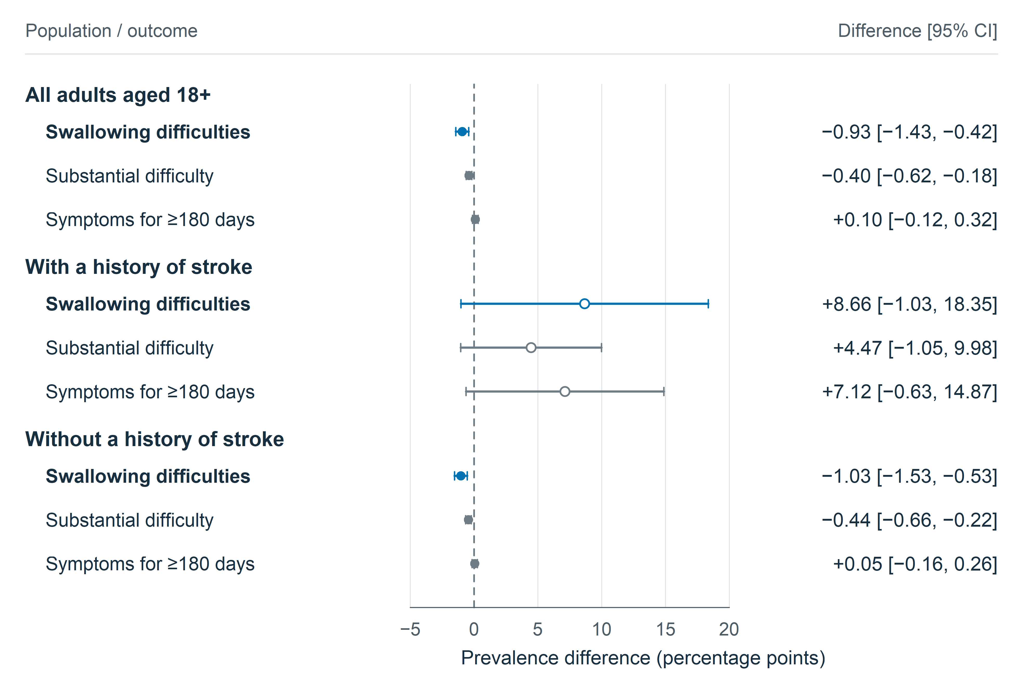
Fig. 2 Absolute age-standardized prevalence differences between 2025 and 2022 by outcome and stroke history. Points indicate differences in percentage points; horizontal lines show 95% confidence intervals. The dashed zero line denotes no difference. Reported swallowing difficulty is the primary outcome. Substantial difficulty represents the response “a lot”; prolonged symptoms represent at least 180 days during the preceding year. Both secondary outcomes use population denominators, with valid primary-negative responses coded as negative and missing follow-up responses retained as missing. Open markers flag sparse contributing year-by-age cells or high relative standard error. Secondary outcomes and the no-stroke comparison are supporting analyses, with nominal intervals and no multiplicity adjustment. Source: National Health Interview Survey public-use data
Interview-period and missing-outcome sensitivities. Restricting interviews to quarters 1–3 yielded an overall standardized difference of −0.61 points (95% CI, −1.17 to −0.05) and a stroke-group difference of 10.46 points (95% CI, 0.30 to 20.63). Assigning all missing outcomes to negative responses in both years yielded differences of −0.81 points overall and 7.93 points in the stroke group; assigning all to positive responses yielded −2.26 and 8.86 points, respectively. Opposing assignments across years produced overall point differences from −5.22 to 2.15 points and stroke-group differences from 2.28 to 14.51 points. These extreme scenarios demonstrate sensitivity to missingness assumptions and do not identify a preferred estimate. The interview-period and opposing-assignment estimates and their sampling intervals are shown in Supplementary Fig. S1.
Additional age and sex adjustment. Model-adjusted differences were −0.73 points overall (95% CI, −1.21 to −0.25), 5.32 points in the separate stroke-history model (95% CI, 0.76 to 9.88), and −0.88 points without stroke history (95% CI, −1.36 to −0.40). Three respondents with valid primary outcomes in 2022 and 20 in 2025 lacked usable sex information and were excluded from these models. The stroke model’s more precise contrast than direct standardization should be interpreted in light of its common year association across age groups.
Restriction to confirmed self-responses. Valid primary-outcome domains decreased to 25,881 adults in 2022 and 22,995 in 2025; stroke-group denominators were 884 and 791. The directly age-standardized difference was −1.06 points overall (95% CI, −1.56 to −0.56). Stroke-group prevalence was 13.19% and 17.22%, a difference of 4.03 points (95% CI, −5.59 to 13.64). Combining self-response restriction with age and sex adjustment yielded differences of −0.88 points overall (95% CI, −1.35 to −0.40) and 3.46 points in the stroke group (95% CI, −0.64 to 7.56). The overall decrease persisted across these methods, whereas stroke-group point estimates were smaller and their intervals included no difference (Table 3; Fig. 3).
Table 3 Primary outcome differences across analysis methods
Method | Overall difference pp (95% CI) | Stroke-history difference pp (95% CI)
Direct age standardization | −0.93 (−1.43 to −0.42) | 8.66 (−1.03 to 18.35)
Age and sex adjustment | −0.73 (−1.21 to −0.25) | 5.32 (0.76 to 9.88)
Self-responses and age standardization | −1.06 (−1.56 to −0.56) | 4.03 (−5.59 to 13.64)
Self-responses with age and sex adjustment | −0.88 (−1.35 to −0.40) | 3.46 (−0.64 to 7.56)
CI, confidence interval; pp, percentage points. Differences are 2025 minus 2022. Model-adjusted estimates use separate population-specific models and the US 2000 age distribution crossed with a fixed 50:50 male:female reference. Self-response restriction uses conservative year-specific classifications that are not fully equivalent and changes the target group. Direct stroke estimates are flagged for sparse contributing age cells. Confidence intervals are nominal.
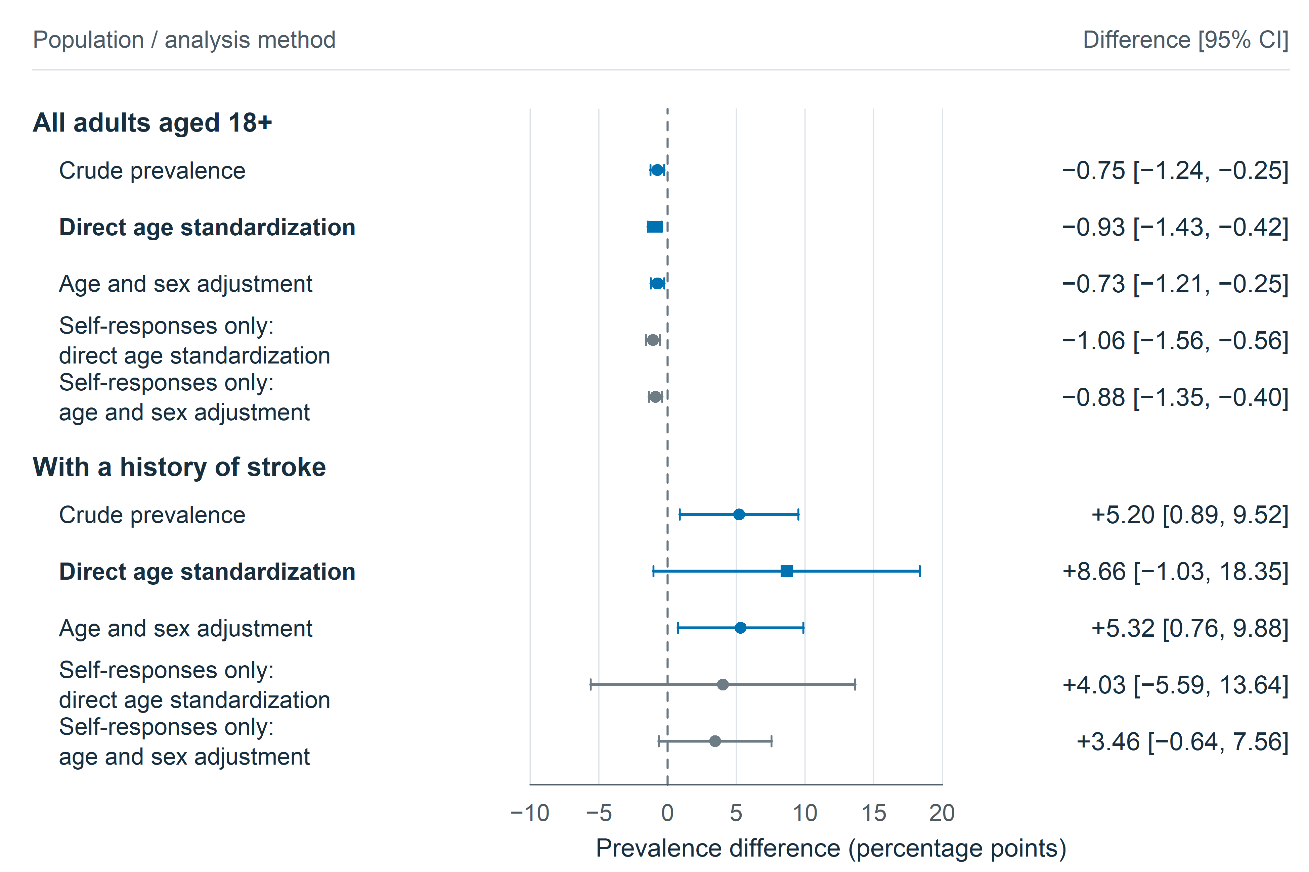
Fig. 3 Differences in reported swallowing difficulties between 2025 and 2022 across analysis methods, overall and separately among respondents with stroke history. Points and horizontal lines show prevalence differences in percentage points and 95% confidence intervals; the dashed line denotes no difference. Squares mark the principal direct age-standardized contrast. Crude estimates describe the observed weighted population. Direct standardization uses the projected US 2000 adult age distribution. Survey-weighted logistic models adjust for year, age group and sex, with marginal predictions averaged over the same age distribution and a fixed 50:50 male:female distribution. Separate models are fitted for the overall population and the stroke group. Restriction to confirmed self-responses excludes proxy and ambiguous response status using conservative year-specific classifications; these classifications are not fully equivalent across years and the restriction changes the target group. Direct estimates remain sensitive to sparse contributing age cells; model-based margins borrow information across age cells and remain subject to model assumptions. Source: National Health Interview Survey public-use data
Age-specific comparisons. The largest estimated decrease in the overall population occurred at ages 18–44: −1.95 points (95% CI, −2.67 to −1.24). Intervals for the other overall age groups included no difference. In the stroke-history group, the corresponding estimate at ages 18–44 was 13.82 points (95% CI, −4.28 to 31.93), based on 5/52 and 11/55 positive responses in 2022 and 2025. These sparse counts and the large standard-population weight for this age group contributed to the uncertainty of the adult stroke estimate. All age-specific contrasts and counts are shown in Fig. 4.
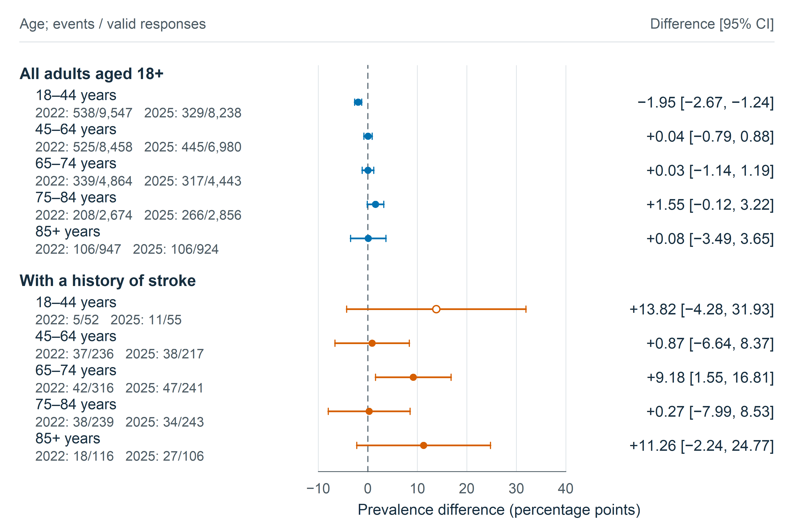
Fig. 4 Age-specific differences in reported swallowing difficulties between 2025 and 2022, overall and separately among respondents with stroke history. Points indicate survey-weighted prevalence differences in percentage points; horizontal lines show 95% confidence intervals. The dashed zero line denotes no difference. Age is age at interview, not age at stroke onset; the public-use age variable is top-coded at 85 years. Counts show unweighted events and valid-response denominators in each survey year. Open markers flag sparse contributing cells or high relative standard error. These age-specific comparisons support interpretation of the adult analyses and use nominal intervals without multiplicity adjustment. Source: National Health Interview Survey public-use data

Discussion
Reported swallowing difficulties were less common in the overall adult population in 2025 than in 2022. The decrease was apparent in crude and age-standardized estimates and persisted with sex adjustment and self-response restriction. The separate stroke-history analysis showed a contrasting pattern: point estimates were higher in 2025, but the principal age-standardized difference was imprecise and the estimated change decreased when restricted to confirmed self-responses. The evidence therefore supports an overall population decrease between the two observed years alongside an uncertain, potentially adverse change among stroke survivors.
The all-adult comparison extends an established NHIS research framework. Previous work documented an increase in reported swallowing difficulties between 2012 and 2022. The present analysis addresses the shorter, subsequent interval using both crude prevalence and a common age standard. The previously reported 2022 value of 5.91% differs from our crude complete-case estimate of 6.18%; differences in analytical eligibility or missing-response handling could contribute, but we did not establish the reason. Standardization and survey operations must also be considered when relating results across studies; earlier comparisons crossed the 2019 NHIS redesign. Two observed years identify a between-year difference, not a continuous trajectory or the timing of a change. [1, 2, 9]
Older-adult prevalence estimates provide context for age-related variation but should not be combined with the current all-adult results into a single prevalence series. NHATS and community studies from Japan, the United Kingdom and Korea used different target populations, questionnaires or clinical screening methods. The UK questionnaire study, for example, excluded participants with a history of neurological disease. The wide ranges and marked heterogeneity in reviews reinforce the importance of matching both measurement and population when interpreting differences between studies. [3–5, 16–18]
The separate stroke-history analysis concerns symptoms among community-dwelling survivors and cannot be interpreted as a comparison of acute post-stroke dysphagia. Time since stroke, severity and recurrence were unavailable. Symptoms may predate stroke or have another cause, and age at interview is not age at stroke onset. Acute-stroke studies use bedside or instrumental assessments and commonly report higher frequencies; longitudinal clinical observations also show that diet recovery and residual swallowing abnormalities need not coincide. The population survey therefore complements clinical surveillance while measuring a different outcome in a different setting. [6–8]
Response status helps explain why the stroke comparison needs qualification. Excluding proxy and ambiguous responses reduced the stroke-group point difference, but such restriction also changes the population represented. Differences in health, functional ability, reporting or classification could contribute; the analysis cannot establish that proxy reports inflated the unrestricted estimate. The stricter 2022 identification also differs from the direct 2025 flag. The overall decline persisted under restriction, while the stroke intervals remained compatible with both no change and appreciable increases. These patterns support transparent reporting of both populations rather than treating one response definition as the true result. [11, 12]
Reported symptoms matter even without diagnostic confirmation. NHIS 2022 analyses linked swallowing complaints with functional limitations, while NHATS analyses found associations with psychosocial health, food insecurity and being homebound. These studies provide context for potential service needs, although they are observational and some use overlapping source populations. Prospective community evidence links clinically assessed swallowing impairment with subsequent respiratory infection. Such findings justify attention to symptom burden but should not be treated as complications demonstrated in the present respondents. [19–22]
Care access remains a separate issue. Previous NHIS work identified disparities in reported swallowing problems and treatment, and a 2012/2022 comparison did not establish a corresponding clear improvement in treatment access. Our analysis did not test care utilization, treatment effectiveness or policy effects. Between-year differences therefore cannot be attributed to reduced access, inadequate rehabilitation or a specific policy. Those explanations require studies with appropriately measured exposures and temporal information. [23, 24]
Several limitations constrain inference. The single symptom question does not distinguish oropharyngeal from esophageal disorders, identify aspiration, or establish clinical severity. Validation of a multi-item instrument such as EAT-10 does not validate the NHIS item. Twelve-month recall, recognition of symptoms and proxy observation may affect reporting. Missing outcomes were handled transparently, but neither complete-case analysis nor extreme assignments remove selection bias. The exclusion of institutionalized adults is particularly relevant to people with severe disability, and weighting cannot guarantee correction of all differential nonresponse. [9, 10, 25]
The 2025 collection interruption creates an additional comparability limitation. Adjusted annual weights, delayed October and November samples, and the absence of the December sample do not recreate uninterrupted collection. Restriction to quarters 1–3 retained the directional overall and stroke patterns, but used annual weights and did not address all participation or seasonal effects. The adult age standard gives ages 18–44 approximately 53% of the reference weight, although this age group represents only about 9–10% of the weighted stroke sample. With only five and eleven positive responses in that stroke age cell, direct standardization produces substantial uncertainty. Crude estimates describe the actual weighted stroke population more directly, while model-adjusted margins impose additional assumptions. Broad age groups cannot remove all within-group age differences. Multiple comparisons, a borderline supporting interaction and sparse secondary cells further argue against a definitive stroke-specific increase. [10]
Strengths include a population-based sampling framework covering the full adult age range, identical outcome coding, explicit preservation of the public-use survey design, a common age standard and reproducible covariance calculations. The revised analysis hierarchy is documented, including its development after the earlier older-adult analysis. Additional survey waves, clinically characterized community stroke cohorts and consistent response-status measures would help distinguish persistent changes in symptom burden from differences in survey participation and survivor composition.

Conclusion
Reported swallowing difficulties were less prevalent among US adults overall in 2025 than in 2022. Adults with stroke history had higher point estimates in 2025, but their principal standardized comparison was imprecise and sensitive to response-status restriction. The findings support continued population surveillance and focused assessment of swallowing symptoms among stroke survivors, without establishing changes in clinically confirmed dysphagia or the causes of the observed differences.

Supplementary figure legend
Fig. S1 Sensitivity to interview period and missing responses. Points and horizontal lines indicate age-standardized prevalence differences between 2025 and 2022 in percentage points and 95% confidence intervals. The dashed line denotes no difference. Restriction to interview quarters 1–3 retains annual weights without recalibration. The two extreme scenarios assign all missing primary responses to yes in 2022 and no in 2025, or vice versa. Their intervals represent sampling uncertainty conditional on each assignment and do not form a confidence band across missing-data mechanisms. These scenarios do not address complete interview nonparticipation or unknown age and stroke status. Source: National Health Interview Survey public-use data

Data availability
The original public-use National Health Interview Survey Sample Adult datasets are publicly available from the Centers for Disease Control and Prevention and the National Center for Health Statistics as compressed CSV files: NHIS 2022 (adult22csv.zip) and NHIS 2025 (adult25csv.zip). The unmodified source tables contain 27,651 records and 637 variables for 2022 and 24,215 records and 577 variables for 2025, before analytical exclusions. 2022 documentation and 2025 documentation provide the questionnaires, codebooks and survey descriptions. [9, 10]
The study materials include original-file checksums, variable mappings, analysis plans, reproducible R code, numerical results, and figure-generation code. The literature search record documents a targeted narrative search, rather than a systematic review.

References
1. Bhattacharyya N (2014) The prevalence of dysphagia among adults in the United States. Otolaryngol Head Neck Surg 151:765–769. https://doi.org/10.1177/0194599814549156
2. Hong I, Bae S, Lee HK, Bonilha HS (2024) Prevalence of Dysphonia and Dysphagia Among Adults in the United States in 2012 and 2022. Am J Speech Lang Pathol 33:1868–1879. https://doi.org/10.1044/2024_AJSLP-23-00407
3. Madhavan A, LaGorio LA, Crary MA, Dahl WJ, Carnaby GD (2016) Prevalence of and Risk Factors for Dysphagia in the Community Dwelling Elderly: A Systematic Review. J Nutr Health Aging 20:806–815. https://doi.org/10.1007/s12603-016-0712-3
4. Rech RS, de Goulart BNG, Dos Santos KW, Marcolino MAZ, Hilgert JB (2022) Frequency and associated factors for swallowing impairment in community-dwelling older persons: a systematic review and meta-analysis. Aging Clin Exp Res 34:2945–2961. https://doi.org/10.1007/s40520-022-02258-x
5. Namasivayam-MacDonald A, Werbeloff M, Shune S (2026) Prevalence and Predictors of Self-Reported Swallowing Difficulties in Community-Dwelling Older Adults: A Population-Based Study from the National Health and Aging Trends Study (NHATS). Dysphagia 41:127–137. https://doi.org/10.1007/s00455-025-10860-0
6. Martino R, Foley N, Bhogal S, Diamant N, Speechley M, Teasell R (2005) Dysphagia after stroke: incidence, diagnosis, and pulmonary complications. Stroke 36:2756–2763. https://doi.org/10.1161/01.STR.0000190056.76543.eb
7. Mann G, Hankey GJ, Cameron D (1999) Swallowing function after stroke: prognosis and prognostic factors at 6 months. Stroke 30:744–748. https://doi.org/10.1161/01.str.30.4.744
8. Dziewas R, Michou E, Trapl-Grundschober M, Lal A, Arsava EM, Bath PM, Clavé P, Glahn J, Hamdy S, Pownall S, Schindler A, Walshe M, Wirth R, Wright D, Verin E (2021) European Stroke Organisation and European Society for Swallowing Disorders guideline for the diagnosis and treatment of post-stroke dysphagia. Eur Stroke J 6:LXXXIX–CXV. https://doi.org/10.1177/23969873211039721
9. National Center for Health Statistics (2023) National Health Interview Survey, 2022 survey description. Centers for Disease Control and Prevention. https://ftp.cdc.gov/pub/Health_Statistics/NCHS/Dataset_Documentation/NHIS/2022/srvydesc-508.pdf
10. National Center for Health Statistics (2026) National Health Interview Survey, 2025 survey description. Centers for Disease Control and Prevention. https://ftp.cdc.gov/pub/Health_Statistics/NCHS/Dataset_Documentation/NHIS/2025/srvydesc-508.pdf
11. National Center for Health Statistics (2023) 2022 National Health Interview Survey: Codebook for Sample Adult File. Centers for Disease Control and Prevention. https://ftp.cdc.gov/pub/Health_Statistics/NCHS/Dataset_Documentation/NHIS/2022/adult-codebook.pdf
12. National Center for Health Statistics (2026) 2025 National Health Interview Survey: Codebook for Sample Adult File. Centers for Disease Control and Prevention. https://ftp.cdc.gov/pub/Health_Statistics/NCHS/Dataset_Documentation/NHIS/2025/adult-codebook.pdf
13. Lumley T (2004) Analysis of Complex Survey Samples. J Stat Softw 9:1–19. https://doi.org/10.18637/jss.v009.i08
14. National Center for Health Statistics (2026) Age adjustment - Health, United States. https://www.cdc.gov/nchs/hus/sources-definitions/age-adjustment.htm. Accessed 6 Nov 2026
15. von Elm E, Altman DG, Egger M, Pocock SJ, Gøtzsche PC, Vandenbroucke JP, STROBE Initiative (2007) The Strengthening the Reporting of Observational Studies in Epidemiology (STROBE) statement: guidelines for reporting observational studies. PLoS Med 4:e296. https://doi.org/10.1371/journal.pmed.0040296
16. Kawashima K, Motohashi Y, Fujishima I (2004) Prevalence of dysphagia among community-dwelling elderly individuals as estimated using a questionnaire for dysphagia screening. Dysphagia 19:266–271. https://doi.org/10.1007/s00455-004-0013-6
17. Holland G, Jayasekeran V, Pendleton N, Horan M, Jones M, Hamdy S (2011) Prevalence and symptom profiling of oropharyngeal dysphagia in a community dwelling of an elderly population: a self-reporting questionnaire survey. Dis Esophagus 24:476–480. https://doi.org/10.1111/j.1442-2050.2011.01182.x
18. Yang EJ, Kim MH, Lim J, Paik N-J (2013) Oropharyngeal Dysphagia in a community-based elderly cohort: the korean longitudinal study on health and aging. J Korean Med Sci 28:1534–1539. https://doi.org/10.3346/jkms.2013.28.10.1534
19. Hong I, Norman RS, Woo H-S, Jin Y, Reistetter TA (2024) Dysphagia and Functional Limitations Among Adults in the United States: Findings from the 2022 National Health Interview Survey. Dysphagia 39:1042–1051. https://doi.org/10.1007/s00455-024-10680-8
20. Leiman DA, Jones HN, North R, Porter Starr KN, Pieper CF, Cohen SM (2023) Self-Reported Dysphagia and Psychosocial Health Among Community-Dwelling Older Adults: Results of a National Study. J Gen Intern Med 38:3329–3338. https://doi.org/10.1007/s11606-023-08232-1
21. Jones HN, Leiman DA, Porter Starr KN, North R, Pieper CF, Robison RD, Cohen SM (2023) Dysphagia in Older Adults is Associated With Food Insecurity and Being Homebound. J Appl Gerontol 42:1993–2002. https://doi.org/10.1177/07334648231177568
22. Serra-Prat M, Palomera M, Gomez C, Sar-Shalom D, Saiz A, Montoya JG, Navajas M, Palomera E, Clavé P (2012) Oropharyngeal dysphagia as a risk factor for malnutrition and lower respiratory tract infection in independently living older persons: a population-based prospective study. Age Ageing 41:376–381. https://doi.org/10.1093/ageing/afs006
23. Zheng M, Zhou S, Hur K, Chambers T, O’Dell K, Johns M (2023) Disparities in the prevalence of self-reported dysphagia and treatment among U.S. adults. Am J Otolaryngol 44:103774. https://doi.org/10.1016/j.amjoto.2022.103774
24. Zhao R, He L, Albert SW, Li A, Rameau A (2025) Dysphagia Care in the United States: Examining the Impact of the Affordable Care Act on Access to Care. Otolaryngol Head Neck Surg 173:162–170. https://doi.org/10.1002/ohn.1239
25. Belafsky PC, Mouadeb DA, Rees CJ, Pryor JC, Postma GN, Allen J, Leonard RJ (2008) Validity and reliability of the Eating Assessment Tool (EAT-10). Ann Otol Rhinol Laryngol 117:919–924. https://doi.org/10.1177/000348940811701210

