Self reported swallowing problems and frequent loneliness in older US adults
Cinja Huber¹, Gero Lueg², Anel Karisik^{3,4}, Sriramya Lapa⁵, Anne Jung¹, Orhan Aktas¹, Michael Gliem¹, Paul Muhle⁶, Sonja Suntrup-Krueger⁶, Rainer Dziewas⁷, Bendix Labeit¹
¹ Department of Neurology, Medical Faculty, University Hospital Duesseldorf, Duesseldorf, Germany.
² Department of Geriatric Medicine, Marien Hospital Herne, Ruhr University Bochum, Herne, Germany.
³ Department of Neurology, Medical University of Innsbruck, Innsbruck, Austria
⁴ VASCage-Centre on Clinical Stroke Research, Innsbruck, Austria
⁵ Department of Neurology, Medical Faculty, University Hospital Frankfurt, Frankfurt, Germany
⁶ Department of Neurology, University Hospital Muenster, Muenster, Germany.
⁷ Department of Neurology and Neurorehabilitation, Klinikum Osnabrueck, Osnabrueck, Germany.
Corresponding author: Bendix Labeit. Department of Neurology, Medical Faculty and University Hospital Duesseldorf, Moorenstraße 5, 40225, Duesseldorf, Germany. Email: benlabeit@gmail.com

Abstract
Swallowing problems may affect social participation, but their relationship with subjective loneliness remains incompletely characterized. We examined this association among US adults aged 65 years or older using cross-sectional data from the 2025 National Health Interview Survey. Exposure was a self-reported swallowing problem during the previous 12 months; frequent loneliness meant always or usually feeling lonely. Survey-weighted modified Poisson regression accounted for the complex sampling design and estimated prevalence ratios. The primary model adjusted for demographic, socioeconomic, household, and health characteristics and in-person and telephone/video contact. Estimates were pooled across ten official income imputations. Logistic standardization provided adjusted absolute estimates. Among 8,231 respondents with valid exposure and outcome data, weighted frequent loneliness prevalence was 10.34% with swallowing problems and 4.17% without. The common regression sample included 8,094 respondents. The primary adjusted prevalence ratio was 1.83 (95% confidence interval 1.42–2.38). Standardized prevalence was 7.94% versus 4.27%, with a difference of 3.67 percentage points (95% confidence interval 1.75–5.60). Adjusted prevalence ratios increased across reported swallowing-difficulty categories. Additional adjustment for frequent depressive feelings attenuated the association, whereas response weighting produced similar estimates. Self-reported swallowing problems were associated with frequent loneliness after adjustment for measured health and social characteristics. These cross-sectional findings do not establish temporal direction or causality. Longitudinal studies should distinguish perceived loneliness from contact frequency and evaluate the social and emotional consequences of swallowing problems.
Keywords: Swallowing problems; Loneliness; Older adults; Social contact; National Health Interview Survey

Introduction
Swallowing problems affect more than the mechanics of food and fluid intake. They may restrict food choices, complicate shared meals, and influence confidence in social settings. Earlier US National Health Interview Survey (NHIS) analyses documented a substantial population burden of swallowing symptoms; analyses of 2012 and 2022 data reported higher symptom prevalence in the later survey, although questionnaire and survey-design differences require caution when interpreting trends. [1,2] Clinical and qualitative studies describe embarrassment, anxiety around meals, and restrictions on choice, control, and social participation. These studies support the relevance of psychosocial outcomes but do not establish their frequency or causes in the general older population. [3,4]
Loneliness is the subjective experience of inadequate social connection. It is related to, but distinct from, the frequency of contact, network size, and living arrangements. An individual can maintain regular contact while feeling lonely, or live alone without experiencing loneliness. Measurement studies and population research therefore distinguish perceived isolation from social disconnectedness. [5,6] Loneliness may interact with depressive symptoms and health-related behavior through several pathways; observational associations can be bidirectional and affected by shared determinants. [7,8]
Existing swallowing research addresses several different social constructs. In the 2019 National Health and Aging Trends Study (NHATS), self-reported dysphagia was associated with anxiety and lower well-being, but an adjusted association with social isolation was not established. [9] A Japanese community study using the Eating Assessment Tool and the Lubben Social Network Scale reported an association between dysphagia and social isolation. [10] A recent analysis of two US cohorts found associations with selected mental health or emotional-support measures, without consistent associations across isolation measures. [11] More directly, Maki and colleagues examined loneliness among Japanese older adults and found an association with aspiration risk alongside associations with depressive symptoms and conversation frequency. [12] These results suggest a relevant relationship while also demonstrating that swallowing symptoms, aspiration risk, loneliness, and social isolation cannot be treated as interchangeable measures.
We examined whether self-reported swallowing problems were associated with frequent loneliness among adults aged 65 years or older in the 2025 NHIS. We estimated the association before and after adjustment for measured social contact, assessed its pattern across reported swallowing difficulty, and quantified adjusted absolute prevalence differences. Supplementary analyses examined depressive feelings, participation, missing-data selection, proxy responses, and the full loneliness response distribution.

Methods

Data source and population
This cross-sectional secondary analysis used the public-use 2025 NHIS Sample Adult file and its multiply imputed income file. NHIS represents the civilian noninstitutionalized population of the United States. The adult file contained 24,215 respondents and 577 variables; the income file provided ten completed records per respondent. We linked the files using the public-use household identifier and imputation number, verified unique linkage, and retained the original downloaded files with checksums. The 2025 survey used a new sample design and experienced collection disruption during the federal government shutdown; the weighted final Sample Adult response rate was 41.3%. These features inform interpretation of representativeness. [13–15]
Adults with numeric age of at least 65 years were eligible. When numeric age was unavailable, the AGE65 indicator could establish eligibility but could not provide the age group needed for regression. Of 8,492 eligible respondents, 8,231 had valid swallowing and loneliness responses. Sequential models used the same 8,094 respondents with complete non-income covariates, including the participation variables used in the final model. This common sample permits meaningful comparisons across adjustment stages. The original analysis plan preceded the primary regressions; the supplementary plan was recorded after reviewing the primary results. Neither plan was prospectively registered. Reporting was informed by STROBE. [16]

Exposure outcome and covariates
Swallowing problems were defined by a yes response to VSLSWYR_A, which concerns a swallowing problem during the previous 12 months. Among respondents reporting a problem, VSLSWDIF_A distinguished a little difficulty, somewhere in between, and a lot of difficulty. We preserved the questionnaire's non-numeric ordering: response codes 1, 3, and 2, respectively. Structural skips among respondents without a swallowing problem were treated as the unexposed reference, not as missing severity. The measure describes self-reported symptoms and does not establish a clinical diagnosis, swallowing physiology, or aspiration. [17]
The primary outcome was frequent loneliness, defined as always or usually feeling lonely (LONELY_A codes 1–2), versus sometimes, rarely, or never (codes 3–5). A broader definition included sometimes. The five original categories were also retained for descriptive and cumulative-threshold analyses. This single question is not equivalent to a multi-item loneliness scale. Missing, refused, and unknown responses were not assigned to an outcome category. [5,17]
Covariates were age group (65–74, 75–84, or at least 85 years), recorded sex, education (less than high school, high school/GED, some college/associate degree, or bachelor's degree or higher), income-to-poverty ratio (<1, 1–<2, 2–<4, or ≥4), married/cohabiting status, living alone, mobility difficulty, hearing difficulty, and a history of stroke. Mobility and hearing responses were grouped as none, some, or a lot/unable. In-person contact and telephone/video contact with people outside the household were each categorized as less than once, 1–2, 3–4, or at least 5 times per week. Additional participation measures described religious-service attendance and group meetings over the previous year (none, 1–3, 4–11, or at least 12). Frequent depressive feelings meant daily or weekly feelings of depression, rather than a diagnosed depressive disorder. The accompanying variable dictionary provides the exact public-use variables and recoding. [17]

Primary statistical analysis
We constructed the survey design in the complete adult file using the final adult weight (WTFA_A), public-use stratum (PSTRAT), and primary sampling unit (PPSU), nested within stratum, before subsetting to analytic domains. Weighted descriptive estimates used valid responses for each measure. Unweighted counts are reported separately from weighted percentages. The primary descriptive confidence intervals used a design-based logit method; supplementary precision assessments used Korn–Graubard intervals, effective sample sizes, design degrees of freedom, and NCHS presentation criteria. [18]
Survey-weighted modified Poisson models with a log link and design-based variance estimation produced prevalence ratios and 95% confidence intervals. [19] M0 included swallowing problems alone; M1 added age and sex; M2 added socioeconomic, household, and health covariates; M3 additionally included the two contact measures and was designated the primary model. M4 added religious and group participation. These stages describe adjustment for measured characteristics. Because contact and participation could be consequences as well as common causes of swallowing problems and loneliness, differences across models were not interpreted as mediation or as fractions causally explained.
We fitted each model separately in all ten official income imputations and pooled coefficients and covariance matrices using Rubin's rules with finite design degrees of freedom. Official income imputation does not impute missing exposure, outcome, or other covariates. [15] We checked convergence, coefficient estimability, confidence intervals, sparse cells, and fitted values. A feasibility screen required at least 20 observations per exposure–outcome cell and at least ten outcome events per non-intercept parameter in M4; this was a practical screen rather than a guarantee against model instability. Analyses used R 4.6.0, survey 4.5, and mitools 2.7; full session information is supplied.

Supplementary analyses
Severity models replaced the binary exposure with the four-category severity variable. We also excluded proxy interviews, used the broader loneliness definition, fitted a logistic model, and added frequent depressive feelings. Depression-adjusted and comparison models used the same depression-complete sample. These analyses were exploratory and were not interpreted as identifying causal mechanisms.
To provide absolute estimates and avoid interpreting out-of-range Poisson fitted values as probabilities, we calculated survey-logistic predictive margins under both exposure settings, standardized to the analytic sample's covariate distribution. [20] We propagated design-based uncertainty and combined estimates across income imputations; prevalence and prevalence-ratio pooling used suitable transformed scales. The contrast estimates were pooled separately, so they need not equal arithmetic contrasts of separately pooled prevalence estimates exactly. These are model-standardized associations, not intervention effects.
We compared included and excluded respondents and estimated response weights for membership in the common analysis sample among 8,468 respondents with known numeric age of at least 65 years. The response model used age group, region, adult household count, presence of any children, and proxy status. Stabilized inverse-probability weights multiplied the survey weights. For the untruncated analysis, stacked estimating-equation linearization incorporated uncertainty from estimating response propensities. A secondary analysis winsorized the multipliers at the first and 99th percentiles and treated the resulting weights as fixed. These analyses address selection only under the response model and cannot remove bias from unmeasured or non-ignorable missingness. [21]
Finally, we fitted four survey-logistic cumulative loneliness thresholds and assessed equality of slopes using their joint covariance. Sixty-nine contrasts compared 23 non-intercept slopes at three thresholds with those at the primary threshold; Bonferroni correction controlled this diagnostic family. A common proportional-odds model was to be reported only if these checks did not reject its assumption. Confidence intervals elsewhere describe estimation uncertainty without a global multiplicity adjustment; supplementary findings should be interpreted accordingly.

Results

Participants and descriptive findings
The eligible sample comprised 8,468 respondents with numeric age of at least 65 years and 24 whose age eligibility was established only by AGE65. Swallowing status was valid for 8,244 and loneliness for 8,242; both were valid for 8,231. The common regression sample included 8,094 respondents, with 429 frequent-loneliness events. Of these respondents, 674 reported swallowing problems, including 82 with frequent loneliness; 7,420 reported no swallowing problems, including 347 with frequent loneliness. The full older-adult domain included 46 strata and 608 primary sampling units. The common regression domain retained 607 primary sampling units and 561 design degrees of freedom.
Weighted prevalence of swallowing problems was 8.12% (95% CI 7.46–8.84), and weighted prevalence of frequent loneliness was 4.66% (4.18–5.20), each using its available-response denominator. Frequent loneliness prevalence was 10.34% (8.16–13.03) with swallowing problems and 4.17% (3.69–4.71) without (Figure 1). Participant characteristics are summarized in Table 1, with full category-level estimates and missingness in Online Resource 2. All six core prevalence estimates and their complements passed the implemented NCHS precision criteria; these checks address statistical precision, not measurement or selection bias.
The full loneliness distribution showed differences beyond the dichotomous endpoint. Among respondents with versus without swallowing problems, 39.45% versus 54.76% reported never feeling lonely, 25.15% versus 18.23% sometimes, 4.49% versus 1.80% usually, and 5.86% versus 2.37% always. Corresponding rarely estimates were 25.06% and 22.83% (Online Resource 1, Fig. S3).

Sequential adjustment and symptom severity
The unadjusted PR was 2.48 (95% CI 1.90–3.24). Adjustment for age and sex changed the estimate little (PR 2.47); adding socioeconomic, household, and health characteristics reduced it to 1.94 (1.49–2.53). The primary model including contact measures yielded a PR of 1.83 (1.42–2.38). Adding religious and group participation yielded a PR of 1.85 (1.43–2.38) (Table 2; Figure 2). Thus, the association persisted across these measured dimensions of social connectedness.
In the severity analysis (n=8,093), adjusted PRs relative to no swallowing problem were 1.49 (95% CI 1.01–2.19) for a little difficulty, 1.92 (1.33–2.77) for somewhere in between, and 2.69 (1.76–4.11) for a lot of difficulty (Figure 3). These categories contained 361, 199, and 113 respondents, with 33, 27, and 22 frequent-loneliness events, respectively. The ordered point estimates suggest a severity gradient; no causal dose–response relationship or formal linear trend was established.

Absolute estimates and robustness
In the primary logistic standardization, estimated frequent loneliness prevalence was 4.27% (95% CI 3.77–4.83) under the no-problem exposure setting and 7.94% (6.27–10.01) under the swallowing-problem setting. The pooled prevalence difference was 3.67 percentage points (1.75–5.60), and the marginal PR was 1.86 (1.43–2.42) (Table 3; Online Resource 1, Fig. S2).
The depression-complete sample included 8,055 respondents. Within this sample, the PR was 1.84 (95% CI 1.42–2.38) before and 1.47 (1.14–1.89) after adding frequent depressive feelings. Depression-adjusted logistic standardization gave a prevalence difference of 2.26 percentage points (0.60–3.92). This attenuation is compatible with overlapping or shared psychosocial processes but does not quantify mediation. Excluding proxy interviews yielded a PR of 1.99 (1.55–2.56; n=7,829). The broader loneliness definition yielded a PR of 1.25 (1.10–1.41), and its standardized prevalence difference was 6.34 percentage points (2.58–10.11). The primary logistic conditional odds ratio was 2.00 (1.48–2.70); it is a different estimand from the prevalence ratio (Online Resource 1, Fig. S1).
The survey-weighted proportion included in the common analysis sample was 95.30% among respondents with known numeric age. Stabilized response multipliers ranged from 0.980 to 1.230, indicating limited reweighting with the measured response predictors. The untruncated response-weighted PR was 1.83 (95% CI 1.41–2.37); winsorization produced a PR of 1.83 (1.41–2.38). These results did not suggest substantial sensitivity to this particular response model.
One of 69 proportional-odds diagnostic contrasts rejected equality after Bonferroni adjustment (highest income category, lowest versus primary threshold; adjusted P=0.037). We therefore did not report a single common ordinal odds ratio. Exposure-specific cumulative odds ratios were 1.49 (95% CI 1.22–1.84) for at least rarely, 1.45 (1.18–1.79) for at least sometimes, 2.00 (1.48–2.70) for at least usually, and 1.92 (1.30–2.84) for always. Rejection was not itself evidence that the swallowing coefficient differed across thresholds. Some supplementary Poisson models produced fitted values above one; probability estimates were consequently taken from logistic standardization.

Discussion

Principal findings and existing evidence
In this national survey of older noninstitutionalized US adults, self-reported swallowing problems were associated with frequent loneliness. Adjustment for measured health and socioeconomic characteristics attenuated the association, whereas adding contact and participation measures produced smaller changes. The primary adjusted PR of 1.83 and standardized difference of approximately 3.7 percentage points describe a potentially relevant psychosocial burden. The severity pattern, proxy-exclusion analysis, and response-weighted estimates support the consistency of the finding across the analyses performed, while remaining subject to the limitations of a cross-sectional survey.
The findings extend an emerging literature rather than establish the first link between swallowing-related difficulties and loneliness. Maki and colleagues studied 1,000 Japanese older adults using the 20-item UCLA Loneliness Scale Version 3 and a swallowing/aspiration-risk score. Their adjusted results linked higher risk with loneliness, alongside depressive symptoms and conversation frequency. [12] Our study differs in its US population coverage, symptom definition, single-item frequent-loneliness endpoint, survey weighting, and income-imputation procedures. The different instruments and sampling approaches preclude direct comparison of prevalence estimates or effect magnitudes.
Studies of social isolation provide related but distinct evidence. Maeda and colleagues found an association using a network-based isolation scale in a smaller Japanese community sample, whereas Leiman and colleagues did not establish an adjusted isolation association in NHATS despite associations with anxiety and well-being. [9,10] Morse and colleagues likewise reported heterogeneous findings across cohorts and psychosocial measures. [11] The persistence of our association after adjusting for contact frequency is consistent with subjective loneliness capturing information beyond measured contact. It does not prove that social isolation is absent or irrelevant, because frequency alone does not measure relationship quality, reciprocity, or unwanted isolation.
Evidence from other settings helps identify plausible pathways without resolving causality. Home-care research has associated swallowing impairment with reduced social interaction, while NHIS research has examined restrictions in social participation and daily activity. [22,23] NHATS analyses also link self-reported dysphagia with food insecurity and homebound status. The latter analysis and Leiman's psychosocial analysis used the same 2019 cohort and should not be counted as independent replications. [9,24] Nursing-home research has considered dysphagia and loneliness in relation to sleep quality; it does not directly estimate the association studied here and concerns a population excluded from NHIS. [25] Broader oral-health reviews supply contextual evidence but cannot substitute for swallowing-specific studies. [26]

Interpretation and implications
Eating with others could become less enjoyable or more difficult when a person worries about coughing, prolonged mealtimes, food texture, or others' reactions. Clinical and qualitative studies describe these experiences. [3,4] Conversely, loneliness, depressive feelings, poor health, and restricted resources may influence symptom awareness, eating behavior, help-seeking, and the perception of social relationships. Shared neurological disease, frailty, oral health, cognitive impairment, pain, or nutritional problems could contribute to both outcomes. The present data cannot distinguish these explanations.
Adjustment for depressive feelings reduced the association but did not eliminate it. Depression could precede either condition, follow them, overlap in self-report, or reflect an unmeasured common cause. Longitudinal loneliness research supports considering reciprocal relationships with depressive symptoms. [8] Accordingly, the attenuation should not be interpreted as proof of mediation or as an estimate of a direct causal effect. The same caution applies to adjusting for social contact and participation.
The findings support considering social and emotional experience when evaluating older adults who report swallowing problems. They do not establish that a screening program improves outcomes or that swallowing treatment reduces loneliness. Prospective studies should measure clinically characterized swallowing function, validated loneliness and depression scales, contact quality, shared meals, nutrition, and change over time. Interventional research would be needed to determine whether swallowing treatment, supported communal eating, or coordinated psychosocial care changes loneliness.

Strengths and limitations
Strengths include a national probability survey, correct use of public-use strata and primary sampling units, explicit differentiation of loneliness from contact, ten income imputations, a common sample for sequential models, and reporting of both relative and absolute estimates. The accompanying source files, code, variable definitions, diagnostics, and tabular results make the analysis inspectable and reproducible. Supplementary precision checks and the decision not to impose unsupported proportional odds reduce the risk of overstating model simplicity.
Several limitations are central. First, exposure and outcome were measured cross-sectionally, with a 12-month swallowing-symptom window and a loneliness-frequency question; their temporal order is unknown. Second, both measures are self-reported and potentially influenced by mood or common reporting tendencies. Swallowing symptoms were not confirmed instrumentally, severity was subjective, and a single loneliness item may miss dimensions captured by validated scales. Proxy exclusion addresses one aspect of reporting but does not eliminate measurement error. Third, NHIS excludes institutionalized adults, including many people with severe swallowing impairment, and the results should not be generalized to nursing-home residents.
Fourth, survey nonresponse and item missingness may cause selection bias despite weighting. The 41.3% adult response rate, 2025 design changes, and collection disruption merit consideration. [14] Our additional weights address analytic-sample inclusion conditional on a limited set of observed predictors, not participation in NHIS or all causes of missingness. The 24 respondents whose exact age group was unknown could enter descriptive eligibility but not age-adjusted models. Fifth, income imputation addresses income uncertainty only, and some covariates were coarsely categorized. Residual confounding, overadjustment, and measurement error remain possible. Finally, multiple supplementary analyses increase the opportunity for chance findings; the severity estimates are based on modest exposed event counts. The evidence supports an association and a research priority, not a causal treatment recommendation.

Conclusion
Self-reported swallowing problems were associated with frequent loneliness among older noninstitutionalized US adults in the 2025 NHIS. After adjustment for measured social contact and other primary covariates, the absolute difference was approximately four percentage points. Additional adjustment for participation produced a similar prevalence ratio. Longitudinal and interventional studies are needed to determine direction, mechanisms, and whether addressing swallowing-related difficulties can improve social and emotional well-being.

Data availability
The analysis used deidentified public-use NHIS files available from the National Center for Health Statistics. Additional tabular results are provided in Online Resource 2. [13,14]

References
1. Bhattacharyya N. The prevalence of dysphagia among adults in the United States. Otolaryngol Head Neck Surg. 2014;151:765–9. https://doi.org/10.1177/0194599814549156
2. Hong I, Bae S, Lee HK, Bonilha HS. Prevalence of Dysphonia and Dysphagia Among Adults in the United States in 2012 and 2022. Am J Speech Lang Pathol. 2024;33:1868–79. https://doi.org/10.1044/2024_AJSLP-23-00407
3. Ekberg O, Hamdy S, Woisard V, Wuttge-Hannig A, Ortega P. Social and psychological burden of dysphagia: its impact on diagnosis and treatment. Dysphagia. 2002;17:139–46. https://doi.org/10.1007/s00455-001-0113-5
4. Smith R, Bryant L, Hemsley B. “I only eat because I have to-to live”: The impacts of dysphagia on quality of life from the perspectives of people with dysphagia, supporters of people with dysphagia and allied health professionals. Int J Lang Commun Disord. 2024;59:1966–80. https://doi.org/10.1111/1460-6984.13044
5. Hughes ME, Waite LJ, Hawkley LC, Cacioppo JT. A Short Scale for Measuring Loneliness in Large Surveys: Results From Two Population-Based Studies. Res Aging. 2004;26:655–72. https://doi.org/10.1177/0164027504268574
6. Cornwell EY, Waite LJ. Social disconnectedness, perceived isolation, and health among older adults. J Health Soc Behav. 2009;50:31–48. https://doi.org/10.1177/002214650905000103
7. Hawkley LC, Cacioppo JT. Loneliness matters: a theoretical and empirical review of consequences and mechanisms. Ann Behav Med. 2010;40:218–27. https://doi.org/10.1007/s12160-010-9210-8
8. Cacioppo JT, Hughes ME, Waite LJ, Hawkley LC, Thisted RA. Loneliness as a specific risk factor for depressive symptoms: cross-sectional and longitudinal analyses. Psychol Aging. 2006;21:140–51. https://doi.org/10.1037/0882-7974.21.1.140
9. Leiman DA, Jones HN, North R, Porter Starr KN, Pieper CF, Cohen SM. Self-Reported Dysphagia and Psychosocial Health Among Community-Dwelling Older Adults: Results of a National Study. J Gen Intern Med. 2023;38:3329–38. https://doi.org/10.1007/s11606-023-08232-1
10. Maeda T, Kamide N, Ando M, Murakami T, Sakamoto M, Sawada T, et al. Association between dysphagia and social isolation in community-dwelling older people. Eur Geriatr Med. 2025;16:605–13. https://doi.org/10.1007/s41999-024-01140-5
11. Morse E, Tucker LH, Kutler RB, Barilka M, Golub JS, Born H. The Association of Dysphagia with Social Isolation, Mental Health, and Cognition in Older Adults. Dysphagia. 2026;41:945–54. https://doi.org/10.1007/s00455-026-10945-4
12. Maki N, Matsuda H, Eto S, Araki A, Takao T, Mayers T. Loneliness and Its Association with Depression, Aspiration Risk, and Conversation in Japanese Older Adults. Healthcare (Basel). 2026;14:190. https://doi.org/10.3390/healthcare14020190
13. National Center for Health Statistics. 2025 NHIS Questionnaires Datasets and Documentation [Internet]. Centers for Disease Control and Prevention. 2026 [cited 2026 Nov 6]. https://www.cdc.gov/nchs/nhis/documentation/2025-nhis.html. Accessed 6 Nov 2026
14. National Center for Health Statistics. 2025 National Health Interview Survey Survey Description [Internet]. Centers for Disease Control and Prevention; 2026. https://ftp.cdc.gov/pub/Health_Statistics/NCHS/Dataset_Documentation/NHIS/2025/srvydesc-508.pdf. Accessed 6 Nov 2026
15. National Center for Health Statistics. Multiple Imputation of Family Income in 2025 National Health Interview Survey Methods [Internet]. Centers for Disease Control and Prevention; 2026. https://ftp.cdc.gov/pub/Health_Statistics/NCHS/Dataset_Documentation/NHIS/2025/NHIS2025-imputation-techdoc-508.pdf. Accessed 6 Nov 2026
16. von Elm E, Altman DG, Egger M, Pocock SJ, Gøtzsche PC, Vandenbroucke JP, et al. Strengthening the Reporting of Observational Studies in Epidemiology (STROBE) statement: guidelines for reporting observational studies. BMJ. 2007;335:806–8. https://doi.org/10.1136/bmj.39335.541782.AD
17. National Center for Health Statistics. 2025 National Health Interview Survey Codebook for Sample Adult File [Internet]. Centers for Disease Control and Prevention; 2026. https://ftp.cdc.gov/pub/Health_Statistics/NCHS/Dataset_Documentation/NHIS/2025/adult-codebook.pdf. Accessed 6 Nov 2026
18. National Center for Health Statistics. National Center for Health Statistics Data Presentation Standards for Proportions [Internet]. Centers for Disease Control and Prevention; 2017. https://www.cdc.gov/nchs/media/pdfs/2024/09/sr02_175.pdf. Accessed 6 Nov 2026
19. Zou G. A modified poisson regression approach to prospective studies with binary data. Am J Epidemiol. 2004;159:702–6. https://doi.org/10.1093/aje/kwh090
20. Bieler GS, Brown GG, Williams RL, Brogan DJ. Estimating model-adjusted risks, risk differences, and risk ratios from complex survey data. Am J Epidemiol. 2010;171:618–23. https://doi.org/10.1093/aje/kwp440
21. Seaman SR, White IR. Review of inverse probability weighting for dealing with missing data. Stat Methods Med Res. 2013;22:278–95. https://doi.org/10.1177/0962280210395740
22. Yoshizaki R, Nakane A, Yoshimi K, Saito T, Saito M, Yamaguchi K, et al. Social Isolation Among Older Adults With Dysphagia Requiring Home Health Care: A Cross-Sectional Study. Cureus. 2025;17:e77528. https://doi.org/10.7759/cureus.77528
23. Hong I, Norman RS, Woo H-S, Jin Y, Reistetter TA. Dysphagia and Functional Limitations Among Adults in the United States: Findings from the 2022 National Health Interview Survey. Dysphagia. 2024;39:1042–51. https://doi.org/10.1007/s00455-024-10680-8
24. Jones HN, Leiman DA, Porter Starr KN, North R, Pieper CF, Robison RD, et al. Dysphagia in Older Adults is Associated With Food Insecurity and Being Homebound. J Appl Gerontol. 2023;42:1993–2002. https://doi.org/10.1177/07334648231177568
25. Wen B, Li Y, Zhang M, Xu H. Association of dysphagia and loneliness and their interaction with sleep quality among older adults in nursing homes: A cross-sectional study. PLoS One. 2024;19:e0311024. https://doi.org/10.1371/journal.pone.0311024
26. Hajek A, Kretzler B, König H-H. Oral Health, Loneliness and Social Isolation. A Systematic Review and Meta-Analysis. J Nutr Health Aging. 2022;26:675–80. https://doi.org/10.1007/s12603-022-1806-8

Table 1 Selected characteristics of the common analytic sample
Characteristic | No swallowing problems  N = 7,420  % (n) | Swallowing problems  N = 674  % (n)
Age 65-74 years | 59.2 (4,064) | 49.9 (310)
Age 75-84 years | 31.8 (2,557) | 36.4 (260)
Age 85 years or older | 9.0 (799) | 13.7 (104)
Female sex | 54.0 (4,203) | 58.5 (414)
Education less than high school | 11.9 (651) | 11.0 (61)
High school or GED | 26.4 (1,956) | 27.8 (184)
Some college or associate degree | 29.0 (2,178) | 33.7 (222)
Bachelor's degree or higher | 32.7 (2,635) | 27.5 (207)
Income below 100% of poverty threshold | 7.6 (580-601) | 10.7 (71-77)
Income 100% to less than 200% | 20.2 (1,545-1,582) | 27.6 (175-187)
Income 200% to less than 400% | 33.4 (2,448-2,483) | 32.3 (216-228)
Income at least 400% | 38.8 (2,788-2,811) | 29.4 (193-204)
Married or cohabiting | 57.3 (3,424) | 52.8 (293)
Living alone | 31.0 (3,552) | 31.9 (332)
Any mobility difficulty | 39.6 (2,988) | 67.7 (455)
Any hearing difficulty | 28.9 (2,211) | 46.9 (317)
History of stroke | 6.3 (479) | 18.0 (106)
In-person contact less than weekly | 16.3 (1,089) | 24.7 (160)
Phone or video contact less than weekly | 9.3 (646) | 13.8 (83)
Daily or weekly depressive feelings | 6.9 (542) | 18.4 (131)
Proxy interview | 4.1 (219) | 10.6 (46)

Percentages are survey-weighted; counts are unweighted. Income percentages are averaged across ten official imputations; parentheses show the minimum-maximum unweighted category counts across those imputations. All displayed covariates except depressive feelings are complete in this sample. Depressive feelings are missing for 34 participants without and 5 with swallowing problems; corresponding percentages use valid-response denominators of 7,386 and 669. Any mobility/hearing difficulty combines some difficulty with a lot of difficulty/unable. Full category-level estimates and available-case characteristics are provided in Online Resource 2.

Table 2 Sequential models for frequent loneliness
Model | Prevalence ratio (95% CI)
M0 Unadjusted | 2.48 (1.90-3.24)
M1 Age and sex | 2.47 (1.89-3.23)
M2 Social and health characteristics | 1.94 (1.49-2.53)
M3 Contact frequency added | 1.83 (1.42-2.38)
M4 Participation added | 1.85 (1.43-2.38)

All models compare swallowing problems with no problems and use N = 8,094 with 429 frequent-loneliness events. Models are survey-weighted and sequentially add the covariates described in Methods. M3 is the primary model; M4 is an extended sensitivity analysis. Income-adjusted models combine all ten official imputations. PR denotes prevalence ratio; CI denotes confidence interval.

Table 3 Standardized absolute and relative estimates
Analysis | N | No problem  % (95% CI) | Problem  % (95% CI) | Difference  percentage points  (95% CI) | Marginal PR  (95% CI)
Primary M3 | 8,094 | 4.27 (3.77-4.83) | 7.94 (6.27-10.01) | 3.67 (1.75-5.60) | 1.86 (1.43-2.42)
Matched sample before additional adjustment | 8,055 | 4.27 (3.77-4.83) | 7.96 (6.28-10.04) | 3.70 (1.76-5.63) | 1.87 (1.43-2.43)
Adjusted for depressive feelings | 8,055 | 4.38 (3.86-4.97) | 6.64 (5.24-8.38) | 2.26 (0.60-3.92) | 1.52 (1.16-1.98)
Broader loneliness outcome | 8,094 | 22.92 (21.82-24.05) | 29.26 (25.75-33.04) | 6.34 (2.58-10.11) | 1.28 (1.12-1.46)

Survey-logistic predictions were standardized to each analytic sample's weighted covariate distribution. Frequent loneliness means always or usually lonely; the broader outcome also includes sometimes. The two depressive-feelings comparisons use the same N = 8,055. All estimates combine ten income imputations. Separate transformed pooling means the displayed contrast need not exactly equal an arithmetic operation on the separately rounded prevalences. These are model-standardized associations, not intervention effects.

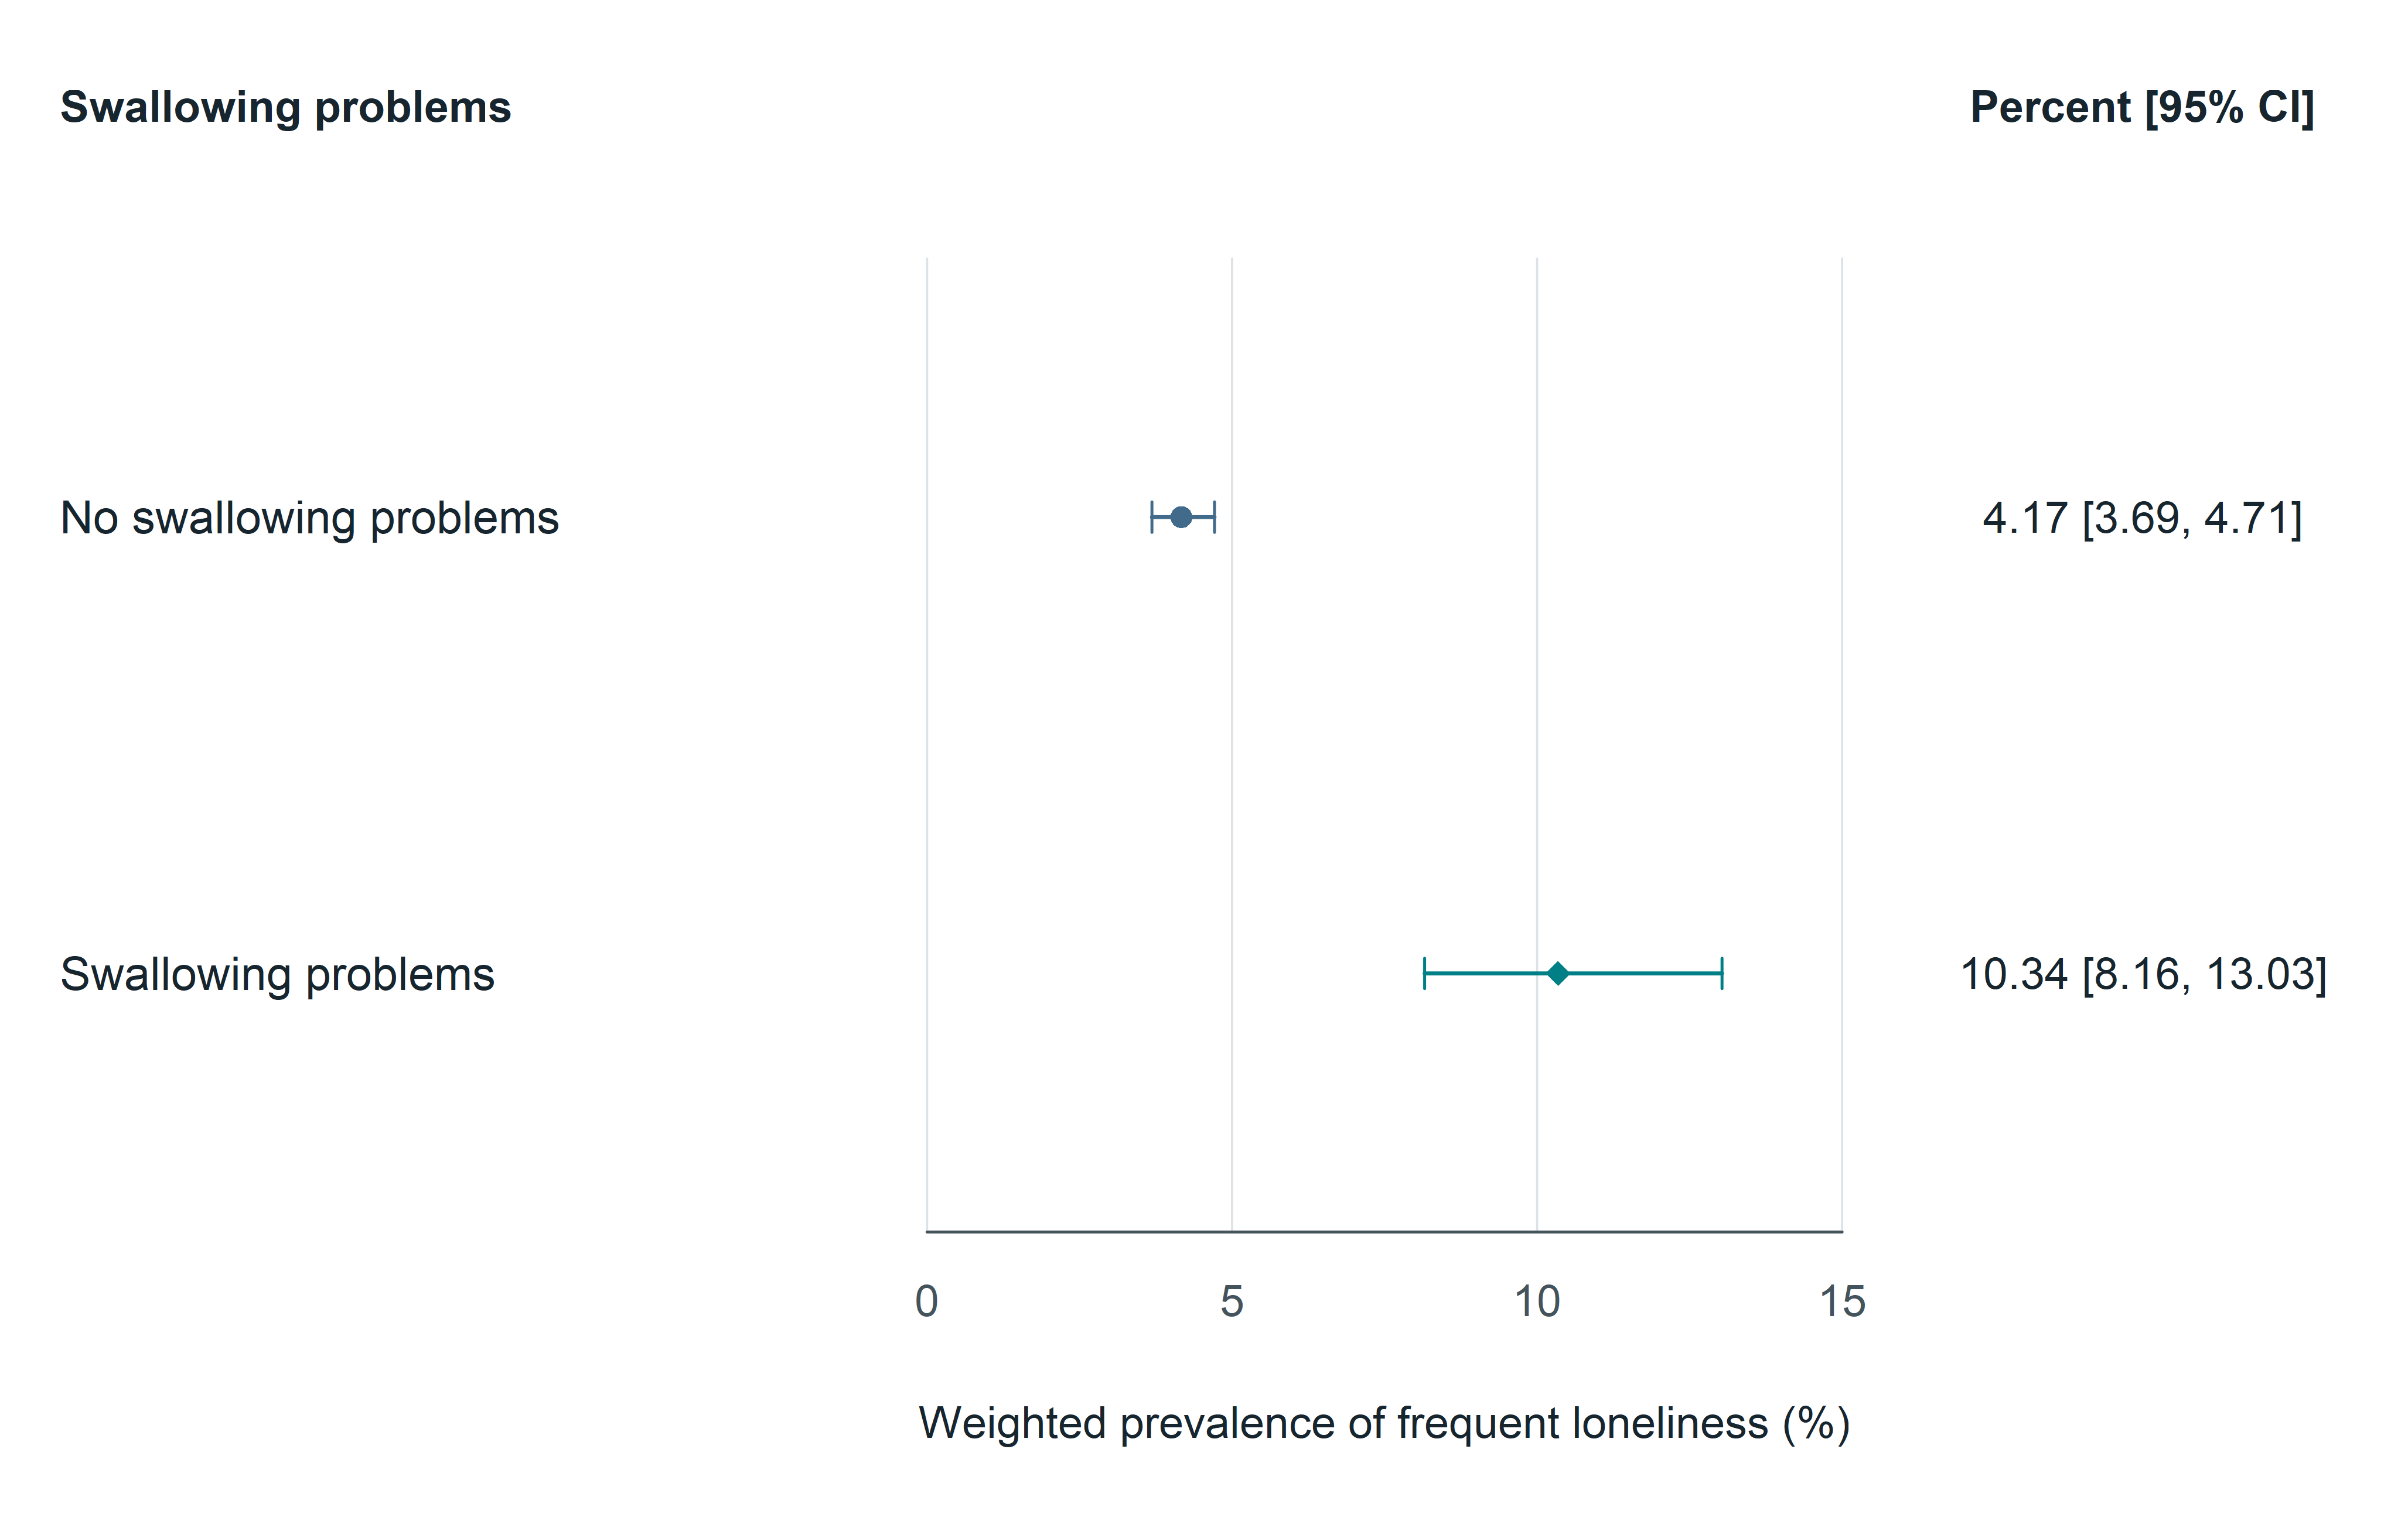
Fig. 1 Survey-weighted prevalence of frequent loneliness by self-reported swallowing problems. Frequent loneliness means always or usually feeling lonely; swallowing problems refer to the preceding 12 months. Points show weighted prevalence and lines show design-based logit 95% confidence intervals. Valid-response denominators are 7,545 without and 686 with swallowing problems (N = 8,231). Counts are unweighted. No covariate adjustment was performed. Created in R 4.6.0 using grid graphics and Cairo devices

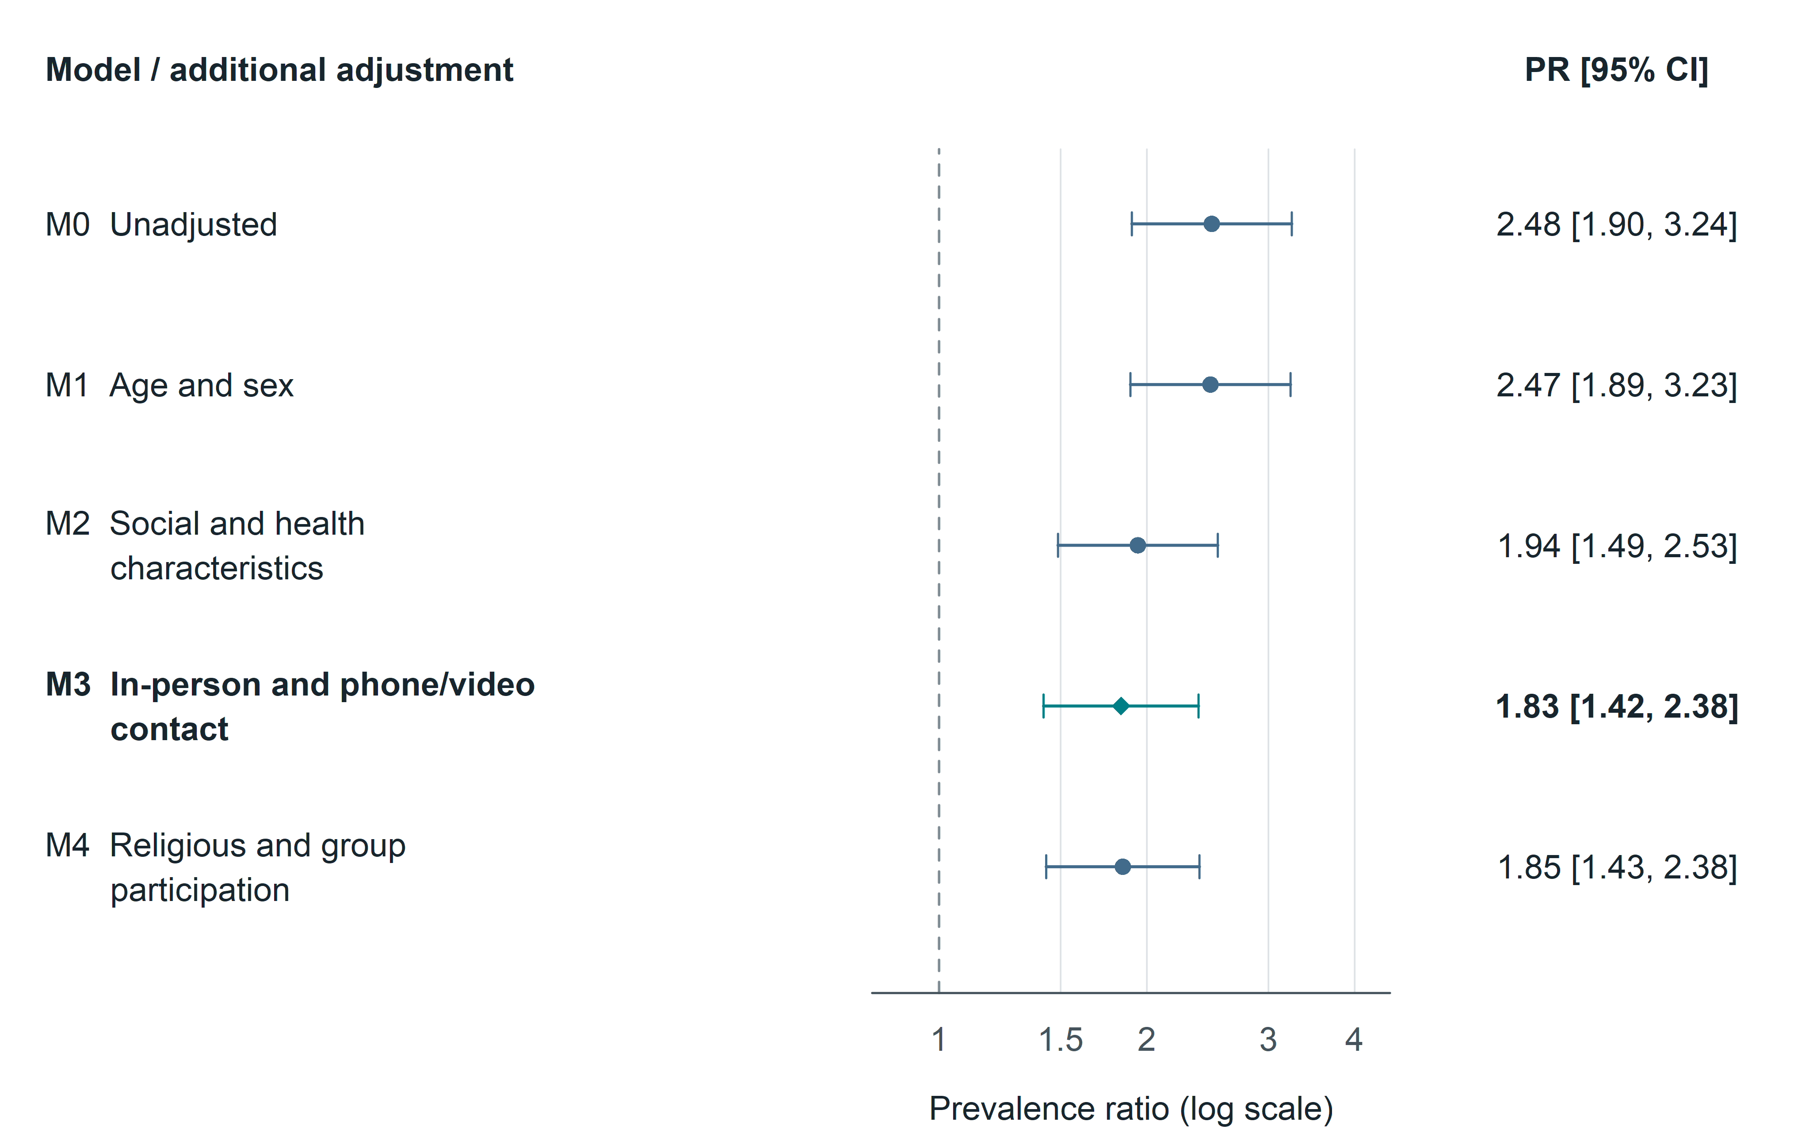
Fig. 2 Prevalence ratios across sequential adjustment models. All models use the same 8,094 adults with 429 events. M1 adds age and sex; M2 adds education, income-to-poverty ratio, partnership, living alone, mobility, hearing and stroke; primary M3 adds in-person and phone/video contact; M4 adds religious and group participation. M3 is highlighted by a diamond and color. Points and lines represent prevalence ratios and 95% confidence intervals from survey-weighted Poisson models. The logarithmic axis marks a prevalence ratio of 1. Income-adjusted estimates combine all ten official income imputations. These are cross-sectional associations. Created in R 4.6.0 using grid graphics and Cairo devices

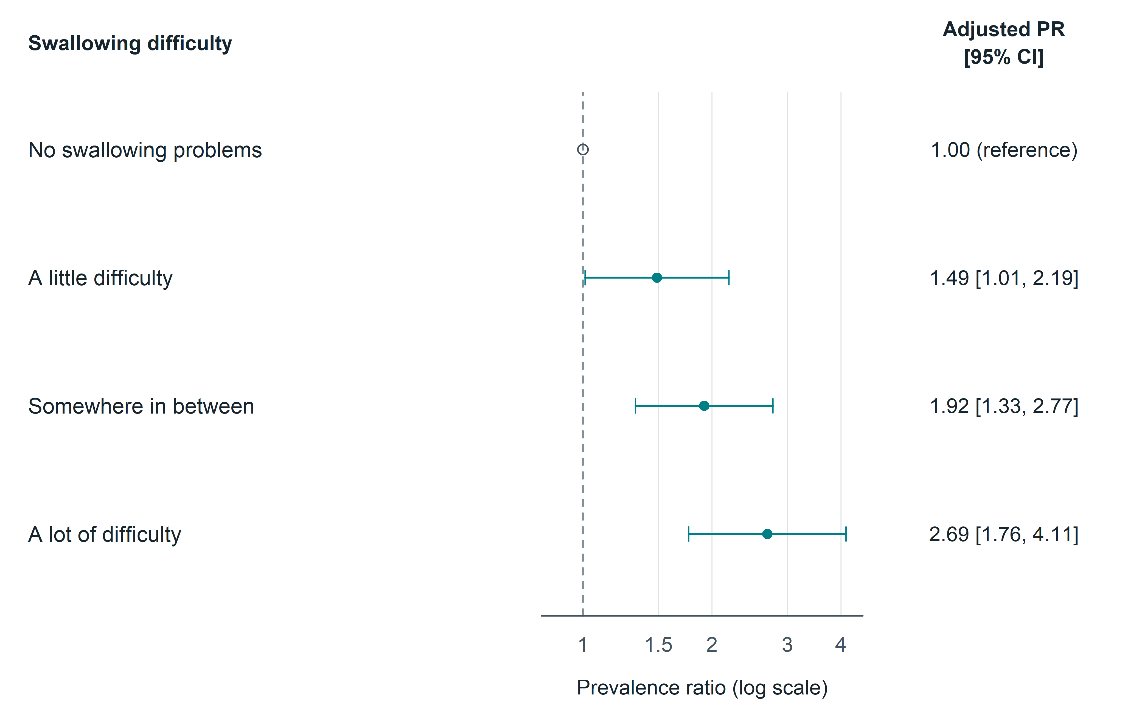
Fig. 3 Secondary analysis of reported swallowing difficulty. M3-adjusted prevalence ratios compare a little difficulty, somewhere in between and a lot of difficulty with no swallowing problems. N = 8,093; the three exposed categories contain 361, 199 and 113 adults, with 33, 27 and 22 events. The reference category has no artificial interval. The categories are not equally spaced and no formal trend test was performed. Small event counts and self-reported severity limit interpretation. Created in R 4.6.0 using grid graphics and Cairo devices

