My project incorporates three datasets. The first data set is collected from my personal Facebook data. From that I was able to scrap the history of songs I listened to on Spotify for the time periods of January 2013 to April 2013 and January 2015 to April January. I must have turned off Spotify or stopped listening to it during that time period. Here’s a line plot of the count of songs I listened to per day. The magnitude is **4460 observations** during 3-month period starting 01/01/2013 and **4830 observations** during 3-month period starting 01/01/2015. The headers of the datasets are **3 features** across, timestamp, name of song, name of artist. This was scrapped from a HTML document provided by Facebook. These datasets will be collectively referenced the **Facebook dataset**

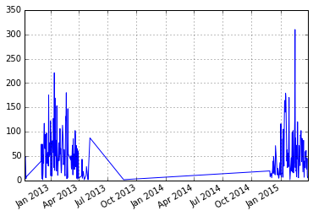

I wrote a scrapper that scrapped [allmusic.com](http://www.allmusic.com/) for each artist’s “genre”, “style”, and “mood.” This will be referenced as the **AllMusic dataset.** There are **41 genres, 525 styles, 274 moods** and **1790 artists**. There is generally 1 to 2 genres, 5-10 styles, and up to 20 moods assigned to each artist. From these metrics, it appears that **style** will be the best descriptor, because of the high number of variability, but lower frequency. Genres there is less variety in genres and greater frequency with moods. For example, [Lil Wayne](http://www.allmusic.com/artist/lil-wayne-mn0000272689) is described as having a “genre” of ‘Rap’ and ‘Pop/Rock’ and having a “style” of ‘Southern Rap’, ‘Dirty South’, ‘Hardcore Rap’, ‘Pop’ and finally as having a “mood” of “Ambitious, Angst-Ridden, Boisterous, Brash, Bravado, Confident, Exciting, Trashy, Celebratory, Exuberant, Freewheeling, Harsh, Hedonistic, Humorous, Provocative, Quirky, Rambunctious, Rollicking, Slick, Snide, Street-Smart ,Uncompromising, Whimsical, Confrontational, Sleazy, Stylish, Aggressive, Energetic, Malevolent, Outrageous, Raucous, Rebellious, Reckless, Rousing, Rowdy, Thuggish, Urgent, Visceral, Volatile”

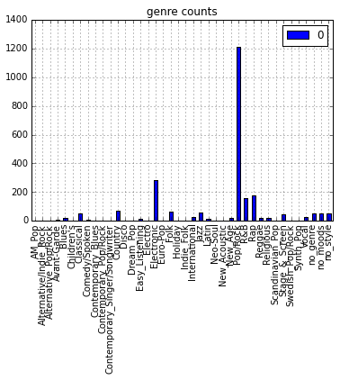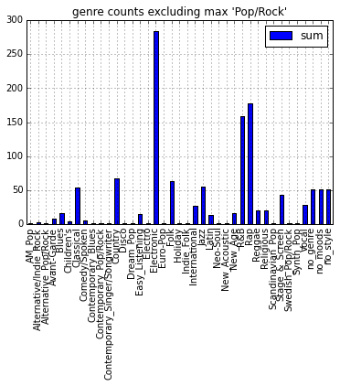

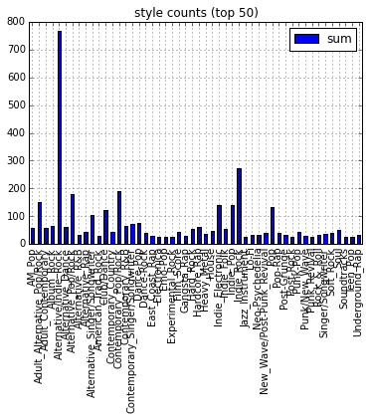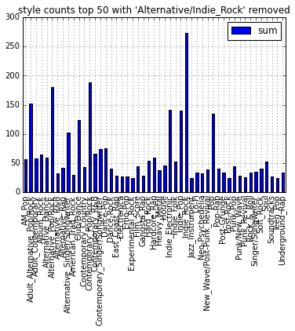

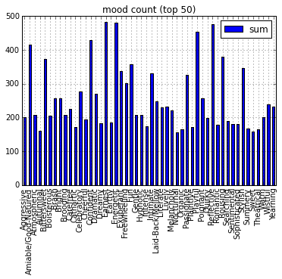

Some interesting features from these charts is the very common occurrence of ‘Pop/Rock’ accounting for more than half of the entire dataset (~1200/1790). I would be curious to see how effective a binary classifier (Pop/Rock and not Pop/Rock) would be, based on the styles and moods of the artists. In addition, I have a dataset the size of the Facebook dataset that matches each song observation to the corresponding artist and keywords associated with that artist.

The third dataset, referenced as the **Weather dataset** , is data collected from [NOAA.gov](http://cdo.ncdc.noaa.gov/qclcd/QCLCD). Since I was living in New Milford, CT during the first time period I collected the weather data from the nearest weather station in Danbury (~15 miles away from my general location). For the second time period, I collected data from the Boston Logan Airport weather station(~3 miles away from my general location). In this dataset, information is indexed by day, and there are almost 30 features describing the weather. This is a very sparse matrix. This data is indexed by hour so I can attempt to match hourly trends in weather with hourly trends with my music selection.

I have a lot of data so it will be important to focus my tasks. First, I want to explore the **AllMusic dataset** and the artists a bit more with a graph. Each artist will be represented as a node and edges will be determined by a Jaccard distance. The top *k* most similar artists will have edges drawn (I still need to determine *k,*  but I assume it will be in the range of 101)

The next direction I want to explore is connecting the **Facebook dataset** and the **AllMusic dataset**. I will cluster the data and investigate any interesting clusters. I do not see dimensionality reduction being useful in this context because each feature and observation plays a distinct role holistically. I will then introduce the **Weather dataset** and recluster the data and investigate interesting clusters. I will group the data based on different features, specifically, time of day (morning/afternoon/evening) and strong weather to investigate a basis for my music selection.

Time permitting, I will look into building a graph where each song is a node. Edges will be determined based on the temporal distance (provided by the **Facebook dataset**).

This is a preliminary graph drawn from the **AllMusic** data set. Each node represents an artists and the edges are determined by a Jaccard similarity of more than 0.995 in represent to only the **moods** of the artists. The nodes represent a subset of the first 50 artists I listened to, as unconnected nodes were eliminated.

