Ben Lorenzetti
Embedded Systems Lab

Exam 1 Regrading

On exam one, I think that 7 of the points taken off were not justified.

Problem 5: 5pts off

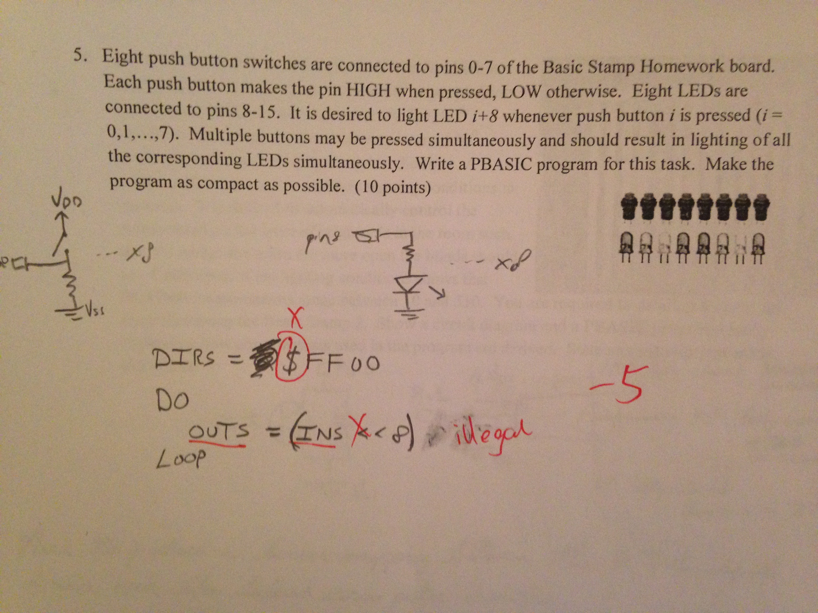

The dollar sign is the hexadecimal indicator in PBASIC. OUTS and INS are both valid, Word-size registers and bitshift left is a valid operation in PBASIC, used just like it is in C.

To demonstrate that my code works, I loaded it onto my Basic STAMP board and recorded a video.
See attached file: Problem-5-Demo.MOV.

Problem 6: 2pts off

I lost 2 points on my answer for problem 6.

The first point was apparently for having too small a charge time. I put 1 millisecond and the grader wrote 100. However, for lab 3 I used 1 millisecond and it worked just fine. You can see my lab 3 implementation (T_RC_CHARGE CON 1) on page 6 of the attached file lab-3-report.pdf. Assuming a current limiting resistor of 220 ohms,

5τ = 5*RC = 5 * 0.1uF * 220 Ω = 0.11 ms

So 1 ms is more than adequate.

The second point I missed was for essentially the same code I was marked for in problem 5.



