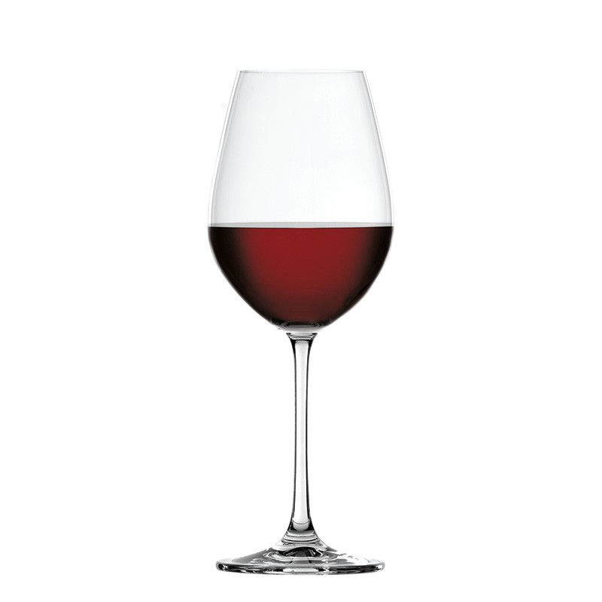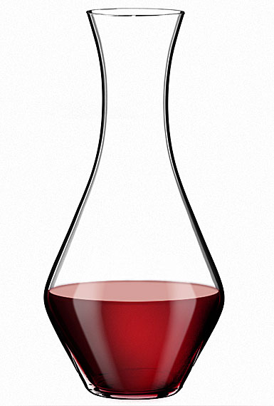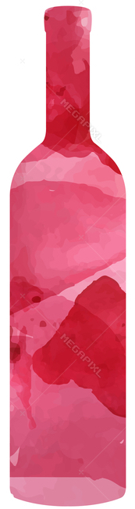**WINE**

**WHITE**

**Soave,** vicentini agostino**,** 2017 (veneto) 12 36 48

**Sancerre,** Les Grands Monts, 2020 (France)17 45 60

**Vernaccia di San Gimignano,** selvabianca 2020(toscana) 15 40 55

**Bourgogne Chardonnay** domaine vincent prunier 2018 (france) 16 48 64

**Pinot Bianco** meran Kellerei cantina 2020 (sudtirol Aldo Adige) 13 35 49

**ROSÉ**

**Zweigelt,** paul direder rosé (austria) *draft* 12 36 48

**Chateu du Rouet,**cotes de provence,2020(france ) 14 38 50

**ORANGE**

**Albana Secco,** *santa lusa****,*** ancarani, 2017 (emilia-romagna*)* 15 45 60

**RED**

**Barbera d’Alba,** cascina pace 2015 (piemonte) *draft* 13 40 50

**Nebbiolo Langhe,** guidobono,2019 (piemonte)15 45 60

**Valpolicella ripasso,** domenico fraccaroli2017 (veneto) 16 48 64

**Tau Toscana** (Merlot, Cabernet Franc, Syrah) leuta 2014 (toscana) 16 48 64

**Cannonau di Sardegna,** atha ruja, 2018 (sardegna) 17 50 65

**BEER**

**Sloop** *Juice Bomb,* Unfiltered IPA, Elizaville, NY ABV 6.5 *16 oz draft* 10

**The Alchemist Brewery** *Heady Topper,* Double IPA, Waterbury, VT ABV 8 *16 oz can* 12

**Three’s Brewing** *Vliet Pilsner,* European Lager, Brooklyn, NY ABV 5.1 *16 oz draft* 10

**Oxbow Brewing Co** *Surfcasting*, Farmhouse Ale, Newcastle, ME ABV 4.5 *12 oz can* 9  
**Collective Arts** *Guava Gose*, Sour, Ontario ABV 4.9 *12 oz can* 9

**N/A Athletic Brewing** *Upside Dawn,*Golden Ale, San Diego, CA ABV 0.4 *12 oz can*  7