ThReshold selection.

Knecmab

Tuesday, November 18, 2014

# ThReshold selection for bi-modal data.

First lets load the package and get a data set.

require(threshold)  
ds <- twoGaussians(seed=123)  
hist(ds$x, breaks='Scott', freq=FALSE)

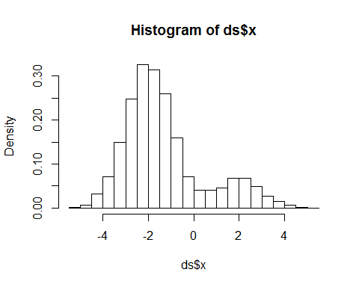

And see what the different threshold selection methods do.

rosin threshold:

th_rosin <- find_threshold(ds$x, method="rosin")  
th_rosin

## [1] "Threshold(s): -0.0105547"  
## [1] "Method: rosin"

plot.threshold(th_rosin)

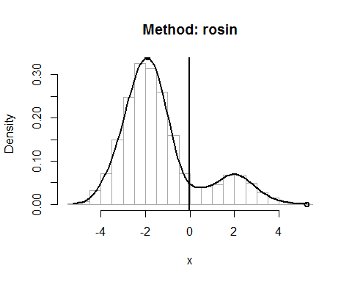

valleys threshold:

th_valleys <- find_threshold(ds$x, method="valleys")  
th_valleys

## [1] "Threshold(s): 0.514605"  
## [1] "Method: valleys"

plot(th_valleys)

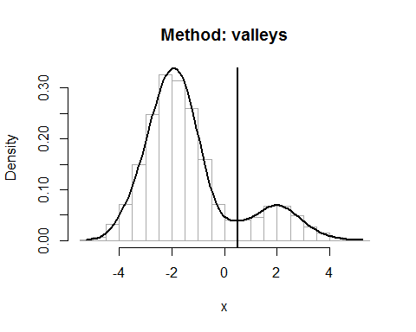

nmm threshold:

th_nmm <- find_threshold(ds$x, method="nmm")  
th_nmm

## [1] "Threshold(s): 0.409573"  
## [1] "Method: nmm"

plot(th_nmm)

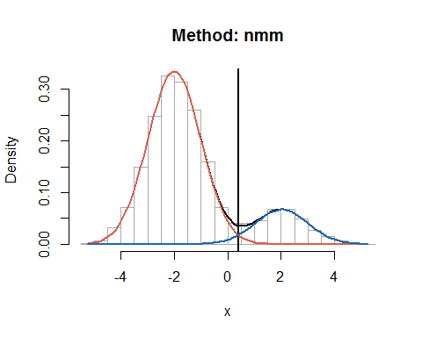

entropy threshold:

th_entropy <- find_threshold(ds$x, method="entropy")  
th_entropy

## [1] "Threshold(s): -0.35"  
## [1] "Method: entropy"

plot(th_entropy)

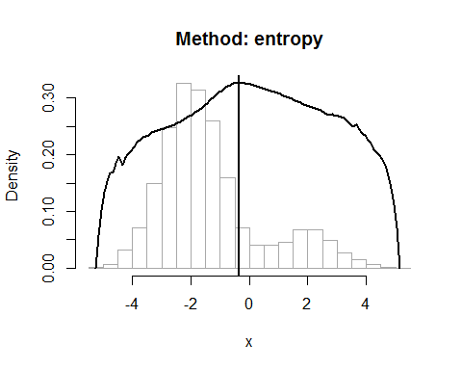

# ThReshold selection for tri-modal data.

First lets load the package and get a data set.

require(threshold)  
ds <- threeGaussians(seed=123)  
hist(ds$x, breaks='Scott', freq=FALSE)

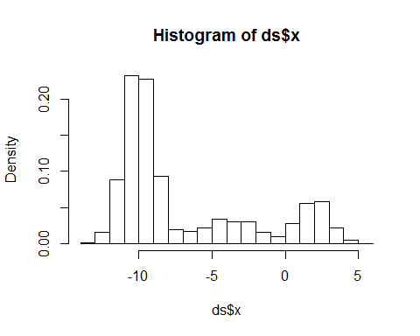

And see what the different threshold selection methods do.

rosin threshold:

th_rosin <- find_threshold(ds$x, method="rosin")  
th_rosin

## [1] "Threshold(s): -7.62386"  
## [1] "Method: rosin"

plot.threshold(th_rosin)

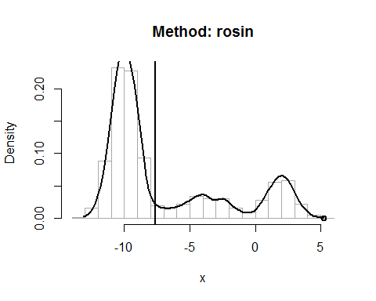

valleys threshold:

th_valleys <- find_threshold(ds$x, method="valleys")  
th_valleys

## [1] "Threshold(s): -6.70494" "Threshold(s): -3.02925"   
## [3] "Threshold(s): -0.640056"  
## [1] "Method: valleys"

plot(th_valleys)

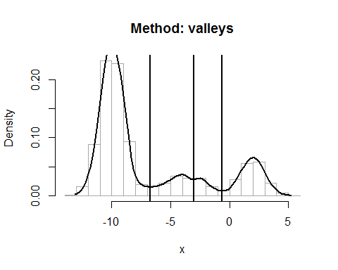

nmm threshold:

th_nmm.g2 <- find_threshold(ds$x, method="nmm", G=2)  
th_nmm.g2

## [1] "Threshold(s): -7.25629"  
## [1] "Method: nmm"

th_nmm.g9 <- find_threshold(ds$x, method="nmm", G=9)  
th_nmm.g9

## [1] "Threshold(s): -0.456272"  
## [1] "Method: nmm"

par(mfrow=c(1,2))  
plot(th_nmm.g2)  
plot(th_nmm.g9)

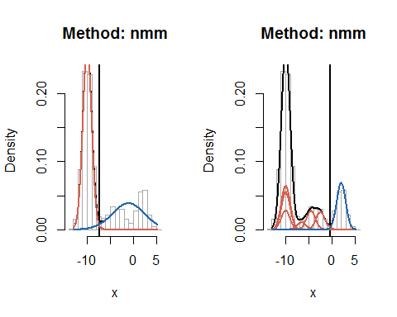

entropy threshold:

th_entropy <- find_threshold(ds$x, method="entropy")  
th_entropy

## [1] "Threshold(s): -7.5"  
## [1] "Method: entropy"

plot(th_entropy)

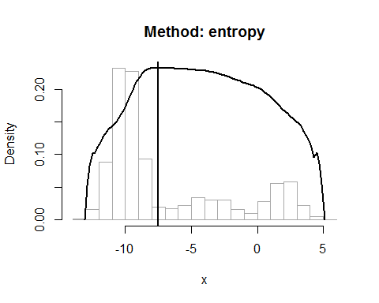

# ThReshold selection for uni-modal data.

First lets load the package and get a data set.

require(threshold)  
ds <- twoGaussians(seed=123, m.pos=0)  
hist(ds$x, breaks='Scott', freq=FALSE)

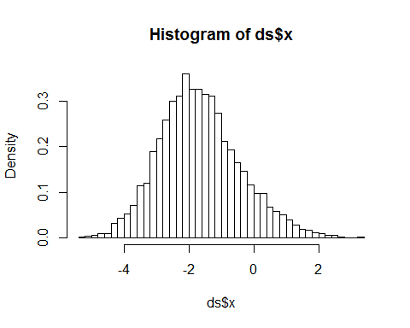

And see what the different threshold selection methods do.

rosin threshold:

th_rosin <- find_threshold(ds$x, method="rosin")  
th_rosin

## [1] "Threshold(s): 0.690083"  
## [1] "Method: rosin"

plot.threshold(th_rosin)

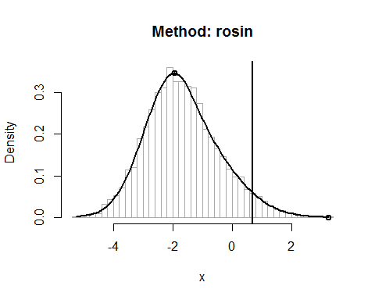

valleys threshold:

th_valleys <- find_threshold(ds$x, method="valleys")  
th_valleys

## [1] "Threshold(s): NA"  
## [1] "Method: valleys"

plot(th_valleys)

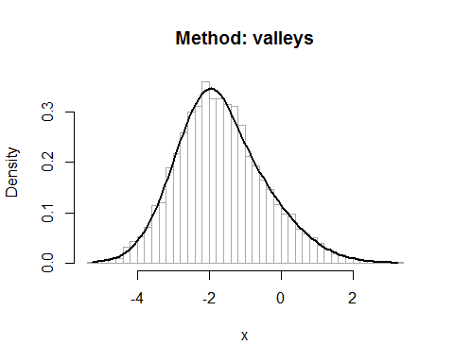

nmm threshold:

th_nmm <- find_threshold(ds$x, method="nmm")  
th_nmm

## [1] "Threshold(s): -0.160236"  
## [1] "Method: nmm"

plot(th_nmm)

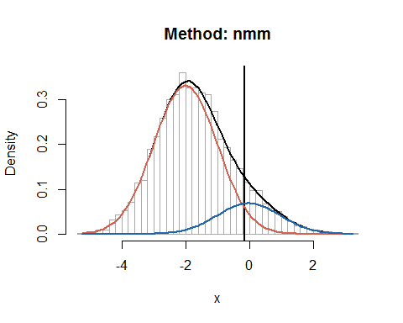

entropy threshold:

th_entropy <- find_threshold(ds$x, method="entropy")  
th_entropy

## [1] "Threshold(s): -0.25"  
## [1] "Method: entropy"

plot(th_entropy)

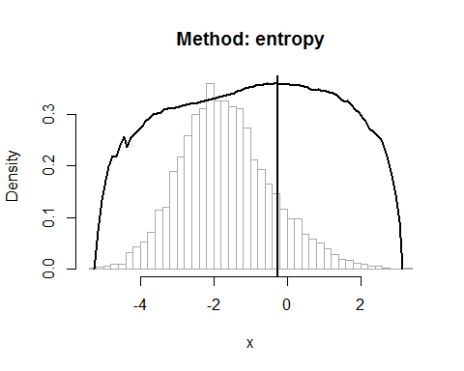

# ThReshold selection - run all at once.

ths <- find_threshold(ds$x, method=c("rosin", "entropy", "valleys", "nmm"))  
ths

## $rosin  
## [1] "Threshold(s): 0.690083"  
## [1] "Method: rosin"  
##   
## $entropy  
## [1] "Threshold(s): -0.25"  
## [1] "Method: entropy"  
##   
## $valleys  
## [1] "Threshold(s): NA"  
## [1] "Method: valleys"  
##   
## $nmm  
## [1] "Threshold(s): -0.160236"  
## [1] "Method: nmm"  
##   
## attr(,"class")  
## [1] "threshold_list"

plot(ths)  
plot(ths)  
  
  
# You might also want to compare it to another set of thresholds.  
plot(ths, ths_add=list('my_th_1'=c(1),  
 'my_th_2'=c(4, 4.2)))

