Gal Ben Maman 205633589 , TBD Sinai

# Deep Learning Assignment 1

## Q.4

Data:

Train: 48,000

Validation: 12,000

Test: 10,000

Number of Classes: 10

Model Configuration:

Layer dimensions=[768(input),20,7,5,10]

Learning rate=0.009

Number of iterations=500

Number of epochs (each iteration)= 94

Batch size=512

Seed=22

Evaluation:

Accuracy:

Train: 97.33%

Validation: 94.50%

Test: 94.58%

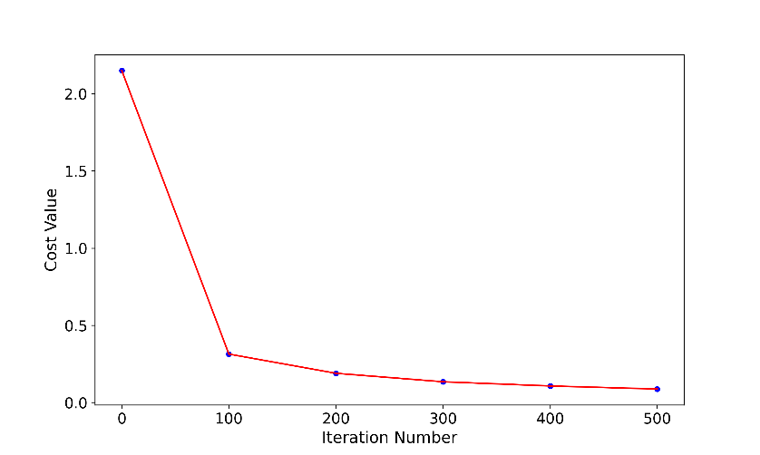Cost value:

|  |  |
| --- | --- |
| **cost** | **iteration** |
| 2.150350 | 0 |
| 0.314010 | 100 |
| 0.189504 | 200 |
| 0.134529 | 300 |
| 0.107483 | 400 |
| 0.087563 | 500 |