|  |  |  |  |
| --- | --- | --- | --- |
|  | P_11101 (MS2R) (Y,Y) | P_11102 (PLACEBO) (N,N) | P_11103 (MS2R) (Y,Y) |
| Day1 |  |  |  |
| Day 28 |  |  |  |
| Follow up |  |  |  |

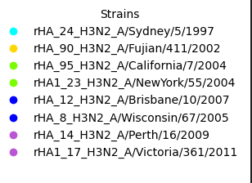

|  |  |  |  |
| --- | --- | --- | --- |
|  | P_11104 (PLACEBO) (Y,Y) | P_11105 (MS2R) (Y,Y) | P_11106 (PLACEBO) (Y,Y) |
| Day1 |  |  |  |
| Day 28 |  |  |  |
| Follow up |  |  |  |

|  |  |  |  |
| --- | --- | --- | --- |
|  | P_11107 (PLACEBO) | P_11108 (MS2R) | P_11109 (MS2R) |
| Day1 |  |  |  |
| Day 28 |  |  |  |
| Follow up |  |  |  |