• Database design – written description – ER diagram – normalization

• Software design – written description – UML diagrams – GUI wireframes

• Testing – description of testing approach used – record, e.g. tables of tests completed

• Conclusion 5 – summary of work done – limitations of the current design/implementation and critical reflection of your work – how you would approach a similar project differently in future

• References – any references here should have matching in-text references – any work which is not your own must be referenced – using the Harvard reference system

Coursework Report

Abstract – a paragraph describing the work, results and conclusions

• Introduction – brief description of your work (not the coursework specification) – brief (paragraph) description of the layout of the rest of the report

This coursework required that I design and produce a database that can be used to store gym bookings for a fictional gym as well as the queries to filter and sort such a database. I also needed to produce the code for a program to run said queries as well as adding and updating entries in the database as well as a second program with a graphical user interface that simplifies the creation of queries.

The layout of this report shall be as follows
- Database design
Here I will explain how I came up with the layout of the database
- Software design
Here I will explain how I designed the software required
- How I tested the product
- Conclusion
- References

Database Design
For this project I decided to use a database comprised of 3 relations. One relation would hold all data on the gym’s clients, these being clientID, firstname and lastname.
The second relation would hold all data on the gym’s trainers, these being trainerID, firstname and lastname. The last relation would hold all bookings made by the gym under the headings bookingID, clientID, trainerID, date, timeStart, timeEnd and focus.
(clientID and trainerID are foreign keys here from their respective tables. Having normalised this to 3rd Normal Form, it is easy to add information to the table without causing update anomalies which means it is possible to add and update entries on the database. This means that the requirement that the gym staff can edit the database is fulfilled.

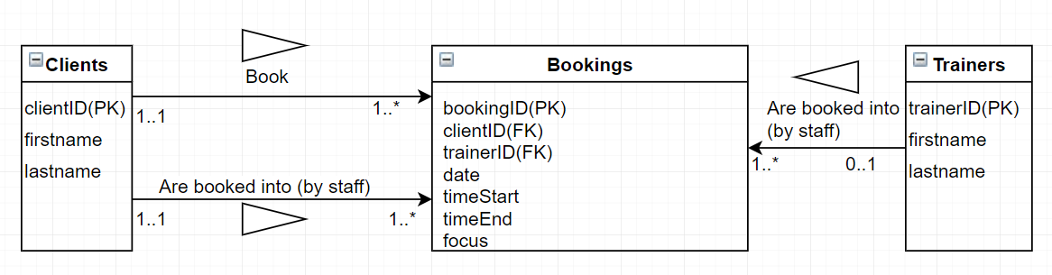
A digital copy of the hand-drawn UML diagram I made for this database.

