Web App Instructions
Welcome to the EQuiPD self-assessment! This tool aims to help you understand your city’s ability to effectively manage, use, craft, and implement policies at the intersection of air quality and equity - informed by air quality, health and equity data. This page will briefly walk you through how to use the web application to 1) download the assessment and submit your results; 2) visualize your scores and identify strengths or weaknesses; and 3) identify recommendations for strengthening your data ecosystem.
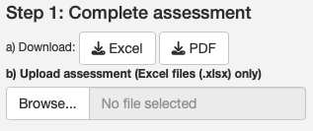
Step 1: Download the assessment and submit results
Click the ‘Excel’ or ‘PDF’ to download (1a) the self-assessment tool. The ‘Excel’ version of the tool provides functionality to input scores, save to your computer, and see scores—this version must be used if you wish to submit results to the web app. The ‘PDF’ version allows for easy printing and sharing by email to colleagues you may work with when filling out the assessment but cannot be used to submit.
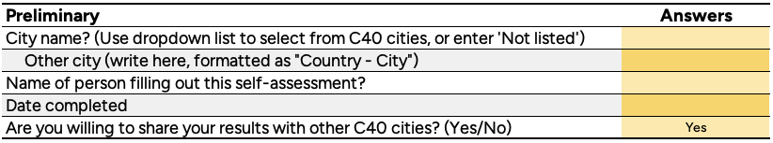
When filling out the Excel spreadsheet, the ‘City’ and ‘Date completed’ inputs (as shown here) will be used in Step 2 below to help identify the assessment of interest and visualize your results. Use the ‘Browse’ button (1b) in the web app to submit your finished self-assessment. If you make a mistake and need to resubmit your results, modify the ‘Date completed’ answer in your spreadsheet (e.g., ‘01/25/26 v2’) and reupload (1b) to the web app. If you reassess in the future, enter a new date so you can visualize the growth of your city’s data ecosystem.
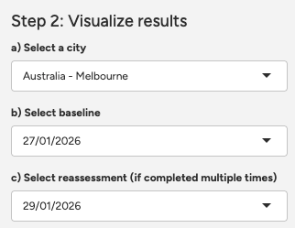
Step 2: Visualize your results
After you have submitted your results it is time to visualize your scores. Use the city dropdown (2a) to first select your city. Next identify the date of the ‘baseline’ (2b) or initial assessment you wish to view—this may be your current assessment if it is your first time completing, or a past assessment use for growth comparison. If this is not the first time you have completed EQuiPD, select the date of the reassessment (2c) for visualizing improvements to your data ecosystem. Upon changing these dropdowns, a graphic of your results will appear to the right side of the screen. When viewing scores and recommendations (step 3), the web app will default to the ‘reassessment’ survey (2c), or ‘baseline’ survey (2b) if no reassessment is selected.
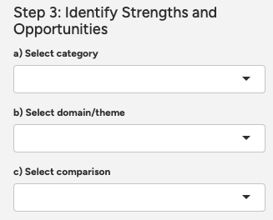
Step 3: Identify strengths and opportunities
Categories, domains, and themes are defined in the Excel tool. Selecting a category (3a) and intersection domain or theme (3b) will produce a table in the lower right portion of the web app. This will show the question, your score, and a recommendation. It will also identify cities who have scored higher in this area. Selecting an assessment from those cities (3c), will allow you to compare scores to identify possible ideas and partners for helping improve your overall data ecosystem.

