NMM Opening Continuations
Top 9 continuations per family to ply 12 (ply 14 for B06/B07). DB = human games ELO ≥ 1400. ★ = teacher-predicted.

B01 Mill Rush
Opening (9-ply): 1.W:d6 2.B:d2 3.W:f4 4.B:b4
5.W:f6 6.B:f2 7.W:b6xb4 8.B:b4
9.W:e5
§ = Book (§15.2 Fig. 175-180) ★ = Teacher-predicted (upper ELO band)
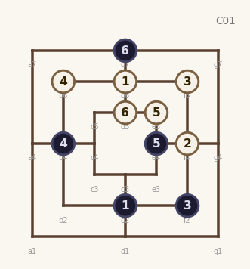  10.B:e4 11.W:d5  12.B:d7  §15.2 parallel (G1) | 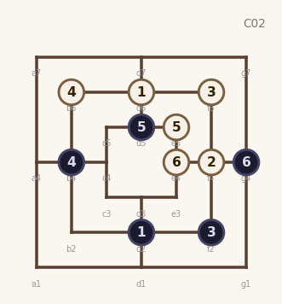  10.B:d5 11.W:e4  12.B:g4  §15.2 perpendicular (G2) | 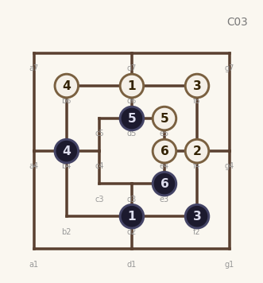  10.B:d5 11.W:e4  12.B:e3  §15.2 ext. parallel (G3)
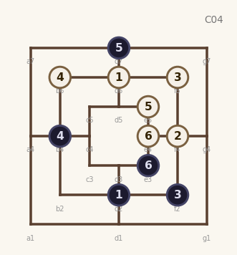  10.B:d7 11.W:e4  12.B:e3  §15.2 alt. parallel (G4) | 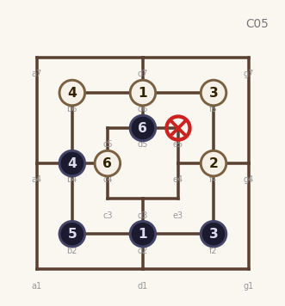  10.B:b2xe5 11.W:c4  12.B:d5  ★ teacher | 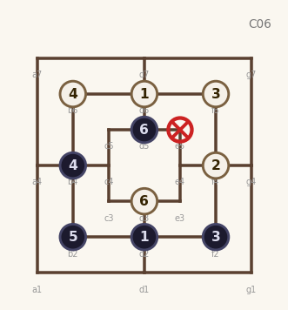  10.B:b2xe5 11.W:d3  12.B:d5  ★ teacher
7.W:b6xf2 8.B:f2  9.W:e5 10.B:e4  11.W:d5 12.B:c5  Mill Rush — Perpendicular | 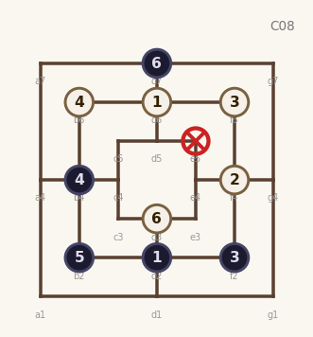  10.B:b2xe5 11.W:d3  12.B:d7  ★ teacher | 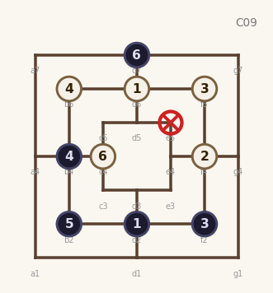  10.B:b2xe5 11.W:c4  12.B:d7  ★ teacher

B02 Inverted Mill Rush
Opening (10-ply): 1.W:d6 2.B:d2 3.W:f4 4.B:b4
5.W:g7 6.B:g4 7.W:d7 8.B:d5
9.W:a7xd5 10.B:d5
★ = Teacher-predicted (upper ELO band)
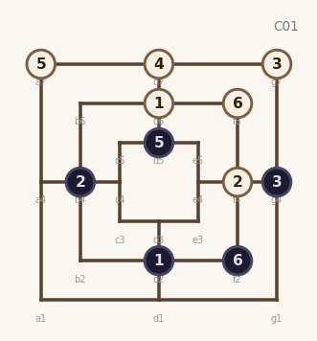  11.W:f6 12.B:f2  freq: 26 | 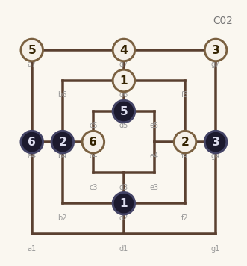  11.W:c4 12.B:a4  freq: 3 | 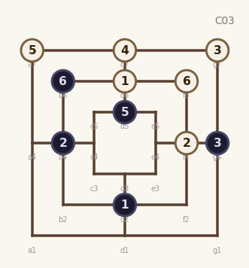  11.W:f6 12.B:b6  freq: 2
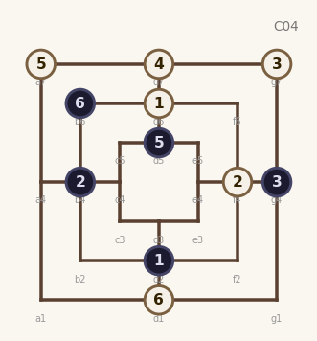  11.W:d1 12.B:b6  ★ teacher | 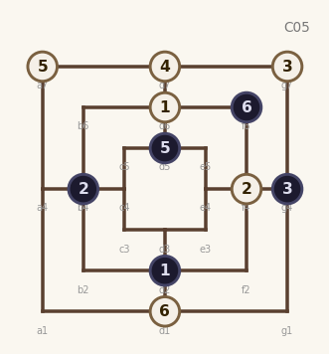  11.W:d1 12.B:f6  ★ teacher | 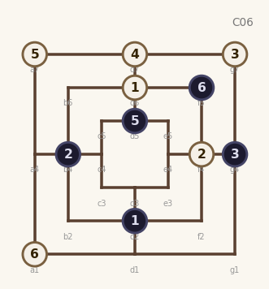  11.W:a1 12.B:f6  ★ teacher
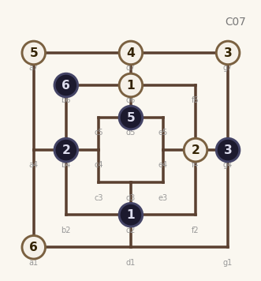  11.W:a1 12.B:b6  ★ teacher | 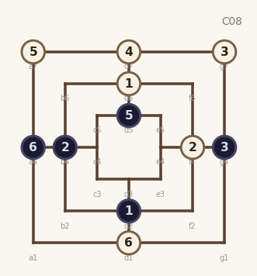  11.W:d1 12.B:a4  ★ teacher | 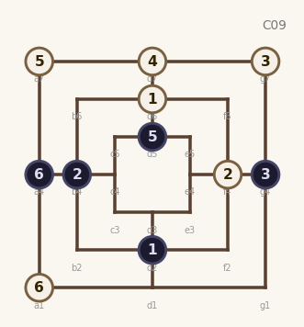  11.W:a1 12.B:a4  ★ teacher

B03 Battle Lines
Opening (8-ply): 1.W:d6 2.B:d2 3.W:f4 4.B:b4
5.W:f6 6.B:f2 7.W:b6xb4 8.B:b2xf4
★ = Teacher-predicted (upper ELO band)
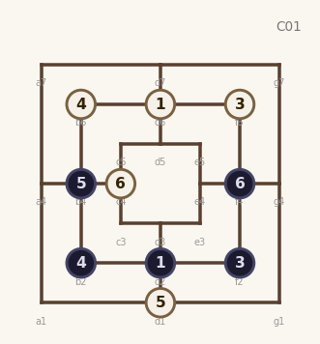  9.W:d1 10.B:b4  11.W:c4 12.B:f4  ★ teacher | 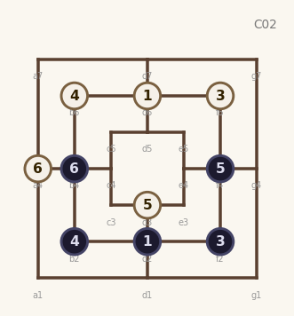  9.W:d3 10.B:f4  11.W:a4 12.B:b4  ★ teacher | 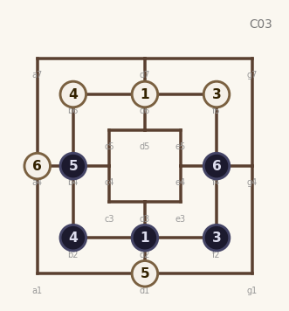  9.W:d1 10.B:b4  11.W:a4 12.B:f4  ★ teacher
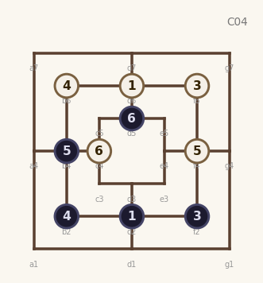  9.W:f4 10.B:b4  11.W:c4 12.B:d5  ★ teacher | 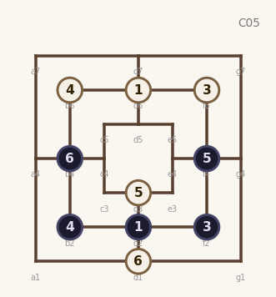  9.W:d3 10.B:f4  11.W:d1 12.B:b4  ★ teacher | 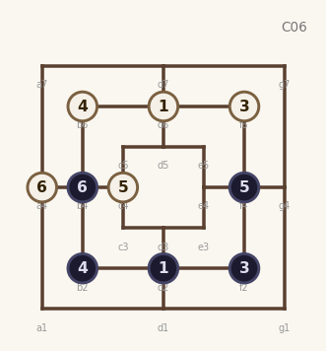  9.W:c4 10.B:f4  11.W:a4 12.B:b4  ★ teacher
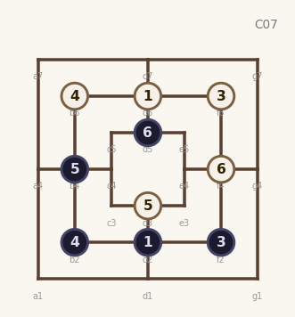  9.W:d3 10.B:b4  11.W:f4 12.B:d5  ★ teacher | 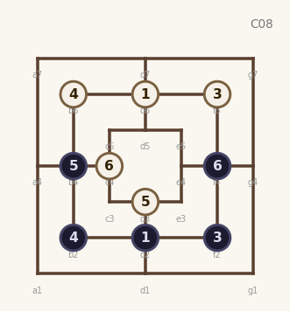  9.W:d3 10.B:b4  11.W:c4 12.B:f4  ★ teacher | 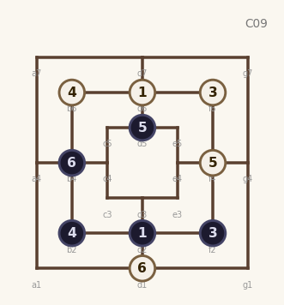  9.W:f4 10.B:d5  11.W:d1 12.B:b4  ★ teacher

B04 Closed Z Mill
Opening (10-ply): 1.W:d6 2.B:d2 3.W:f4 4.B:b4
5.W:f6 6.B:f2 7.W:b6xb4 8.B:b4
9.W:b2 10.B:c5
Part A — Mill Rush trunk (from ply 8, +4 moves to ply 12):
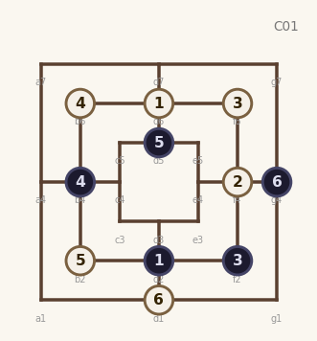  9.W:b2 10.B:d5  11.W:d1 12.B:g4  freq: 38 | 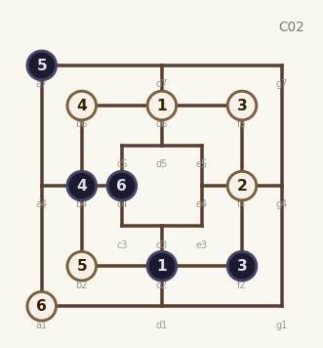  9.W:b2 10.B:a7  11.W:a1 12.B:c4  freq: 38 | 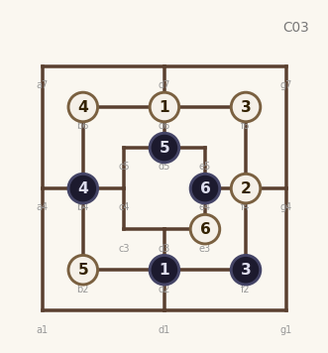  9.W:b2 10.B:d5  11.W:e3 12.B:e4  freq: 37
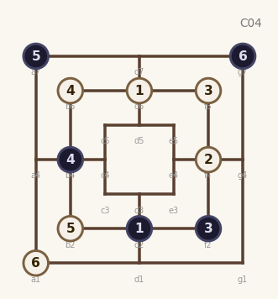  9.W:b2 10.B:a7  11.W:a1 12.B:g7  freq: 37 | 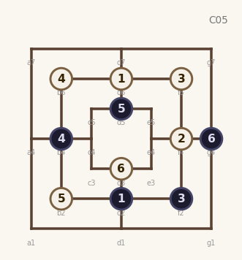  9.W:b2 10.B:d5  11.W:d3 12.B:g4  freq: 34 | 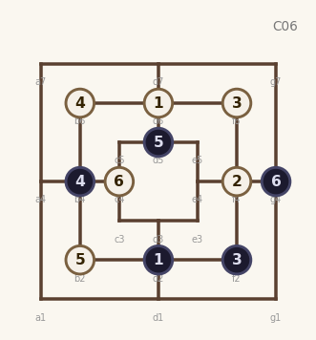  9.W:b2 10.B:d5  11.W:c4 12.B:g4  freq: 33
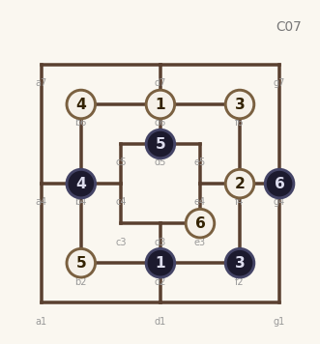  9.W:b2 10.B:d5  11.W:e3 12.B:g4  freq: 33 | 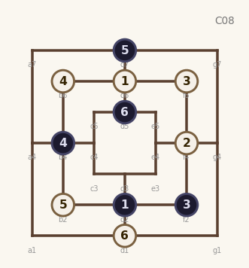  9.W:b2 10.B:d7  11.W:d1 12.B:d5  freq: 29 | 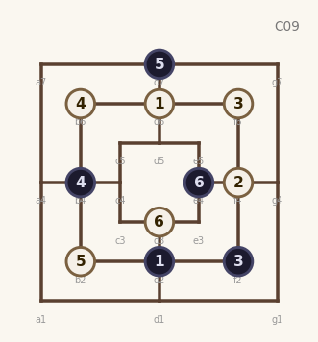  9.W:b2 10.B:d7  11.W:d3 12.B:e4  freq: 28

Part B — Closed Z Mill (from ply 10, +2 moves to ply 12):
★ = Teacher-predicted (upper ELO band)
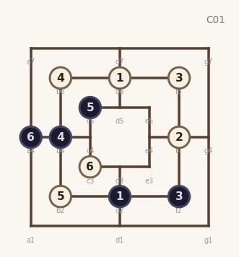  11.W:c3 12.B:a4  freq: 13 | 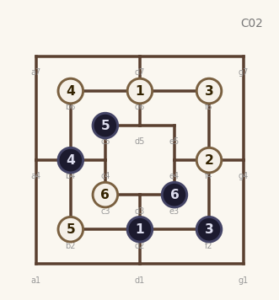  11.W:c3 12.B:e3  freq: 3 | 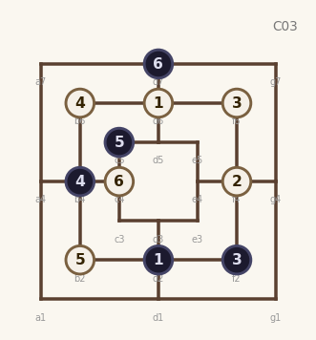  11.W:c4 12.B:d7  ★ teacher
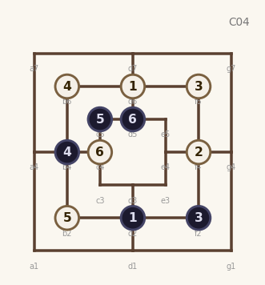  11.W:c4 12.B:d5  ★ teacher | 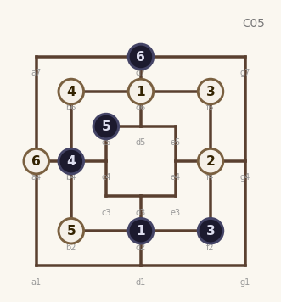  11.W:a4 12.B:d7  ★ teacher | 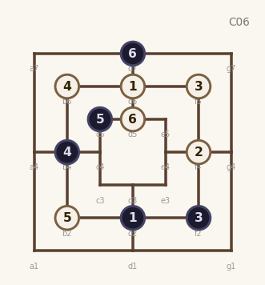  11.W:d5 12.B:d7  ★ teacher
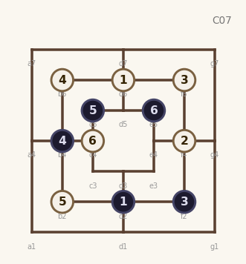  11.W:c4 12.B:e5  ★ teacher | 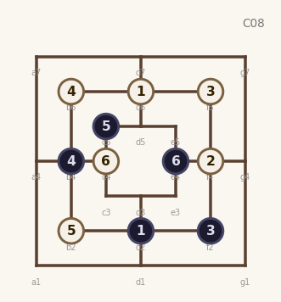  11.W:c4 12.B:e4  ★ teacher | 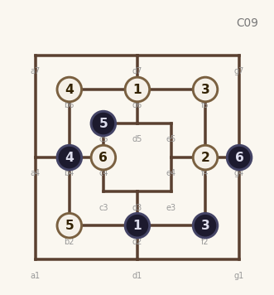  11.W:c4 12.B:g4  ★ teacher

B05 Open Z Mill
Opening (10-ply): 1.W:d6 2.B:d2 3.W:f4 4.B:b4
5.W:f6 6.B:f2 7.W:b6xb4 8.B:b4
9.W:c4 10.B:d7
★ = Teacher-predicted (upper ELO band)
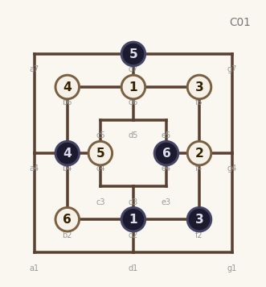  11.W:b2 12.B:e4  ★ teacher | 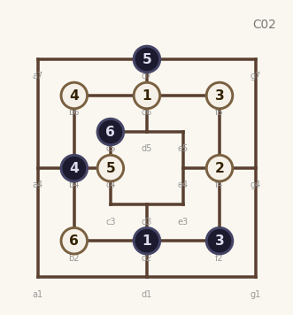  11.W:b2 12.B:c5  ★ teacher | 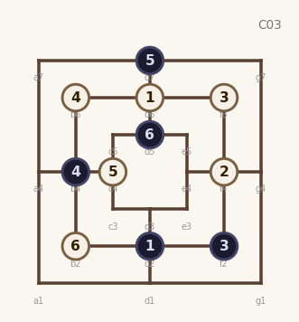  11.W:b2 12.B:d5  ★ teacher
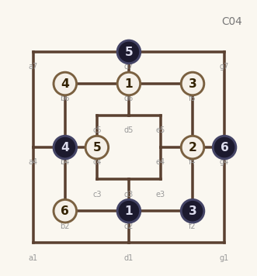  11.W:b2 12.B:g4  ★ teacher | 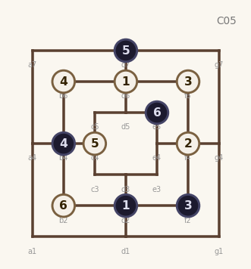  11.W:b2 12.B:e5  ★ teacher | 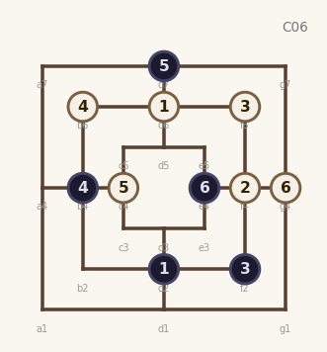  11.W:g4 12.B:e4  ★ teacher
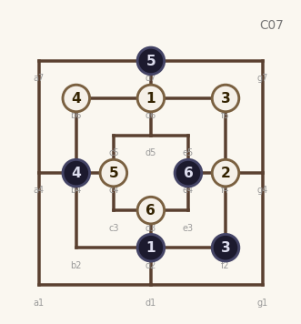  11.W:d3 12.B:e4  ★ teacher | 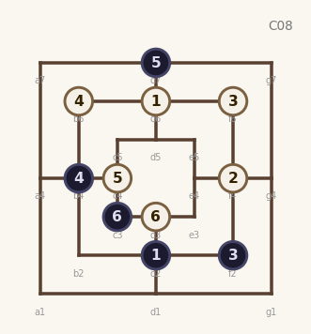  11.W:d3 12.B:c3  ★ teacher | 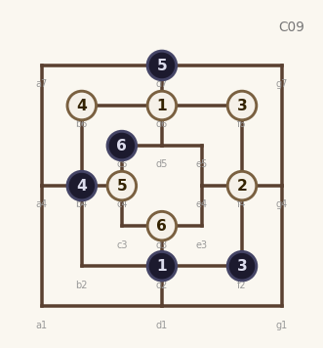  11.W:d3 12.B:c5  ★ teacher

B06 Z Mill – c4 to d3
Opening (12-ply): 1.W:d6 2.B:d2 3.W:f4 4.B:b4
5.W:f6 6.B:f2 7.W:b6xb4 8.B:b4
9.W:c4 10.B:d7 11.W:d3 12.B:d5
★ = Teacher-predicted (upper ELO band)
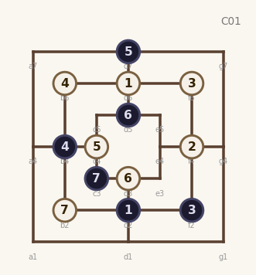  13.W:b2 14.B:c3  ★ teacher | 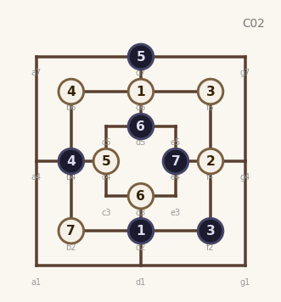  13.W:b2 14.B:e4  ★ teacher | 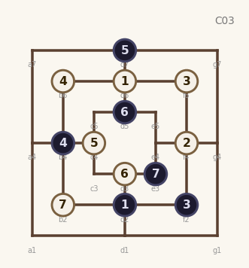  13.W:b2 14.B:e3  ★ teacher
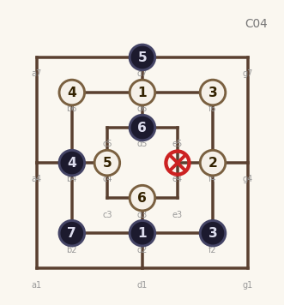  13.W:e4 14.B:b2xe4  ★ teacher | 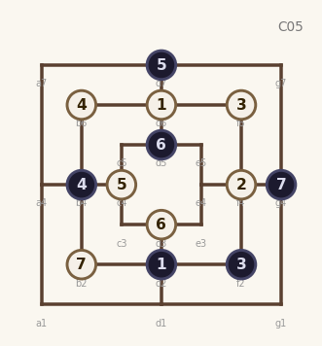  13.W:b2 14.B:g4  ★ teacher | 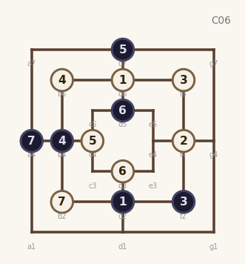  13.W:b2 14.B:a4  ★ teacher
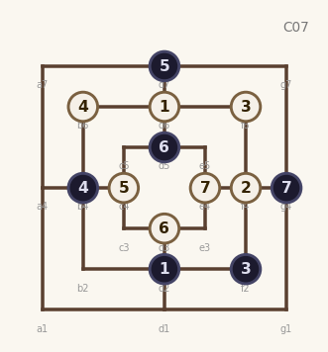  13.W:e4 14.B:g4  ★ teacher | 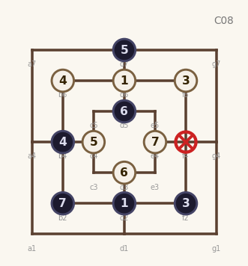  13.W:e4 14.B:b2xf4  ★ teacher | 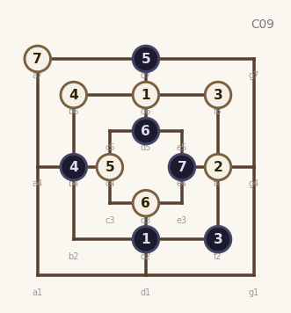  13.W:a7 14.B:e4  ★ teacher

B07 Z Mill – c4 and e3
Opening (12-ply): 1.W:d6 2.B:d2 3.W:f4 4.B:b4
5.W:f6 6.B:f2 7.W:b6xb4 8.B:b4
9.W:c4 10.B:d5 11.W:e3 12.B:e4
★ = Teacher-predicted (upper ELO band)
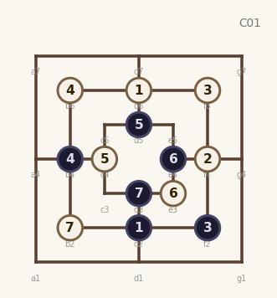  13.W:b2 14.B:d3  ★ teacher | 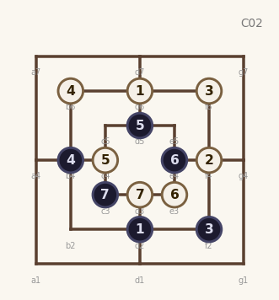  13.W:d3 14.B:c3  ★ teacher | 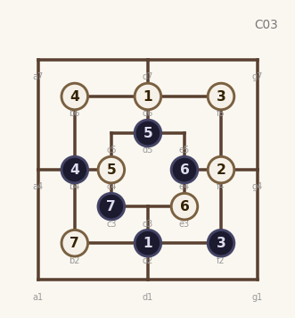  13.W:b2 14.B:c3  ★ teacher
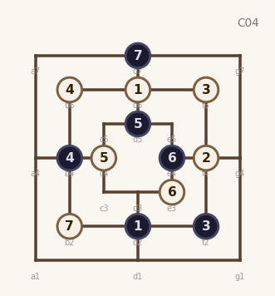  13.W:b2 14.B:d7  ★ teacher | 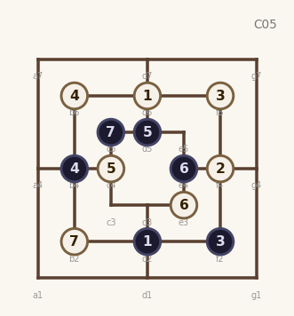  13.W:b2 14.B:c5  ★ teacher | 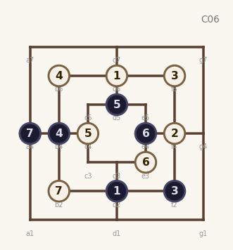  13.W:b2 14.B:a4  ★ teacher
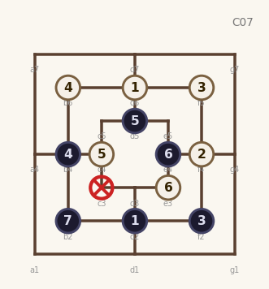  13.W:c3 14.B:b2xc3  ★ teacher | 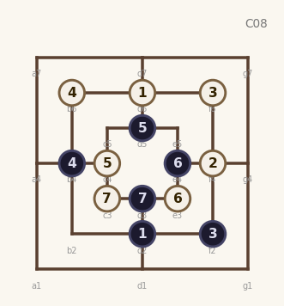  13.W:c3 14.B:d3  ★ teacher | 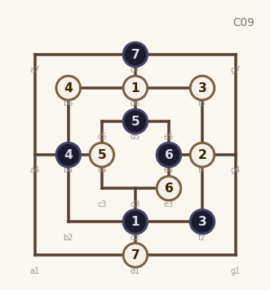  13.W:d1 14.B:d7  ★ teacher

B08 Z Mill Interrupted
Opening (8-ply): 1.W:d6 2.B:d2 3.W:f4 4.B:b6
5.W:c3 6.B:b2 7.W:f2 8.B:b4xf2
★ = Teacher-predicted (upper ELO band)
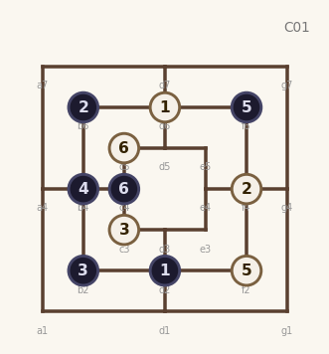  9.W:f2 10.B:f6  11.W:c5 12.B:c4  freq: 2 | 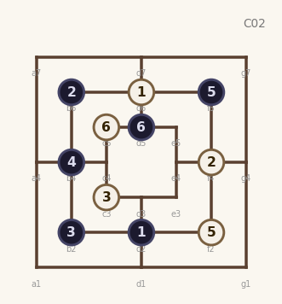  9.W:f2 10.B:f6  11.W:c5 12.B:d5  freq: 2 | 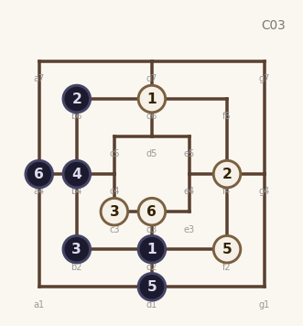  9.W:f2 10.B:d1  11.W:d3 12.B:a4  freq: 2
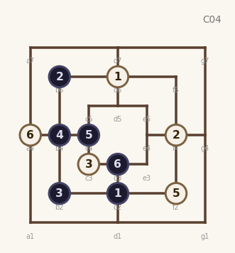  9.W:f2 10.B:c4  11.W:a4 12.B:d3  ★ teacher | 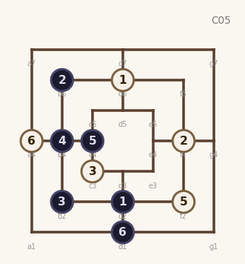  9.W:f2 10.B:c4  11.W:a4 12.B:d1  ★ teacher | 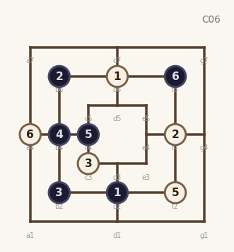  9.W:f2 10.B:c4  11.W:a4 12.B:f6  ★ teacher
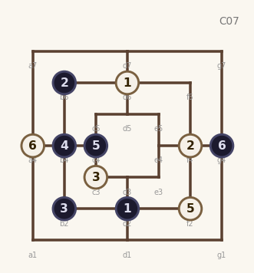  9.W:f2 10.B:c4  11.W:a4 12.B:g4  ★ teacher | 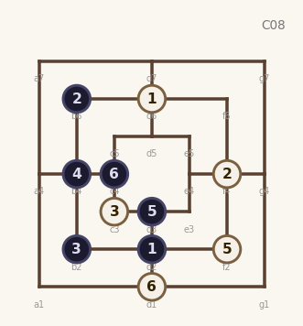  9.W:f2 10.B:d3  11.W:d1 12.B:c4  ★ teacher | 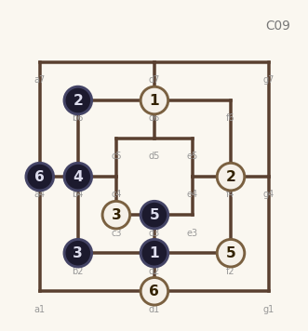  9.W:f2 10.B:d3  11.W:d1 12.B:a4  ★ teacher

B09 Mill Rush Interrupt
Opening (8-ply): 1.W:d6 2.B:d2 3.W:f4 4.B:b4
5.W:g7 6.B:d3 7.W:d1 8.B:c4
★ = Teacher-predicted (upper ELO band)
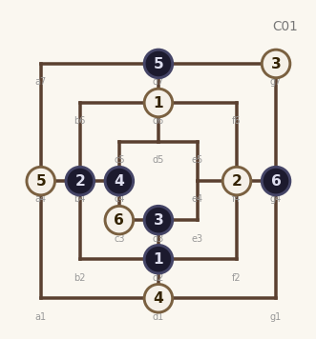  9.W:a4 10.B:d7  11.W:c3 12.B:g4  ★ teacher | 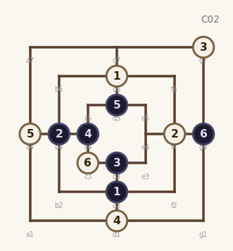  9.W:a4 10.B:d5  11.W:c3 12.B:g4  ★ teacher | 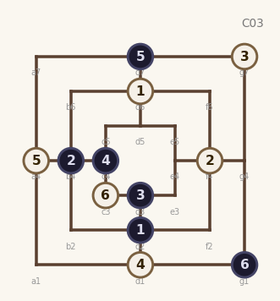  9.W:a4 10.B:d7  11.W:c3 12.B:g1  ★ teacher
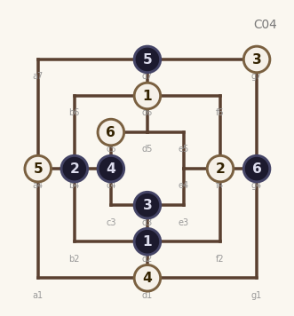  9.W:a4 10.B:d7  11.W:c5 12.B:g4  ★ teacher | 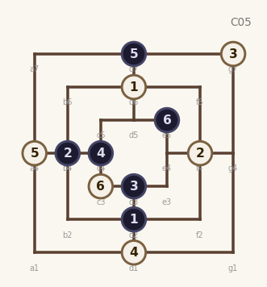  9.W:a4 10.B:d7  11.W:c3 12.B:e5  ★ teacher | 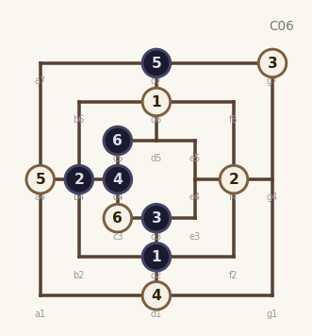  9.W:a4 10.B:d7  11.W:c3 12.B:c5  ★ teacher
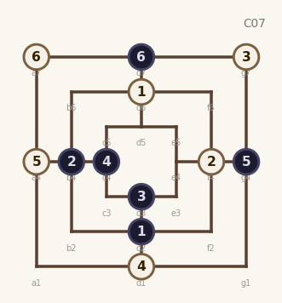  9.W:a4 10.B:g4  11.W:a7 12.B:d7  ★ teacher | 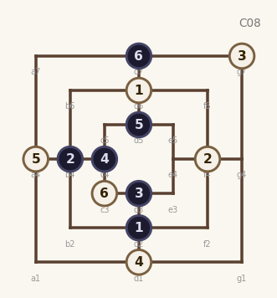  9.W:a4 10.B:d5  11.W:c3 12.B:d7  ★ teacher | 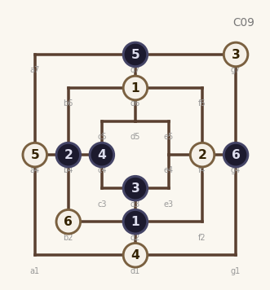  9.W:a4 10.B:d7  11.W:b2 12.B:g4  ★ teacher

B10 Black into White
Opening (8-ply): 1.W:d6 2.B:d2 3.W:f4 4.B:b2
5.W:f2 6.B:f6 7.W:g7 8.B:d5
★ = Teacher-predicted (upper ELO band)
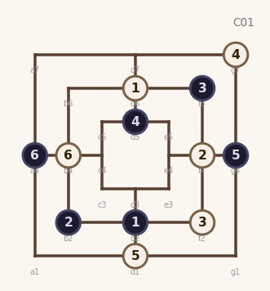  9.W:d1 10.B:g4  11.W:b4 12.B:a4  ★ teacher | 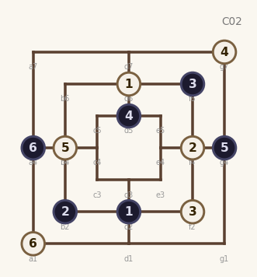  9.W:b4 10.B:g4  11.W:a1 12.B:a4  ★ teacher | 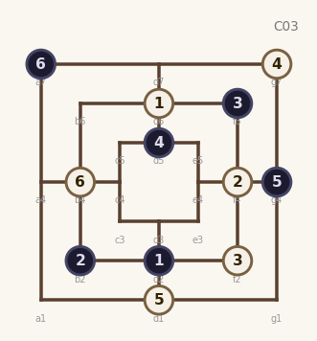  9.W:d1 10.B:g4  11.W:b4 12.B:a7  ★ teacher
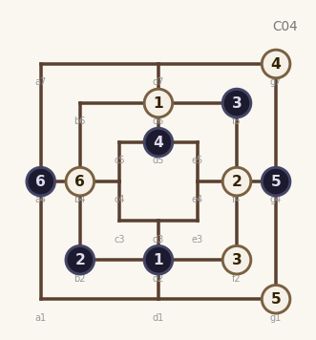  9.W:g1 10.B:g4  11.W:b4 12.B:a4  ★ teacher | 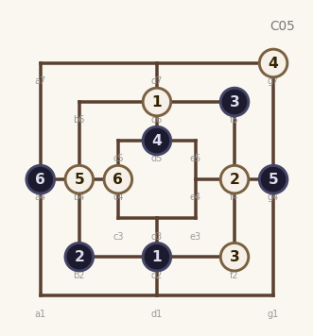  9.W:b4 10.B:g4  11.W:c4 12.B:a4  ★ teacher | 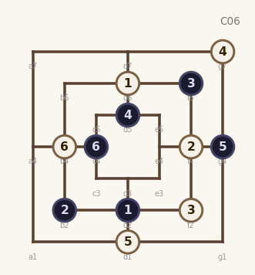  9.W:d1 10.B:g4  11.W:b4 12.B:c4  ★ teacher
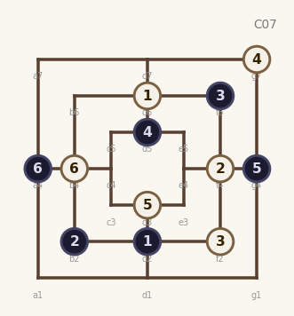  9.W:d3 10.B:g4  11.W:b4 12.B:a4  ★ teacher | 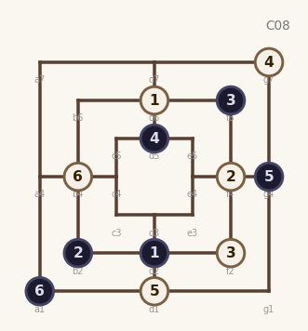  9.W:d1 10.B:g4  11.W:b4 12.B:a1  ★ teacher | 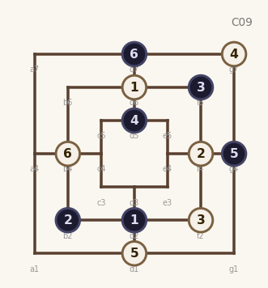  9.W:d1 10.B:g4  11.W:b4 12.B:d7  ★ teacher

B11 Black away from White
Opening (8-ply): 1.W:d6 2.B:d2 3.W:f4 4.B:f2
5.W:b2 6.B:b4 7.W:g7 8.B:e4
★ = Teacher-predicted (upper ELO band)
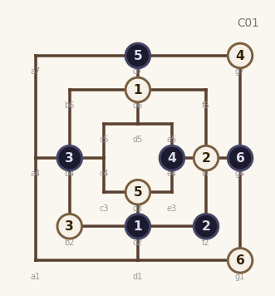  9.W:d3 10.B:d7  11.W:g1 12.B:g4  ★ teacher | 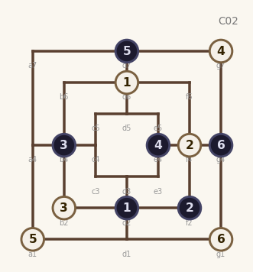  9.W:a1 10.B:d7  11.W:g1 12.B:g4  ★ teacher | 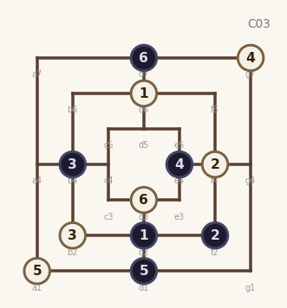  9.W:a1 10.B:d1  11.W:d3 12.B:d7  ★ teacher
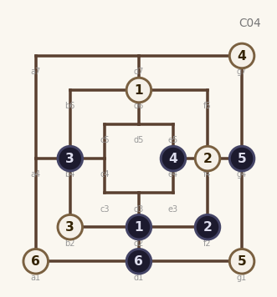  9.W:g1 10.B:g4  11.W:a1 12.B:d1  ★ teacher | 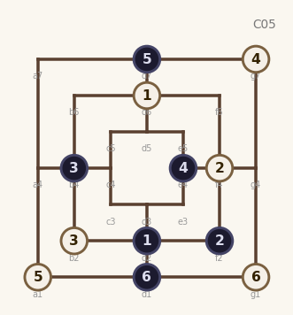  9.W:a1 10.B:d7  11.W:g1 12.B:d1  ★ teacher | 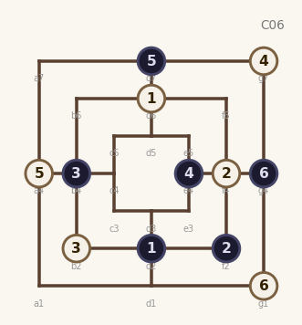  9.W:a4 10.B:d7  11.W:g1 12.B:g4  ★ teacher
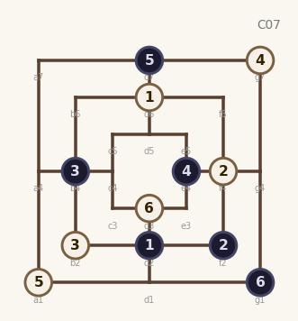  9.W:a1 10.B:d7  11.W:d3 12.B:g1  ★ teacher | 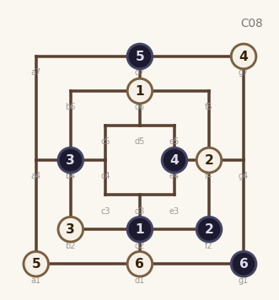  9.W:a1 10.B:d7  11.W:d1 12.B:g1  ★ teacher | 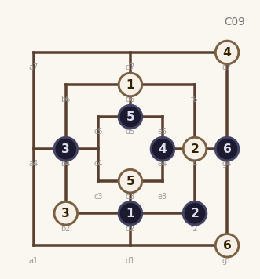  9.W:d3 10.B:d5  11.W:g1 12.B:g4  ★ teacher

H01 B-Column Double – ply8 E4
Opening (8-ply): 1.W:d6 2.B:d2 3.W:b4 4.B:f6
5.W:f4 6.B:b2 7.W:f2 8.B:e4
★ = Teacher-predicted (upper ELO band)
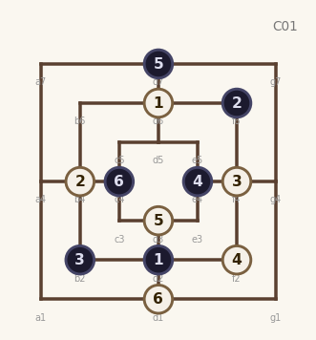  9.W:d3 10.B:d7  11.W:d1 12.B:c4  freq: 13 | 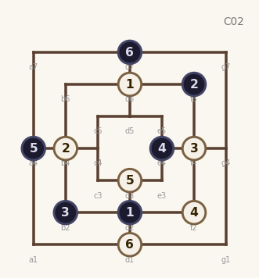  9.W:d3 10.B:a4  11.W:d1 12.B:d7  freq: 10 | 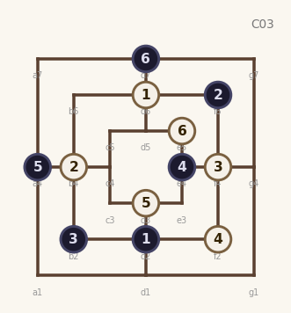  9.W:d3 10.B:a4  11.W:e5 12.B:d7  freq: 7
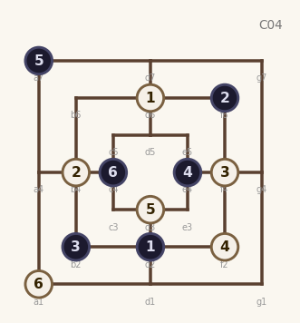  9.W:d3 10.B:a7  11.W:a1 12.B:c4  freq: 4 | 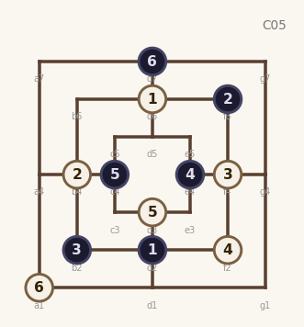  9.W:d3 10.B:c4  11.W:a1 12.B:d7  freq: 2 | 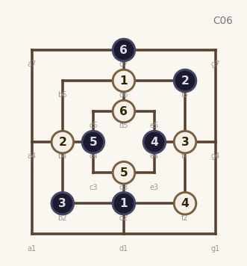  9.W:d3 10.B:c4  11.W:d5 12.B:d7  ★ teacher
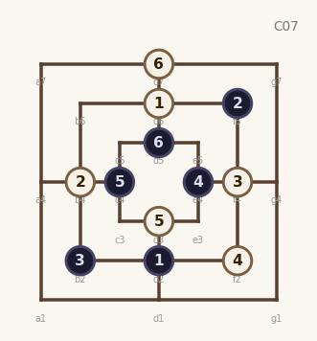  9.W:d3 10.B:c4  11.W:d7 12.B:d5  ★ teacher | 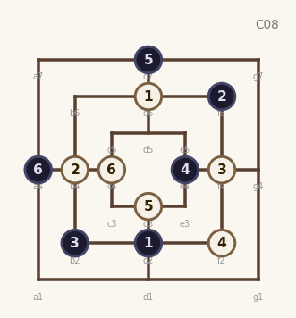  9.W:d3 10.B:d7  11.W:c4 12.B:a4  ★ teacher | 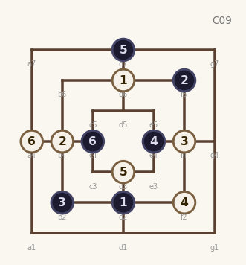  9.W:d3 10.B:d7  11.W:a4 12.B:c4  ★ teacher

H02 B-Column Double – ply8 D5
Opening (8-ply): 1.W:d6 2.B:d2 3.W:b4 4.B:f6
5.W:f4 6.B:b2 7.W:f2 8.B:d5
★ = Teacher-predicted (upper ELO band)
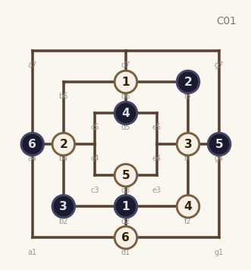  9.W:d3 10.B:g4  11.W:d1 12.B:a4  freq: 12 | 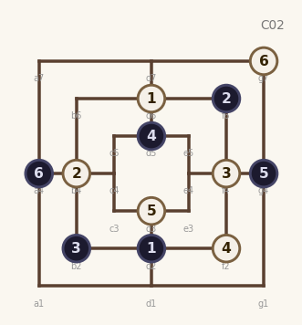  9.W:d3 10.B:g4  11.W:g7 12.B:a4  freq: 4 | 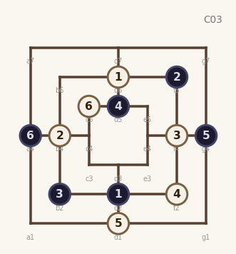  9.W:d1 10.B:g4  11.W:c5 12.B:a4  freq: 4
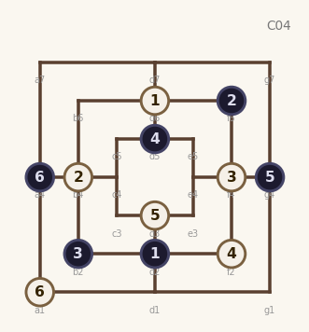  9.W:d3 10.B:g4  11.W:a1 12.B:a4  freq: 3 | 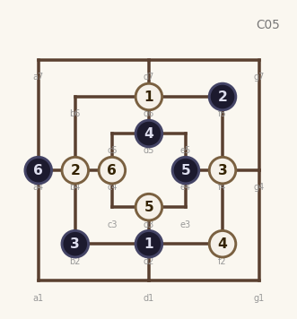  9.W:d3 10.B:e4  11.W:c4 12.B:a4  ★ teacher | 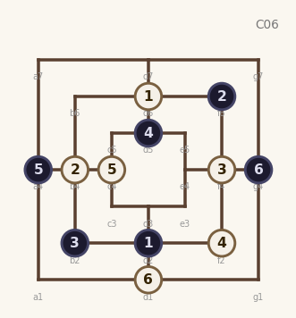  9.W:c4 10.B:a4  11.W:d1 12.B:g4  ★ teacher
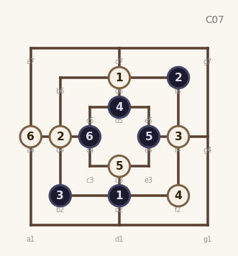  9.W:d3 10.B:e4  11.W:a4 12.B:c4  ★ teacher | 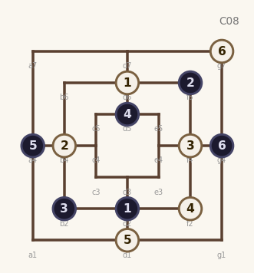  9.W:d1 10.B:a4  11.W:g7 12.B:g4  ★ teacher | 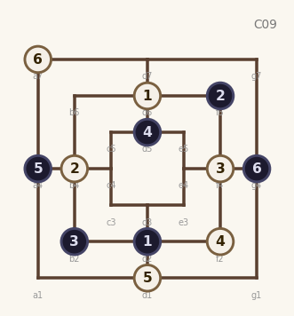  9.W:d1 10.B:a4  11.W:a7 12.B:g4  ★ teacher

H03 B-Column Double – ply8 G4
Opening (8-ply): 1.W:d6 2.B:d2 3.W:b4 4.B:f6
5.W:f4 6.B:b2 7.W:f2 8.B:g4
★ = Teacher-predicted (upper ELO band)
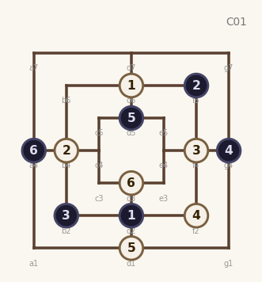  9.W:d1 10.B:d5  11.W:d3 12.B:a4  freq: 12 | 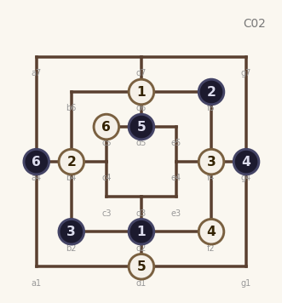  9.W:d1 10.B:d5  11.W:c5 12.B:a4  freq: 4 | 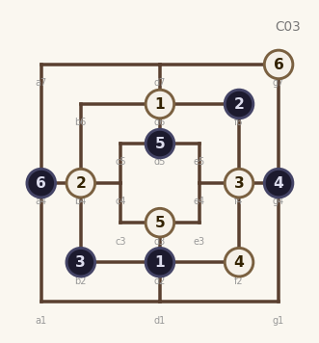  9.W:d3 10.B:d5  11.W:g7 12.B:a4  freq: 4
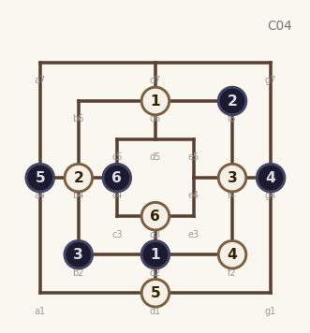  9.W:d1 10.B:a4  11.W:d3 12.B:c4  freq: 3 | 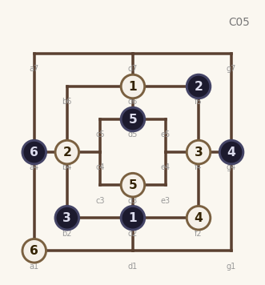  9.W:d3 10.B:d5  11.W:a1 12.B:a4  freq: 3 | 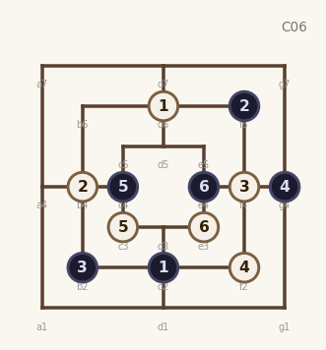  9.W:c3 10.B:c4  11.W:e3 12.B:e4  freq: 2
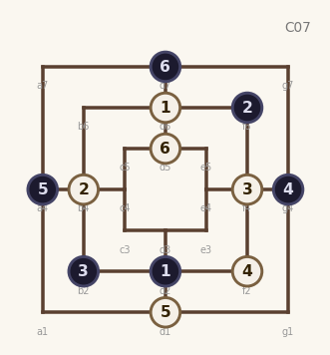  9.W:d1 10.B:a4  11.W:d5 12.B:d7  ★ teacher | 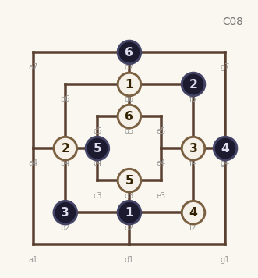  9.W:d3 10.B:c4  11.W:d5 12.B:d7  ★ teacher | 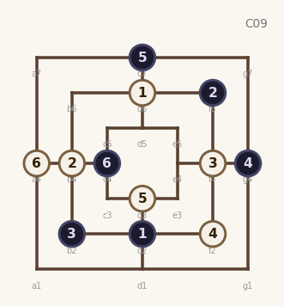  9.W:d3 10.B:d7  11.W:a4 12.B:c4  ★ teacher

H04 Inner Diagonal – D7
Opening (8-ply): 1.W:d6 2.B:b4 3.W:d2 4.B:f4
5.W:c4 6.B:d3 7.W:g4 8.B:d7
★ = Teacher-predicted (upper ELO band)
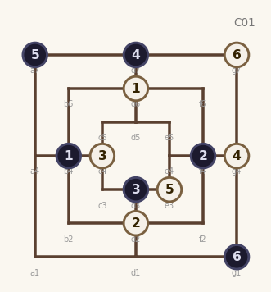  9.W:e3 10.B:a7  11.W:g7 12.B:g1  freq: 7 | 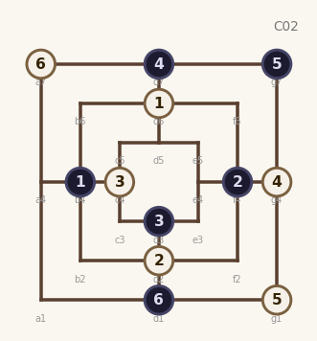  9.W:g1 10.B:g7  11.W:a7 12.B:d1  freq: 5 | 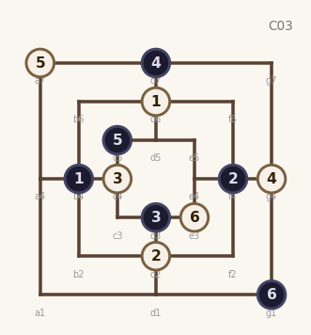  9.W:a7 10.B:c5  11.W:e3 12.B:g1  freq: 4
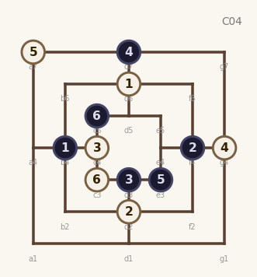  9.W:a7 10.B:e3  11.W:c3 12.B:c5  freq: 3 | 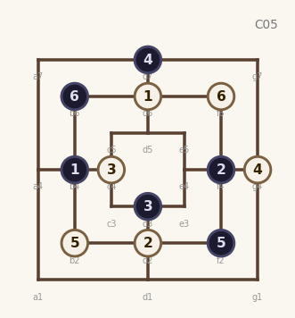  9.W:b2 10.B:f2  11.W:f6 12.B:b6  ★ teacher | 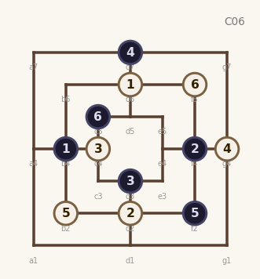  9.W:b2 10.B:f2  11.W:f6 12.B:c5  ★ teacher
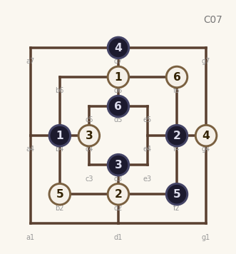  9.W:b2 10.B:f2  11.W:f6 12.B:d5  ★ teacher | 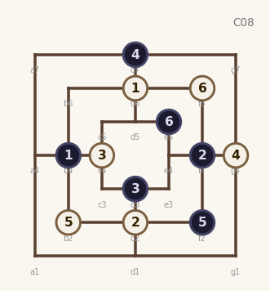  9.W:b2 10.B:f2  11.W:f6 12.B:e5  ★ teacher | 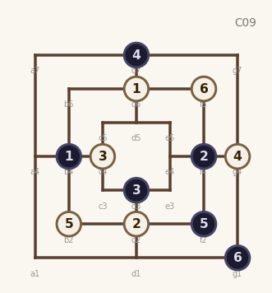  9.W:b2 10.B:f2  11.W:f6 12.B:g1  ★ teacher

H05 B-Column Double – ply8 C4
Opening (8-ply): 1.W:d6 2.B:d2 3.W:b4 4.B:f6
5.W:f4 6.B:b2 7.W:f2 8.B:c4
★ = Teacher-predicted (upper ELO band)
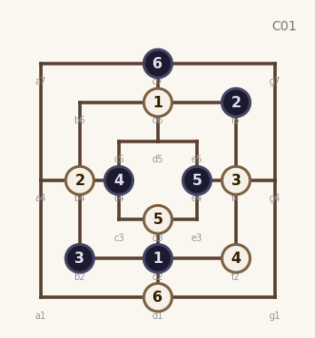  9.W:d3 10.B:e4  11.W:d1 12.B:d7  freq: 13 | 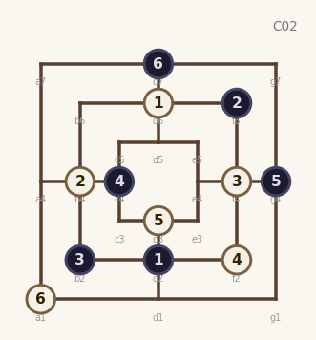  9.W:d3 10.B:g4  11.W:a1 12.B:d7  freq: 2 | 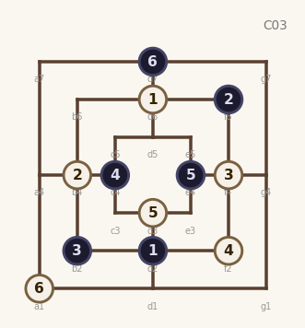  9.W:d3 10.B:e4  11.W:a1 12.B:d7  freq: 2
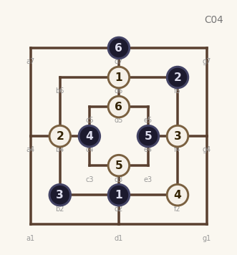  9.W:d3 10.B:e4  11.W:d5 12.B:d7  ★ teacher | 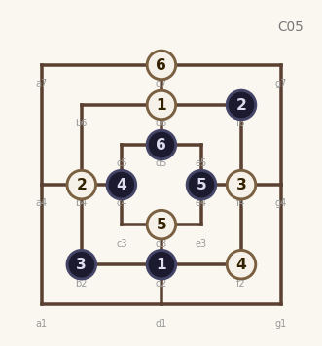  9.W:d3 10.B:e4  11.W:d7 12.B:d5  ★ teacher | 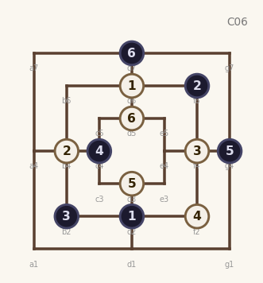  9.W:d3 10.B:g4  11.W:d5 12.B:d7  ★ teacher
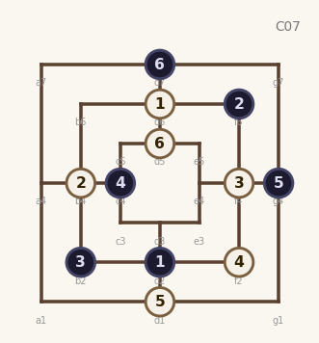  9.W:d1 10.B:g4  11.W:d5 12.B:d7  ★ teacher | 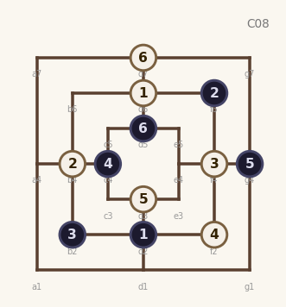  9.W:d3 10.B:g4  11.W:d7 12.B:d5  ★ teacher | 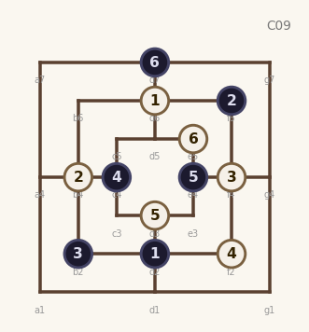  9.W:d3 10.B:e4  11.W:e5 12.B:d7  ★ teacher

H06 B-Column Double – ply8 F6
Opening (8-ply): 1.W:d6 2.B:d2 3.W:b4 4.B:f4
5.W:b6 6.B:b2 7.W:f2 8.B:f6
★ = Teacher-predicted (upper ELO band)
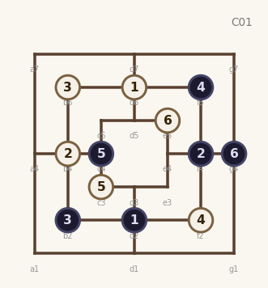  9.W:c3 10.B:c4  11.W:e5 12.B:g4  freq: 5 | 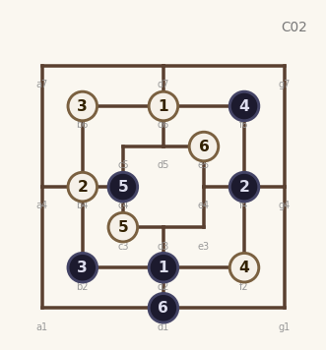  9.W:c3 10.B:c4  11.W:e5 12.B:d1  freq: 3 | 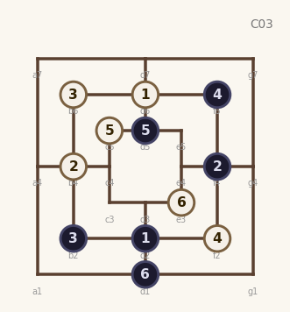  9.W:c5 10.B:d5  11.W:e3 12.B:d1  freq: 3
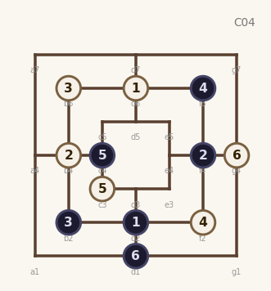  9.W:c3 10.B:c4  11.W:g4 12.B:d1  freq: 2 | 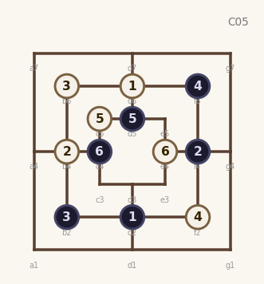  9.W:c5 10.B:d5  11.W:e4 12.B:c4  freq: 2 | 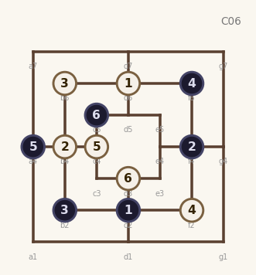  9.W:c4 10.B:a4  11.W:d3 12.B:c5  ★ teacher
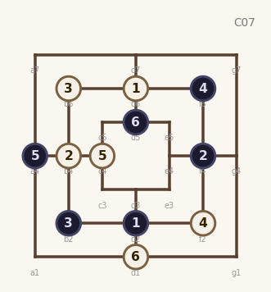  9.W:c4 10.B:a4  11.W:d1 12.B:d5  ★ teacher | 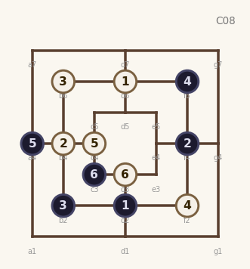  9.W:c4 10.B:a4  11.W:d3 12.B:c3  ★ teacher | 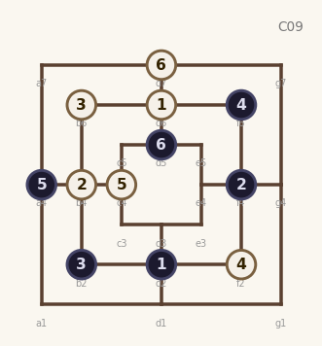  9.W:c4 10.B:a4  11.W:d7 12.B:d5  ★ teacher

H07 Corner Double
Opening (8-ply): 1.W:d6 2.B:d2 3.W:b4 4.B:b6
5.W:f2 6.B:f4 7.W:e4 8.B:d5
★ = Teacher-predicted (upper ELO band)
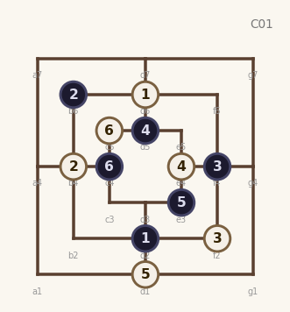  9.W:d1 10.B:e3  11.W:c5 12.B:c4  freq: 11 | 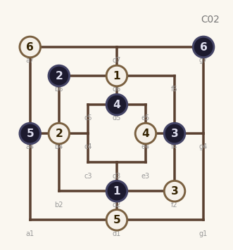  9.W:d1 10.B:a4  11.W:a7 12.B:g7  freq: 7 | 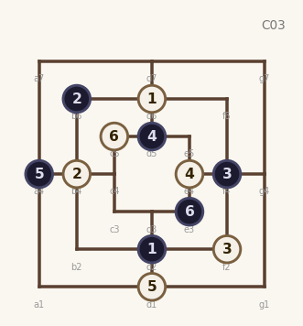  9.W:d1 10.B:a4  11.W:c5 12.B:e3  freq: 5
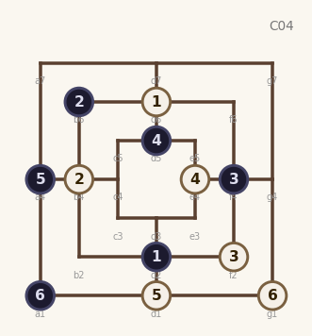  9.W:d1 10.B:a4  11.W:g1 12.B:a1  freq: 5 | 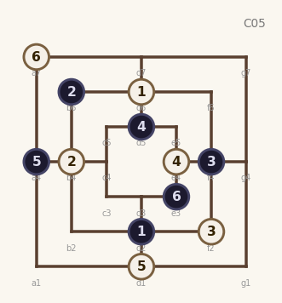  9.W:d1 10.B:a4  11.W:a7 12.B:e3  freq: 3 | 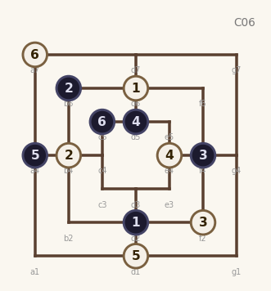  9.W:d1 10.B:a4  11.W:a7 12.B:c5  freq: 3
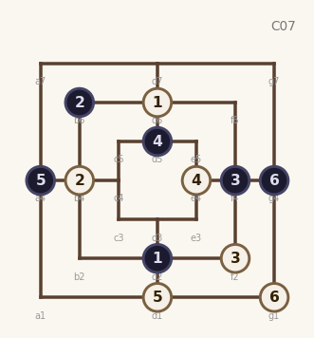  9.W:d1 10.B:a4  11.W:g1 12.B:g4  freq: 2 | 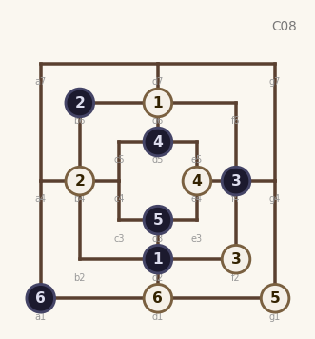  9.W:g1 10.B:d3  11.W:d1 12.B:a1  ★ teacher | 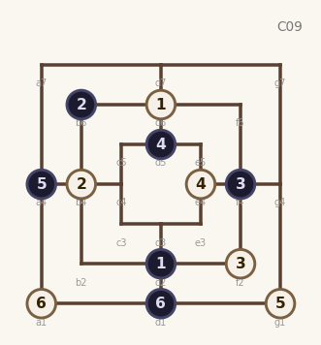  9.W:g1 10.B:a4  11.W:a1 12.B:d1  ★ teacher

H08 Inner Counter – E4
Opening (8-ply): 1.W:d6 2.B:d2 3.W:b4 4.B:f6
5.W:f4 6.B:c4 7.W:d3 8.B:e4
★ = Teacher-predicted (upper ELO band)
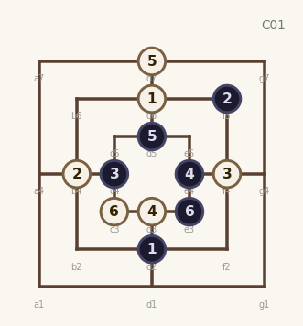  9.W:d7 10.B:d5  11.W:c3 12.B:e3  freq: 4 | 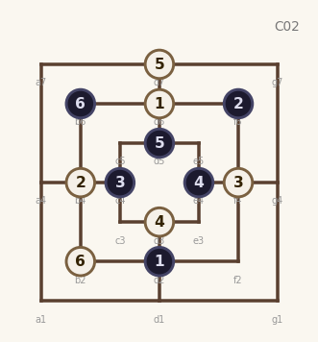  9.W:d7 10.B:d5  11.W:b2 12.B:b6  freq: 4 | 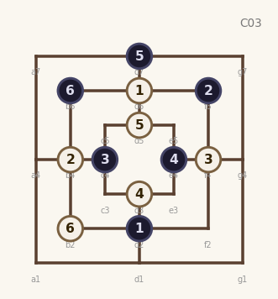  9.W:d5 10.B:d7  11.W:b2 12.B:b6  ★ teacher
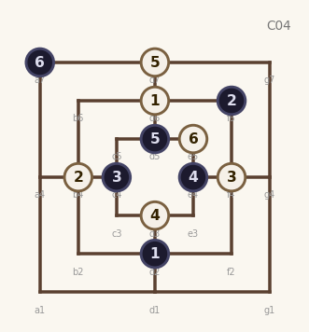  9.W:d7 10.B:d5  11.W:e5 12.B:a7  ★ teacher | 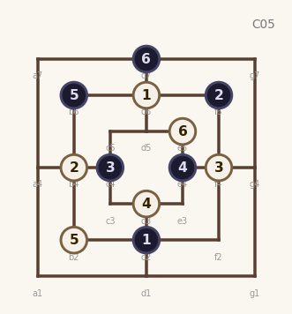  9.W:b2 10.B:b6  11.W:e5 12.B:d7  ★ teacher | 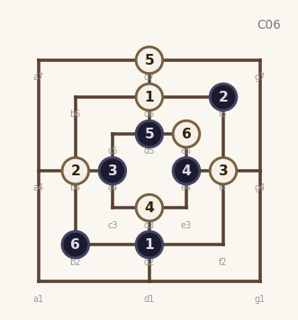  9.W:d7 10.B:d5  11.W:e5 12.B:b2  ★ teacher
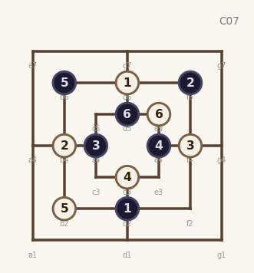  9.W:b2 10.B:b6  11.W:e5 12.B:d5  ★ teacher | 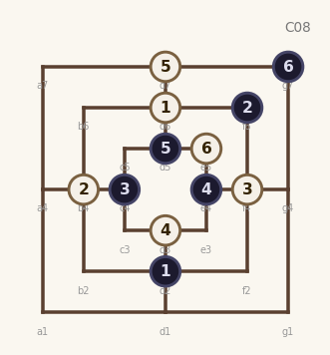  9.W:d7 10.B:d5  11.W:e5 12.B:g7  ★ teacher | 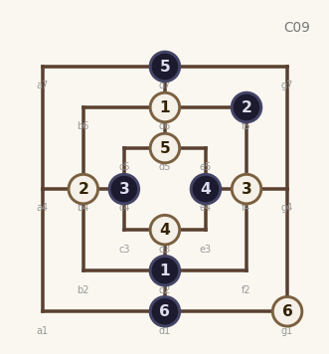  9.W:d5 10.B:d7  11.W:g1 12.B:d1  ★ teacher

H09 B-Column Double – ply8 A4
Opening (8-ply): 1.W:d6 2.B:d2 3.W:b4 4.B:f6
5.W:f4 6.B:b2 7.W:f2 8.B:a4
★ = Teacher-predicted (upper ELO band)
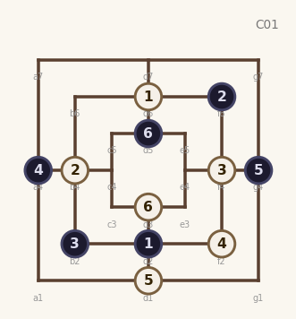  9.W:d1 10.B:g4  11.W:d3 12.B:d5  freq: 12 | 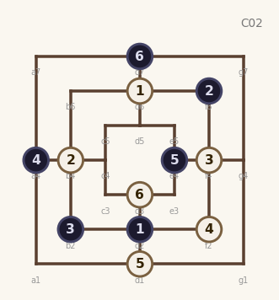  9.W:d1 10.B:e4  11.W:d3 12.B:d7  freq: 10 | 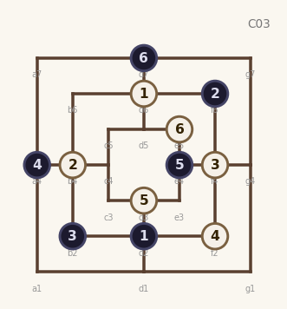  9.W:d3 10.B:e4  11.W:e5 12.B:d7  freq: 7
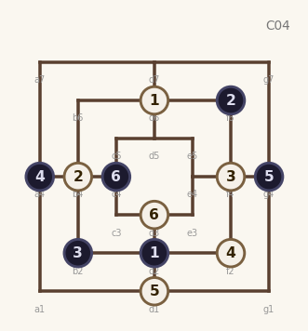  9.W:d1 10.B:g4  11.W:d3 12.B:c4  freq: 3 | 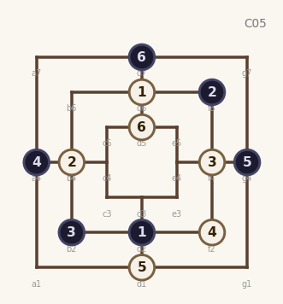  9.W:d1 10.B:g4  11.W:d5 12.B:d7  ★ teacher | 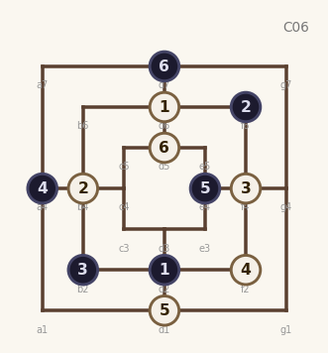  9.W:d1 10.B:e4  11.W:d5 12.B:d7  ★ teacher
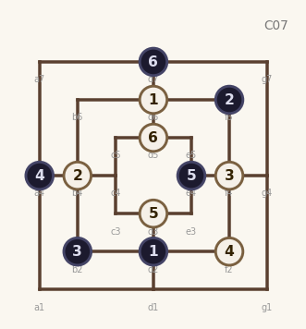  9.W:d3 10.B:e4  11.W:d5 12.B:d7  ★ teacher | 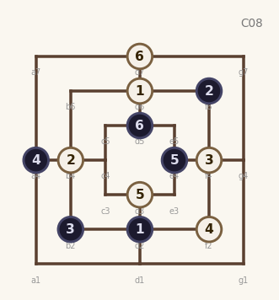  9.W:d3 10.B:e4  11.W:d7 12.B:d5  ★ teacher | 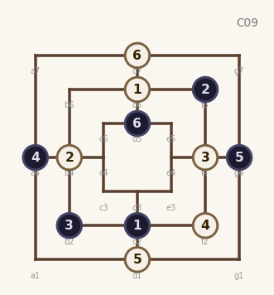  9.W:d1 10.B:g4  11.W:d7 12.B:d5  ★ teacher

H10 B-Column Double – ply8 B6
Opening (8-ply): 1.W:d6 2.B:d2 3.W:b4 4.B:f4
5.W:d1 6.B:f2 7.W:f6 8.B:b6
★ = Teacher-predicted (upper ELO band)
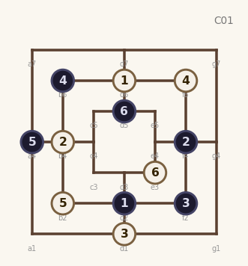  9.W:b2 10.B:a4  11.W:e3 12.B:d5  freq: 3 | 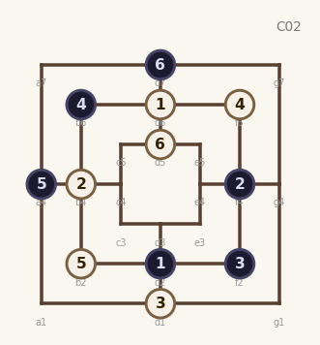  9.W:b2 10.B:a4  11.W:d5 12.B:d7  ★ teacher | 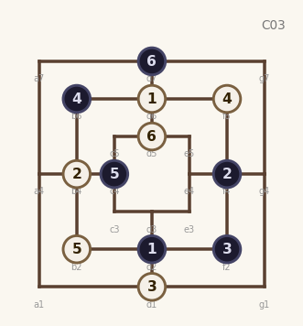  9.W:b2 10.B:c4  11.W:d5 12.B:d7  ★ teacher
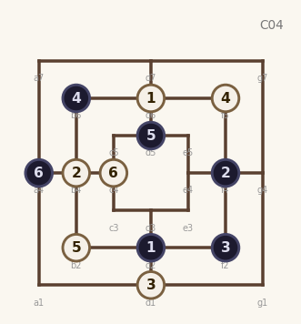  9.W:b2 10.B:d5  11.W:c4 12.B:a4  ★ teacher | 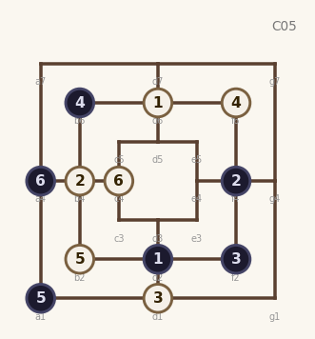  9.W:b2 10.B:a1  11.W:c4 12.B:a4  ★ teacher | 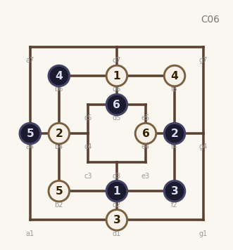  9.W:b2 10.B:a4  11.W:e4 12.B:d5  ★ teacher
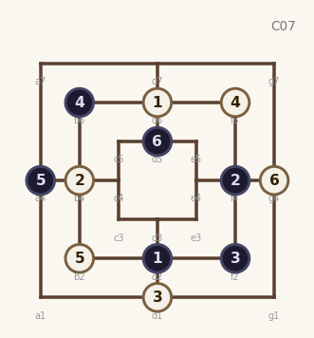  9.W:b2 10.B:a4  11.W:g4 12.B:d5  ★ teacher | 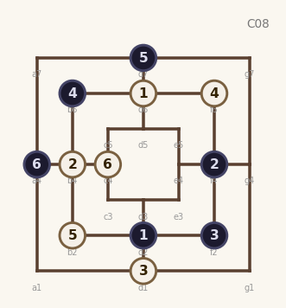  9.W:b2 10.B:d7  11.W:c4 12.B:a4  ★ teacher | 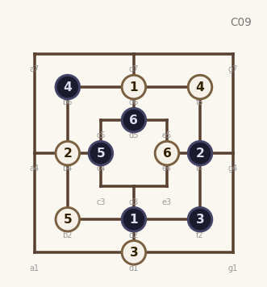  9.W:b2 10.B:c4  11.W:e4 12.B:d5  ★ teacher

H11 Black Inner Outer
Opening (8-ply): 1.W:d6 2.B:d2 3.W:b4 4.B:f6
5.W:f4 6.B:c4 7.W:g7 8.B:d7
★ = Teacher-predicted (upper ELO band)
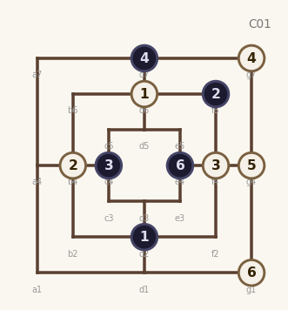  9.W:g4 10.B:e4  11.W:g1xe4 12.B:e4  freq: 25 | 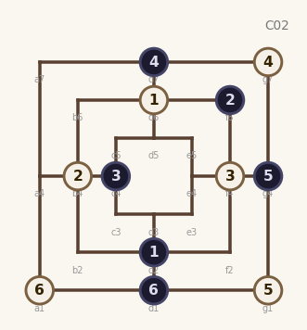  9.W:g1 10.B:g4  11.W:a1 12.B:d1  ★ teacher | 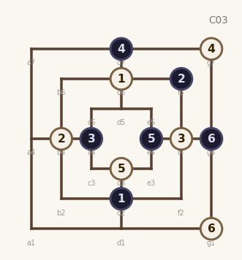  9.W:d3 10.B:e4  11.W:g1 12.B:g4  ★ teacher
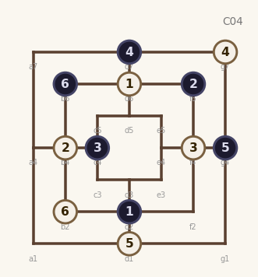  9.W:d1 10.B:g4  11.W:b2 12.B:b6  ★ teacher | 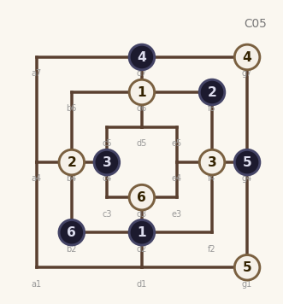  9.W:g1 10.B:g4  11.W:d3 12.B:b2  ★ teacher | 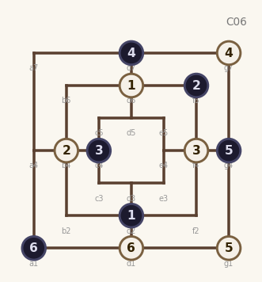  9.W:g1 10.B:g4  11.W:d1 12.B:a1  ★ teacher
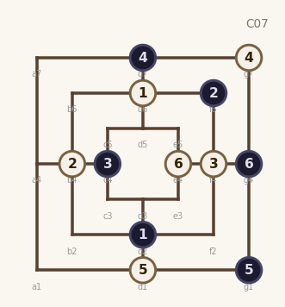  9.W:d1 10.B:g1  11.W:e4 12.B:g4  ★ teacher | 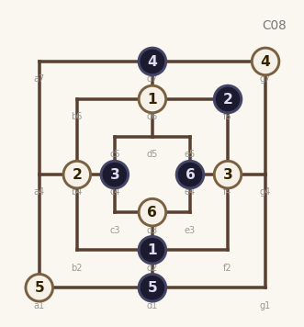  9.W:a1 10.B:d1  11.W:d3 12.B:e4  ★ teacher | 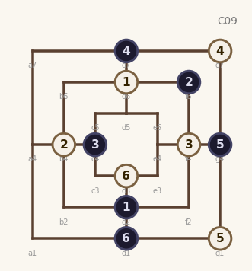  9.W:g1 10.B:g4  11.W:d3 12.B:d1  ★ teacher

H12 Black Outer Mill
Opening (8-ply): 1.W:d6 2.B:b4 3.W:d2 4.B:f4
5.W:c4 6.B:g7 7.W:g4 8.B:a7
★ = Teacher-predicted (upper ELO band)
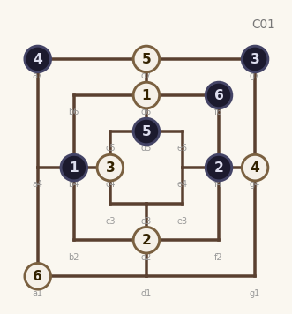  9.W:d7 10.B:d5  11.W:a1 12.B:f6  freq: 7 | 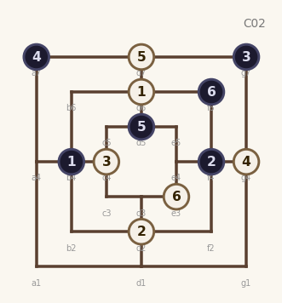  9.W:d7 10.B:d5  11.W:e3 12.B:f6  freq: 5 | 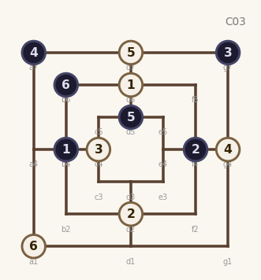  9.W:d7 10.B:d5  11.W:a1 12.B:b6  freq: 3
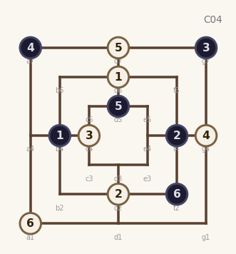  9.W:d7 10.B:d5  11.W:a1 12.B:f2  freq: 3 | 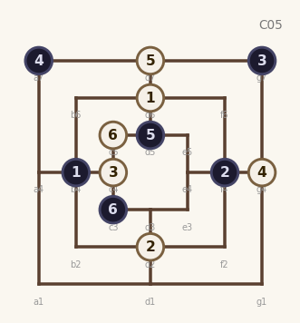  9.W:d7 10.B:d5  11.W:c5 12.B:c3  ★ teacher | 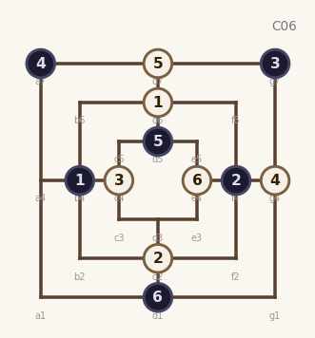  9.W:d7 10.B:d5  11.W:e4 12.B:d1  ★ teacher
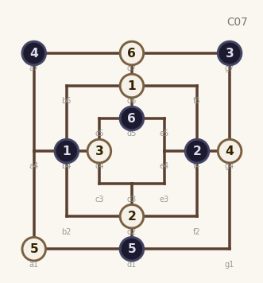  9.W:a1 10.B:d1  11.W:d7 12.B:d5  ★ teacher | 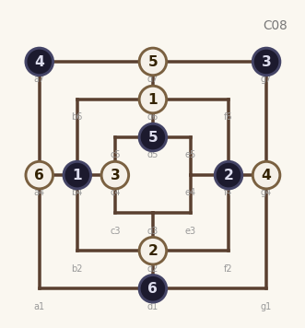  9.W:d7 10.B:d5  11.W:a4 12.B:d1  ★ teacher | 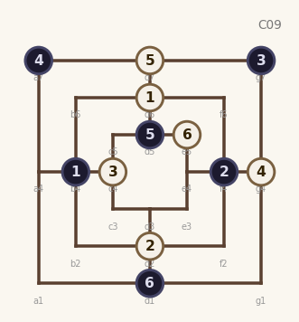  9.W:d7 10.B:d5  11.W:e5 12.B:d1  ★ teacher

H13 Inner Diagonal – B6
Opening (8-ply): 1.W:d6 2.B:d2 3.W:e5 4.B:d5
5.W:f4 6.B:e4 7.W:f6 8.B:b6
★ = Teacher-predicted (upper ELO band)
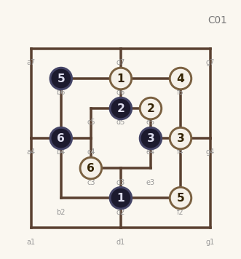  9.W:f2xb6 10.B:b6  11.W:c3 12.B:b4  freq: 6 | 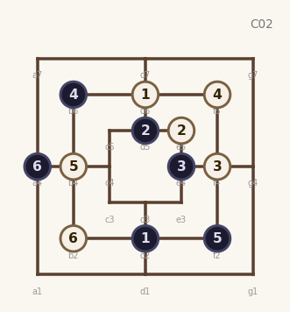  9.W:b4 10.B:f2  11.W:b2 12.B:a4  ★ teacher | 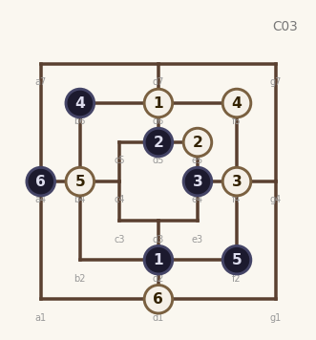  9.W:b4 10.B:f2  11.W:d1 12.B:a4  ★ teacher
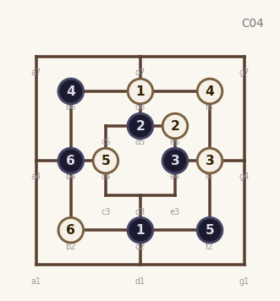  9.W:c4 10.B:f2  11.W:b2 12.B:b4  ★ teacher | 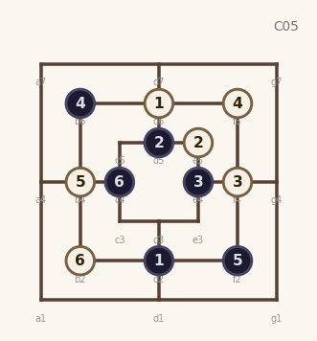  9.W:b4 10.B:f2  11.W:b2 12.B:c4  ★ teacher | 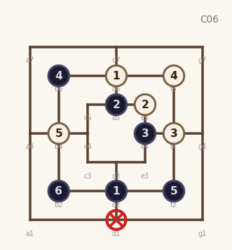  9.W:b4 10.B:f2  11.W:d1 12.B:b2xd1  ★ teacher
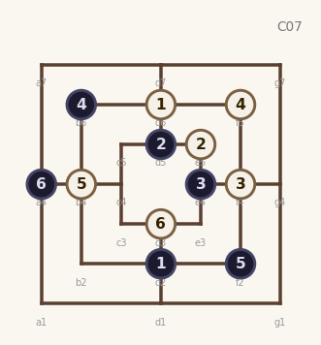  9.W:b4 10.B:f2  11.W:d3 12.B:a4  ★ teacher | 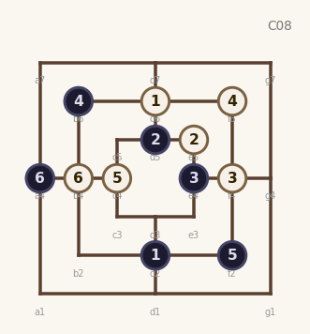  9.W:c4 10.B:f2  11.W:b4 12.B:a4  ★ teacher | 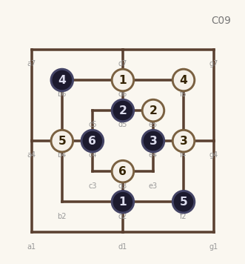  9.W:b4 10.B:f2  11.W:d3 12.B:c4  ★ teacher

H14 B-Column Double – ply8 D7
Opening (8-ply): 1.W:d6 2.B:d2 3.W:b4 4.B:f6
5.W:f4 6.B:b2 7.W:f2 8.B:d7
★ = Teacher-predicted (upper ELO band)
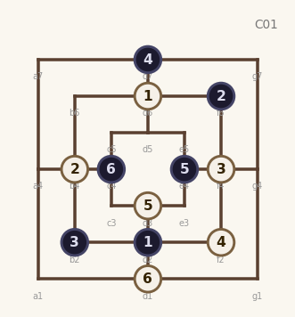  9.W:d3 10.B:e4  11.W:d1 12.B:c4  freq: 13 | 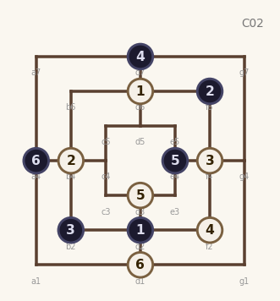  9.W:d3 10.B:e4  11.W:d1 12.B:a4  freq: 10 | 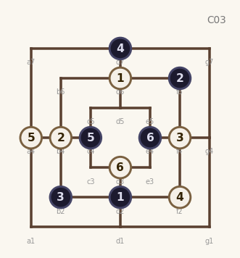  9.W:a4 10.B:c4  11.W:d3 12.B:e4  ★ teacher
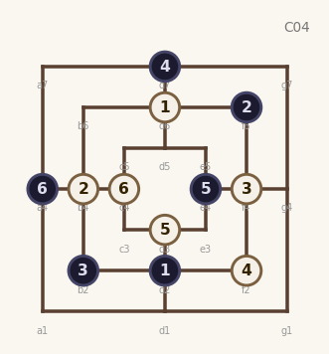  9.W:d3 10.B:e4  11.W:c4 12.B:a4  ★ teacher | 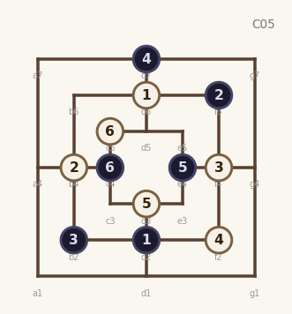  9.W:d3 10.B:e4  11.W:c5 12.B:c4  ★ teacher | 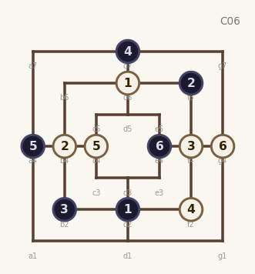  9.W:c4 10.B:a4  11.W:g4 12.B:e4  ★ teacher
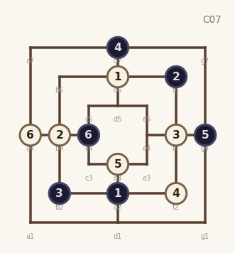  9.W:d3 10.B:g4  11.W:a4 12.B:c4  ★ teacher | 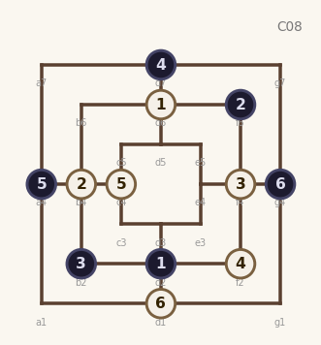  9.W:c4 10.B:a4  11.W:d1 12.B:g4  ★ teacher | 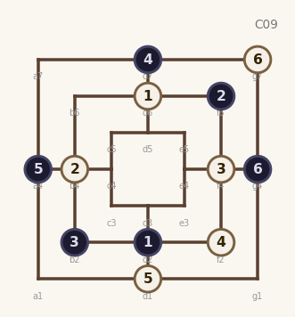  9.W:d1 10.B:a4  11.W:g7 12.B:g4  ★ teacher

H15 White Inner Diagonal
Opening (8-ply): 1.W:d6 2.B:d2 3.W:b4 4.B:f4
5.W:c5 6.B:d5 7.W:d1 8.B:a4
★ = Teacher-predicted (upper ELO band)
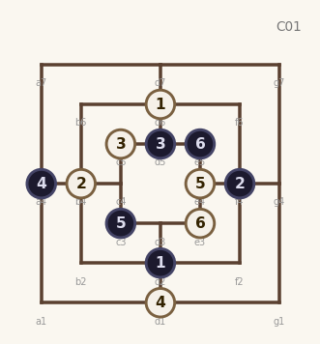  9.W:e4 10.B:c3  11.W:e3 12.B:e5  ★ teacher | 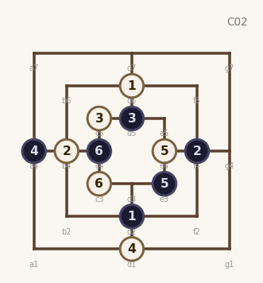  9.W:e4 10.B:e3  11.W:c3 12.B:c4  ★ teacher | 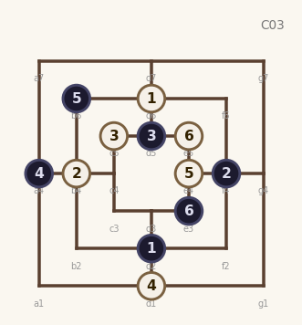  9.W:e4 10.B:b6  11.W:e5 12.B:e3  ★ teacher
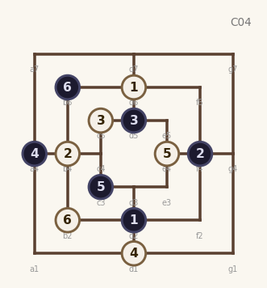  9.W:e4 10.B:c3  11.W:b2 12.B:b6  ★ teacher | 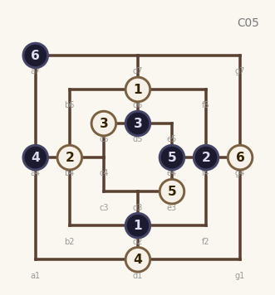  9.W:e3 10.B:e4  11.W:g4 12.B:a7  ★ teacher | 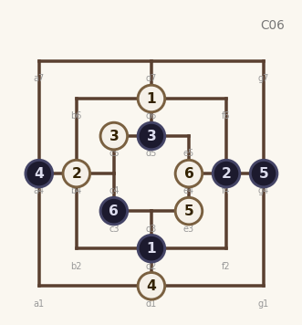  9.W:e3 10.B:g4  11.W:e4 12.B:c3  ★ teacher
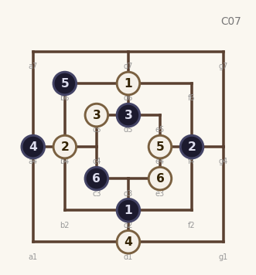  9.W:e4 10.B:b6  11.W:e3 12.B:c3  ★ teacher | 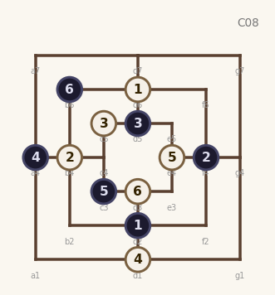  9.W:e4 10.B:c3  11.W:d3 12.B:b6  ★ teacher | 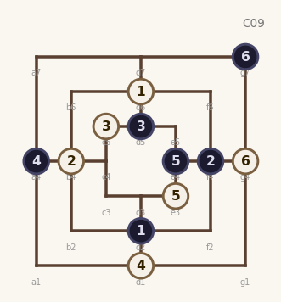  9.W:e3 10.B:e4  11.W:g4 12.B:g7  ★ teacher

H16 Three Cardinal
Opening (8-ply): 1.W:d6 2.B:d2 3.W:b4 4.B:f6
5.W:f4 6.B:a4 7.W:g1 8.B:g4
★ = Teacher-predicted (upper ELO band)
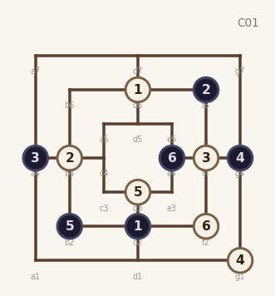  9.W:d3 10.B:b2  11.W:f2 12.B:e4  freq: 9 | 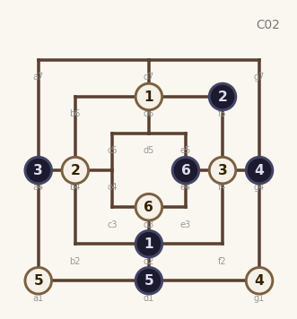  9.W:a1 10.B:d1  11.W:d3 12.B:e4  ★ teacher | 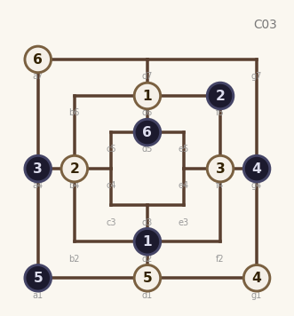  9.W:d1 10.B:a1  11.W:a7 12.B:d5  ★ teacher
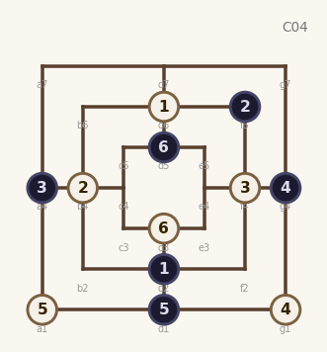  9.W:a1 10.B:d1  11.W:d3 12.B:d5  ★ teacher | 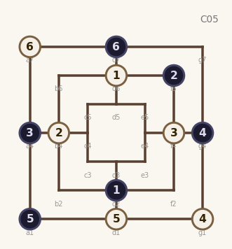  9.W:d1 10.B:a1  11.W:a7 12.B:d7  ★ teacher | 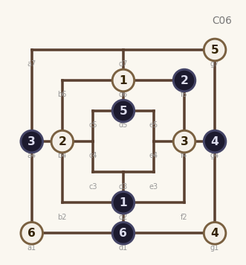  9.W:g7 10.B:d5  11.W:a1 12.B:d1  ★ teacher
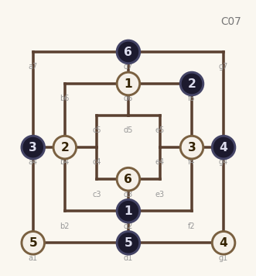  9.W:a1 10.B:d1  11.W:d3 12.B:d7  ★ teacher | 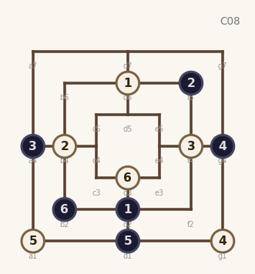  9.W:a1 10.B:d1  11.W:d3 12.B:b2  ★ teacher | 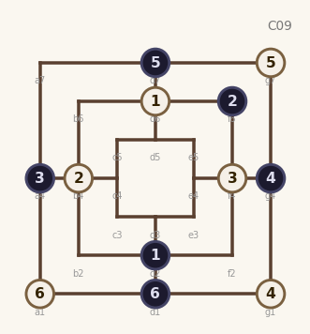  9.W:g7 10.B:d7  11.W:a1 12.B:d1  ★ teacher

H17 Inner Counter – D3
Opening (8-ply): 1.W:d6 2.B:d5 3.W:f4 4.B:f6
5.W:d2 6.B:b2 7.W:b4 8.B:d3
★ = Teacher-predicted (upper ELO band)
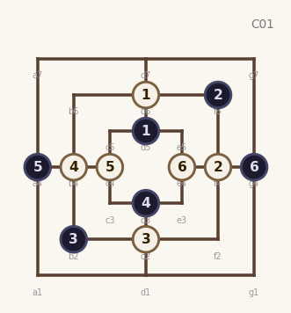  9.W:c4 10.B:a4  11.W:e4 12.B:g4  ★ teacher | 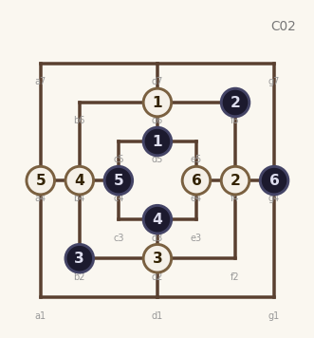  9.W:a4 10.B:c4  11.W:e4 12.B:g4  ★ teacher | 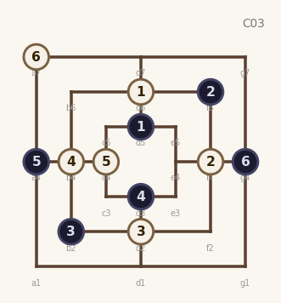  9.W:c4 10.B:a4  11.W:a7 12.B:g4  ★ teacher
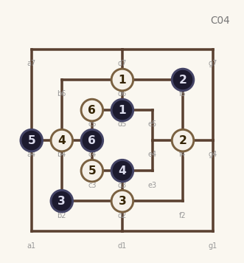  9.W:c3 10.B:a4  11.W:c5 12.B:c4  ★ teacher | 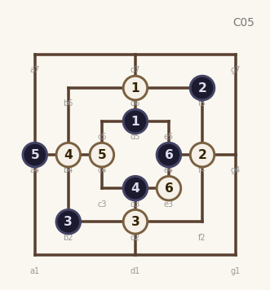  9.W:c4 10.B:a4  11.W:e3 12.B:e4  ★ teacher | 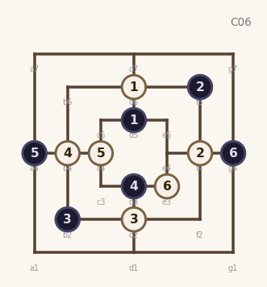  9.W:c4 10.B:a4  11.W:e3 12.B:g4  ★ teacher
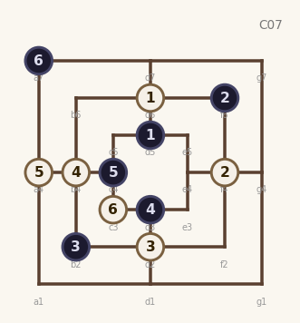  9.W:a4 10.B:c4  11.W:c3 12.B:a7  ★ teacher | 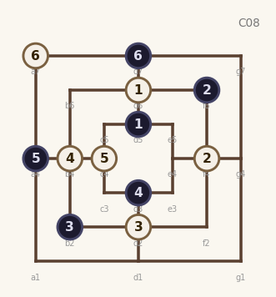  9.W:c4 10.B:a4  11.W:a7 12.B:d7  ★ teacher | 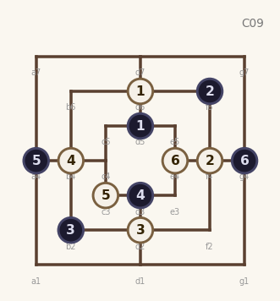  9.W:c3 10.B:a4  11.W:e4 12.B:g4  ★ teacher

H18 Corner Response
Opening (8-ply): 1.W:d6 2.B:d2 3.W:b4 4.B:f4
5.W:g1 6.B:e4 7.W:g4 8.B:g7
★ = Teacher-predicted (upper ELO band)
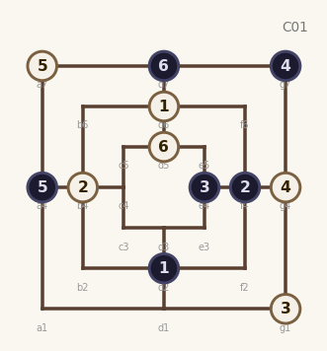  9.W:a7 10.B:a4  11.W:d5 12.B:d7  freq: 5 | 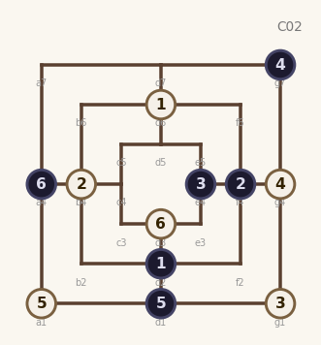  9.W:a1 10.B:d1  11.W:d3 12.B:a4  ★ teacher | 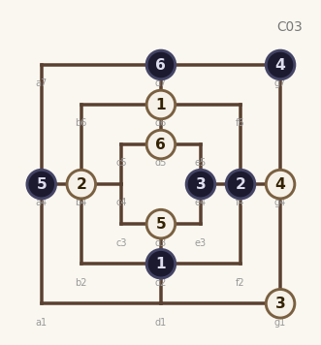  9.W:d3 10.B:a4  11.W:d5 12.B:d7  ★ teacher
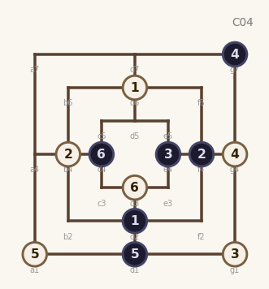  9.W:a1 10.B:d1  11.W:d3 12.B:c4  ★ teacher | 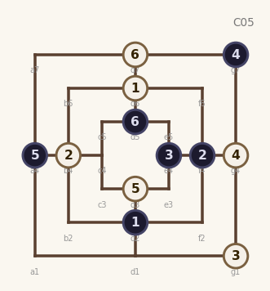  9.W:d3 10.B:a4  11.W:d7 12.B:d5  ★ teacher | 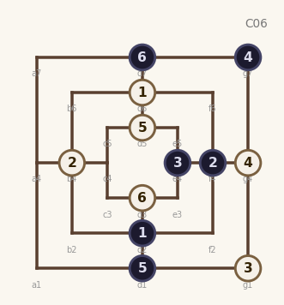  9.W:d5 10.B:d1  11.W:d3 12.B:d7  ★ teacher
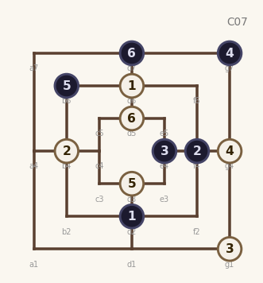  9.W:d3 10.B:b6  11.W:d5 12.B:d7  ★ teacher | 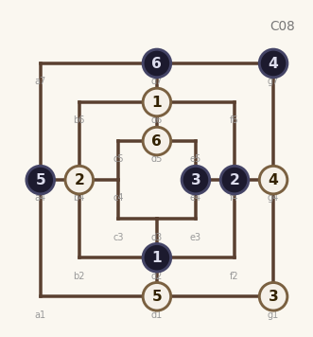  9.W:d1 10.B:a4  11.W:d5 12.B:d7  ★ teacher | 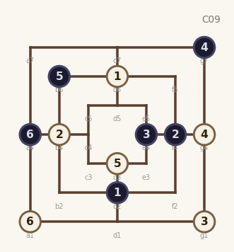  9.W:d3 10.B:b6  11.W:a1 12.B:a4  ★ teacher

H19 Delayed Rush
Opening (8-ply): 1.W:d6 2.B:d2 3.W:b4 4.B:f4
5.W:c5 6.B:d5 7.W:c4 8.B:a4
★ = Teacher-predicted (upper ELO band)
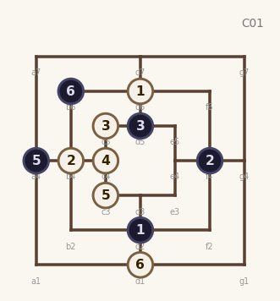  9.W:c3xa4 10.B:a4  11.W:d1 12.B:b6  freq: 13 | 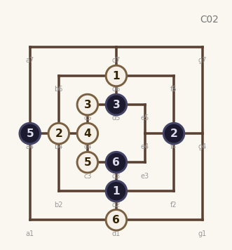  9.W:c3xa4 10.B:a4  11.W:d1 12.B:d3  freq: 9 | 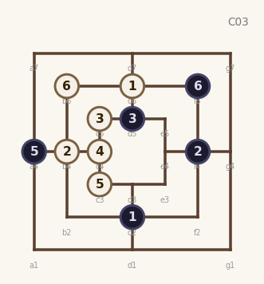  9.W:c3xa4 10.B:a4  11.W:b6 12.B:f6  freq: 4
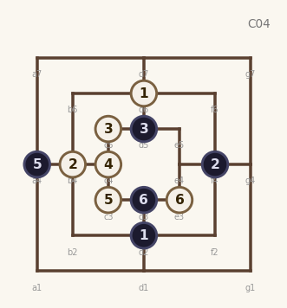  9.W:c3xa4 10.B:a4  11.W:e3 12.B:d3  ★ teacher | 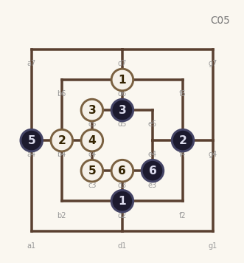  9.W:c3xa4 10.B:a4  11.W:d3 12.B:e3  ★ teacher | 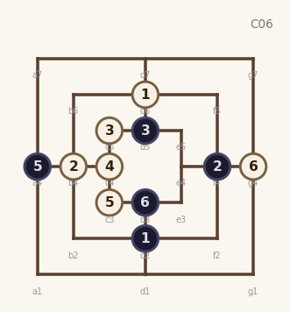  9.W:c3xa4 10.B:a4  11.W:g4 12.B:d3  ★ teacher
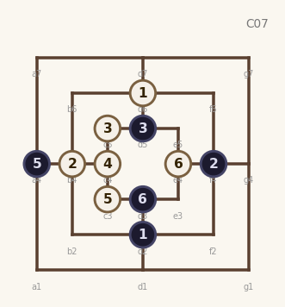  9.W:c3xa4 10.B:a4  11.W:e4 12.B:d3  ★ teacher | 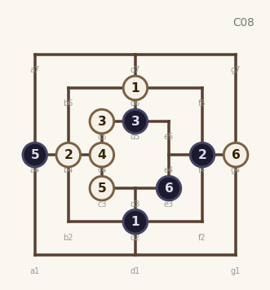  9.W:c3xa4 10.B:a4  11.W:g4 12.B:e3  ★ teacher | 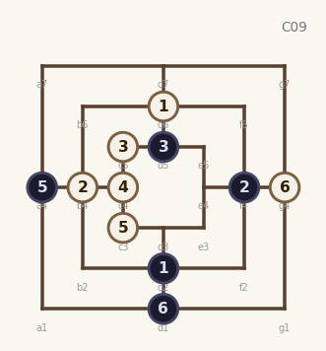  9.W:c3xa4 10.B:a4  11.W:g4 12.B:d1  ★ teacher

H20 Cardinal Cross
Opening (8-ply): 1.W:d6 2.B:d2 3.W:b4 4.B:f6
5.W:f2 6.B:d7 7.W:g4 8.B:e4
★ = Teacher-predicted (upper ELO band)
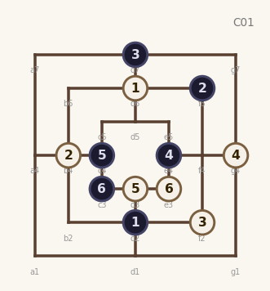  9.W:d3 10.B:c4  11.W:e3 12.B:c3  freq: 8 | 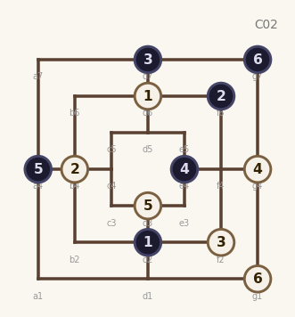  9.W:d3 10.B:a4  11.W:g1 12.B:g7  freq: 6 | 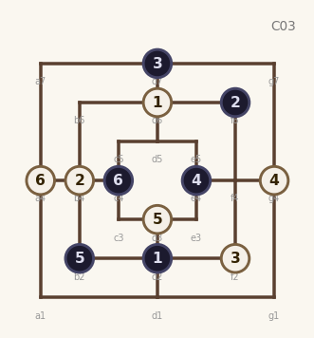  9.W:d3 10.B:b2  11.W:a4 12.B:c4  ★ teacher
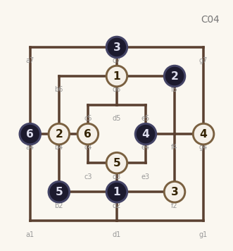  9.W:d3 10.B:b2  11.W:c4 12.B:a4  ★ teacher | 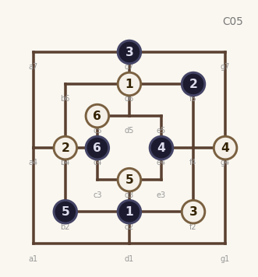  9.W:d3 10.B:b2  11.W:c5 12.B:c4  ★ teacher | 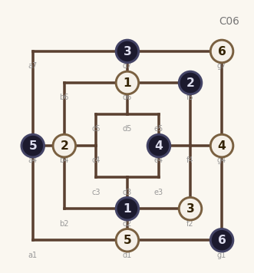  9.W:d1 10.B:a4  11.W:g7 12.B:g1  ★ teacher
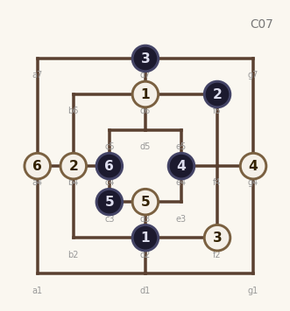  9.W:d3 10.B:c3  11.W:a4 12.B:c4  ★ teacher | 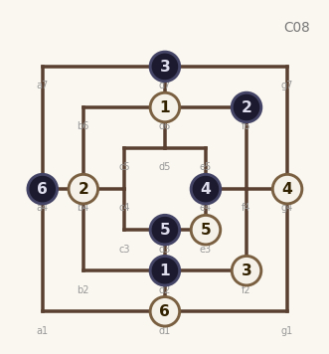  9.W:e3 10.B:d3  11.W:d1 12.B:a4  ★ teacher | 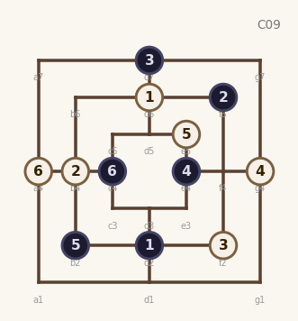  9.W:e5 10.B:b2  11.W:a4 12.B:c4  ★ teacher

H21 Outer Ring Race
Opening (8-ply): 1.W:d6 2.B:d2 3.W:b4 4.B:f4
5.W:a7 6.B:a4 7.W:g1 8.B:d7
★ = Teacher-predicted (upper ELO band)
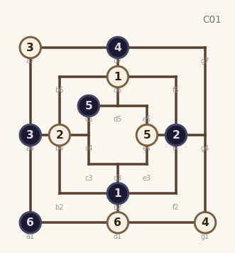  9.W:e4 10.B:c5  11.W:d1 12.B:a1  freq: 8 | 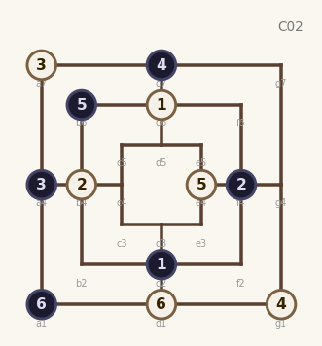  9.W:e4 10.B:b6  11.W:d1 12.B:a1  freq: 7 | 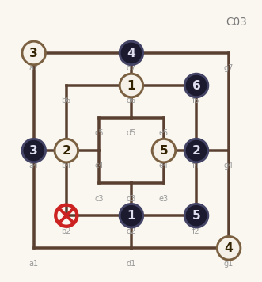  9.W:e4 10.B:f2  11.W:b2 12.B:f6xb2  freq: 2
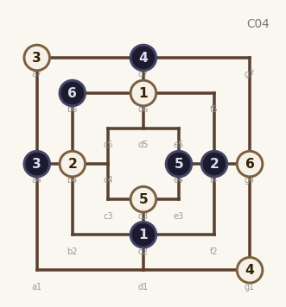  9.W:d3 10.B:e4  11.W:g4 12.B:b6  ★ teacher | 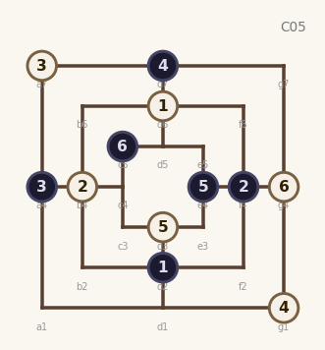  9.W:d3 10.B:e4  11.W:g4 12.B:c5  ★ teacher | 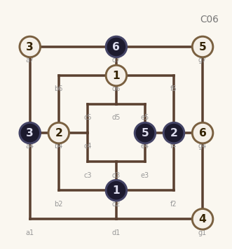  9.W:g7 10.B:e4  11.W:g4xd7 12.B:d7  ★ teacher
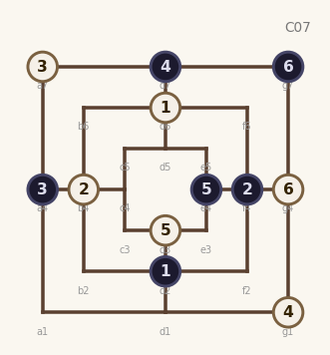  9.W:d3 10.B:e4  11.W:g4 12.B:g7  ★ teacher | 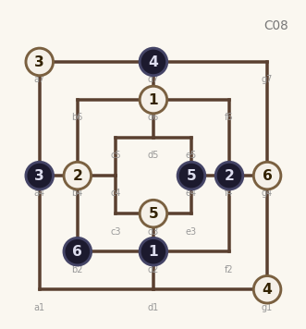  9.W:d3 10.B:e4  11.W:g4 12.B:b2  ★ teacher | 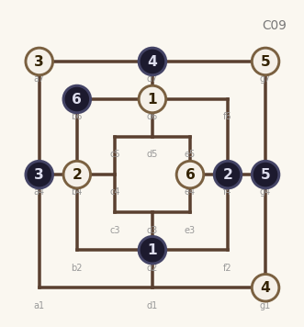  9.W:g7 10.B:g4  11.W:e4 12.B:b6  ★ teacher

H22 B-Column Double – ply8 D5
Opening (8-ply): 1.W:d6 2.B:d2 3.W:b4 4.B:f4
5.W:b6 6.B:b2 7.W:f2 8.B:d5
★ = Teacher-predicted (upper ELO band)
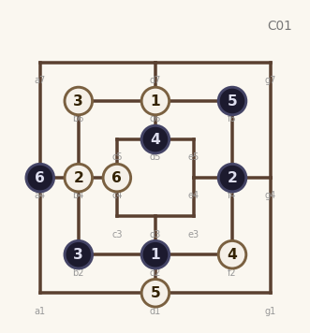  9.W:d1 10.B:f6  11.W:c4 12.B:a4  ★ teacher | 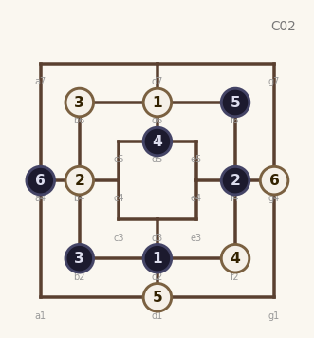  9.W:d1 10.B:f6  11.W:g4 12.B:a4  ★ teacher | 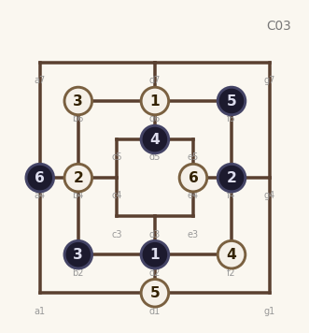  9.W:d1 10.B:f6  11.W:e4 12.B:a4  ★ teacher
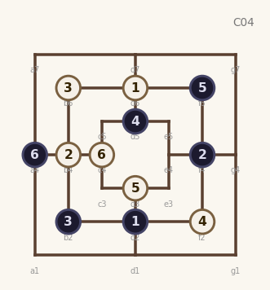  9.W:d3 10.B:f6  11.W:c4 12.B:a4  ★ teacher | 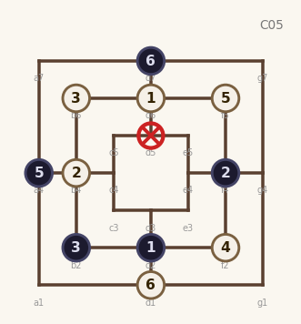  9.W:f6xd5 10.B:a4  11.W:d1 12.B:d7  ★ teacher | 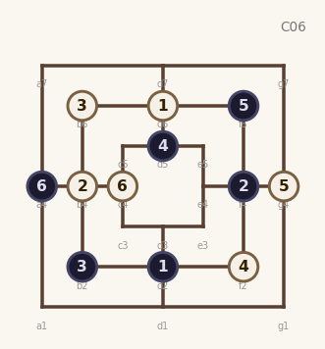  9.W:g4 10.B:f6  11.W:c4 12.B:a4  ★ teacher
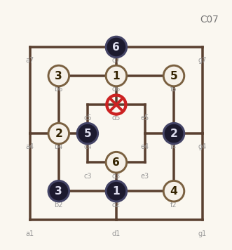  9.W:f6xd5 10.B:c4  11.W:d3 12.B:d7  ★ teacher | 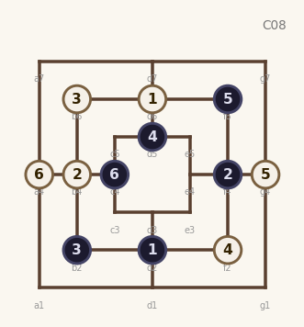  9.W:g4 10.B:f6  11.W:a4 12.B:c4  ★ teacher | 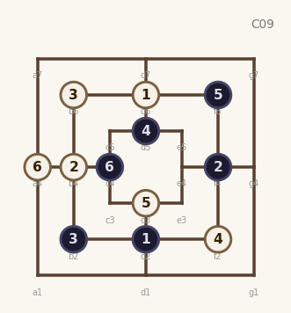  9.W:d3 10.B:f6  11.W:a4 12.B:c4  ★ teacher

