NMM AI Opening Continuations — gen v4 (Illustrated)
Top 9 continuations per family from W5/B5 to W6/B6 (3 W choices × 3 B responses, 4 moves deep). ★ gen v4 = Generalist v4 policy (difficulty 18/20). Gold ring = last move. Red dot = mill.

A01 Corner Cross
Trunk (8-ply): W1:d6 B1:b4
W2:d3 B2:e4
W3:g7 B3:e3
W4:c3xe5 B4:b6
★ = Generalist v4 · DB: 1007 games

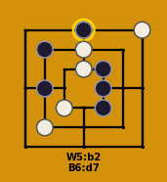  W5:b2 B5:e5xd3  W6:d5 B6:d7  ★ gen v4 | 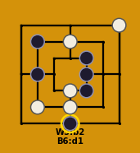  W5:b2 B5:e5xc3  W6:d2 B6:d1  ★ gen v4 | 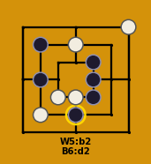  W5:b2 B5:e5xd6  W6:d6 B6:d2  ★ gen v4
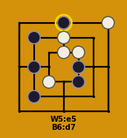  W5:e5 B5:b2xd3  W6:d5 B6:d7  ★ gen v4 | 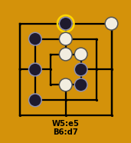  W5:e5 B5:b2xc3  W6:d5 B6:d7  ★ gen v4 | 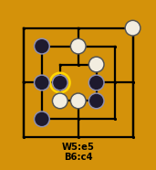  W5:e5 B5:b2xd6  W6:d6 B6:c4  ★ gen v4
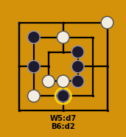  W5:d7 B5:e5xd7  W6:b2 B6:d2  ★ gen v4 | 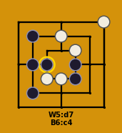  W5:d7 B5:b2xd7  W6:e5 B6:c4  ★ gen v4 | 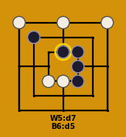  W5:d7 B5:e5xd6  W6:a7xb4 B6:d5  ★ gen v4

A02 Counter Flank
Trunk (8-ply): W1:f4 B1:b4
W2:d5 B2:d1
W3:b6 B3:f2
W4:c5 B4:e3
★ = Generalist v4 · DB: 353 games

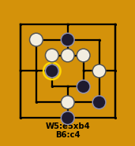  W5:e5xb4 B5:d6  W6:d2 B6:c4  ★ gen v4 | 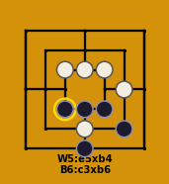  W5:e5xb4 B5:d3  W6:d2 B6:c3xb6  ★ gen v4 | 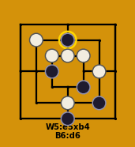  W5:e5xb4 B5:c4  W6:d2 B6:d6  ★ gen v4
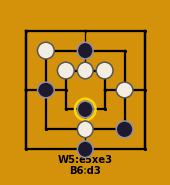  W5:e5xe3 B5:d6  W6:d2 B6:d3  ★ gen v4 | 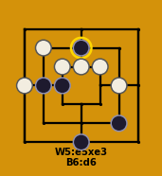  W5:e5xe3 B5:c4  W6:a4 B6:d6  ★ gen v4 | 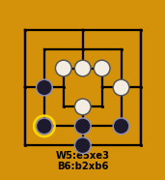  W5:e5xe3 B5:d2  W6:d3 B6:b2xb6  ★ gen v4
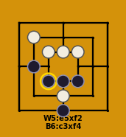  W5:e5xf2 B5:d3  W6:d2 B6:c3xf4  ★ gen v4 | 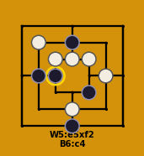  W5:e5xf2 B5:d6  W6:d2 B6:c4  ★ gen v4 | 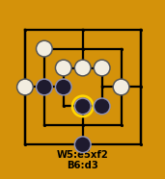  W5:e5xf2 B5:c4  W6:a4 B6:d3  ★ gen v4

A03 Diagonal Setup
Trunk (8-ply): W1:d6 B1:d7
W2:d5xb4 B2:b2
W3:f4 B3:e4
W4:g1 B4:a4
★ = Generalist v4 · DB: 319 games

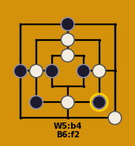  W5:b4 B5:c4  W6:d2 B6:f2  ★ gen v4 | 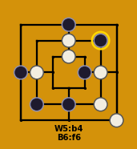  W5:b4 B5:d2  W6:f2 B6:f6  ★ gen v4 | 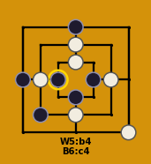  W5:b4 B5:d3  W6:d2 B6:c4  ★ gen v4
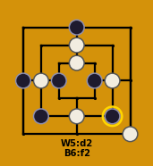  W5:d2 B5:c4  W6:b4 B6:f2  ★ gen v4 | 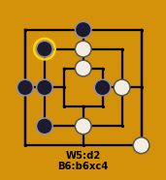  W5:d2 B5:b4  W6:c4 B6:b6xc4  ★ gen v4 | 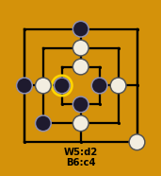  W5:d2 B5:d3  W6:b4 B6:c4  ★ gen v4
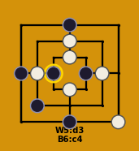  W5:d3 B5:d1  W6:b4 B6:c4  ★ gen v4 | 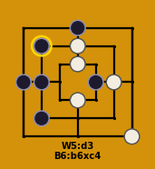  W5:d3 B5:b4  W6:c4 B6:b6xc4  ★ gen v4 | 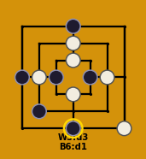  W5:d3 B5:c4  W6:b4 B6:d1  ★ gen v4

A04 Center Rush
Trunk (8-ply): W1:f4 B1:d5
W2:b4 B2:d1
W3:f2 B3:b6
W4:a1 B4:c5
★ = Generalist v4 · DB: 258 games

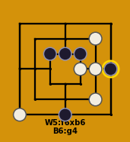  W5:f6xb6 B5:e5xb4  W6:e4 B6:g4  ★ gen v4 | 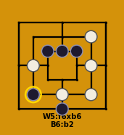  W5:f6xb6 B5:e5xa1  W6:d2 B6:b2  ★ gen v4 | 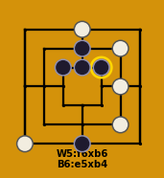  W5:f6xb6 B5:d6  W6:d7 B6:e5xb4  ★ gen v4
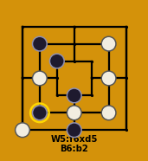  W5:f6xd5 B5:d3  W6:d2 B6:b2  ★ gen v4 | 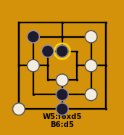  W5:f6xd5 B5:d2  W6:d3 B6:d5  ★ gen v4 | 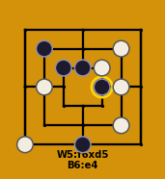  W5:f6xd5 B5:d5  W6:e5 B6:e4  ★ gen v4
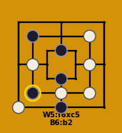  W5:f6xc5 B5:d3  W6:d2 B6:b2  ★ gen v4 | 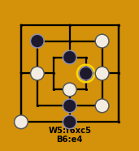  W5:f6xc5 B5:d2  W6:d3 B6:e4  ★ gen v4 | 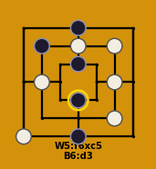  W5:f6xc5 B5:d7  W6:d6 B6:d3  ★ gen v4

A05 Column Strike
Trunk (8-ply): W1:f4 B1:b6
W2:a4 B2:d5
W3:c4 B3:d2
W4:g7 B4:c5
★ = Generalist v4 · DB: 187 games

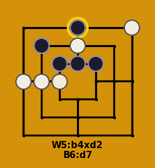  W5:b4xd2 B5:e5xf4  W6:d6 B6:d7  ★ gen v4 | 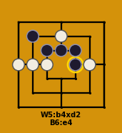  W5:b4xd2 B5:e5xg7  W6:d6 B6:e4  ★ gen v4 | 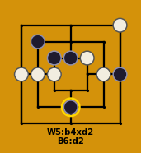  W5:b4xd2 B5:g4  W6:e5 B6:d2  ★ gen v4
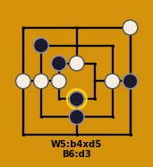  W5:b4xd5 B5:g4  W6:d5 B6:d3  ★ gen v4 | 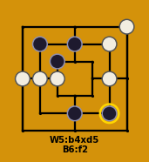  W5:b4xd5 B5:d6  W6:f6 B6:f2  ★ gen v4 | 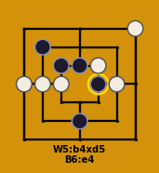  W5:b4xd5 B5:d5  W6:e5 B6:e4  ★ gen v4
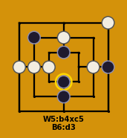  W5:b4xc5 B5:g4  W6:d6 B6:d3  ★ gen v4 | 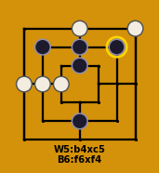  W5:b4xc5 B5:d6  W6:d7 B6:f6xf4  ★ gen v4 | 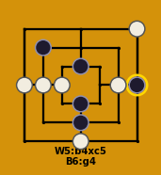  W5:b4xc5 B5:d3  W6:d1 B6:g4  ★ gen v4

A06 d5-c4
Trunk (8-ply): W1:c4 B1:d3
W2:d3-e3 B2:f2-d2
W3:e3-e4 B3:e4-e5
W4:e5-e4 B4:d6-f6
★ = Generalist v4 · DB: 139 games

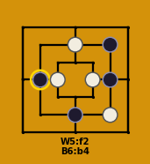  W5:f2 B5:f4  W6:d6 B6:b4  ★ gen v4 | 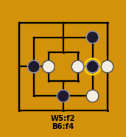  W5:f2 B5:b4  W6:g4 B6:f4  ★ gen v4 | 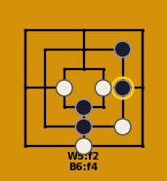  W5:f2 B5:d3  W6:d1 B6:f4  ★ gen v4
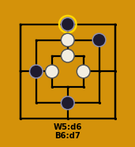  W5:d6 B5:b4  W6:d5 B6:d7  ★ gen v4 | 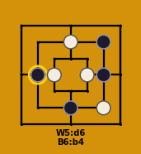  W5:d6 B5:f4  W6:f2 B6:b4  ★ gen v4 | 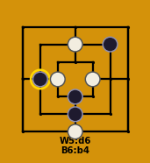  W5:d6 B5:d3  W6:d1 B6:b4  ★ gen v4
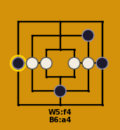  W5:f4 B5:g4  W6:b4 B6:a4  ★ gen v4 | 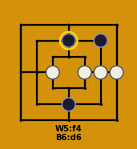  W5:f4 B5:d6  W6:g4xd6 B6:d6  ★ gen v4 | 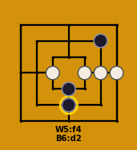  W5:f4 B5:d3  W6:g4xd2 B6:d2  ★ gen v4

A07 d6-g4
Trunk (8-ply): W1:f4 B1:d7
W2:b4 B2:d1
W3:c3 B3:f6
W4:b2 B4:c5
★ = Generalist v4 · DB: 127 games

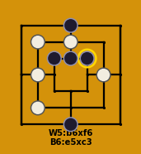  W5:b6xf6 B5:d5  W6:d6 B6:e5xc3  ★ gen v4 | 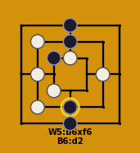  W5:b6xf6 B5:d6  W6:d5 B6:d2  ★ gen v4 | 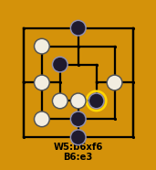  W5:b6xf6 B5:d2  W6:d3 B6:e3  ★ gen v4
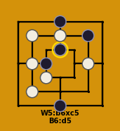  W5:b6xc5 B5:c4  W6:d6 B6:d5  ★ gen v4 | 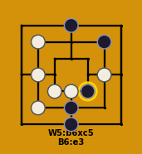  W5:b6xc5 B5:d2  W6:d3 B6:e3  ★ gen v4 | 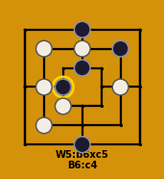  W5:b6xc5 B5:d5  W6:d6 B6:c4  ★ gen v4
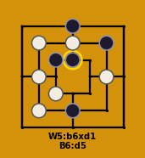  W5:b6xd1 B5:d2  W6:d6 B6:d5  ★ gen v4 | 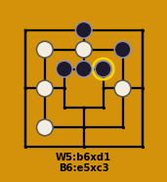  W5:b6xd1 B5:d5  W6:d6 B6:e5xc3  ★ gen v4 | 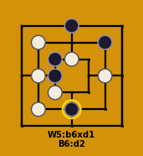  W5:b6xd1 B5:c4  W6:d5 B6:d2  ★ gen v4

A08 d7-g4
Trunk (8-ply): W1:d7 B1:g4
W2:b6 B2:f2
W3:d3 B3:a4
W4:g1 B4:e4
★ = Generalist v4 · DB: 117 games

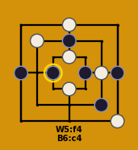  W5:f4 B5:d6  W6:d5 B6:c4  ★ gen v4 | 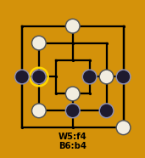  W5:f4 B5:d2  W6:b2 B6:b4  ★ gen v4 | 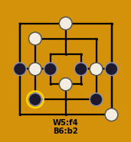  W5:f4 B5:c4  W6:b4 B6:b2  ★ gen v4
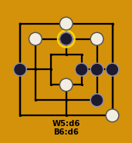  W5:d6 B5:f4xd6  W6:f6 B6:d6  ★ gen v4 | 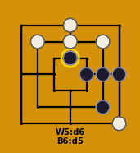  W5:d6 B5:f4xd3  W6:f6xa4 B6:d5  ★ gen v4 | 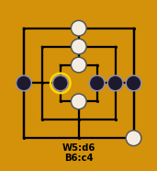  W5:d6 B5:f4xb6  W6:d5xf2 B6:c4  ★ gen v4
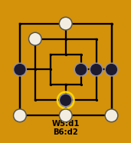  W5:d1 B5:f4xd3  W6:a1xf2 B6:d2  ★ gen v4 | 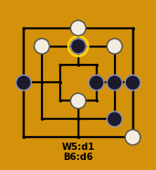  W5:d1 B5:f4xd1  W6:f6 B6:d6  ★ gen v4 | 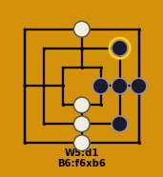  W5:d1 B5:f4xg1  W6:d2xa4 B6:f6xb6  ★ gen v4

A09 d2-d7
Trunk (8-ply): W1:d2 B1:d7
W2:b4 B2:d5
W3:g1 B3:e4
W4:a4 B4:f6
★ = Generalist v4 · DB: 111 games

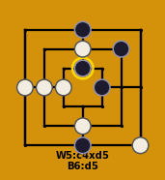  W5:c4xd5 B5:d1  W6:d6 B6:d5  ★ gen v4 | 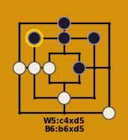  W5:c4xd5 B5:d6  W6:d5 B6:b6xd5  ★ gen v4 | 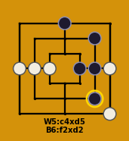  W5:c4xd5 B5:f4  W6:g4 B6:f2xd2  ★ gen v4
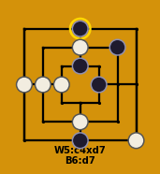  W5:c4xd7 B5:d1  W6:d6 B6:d7  ★ gen v4 | 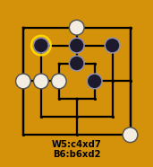  W5:c4xd7 B5:d6  W6:d7 B6:b6xd2  ★ gen v4 | 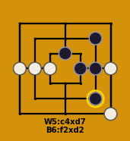  W5:c4xd7 B5:f4  W6:g4 B6:f2xd2  ★ gen v4
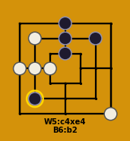  W5:c4xe4 B5:d6xd2  W6:b6 B6:b2  ★ gen v4 | 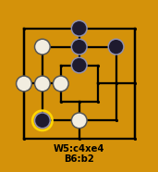  W5:c4xe4 B5:d6xg1  W6:b6 B6:b2  ★ gen v4 | 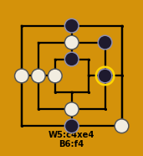  W5:c4xe4 B5:d1  W6:d6 B6:f4  ★ gen v4

A10 d2-d5
Trunk (8-ply): W1:d2 B1:d5
W2:b4 B2:g4
W3:e4 B3:b2
W4:b6xf2 B4:f6
★ = Generalist v4 · DB: 110 games

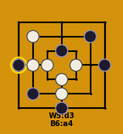  W5:d3 B5:d1  W6:c4 B6:a4  ★ gen v4 | 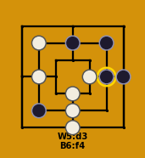  W5:d3 B5:d6  W6:d1xd5 B6:f4  ★ gen v4 | 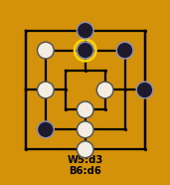  W5:d3 B5:d7  W6:d1xd5 B6:d6  ★ gen v4
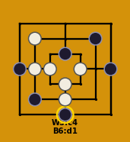  W5:c4 B5:a4  W6:d3 B6:d1  ★ gen v4 | 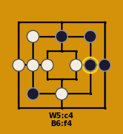  W5:c4 B5:d6  W6:a4xd5 B6:f4  ★ gen v4 | 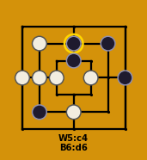  W5:c4 B5:f4  W6:a4xf4 B6:d6  ★ gen v4
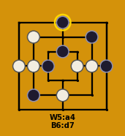  W5:a4 B5:c4  W6:f4 B6:d7  ★ gen v4 | 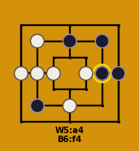  W5:a4 B5:d6  W6:c4xd5 B6:f4  ★ gen v4 | 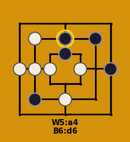  W5:a4 B5:f4  W6:c4xf4 B6:d6  ★ gen v4

A11 Corner Setup
Trunk (8-ply): W1:d6 B1:a7
W2:b2 B2:d7
W3:g7xb4 B3:f4
W4:d1 B4:e3
★ = Generalist v4 · DB: 102 games

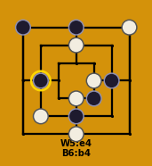  W5:e4 B5:d2  W6:d3 B6:b4  ★ gen v4 | 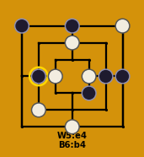  W5:e4 B5:g4  W6:c4 B6:b4  ★ gen v4 | 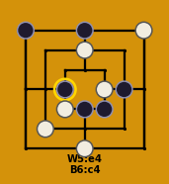  W5:e4 B5:d3  W6:c3 B6:c4  ★ gen v4
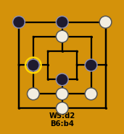  W5:d2 B5:d3  W6:f2xe3 B6:b4  ★ gen v4 | 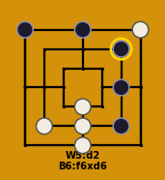  W5:d2 B5:f2  W6:d3xe3 B6:f6xd6  ★ gen v4 | 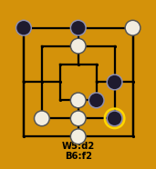  W5:d2 B5:e4  W6:d3xe4 B6:f2  ★ gen v4
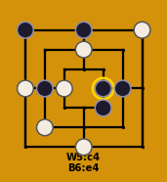  W5:c4 B5:b4  W6:a4 B6:e4  ★ gen v4 | 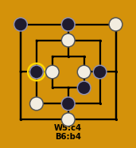  W5:c4 B5:d2  W6:e4 B6:b4  ★ gen v4 | 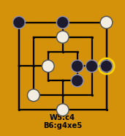  W5:c4 B5:e4  W6:e5 B6:g4xe5  ★ gen v4

