NMM AI Opening Plays — gen v4 (Illustrated)
Top 11 opening families · Generalist v4 · difficulty 18/20 · 13,209 games · 5,953 winning/draw lines from data/specialist_db_v4.sqlite.
Board shows trunk position after 8 plies. ● cream = White, ● dark = Black. Gold ring = last move. Red dot = mill.

A01 Corner Cross
8-ply · DB: 1007 games · seed: d6-f4
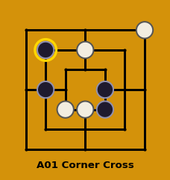 | Moves:  W1:d6 B1:b4  W2:d3 B2:e4  W3:g7 B3:e3  W4:c3xe5 B4:b6

A02 Counter Flank
8-ply · DB: 353 games · seed: f4-b4
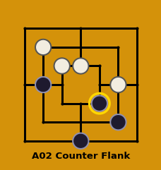 | Moves:  W1:f4 B1:b4  W2:d5 B2:d1  W3:b6 B3:f2  W4:c5 B4:e3

A03 Diagonal Setup
8-ply · DB: 319 games · seed: d6-d7
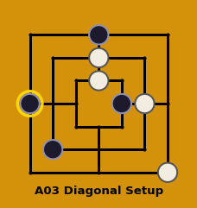 | Moves:  W1:d6 B1:d7  W2:d5xb4 B2:b2  W3:f4 B3:e4  W4:g1 B4:a4

A04 Center Rush
8-ply · DB: 258 games · seed: f4-d5
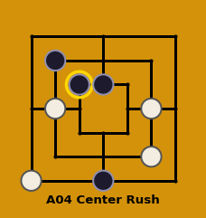 | Moves:  W1:f4 B1:d5  W2:b4 B2:d1  W3:f2 B3:b6  W4:a1 B4:c5

A05 Column Strike
8-ply · DB: 187 games · seed: f4-b6
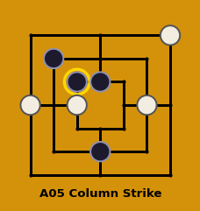 | Moves:  W1:f4 B1:b6  W2:a4 B2:d5  W3:c4 B3:d2  W4:g7 B4:c5

A06 d5-c4
8-ply · DB: 139 games · seed: d5-c4
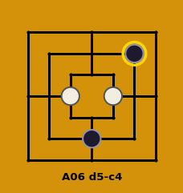 | Moves:  W1:c4 B1:d3  W2:d3-e3 B2:f2-d2  W3:e3-e4 B3:e4-e5  W4:e5-e4 B4:d6-f6

A07 d6-g4
8-ply · DB: 127 games · seed: d6-g4
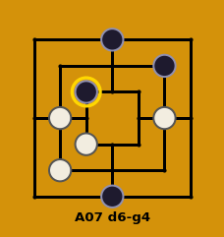 | Moves:  W1:f4 B1:d7  W2:b4 B2:d1  W3:c3 B3:f6  W4:b2 B4:c5

A08 d7-g4
8-ply · DB: 117 games · seed: d7-g4
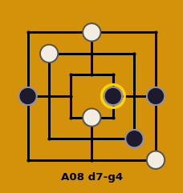 | Moves:  W1:d7 B1:g4  W2:b6 B2:f2  W3:d3 B3:a4  W4:g1 B4:e4

A09 d2-d7
8-ply · DB: 111 games · seed: d2-d7
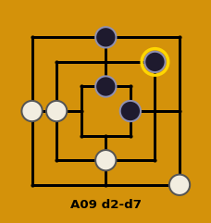 | Moves:  W1:d2 B1:d7  W2:b4 B2:d5  W3:g1 B3:e4  W4:a4 B4:f6

A10 d2-d5
8-ply · DB: 110 games · seed: d2-d5
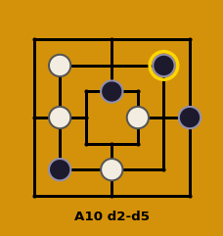 | Moves:  W1:d2 B1:d5  W2:b4 B2:g4  W3:e4 B3:b2  W4:b6xf2 B4:f6

A11 Corner Setup
8-ply · DB: 102 games · seed: d6-a7
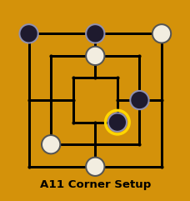 | Moves:  W1:d6 B1:a7  W2:b2 B2:d7  W3:g7xb4 B3:f4  W4:d1 B4:e3

