NMM AI Opening Continuations — gen v5 (from_v4, diff 19-20) (Illustrated)
Top 9 continuations per family from W5/B5 to W6/B6 (3 W choices × 3 B responses, 4 moves deep). ★ gen v5 (from_v4, diff 19-20) = policy (difficulty 20/20). Gold ring = last move. Red dot = mill.

A01 Corner Cross
Trunk (8-ply): W1:d6 B1:b4
W2:d3 B2:f4
W3:c3 B3:b6
W4:f6xb2 B4:b2xf2
★ = gen v5 (from_v4, diff 19-20) · DB: 184 games

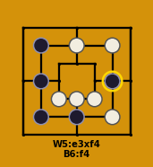  W5:e3xf4 B5:d2  W6:f2 B6:f4  ★ gen v4 | 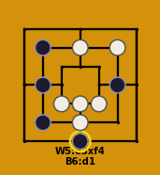  W5:e3xf4 B5:f4  W6:d2 B6:d1  ★ gen v4 | 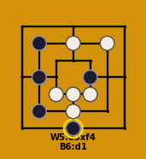  W5:e3xf4 B5:e4  W6:d2 B6:d1  ★ gen v4
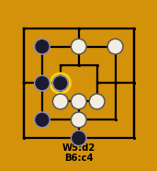  W5:d2 B5:d1  W6:e3xf4 B6:c4  ★ gen v4 | 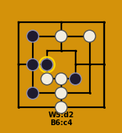  W5:d2 B5:e3  W6:d1xf4 B6:c4  ★ gen v4 | 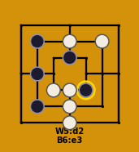  W5:d2 B5:d5  W6:d1xf4 B6:e3  ★ gen v4
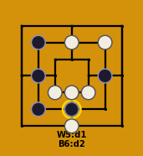  W5:d1 B5:d2  W6:e3xd2 B6:d2  ★ gen v4 | 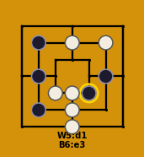  W5:d1 B5:e3  W6:d2xe3 B6:e3  ★ gen v4 | 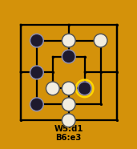  W5:d1 B5:d5  W6:d2xf4 B6:e3  ★ gen v4

A02 Counter Flank
Trunk (8-ply): W1:f4 B1:b4
W2:d2 B2:d5
W3:c4 B3:a7
W4:g1 B4:e3
★ = gen v5 (from_v4, diff 19-20) · DB: 51 games

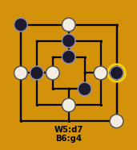  W5:d7 B5:d6  W6:a4 B6:g4  ★ gen v4 | 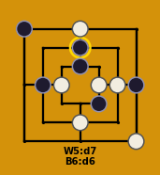  W5:d7 B5:g4  W6:e4 B6:d6  ★ gen v4 | 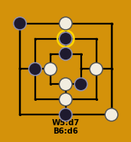  W5:d7 B5:d1  W6:d3 B6:d6  ★ gen v4
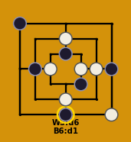  W5:d6 B5:g4  W6:e4 B6:d1  ★ gen v4 | 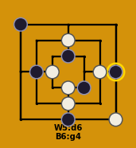  W5:d6 B5:d1  W6:d3 B6:g4  ★ gen v4 | 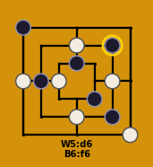  W5:d6 B5:f2  W6:a4 B6:f6  ★ gen v4
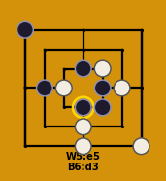  W5:e5 B5:e4  W6:d1 B6:d3  ★ gen v4 | 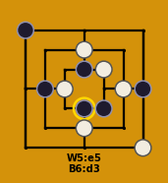  W5:e5 B5:g4  W6:d6 B6:d3  ★ gen v4 | 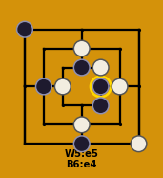  W5:e5 B5:d1  W6:d6 B6:e4  ★ gen v4

A03 Center Rush
Trunk (8-ply): W1:f4 B1:d5
W2:b4 B2:d1
W3:b2 B3:f6
W4:g1 B4:e5
★ = gen v5 (from_v4, diff 19-20) · DB: 28 games

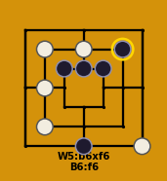  W5:b6xf6 B5:c5xf4  W6:d6 B6:f6  ★ gen v4 | 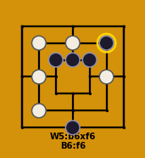  W5:b6xf6 B5:c5xg1  W6:d6 B6:f6  ★ gen v4 | 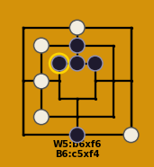  W5:b6xf6 B5:d6  W6:d7 B6:c5xf4  ★ gen v4
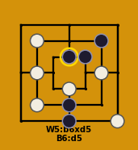  W5:b6xd5 B5:d2  W6:d3 B6:d5  ★ gen v4 | 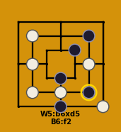  W5:b6xd5 B5:d3  W6:d2 B6:f2  ★ gen v4 | 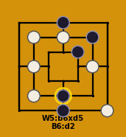  W5:b6xd5 B5:d7  W6:d6 B6:d2  ★ gen v4
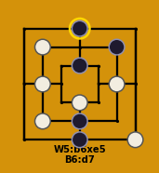  W5:b6xe5 B5:d2  W6:d3 B6:d7  ★ gen v4 | 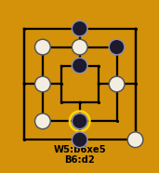  W5:b6xe5 B5:d7  W6:d6 B6:d2  ★ gen v4 | 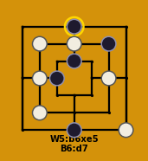  W5:b6xe5 B5:c4  W6:d6 B6:d7  ★ gen v4

A04 Star-Square
Trunk (8-ply): W1:b6 B1:a4
W2:c4 B2:d2
W3:f4 B3:d7
W4:f6 B4:a7
★ = gen v5 (from_v4, diff 19-20) · DB: 25 games

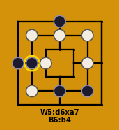  W5:d6xa7 B5:f2  W6:b2 B6:b4  ★ gen v4 | 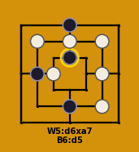  W5:d6xa7 B5:b4  W6:f2xa4 B6:d5  ★ gen v4 | 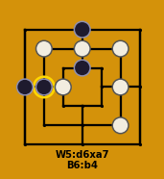  W5:d6xa7 B5:d5  W6:f2xd2 B6:b4  ★ gen v4
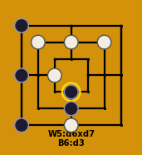  W5:d6xd7 B5:a1xf4  W6:d1 B6:d3  ★ gen v4 | 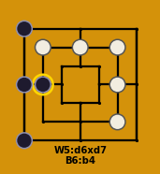  W5:d6xd7 B5:a1xc4  W6:f2xd2 B6:b4  ★ gen v4 | 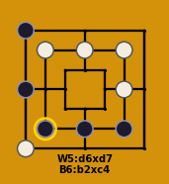  W5:d6xd7 B5:f2  W6:a1 B6:b2xc4  ★ gen v4
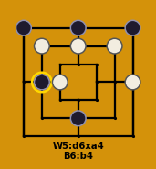  W5:d6xa4 B5:g7xf4  W6:g4 B6:b4  ★ gen v4 | 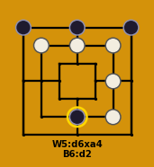  W5:d6xa4 B5:g7xc4  W6:f2xd2 B6:d2  ★ gen v4 | 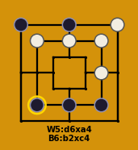  W5:d6xa4 B5:f2  W6:g7 B6:b2xc4  ★ gen v4

A05 Column Diagonal
Trunk (8-ply): W1:d2 B1:b6
W2:b2 B2:b4xf2
W3:f6 B3:d7
W4:g4 B4:d3
★ = gen v5 (from_v4, diff 19-20) · DB: 19 games

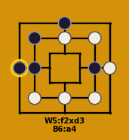  W5:f2xd3 B5:f4  W6:d6 B6:a4  ★ gen v4 | 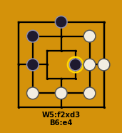  W5:f2xd3 B5:e4  W6:f4xe4 B6:e4  ★ gen v4 | 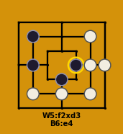  W5:f2xd3 B5:d3  W6:f4xd7 B6:e4  ★ gen v4
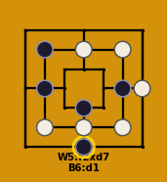  W5:f2xd7 B5:f4  W6:d6 B6:d1  ★ gen v4 | 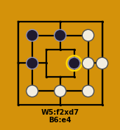  W5:f2xd7 B5:d6  W6:f4xd3 B6:e4  ★ gen v4 | 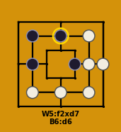  W5:f2xd7 B5:e4  W6:f4xd3 B6:d6  ★ gen v4
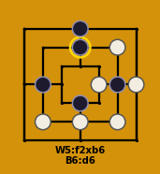  W5:f2xb6 B5:f4  W6:e4 B6:d6  ★ gen v4 | 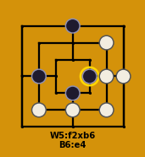  W5:f2xb6 B5:e4  W6:f4xe4 B6:e4  ★ gen v4 | 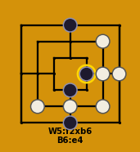  W5:f2xb6 B5:d1  W6:f4xb4 B6:e4  ★ gen v4

A06 North Hold
Trunk (8-ply): W1:d2 B1:f2
W2:b4 B2:e4
W3:d7 B3:g4
W4:d5 B4:a1
★ = gen v5 (from_v4, diff 19-20) · DB: 15 games

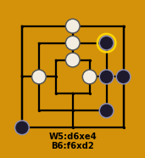  W5:d6xe4 B5:f4  W6:e4 B6:f6xd2  ★ gen v4 | 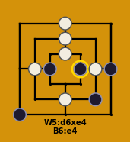  W5:d6xe4 B5:c4  W6:f4 B6:e4  ★ gen v4 | 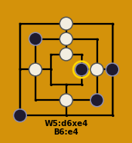  W5:d6xe4 B5:b6  W6:f4 B6:e4  ★ gen v4
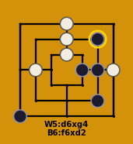  W5:d6xg4 B5:f4  W6:g4 B6:f6xd2  ★ gen v4 | 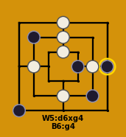  W5:d6xg4 B5:b6  W6:f4 B6:g4  ★ gen v4 | 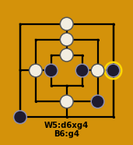  W5:d6xg4 B5:c4  W6:f4 B6:g4  ★ gen v4
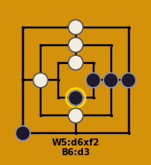  W5:d6xf2 B5:f4xd2  W6:d2 B6:d3  ★ gen v4 | W5:d6xf2 B5:f4xb4  W6:b4 B6:d3  ★ gen v4 | 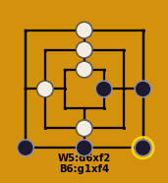  W5:d6xf2 B5:d1  W6:f4 B6:g1xf4  ★ gen v4

A07 Diagonal Setup
Trunk (8-ply): W1:f4 B1:g4
W2:d2 B2:b4
W3:d5 B3:a7
W4:c5 B4:e3
★ = gen v5 (from_v4, diff 19-20) · DB: 14 games

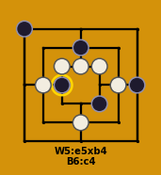  W5:e5xb4 B5:d6  W6:b4 B6:c4  ★ gen v4 | 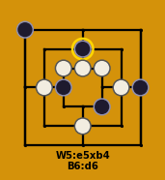  W5:e5xb4 B5:c4  W6:b4 B6:d6  ★ gen v4 | 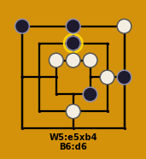  W5:e5xb4 B5:d7  W6:g7 B6:d6  ★ gen v4
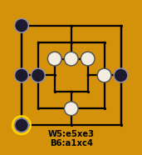  W5:e5xe3 B5:a4  W6:c4 B6:a1xc4  ★ gen v4 | 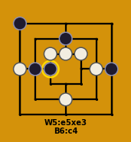  W5:e5xe3 B5:d6  W6:a4 B6:c4  ★ gen v4 | 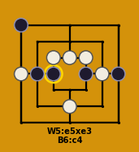  W5:e5xe3 B5:e4  W6:a4 B6:c4  ★ gen v4
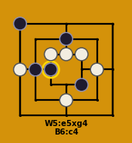  W5:e5xg4 B5:d6  W6:a4 B6:c4  ★ gen v4 | 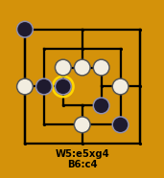  W5:e5xg4 B5:f2  W6:a4 B6:c4  ★ gen v4 | 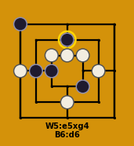  W5:e5xg4 B5:c4  W6:a4 B6:d6  ★ gen v4

A08 d6-g7
Trunk (8-ply): W1:d6 B1:g7
W2:e4 B2:b2
W3:f2 B3:d3
W4:a4 B4:f4
★ = gen v5 (from_v4, diff 19-20) · DB: 4 games

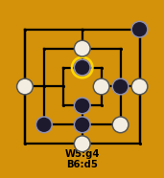  W5:g4 B5:d2  W6:d1 B6:d5  ★ gen v4 | 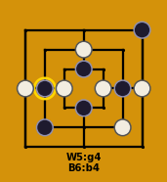  W5:g4 B5:d5  W6:c4 B6:b4  ★ gen v4 | 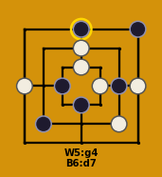  W5:g4 B5:c4  W6:d5 B6:d7  ★ gen v4
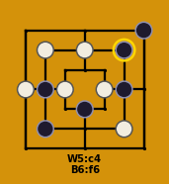  W5:c4 B5:b4  W6:b6 B6:f6  ★ gen v4 | 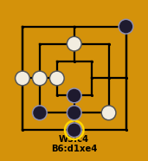  W5:c4 B5:d2  W6:b4xf4 B6:d1xe4  ★ gen v4 | 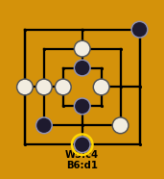  W5:c4 B5:d5  W6:b4xf4 B6:d1  ★ gen v4
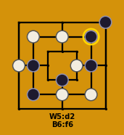  W5:d2 B5:b4  W6:b6 B6:f6  ★ gen v4 | 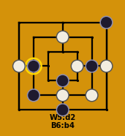  W5:d2 B5:d1  W6:g4 B6:b4  ★ gen v4 | 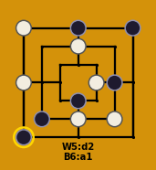  W5:d2 B5:d7  W6:a7 B6:a1  ★ gen v4

