NMM AI Opening Plays — gen v5 (from_v4, diff 19-20) (Illustrated)
Top opening families · gen v5 (from_v4, diff 19-20) · difficulty 20/20 · 15,979 games · 888 winning/draw lines from data/specialist_db_v5.sqlite.
Board shows trunk position after 8 plies. ● cream = White, ● dark = Black. Gold ring = last move. Red dot = mill.

A01 Corner Cross
8-ply · DB: 184 games · seed: d6-f4
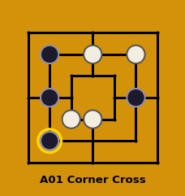 | Moves:  W1:d6 B1:b4  W2:d3 B2:f4  W3:c3 B3:b6  W4:f6xb2 B4:b2xf2

A02 Counter Flank
8-ply · DB: 51 games · seed: f4-b4
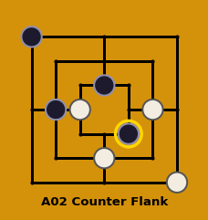 | Moves:  W1:f4 B1:b4  W2:d2 B2:d5  W3:c4 B3:a7  W4:g1 B4:e3

A03 Center Rush
8-ply · DB: 28 games · seed: f4-d5
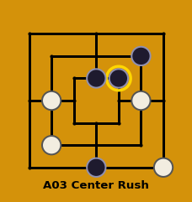 | Moves:  W1:f4 B1:d5  W2:b4 B2:d1  W3:b2 B3:f6  W4:g1 B4:e5

A04 Star-Square
8-ply · DB: 25 games · seed: f2-d1
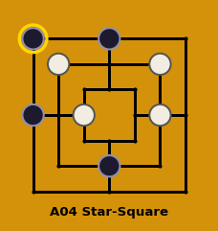 | Moves:  W1:b6 B1:a4  W2:c4 B2:d2  W3:f4 B3:d7  W4:f6 B4:a7

A05 Column Diagonal
8-ply · DB: 19 games · seed: d2-f6
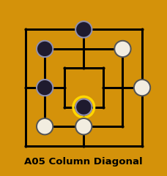 | Moves:  W1:d2 B1:b6  W2:b2 B2:b4xf2  W3:f6 B3:d7  W4:g4 B4:d3

A06 North Hold
8-ply · DB: 15 games · seed: d2-f2
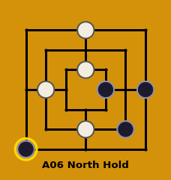 | Moves:  W1:d2 B1:f2  W2:b4 B2:e4  W3:d7 B3:g4  W4:d5 B4:a1

A07 Diagonal Setup
8-ply · DB: 14 games · seed: d6-d7
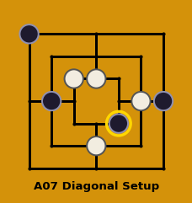 | Moves:  W1:f4 B1:g4  W2:d2 B2:b4  W3:d5 B3:a7  W4:c5 B4:e3

A08 d6-g7
8-ply · DB: 4 games · seed: d6-g7
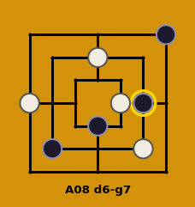 | Moves:  W1:d6 B1:g7  W2:e4 B2:b2  W3:f2 B3:d3  W4:a4 B4:f4

