Supplement to ‘The First Australian Plant Foods at Madjedbebe, 65,000–53,000 years ago’

Ben Marwick

S. Anna Florin

18 December, 2019

This repository includes code and data for Supplementary Figure 1

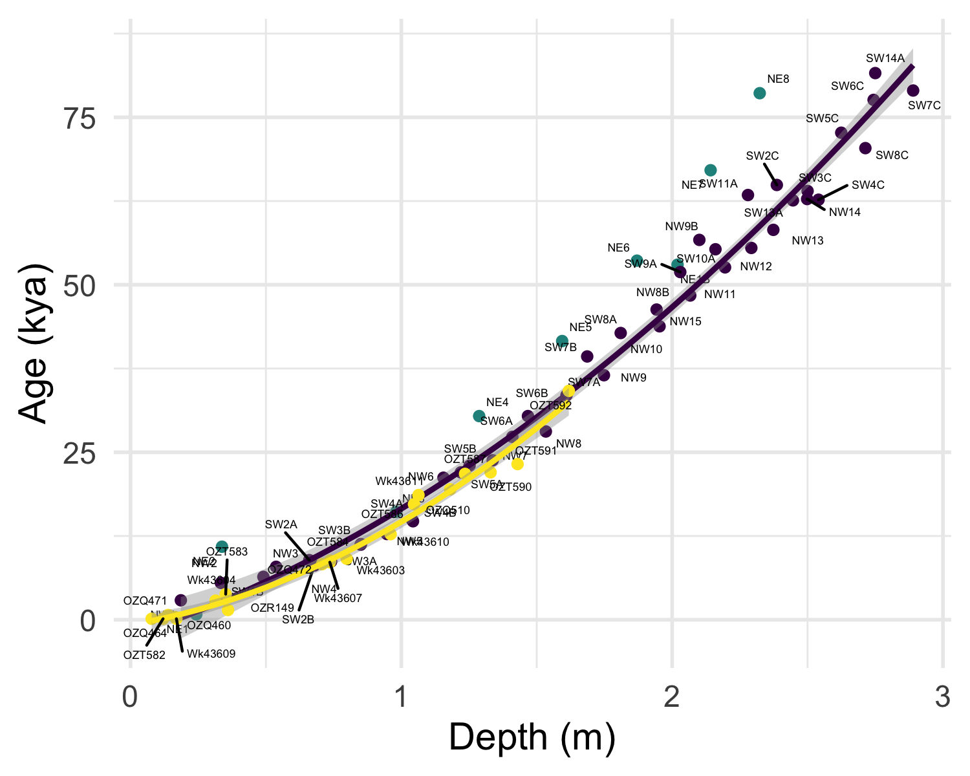

Age depth curve model, comparing OSL ages (in purple) from the northwest and southwest sides of Squares A, B and C to AMS radiocarbon ages (in yellow) from Squares B, C, D and E, 3-5 (excluding WK43606 and OZT593, see Supplementary Fig. 2c). Green points show OSL ages from the NE side for reference, these are not included in the statistical models. The age-depth models for C14 ages and OSL ages are not significantly different (ANOVA on linear models with quadratic terms, F = 1.518, df = 3, p = 0.2195)

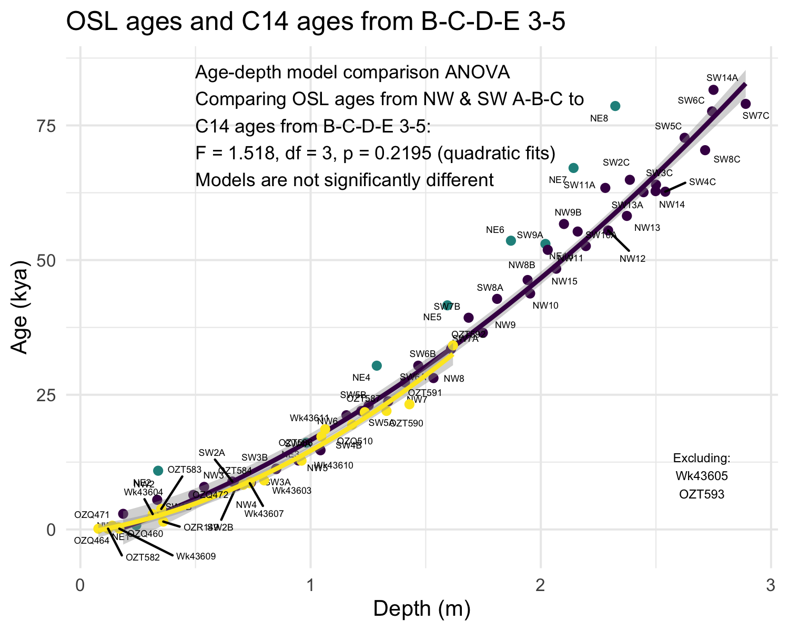

### Colophon

This report was generated on 2019-12-18 14:35:51 using the following computational environment and dependencies:

#> ─ Session info ───────────────────────────────────────────────────────────────  
#> setting value   
#> version R version 3.6.0 (2019-04-26)  
#> os macOS Mojave 10.14.6   
#> system x86_64, darwin15.6.0   
#> ui X11   
#> language (EN)   
#> collate en_US.UTF-8   
#> ctype en_US.UTF-8   
#> tz America/Los_Angeles   
#> date 2019-12-18   
#>   
#> ─ Packages ───────────────────────────────────────────────────────────────────  
#> package * version date lib source   
#> assertthat 0.2.1 2019-03-21 [1] CRAN (R 3.6.0)   
#> backports 1.1.5 2019-10-02 [1] CRAN (R 3.6.0)   
#> bookdown 0.16 2019-11-22 [1] CRAN (R 3.6.0)   
#> callr 3.3.2 2019-09-22 [1] CRAN (R 3.6.0)   
#> cli 2.0.0 2019-12-09 [1] CRAN (R 3.6.0)   
#> colorspace 1.4-1 2019-03-18 [1] CRAN (R 3.6.0)   
#> crayon 1.3.4 2019-05-28 [1] Github (gaborcsardi/crayon@84be620)  
#> desc 1.2.0 2018-05-01 [1] CRAN (R 3.6.0)   
#> devtools 2.2.1 2019-09-24 [1] CRAN (R 3.6.0)   
#> digest 0.6.23 2019-11-23 [1] CRAN (R 3.6.0)   
#> dplyr 0.8.3 2019-07-04 [1] CRAN (R 3.6.0)   
#> ellipsis 0.3.0 2019-09-20 [1] CRAN (R 3.6.0)   
#> evaluate 0.14 2019-05-28 [1] CRAN (R 3.6.0)   
#> fansi 0.4.0 2018-10-05 [1] CRAN (R 3.6.0)   
#> farver 2.0.1 2019-11-13 [1] CRAN (R 3.6.0)   
#> fs 1.3.1 2019-05-06 [1] CRAN (R 3.6.0)   
#> gdtools * 0.2.0 2019-09-03 [1] CRAN (R 3.6.0)   
#> ggplot2 * 3.2.1 2019-08-10 [1] CRAN (R 3.6.0)   
#> ggrepel * 0.8.1 2019-05-07 [1] CRAN (R 3.6.0)   
#> glue 1.3.1 2019-03-12 [1] CRAN (R 3.6.0)   
#> gridExtra 2.3 2017-09-09 [1] CRAN (R 3.6.0)   
#> gtable 0.3.0 2019-03-25 [1] CRAN (R 3.6.0)   
#> here * 0.1 2017-05-28 [1] CRAN (R 3.6.0)   
#> hms 0.5.2 2019-10-30 [1] CRAN (R 3.6.0)   
#> htmltools 0.4.0 2019-10-04 [1] CRAN (R 3.6.0)   
#> knitr 1.26 2019-11-12 [1] CRAN (R 3.6.0)   
#> labeling 0.3 2014-08-23 [1] CRAN (R 3.6.0)   
#> lazyeval 0.2.2 2019-03-15 [1] CRAN (R 3.6.0)   
#> lifecycle 0.1.0 2019-08-01 [1] CRAN (R 3.6.0)   
#> magrittr 1.5 2014-11-22 [1] CRAN (R 3.6.0)   
#> memoise 1.1.0 2017-04-21 [1] CRAN (R 3.6.0)   
#> munsell 0.5.0 2018-06-12 [1] CRAN (R 3.6.0)   
#> pillar 1.4.2 2019-06-29 [1] CRAN (R 3.6.0)   
#> pkgbuild 1.0.6 2019-10-09 [1] CRAN (R 3.6.0)   
#> pkgconfig 2.0.3 2019-09-22 [1] CRAN (R 3.6.0)   
#> pkgload 1.0.2 2018-10-29 [1] CRAN (R 3.6.0)   
#> prettyunits 1.0.2 2015-07-13 [1] CRAN (R 3.6.0)   
#> processx 3.4.1 2019-07-18 [1] CRAN (R 3.6.0)   
#> ps 1.3.0 2018-12-21 [1] CRAN (R 3.6.0)   
#> purrr 0.3.3 2019-10-18 [1] CRAN (R 3.6.0)   
#> R6 2.4.1 2019-11-12 [1] CRAN (R 3.6.0)   
#> Rcpp 1.0.3 2019-11-08 [1] CRAN (R 3.6.0)   
#> readr * 1.3.1 2018-12-21 [1] CRAN (R 3.6.0)   
#> remotes 2.1.0 2019-06-24 [1] CRAN (R 3.6.0)   
#> rlang 0.4.2 2019-11-23 [1] CRAN (R 3.6.0)   
#> rmarkdown 2.0 2019-12-12 [1] CRAN (R 3.6.0)   
#> rprojroot 1.3-2 2018-01-03 [1] CRAN (R 3.6.0)   
#> scales 1.1.0 2019-11-18 [1] CRAN (R 3.6.0)   
#> sessioninfo 1.1.1 2018-11-05 [1] CRAN (R 3.6.0)   
#> stringi 1.4.3 2019-03-12 [1] CRAN (R 3.6.0)   
#> stringr 1.4.0 2019-02-10 [1] CRAN (R 3.6.0)   
#> svglite 1.2.2 2019-05-17 [1] CRAN (R 3.6.0)   
#> systemfonts 0.1.1 2019-07-01 [1] CRAN (R 3.6.0)   
#> testthat 2.2.1 2019-07-25 [1] CRAN (R 3.6.0)   
#> tibble 2.1.3 2019-06-06 [1] CRAN (R 3.6.0)   
#> tidyselect 0.2.5 2018-10-11 [1] CRAN (R 3.6.0)   
#> usethis 1.5.1 2019-07-04 [1] CRAN (R 3.6.0)   
#> vctrs 0.2.0 2019-07-05 [1] CRAN (R 3.6.0)   
#> viridis * 0.5.1 2018-03-29 [1] CRAN (R 3.6.0)   
#> viridisLite * 0.3.0 2018-02-01 [1] CRAN (R 3.6.0)   
#> withr 2.1.2 2018-03-15 [1] CRAN (R 3.6.0)   
#> xfun 0.11 2019-11-12 [1] CRAN (R 3.6.0)   
#> yaml 2.2.0 2018-07-25 [1] CRAN (R 3.6.0)   
#> zeallot 0.1.0 2018-01-28 [1] CRAN (R 3.6.0)   
#>   
#> [1] /Library/Frameworks/R.framework/Versions/3.6/Resources/library

The current Git commit details are:

#> Local: master /Users/bmarwick/Desktop/firstaustralianplantfoods  
#> Head: [dd878d2] 2019-12-18: Initial commit