Correspondence analysis to explore temporal variability in the Madjedbebe plant macrofossil assemblage

Anna Florin

Ben Marwick

12 February, 2021

### 0.0.1 Read in the data and prepare it

cordata <- readxl::read_excel(here::here("analysis/data/raw_data/Correspondence Analysis.xlsx"))  
  
library(FactoMineR)  
library(factoextra)  
library(tidyverse)  
  
# select numeric columns  
cordata_num <-   
cordata %>%   
 unite(col = "ellipse", c(`Phase-num`, `context-type`)) %>%   
 dplyr::select(where(is.numeric), ellipse)

### 0.0.2 Compute the correspondence analysis

library(ca)  
  
ca.fit <- ca(cordata_num[-ncol(cordata_num)])  
ca.plot <- plot(ca.fit)  
  
ca.dims1 <- tibble(dim1 = ca.plot$rows[,1],   
 dim2 = ca.plot$rows[,2],  
 Phase = as.factor(cordata$`Phase-num`),  
 Context = cordata$`context-type`)  
  
ca.dims2 <- tibble(dim1 = ca.plot$cols[,1],   
 dim2 = ca.plot$cols[,2],  
 labels = colnames(cordata_num)[-ncol(cordata_num)])

### 0.0.3 Visualise the CA with plots

library(ggrepel)  
ca_plot_with_ellipse <-   
ggplot() +  
 stat_ellipse(data = ca.dims1,  
 aes(dim1,  
 dim2,  
 colour = Phase)) +  
 geom_point(data = ca.dims1,  
 aes(dim1,  
 dim2,  
 shape = Context,  
 colour = Phase),  
 size = 3) +  
 geom_point(data = ca.dims2,  
 aes(dim1,  
 dim2),  
 colour = "black",  
 shape = 20) +  
 geom_text_repel(data = ca.dims2,  
 aes(dim1,  
 dim2,  
 label = labels),  
 size = 3,  
 bg.colour = "white",  
 bg.r = 0.1,  
 force = 100,  
 segment.color = "grey80",  
 max.overlaps = 20,  
 min.segment.length = 0.1,  
 colour = "blue") +  
 labs(x = "Dimension 1",  
 y = "Dimension 2") +  
 scale_colour_discrete() +  
 scale_x_continuous(limits = c(-5, 5)) +  
 scale_y_continuous(limits = c(-5, 9)) +  
 theme_minimal()  
  
ggsave(here::here("analysis/figures/ca-ellipse-plot.png"),  
 dpi = 300)  
  
ggsave(here::here("analysis/figures/ca-ellipse-plot.svg"))

ca_plot_zoom <-   
 ggplot() +  
 geom_point(data = ca.dims1,  
 aes(dim1,  
 dim2,  
 shape = Context,  
 colour = Phase),  
 size = 2) +  
 geom_point(data = ca.dims2,  
 aes(dim1,  
 dim2),  
 colour = "black",  
 shape = 20) +  
 geom_text_repel(data = ca.dims2,  
 aes(dim1,  
 dim2,  
 label = labels),  
 size = 2,  
 bg.colour = "white",  
 bg.r = 0.1,  
 force = 100,  
 segment.color = "grey80",  
 max.overlaps = 20,  
 min.segment.length = 0.1,  
 colour = "blue") +  
 scale_colour_discrete() +  
 theme_minimal() +  
 xlim(-1, 1.0) +   
 ylim(-0.5, 0.5) +  
 labs(x = "",  
 y = "") +  
 guides(colour = FALSE,  
 shape = FALSE) +  
 theme_bw(base_size = 6)  
  
ggsave(here::here("analysis/figures/ca-zoom-plot.png"),  
 dpi = 300)  
  
ggsave(here::here("analysis/figures/ca-zoom-plot.svg"))

# combine plots  
library(cowplot)  
  
ggdraw(ca_plot_with_ellipse + theme_half_open(12)) +  
 draw_plot(ca_plot_zoom,   
 x = 0.07,   
 y = 0.67,   
 width = 0.33,   
 height = 0.33)   
  
ggsave(here::here("analysis/figures/ca-inset-plot.png"),  
 height = 8,  
 width = 11,  
 dpi = 300)  
  
ggsave(here::here("analysis/figures/ca-inset-plot.svg"),  
 height = 8,  
 width = 11)

knitr::include_graphics(here::here("analysis/figures/ca-inset-plot.png"))

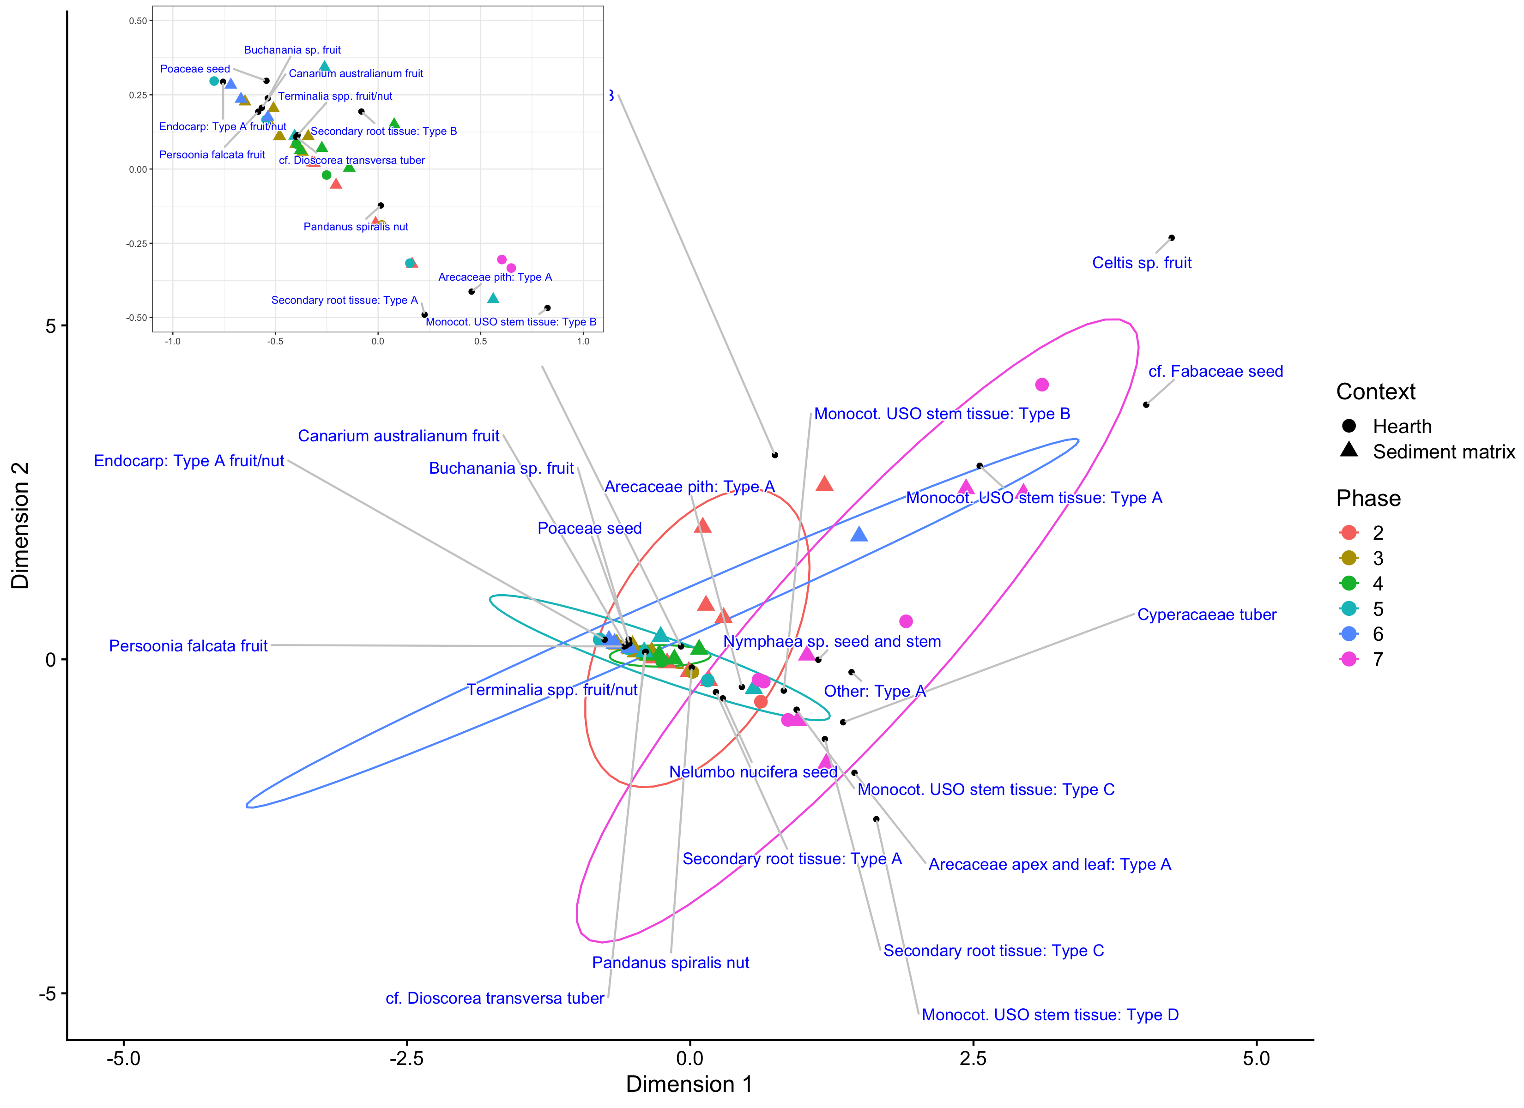

### 0.0.4 Colophon

This report was generated on 2021-02-12 18:52:37 using the following computational environment and dependencies:

# which R packages and versions?  
if ("devtools" %in% installed.packages()) devtools::session_info()  
#> ─ Session info ───────────────────────────────────────────────────────────────  
#> setting value   
#> version R version 4.0.3 (2020-10-10)  
#> os macOS Catalina 10.15.7   
#> system x86_64, darwin17.0   
#> ui X11   
#> language (EN)   
#> collate en_US.UTF-8   
#> ctype en_US.UTF-8   
#> tz America/Los_Angeles   
#> date 2021-02-12   
#>   
#> ─ Packages ───────────────────────────────────────────────────────────────────  
#> package * version date lib source   
#> assertthat 0.2.1 2019-03-21 [1] CRAN (R 4.0.0)   
#> backports 1.2.1 2020-12-09 [1] CRAN (R 4.0.2)   
#> bookdown 0.21 2020-10-13 [1] CRAN (R 4.0.2)   
#> broom 0.7.4 2021-01-29 [1] CRAN (R 4.0.3)   
#> ca * 0.71.1 2020-01-24 [1] CRAN (R 4.0.0)   
#> cachem 1.0.1 2021-01-21 [1] CRAN (R 4.0.2)   
#> callr 3.5.1 2020-10-13 [1] CRAN (R 4.0.2)   
#> cellranger 1.1.0 2016-07-27 [1] CRAN (R 4.0.0)   
#> cli 2.3.0 2021-01-31 [1] CRAN (R 4.0.2)   
#> cluster 2.1.0 2019-06-19 [1] CRAN (R 4.0.3)   
#> colorspace 2.0-0 2020-11-11 [1] CRAN (R 4.0.2)   
#> cowplot * 1.1.1 2020-12-30 [1] CRAN (R 4.0.2)   
#> crayon 1.4.0 2021-01-30 [1] CRAN (R 4.0.3)   
#> DBI 1.1.1 2021-01-15 [1] CRAN (R 4.0.2)   
#> dbplyr 2.0.0 2020-11-03 [1] CRAN (R 4.0.2)   
#> desc 1.2.0 2018-05-01 [1] CRAN (R 4.0.0)   
#> devtools 2.3.2 2020-09-18 [1] CRAN (R 4.0.2)   
#> digest 0.6.27 2020-10-24 [1] CRAN (R 4.0.2)   
#> dplyr * 1.0.4 2021-02-02 [1] CRAN (R 4.0.2)   
#> DT 0.17 2021-01-06 [1] CRAN (R 4.0.2)   
#> ellipsis 0.3.1 2020-05-15 [1] CRAN (R 4.0.0)   
#> evaluate 0.14 2019-05-28 [1] CRAN (R 4.0.0)   
#> factoextra * 1.0.7 2020-04-01 [1] CRAN (R 4.0.0)   
#> FactoMineR * 2.4 2020-12-11 [1] CRAN (R 4.0.2)   
#> farver 2.0.3 2020-01-16 [1] CRAN (R 4.0.0)   
#> fastmap 1.1.0 2021-01-25 [1] CRAN (R 4.0.2)   
#> flashClust 1.01-2 2012-08-21 [1] CRAN (R 4.0.0)   
#> forcats * 0.5.1 2021-01-27 [1] CRAN (R 4.0.2)   
#> fs 1.5.0 2020-07-31 [1] CRAN (R 4.0.2)   
#> gdtools * 0.2.3 2021-01-06 [1] CRAN (R 4.0.2)   
#> generics 0.1.0 2020-10-31 [1] CRAN (R 4.0.2)   
#> ggplot2 * 3.3.3 2020-12-30 [1] CRAN (R 4.0.2)   
#> ggrepel * 0.9.1.9999 2021-01-19 [1] Github (slowkow/ggrepel@54838c6)  
#> glue 1.4.2 2020-08-27 [1] CRAN (R 4.0.2)   
#> gtable 0.3.0 2019-03-25 [1] CRAN (R 4.0.0)   
#> haven 2.3.1 2020-06-01 [1] CRAN (R 4.0.0)   
#> here 1.0.1 2020-12-13 [1] CRAN (R 4.0.2)   
#> highr 0.8 2019-03-20 [1] CRAN (R 4.0.0)   
#> hms 1.0.0 2021-01-13 [1] CRAN (R 4.0.2)   
#> htmltools 0.5.1.1 2021-01-22 [1] CRAN (R 4.0.2)   
#> htmlwidgets 1.5.3 2020-12-10 [1] CRAN (R 4.0.2)   
#> httr 1.4.2 2020-07-20 [1] CRAN (R 4.0.2)   
#> jsonlite 1.7.2 2020-12-09 [1] CRAN (R 4.0.2)   
#> knitr 1.31 2021-01-27 [1] CRAN (R 4.0.2)   
#> labeling 0.4.2 2020-10-20 [1] CRAN (R 4.0.2)   
#> lattice 0.20-41 2020-04-02 [1] CRAN (R 4.0.3)   
#> leaps 3.1 2020-01-16 [1] CRAN (R 4.0.0)   
#> lifecycle 0.2.0 2020-03-06 [1] CRAN (R 4.0.0)   
#> lubridate 1.7.9.2 2020-11-13 [1] CRAN (R 4.0.2)   
#> magrittr 2.0.1 2020-11-17 [1] CRAN (R 4.0.2)   
#> MASS 7.3-53 2020-09-09 [1] CRAN (R 4.0.3)   
#> memoise 2.0.0 2021-01-26 [1] CRAN (R 4.0.2)   
#> modelr 0.1.8 2020-05-19 [1] CRAN (R 4.0.0)   
#> munsell 0.5.0 2018-06-12 [1] CRAN (R 4.0.0)   
#> pillar 1.4.7 2020-11-20 [1] CRAN (R 4.0.2)   
#> pkgbuild 1.2.0 2020-12-15 [1] CRAN (R 4.0.2)   
#> pkgconfig 2.0.3 2019-09-22 [1] CRAN (R 4.0.0)   
#> pkgload 1.1.0 2020-05-29 [1] CRAN (R 4.0.0)   
#> png 0.1-7 2013-12-03 [1] CRAN (R 4.0.0)   
#> prettyunits 1.1.1 2020-01-24 [1] CRAN (R 4.0.0)   
#> processx 3.4.5 2020-11-30 [1] CRAN (R 4.0.2)   
#> ps 1.5.0 2020-12-05 [1] CRAN (R 4.0.2)   
#> purrr * 0.3.4 2020-04-17 [1] CRAN (R 4.0.0)   
#> R6 2.5.0 2020-10-28 [1] CRAN (R 4.0.2)   
#> Rcpp 1.0.6 2021-01-15 [1] CRAN (R 4.0.2)   
#> readr * 1.4.0 2020-10-05 [1] CRAN (R 4.0.2)   
#> readxl 1.3.1 2019-03-13 [1] CRAN (R 4.0.0)   
#> remotes 2.2.0 2020-07-21 [1] CRAN (R 4.0.2)   
#> reprex 1.0.0 2021-01-27 [1] CRAN (R 4.0.2)   
#> rlang 0.4.10 2020-12-30 [1] CRAN (R 4.0.3)   
#> rmarkdown 2.6 2020-12-14 [1] CRAN (R 4.0.2)   
#> rprojroot 2.0.2 2020-11-15 [1] CRAN (R 4.0.2)   
#> rstudioapi 0.13 2020-11-12 [1] CRAN (R 4.0.2)   
#> rvest 0.3.6 2020-07-25 [1] CRAN (R 4.0.2)   
#> scales 1.1.1 2020-05-11 [1] CRAN (R 4.0.0)   
#> scatterplot3d 0.3-41 2018-03-14 [1] CRAN (R 4.0.0)   
#> sessioninfo 1.1.1 2018-11-05 [1] CRAN (R 4.0.0)   
#> stringi 1.5.3 2020-09-09 [1] CRAN (R 4.0.2)   
#> stringr * 1.4.0 2019-02-10 [1] CRAN (R 4.0.0)   
#> svglite 1.2.3.2 2020-07-07 [1] CRAN (R 4.0.2)   
#> systemfonts 0.3.2 2020-09-29 [1] CRAN (R 4.0.2)   
#> testthat 3.0.1 2020-12-17 [1] CRAN (R 4.0.2)   
#> tibble * 3.0.6 2021-01-29 [1] CRAN (R 4.0.2)   
#> tidyr * 1.1.2 2020-08-27 [1] CRAN (R 4.0.2)   
#> tidyselect 1.1.0 2020-05-11 [1] CRAN (R 4.0.0)   
#> tidyverse * 1.3.0 2019-11-21 [1] CRAN (R 4.0.2)   
#> usethis 2.0.0 2020-12-10 [1] CRAN (R 4.0.2)   
#> vctrs 0.3.6 2020-12-17 [1] CRAN (R 4.0.2)   
#> withr 2.4.1 2021-01-26 [1] CRAN (R 4.0.2)   
#> xfun 0.20 2021-01-06 [1] CRAN (R 4.0.2)   
#> xml2 1.3.2 2020-04-23 [1] CRAN (R 4.0.0)   
#> yaml 2.2.1 2020-02-01 [1] CRAN (R 4.0.0)   
#>   
#> [1] /Library/Frameworks/R.framework/Versions/4.0/Resources/library

The current Git commit details are:

# what commit is this file at?   
if ("git2r" %in% installed.packages() & git2r::in_repository(path = ".")) git2r::repository(here::here())   
#> Local: master /Users/bmarwick/Desktop/florinplantscorran  
#> Remote: master @ origin (git@github.com:benmarwick/florinplantscorran.git)  
#> Head: [d7a9efb] 2020-06-07: Add GitHub links to DESCRIPTION