Guanyingdong Stone Artefact Assemblage Report

HY and BM

18 January, 2017

# Introduction

The Guanyindong site, located in Guanyindong village, Qianxi County of Guizhou Province (26°51′26″N, 105°58′7″E) at an elevation of 1464 m a.s.l., is a limestone cave site extending from east to west it was discovered by a team organized by the institute of Vertebrate Paleontology and Paleoanthropolgy (IVPP), Chinese Academy of Sciences in 1964. Several excavations were conducted in 1965, 1972 and 1973, yeilding A total of 176 cores, 1292 flakes, 1101 retouched pieces and 804 pieces of debris were identified.

Introduction of paleolithc research in south Asia (or China).

Introduction the distribution of levollois technique (origin, dispersion, distribution).

Prolem: East Asia, why people thought no levollois. Why studying this site is important. Aim in this study.

## Raw materials

Previous research reported that the stone artefacts are preliminarily made of siliceous limestone, In my observation,the majority of siliceous limestone is classified as chert, therefore, the assemblage is dominated by chert (78.02%) followed by limestone (20.59%) and basalt, sandstone and quartz were only occasionally used and constitute % and % of the assemblage respectively. Although the chert selected varies slightly from color to texture, sub-classification is not conducted due to the consistence of their physical properties which are homogeneous without fracture, joint and constant hardness. Table? Shows the different types of stone artefact that chert and limestone were employed. 84.92 % chert flakes were retouched into stone tools indicating a high efficient exploit of this raw material, although it can be easily obtained nearby. In terms of retouched pieces, 856 of them are made of chert, 216 of them are made from limestone. It is obvious that hominins intended to selected chert as optimal raw material to manufacture stone tools.

flakes Retouched flakes cores debris total

Chert  
limestone

The raw material source are mostly from local area that no further than 10km based on Leng and Li's investigation indicating the ability of local raw material guides the selectivity of kanppers . One possible chert source, located about 4 km (straight distence) is called Jinyan hill, where chert nodules are exposed on surface (Leng, 2001).For limestone and volcanic rocks like basalt and quartz are all from local mountain, river bed and exposed layers. The majority of raw material are accessable within 6 km (Li, 2009) suggesting an relative small foraging territory. Leng also found that the natural chert, volcanic rock, and siliceous limestone nodules were generally larger than specimen from GYD. According to source investigation, ancient knappers were inclined to obtain raw material locally and traverl short distence to get access to raw material, besides, they were aware of raw material selection indicated by the preference of chert, which is easier control and has better flaking property as main knapping object. It also suggests that their foraging radius allows them to collect raw material and return to cave without overnight stop.

## Flakes

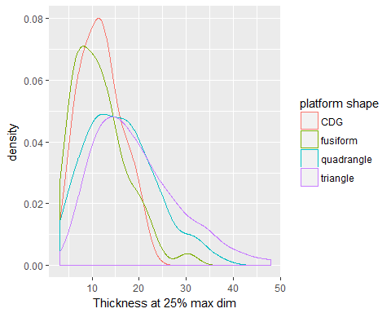

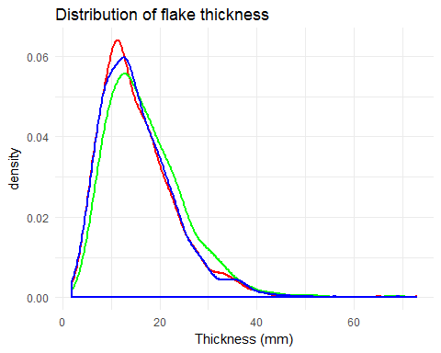

Figure 1 Distribution of flake thickness at three points across the flake

We found 1292 flake pieces including complete flake (195), retouched flake(195), flake breaks(195), and retouched flake breaks(195),. The average maximum length of the flakes pieces is 51.3 mm, the average thickness is18.3 mm. These figures suggest that the flake from GYD are thin, indicating the ability of knapping control. There are 175 flakes or broken flake that have distinguishable platforms, that can be divided into cortex (9.1 %), plain (61.1 %), facet (%), dihederal (10.3 %%) and focus. One noticeable character of the flake assemblage is the relative higher prepared platform compared with other sites in China during Middle Palaeolithic. It indicates a high exploitation capacity of raw material, probably due either to technological capacity or raw material’s flaking property. The average thickness of platform is 14.09mm; the average width of platform is 33.47mm. The shapes of platform include triangle (37.2 %), fusiform (19.6%), quadrangle (27.7%) and CDG (13.5%) and with a small account of trapezoid ，rectangle and irregular.

In order to explore the possible relationship between platform shape with flake thickness, we compared the platform shapes with thickness at 50 max dim. Fig? shows that thickness of flakes which have CDG platform shape is more concentrated around 10-15mm. Flakes with triangle platform shape is the thickest around 20mm. Fig? shows the relationship between platform shapes and flake dimension. % of flakes dorsal side is partially covered with cortex. Most of The cortex is limited ranging from 5 to 10 percentage. The average scar number is 2.96 while the standard deviation is 1.66. Flakes with 3 dorsal scars are the largest proportion.87% flakes have scar number less than 4. It suggests that before hominins brought knapping products into the cave, they knapped the blank outside of the cave therefore the flakes are on the late stage of knapping and with less cortex. The directions of scars of 356 flakes are recorded. We divided the directions into 8 sections. Among them, 190 flakes have dorsal scars that with the same directions of the flake, following with opposite direction(%). We also found a number of centripetal scars (%). Figure 1 shows the thickness distribution at 25%. 50% and 75%.From the chart, we can infer that the thickness at 25% is the thinnest place and thickness at 50% and 75% shares the same max dimension. It indicates that the knappers have a good control over thickness that can make the thickness under a particular thickness range. Since the max points of thickness of these three places are all around 12mm in GYD, it is reasonable to conclude that the form flakes of GYD is well controlled and relative flat.

## Cores

We found 176 cores in the lithic assemblage. The average dimension is xxx and with an average weight of xxx g. This dimension is slightly larger than flakes indicating The average max dimensions of cores are xx mm.The flaking technique of GYD is free hand percussion with hard hammer. Chert dominates the raw material of cores(%). There are various geometries of cores including irregular(%), conic(%), column(%) and small account of wedged and circle. According to the number of platform, there are 3 types of cores: single platform (%), double platform (%) and multiple platform (%). According to technological reduction, they can be classified as ordinary core (%), blade core (%), disc core (%) and Levallois core(%). Fig? shows the scar number of each core. The primary cores just produced 1-4 flake scars and then discarded. The cores that have more than 8 scars are occasionally shown. It suggests that the cores are not efficiently exploited. The average scar length is xxx mm which is . Most of them are covered with zero(%) or low percentage cortex( %Fig?) . The cortex location is always on platform (%) and bottom (%). Fig? shows the types of platform. The majority of platform type is plain (%) which suggests that using former scars as platform to continue flaking following flakes is the main strategy of knapping. Remarkably, there are a notable amount of facet platforms() which presented with higher frequency on Levallois, blade and discoid cores indicating predetermined strategy was applied on more complicated techniques. The majority of cores have 1 or 2 rotation which means after knapping from one platform and then make a rotation to find a new platform to keep flaking when the original platform is no longer suitable for further knapping. The small number of rotations reinforced the observation that most of cores in GYD are casual cores either due to the technological limitation or to the availability source of local raw materials.

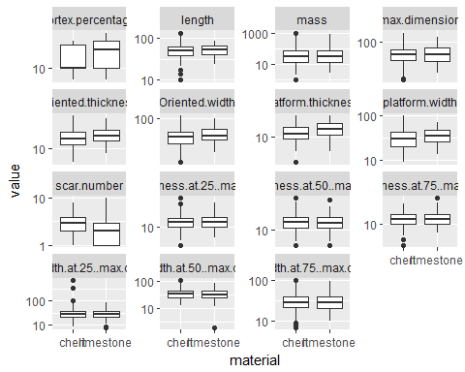

## # A tibble: 2 × 13  
## variable data t_test estimate estimate1  
## <chr> <list> <list> <dbl> <dbl>  
## 1 platform.thickness <tibble [211 × 2]> <S3: htest> -3.648798 14.272254  
## 2 cortex.percentage <tibble [253 × 2]> <S3: htest> -11.256039 8.743961  
## # ... with 8 more variables: estimate2 <dbl>, statistic <dbl>,  
## # p.value <dbl>, parameter <dbl>, conf.low <dbl>, conf.high <dbl>,  
## # method <fctr>, alternative <fctr>

## [1] 783

## [1] 0.5828677

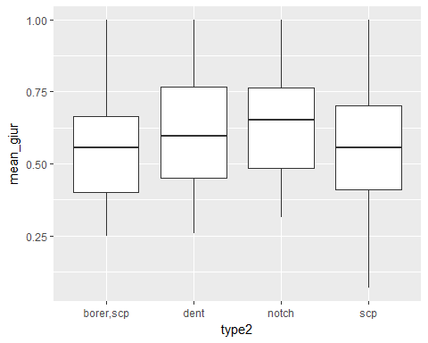

## geom_sina: na.rm = FALSE  
## stat_sina: na.rm = FALSE  
## position_identity

## Retouched pieces

A total of 1101 retouched pieces were found in the assemblage, accounting for 48.5% of lithic assemblage. The average max dimension is 56.71mm. Compared with unretouched flakes, retouched pieces are generally larger according to the fact that retouched pieces are greater on length, max dimension, width and thickness. This indicates that after flake production, the knappers prefer to choose bigger flakes or flake fragments to retouch, especially, longer and thicker ones. In terms of raw materials, we compared all variables between stone artefacts made of chert and limestone, the difference between them are minor except the cortext percentage and platform thickness of limestone are larger than chert. % retouched pieces are made on flakes (%) and flake breaks (%), a small number of them are made on either chunks or pebbles. Side scrapers dominate the sub-division of retouched pieces (%), followed by denticulates and borers. Over % retouched pieces have more than 1 edge. The edge shapes of 1858 retouched edges were recorded from retouched pieces. The edge shapes include convex, concave, straight, denticulate, end, notch, borer. Among them, straight edge constitutes the largest proportion of the retouched edge (n=575 %) followed by convex(n=395) and concave(n=248)(significance of straight edge).We calculated the edge angle by measuring the width at the 3 mm depth of the edge. The average angle of each edge is?. Notably, there is amount of the edge angles are extreme steep which is not common in other site. This feature can be explained in two ways: 1) the lack of good quality raw materials leaded tool makers to elongate the lives of tools as long as possible, therefore, the edges had been retouched multiple times after using; 2) they intended to produce the steep edge in order to apply to a special tusk. Fig? and Fig? show the edge number distribution and edge shapes of each piece. The result shows that the majority of tools are not only retouched one edge, instead, they retouched several edges on one single piece. It also suggest the high efficient of exploit. Most of the layers of retouch is 1(n=760) and 2 (n=322). Looking at the location of retouch and the size of the retouched flakes can provide us further insight into retouching behaviours. Most of tools have more than one retouched edges.

We introduced two concepts “Zone Index” and “Geometric Index of Unifacial Reduction(GIUR)” to estimate the invasion and intensity of retouching. In this assemblage, if a flake is retouched, the retouch tends to be extensive. This is suggested by the GIUR values. We found that 63% of retouched artefacts have a GIUR greater than 0.5. However, there is no obvious correlations between GIUR values and other variables such like length, width and thickness. From our observation… We also measured the angle of each retouched edge. For notch pieces(n=91), we found that most notches only have one notch end on each retouched piece and the average depth and length is xx and xx. The location of retouching is mainly on one side which defined as longer geometric side of the piece. Except retouching with hard hammer percussing, pressing is also likely utilized demonstrated by flat and enlonged retouching scars. One remarkable feature of the retouching is demonstrated by a strong moustrian style with regular and continues retouching scars producing even edges on a large number of tools.

### Indices

## Levallois

We distinguished 70 stone artifacts that are Levallois like products including 11 cores, 22 flakes, 4 points and 33 tools made on levallois flakes. The average dimension of levallois products is xxx which is smaller (or larger) than ordinary products. The platform shapes of levallois flakes are various ranging from triangle, quadrangle, fusiformis to chapeau de gendarme(CDG). For flakes, we measured the thickness at 25%, 50%, 70% max dimension and compared them with ordinary flakes found that levallois flakes are relatively more flat. This found is consistent with the theory that ... The scar number is also relatively more than ordinary flakes, the direction of which is mostly centripetal. The platform of Levallois flakes and flake fragments are mainly plain(n=22), followed by facet(n=12) and the platform shapes are mainly CDG(n=15), followed by triangle(n=8) and quadrangle(n=6). The dorsal scar patterns can be divided into two main types: centripetal pattern which is covered by flake scars that are distributed centripetally and big scar pattern which is characterized by a giant scar from the same direction covering the most part of the dorsal area with proximal parts of centripetal scars on the margin(Fig?). Generally, the later pattern ends up with a relative flatter body and more possibilities of CDG platform shape. The configuration of levallois cores volumes were maintained through the detachment of predetermining Levallois and trimming striking platform flakes. The average max dimension is 82mm. Most of their platforms are facet(n=5). These cores are classified as Levallois is accorded to several key technical criteria (Boeda,1994) : 1) the flaking surface is maintained through predetermined flake scars that is arranged centripetally; 2) the fracture plane of detachment are almost parallel to the plane of intersection of the upper and lower surface; 3) and the two surface are hierarchicaly related. More than half of these cores retain a portion of cortex on the surface. The average scar number of each core is 4.5, and the average length of these scars is 40mm. 12 discoid cores are also found in the assemblage which are separated with Levallois cores. Although most of discoid cores also share similar features with Levallois, based on the 5 criteria definited by Boeda, it is more reasonable to classify them to discoid.

# Discussion

1. Comparing with other sites in south China, Guanyindong is featured by the appearance of Levallois technique.Why do you think Gyd has levallois? Previous results from other sites in South China suggest that they have no levallois techinique (give examples and discussions)
2. In the lithic assemblage, we found 59 Levallois flakes, 11 Levallois cores, with distinguishable characters from Europe and Africa(less proportion, relative more proto morphology). What are the main difference between Gyd and other sites. What is the implication of such difference. Are there any difference in the Levallois techniques in Europe and Africa or other Asia sites?
3. Provide detailed discussion on the Demographic model, and explain the reason why Levallois technique in Southeast Asia is different from western. China and Southeast Asia is geographically distant from East Africa where Levallois technique is originated, as hominids dispersal from western to eastern, progressively smaller population, drastic changes of environment have made an inevitable influence on the style of Levallois technique.
4. Drawbacks (assumptions) of the model. Other possible explanation you can offer.

# Conclusion