**INVESTIGATING ARCHAEOLOGISTS’ ENGAGEMENT WITH FEMINIST THEORY USING TEXTUAL MACROANALYSIS: 25 YEARS AFTER CHACMOOL 1989**

Whether and to what extent feminist theory should inform archaeological research on gender has been the subject of some debate. Though pioneering gender studies advocated for feminist-inspired approaches, archaeologists as a whole appear to have examined gender with little influence from feminist thought. Abstracts from the 1989 Chacmool Conference on “The Archaeology of Gender” have been viewed as key evidence in support of this position, as few abstracts contained references to feminist theory or concepts. In this paper, we used textual macroanalysis to explore whether the highly influential findings from the 1989 Chacmool Conference represent the work of archaeologists at a broader scale. Tracking diachronic changes in the relative frequencies of and correlations between keywords in nearly 6,000 scholarly publications, we found that while explicit contextualization within feminist thought is often missing, feminism has exerted a substantial albeit more subtle influence on gender research. Our results complicate dominant narratives about gender research and highlight the potential of textual macroanalysis for developing quantitative accounts of archaeological history.

The rapid rise of gender research stands as one of the most significant recent developments in archaeology. In North America, this work can be traced to Conkey and Spector (1984) who first seriously exposed the androcentric, ethnocentric, and presentist biases that pervade archaeologists’ understanding of gender in the past. They called for a more critical archaeology of gender, one predicated on the notion that gender relations are an integral component of human societies and thus worthy of robust theoretical and methodological approaches. In the intervening three decades, archaeologists have answered their call. The now substantial corpus on gender and archaeology (see Conkey and Gero 1997; Engelstad 2007) highlights the viability and insight of this work for augmenting our understanding of gender relations and identities in the past and combating sexism, classicism, and homophobia that continue to structure the composition of the discipline.

Theoretically, gender research has found expression within numerous schools of thought, yet its primary debt lies with feminist theory. The emergence of gender research in archaeology followed directly from feminist critiques making headway in other disciplines. Focusing these critiques at archaeology, pioneering studies argued that the objectivist frameworks guiding archaeological research were not only politically situated, they served to minimize women’s presence in the past and contributions to the discipline (Conkey and Spector 1984; Wylie 1991). A key insight of these studies is that gender research, when contextualized within feminist thought, has the potential to “foster a conceptually richer, empirically more robust, and more broadly accountable archaeology” (Wylie 2007:215). In this sense, feminism has been and remains fundamental to the development and transformative potential of gender research (Engelstad 2007).

While there is general consensus that feminist theory was integral to the initial fluorescence of gender research, some archaeologists have expressed concern about the long-term impact of this relationship. This position is articulated by Sørensen (2000), who contends feminism is simply one of many minority “voices” and therefore unlikely to attract discipline-wide support. Feminism, in her view, is essentially a political stance whose adherents are unable to escape their own biases or “provide a starting point for developing models of scientific rationality” (2000:36). Moore (1997:251) similarly claims that feminism will prevent gender research from entering archaeology’s “mainstream” and precludes the discovery of “any objective truth which is not the vehicle of some particular interest group”. Apparent in these positions is a reticence to embrace feminist thought lest gender research be marginalized as politicized niche devoid of significant archaeological import.

Despite compelling epistemological positions outlined by Wylie (1991, 2007) that resolve feminism’s perceived association with relativism, there is evidence to suggest archaeologists on the whole support disentangling gender research from its feminist roots. This was clear at one of the first major archaeology conferences devoted to gender: the 1989 Chacmool Conference. The conference attracted considerable interest, drawing more paper submissions and a larger attendance than any previous Chacmool Conference. The intellectual merit of the conference was similarly high. Papers tackled a range of foundational theoretical and methodological challenges faced by a nascent archaeology of gender. Given that gender research was still in its infancy—only five years had passed since the publication of Conkey and Spector (1984)—the success of the conference is notable. It suggests an interest in gender already existed within the discipline and had finally found an outlet (Wylie 1997). Hanen and Kelley (1992), seeking to identify emerging trends in this work, analyzed all 103 abstracts from the conference. To their surprise, relatively few conference participants made explicit mentions of feminist theory. Fewer than 20% contained “feminism” or “feminist” and few referenced or cited feminist critiques.

These patterns have proven resilient. At the 2004 Chacmool Conference, titled “Que(e)rying Archaeology”, interaction between gender research and third-wave feminist concepts such as identity, sexuality, and intersectionality seemed likely. Yet analysis of 141 conference abstracts revealed little conceptual and theoretical change since the 1989 conference (Geller 2009). Archaeologists continued to explore sexual/gendered divisions of labor, conflate sex and gender, and rely on essentialized gender dichotomies, all of which have been problematized by feminist theorists. Again, few abstracts—this time, only 4%—included “feminism” or “feminist”. As at the 1989 conference, gender generated considerable interest, yet it appeared as “just another variable that has been added to an unreflexive, positivist approach” (Conkey 2003:876), that is, a non-feminist one.

While it is tempting to regard these findings as specific to the Chacmool Conference, analysis of non-Chacmool gender studies has returned similar results (see Engelstad 2007). Consequently, the Chacmool findings have been interpreted as a reflection of a discipline-wide pattern. Prominent review articles (Hays-Gilpin 2000; Wylie 2007) have forwarded the Chacmool abstracts as support for qualitative observations about the dearth of feminist theory in gender research. Review articles play a key role in summarizing existing research trends; in doing so, they shape our understanding of the history of given research traditions. For gender research in archaeology, the dominant narrative that has emerged is one of sustained intellectual interest but with little contribution from feminist theory.

The above quantitative studies have provided valuable insight about the nature of gender research in archaeology, but their relatively small sample size and focus on non-peer reviewed publications raises questions. How confident can we be that conference abstracts provide a representative sample of research discipline wide? Would analysis of publications in their entirety yield different results? Is it possible that feminist theory has played a greater, albeit more subtle, role in archaeologists’ examinations of gender?

We argue that conceptions of archaeological history based on qualitative assessments and limited quantitative studies do not necessarily reflect the work of archaeologists more broadly. Of course, crafting cogent historical narratives necessitates some level of homogenization and simplification and thus a typical review article cannot account for the full text of every relevant publication. However, aided by computational methods, we can bring larger and more inclusive data sets to bear on questions about archaeological history. In this paper, we present the results of a textual macroanalysis of nearly 6,000 articles published in five major archaeological journals over the past forty years. We evaluated the role of feminist theory in gender research by tracking changes in the relative frequencies of and correlations between keywords through time and comparing these findings with select close readings of texts from the corpus. Our results suggest that gender research exhibits more diversity and engagement with feminism than has been previously surmised.

**Textual Macroanalysis and its Application in Archaeology**

The conventional way we engage with scholarly literature is focused and time-intensive. We read words sequentially and mentally thread these words together to create meaning. This approach is known as “close reading” and is highly effective for parsing individual documents and small collections of texts. However, when investigating corpora that contain hundreds or even thousands of documents, the time required for diligent close reading is beyond what we can muster in any realistic context. This problem has been tackled by scholars in the digital humanities, who argue computational methods offer a new way forward for understanding literary history. By shifting the level of analysis from a narrow selection of celebrated works to entire genres and literary traditions, scholars have identified changes in writing style, explored the relationship between historical events and literary trends, and questioned whether differences exist between canonical works and those by historically marginalized authors, among many others (Jockers 2013). This approach to analyzing large volumes of text is often referred to as “distant reading” or textual macroanalysis.

Textual macroanalysis can be applied to archaeology in a number of ways. Similar to studies in the digital humanities, we can investigate shifts in archaeologists’ writing styles through time, track the rise and fall of particular theoretical perspectives, and quantify inter-journal differences related to geographic foci and author demographics. In addition, we believe textual macroanalysis may have potential to reveal new insights about archaeological history. Disciplinary histories are generally written by and reflect the work of select scholars and theorists (c.f. Trigger 2006). In describing explanatory, theoretical, and methodological shifts, these works rely on subjective interpretations of previous research. This is not to say this approach leads to incorrect or skewed accounts, only that it remains to be seen whether histories of ostensibly influential individuals reflects the research of the majority of practitioners across the discipline. Using textual macroanalysis, we can investigate discipline-wide research patterns and construct accounts of archaeological history to evaluate prevailing historical narratives.

As a demonstration of this approach, we assessed the role of feminist theory in gender research over the past forty years. We first wrote software in the R programming language that would allow us to identify and visualize patterns within a large corpus (Marwick 2014). Our software is freely available from https://github.com/benmarwick/JSTORr/. To acquire our corpus, we turned to JSTOR’s Data for Research, an online repository of scholarly publications built for distant reading-style research. We downloaded 5,688 full text publications from five major archaeology journals: *American Antiquity, Journal of Archaeological Research, World Archaeology, Journal of World Prehistory*, and *Journal of Field Archaeology*.

With this corpus, we sought to identify the role, if any, feminism has played in gender research. Our study has two components. First, we conducted frequency analysis to investigate diachronic changes in the relative frequency of “gender” and “feminism/feminist”. Second, using correlation analysis we tracked the correlation between “gender” and key feminist concepts through time. Inspired by the results from previous Chacmool Conferences (Geller 2009; Hanen and Kelley 1992), we predicted that 1) “gender” would be mentioned in more articles and with a higher relative frequency than “feminism/feminist” through time and 2) words associated with key feminist concepts would not be highly correlated with “gender” through time.

**RESULTS**

Figure 1 illustrates the relative frequencies of “gender” and “feminism/feminist” in our corpus from 1970 to 2007. Each data point corresponds to an article in which these words appear and a higher relative frequency indicates these words occurred more often compared to the total number of words in each article. “Gender” and “feminism/feminist” have broadly comparative relative frequencies, though with differing degrees of variation. “Feminism/feminist” exhibits a bimodal distribution, peaking in the mid-1980s and mid-2000s and exceeding the relative frequency of “gender” during these periods. From the late 1970s onwards, “gender” appears to have attracted more consistent interest. The relative frequency of “gender” peaks during the mid-1990s, a period when mentions of feminism reached their nadir.

These patterns only partially support our first prediction. Figure 1 speaks to the rapid emergence of gender research in archaeology. Interest in gender appears to predate the publication of Conkey and Spector (1984) and has remained stable in the intervening years. The sample size for “gender” dwarfs that of “feminism/feminist”. “Gender” appears in over three times as many articles (n = 364) as does “feminism/feminist” (n = 110) and the total number of mentions for “gender” (n = 2741) are nearly five times that of “feminism/feminist” (n = 591).

These patterns can be interpreted in several different ways. The disparities in total word counts could be explained by incorporation of feminism as a theoretical perspective but not necessarily the primary research focus. Authors may reference feminist critiques in the introduction and background sections of their work but spend the bulk of the paper exploring gender at their study site. If this were true, however, we would expect “gender” and “feminism/feminist” to appear in comparable numbers of articles. This is not the case. “Gender” is mentioned more often and in more articles than “feminism/feminist”, suggesting that feminist theory plays a minimal, or at least not an explicit, role in a significant proportion of this research.

How then do we make sense of the two peaks in the relative frequency of “feminism/feminist”? These words appear in far fewer articles than “gender” but when they do, they attract considerable discussion. This suggests these peaks were periods of significant theoretical articulation, an interpretation that makes sense given their temporal distribution. Many pioneering studies from the mid- to late 1980s explicitly linked feminism and gender research (e.g. Wylie 1991). These works may have inspired engagement with feminism across the discipline, paving the way for feminist-inspired journal publications. Similarly, the recent increase in references to “feminism/feminist” may reflect reengagement with feminist theory. Within gender research, the turn of the twenty-first century stimulated reflection on existing approaches and recommendations for future work (Conkey and Gero 1997; Hays-Gilpin 2000). These publications emphasized gender research’s roots in feminist theory and advocated for more explicitly feminist approaches. If Figure 1 is any indication, they may have successfully reignited archaeologists’ engagement with feminist theory and concepts.

Our results present an interesting contrast with previous research. As argued by Hanen and Kelley (1992), feminism is missing from many gender studies, but it is not completely absent. In our data, feminism is mentioned in 30% of publications on gender, far more than the 1989 and 2004 Chacmool Conference abstracts. This suggests that the previous quantitative studies, and the dominant narrative historical narratives they support, may have underestimated archaeologists’ interest in feminist thought.

Word frequency analysis highlights the potential of distant reading for extracting new insights about the history of archaeology. And when used in tandem with close reading, comprehensive and nuanced interpretations of archaeological literature are possible. To that end, we paired our frequency analysis data with close readings of randomly selected articles within our corpus. Specifically, we examined the use of “feminism/feminist” in context. In some instances, especially in articles with low relative frequencies, these words appear as passing references to feminist concepts or publications. In many others, we found authors drawing on feminist critiques of ethnoarchaeological interpretations: “Feminist scholars point to the androcentric biases of the ethnographic genre, and archaeologists who employ these studies…commonly project these biases into the past” (Stahl 1993:250), and the composition of the discipline: “Feminist theory has…turned our gaze inward, to be self-reflexive about how gender bias and a lack of diversity has affected the work that archaeologists produce” (Wilkie and Hayes 2006:253). In other words, we found archaeologists substantially engaging with feminist literature in ways that lend support to our interpretations of the frequency data.

Diachronic changes in word frequencies, such as depicted in Figure 1, offer a first-order approximation of archaeologists’ engagement with feminist theory. But they may misrepresent feminism’s role in this corpus. We assumed that increases in the relative frequencies of “feminism/feminist” correlate with more extensive discussion of these words. Such a simple assumption is likely to be vulnerable to numerous flaws and exceptions. For example, publications that employ concepts forwarded by feminist theorists but contain few mentions of “feminism/feminist” will be interpreted as minimally engaged with feminist theory. Alternatively, articles critical of applications of feminism in archaeology may exhibit high relative frequencies of these words but again will be interpreted incorrectly. Some such incongruities are expected when doing distant reading, but whether we can dismiss them as merely statistical “noise” remains to be seen.

Correlation analyses provide one possible approach to mitigating these problems. By tracking the correlation between the relative frequencies “gender” and sets of words associated with feminism, we can assess whether and to what extent feminism has played a less obvious and more conceptual role in gender research. With this analysis, we can assess at a larger scale Geller’s (2009) observation that gender research has proceeded out of step with developments in feminist thought. We selected two sets of keywords for this analysis. First, we sought to evaluate the relationship between gender research and sexual/gendered divisions of labor. We chose the following keywords: “labor”, “division”, “role”, “hunt”, “hunter”, “gather”, and “gatherer”. Second, we were interested in the impact of third-wave feminist concepts on gender research. We chose the following keywords: “intersectional”, “intersectionality”, “identity”, “race”, “queer”, and “sexuality”. Collectively, these words serve as proxies for studies that rely on stereotypical and uncritical portrayals of men and women as gender categories and those that recognize the fluidity and complexity of lived experiences, respectively. We expected the appearance of some or all of these words in articles that include “gender” to offer insight about whether gender research has been influenced primarily by dated views of gender or more recent feminist concepts.

Figure 2 illustrates the correlation between the relative frequency of “gender” and the first set of keywords in our corpus through time. References to divisions of labor have been relatively stable, albeit with peaks in mid-1980s and late 1990s and a decrease in the mid-2000s. The first peak correlates with the initial rise of gender research, which is not surprising given that many early studies focused on “finding” women in the archaeological record and combatting “Man the Hunter” view of gender relations. In recent years, feminist theorists have advocated moving away from studies predicated on monolithic gender categories and toward more nuanced and culturally-situated explorations of gender. Interest in sexual/gendered divisions of labor has persisted nonetheless, as was found at the 2004 Chacmool Conference (Geller 2009).

Close reading further supports this interpretation. Within our corpus, we found gender studies reliant on dichotomous and essentialized definitions of “men” and “women”. These were published in the 1990s: “major features are in agreement: (1) the wetlands are the focus of women's foraging…(3) men should have devoted time to logistical hunting of large game in the mountains (Kelly 1997:16) and more recently: “women shifted focus to grasses and other small seeded plants …men continued targeting large game” (Janetski et al. 2012:153). While interest in this subject may be waning, overall it has been a major avenue of inquiry in gender research.

What about feminist concepts related to intersectionality? Figure 3 illustrates the correlation between the relative frequency of “gender” and the second set of keywords in our corpus through time. The bimodal distribution resembles the relative frequency of “feminism/feminist”. This is not surprising, as we would expect publications with numerous references to feminism to also include concepts taking hold within feminist theory. Even so, high correlation between these words since the mid-2000s points to renewed and possibly sustained interest in these concepts. Time will tell whether this trend represents a more fundamental shift in gender research. It is clear, however, that our second prediction, that words associated with key feminist concepts would not be highly correlated with “gender” through time, is only partially supported. Interest in sexual/gendered divisions of labor persists, as argued by Geller (2009), but engagement with intersectionality appears to have also occurred.

Turning again to the articles themselves, we find support for this interpretation. Authors have considered the ways in which gender articulates with other aspects of identity: “although gender conflict can be shown to exist throughout the world, the quality (arrangements and intensity), meaning, and struggles also can be shown to vary in different social formation” (Ensor 2000:18). Similarly, Stockett (2005:574) has noted more broadly the potential of feminist theory vis-á-vis identity studies: “feminist researchers may contribute to a long-standing debate…that reaches far beyond specific questions about gender…through investigating identity, we may productively explore the juncture between society and the individual”.

**CONCLUSION**

The above results complicate the accepted history of gender research in archaeology. They suggest that archaeologists remain committed to gender research and that their work, which while on the whole cannot be said to reflect widespread contextualization within feminist thought, has drawn on feminism to a greater degree than the 1989 and 2004 Chacmool Conference abstracts would suggest. If anything, our study suggests that archaeologists cannot be uniformly categorized as engaged or not engaged with feminist thought. Rather, at least two camps of gender researchers appear to exist in archaeology today: those that explore gender in the absence of feminist theory and those that do. Certainly, explicit references to feminist literature have been relatively minimal—though feminism is mentioned more discipline-wide than in abstracts from the 1989 and 2004 Chacmool Conferences—but nevertheless feminist theory and concepts have featured in a substantial portion of gender research.

That feminist theory has exerted a more extensive yet perhaps more subtle influence on gender research was on display at the 2014 Chacmool Conference. Papers presented at the “Gender and Identity” session covered a range of topics from women in Roman Britain to slave quarters in the Caribbean. Not a single presenter explicitly mentioned feminist theory, yet their studies were, intentionally or not, clearly informed by feminist thought. Most obvious were papers’ exploration of identity, which consistently recognized the intersection of multiple axes of privilege and oppression including gender, race, age, and class. These concepts have a long intellectual history within feminist scholarship, and their inclusion in the “Gender and Identity” session encouraged thoughtful and compelling research. Ironically, though the 2014 Chacmool Conference was not explicitly focused on gender, it may have provided a more accurate snapshot of gender research in archaeology generally than the gender-oriented 1989 and 2004 conferences.

We do not yet fully understand the extent to which feminist theory has shaped in gender research in archaeology. Nevertheless, we believe that this study highlights the utility of textual macroanalysis in archaeology and will hopefully encourage similar research. In our view, “distant reading” has applicability beyond gender research and will prove useful for identifying conceptual, methodological, and linguistic shifts across the discipline. By shifting our perspective from individual works to large corpora of scholarly publications, textual macroanalysis can produce quantitative accounts of archaeological history that more inclusively reflect the large number of archaeologists active in producing scholarly literature rather than a select group of celebrity theorists. As a tool for reassessing dominant historical narratives, textual macroanalysis holds great potential, as we hope this study has demonstrated.

*Acknowledgements* Many thanks to Joss Whittaker and Jiun-Yu Liu for comments on earlier versions of this work and to Alison Wylie for her guidance on this topic. We would also like to thank Maegan Huber for organizing the “Gender and Identity” session and all the 2014 Chacmool Conference organizers for the opportunity to present.

**REFERENCES CITED**

Conkey, Margaret W.

2003 Has Feminism Changed Archaeology? *Signs* 28(3):867-880.

Conkey, Margaret W., and Janet D. Spector

1984 Archaeology and the Study of Gender. *Advances in Archaeological Method and Theory* 7:1-38.

Conkey, Margaret W., and Joan M. Gero

1997 Programme to Practice: Gender and Feminism in Archaeology. *Annual Review of Anthropology* 26:411-437.

Engelstad, Ericka

2007  Much More than Gender. *Journal of Archaeological Method and Theory* 14:217-234.

Ensor, Bradley E.

2000 Social Formations, Modo de Vida, and Conflict in Archaeology. *American Antiquity* 65(1):15-42.

Geller, Pamela L.

2009 Identity and Differences: Complicating Gender in Archaeology. *Annual Review of Anthropology* 38:65-81.

Hanen, Marsha, and Jane Kelley

1992 Gender and Archaeological Knowledge. In *Metaarchaeology: Reflections by Archaeologists and Philosophers*, edited by Lester E. Embree, pp. 195-225. Kluwer Academic Publishers, Boston.

Hays-Gilpin, Kelley

2000 Feminist Scholarship in Archaeology. *The ANNALS of the American Academy of Political and Social Science* 571:89-106.

Janetski, Joel, with Mark L. Bodily, Bradley A. Newbold, and David T. Yoder

2012 The Paleoarchaic to Early Archaic Transition on the Colorado Plateau: The Archaeology North Creek Shelter. *American Antiquity* 77(1):125-129.

Jockers, Matthew L.

2013 *Macroanalysis: Digital Methods & Literary History.* University of Illinois Press, Chicago.

Kelly, Robert L.

1997 Late Holocene Great Basin Prehistory. *Journal of World Prehistory* 11(1):1-49.

Marwick, Ben

2014 JSTORr: Simple Text Mining of Journal Articles from JSTOR’s Data for Research Service. Electronic document, http://dx.doi.org/10.6084/m9.figshare.1029396, accessed January 5, 2015.

Moore, Jenny

1997 Conclusion: The Visibility of the Invisible. In *Invisible People and Processes: Writing Gender and Childhood into European Archaeology*, edited by Jenny Moore and Eleanor Scott, pp. 251-257. Leicester University Press, London.

Sørensen, Marie Louise Stig

2000 *Gender Archaeology.* Polity Press, Cambridge.

Stahl, Ann Brower

1993 Concepts of Time and Approaches to Analogical Reasoning in Historical Perspective. *American Antiquity* 58(2):235-260.

Stockett, Miranda K.

2005 On the Importance of Difference: Re-Envisioning Sex and Gender in Ancient Mesoamerica. *World Archaeology* 37(4):566-578.

Trigger, Bruce G.

2006 *A History of Archaeological Thought*. 2nd ed. Cambridge University Press, Cambridge.

Wilkie, Laurie A., and Katherine Howlett Hayes

2006 Engendered and Feminist Archaeologies of the Recent and Documented Pasts. *Journal of Archaeological Research* 14(3):243-264.

Wylie, Alison

1991 Gender Theory and the Archaeological Record: Why is there no Archaeology of Gender? In *Engendering Archaeology: Women in Prehistory*, edited by Joan M. Gero and Margaret W. Conkey, pp. 31-54. Blackwell, Oxford.

1997  The Engendering of Archaeology: Refiguring Feminist Science Studies. *OSIRIS* 12:80-99.

2007 Doing Archaeology as a Feminist: Introduction. *Journal of Archaeological Method and Theory* 14:209-216.

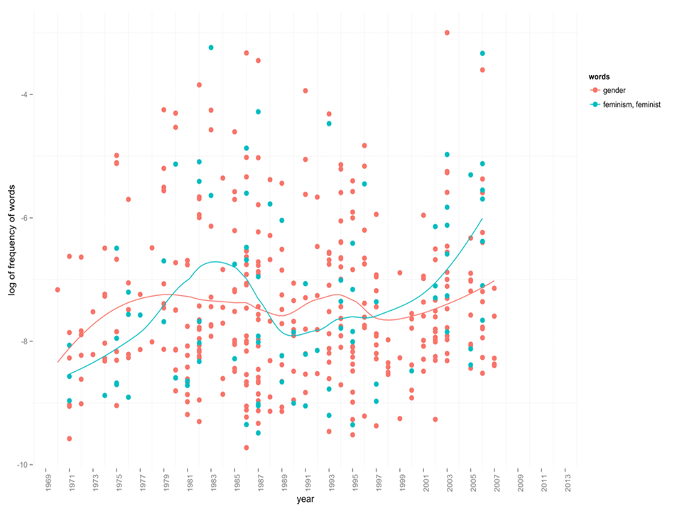

Figure 1. Relative frequencies of “gender” and “feminism/feminist” in our corpus since 1970.

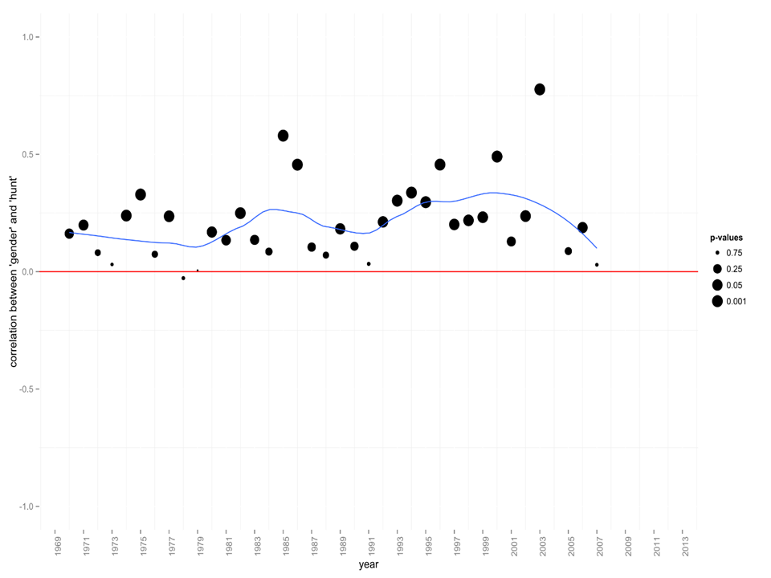

Figure 2. Correlation between the relative frequency of “gender” and keywords associated with sexual/gendered divisions of labor in our corpus since 1970.

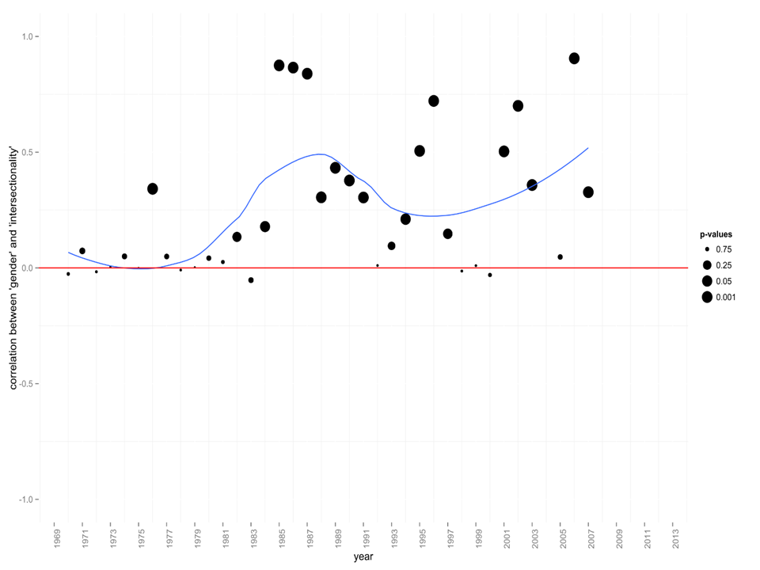

Figure 3. Correlation between the relative frequency of “gender” and keywords associated with intersectionality in our corpus since 1970.