**Diverse lithic production strategies in southwest China during Late Middle Pleistocene**

**Authors:** Yue Hu1,2*, Ben Marwick3*, Hongliang Lv1, Yamei Hou4,5, Weiwen Huang4,5, Bo Li2,6

**Affiliations:**

1 School of Archaeology and Museology, Sichuan University, Chengdu 610207, China

2Centre for Archaeological Science, School of Earth and Environmental Sciences, University of Wollongong, Wollongong, NSW 2522, Australia

3Department of Anthropology, University of Washington, Seattle 98195, USA

4Key Laboratory of Vertebrate Evolution and Human Origins, Institute of Vertebrate Paleontology and Paleoanthropology, Chinese Academy of Sciences, Beijing 100044, China

5Institute of Vertebrate Paleontology and Paleoanthropology, Chinese Academy of Sciences, Beijing 100044, China

6ARC Centre of Excellence for Australian Biodiversity and Heritage, University of Wollongong, Wollongong, NSW 2522, Australia

*Correspondence to: YH ([yh280@scu.edu.cn](mailto:yh280@scu.edu.cn)), BM (bmarwick@uw.edu).

**Keywords:** Middle Palaeolithic, Southwest China, Diversity, Levallois, Quina

# **Abstract**

It has long been considered that there were no obvious lithic technological changes in East Asia during the Middle and Late Pleistocene until the appearance of Upper Palaeolithic forms in the Late Pleistocene. We challenge this view with evidence of multiple Middle Palaeolithic lithic production systems appearing much earlier, from the Guanyindong site, southwest China, dated to 170–80 ka. Our analysis of the lithic assemblage reveals technological diversity in methods of core reduction and tool retouching. These methods include Levallois, discoid systems, core-on-flake, and volumetric methods, consistent with and contemporary to those widely observed in west Eurasia. The presence of a “pool of technological knowledge” reflects a mosaic package of multiple technological or strategical capability acquired by Late Middle Pleistocene populations in Guanyindong during this period. This ability clearly differs with what we observed in Early Palaeolithic as well as the notion of a long-lasting, static Middle Palaeolithic in East Asia.

# **Introduction**

The late Middle Pleistocene (LMP) witnessed the transition from Lower Palaeolithic to Middle Palaeolithic (MP) in west Eurasia and Africa (Early Stone Age to Middle Stone Age) and in many areas included significant milestones in human evolution, such as the replacement of *Homo erectus*/*Homo heidelbergensis* by *Homo sapiens* and other species (e.g. Hublin, Ben-Ncer et al. 2017, Harvati, Röding et al. 2019, Jacobs, Li et al. 2019). This transition was accompanied by the emergence and wide spread of Levallois strategies in Africa, Europe and Levant (e.g. Tryon, McBrearty et al. 2005, Goren-Inbar 2011, Fontana, Moncel et al. 2013). Levallois lithic technology is often recognized as the hallmark of the MP (McBrearty and Brooks 2000, Monnier 2006). However, less visually striking shifts are also an important part of the MP technological complex (Tryon and Faith 2013). The shift to a variety of flake reduction systems and small tools made on flakes, replacing large cutting tools (LCTs) and core tools (Dibble and McPherron 2006, Kuhn 2013), is almost as indictive as the Levallois concept in symbolizing MP technological change. These technological systems reflect changes among MP hominins which indicate differences from their ancestors in, for example, cognitive, mobility strategies, social and adaptive behaviors, demographic growth, and expansion of hunting and resource territories (, Shennan 2001, Berna and Goldberg 2007, Kuhn 2013).

Recognition of these less visually striking technological changes is important to debates about distinctiveness of a ‘Middle Palaeolithic’ in East Asia, which has been controversial since the mid-20th century ( Gao and Norton 2002, Norton Christopher and Jin Jennie 2009, Kei 2012). Clearly Middle Palaeolithic technologies and cultures of East Asia and west Eurasia are different, due to differences in raw material constraints, different reduction intensity, tool functions, the geographical and individual ranges of technical knowledge (Delagnes and Meignen 2006), population densities, ecological settings, and so on (Rolland and Dibble 1990). The interaction of these factors and the geographical factors that influence them are important for understanding differences in Pleistocene technologies in East Asia and west Eurasia. We present evidence here not only that these differences may have been overstated in previous work, but that recognition of the less visually striking technological strategies of the MP can improve our understanding of global variation in Pleistocene lithic technologies.

In contrast to west Eurasia and Africa, it has been argued for East Asia that there was a lack of distinct technological change (i.e., presence of the Levallois concept) in lithic technologies in since the Lower Palaeolithic period (Gao 1999) until relatively late in Upper Palaeolithic period, approximately 30 to 40 ka, which may be due to culturally modern humans migrating into these regions, bringing the new technologies with them ( Bae, Douka et al. 2017). The lack of complex stone tool technologies in East Asia (i.e. the dominance of simple core and flake production systems) before MIS 3 has been interpreted as evidence that hominin populations in this region were culturally and genetically isolated during the early and middle Pleistocene (Wang 2017). Biological evidence of *Homo sapiens* dating to the LMP and Late Pleistocene suggest that genetic isolation is no longer tenable (Liu, Martinon-Torres et al. 2015, Chen, Welker et al. 2019). However, the archaeological evidence is not yet sufficient to reject the interpretation of cultural isolation. A recent discovery of Levallois technology from the Guanyindong site, southwest China, dated to ~170 to 80 ka (Hu, Marwick et al. 2019) ignited debate by challenging this interpretation (See SI section 2 for a summary of the debate). The findings from Guanyindong suggest that the degree of stasis and isolation in the stone artefact technologies in East Asia during Middle and Late Pleistocene may have been overestimated. We present here the results of a systematic study of the lithic assemblage from Guanyindong, which further reveals the diverse lithic production strategies that are comparable to those found in west Eurasia and Africa during the same period.

Detailed description of the geological context and stratigraphy of Guanyindong has been provided in Li (1986), Li (2009), andHu, Marwick et al. (2019). The artefact-bearing sediments from the west entrance were dated to between ~170 and ~80 ka (Hu, Marwick et al. 2019). Here we report on the lithic technological strategies evident in the Guanyindong assemblage, based on our analysis of 2,211 artifacts from the west entrance (Table S1). Divergent phases were identified from the production processes of cores, flakes and retouched pieces, suggesting a complicated reduction system, including Levallois concept, multiple blank production strategies such as discoid, Quina, core-on-flake and volumetric production. Extensive supporting details of the methods and results of our technological analysis of the entire assemblage are presented in the Supplementary Information (SI).

# **Results**

## Levallois production

The systematics of Levallois lithic technology at Guanyindong was discussed previously (Hu, Marwick et al. 2019). Here we extend this analysis with an investigation of the ‘standardization’ of Levallois flakes in the assemblage by comparing Levallois flakes and non-Levallois flakes. Levallois debitage systems are optimal in terms of raw material economics and flake utility since they increase the raw material’s efficiency and the length of ‘cutting edge’ that can be created from a given blank (Brantingham and Kuhn 2001, Lycett and Eren 2013). In other words, Levallois flakes exhibit a greater standardization in their attributes compared with the ‘non-preferred’ flakes. In order to test this, we compared the coefficient of variation (CV) of Levallois and complete flakes (including retouched complete flakes) across several key attributes (Table 1). We found that the CV values of Levallois flakes are substantially smaller than those of complete flakes (Mann-Whitney W = 61; p = 0.033), supporting previous finds that Levallois flakes are more standardized than other complete flakes (Lycett and Eren 2013). We found that mass and metric dimensions are similar between Levallois and non-Levallois, but Levallois flakes are thinner than non-Levallois flakes (Figure 1A-C). We might infer that the Levallois strategy was employed at Guanyindong to reliably produce thinner flakes. Although the results of our comparison shows that Levallois flakes are statistically distinctive, concluding definitively whether they were ‘preferred’ would benefit from further analysis, e.g. usewear and residue analysis, and refitting (unfortunately not currently possible with this assemblage).

**Table 1 | Results of descriptive statistics for Levallois and non-Levallois flakes. ‘PLF’ = preferential Levallois flake; ‘CF’ = complete flake.**

|  | **Mean (mm)** | | **SD** | | **CV (%)** | | |
| --- | --- | --- | --- | --- | --- | --- | --- |
| PLF | CF | PLF | CF | PLF | CF | Difference |
| Length | 47.43 | 49.12 | 18.42 | 19.93 | 38.83 | 40.57 | -1.74 |
| Max dimension | 55.96 | 62.73 | 20.25 | 24.47 | 36.18 | 39.00 | -2.82 |
| Oriented width | 46.90 | 50.29 | 17.91 | 21.02 | 38.18 | 41.79 | -3.61 |
| Width at 25% max | 32.40 | 36.06 | 12.40 | 14.59 | 38.27 | 40.47 | -2.20 |
| Width at 50% max | 37.13 | 41.66 | 13.37 | 16.74 | 35.99 | 40.18 | -4.18 |
| Width at 75% max | 30.60 | 34.96 | 12.49 | 15.88 | 40.82 | 45.42 | -4.60 |
| Oriented thickness | 12.16 | 17.88 | 4.45 | 9.02 | 36.64 | 50.46 | -13.82 |
| Thickness at 25% max | 11.05 | 16.10 | 4.44 | 8.14 | 40.20 | 50.55 | -10.35 |
| Thickness at 50% max | 11.95 | 17.07 | 4.78 | 8.68 | 40.01 | 50.87 | -10.86 |
| Thickness at 75% max | 10.04 | 14.24 | 4.29 | 7.68 | 42.74 | 53.93 | -11.19 |
| Platform width | 31.69 | 33.46 | 16.38 | 18.28 | 51.68 | 54.64 | -2.95 |
| Platform thickness | 10.98 | 13.30 | 4.66 | 8.07 | 42.46 | 60.67 | -18.21 |

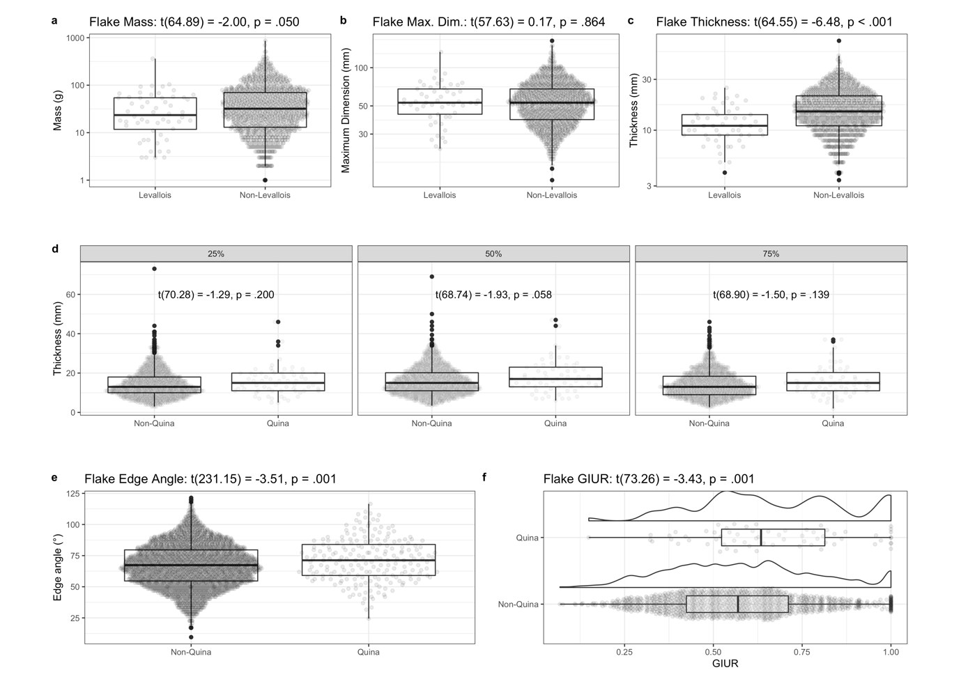

**Figure 1 | Comparison of Levallois flakes vs non-Levallois flakes and Quina tools vs non-Quina tools.** (A – C) Histograms showing comparison between Levallois flakes and non-Levallois flakes on mass, maximum dimension and thickness at 50% of maximum dimension. (D) Histograms showing comparison of thickness distributions between Quina and non-Quina tools at different locations on the flake (25%, 50% and 75% at maximum dimension). (E) Histogram of edge angles between Quina and non-Quina tools. (F) Histograms of GIUR of Quina and non-Quina tools, also showing a density line to reveal the details of the distribution of GIUR values.

## Discoid Production

Discoid/Mousterian debitage (Boëda 1993) has been found in many sites and shows substantial variability ( Pasty 2000). In a discoid system, the core consists of two highly convex surfaces and these surfaces can be used for both flake detachment or as striking platforms within a single operational sequence. This can be contrasted with the Levallois strategy where the two surfaces are hierarchically related and cannot be reversed and their roles cannot be exchanged. The use of the discoid method in Guanyindong is indicated by ten discoid cores (Figure 2) and diversified products such as triangles, and short thick flakes as well as débordants and backed flakes (Figure 2 and SI Figure S4).

Most cores exhibit one flaking surface with peripheral exploitations by secant and steeped removals. Those cores, which might have roots in Lower Palaeolithic technologies, show a pyramidal cross-section and always have one surface remaining flat as a striking platform, and the other surface working as flaking surface formed by centripetal scars which extend to the distal end. The morphologies varied depending on the original blank shapes, either a sizable flake or a nodule.

Chert is the main raw material (>90%) utilized at Guanyindong. Core sizes are moderate. around 70 mm long and the average mass is about 160g. According to the major scars left on the working surface, those cores yielded a limited number of products (always around 4-6). More than half of them have partial cortex (the cortex covers mostly 10%, but 50% area on some extreme specimen) remaining on the platforms or distal places, probably as a result of local or early stage of manufacture. Platforms were rarely prepared.

A variety of end-products of discoid production are found in the Guanyindong assemblage including pseudo-Levallois points, short débordant flakes, triangular and quadrangular flakes (Figure 2e-g). Among those products, Pseudo-Levallois points and débordant flakes appeared in small quantities. Because both centripetal recurrent Levallois methods and discoid production can be responsible for these kinds of flakes, it is hard to separate those byproducts from either of the two production systems. The importance of debitage from discoid production at Guanyindong is indicated by numerous triangular flakes, most of which were retouched into tools (further details on retouch are available in the SI). Among the triangular flakes, some of them have a triangular scar covering most of the dorsal surface, creating the ridge that guided the detachment of the subsequent flake, leading to the formation of parallel or sub-parallel ventral and dorsal surfaces and a flat morphology. These flakes may have resulted from repeated parallel removals, rather than the secant percussion that is typical of discoidal systems.

The relatively small number of discoid cores and large number of flakes potentially from discoid cores, as well as the high ratio of those transformed into tools, may indicate a highly mobile subsistence strategy. The very low proportion of late-stage cores indicated by our cortex measurements may be due to transportation after the production of the targeted end-products which are short, thick and ‘pointed’ (i.e. triangular flakes). Despite the fact that the manufacture of discoid methods involves a relatively a low degree of predetermination, compared to Levallois strategies, the relatively high productivity (since it does not need re-preparation between each reduction phase) and lower requirement for technological investment (Picin and Vaquero 2016, Delpiano and Peresani 2017), may reflect the capacity of knappers at Guanyindong to make foraging plans that anticipate their tooling needs in a high-mobility land use strategy.

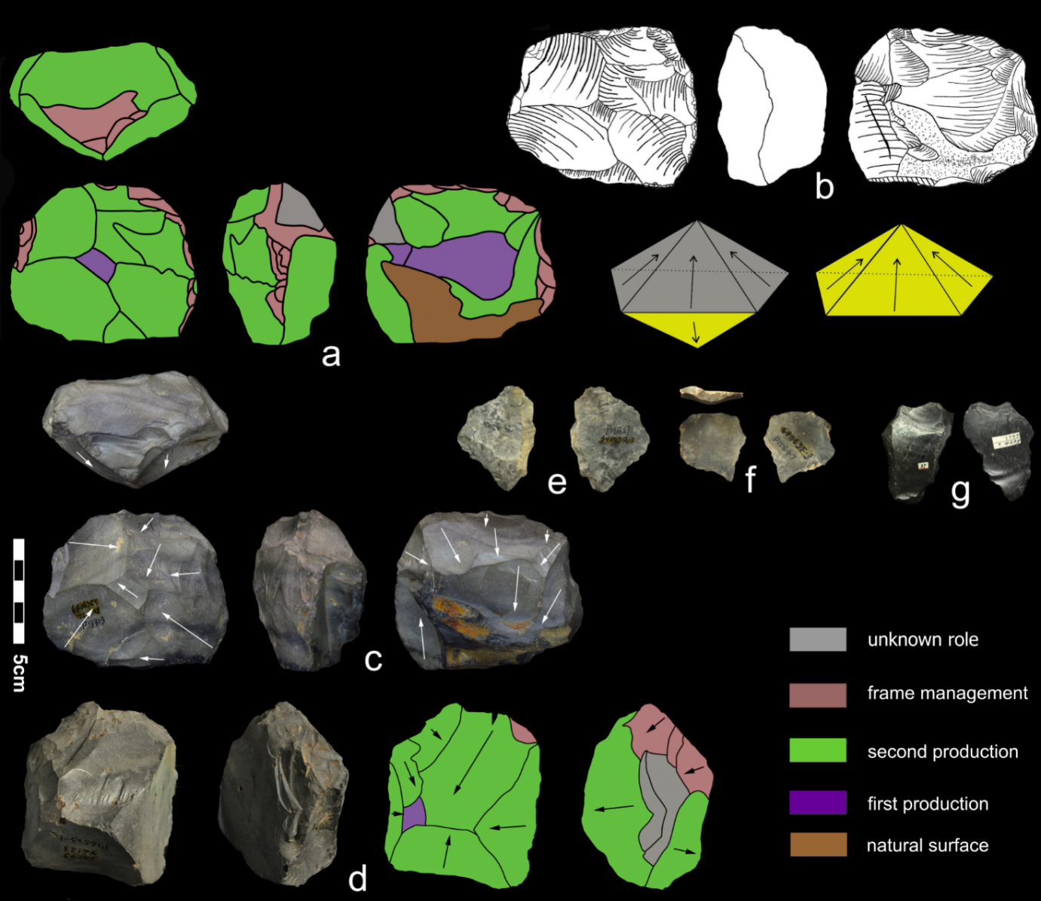

**Figure 2 | Discoid cores.** (a-c): scheme, sketch and photo of a discoid core, the white arrows show the directions of removals. The core is formed by two surfaces, with radioactive recurrent scars from two production phases left on each surface (one surface is complete peripheral exploitation and the other is partial peripheral exploitation). (d): photo and scheme of another discoid core. The black arrows show the directions of the removals. This core is mainly exploited on one side. (e-f): pseudo Levallois point. (g): triangle flake with a main triangular scar covers the dorsal surface.

## Quina exploitation

We found seventy Quina sidescrapers and Quina resharpening flakes at Guanyindong (Figure 3a-e). The retouching scars on these tools form a distinctive stepped morphology, especially where those scars overlapped on the retouched edge (Agam and Zupancich 2020). These tools were probably produced to meet multiple functional requirements such as treating various organic materials including both animal (hides, meat) and plants (wood) (Hardy 2004, Hiscock, Turq et al. 2009). For example, by blunting the edge, knappers made the edges less efficient when processing hides (Preysler 2010). Frequent resharpening and recycling to extend the use-life of tools are probably another explanation for the presence of Quina at Guanyindong, resulting in the distinctive features of the Quina system (Delagnes and Rendu 2011).

Other observations from the assemblage that support the identification of Quina exploitation include: (1) the prevailing steep edges, the median retouched edge angle of the assemblage is nearly 70° (**Figure 1D-F**, also see discussion in **SI**); (2) relatively thick blanks that provide high retouch potential (the average ratio of oriented width to oriented thickness = 3.1 (sd = 1.06), and the mean thickness = 17.9mm (sd = 8.69), **Figure 3f**); and (3) the presence of several retouching phases on artefacts (see discussion in **SI**).

Although there are debates about whether Quina retouch was deliberately produced (e.g. Lenoir 1986) or whether it was the result of resharpening thick blanks unintentionally, nevertheless the presence of Quina artefacts at Guanyindong indicates intensive retouching activity on long-lived tools, which is relevant to understanding mobility patterns of the hominin occupants of the site. In Europe, Quina products were frequently found with seasonally migrating fauna (Delagnes and Rendu 2011). This association, together with several successive retouching phases on the same edge, is often interpreted as indicating a higher level of mobility and regular long-distance travel. If this is also the case at Guanyindong, it indicates technological responses to environmental conditions that reflect the adaptive capacity and plasticity of the hominins active in this region during the LMP.

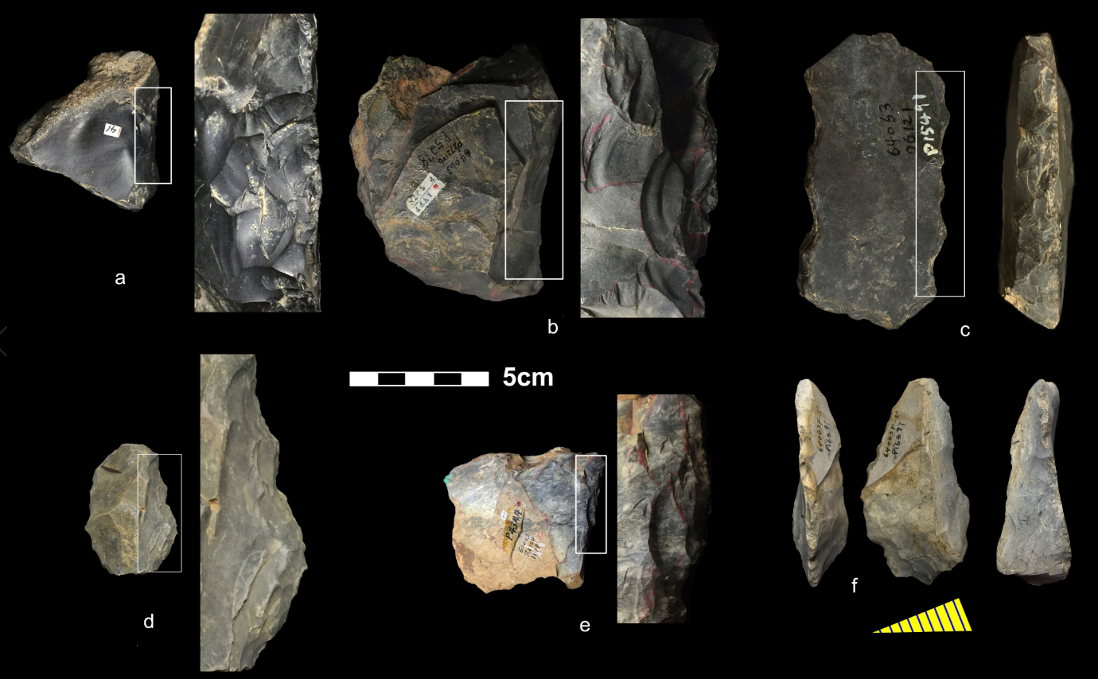

**Figure 3 | Quina tools and retouched blank. (**a-e): Quina scrapers with stepped retouching scars that obtained from several phases of retouching. The white boxes on each tool edge show the areas of which the zoomed details on the right. (f): a blank, once achieved from Quina reduction, was retouched into scraper, the yellow oblique triangle below is the cross-section of the blank.

## Core-on-flake

At Guanyindong, core-on-flake strategies are mainly presented by both truncated-faceted pieces (flakes with a truncation, on one or more margins, that was used as a platform for the removal of one or more small flakes from the exterior surface) and Kombewa flakes (when the ventral surface of a flake was used as a flake-release surface, and the resulting flake may can appear to have two ventral faces). Truncated-facetted pieces have been frequently identified under different names through the Middle to Upper Paleolithic in Africa, Europe, Levant and north Asia (e.g. , Hovers 2007, Schroeder 2007, Shalagina, Krivoshapkin et al. 2015). It is sometimes regarded as a response to lithic raw material scarcity and to high mobility of forager groups (Wallace and Shea 2006). These pieces usually start from a plain flake which is subsequently knapped along its periphery across the ventral surface. The consequent final morphology is a core with flake scars on the ventral surface, indicating the production of invasive flakes from platforms along the flake’s dorsal edge.

The likely functions of truncated faceted pieces are disputed. Some believe they are a type of prepared core ( Brantingham, Olsen et al. 2000), while others primarily regard them as tools (Shalagina, Krivoshapkin et al. 2015) or "specific oriented products" (Dibble 1984), or thinning for hafting as phrased by Schroeder (2007). In the case of Guanyindong, either working as a core or producing a particular working edge is plausible, subject to the requirements of different scenarios. In order to distinguish from ordinary retouching, however, we excluded scars smaller than 10mm on the ventral surfaces as indictive for this category. Other truncated facets bearing relatively large ventral flake scars and irregular edges suggest they may have been utilized as cores (see examples in **Figure 4a, c and e** and **SI Figure S4**), though we expect the function varied as needed. The average dimension and mass are 76 mm and 135 g respectively, which are consistent with the data of general cores in the site (75 mm and 175 g). The raw material was dominated by chert (80%), followed by limestone. The exploitation of flakes as blanks for the truncated faceted technique may be evidence of a predetermination concept, since this strategy requires multi-stage production, indicating advance planning.

Another important type of core-on-flake flaking found in Guanyindong is the Kombewa flake (Figure 4d, h, f-g). We found 21 Kombewa flakes (median maximum dimension = 69 mm), and 10 Kombewa cores (median maximum dimension = 82.4 mm), most of which show truncated faceting also. Kombewa production, is well known in Africa, but has also been found in many lithic industries around Eurasia (see J. Wang 1994, Boëda and Au Présent 2018). During the Early Stone Age, the Kombewa technique is mainly used in the Acheulean assemblages from Africa and Europe before the development of Levallois strategies (Inizan 1999. At Guanyindong, the Kombewa method was utilized to produce relatively small flakes with sharp edges.

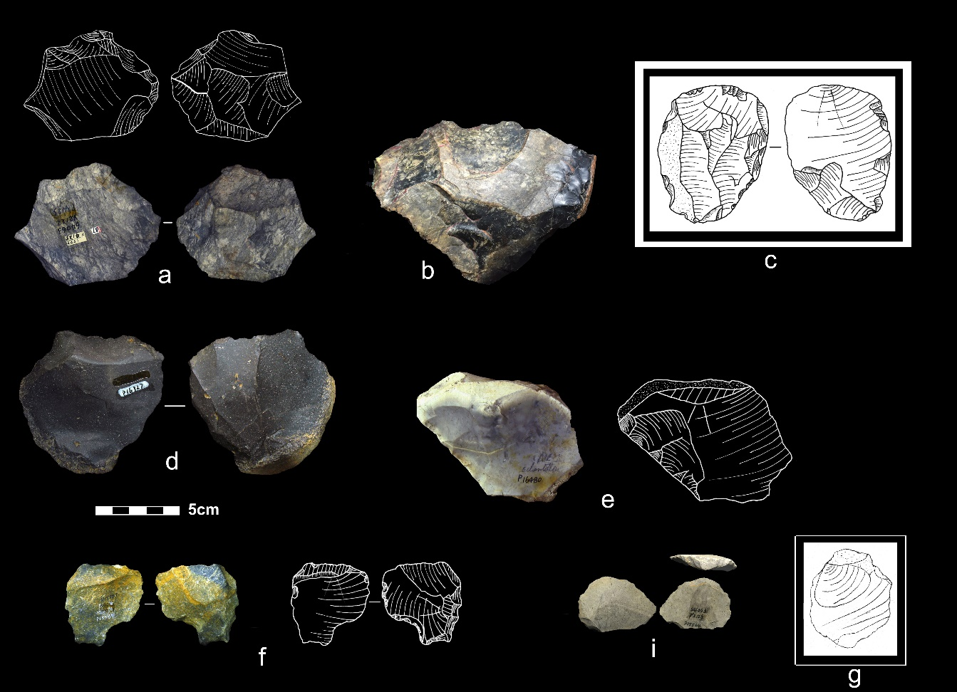

**Figure 4 | Core-on-flakes cores and flakes.** (a-c,e): truncated faceted pieces with flake scars left on the ventral side. (d,g): Kombewa cores with the proximal end being detached. (f,i): Kombewa flakes consist of two ventral surfaces.

## Volumetric exploitation

Cores presenting a volumetric exploitation (e.g. pyramidal, prismatic, etc. geometries, where the striking platform is prepared but the convexities are not prepared and only the natural convexities of the raw block are used) appeared in a small quantity (n = 12, see examples in **Figure 5 and SI Figure S4**). Most of their striking platforms were parsimoniously prepared, reduction was by direct hard hammer, and most cores have no cortex. Those preparations are clearly demonstrated through successive small removals on the striking part, leaving the remainder of the surface nearly untouched (cortical or minimally prepared). The selection of blanks was intentionally focused on columnar nodules or chunks with one flat surface. The flat surface, thus, could potentially serve as a striking platform. The sizes of these cores are consistently smaller (around 50 mm) than general cores, with no cores found larger than 100 mm. Core volume was maintained by centralizing the working surface through detachment of rear lateral removals. The core volumes were mainly achieved by semi-rotating between debitage removals (Delagnes 1999, Delagnes and Meignen 2006).

However, very few by-products (n = 11) related to this reduction have been found in the system. This may due to the transportation of end-products outside of the site, or the importation of the cores from elsewhere, since frequent mobility is one of the distinctive strategies of the site.

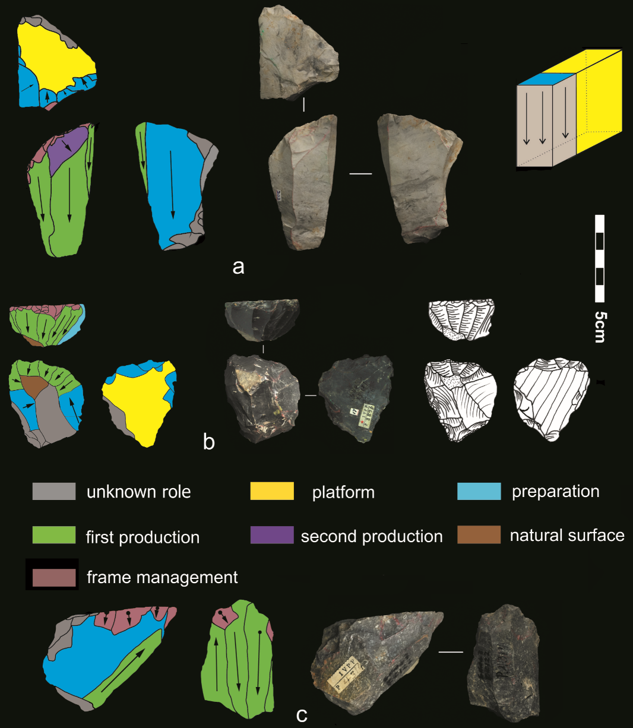

**Figure 5 | Volumetric cores.** (a): scheme and photo of a volumetric core, from which 3 end products are detached. The platform is prepared and the lateral part is removed in order to preparing the flaking surface. (b): scheme, photo and sketch of another volumetric core, from which successive end-products were achieved. Platform and lateral parts are prepared. (c): scheme and photo of another volumetric core. The black arrows with black circle show the directions and impacts of removals. The reduction pattern is bidirectional.

# **Discussion**

The variability of LMP lithic technology in East Asia was clearly more complex than the classificatory schemes in current use for lithic systematics in this region. The technical knowledge evident at Guanyindong may initially have arisen among the small groups of hominins that implemented techno-cultural diversity as they repeatedly occupied the cave during the LMP (Lycett and Norton 2010). The various technological systems at Guanyindong were entangled internally, for example the flakes produced by a discoid system, for example, can be transferred into a core-on-flake system (Faivre 2004). The by-products and end-products of these strategies were likely intertwined, rather than discrete, unrelated sequences. This kind of lithic production may be considered as a ‘fluid behavioral set’ that is influenced by technique, raw material and environment (Shott, Lindly et al. 2011). This perplexity is broadly documented in many sites, especially in Europe, and described as a ‘fragmented character’ (Turq, Roebroeks et al. 2013). We propose this concept may be relevant to understanding the Guanyindong hominins also. The selection of knapping manufacture and maintenance procedures for tools in the MP industry at Guanyindong was contingent on numerous factors, including raw materials, on-site activities, mobility, and the environment. All of these factors contributed to the diverse circumstances in which stone artefacts were made and used at Guanyindong.

The Guanyindong assemblage is chronologically associated with the Marine Isotopic Stages 6 and 5. This means that the MP hominins in Guanyindong cave have experienced at least one significant climate transition from a glacial period (MIS 6) of cooler temperatures to a warmer interglacial condition (MIS 5). These climate fluctuations and environmental changes likely stimulated hominins to alternate among a variety of tool-making strategies as they explored the space of technological strategies to find optima for new and unfamiliar conditions. During harsher periods we infer that people maintained a supply of tools by foraging in larger territories, which resulted in multi-purpose and long-life tools or easily transformed artifacts, such as discoid/Quina production (Delagnes and Rendu 2011, but also see Thiébaut 2013). Another response to these harsher periods were Levallois strategies that are adapted to a variety of hunting strategies in dynamics environments (White and Pettitt 1995).

If we leave out the by-products and end-products and only take cores into account, they account for a relatively small proportion of the whole assemblage (17%, and including truncated faceted pieces, the percentage is ~40%, see details in **SI**). The small proportion cannot be easily interpreted, but indicates high fragmentation of lithic reduction across time and space. This segmentation could be attributable to the inherent flexibility and mobility of the MP which is embedded in lithic technologies (Turq, Roebroeks et al. 2013). In the case of Guanyindong, the products of reduction sequences are even more diffuse relative to the western hemisphere. Equal with the mechanism underlying the paucity of the Levallois concept at Guanyindong, the rarity of material traces may have been due to the narrower ranges of technological strategies adopted by fragmented populations, compared to the relative high population and/or high-density conditions of Middle Pleistocene in west Eurasia. Consequently, the weak and/or irregular patterns of social interconnectedness due to small population sizes and densities may have impeded the spread and establishment of technological innovations (Lycett and Norton 2010).

An important limitation to the implications of our analysis of the Guanyindong assemblage is the scarcity of artefact provenance data in the excavation records. Our previous work established that artefacts were produced in two discrete periods, one clustered at around 170 ka (MIS 6) and the other clustered at 80 ka (MIS 5). The large chronological gap (~80-90 ka) between the two periods is due to an erosional hiatus in the deposits. The field recording methods employed in the initial excavation mean that we cannot confidently allocate the artefacts to a specific time period. Unfortunately, future excavations at Guanyindong are unlikely to resolve this as most of the excavable deposit was removed by the previous excavators. This also limits our ability to make robust claims about change over time. The diversity described here, for example, on one hand, could either represent coexistence of multiple technological strategies in a certain time or, on the other hand, a sequence of technological changes over time, similar to that widely observed at sites in west Eurasia (Delagnes and Meignen 2006).

In contrast to the fine-grained behavioural evidence and high-resolution technological studies from a wide range of MP sites in West Eurasia, the data from East Asia are sparse and reports are typically coarse-grained. To date, many paleolithic sites in southwest China have been found (e.g. Wu 1975, Cao 1978, Cai 1991, Zhu 2011, Hu, Ruan et al. 2019), though only a few of them, such as Guanyindong and Panxiandadong (Zhang, Huang et al. 2015), have been reliably dated to the LMP period. Evidence of various traits of MP technologies in Guanyindong, such as Levallois strategies, multiple blank production techniques including discoid and core-on-flake, and various methods on tool manufacture and management such like Quina-like systems, implies that during MIS 6 – 5 hominins in this area had the comparable technological abilities as those in west Eurasia and Africa.

Our paper systematically demonstrates the diversity of MP in East Asia for the first time, indicating that the appearance of Levallois concept in Guanyindong is not an isolated technological strategy at this location. On the contrary, the Guanyindong hominins developed many complex elements of MP tool-kits to cope with their daily routines, challenging the longstanding view of long-term simplicity in lithic technology during the Early and Middle Palaeolithic periods in East Asia. The absence of human fossils dated to the same period in southwest China, hampers speculation about the hominin species that produced the Guanyindong Cave assemblage. However, accumulated anthropological studies in and/or near this region have shed the light on the probable hominin taxa. The Denisovan fossil found in Baishiya, dated 160ka, provides the first evidence of Denisovan territories in East Asia (Chen, Welker et al. 2019). The appearance of modern humans (e.g. Liu, Martinon-Torres et al. 2015), and shared morphology with the Neandertals found on crania from Xuchang (Li, Wu et al. 2017) suggest that the identity of the hominins that lived here is more complex and interlaced than we previously thought.

The limited number of available assemblages for the Palaeolithic in the Eastern hemisphere does not at present allow robust clarification of relationships among technical behaviors and resolution of the debate on where and when the common technological ancestor for East Asian and Western MP may be found, and what circumstances lead to the appearance of MP technologies in East Asia (e.g. direct descent from a common technological ancestor or recent convergent technological evolution after substantial divergence). A key challenge for future research on other LMP sites in this region is to establish more detailed pattern and timing of the MP production and specifically evaluate models of technological convergence or transmission.

# **Methods**

Based on the technical analyses developed by authors such as Geneste (1988), Boëda et al. (1990, 1993), Geneste et al. (1997) and Vaquero (2008), the whole lithic assemblage was fully studied to record both qualitative and quantitative parameters. The qualitative method follows the general concepts of the chaîne opératoire (Pelegrin, Karlin et al. 1988, Geneste 1991, Sellet 1993, Bar‐Yosef and Van Peer 2009). The process includes the recognition of the raw material, identification of their origins according to previous studies, the reduction strategies of cores such as knapping modes, shaping and retouching according to the observation of technical products, and the retouched or unretouched products (flakes, debris, flake tool types, shaped tools). The quantitative analysis was mainly based on metrical and morphometric data that produces the basic statistics on artifacts dimensions and main attributes of different categories. For the chunks and debris, only mass was measured.

Levallois cores were identified following the guidelines set out by Boëda (1995). The recognition of Levallois products from Levallois system is harder compared with the identification of cores (e.g. Van Peer 1992, Boëda 1995, Shimelmitz and Kuhn 2013). Unfortunately, the recognition of Levallois flakes is not based on refitting analysis due to the insufficiency of specimens. However, several criteria were taken into consider to avoid arbitrariness. Those criteria include a clearly organized scar pattern (Debénath and Dibble 1993) which indicates the predetermined process, and the angles between the striking platform and debitage surfaces to monitor the percussion angle of the flake, also consideration morphology was included, such as a relatively flat and uniform cross-section (Debénath and Dibble 1993).

In terms of discoid production, the definition developed by Boëda (1993, 1995) is taken into account here as well as broader criteria. The Quina exploitation is identified according to the widely accepted definition of Quina debitage by Bourguignon (1996) and the interpretations of subsequent scholars (e.g. Hiscock, Turq et al. 2009). The core-on-flake consist of two main categories: truncated-faceted and Kombewa debitage. Truncated-faceted has been studied and discussed in a wide range in many reports (e.g. Brantingham, Olsen et al. 2000, Dibble and McPherron 2006, Marwick, Clarkson et al. 2016). Based on the general principles of those reports, we ascribe the truncated-faceted preliminarily to flakes that were truncated first and then removals were detached mostly, but not always, on the ventral surface. The term of Kombewa in the study is referring to a wider meaning rather than Kombewa *stricto sensu* (Tixier and Turq 1999). The recognition of Kombewa method is associated with two bulbs on the proximal end of both the ventral and dorsal surfaces of a flake. Correspondingly, the cores produced these flakes are actually flakes with a pronounced bulb having another flake detached from it, rather than a core nodule (Kombewa flake). Our diagnosis of volumetric exploitation used the volumetric concept for reference and analytical approach described by Carmignani (2017).

# **References**

Agam, A. and A. Zupancich (2020). "Interpreting the Quina and demi-Quina scrapers from Acheulo-Yabrudian Qesem Cave, Israel: Results of raw materials and functional analyses." Journal of Human Evolution **144**: 102798.

Bae, C. J., K. Douka and M. D. Petraglia (2017). "On the origin of modern humans: Asian perspectives." Science **358**(6368): eaai9067.

Bar‐Yosef, O. and P. Van Peer (2009). "The Chaîne Opératoire Approach in Middle Paleolithic Archaeology." Current Anthropology **50**(1): 103-131.

Berna, F. and P. Goldberg (2007). Assessing Paleolithic pyrotechnology and associated hominin behavior in Israel.

Boëda, E. (1993). "Le débitage discoïde et le débitage Levallois récurrent centripède." Bulletin de la Société préhistorique française **90**: 392-404.

Boëda, E. (1995). Levallois: A volumetric construction, methods, a technique. The Definition and Interpretation of Levallois Technology. H. Dibble and O. Bar-Yosef. Madison, Prehistory Press**:** 41–68.

Boëda, E. and P. Au Présent (2018). Techno-logique & Technologie Une Paléo-histoire des objets lithiques tranchants.

Bourguignon, L. (1996). "La conception de debitage quina." Quaternaria Nova **VI**: 149-166.

Brantingham, P. J. and S. L. Kuhn (2001). "Constraints on Levallois Core Technology: A Mathematical Model." Journal of Archaeological Science **28**(7): 747-761.

Brantingham, P. J., J. W. Olsen, J. A. Rech and A. I. Krivoshapkin (2000). "Raw Material Quality and Prepared Core Technologies in Northeast Asia." Journal of Archaeological Science **27**(3): 255-271.

Cai, H. W., Xinjin.; Xu, Chunhua (1991). "Paleolith of Bianbian cave at Bijie county, Guizhou province." Acta Anthropologica Sinica **10**(1): 50-57.

Cao, Z. (1978). "Palaeolithic site found in Xiaohuidong cave at Shuicheng, Guizhou Province." Vertebrata Palasiatica **16**(1): 67-72.

Carmignani, L., M.-H. Moncel, P. Fernandes and L. Wilson (2017). "Technological variability during the Early Middle Palaeolithic in Western Europe. Reduction systems and predetermined products at the Bau de l'Aubesier and Payre (South-East France)." PLOS ONE **12**(6): e0178550.

Chen, F., F. Welker, C.-C. Shen, S. E. Bailey, I. Bergmann, S. Davis, H. Xia, H. Wang, R. Fischer, S. E. Freidline, T.-L. Yu, M. M. Skinner, S. Stelzer, G. Dong, Q. Fu, G. Dong, J. Wang, D. Zhang and J.-J. Hublin (2019). "A late Middle Pleistocene Denisovan mandible from the Tibetan Plateau." Nature **569**(7756): 409-412.

Debénath, A. and H. L. Dibble (1993). Handbook of Paleolithic Typology: Lower and Middle Paleolithic of Europe. Philadelphia, University of Pennsylvania Press.

Delagnes, A. (1999). Blade Production During the Middle Paleolithic in Northwestern Europe. Blade Production During the Middle Paleolithic in Northwestern Europe, China, Acta Anthropologica Sinica (Supplement to Vol. 19).

Delagnes, A. and L. Meignen (2006). Diversity of lithic production systems during the Middle Paleolithic in France : are there any chronological trends?**:** 85-108.

Delagnes, A. and W. Rendu (2011). "Shifts in Neandertal mobility, technology and subsistence strategies in western France." Journal of Archaeological Science **38**(8): 1771-1783.

Delpiano, D. and M. Peresani (2017). "Exploring Neanderthal skills and lithic economy. The implication of a refitted Discoid reduction sequence reconstructed using 3D virtual analysis." Comptes Rendus Palevol **16**(8): 865-877.

Dibble, H., L. and S. McPherron, P. (2006). "The missing Mousterian." Current Anthropology **47**(5): 777.

Dibble, H. and S. McPherron (2006). "The Missing Mousterian." Current Anthropology **47**(5): 777-803.

Dibble, H. L. (1984). "Interpreting typological variation of Middle Paleolithic scrapers: function, style, or sequence of reduction? Journal of Field Archaeology." Journal of Field Archaeology **11**(431-436).

Eric Boëda, J.-M. G., Liliane Meignen (1990). "Identification de chaînes opératoires lithiques du Paléolithique ancien et moyen." Paléo **2**: 43-80.

Faivre, J. P. (2004). "L’industrie lithique moustérienne du niveau G7 des Fieux (Miers, Lot): des matériaux, des schémas opératoires, un même objectif." Paléo **16**: 71-90.

Fontana, F., M. H. Moncel, G. Nenzioni, G. Onorevoli, C. Peretto and J. Combier (2013). "Widespread diffusion of technical innovations around 300,000 years ago in Europe as a reflection of anthropological and social transformations? New comparative data from the western Mediterranean sites of Orgnac (France) and Cave dall’Olio (Italy)." Journal of Anthropological Archaeology **32**(4): 478-498.

Gao, X. (1999). "A discussion of the 'Chinese Middle Paleolithic'." Acta Anthropologica Sinica **18**(1): 1-16.

Gao, X. and C. J. Norton (2002). "A critique of the Chinese 'Middle Palaeolithic'." Antiquity **76**(292): 397-412.

Geneste, J.-M. (1988). Systèmes d’approvisionnement en matières premières au Paléolithique moyen et au Paléolithique supérieur en Aquitaine. L’Homme de Néandertal. M. Otte. La Mutation. **8:** 61-70.

Geneste, J.-M. (1991). "Systèmes techniques de production lithique: variations techno-e ´conomiques dans les processus de re ´alisation des outillages pale ´olithiques." Techniques et culture **17-18**: 1-35.

Geneste, J.-M., J. Jaubert, M. Lenoir, L. Meignen and A. Turq (1997). "Approche technologique des Moustériens charentiens du sud-ouest de la France et du Languedoc oriental." Paleo **9**: 101-142.

Goren-Inbar, N. (1988). Too Small to Be True? Reevaluation of Cores on Flakes in Levantine Mousterian Assemblages.

Hardy, B. L. (2004). "Neanderthal behaviour and stone tool function at the Middle Palaeolithic site of La Quina, France." Antiquity **78**(301): 547-565.

Harvati, K., C. Röding, A. M. Bosman, F. A. Karakostis, R. Grün, C. Stringer, P. Karkanas, N. C. Thompson, V. Koutoulidis, L. A. Moulopoulos, V. G. Gorgoulis and M. Kouloukoussa (2019). "Apidima Cave fossils provide earliest evidence of Homo sapiens in Eurasia." Nature **571**(7766): 500-504.

Hiscock, P., A. Turq, J. P. Faivre and L. Bourguignon (2009). Quina Procurement and Tool Production. Lithic Materials and Paleolithic Societies. B. Adams and B. S. Blades**:** 232-246.

Hovers, E. (2007). The many faces of cores-on-flakes: a perspective from the Levantine Mousterian. Cores or Tools? Alternative Approaches to Stone Tool Analysis. S. P. McPherron. Cambridge, Cambridge Scholars Press**:** 42-74.

Hu, Y., B. Marwick, J.-F. Zhang, X. Rui, Y.-M. Hou, J.-P. Yue, W.-R. Chen, W.-W. Huang and B. Li (2019). "Late Middle Pleistocene Levallois stone-tool technology in southwest China." Nature **565**(7737): 82-85.

Hu, Y., Q. Ruan, J. Liu, B. Marwick and B. Li (2019). "Luminescence chronology and lithic technology of Tianhuadong Cave, an early Upper Pleistocene Paleolithic site in southwest China." Quaternary Research **94**: 121-136.

Hublin, J.-J., A. Ben-Ncer, S. E. Bailey, S. E. Freidline, S. Neubauer, M. M. Skinner, I. Bergmann, A. Le Cabec, S. Benazzi, K. Harvati and P. Gunz (2017). "New fossils from Jebel Irhoud, Morocco and the pan-African origin of Homo sapiens." Nature **546**(7657): 289-292.

Inizan, M.-L., Reduron-Ballinger, M., Roche, H., Tixier, J., (1999). Technology and Terminology of Knapped Stone. Paris, CREP, Nanterre.

J. Wang, F. H. T., Y.R. Wang (1994). "The report of excavation and survey at the Dingcun Site." Journal of Chinese Antiquity(3): 1-75.

Jacobs, Z., B. Li, M. V. Shunkov, M. B. Kozlikin, N. S. Bolikhovskaya, A. K. Agadjanian, V. A. Uliyanov, S. K. Vasiliev, K. O’Gorman, A. P. Derevianko and R. G. Roberts (2019). "Timing of archaic hominin occupation of Denisova Cave in southern Siberia." Nature **565**(7741): 594-599.

Kei, Y. M. (2012). "The Middle Palaeolithic in China a review of current interpretations." Antiquity **86**(333): 619-626.

Kuhn, S. L. (2013). "Roots of the Middle Paleolithic in Eurasia." Current Anthropology **54**(SUPPL8.): S255-S268.

Lenoir, M. (1986). " Un mode d'obtention de la retouche Quina dans le Mousterien de Combe Grenal (Domme, Dordogne)." Bulletin de la Soci´et´e d’Anthropologie du Sud-Ouest XXI: 153-160.

Li, Y. (2009). Technological study of lithic industry of the Guanyindong site, Guizhou Province, south-west of China. Ph.D.

Li, Y., Wen, B. (1986). "Guanyindong: A Lower Paleolithic Site at Qianxi County, Guizhou Province." 1–181.

Li, Z.-Y., X.-J. Wu, L.-P. Zhou, W. Liu, X. Gao, X.-M. Nian and E. Trinkaus (2017). "Late Pleistocene archaic human crania from Xuchang, China." Science **355**(6328): 969.

Liu, W., M. Martinon-Torres, Y.-j. Cai, S. Xing, H.-w. Tong, S.-w. Pei, M. J. Sier, X.-h. Wu, R. L. Edwards, H. Cheng, Y.-y. Li, X.-x. Yang, J. M. B. de Castro and X.-j. Wu (2015). "The earliest unequivocally modern humans in southern China." Nature **526**(7575): 696-699.

Lycett, S. J. and M. I. Eren (2013). "Levallois economics: an examination of 'waste' production in experimentally produced Levallois reduction sequences." Journal of Archaeological Science **40**(5): 2384-2392.

Lycett, S. J. and C. J. Norton (2010). "A demographic model for Palaeolithic technological evolution: The case of East Asia and the Movius Line." Quaternary International **211**(1–2): 55-65.

Marwick, B., C. Clarkson, S. O'Connor and S. Collins (2016). "Early modern human lithic technology from Jerimalai, East Timor." Journal of Human Evolution **101**: 45-64.

McBrearty, S. and A. S. Brooks (2000). "The revolution that wasn't: a new interpretation of the origin of modern human behavior." Journal of Human Evolution **39**(5): 453-563.

Monnier, G. (2006). "The Lower/Middle Paleolithic Periodization in Western Europe An Evaluation." Current Anthropology **47**(5): 709-744.

Norton Christopher, J. and J. H. Jin Jennie (2009). "The evolution of modern human behavior in East Asia: Current perspectives." Evolutionary Anthropology: Issues, News, and Reviews **18**(6): 247-260.

Pasty, J.-F. (2000). "Le gisement Paléolithique moyen de Meillers (Allier) : un exemple de la variabilité du débitage Discoïde." Bulletin de la Société préhistorique française **97**(2): 165-190.

Pelegrin, J., C. Karlin and P. Bodu (1988). Chaines Opératoires: un outil pour le Préhistorien. Journee d 'Etudes Technologiques en Prehistoire. J. Tixier. Paris, CNRS**:** 55-62.

Picin, A. and M. Vaquero (2016). "Flake productivity in the Levallois recurrent centripetal and discoid technologies: New insights from experimental and archaeological lithic series." Journal of Archaeological Science: Reports **8**: 70-81.

Preysler, J. (2010). Experimental Approach to the Function and Technology of Quina Side-Scrapers**:** 172-202.

Rolland, N. and H. L. Dibble (1990). "A New Synthesis of Middle Paleolithic Variability." American Antiquity **55**(3): 480-499.

Schroeder, B. (2007). "Truncated-faceted pieces from Jerf Al-Ajla." Tools Versus Cores. Alternative Approaces to Stone Tool Analysis: 17-41.

Sellet, F. (1993). "Chaine Operatoire; The Concept and Its Applications." Lithic Technology **18**(1-2): 106-112.

Shalagina, A. V., A. I. Krivoshapkin and K. A. Kolobova (2015). "TRUNCATED-FACETED PIECES IN THE PALEOLITHIC OF NORTHERN ASIA." Archaeology, Ethnology and Anthropology of Eurasia **43**(4): 33-45.

Shennan, S. (2001). "Demography and Cultural Innovation: a Model and its Implications for the Emergence of Modern Human Culture." Cambridge Archaeological Journal **11**(01): 5-16.

Shimelmitz, R. and S. Kuhn (2013). "Early Mousterian Levallois technology in Unit IX of Tabun Cave." Paleoanthropology **2013**: 1-27.

Shott, M. J., J. Lindly and G. A. Clark (2011). "Special issue: reduction sequence, chaîne opératoire, and other methods: the epistemologies of different approaches to lithic analysis. Continuous modeling of core reduction: lessons from refitting cores from WHS 623x, an Upper Paleolithic site in Jordan." PaleoAnthropology **11**: 320-330.

Thiébaut, C. (2013). "Discoid debitage stricto sensus: a method adapted to highly mobile Middle Paleolithic groups?" Palethnologie: 4-20.

Tixier, J. and A. Turq (1999). "Kombewa et alii." Paléo **11**: 135-143.

Tryon, C. A., S. McBrearty and P.-J. Texier (2005). "Levallois Lithic Technology from the Kapthurin Formation, Kenya: Acheulian Origin and Middle Stone Age Diversity." African Archaeological Review **22**(4): 199-229.

Turq, A., W. Roebroeks, L. Bourguignon and J.-P. Faivre (2013). "The fragmented character of Middle Palaeolithic stone tool technology." Journal of Human Evolution **65**(5): 641-655.

Van Peer, P. (1992). The Levallois Reduction Strategy. Madison, Prehistory Press.

Vaquero, M. (2008). "The history of stones: behavioural inferences and temporal resolution of an archaeological assemblage from the Middle Palaeolithic." Journal of Archaeological Science **35**(12): 3178-3185.

Wallace, I. J. and J. J. Shea (2006). "Mobility patterns and core technologies in the Middle Paleolithic of the Levant." Journal of Archaeological Science **33**(9): 1293-1309.

Wang, Y. (2017). "Late Pleistocene Human Migrations in China." Current Anthropology **58**(S17): S504-S513.

White, M. J. and P. B. Pettitt (1995). "Technology of early Palaeolithic western Europe: innovation, variability and a unified framework." Lithics **16**: 27-40.

Wu, M. W. L. Z., Yinyun; Zhang, Senshui (1975). "Ancient Human fossils and cultural remains in Tongzi, Guizhou Province." Vertebrata Palasiatica **13**(1): 14-23.

Zhang, J. F., W. W. Huang, Y. Hu, S. X. Yang and L. P. Zhou (2015). "Optical dating of flowstone and silty carbonate-rich sediments from Panxian Dadong Cave, Guizhou, southwestern China." Quaternary Geochronology **30**: 479-486.

Zhu, Z. J., Xueping (2011). "Study on the Stone Artifacts From the Laohu Cave Paleolithic Site , Baoshan County, Yunnan " Research of China's frontier archaeology **4**.

# **Acknowledgments**

Thank Sam Lin for advice on lithic analysis. Also thank Ning Ma, Yushan Lou, Jianping Yue and Lei Lei for their assistances during the research in IVPP. This work was supported by the Australian Research Council through Future Fellowships to B.L. (FT140100384) and B.M. (FT140100101). Postgraduate scholarships from the University of Wollongong, Launch funding from Sichuan University, and National Science Foundation of China (NO. 42002201) to Y.H., the Chinese Academy of Science (CAS) Strategic Priority Research Program Grants of “Macroevolutionary Processes and Paleoenvironments of Major Historical Biota” (No. XDPB05), State Key Laboratory of Loess and Quaternary Geology, Institute of Earth Environment, CAS (No. SKLLQG1501) and National Science Foundation of China (No. 41272033) to Y.-M.H.

# **Author contributions**

B.L., Y.H. and W.-W.H. conceived and coordinated the study. Y.H., B.L. and Y.-M.H. conducted the fieldwork. Y.H., B.M., H.-L.L., and Y.-M.H. conducted the stone artefact analysis. Y.H., B.M., and H.-L.L. wrote the manuscript, with contributions from the other authors.