Some normal text.

## [1] "table of lithic types"

|  |  |  |
| --- | --- | --- |
| type | count | proportion |
| flake_ids | 1199 | 0.541 |
| core_ids | 249 | 0.112 |
| debris_ids | 769 | 0.347 |
| total | 2217 | 1 |

## [1] "tables for raw materials of the assemblage"

|  |  |  |  |  |  |  |
| --- | --- | --- | --- | --- | --- | --- |
| category | chert | limestone | basalt | quartz | sandstone | total |
| flake | 932 | 249 | 11 | 2 | 5 | 1199 |
| core | 208 | 38 | 2 | 0 | 0 | 248 |
| debris | 569 | 190 | 8 | 1 | 1 | 769 |
| retouched pieces | 767 | 201 | 11 | 1 | 4 | 984 |
| backed knife | 6 | 2 | 0 | 0 | 0 | 8 |
| bec | 6 | 1 | 0 | 0 | 0 | 7 |
| borer | 52 | 17 | 0 | 0 | 0 | 69 |
| BUR | 4 | 1 | 0 | 0 | 0 | 5 |
| chopper | 0 | 0 | 1 | 0 | 0 | 1 |
| cleaver | 1 | 0 | 0 | 0 | 0 | 1 |
| Denticular | 54 | 21 | 1 | 0 | 1 | 77 |
| Endscraper | 32 | 6 | 0 | 0 | 0 | 38 |
| Point | 24 | 5 | 0 | 0 | 0 | 29 |
| scraper | 486 | 130 | 7 | 1 | 3 | 627 |
| nature backed | 4 | 2 | 0 | 0 | 0 | 6 |
| notch | 65 | 12 | 2 | 0 | 0 | 79 |
| tanged point | 9 | 1 | 0 | 0 | 0 | 10 |

## [1] "proportion tables for raw materials of the assemblage"

|  |  |  |  |  |  |  |
| --- | --- | --- | --- | --- | --- | --- |
| category | chert | limestone | basalt | quartz | sandstone | total |
| flake | 77.7 | 20.8 | 0.9 | 0.2 | 0.4 | 100 |
| core | 83.9 | 15.3 | 0.8 | 0.0 | 0.0 | 100 |
| debris | 74.0 | 24.7 | 1.0 | 0.1 | 0.1 | 100 |
| retouched pieces | 77.9 | 20.4 | 1.1 | 0.1 | 0.4 | 100 |
| backed knife | 75.0 | 25.0 | 0.0 | 0.0 | 0.0 | 100 |
| bec | 85.7 | 14.3 | 0.0 | 0.0 | 0.0 | 100 |
| borer | 75.4 | 24.6 | 0.0 | 0.0 | 0.0 | 100 |
| BUR | 80.0 | 20.0 | 0.0 | 0.0 | 0.0 | 100 |
| chopper | 0.0 | 0.0 | 100.0 | 0.0 | 0.0 | 100 |
| cleaver | 100.0 | 0.0 | 0.0 | 0.0 | 0.0 | 100 |
| Denticular | 70.1 | 27.3 | 1.3 | 0.0 | 1.3 | 100 |
| Endscraper | 84.2 | 15.8 | 0.0 | 0.0 | 0.0 | 100 |
| Point | 82.8 | 17.2 | 0.0 | 0.0 | 0.0 | 100 |
| scraper | 77.5 | 20.7 | 1.1 | 0.2 | 0.5 | 100 |
| nature backed | 66.7 | 33.3 | 0.0 | 0.0 | 0.0 | 100 |
| notch | 82.3 | 15.2 | 2.5 | 0.0 | 0.0 | 100 |
| tanged point | 90.0 | 10.0 | 0.0 | 0.0 | 0.0 | 100 |

## [1] "summary of core attributes"

|  |  |  |  |  |  |  |  |  |  |  |  |  |
| --- | --- | --- | --- | --- | --- | --- | --- | --- | --- | --- | --- | --- |
|  | length | max_dimension | medial_width | distal_width | thickness | distal_thickness | mass | platform | platform_width | platform_thickness | scar_number | cortex_percentage |
| mean | 47.2 | 75.1 | 58.0 | 49.2 | 51.8 | 38.7 | 198.9 | 1.5 | 50.9 | 43.7 | 2.9 | 14.5 |
| sd | 20.2 | 21.6 | 21.2 | 21.5 | 29.6 | 17.1 | 166.8 | 0.8 | 20.0 | 19.8 | 2.0 | 19.4 |
| CV | 0.4 | 0.3 | 0.4 | 0.4 | 0.6 | 0.4 | 0.8 | 0.5 | 0.4 | 0.5 | 0.7 | 1.3 |
| 25% | 33.0 | 63.0 | 43.0 | 35.2 | 38.2 | 27.2 | 100.2 | 1.0 | 37.0 | 30.2 | 1.2 | 0.0 |
| 50% | 43.5 | 72.0 | 55.0 | 45.0 | 47.0 | 37.0 | 149.5 | 1.0 | 50.0 | 40.0 | 2.0 | 7.5 |
| 75% | 57.8 | 83.8 | 68.0 | 60.6 | 60.8 | 48.0 | 243.0 | 2.0 | 61.8 | 51.9 | 4.0 | 20.0 |

We will try univariate clustering for flake mass:

## [1] "flake grouping result according to mass"

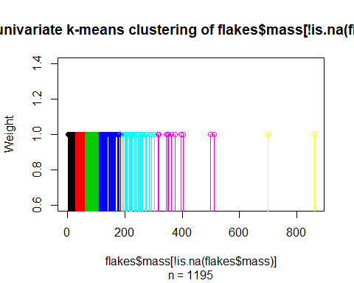

## [1] "flake" "ret" "ret brk" "flake brk"   
## [5] "LVF_?" "KBW" "leva" "leva?"   
## [9] "ret leva?" "LVF" "tablet" "DBD"   
## [13] "blade brk?" "blade" NA "LVT"   
## [17] "ret pro-lepoin" "crest" "LVFB" "BUR"   
## [21] "FACETED" "proximal"

## [1] "compare the mass of Leva and non-leva flakes"

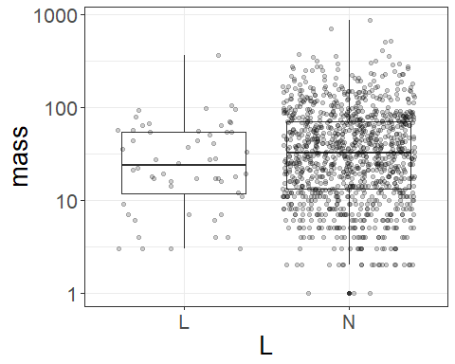

## [1] "t-test to see if it is statistically significant?"

##   
## Welch Two Sample t-test  
##   
## data: mass by L  
## t = -1.9714, df = 64.674, p-value = 0.05296  
## alternative hypothesis: true difference in means is not equal to 0  
## 95 percent confidence interval:  
## -28.6440377 0.1870471  
## sample estimates:  
## mean in group L mean in group N   
## 39.28571 53.51421

## [1] "variation of thickness for all flakes (red = 25%max_dim,green = 50%max,blue=75%max"

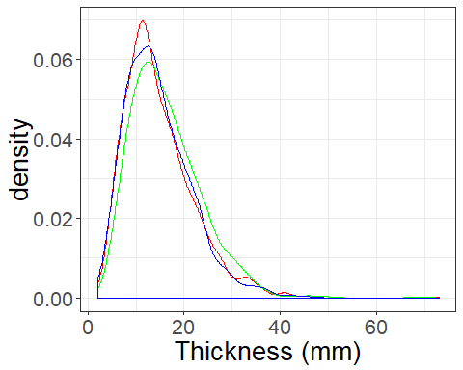

## [1] "variation of width for all flakes (red = 25%max_dim,green = 50%max,blue=75%max"

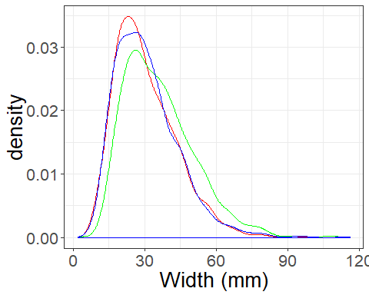

## [1] "compare thickness of leva and non-leva (red = 25%max_dim, \n green = 50%max, blue=75%max"

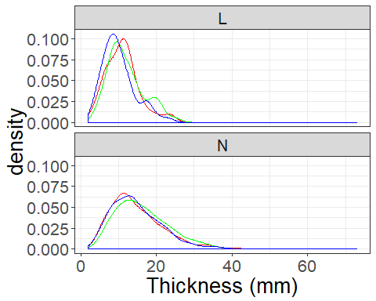

## [1] "summary of cv for thickness and width for leva and non-leva flakes"

## # A tibble: 2 x 8  
## L cv_25_thick cv_50_thick cv_75_thick cv_25_width cv_50_width  
## <chr> <dbl> <dbl> <dbl> <dbl> <dbl>  
## 1 L 40.2 40.0 42.7 38.3 36.0  
## 2 N 48.8 44.7 46.0 42.1 40.6  
## # ... with 2 more variables: cv_75_width <dbl>, n <int>

The following are results for cores

## [1] "summary for core geometry"

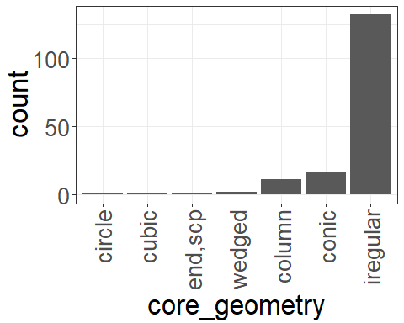

##   
## circle column conic cubic end,scp iregular wedged   
## 0.61 6.71 9.76 0.61 0.61 80.49 1.22

## [1] "summary for core platform"

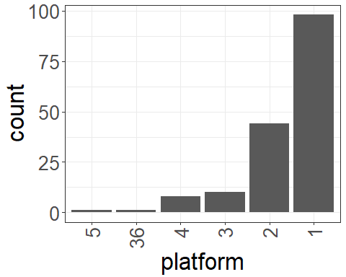

##   
## 1 2 3 4 5 36   
## 60.49 27.16 6.17 4.94 0.62 0.62

## [1] "cortex proportion of cores"

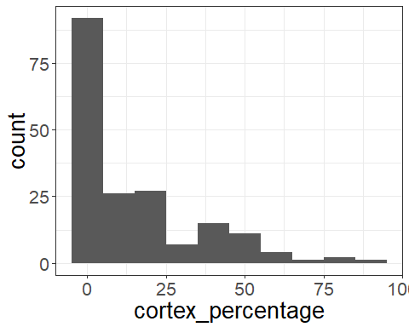

##   
## 0 5 10 15 20 30 40 50 60 70 80 90   
## 46.24 3.23 13.44 0.54 14.52 3.76 8.06 5.91 2.15 0.54 1.08 0.54

## [1] "summary for core platform preparation"

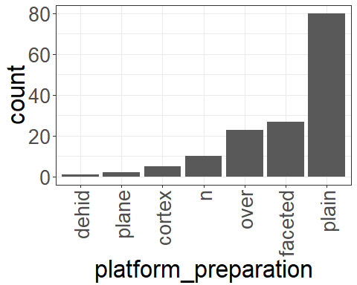

##   
## cortex dehid faceted n over plain plane   
## 3.38 0.68 18.24 6.76 15.54 54.05 1.35

## [1] "summary for core rotations"

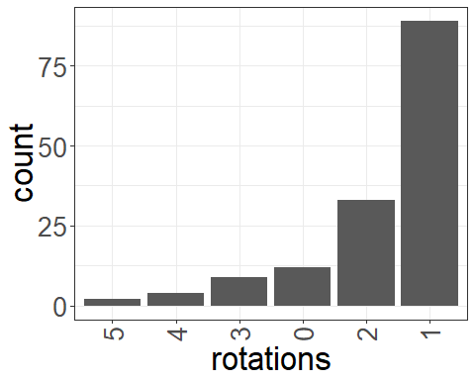

##   
## 0 1 2 3 4 5   
## 8.05 59.73 22.15 6.04 2.68 1.34

## [1] "summary for core reduction type"

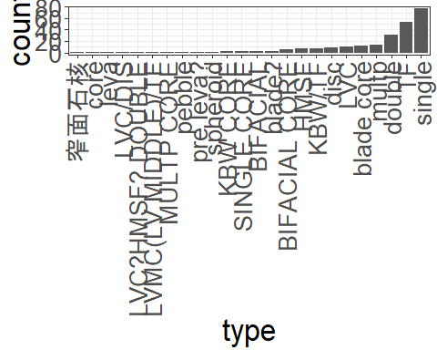

##   
## <U+7A84><U+9762><U+77F3><U+6838> BIFACIAL BIFACIAL CORE   
## 0.40 1.21 2.42   
## blade core blade? core   
## 4.84 1.21 0.40   
## disc double HMSF   
## 3.63 12.50 2.82   
## KBW CORE KBW/TF leva   
## 0.81 3.23 0.40   
## LVC LVC/DIS LVC?HMSF? DOUBLE   
## 4.44 0.40 0.40   
## LVMC(LV MIDDLE)/TF multp MULTP CORE   
## 0.40 5.65 0.40   
## pebble pre leva? single   
## 0.40 0.40 31.05   
## SINGLE CORE spheroid TF   
## 0.81 0.40 21.37

## [1] "summary of core scar number"

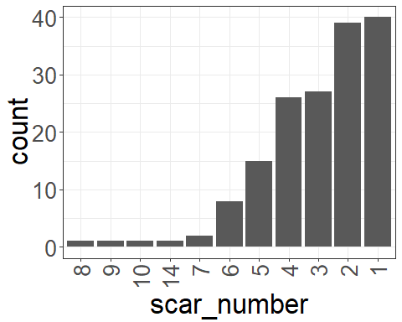

##   
## 1 2 3 4 5 6 7 8 9 10 14   
## 24.84 24.22 16.77 16.15 9.32 4.97 1.24 0.62 0.62 0.62 0.62

## [1] "summary for core flake scar length"

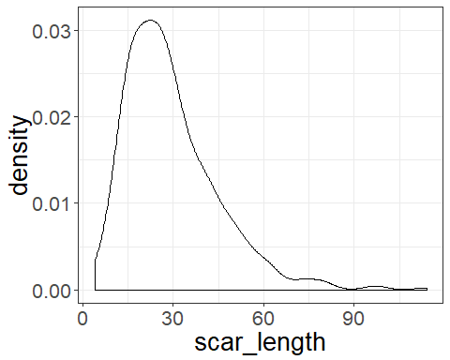

## [1] "median of scar length"

## [1] 26

The following results are for flakes

## [1] "table for flake attributes"

|  |  |  |  |  |  |  |  |  |  |  |  |  |  |  |  |
| --- | --- | --- | --- | --- | --- | --- | --- | --- | --- | --- | --- | --- | --- | --- | --- |
|  | length | max_dimension | oriented_width | Width_25%max | Width_50%max | Width_75%max | oriented_thickness | Thickness_25%max | Thickness_50%max | Thickness_75%max | mass | platform_width | platform_thickness | scar_number | cortex_percentage |
| mean | 49.4 | 62.5 | 50.3 | 36.3 | 41.9 | 35.2 | 17.6 | 16.1 | 16.6 | 13.7 | 68.2 | 32.8 | 13.7 | 2.9 | 9.4 |
| sd | 19.2 | 22.5 | 19.2 | 14.1 | 15.3 | 14.8 | 8.1 | 7.6 | 7.8 | 6.8 | 81.7 | 16.8 | 7.8 | 1.6 | 15.1 |
| cv | 0.4 | 0.4 | 0.4 | 0.4 | 0.4 | 0.4 | 0.5 | 0.5 | 0.5 | 0.5 | 1.2 | 0.5 | 0.6 | 0.6 | 1.6 |
| 25% | 35.0 | 48.2 | 36.0 | 26.0 | 30.1 | 25.0 | 11.8 | 10.9 | 11.0 | 9.0 | 18.8 | 19.9 | 8.0 | 2.0 | 0.0 |
| 50% | 48.0 | 60.0 | 49.0 | 35.0 | 41.0 | 34.0 | 16.0 | 15.0 | 15.0 | 12.6 | 45.5 | 30.9 | 12.0 | 3.0 | 0.0 |
| 75% | 60.8 | 76.0 | 61.7 | 44.9 | 51.1 | 43.0 | 23.0 | 20.9 | 21.0 | 18.0 | 90.0 | 43.0 | 18.3 | 4.0 | 10.0 |

## [1] "summary for flake type1"

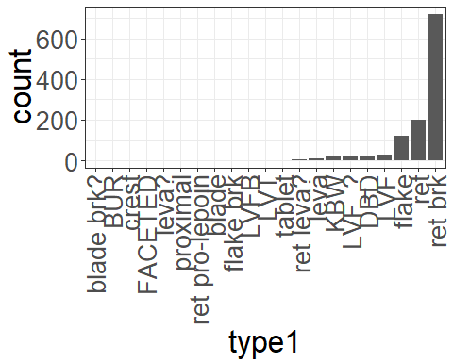

##   
## blade blade brk? BUR crest DBD   
## 2 1 1 1 26   
## FACETED flake flake brk KBW leva   
## 1 123 2 20 12   
## leva? LVF LVF_? LVFB LVT   
## 1 30 21 3 3   
## proximal ret ret brk ret leva? ret pro-lepoin   
## 1 202 720 5 1   
## tablet   
## 3

##   
## blade blade brk? BUR crest DBD   
## 0.2 0.1 0.1 0.1 2.2   
## FACETED flake flake brk KBW leva   
## 0.1 10.4 0.2 1.7 1.0   
## leva? LVF LVF_? LVFB LVT   
## 0.1 2.5 1.8 0.3 0.3   
## proximal ret ret brk ret leva? ret pro-lepoin   
## 0.1 17.1 61.1 0.4 0.1   
## tablet   
## 0.3

## [1] "summary for flake type2"

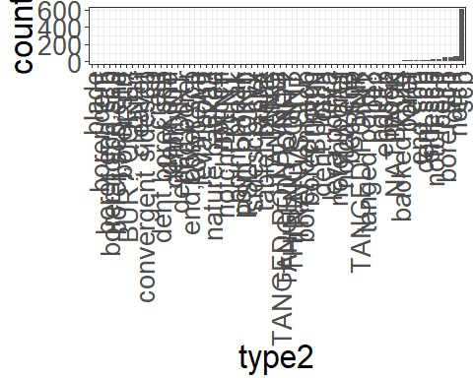

##   
## backed knife bec bec,scp   
## 8 4 3   
## blade borer borer,dent   
## 1 13 1   
## borer,dent,scp borer,end,scp borer,notch   
## 2 1 2   
## borer,notch,scp borer,scp borer,scp,end   
## 1 47 1   
## borer,strt BUR BUR? CORE?   
## 1 3 1   
## burin BURIN cleaver   
## 1 2 1   
## convergent sidescp cp crest   
## 1 1 1   
## dent dent,borer,scp dent,end   
## 51 1 1   
## dent,notch dent,scp dent/NOT   
## 2 20 1   
## dent/POINT end end,borer   
## 1 14 1   
## end,borer,scp end,scp endscp   
## 1 17 6   
## kombewa leva leva point   
## 1 2 1   
## leva point? leva? moon   
## 2 1 7   
## NATBACK nature backed notcch   
## 7 1 1   
## notch notch,borer notch,end   
## 61 2 2   
## notch,scp notch/DENT point   
## 21 1 22   
## POINT point break point,broken   
## 1 1 1   
## point? PSD POINT scp   
## 5 1 606   
## sidescp sidescp-cvx tablet   
## 20 1 1   
## tablet break TANG TANGED   
## 1 1 1   
## TANGED POINT TANGED POINT /NOT tanged point?   
## 3 1 3   
## TANGED POINT? THINING POINT TRANVS SCP   
## 1 1 1

##   
## backed knife bec bec,scp   
## 0.8 0.4 0.3   
## blade borer borer,dent   
## 0.1 1.3 0.1   
## borer,dent,scp borer,end,scp borer,notch   
## 0.2 0.1 0.2   
## borer,notch,scp borer,scp borer,scp,end   
## 0.1 4.7 0.1   
## borer,strt BUR BUR? CORE?   
## 0.1 0.3 0.1   
## burin BURIN cleaver   
## 0.1 0.2 0.1   
## convergent sidescp cp crest   
## 0.1 0.1 0.1   
## dent dent,borer,scp dent,end   
## 5.1 0.1 0.1   
## dent,notch dent,scp dent/NOT   
## 0.2 2.0 0.1   
## dent/POINT end end,borer   
## 0.1 1.4 0.1   
## end,borer,scp end,scp endscp   
## 0.1 1.7 0.6   
## kombewa leva leva point   
## 0.1 0.2 0.1   
## leva point? leva? moon   
## 0.2 0.1 0.7   
## NATBACK nature backed notcch   
## 0.7 0.1 0.1   
## notch notch,borer notch,end   
## 6.1 0.2 0.2   
## notch,scp notch/DENT point   
## 2.1 0.1 2.2   
## POINT point break point,broken   
## 0.1 0.1 0.1   
## point? PSD POINT scp   
## 0.5 0.1 61.0   
## sidescp sidescp-cvx tablet   
## 2.0 0.1 0.1   
## tablet break TANG TANGED   
## 0.1 0.1 0.1   
## TANGED POINT TANGED POINT /NOT tanged point?   
## 0.3 0.1 0.3   
## TANGED POINT? THINING POINT TRANVS SCP   
## 0.1 0.1 0.1

## [1] "summary for flake retouch"

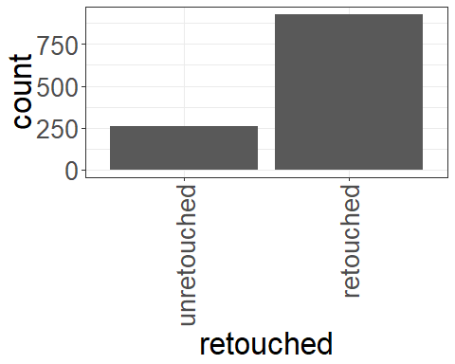

##   
## retouched unretouched   
## 928 258

##   
## retouched unretouched   
## 78.2 21.8

## [1] "summary for flake material"

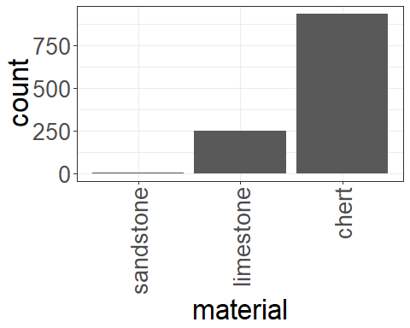

## [1] "summary for flake platform shape"

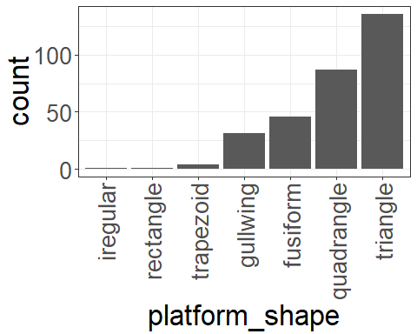

##   
## fusiform gullwing iregular quadrangle rectangle trapezoid   
## 46 31 1 87 1 4   
## triangle   
## 136

##   
## fusiform gullwing iregular quadrangle rectangle trapezoid   
## 15.03 10.13 0.33 28.43 0.33 1.31   
## triangle   
## 44.44

## [1] "summary for flake platform"

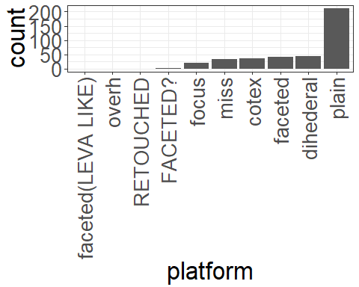

## [1] "number of flakes with distinctive platform = 396"

##   
## cotex dihederal faceted   
## 36 45 42   
## faceted(LEVA LIKE) FACETED? focus   
## 1 3 20   
## miss overh plain   
## 35 1 212   
## RETOUCHED   
## 1

##   
## cotex dihederal faceted   
## 9.1 11.4 10.6   
## faceted(LEVA LIKE) FACETED? focus   
## 0.3 0.8 5.1   
## miss overh plain   
## 8.8 0.3 53.5   
## RETOUCHED   
## 0.3

## [1] "mass of flakes"

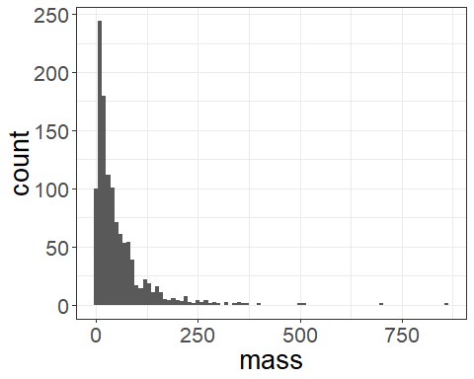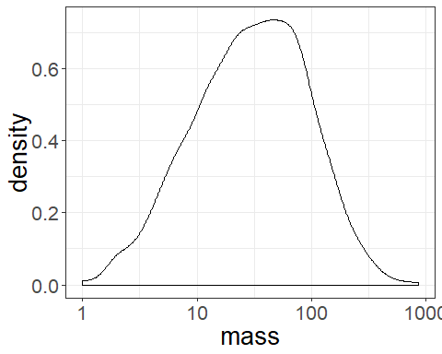

## [1] "length vs width at 50% max dim"

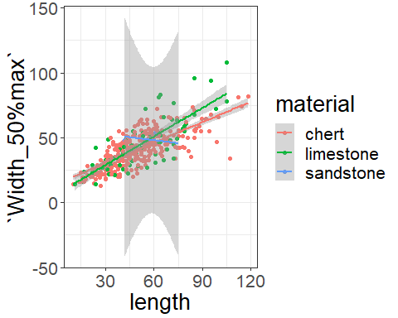

## [1] "platform shape vs thickness at 50% max dim"

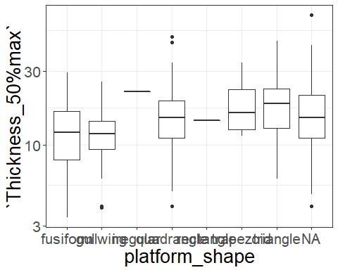

## [1] "mass for retouched and non-retouched flakes"

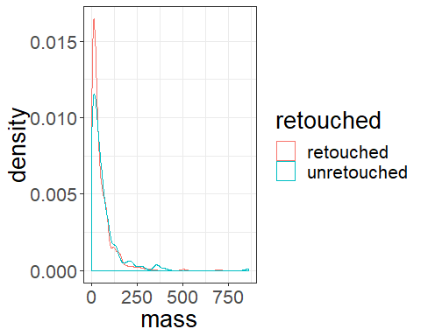

## [1] "mass for flakes of different raw materials"

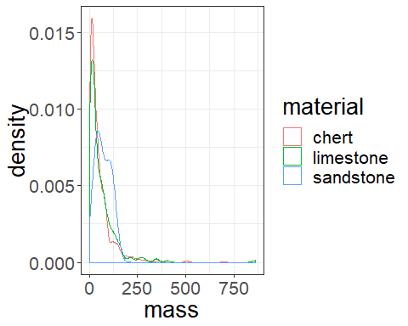

## [1] "max dim for all flakes"

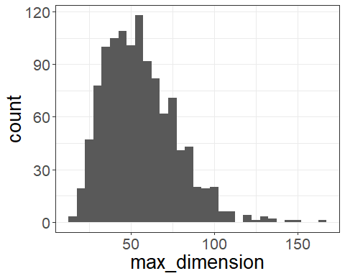

## [1] "max dim for all flakes, retouched or not"

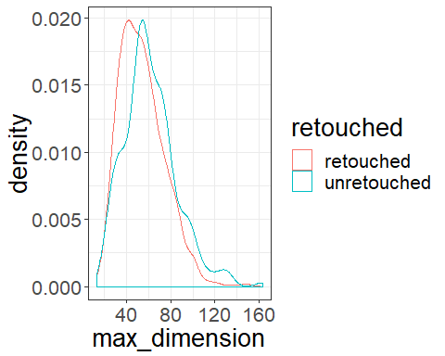

## [1] "max dim for all flakes, by raw material"

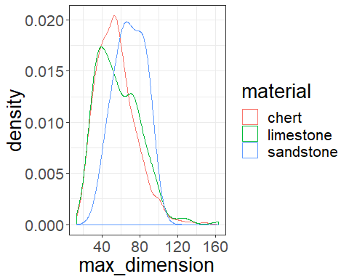

## [1] "scar counts for all flakes, by raw material"

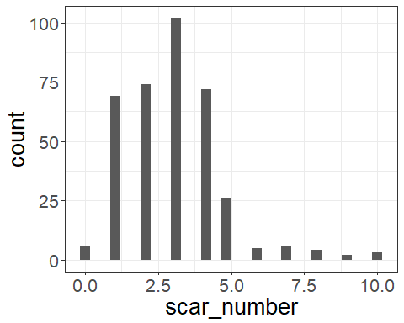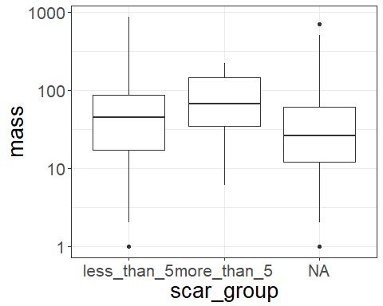

## [1] "facetted platforms"

##   
## fac no   
## 43 1143

##   
## fac no   
## 3.63 96.37

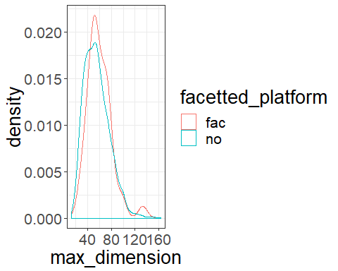

## [1] "cortex proportion of flakes"

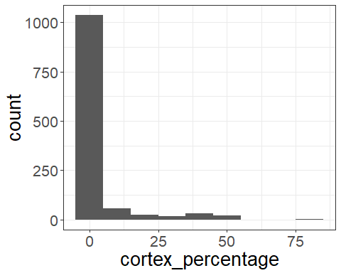

## [1] "compare cortex for ret and non-retouched flakes"

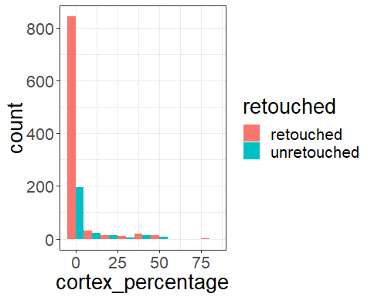

## [1] "platform shape vs max dim"

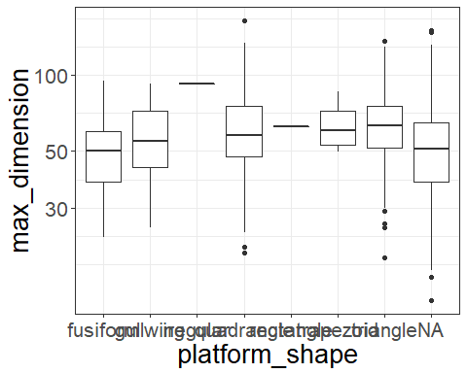

## [1] "how many points?"

##   
## backed other point   
## 9 1133 44

##   
## backed other point   
## 0.76 95.53 3.71

Group the flakes according to their

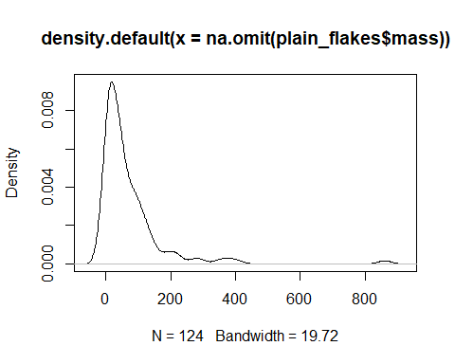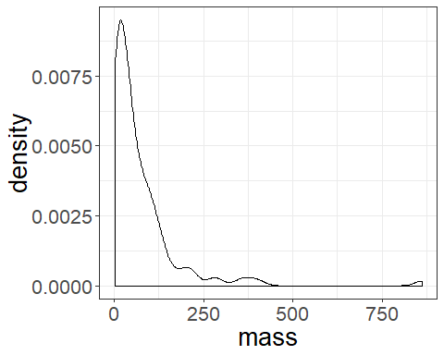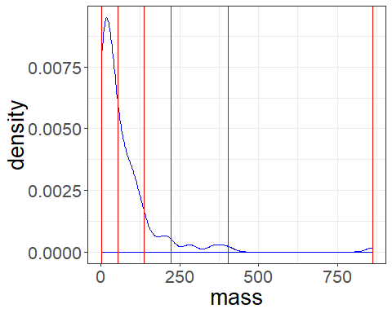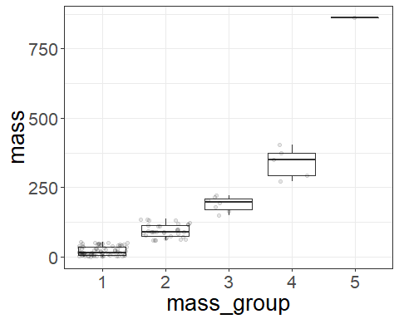

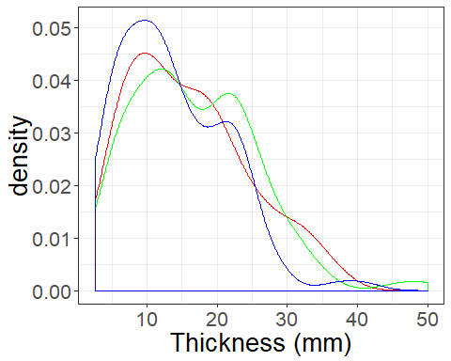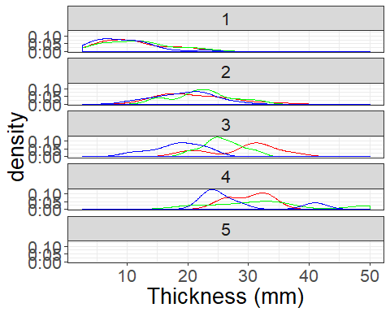

## # A tibble: 5 x 8  
## mass_group cv_25_thick cv_50_thick cv_75_thick cv_25_width cv_50_width  
## <fct> <dbl> <dbl> <dbl> <dbl> <dbl>  
## 1 1 47.7 46.5 49.8 35.3 34.4   
## 2 2 26.7 21.5 24.0 17.5 17.2   
## 3 3 20.9 12.9 23.4 23.8 9.65  
## 4 4 11.1 32.1 26.4 17.7 10.6   
## 5 5 NA NA NA NA NA   
## # ... with 2 more variables: cv_75_width <dbl>, n <int>

Results for edge angles

## [1] "edge angels"

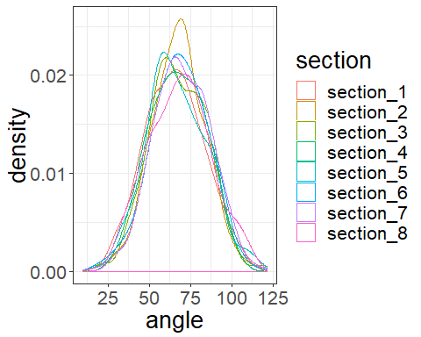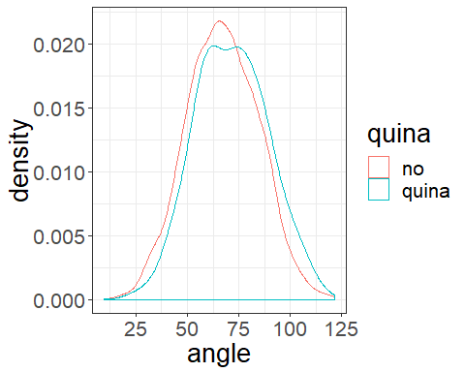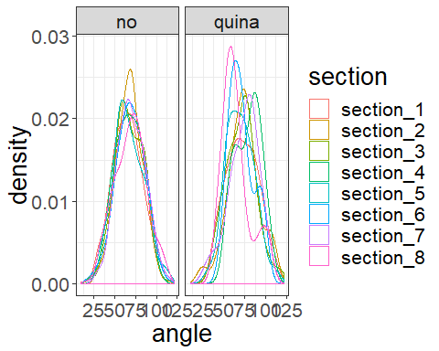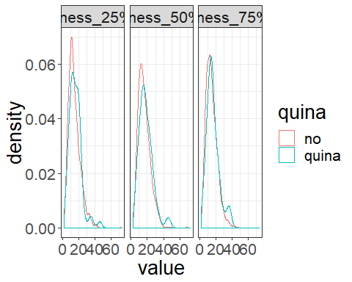

## [1] "thickness of 50% max dim"

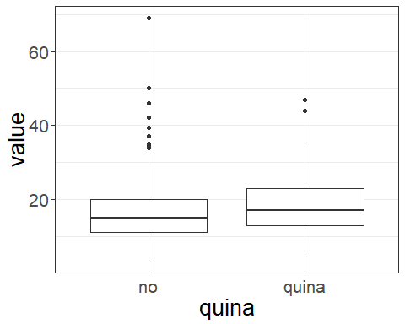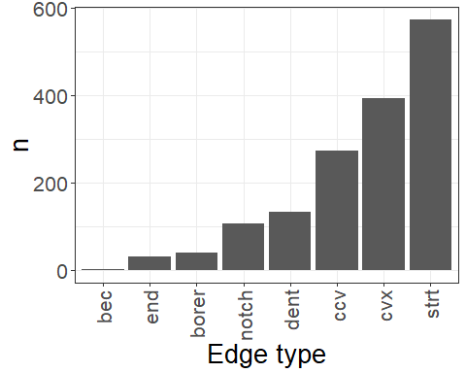

## edge_shapes Freq  
## 1 bec 3  
## 2 borer 40  
## 3 ccv 274  
## 4 cvx 395  
## 5 dent 134  
## 6 end 32  
## 7 notch 106  
## 8 strt 575

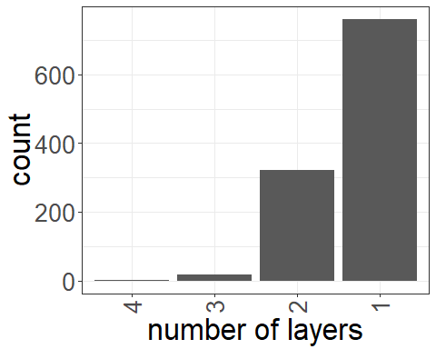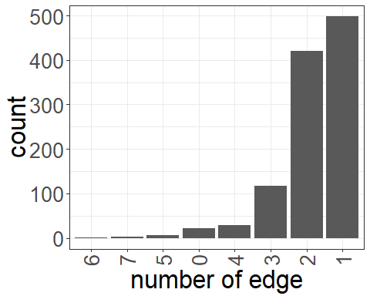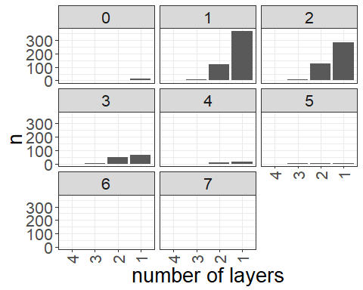

scar number and direction

## [1] "count how many scars from each direction"

##   
## 0 1 2 3 4 5 6 7 8   
## 85 221 168 109 73 68 61 71 138

## [1] "compare the GIUR and edge angle for different sections"

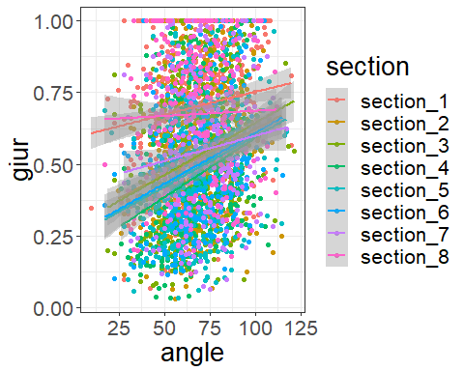

## [1] "compare the GIUR and edge angle for all sections"

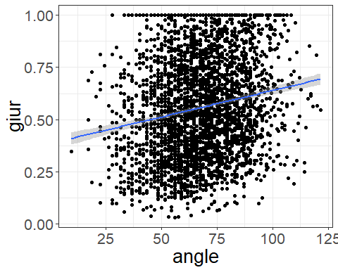

## [1] "compare GIUR for different mass groups"

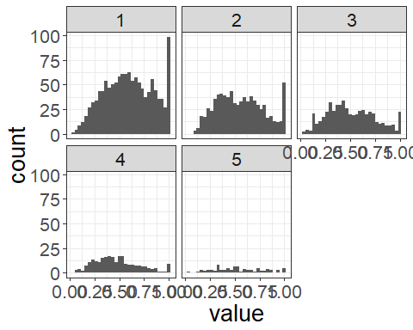

## [1] "the median GIUR for each group"

## 1 2 3 4 5   
## 0.5963639 0.5433333 0.4739884 0.4400000 0.5151515

## [1] "Compare GIUR for Quina and non-quina"

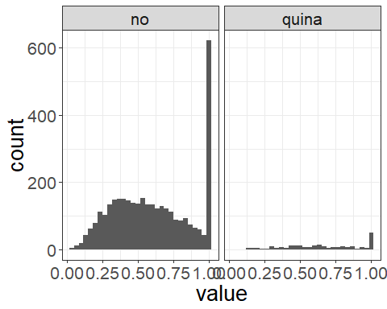

## [1] "Histogram of GIUR for Quina"

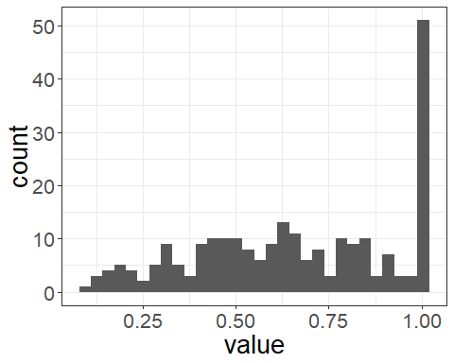

## [1] "Histogram of GIUR for non Quina"

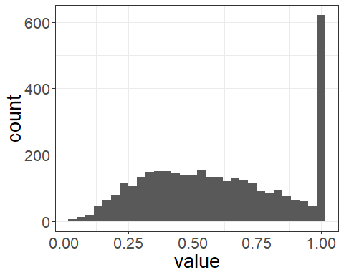

## [1] "the median GIUR for quina and non-quina"

## no quina   
## 0.6533333 0.7333333

## [1] "results for invasiveness index"

