Late Pleistocene stone artefact technology at Mau A, Yen Bai, Northern Vietnam

Quinn Habedank1,✉, and Ben Marwick2

04 March, 2022

Text of abstract

1 University of One Place  
2 University of Another Place

✉ Correspondence: [Quinn Habedank <[fl@oneoeurhg.edu](mailto:fl@oneoeurhg.edu)>](mailto:fl@oneoeurhg.edu)

Keywords: keyword 1; keyword 2; keyword 3

Highlights: These are the highlights.

# Abstract

Flaked stone artefacts from Southeast Asia typically lack visually distinctive and strongly patterned forms, which can make them challenging to analyze and interpret. As a result, many of the cultural dynamics of Pleistocene hunter-gatherers of this region are poorly understood. We use 2D shape data to hypothesize a relationship between unretouched flake shape and assemblage reduction intensity at Mau A, an early Holocene archaeological site in northern Vietnam. We apply a Principal Components Analysis to the flake outlines to investigate shape variation throughout the reduction sequence (measured by dorsal cortex coverage). We find that flake shape varies by reduction stage, primarily through differences in flake length and width. Our results suggest that flake shape is sensitive to assemblage reduction intensity, and may give useful comparative insights when other attributes show little variation. These results are important for understanding stone artefact assemblages from Southeast Asia which often yield little variation when analysed with traditional approaches.

## Introduction

* Stone tools from South East Asia tend to lack distinctive typological categories (Mijares 2008; Borel et al. 2013; Borel et al. 2017)
* The purpose of this study was to examine the relationship between flake shape and reduction intensity
* Approach used in the paper is a response to the lack of traditional typological categories in South East Asia -Further context from (McAdams et al, 2020)

Here is a citation (Marwick, 2017)

## Excavations at Mau A

Mau A is an open air archaeological site located on the banks above 5 m above the Red River in Yen Bai Province, Northern Vietnam, at the confluence of a small stream entering the river. Excavations were conducted in 2015 by a collaboration including researchers from the University of Washington, the Yen Bai Provincial Museum, the Institute of Archaeology in Hanoi, and the Vietnam National University - Social Sciences and Humanities University. An area of 2 x 2 m was excavated in 13 units of ten centimeters deep, through dense silty clay deposits to a depth of about 1.3 m below the surface. Subtle changes in stratigraphy indicated a slightly sloping deposit with four layers, consistent with reports of excavations in this location in the 1980s. A small amount of plastic and modern ceramics were found in the uppermost 0.1 m of deposit. The most striking feature identified during our excavations was the third layer, which is distinctive as very dense layer of flaked stone artefacts at about 0.6-1.1 m below the surface. No other features were identified during excavation.

This dense lithic layer contained the majority of stone artefacts recovered from the site. The chaîne opératoire of Mau A lithic technology is composed of unifacial shaping on long cobbles to produce sumatraloids (sumatralith-like pieces). The chaîne opératoire also involved the shaping of thick ovoid cobbles for the production of choppers or chopping-tools and half-cobbles (longitudinally split) that are shaped into tools with transverse cutting edges. Flake scar surfaces and edges are fresh and unweathered, indicating *in situ* production and limited post-depositional movement. While previous work has claimed the Mau A assemblage is Son Vian (a precurser to Hoabinhian technology, characterised by unifacial flaking of blocky, cubic cobbles)

Four radiocarbon ages were obtained from isolated charcoal fragments in the deposit. The charcoal was sampled to bracket the upper and lower boundaries of the dense lithic layer. The ages indicate a rapid accumulation process for this layer at the terminal Pleistocene.

## Methods

Dorsal cortex percentages discretized upon standard cut points were used to create reduction categories. Flakes with no dorsal cortex were categorized as tertiary flakes, those with up to a dorsal cortex percentage of 50% were considered secondary and those with a dorsal cortex value greater than 50% were considered primary (Bradbury & Carr 1995).

Mass clusters were generated using univariate k-means, with the end result being 6 mass clusters, with mass cluster 1 having the least mass on average and 6 having the greatest mass on average. Univariate k-means is a non-hierarchical clustering technique that creates a set number of groups equal to k, with points being assigned to groups in such a manner that the total distances between each point and mean of the group is minimized. We used the Ckmeans.1d.dp package in R to perform our univariate k-means analysis (Wang & Song, 2011). The Ckmeans.1d.dp has been used for univariate clustering in applications outside of archaeology (Song & Zhong, 2020).

We initially recorded conventional linear dimension measurements, such as max dimension length and width at various points along the max dimension length, from all flakes recovered from the excavation. Then we converted these linear dimensions into landmarks points to represent the shape of each artefact. The specific linear measurements used to create the 2D landmarks were the top horizontal measurement, the max dimension length, width at a quarter of the maximum length, width at half of the maximum length, and width at three quarters of the maximum length.

In analysing the landmarks we followed a conventional shape analysis workflow of Generalized Procrustes Analysis (GPA) followed by Principal Components Analysis (PCA) (Riede & Pedersen, 2018; Hoggard et al., 2019; Radinović & Kajtez, 2021; Okumura & Araujo 2014; Archer et al., 2021; Theska et al. 2020). We used GPA to normalize landmarks for size, orientation, and rotation, leaving only shape data. The normalized landmarks were then analysed by PCA, a form of exploratory data analysis. Principal Component Analysis takes the initial set of data and transforms and reduces them into a smaller set of variables, whist still preserving most of the variation. To explore the output we made PCA biplots of the first two Principal Components to visualize shape variation based upon secondary categorical variables, namely flake reduction categories, excavation units, and mass clusters.

## Results

## Principal Components Analyses exploring flake shape variation

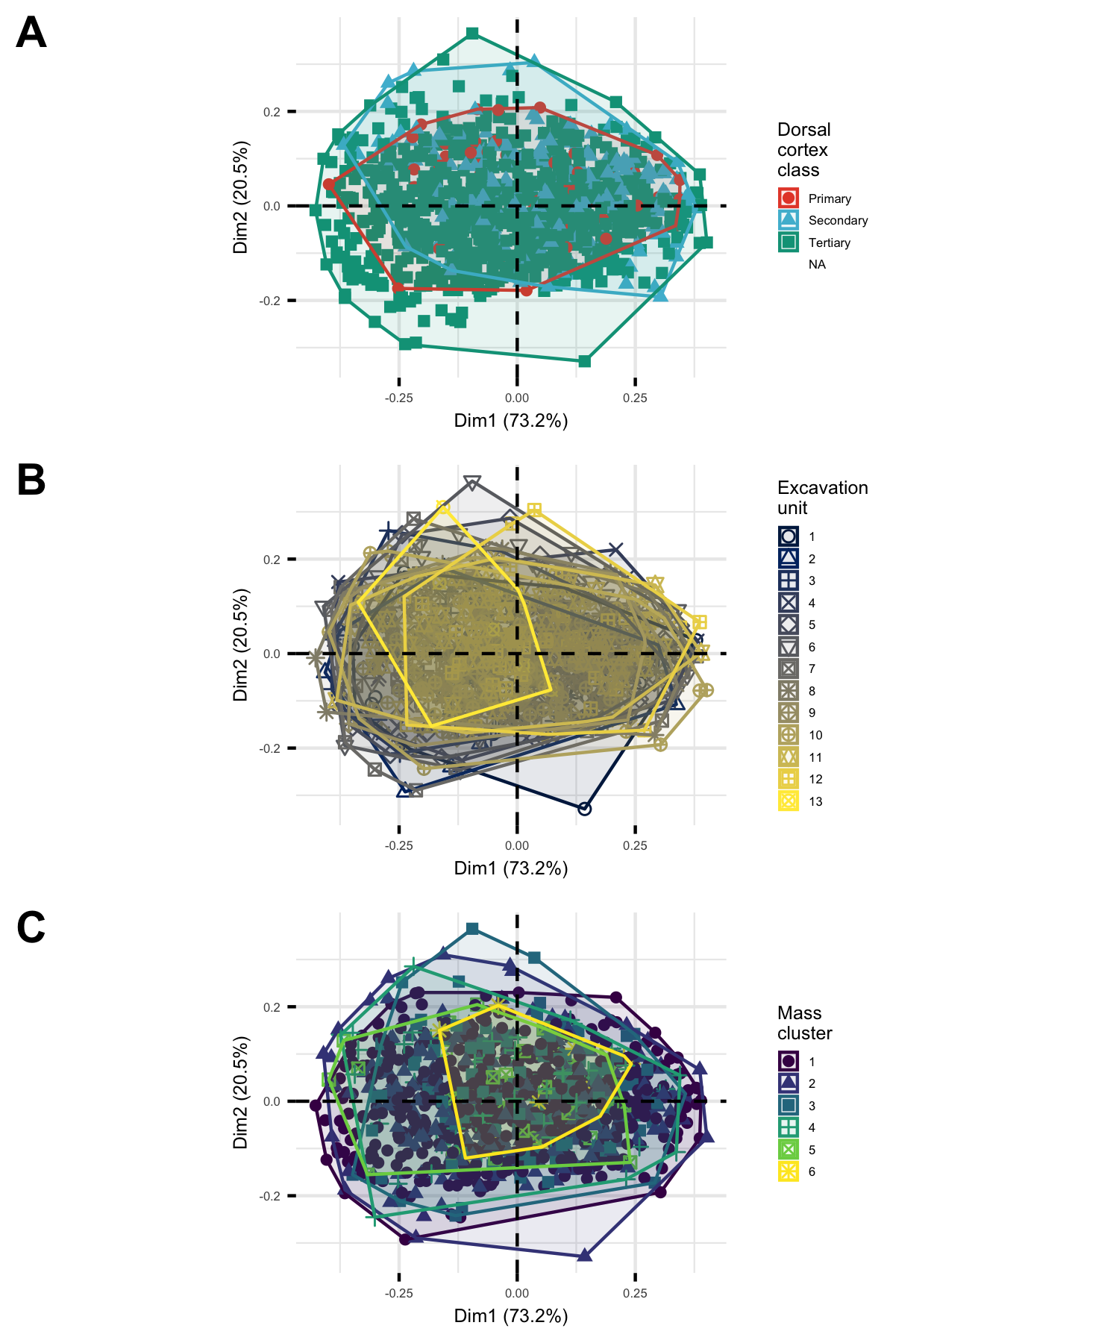

Figure 1: PCA biplots showing (A) variation in flake shape with dorsal cortex class, (B) depth below surface, and (C) mass cluster

Figure 1A shows flake shape (as defined within the first two principal components) in relation to dorsal cortex class. The primary class of dorsal cortex, representing initial, unretouched flakes in the reduction sequence, has the smallest range of shape variation. Secondary flakes, which have been retouched and thus have less dorsal cortex than the primary flakes, show a slightly larger range of shape variation. Lastly, the tertiary flakes at the end of the reduction sequence show the greatest amount of shape variation.

Shape variation is not equal along both principal components. For flakes in all three dorsal cortex classes, the largest differences between each inter-nested is along the first principal component. Slight differences are seen along the second principal component, with an increasing amount of variation as one goes from primary to secondary to tertiary flakes, but these changes are minor when compared to the larger changes seen in the first principal component.

Figure 1B shows the flake shapes projected on the first two principal components, and colored according to the excavation unit that they were recovered from. Excavation unit one is near the surface, and unit 13 is near the base. The general picture here is that shape variation changes little through the deposit. Units with fewer flakes, such as 13, show lower shape variation.

In Figure 1C we see that greater shape variation is found in the lightest mass classes. The two lightest mass clusters, one and two, are in purple and blue respectively. These first two mass classes span the largest area on the biplot, signifying a larger degree of variation overall.

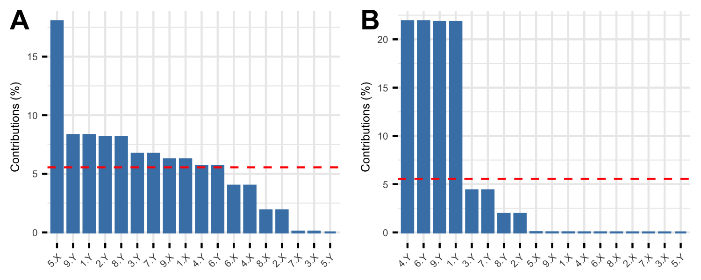

Figure 2: Plots showing the contribution of landmarks to the first two Principal Components (A: PC1, B: PC2) that summarise the overall shape variation among flakes. The dashed red horizontal line corresponds to the expected value if the contribution from each landmark was uniform.

Figure 2 shows the relative contribution of each of the original 18 variables put through our PCA. The first principal component is primarily composed of the x-value for the distal tip landmark, with smaller contributions from the y-values from the two upper-most and mid-upper points. The second principal component is composed largely of the y-values for bottom-most and upper-most points.

## Principal Components Analyses exploring core shape variation

# Discussion

Flake shape variation generally shows limited correspondence with other factors. Figure ??B shows very little variation over time, with lots of overlap between groups in the biplot. Units with fewer flakes, such as 13, show lower shape variation. This generally confirms our conclusion from the radiocarbon ages that the deposit accumulated relatively quickly, and the assemblage represents knapping events occurring at a similar time with little, if any perceptible change over time. By contrast, a more definitive difference between groups in seen in Figure ??C, where there is a high degree of shape variation in the lightest flakes. This reflects the production of different types and shapes of cores as the flakes become smaller and thus lighter. This is further supported by Figure ??A where tertiary flakes with little dorsal cortex show the highest shape variation. This supports our interpretation of the previous result, with flakes from later in the reduction process showing greater shape variation as different types of cores were produced at the site.

Looking at 2, the landmarks which contributed the most to each principal component were all located on the left side of our artefacts. This means that linking our initial flake measurements (maximum length, top width etc.) to either of the first two principal components is nearly impossible, as every one of our initial flake measurements (with the) one can see that there is no consistent pattern in which certain initial flake measurements align closely with either the first or second principal components. Interestingly, the landmarks which contributed the most to each principal component were all located on the left side of our artefacts..

The lack of distinct morphological groupings and the increased variability of shape in the smaller, tertiary flakes is consistent with previous studies. Other studies which investigated the morphology of flake outlines from South East Asia concluded that there is no significant relationship between flake outline and flake use (Borel et al., 2013; Borel et al., 2017). While our analysis does not rely upon outlines, both outlines and landmarks are methods for measuring the morphology of flaked stone tools, and as such, the same models which explain outline variability can be cautiously applied to our analysis. The high variability in flake shape, especially in the tertiary flakes, suggests that knappers were not looking to systematically create a small set of specific shapes of flake, with the amount of variability increasing as flakes are struck off of increasingly differed cores. This behavior is consistent with processes of expedient knapping, where a large number of flakes are created in a relatively free-form manner and useful flakes are picked up and used after knapping is finished (Holdaway & Douglass, 2012; McCall, 2012). Processes of expedient knapping suggest that stone tools were of secondary importance in the material culture of the knappers (Sillitoe & Hardy, 2003), relative to organic technologies. Mijares (2001) suggested stone tools were primarily used to create bamboo tools in South East Asia. A reliance upon bamboo tools, with stone flakes being an intermediary to produce bamboo tools, may explain the great variability in the lithic assemblages at Mau A.

# Conclusion

# Acknowledgements

## References

Archer, W., Djakovic, I., Brenet, M., Bourguignon, L., Presnyakova, D., Schlager, S., Soressi, M., & McPherron, S. P. (2021). Quantifying differences in hominin flaking technologies with 3D shape analysis. Journal of Human Evolution, 150, 102912. <https://doi.org/10.1016/j.jhevol.2020.102912>

Borel, Antony, Richard Cornette, and Michel Baylac. 2017. “Stone Tool Forms and Functions: A Morphometric Analysis of Modern Humans’ Stone Tools From Song Terus Cave (Java, Indonesia).” Archaeometry 59 (3): 455–71. <https://doi.org/10.1111/arcm.12264>.

Borel, Antony, Claire Gaillard, Marie-Hélène Moncel, Robert Sala, Emmanuelle Pouydebat, Truman Simanjuntak, and François Sémah. 2013. “How to Interpret Informal Flakes Assemblages? Integrating Morphological Description, Usewear and Morphometric Analysis Gave Better Understanding of the Behaviors of Anatomically Modern Human from Song Terus (Indonesia).” Journal of Anthropological Archaeology 32 (4): 630–46. <https://doi.org/10.1016/j.jaa.2013.03.002>.

Bradbury, Andrew P., and Philip J. Carr. “Flake Typologies and Alternative Approaches: An Experimental Assessment.” Lithic Technology 20, no. 2 (1995): 100-15. Accessed June 11, 2021. <http://www.jstor.org/stable/23273168>.

Hoggard, C. S., McNabb, J., & Cole, J. N. (2019). The Application of Elliptic Fourier Analysis in Understanding Biface Shape and Symmetry Through the British Acheulean. Journal of Paleolithic Archaeology, 2(2), 115–133. <https://doi.org/10.1007/s41982-019-00024-6>

Holdaway, S., & Douglass, M. (2012). A Twenty-First Century Archaeology of Stone Artifacts. Journal of Archaeological Method and Theory, 19(1), 101–131. <https://doi.org/10.1007/s10816-011-9103-6>

McAdams, C., Morley, M. W., Fu, X., Kandyba, A. V., Derevianko, A. P., Nguyen, D. T., Doi, N. G., & Roberts, R. G. (2020). The Pleistocene geoarchaeology and geochronology of Con Moong Cave, North Vietnam: Site formation processes and hominin activity in the humid tropics. Geoarchaeology, 35(1), 72–97. <https://doi.org/10.1002/gea.21758>

McCall, G. S. (2012). Ethnoarchaeology and the Organization of Lithic Technology. Journal of Archaeological Research, 20(2), 157–203. <https://doi.org/10.1007/s10814-011-9056-z>

Mijares, A. S. B. (2001). An Expedient Lithic Technology in Northern Luzon (Philippines). Lithic Technology, 26(2), 138–152. <https://doi.org/10.1080/01977261.2001.11720983>

Mijares, A. 2008. “The late pleistocene to early holocene foragers of northern Luzon.” Bulletin of the Indo-Pacific Prehistory Association 28: 99-107.

Okumura, M., & Araujo, A. G. M. (2014). Long-term cultural stability in hunter–gatherers: A case study using traditional and geometric morphometric analysis of lithic stemmed bifacial points from Southern Brazil. Journal of Archaeological Science, 45, 59–71. <https://doi.org/10.1016/j.jas.2014.02.009>

Radinović, M., & Kajtez, I. (2021). Outlining the knapping techniques: Assessment of the shape and regularity of prismatic blades using elliptic Fourier analysis. Journal of Archaeological Science: Reports, 38, 103079. <https://doi.org/10.1016/j.jasrep.2021.103079>

Riede, F., & Pedersen, J. B. (2018). Late Glacial Human Dispersals in Northern Europe and Disequilibrium Dynamics. Human Ecology, 46(5), 621–632. <https://doi.org/10.1007/s10745-017-9964-8>

Sillitoe, P., & Hardy, K. (2003). Living Lithics: Ethnoarchaeology in Highland Papua New Guinea. Antiquity, 77(297), 555–566. <https://doi.org/10.1017/S0003598X00092619>

Song, M., & Zhong, H. (2020). Efficient weighted univariate clustering maps outstanding dysregulated genomic zones in human cancers. Bioinformatics, 36(20), 5027–5036. <https://doi.org/10.1093/bioinformatics/btaa613>

Theska, T., Sieriebriennikov, B., Wighard, S. S., Werner, M. S., & Sommer, R. J. (2020). Geometric morphometrics of microscopic animals as exemplified by model nematodes. Nature Protocols, 15(8), 2611–2644. <https://doi.org/10.1038/s41596-020-0347-z>

Wang, H., & Song, M. (2011). Ckmeans.1d.dp: Optimal k-means Clustering in One Dimension by Dynamic Programming. The R Journal, 3(2), 29–33.

Marwick, B., 2017. Computational reproducibility in archaeological research: Basic principles and a case study of their implementation. Journal of Archaeological Method and Theory 24, 424–450. <https://doi.org/10.1007/s10816-015-9272-9>

### Colophon

This report was generated on 2022-03-04 22:36:04 using the following computational environment and dependencies:

#> ─ Session info ───────────────────────────────────────────────────────────────  
#> setting value  
#> version R version 4.1.2 (2021-11-01)  
#> os macOS Catalina 10.15.7  
#> system x86_64, darwin17.0  
#> ui X11  
#> language (EN)  
#> collate en_US.UTF-8  
#> ctype en_US.UTF-8  
#> tz America/Los_Angeles  
#> date 2022-03-04  
#> pandoc 2.14.0.3 @ /Applications/RStudio.app/Contents/MacOS/pandoc/ (via rmarkdown)  
#>   
#> ─ Packages ───────────────────────────────────────────────────────────────────  
#> package * version date (UTC) lib source  
#> abind 1.4-5 2016-07-21 [2] CRAN (R 4.1.0)  
#> ape 5.6-1 2022-01-07 [2] CRAN (R 4.1.2)  
#> assertthat 0.2.1 2019-03-21 [2] CRAN (R 4.1.0)  
#> backports 1.4.1 2021-12-13 [2] CRAN (R 4.1.0)  
#> bezier 1.1.2 2018-12-14 [2] CRAN (R 4.1.0)  
#> bit 4.0.4 2020-08-04 [2] CRAN (R 4.1.0)  
#> bit64 4.0.5 2020-08-30 [2] CRAN (R 4.1.0)  
#> bookdown 0.24 2021-09-02 [2] CRAN (R 4.1.0)  
#> brio 1.1.3 2021-11-30 [2] CRAN (R 4.1.0)  
#> broom 0.7.12 2022-01-28 [2] CRAN (R 4.1.2)  
#> cachem 1.0.6 2021-08-19 [2] CRAN (R 4.1.0)  
#> callr 3.7.0 2021-04-20 [2] CRAN (R 4.1.0)  
#> car 3.0-12 2021-11-06 [2] CRAN (R 4.1.0)  
#> carData 3.0-5 2022-01-06 [2] CRAN (R 4.1.2)  
#> cellranger 1.1.0 2016-07-27 [2] CRAN (R 4.1.0)  
#> Ckmeans.1d.dp * 4.3.4 2022-01-31 [2] CRAN (R 4.1.2)  
#> cli 3.2.0 2022-02-14 [1] CRAN (R 4.1.2)  
#> cluster * 2.1.2 2021-04-17 [2] CRAN (R 4.1.2)  
#> codetools 0.2-18 2020-11-04 [2] CRAN (R 4.1.2)  
#> colorRamps 2.3 2012-10-29 [2] CRAN (R 4.1.0)  
#> colorspace 2.0-3 2022-02-21 [2] CRAN (R 4.1.2)  
#> cowplot * 1.1.1 2020-12-30 [2] CRAN (R 4.1.0)  
#> crayon 1.5.0 2022-02-14 [1] CRAN (R 4.1.2)  
#> DBI 1.1.2 2021-12-20 [2] CRAN (R 4.1.0)  
#> dbplyr 2.1.1 2021-04-06 [2] CRAN (R 4.1.0)  
#> desc 1.4.0 2021-09-28 [2] CRAN (R 4.1.0)  
#> devtools 2.4.3 2021-11-30 [2] CRAN (R 4.1.0)  
#> digest 0.6.29 2021-12-01 [2] CRAN (R 4.1.0)  
#> doParallel 1.0.17 2022-02-07 [2] CRAN (R 4.1.2)  
#> dplyr * 1.0.8 2022-02-08 [1] CRAN (R 4.1.2)  
#> ellipsis 0.3.2 2021-04-29 [2] CRAN (R 4.1.0)  
#> evaluate 0.14 2019-05-28 [2] CRAN (R 4.1.0)  
#> extrafont 0.17 2014-12-08 [2] CRAN (R 4.1.0)  
#> extrafontdb 1.0 2012-06-11 [2] CRAN (R 4.1.0)  
#> factoextra * 1.0.7 2020-04-01 [2] CRAN (R 4.1.0)  
#> fansi 1.0.2 2022-01-14 [2] CRAN (R 4.1.2)  
#> farver 2.1.0 2021-02-28 [2] CRAN (R 4.1.0)  
#> fastmap 1.1.0 2021-01-25 [2] CRAN (R 4.1.0)  
#> forcats * 0.5.1 2021-01-27 [2] CRAN (R 4.1.0)  
#> foreach 1.5.2 2022-02-02 [2] CRAN (R 4.1.2)  
#> fs 1.5.2 2021-12-08 [2] CRAN (R 4.1.0)  
#> generics 0.1.2 2022-01-31 [2] CRAN (R 4.1.2)  
#> geomorph * 4.0.1 2021-10-13 [2] CRAN (R 4.1.0)  
#> ggplot2 * 3.3.5 2021-06-25 [2] CRAN (R 4.1.0)  
#> ggpubr 0.4.0 2020-06-27 [2] CRAN (R 4.1.0)  
#> ggrepel 0.9.1 2021-01-15 [2] CRAN (R 4.1.0)  
#> ggsci 2.9 2018-05-14 [2] CRAN (R 4.1.0)  
#> ggsignif 0.6.3 2021-09-09 [2] CRAN (R 4.1.0)  
#> glue 1.6.1 2022-01-22 [2] CRAN (R 4.1.2)  
#> gridExtra 2.3 2017-09-09 [2] CRAN (R 4.1.0)  
#> gtable 0.3.0 2019-03-25 [2] CRAN (R 4.1.0)  
#> haven 2.4.3 2021-08-04 [2] CRAN (R 4.1.0)  
#> here 1.0.1 2020-12-13 [2] CRAN (R 4.1.0)  
#> highr 0.9 2021-04-16 [2] CRAN (R 4.1.0)  
#> hms 1.1.1 2021-09-26 [2] CRAN (R 4.1.0)  
#> htmltools 0.5.2 2021-08-25 [2] CRAN (R 4.1.0)  
#> htmlwidgets 1.5.4 2021-09-08 [2] CRAN (R 4.1.0)  
#> httr 1.4.2 2020-07-20 [2] CRAN (R 4.1.0)  
#> iterators 1.0.14 2022-02-05 [2] CRAN (R 4.1.2)  
#> jpeg 0.1-9 2021-07-24 [2] CRAN (R 4.1.0)  
#> jsonlite 1.7.3 2022-01-17 [2] CRAN (R 4.1.2)  
#> knitr 1.37.4 2022-01-29 [2] https://yihui.r-universe.dev (R 4.1.2)  
#> labeling 0.4.2 2020-10-20 [2] CRAN (R 4.1.0)  
#> lattice 0.20-45 2021-09-22 [2] CRAN (R 4.1.2)  
#> lifecycle 1.0.1 2021-09-24 [2] CRAN (R 4.1.0)  
#> lubridate 1.8.0 2021-10-07 [2] CRAN (R 4.1.0)  
#> magrittr 2.0.2 2022-01-26 [2] CRAN (R 4.1.2)  
#> MASS 7.3-55 2022-01-13 [2] CRAN (R 4.1.2)  
#> Matrix * 1.4-0 2021-12-08 [2] CRAN (R 4.1.0)  
#> mclust * 5.4.9 2021-12-17 [2] CRAN (R 4.1.0)  
#> memoise 2.0.1 2021-11-26 [2] CRAN (R 4.1.0)  
#> modelr 0.1.8 2020-05-19 [2] CRAN (R 4.1.0)  
#> Morpho * 2.9 2021-09-09 [2] CRAN (R 4.1.0)  
#> munsell 0.5.0 2018-06-12 [2] CRAN (R 4.1.0)  
#> nlme 3.1-155 2022-01-13 [2] CRAN (R 4.1.2)  
#> pillar 1.7.0 2022-02-01 [2] CRAN (R 4.1.2)  
#> pkgbuild 1.3.1 2021-12-20 [2] CRAN (R 4.1.0)  
#> pkgconfig 2.0.3 2019-09-22 [2] CRAN (R 4.1.0)  
#> pkgload 1.2.4 2021-11-30 [2] CRAN (R 4.1.0)  
#> prettyunits 1.1.1 2020-01-24 [2] CRAN (R 4.1.0)  
#> processx 3.5.2 2021-04-30 [2] CRAN (R 4.1.0)  
#> ps 1.6.0 2021-02-28 [2] CRAN (R 4.1.0)  
#> purrr * 0.3.4 2020-04-17 [2] CRAN (R 4.1.0)  
#> R6 2.5.1 2021-08-19 [2] CRAN (R 4.1.0)  
#> rbibutils 2.2.7 2021-12-07 [2] CRAN (R 4.1.0)  
#> Rcpp 1.0.8 2022-01-13 [2] CRAN (R 4.1.2)  
#> Rdpack 2.1.3 2021-12-08 [2] CRAN (R 4.1.0)  
#> readr * 2.1.2 2022-01-30 [2] CRAN (R 4.1.2)  
#> readxl 1.3.1 2019-03-13 [2] CRAN (R 4.1.0)  
#> remotes 2.4.2 2021-11-30 [2] CRAN (R 4.1.0)  
#> reprex 2.0.1 2021-08-05 [2] CRAN (R 4.1.0)  
#> rgl * 0.108.3 2021-11-21 [2] CRAN (R 4.1.0)  
#> rlang 1.0.1 2022-02-03 [2] CRAN (R 4.1.2)  
#> rmarkdown 2.11 2021-09-14 [2] CRAN (R 4.1.2)  
#> rprojroot 2.0.2 2020-11-15 [2] CRAN (R 4.1.0)  
#> RRPP * 1.1.2 2021-11-04 [2] CRAN (R 4.1.0)  
#> rstatix 0.7.0 2021-02-13 [2] CRAN (R 4.1.0)  
#> rstudioapi 0.13 2020-11-12 [2] CRAN (R 4.1.0)  
#> Rttf2pt1 1.3.10 2022-02-07 [2] CRAN (R 4.1.2)  
#> Rvcg 0.20.2 2021-09-08 [2] CRAN (R 4.1.0)  
#> rvest 1.0.2 2021-10-16 [2] CRAN (R 4.1.0)  
#> scales 1.1.1 2020-05-11 [2] CRAN (R 4.1.0)  
#> sessioninfo 1.2.2 2021-12-06 [2] CRAN (R 4.1.0)  
#> stringi 1.7.6 2021-11-29 [2] CRAN (R 4.1.0)  
#> stringr * 1.4.0 2019-02-10 [2] CRAN (R 4.1.0)  
#> testthat 3.1.2 2022-01-20 [2] CRAN (R 4.1.2)  
#> tibble * 3.1.6 2021-11-07 [2] CRAN (R 4.1.0)  
#> tidyr * 1.2.0 2022-02-01 [2] CRAN (R 4.1.2)  
#> tidyselect 1.1.1 2021-04-30 [2] CRAN (R 4.1.0)  
#> tidyverse * 1.3.1 2021-04-15 [2] CRAN (R 4.1.0)  
#> tzdb 0.2.0 2021-10-27 [2] CRAN (R 4.1.0)  
#> usethis 2.1.5 2021-12-09 [2] CRAN (R 4.1.0)  
#> utf8 1.2.2 2021-07-24 [2] CRAN (R 4.1.0)  
#> vctrs 0.3.8 2021-04-29 [2] CRAN (R 4.1.0)  
#> viridis 0.6.2 2021-10-13 [2] CRAN (R 4.1.0)  
#> viridisLite 0.4.0 2021-04-13 [2] CRAN (R 4.1.0)  
#> vroom 1.5.7 2021-11-30 [2] CRAN (R 4.1.0)  
#> withr 2.4.3 2021-11-30 [2] CRAN (R 4.1.0)  
#> xfun 0.29 2021-12-14 [2] CRAN (R 4.1.0)  
#> xml2 1.3.3 2021-11-30 [2] CRAN (R 4.1.0)  
#> yaml 2.3.4 2022-02-17 [1] CRAN (R 4.1.2)  
#>   
#> [1] /Users/bmarwick/Library/Caches/org.R-project.R/R/renv/library/maualithicspaper-79ebe2c8/R-4.1/x86_64-apple-darwin17.0  
#> [2] /Library/Frameworks/R.framework/Versions/4.1/Resources/library  
#>   
#> ──────────────────────────────────────────────────────────────────────────────

The current Git commit details are:

#> Local: master /Users/bmarwick/Desktop/maualithicspaper  
#> Remote: master @ origin (https://github.com/benmarwick/maualithicspaper)  
#> Head: [e47e716] 2022-03-04: start table for long labels on contribution plot