Title Goes Here

Myfirstname Mylastname1,✉, and Yourfirstname Yourlastname2

26 March, 2021

Text of abstract

1 University of One Place  
2 University of Another Place

✉ Correspondence: [Myfirstname Mylastname <[fl@oneplace.edu](mailto:fl@oneplace.edu)>](mailto:fl@oneplace.edu)

Keywords: keyword 1; keyword 2; keyword 3

Highlights: These are the highlights.

# 1 Introduction

Here is a citation (Marwick, 2017) Here is one of my favourite recent papers Riede et al. (2019)

# 2 Background

# 3 Methods

# 4 Results

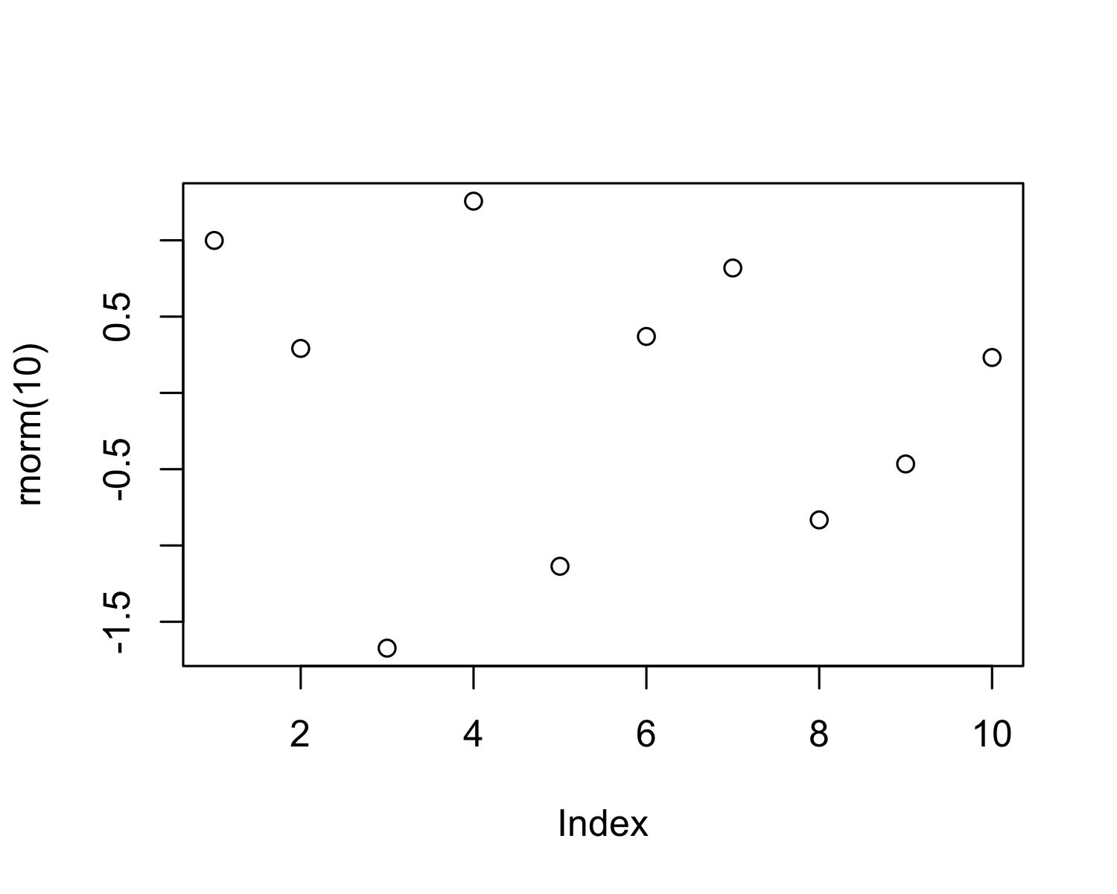

Figure 4.1: A plot of random numbers

Figure 4.1 shows how we can have a caption and cross-reference for a plot

Here is an example of inline code 3.14 in the middle of a sentence.

# 5 Discussion

# 6 Conclusion

# 7 Acknowledgements

# 8 References

Marwick, B., 2017. Computational reproducibility in archaeological research: Basic principles and a case study of their implementation. Journal of Archaeological Method and Theory 24, 424–450. <https://doi.org/10.1007/s10816-015-9272-9>

Riede, F., Hoggard, C., Shennan, S., 2019. Reconciling material cultures in archaeology with genetic data requires robust cultural evolutionary taxonomies. Palgrave Communications 5, 1–9. <https://doi.org/10.1057/s41599-019-0260-7>

### 8.0.1 Colophon

This report was generated on 2021-03-26 02:55:38 using the following computational environment and dependencies:

#> ─ Session info ───────────────────────────────────────────────────────────────  
#> setting value   
#> version R version 4.0.4 (2021-02-15)  
#> os macOS Catalina 10.15.7   
#> system x86_64, darwin17.0   
#> ui X11   
#> language (EN)   
#> collate en_US.UTF-8   
#> ctype en_US.UTF-8   
#> tz America/Los_Angeles   
#> date 2021-03-26   
#>   
#> ─ Packages ───────────────────────────────────────────────────────────────────  
#> package * version date lib source   
#> assertthat 0.2.1 2019-03-21 [1] CRAN (R 4.0.0)   
#> bookdown 0.21.7 2021-03-25 [1] Github (rstudio/bookdown@0cec2fd)   
#> cachem 1.0.4 2021-02-13 [1] CRAN (R 4.0.2)   
#> callr 3.5.1 2020-10-13 [1] CRAN (R 4.0.2)   
#> cli 2.3.1 2021-02-23 [1] CRAN (R 4.0.3)   
#> crayon 1.4.1 2021-02-08 [1] CRAN (R 4.0.2)   
#> desc 1.3.0 2021-03-05 [1] CRAN (R 4.0.4)   
#> devtools 2.3.2 2020-09-18 [1] CRAN (R 4.0.2)   
#> digest 0.6.27 2020-10-24 [1] CRAN (R 4.0.2)   
#> ellipsis 0.3.1 2020-05-15 [1] CRAN (R 4.0.0)   
#> evaluate 0.14 2019-05-28 [1] CRAN (R 4.0.0)   
#> fastmap 1.1.0 2021-01-25 [1] CRAN (R 4.0.2)   
#> fs 1.5.0 2020-07-31 [1] CRAN (R 4.0.2)   
#> glue 1.4.2 2020-08-27 [1] CRAN (R 4.0.2)   
#> highr 0.8 2019-03-20 [1] CRAN (R 4.0.0)   
#> htmltools 0.5.1.1 2021-01-22 [1] CRAN (R 4.0.2)   
#> knitr 1.31 2021-01-27 [1] CRAN (R 4.0.2)   
#> lifecycle 1.0.0 2021-02-15 [1] CRAN (R 4.0.2)   
#> magrittr 2.0.1 2020-11-17 [1] CRAN (R 4.0.2)   
#> memoise 2.0.0 2021-01-26 [1] CRAN (R 4.0.2)   
#> pkgbuild 1.2.0 2020-12-15 [1] CRAN (R 4.0.2)   
#> pkgload 1.2.0 2021-02-23 [1] CRAN (R 4.0.2)   
#> prettyunits 1.1.1 2020-01-24 [1] CRAN (R 4.0.0)   
#> processx 3.5.0 2021-03-23 [1] CRAN (R 4.0.2)   
#> ps 1.6.0 2021-02-28 [1] CRAN (R 4.0.4)   
#> purrr 0.3.4 2020-04-17 [1] CRAN (R 4.0.0)   
#> R6 2.5.0 2020-10-28 [1] CRAN (R 4.0.2)   
#> remotes 2.2.0 2020-07-21 [1] CRAN (R 4.0.2)   
#> rlang 0.4.10 2020-12-30 [1] CRAN (R 4.0.3)   
#> rmarkdown 2.7.4 2021-03-25 [1] Github (rstudio/rmarkdown@a11240d)  
#> rprojroot 2.0.2 2020-11-15 [1] CRAN (R 4.0.2)   
#> sessioninfo 1.1.1 2018-11-05 [1] CRAN (R 4.0.0)   
#> stringi 1.5.3 2020-09-09 [1] CRAN (R 4.0.2)   
#> stringr 1.4.0 2019-02-10 [1] CRAN (R 4.0.0)   
#> testthat 3.0.2 2021-02-14 [1] CRAN (R 4.0.2)   
#> usethis 2.0.1 2021-02-10 [1] CRAN (R 4.0.2)   
#> withr 2.4.1 2021-01-26 [1] CRAN (R 4.0.2)   
#> xfun 0.22 2021-03-11 [1] CRAN (R 4.0.2)   
#> yaml 2.2.1 2020-02-01 [1] CRAN (R 4.0.0)   
#>   
#> [1] /Library/Frameworks/R.framework/Versions/4.0/Resources/library

The current Git commit details are:

#> Local: /Users/bmarwick/Desktop/DialPast Reproducible Quantitative Research in Archaeology/preparation/mynewpaper  
#> Head: nothing commited (yet)