Robert C. Dunnell’s Systematics in Prehistory at 50

Felix Riede1,✉, and Ben Marwick3

18 July, 2021

2021 marks the fiftieth anniversary of the publication of Robert C. Dunnell’s (1971) diminutive yet dense Systematics in Prehistory. At the height of the debate between Culture History and New Archaeology, Dunnell’s work sought to address a more fundamental issue that was and still is relevant to all branches of prehistoric archaeology, and especially to the study of the Paleolithic: systematics. Dunnell himself was notorious and controversial, however, but the importance of his work remains underappreciated. Like other precocious works of that tumultuous time Systematics in Prehistory today remains absent from most course reading lists and gathers dust on library shelves. In this contribution we argue for a greater appreciation of its as yet unfulfilled conceptual and analytical promise. In particular, we briefly chart its somewhat delayed impact via evolutionary archaeology, including how it has also influenced non-Anglophone traditions, especially in South America. The obstinate persistence of classification issues in paleoanthropology and Paleolithic archaeology, we argue, warrants a second look at Dunnell’s Systematics.

1 Department of Archaeology and Heritage Studies, Aarhus University, Moesgård Allé 20, 8270 Højbjerg, Denmark  
2 Department of Anthropology, University of Washington, Seattle, WA, USA  
3 UofWA

✉ Correspondence: [Felix Riede <[f.riede@cas.au.dk](mailto:f.riede@cas.au.dk)>](mailto:f.riede@cas.au.dk)

Keywords: Systematics; Evolutionary archaeology; Cultural phylogenetics; Robert C. Dunnell

Highlights: These are the highlights.

## 1 INTRODUCTION

The notion of major paradigm shifts in the history of archaeology is characterized by a great deal of hyperbole and rhetorical maneuvering. That said, the late 1960s and 1970s really do stand out as rather revolutionary. In the US, the Binfordian steamroller increasingly hammered away at its culture-historical nemesis, while in the UK, David Clarke’s formidable *Analytical Archaeology* was shaking up the establishment with novel concepts, novel methods and an incisive rhetoric (Clarke, 1968). The reception and impact of these works has seen a great deal of attention in later years, especially as many researchers are rediscovering the merits of Clarke’s approach in particular (Lycett and Shennan, 2018; Nicholas, 2012). The year 2021 marks the fiftieth anniversary of the publication of Robert C. Dunnell’s (1971) diminutive yet dense *Systematics in Prehistory*, a volume that is concerned with nothing but classification in archaeology. Published at the height of the debate between Culture History and New Archaeology, Dunnell’s work was no less iconoclastic than that of Binford or Clarke, but it was considerably narrower in its endeavor to address a more fundamental issue that was and still is relevant to all branches of prehistoric archaeology, and especially to the study of the Paleolithic: systematics.

Dunnell himself was notorious and controversial, and his *Systematics* was received with mixed reactions by his contemporaries who commented - mostly negatively - both on his style of writing and the book’s content (Bayard, 1973; Shenkel, 1973; Spaulding, 1974; Tuggle, 1974). Like other precocious works of that tumultuous time *Systematics in Prehistory* today remains absent from most course reading lists and gathers dust on library shelves. As Lyman has recently shown, systematics takes up little space in contemporary archaeological research or teaching (Lyman, 2021). If at least some of the success of Clarke and Binford can be attributed to them boldly tackling exciting and large-scale topics such as migration and adaptation using then avant-garde terminology, then the corresponding obscurity of Dunnell’s *Systematics* can perhaps be attributed to him focusing on an issue that simply seemed too uninteresting. Furthermore, archaeology has moved ahead in such a way that leaves some of the key claims *Systematics* exposed as a distinct outliers in modern American archaeology. For example, his insistence that the exclusive focus of archaeology be the physical traces of pasts human activity, and that archaeology cannot be both a science and a sub-discipline of anthropology, are generally minority positions now, with archaeology continuing to be a sub-field of anthropology in most US universities. Yet, Dunnell was correct in his axiomatic insistence that rigorous classification comes before any other analysis or interpretation. Without consistent and explicit classification, any scientific discipline will inevitably fail to produce cumulative insights.

## 2 SYSTEMATICS IN PREHISTORY AND THE EMERGENCE OF EVOLUTIONARY ARCHAEOLOGY

For Dunnell himself, the soul-searching that began with writing *Systematics in Prehistory* led him to discover evolutionary theory. In a series of follow-up papers, he forcefully argued for the benefits of a scientific and Darwinian archaeology (Dunnell, 1982, 1980). While not making him many friends, these writings have since become foundational for the development of evolutionary archaeology, especially in the Americas (O’Brien, 1996). Initially, following the direct lead of Dunnell, this approach was rather narrowly selectionist - treating artefacts as the hard parts of the human phenotype and selection acting on these as the main driver of change (O’Brien and Holland, 1990) - but which since has become more fully aligned with cultural evolutionary thinking in the form of dual-inheritance and niche construction theory (Marwick, 2006; Riede, 2019). Vitally, cultural evolutionary theory and its focus on the transmission of cultural knowledge via various modes of learning has provided the generative mechanism for material culture systematics. In its contemporary form, selection, but also drift and a range of transmission biases, play important roles in explaining culture change.

While Dunnell worked exclusively on the Holocene prehistory of the Americas, the idiosyncrasies of archaeological classification are nowhere more apparent and acute than in the archaeology of human evolutionary history. Rooted in French antiquarianism, the development of Paleolithic systematics has been likened to ‘accidents of history’ (Clark, 2009), and there are few periods or regions of the Paleolithic that have not seen debate about the validity or otherwise of their analytical units (Reynolds and Riede, 2019). The use of, more often than not, older typological classifications remains prevalent, despite clear and repeated critiques (e.g. Bisson, 2000). More recently, the analysis of technological traits has supplemented or even eclipsed purely typological approaches. However, theoretical explications of the generative mechanisms, and rigorous comparative systematics backed by transparent and replicable analytics as demanded by Dunnell, remain exceptions rather than the rule (Tostevin, 2013). Today, a great deal attention is being paid to systematics in prehistory, and as Barton and Clark (2021) have pointed out, the continuing adherence to outmoded classifications is preventing the exploration of more relevant and pressing research questions . Several researchers are tackling classificatory issues with novel and mostly quantitative means (Grove and Blinkhorn, 2021; Ivanovaitė et al., 2020; Leplongeon et al., 2020). At the same time, however, it appears that the topic remains poorly heeded in archaeological teaching (Lyman, 2021). Given that cultural evolutionary theory itself teaches us that aspects of culture most easily and rapidly change when scaffolded through active teaching (Riede et al., 2021), we suggest that, after half a century, Dunnell’s *Systematics in Prehistory* - and with it rigorous and replicable ways of classifying material culture - are placed more abundantly on our curricula, in addition to continuing the ongoing critique and transformation of existing classifications through novel research. Only when the construction and meaning of our analytical units and their relationships among one another are transparent, and robust cultural taxonomies are in place can we seriously hope to understand the patterns and processes that have shaped cultural evolution in deep history.

## 3 THE CONTRIBUTION OF *SYSTEMATICS*

To survey the contribution that *Systematics in Prehistory* has made to evolutionary anthropology, we take inspiration from its concept of statistical clustering as a method for organising variability, and recent developments in the statistical analysis of texts. We searched for items citing *Systematics in Prehistory* on Google Scholar, downloaded all the search result pages (data were collected on July 2021), and extracted bibliographic data from each work citing *Systematics*. The raw data and R code for our analysis of the Google Scholar results are openly available online at <http://doi.org/xxx/xxx>.

We found 475 citations of *Systematics*, for reference the most highly cited archaeology publication from the same year is Binford’s (1971) ‘Mortuary Practices: Their Study and Their Potential’ with 1621 citations currently on Google Scholar. Citations to *Systematics* have steadily accumulated over time, with a distinct increase in the annual rate of citation in the early 2000s as evolutionary concepts become increasingly integrated into archaeological science (Figure 1). Several works that cite *Systematics* have themselves been very highly cited, with ten publications receiving over 500 citations, demonstrating its influence over a range of topics including social theory (Shanks and Tilley, 1987), behavioural archaeology (Schiffer, 2016), and lithics (Andrefsky, 1998) and. Looking at the top fifty words in the titles of the works citing *Systematics*, we can also see that ‘lithics’ and ‘stone’ are prominent, indicating that its contribution was especially noted by archaeologists working on stone artefacts (Figure 2). Pottery are the only other artefact type where analysts substantially engaged with *Systematics*. Notable in the title keywords are words relating to evolution, for example, ‘transmission,’ ‘variation,’ and ‘evolutionary.’ Evolution is a very minor theme in *Systematics*, but it has proven to be a foundational text in applications of evolutionary theory to explaining variability in the archaeological record. Beyond the Anglosphere, we see citations from a small number works in Russian and European languages, but the impact of *Systematics* is most evident in Spanish-language publications by scholars working on South American stone artefact assemblages.

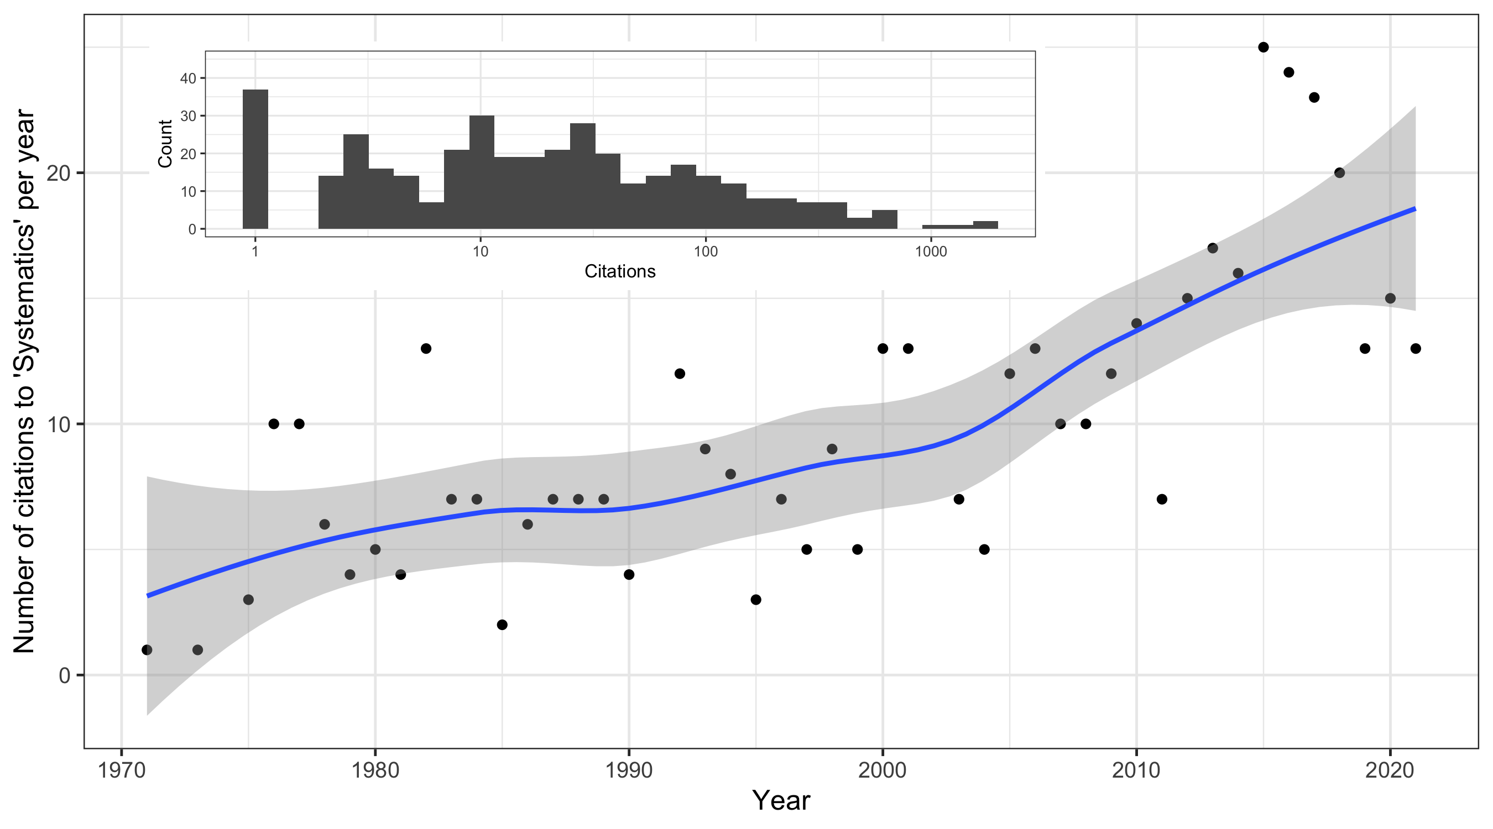

Figure 1: Citations to ‘Systematics’ over time. Inset shows distributions of citations to works citing ‘Systematics.’ Data collected from Google Scholar on July 2021

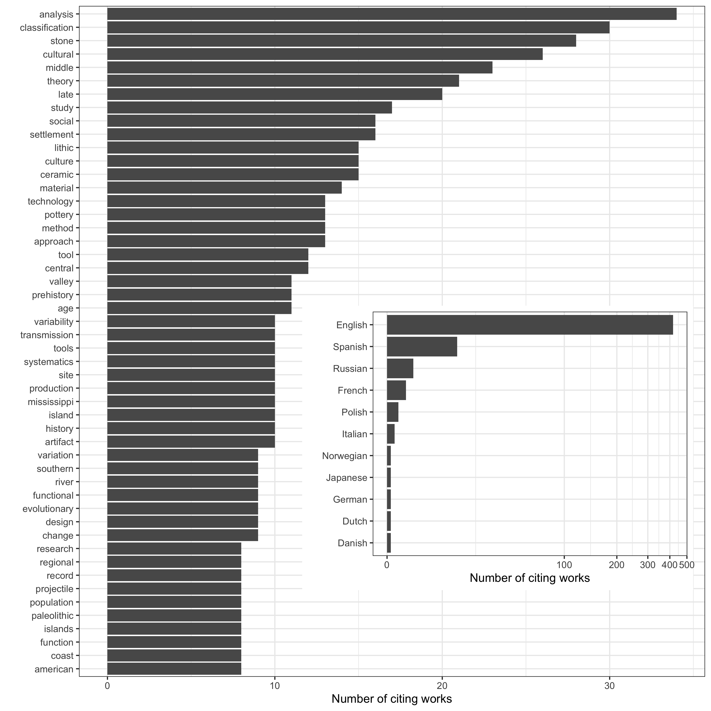

Figure 2: Keywords in titles of works citing ‘Systematics.’ Inset shows languages of works citing ‘Systematics’

These South American studies have been especially innovative, taking to heart the critique in *Systematics* that archaeological typologies are often intuitive, arbitrary, and difficult to replicate by other researchers. Motivated by this critique, scholars such as Marcelo Cardillo, Judith Charlin and others have done pioneering work in the application of geometric morphometry to stone artefact assemblages to provide a materialist view of technological variation where the focus is on continuous quantitative phenomena. While geometric morphometry has been applied by archaeologists to a range of regions and artefact types (including ceramic and metal), what makes this South American work remarkable as part of the legacy of *Systematics* is their exploration of phylogenetic comparative methods to model and quantify technological variation and change over space and time (e.g. Cardillo and Alberti, 2015). These works show that one of the most important contributions of *Systematics* has been as a bridge between archaeology and cognate fields, for example, palaeontology, dealing with challenges of classification and concerned with modelling macroevolutionary processes. The bridge-building that has followed from this has been a fruitful, as we can see from the increasing number of archaeological presentations at meetings of the Cultural Evolution Society.



Figure 3: Left: Top twenty topics in titles of works citing ‘Systematics.’ The gamma value indicates their overall abunadnace, and the topics are labelled with the most heavily weighted words in each topic. Right upper: Clusters of citing works according to topic similarity, with clusters labelled by the most prominent topic. Clusters were computed by Principle Components Analysis of the topic proportions in each citing work, then a t-SNE to reduce dimensionality, and density based clustering and to identify clusters. Each data point is one document. Right lower: Plot of topics showing coherence and exlusivity metrics for each topic. Each data point is one topic

The South American research stands out as a distinctly coherent and exclusive topic (Topic 59) in our topic model of titles of works citing *Systematics* (Figure 3). A topic model is an unsupervised classification of a collection of documents, in this case titles, that uses a probabilistic model to generate mixtures of words that represent themes or topics in the collection (Roberts et al., 2016; Roberts et al., 2014). This finds natural groups of topics similar to how clustering on numeric data finds groups of similar items. We generated a topic model using Latent Dirichlet Allocation method, which resulted in an optimal number of 76 topics. The topic model shows the persistence of the core themes of *Systematics* in the citing literature, with the most abundant and central topic (Topic 53) about the measurement of material culture variation, and transmission of that variation. The topic model provides additional insights into the contribution of *Systematics* that are not evident in the word frequency analysis. The archaeology of the central and southern Pacific Ocean stands out, includes works on Polynesian fish hooks, fabrics and stone adzes. Rapa Nui has its own topic, representing the work of Carl Lipo and colleagues on pottery, monuments and population dynamics of that island and the region. Lipo’s work is thoroughly grounded in a concern for rigorous and explicit unit construction and innovative testing of archaeological systematics, noting that ‘Systematics enables us to move beyond common sense’ (Lipo et al., 2021). We see a concern for the construction of analytical units in areas as diverse as the Palaeolithic of Africa, ceramics of the Maya and Papua New Guinea, and several regions of the Unites States.

While the influence of *Systematics* has extended well beyond Dunnell’s own primary study area of the US Southeast, there are some notable limits to its contributions. In our data we see only work in an East or Southeast Asian language, a book chapter in Japanese surveying the literature on cultural phylogenetics, indicating limited attention to *Systematics* from researchers in the Eastern hemisphere. Could it be that cultural differences in reasoning styles (Henrich et al., 2010) result in a diminished relevance for the philosophical content of *Systematics* outside of Western academic communities? Or perhaps it is simply that book is quite difficult to read, a detail noted by the reviewers when it was first published (‘confusion followed by grudging agreement’ is how Spaulding (Spaulding, 1974) described his reaction to the book), and acknowledged by Dunnell in his forward to the 2002 edition. The low readability of the book likely limited the accessibility of its contents for readers whose first language is not English. A second limitation, or maybe better described as an unrealised contribution, of *Systematics* is the absence of a distinct research area and community of archaeological systemics. While biology has a Society of Systematic Biologists, and journals such as *Systematic Biology*, *Systematics and Evolution*, and *Systematics and Biodiversity*, archaeology has no equivalent focal points for discussions of systematics that transcends specific geographical and chronological concerns. *Systematics* was not a work that provided a universal motor force for moving archaeologists together at scale to tackle questions about the formation of units of measurement and classification. Instead these discussions happen deep within discrete research communities, constrained by the culture and norms of those groups.

Dunnell intended *Systematics* to establish a distinctive form of scientific archaeology, and it faced overwhelming competition from the program advocated by New Archaeology, which dominated the literature in the decade after the publication of *Systematics*. What makes *Systematics* a classic contribution is that is provides archaeologists with the master key to release themselves from the ‘prison of de Mortillet’ (Shea, 2016, p. xvii), namely the inherited and entrenched habits of research traditions (Gabriel de Mortillet, 1821–1898, was an archaeologist who published the first widely used classification of the Paleolithic, much of which remains in use today). *Systematics* endures as a striking and precocious provocation to archaeologists to be transparent, rigorous, precise, and deliberate about how we divide up and aggregate material culture and the measurements we take from it to describe and explain the human experience in the past. With archaeologists increasingly pursuing ambitious questions about evolutionary processes that require large scale syntheses of disparate datasets, the message of *Systematics* will only become more relevant.

# Acknowledgements

# References

Andrefsky, W., 1998. Lithics: A macroscopic approach. Cambridge University Press.

Barton, C.M., Clark, G.A., 2021. From artifacts to cultures: Technology, society, and knowledge in the upper paleolithic. Journal of Paleolithic Archaeology 4, 16. <https://doi.org/10.1007/s41982-021-00091-8>

Bayard, D.T., 1973. ’Prehistory: A systematic science?’: A review of robert c. Dunnell’s "systematics in prehistory" (book review). Mankind 9, 39.

Binford, L.R., 1971. Mortuary practices: Their study and their potential. Memoirs of the Society for American Archaeology 25, 6–29.

Bisson, M.S., 2000. Nineteenth century tools for twenty-first century archaeology? Why the middle paleolithic typology of françois bordes must be replaced. Journal of Archaeological Method and Theory 7, 1–48. https://doi.org/<http://dx.doi.org/10.1023/A:1009578011590>

Cardillo, M., Alberti, J., 2015. The evolution of projectile points and technical systems: A case from northern patagonian coast (argentina). Journal of Archaeological Science: Reports 2, 612–623.

Clark, G.A., 2009. Accidents of history: Conceptual frameworks in paleoarchaeology, in: Camps, M., Chauhan, P. (Eds.),. Springer New York, New York, NY, pp. 19–41.

Clarke, D.L., 1968. Analytical archaeology. Methuen & Co., London.

Dunnell, R.C., 1982. Science, social science, and common sense: The agonizing dilemma of modern archaeology. Journal of Anthropological Research 38, 1–25.

Dunnell, R.C., 1980. Evolutionary theory in archaeology. Advances in Archaeological Method and Theory 3, 35–99.

Dunnell, R.C., 1971. Systematics in prehistory. The Free Press, New York.

Grove, M., Blinkhorn, J., 2021. Testing the integrity of the middle and later stone age cultural taxonomic division in eastern africa. Journal of Paleolithic Archaeology 4, 14. <https://doi.org/10.1007/s41982-021-00087-4>

Henrich, J., Heine, S.J., Norenzayan, A., 2010. The weirdest people in the world? Behavioral and brain sciences 33, 61–83.

Ivanovaitė, L., Serwatka, K., Hoggard, C.S., Sauer, F., Riede, F., 2020. All these fantastic cultures? Research history and regionalization in the late palaeolithic tanged point cultures of eastern europe. European Journal of Archaeology 23, 162–185. <https://doi.org/10.1017/eaa.2019.59>

Leplongeon, A., Ménard, C., Bonhomme, V., Bortolini, E., 2020. Backed pieces and their variability in the later stone age of the horn of africa. African Archaeological Review 37, 437–468. <https://doi.org/10.1007/s10437-020-09401-x>

Lipo, C.P., HUNT, T.L., DINAPOLI, R.J., Thompson, V.D., 2021. Temporal systematics: The colonization of rapa nui (easter island) and the conceptualization of time, in: The Archaeology of Island Colonization: Global Approaches to Initial Human Settlement. University Press of Florida, pp. 61–86.

Lycett, S.J., Shennan, S.J., 2018. David clarke’s analytical archaeology at 50. World Archaeology 50, 210–220. <https://doi.org/10.1080/00438243.2018.1470561>

Lyman, R.L., 2021. On the importance of systematics to archaeological research: The covariation of typological diversity and morphological disparity. Journal of Paleolithic Archaeology 4, 3. <https://doi.org/10.1007/s41982-021-00077-6>

Marwick, B., 2006. What can archaeology do with boyd and richerson’s cultural evolutionary program? The Review of Archaeology 26, 30–40.

Nicholas, G.P., 2012. “Making us uneasy”: Clarke, wobst, and their critique of archaeology put into practice. Archaeologies 8, 209–224. <https://doi.org/10.1007/s11759-012-9204-1>

O’Brien, M.J., 1996. The historical development of an evolutionary archaeology, in: Maschner, H.D.G. (Ed.),. Springer US, Boston, MA, pp. 17–32. <https://doi.org/10.1007/978-1-4757-9945-3_2>

O’Brien, M.J., Holland, T.D., 1990. Variation, selection, and the archaeological record, in: Schiffer, M.B. (Ed.),. University of Arizona Press, Tucson, AZ, pp. 31–79.

Reynolds, N., Riede, F., 2019. House of cards: cultural taxonomy and the study of the European Upper Palaeolithic. Antiquity 93, 1350–1358. <https://doi.org/10.15184/aqy.2019.49>

Riede, F., 2019. Niche construction theory and human biocultural evolution, in: Prentiss, A.M. (Ed.),. Springer International Publishing, Cham, pp. 337–358. <https://doi.org/10.1007/978-3-030-11117-5_17>

Riede, F., Walsh, M.J., Nowell, A., Langley, M.C., Johannsen, N.N., 2021. Children and innovation: Play, play objects and object play in cultural evolution. Evolutionary Human Sciences 3. <https://doi.org/10.1017/ehs.2021.7>

Roberts, M.E., Stewart, B.M., Airoldi, E.M., 2016. A model of text for experimentation in the social sciences. Journal of the American Statistical Association 111, 988–1003. <https://doi.org/10.1080/01621459.2016.1141684>

Roberts, M.E., Stewart, B.M., Tingley, D., others, 2014. Stm: R package for structural topic models. Journal of Statistical Software 10, 1–40.

Schiffer, M.B., 2016. Behavioral archaeology: Principles and practice. Routledge.

Shanks, M., Tilley, C.Y., 1987. Social theory and archaeology. Polity Press Cambridge.

Shea, J.J., 2016. Stone tools in human evolution: Behavioral differences among technological primates. Cambridge University Press.

Shenkel, J.R., 1973. Archeology: Systematics in prehistory. ROBERT c. DUNNELL. American Anthropologist 75, 505–506. https://doi.org/<https://doi.org/10.1525/aa.1973.75.2.02a01030>

Spaulding, A.C., 1974. Review: Systematics in prehistory by robert c. dunnell. American Antiquity 39, 513516.

Tostevin, G.B., 2013. Seeing lithics: a middle-range theory for testing for cultural transmission in the Pleistocene, American school of prehistoric research monograph series. Oxbow Books, Oxford.

Tuggle, H.D., 1974. Plains Anthropologist 19, 7678.

### Colophon

This report was generated on 2021-07-18 15:57:46 using the following computational environment and dependencies:

#> ─ Session info ───────────────────────────────────────────────────────────────  
#> setting value   
#> version R version 4.0.5 (2021-03-31)  
#> os macOS Catalina 10.15.7   
#> system x86_64, darwin17.0   
#> ui X11   
#> language (EN)   
#> collate en_US.UTF-8   
#> ctype en_US.UTF-8   
#> tz America/Los_Angeles   
#> date 2021-07-18   
#>   
#> ─ Packages ───────────────────────────────────────────────────────────────────  
#> ! package * version date lib source   
#> P assertthat 0.2.1 2019-03-21 [?] CRAN (R 4.0.0)  
#> P backports 1.2.1 2020-12-09 [?] CRAN (R 4.0.2)  
#> P bookdown 0.22 2021-04-22 [?] CRAN (R 4.0.2)  
#> P broom 0.7.6 2021-04-05 [?] CRAN (R 4.0.2)  
#> P cachem 1.0.5 2021-05-15 [?] CRAN (R 4.0.2)  
#> P callr 3.7.0 2021-04-20 [?] CRAN (R 4.0.2)  
#> P cellranger 1.1.0 2016-07-27 [?] CRAN (R 4.0.0)  
#> P cli 2.5.0 2021-04-26 [?] CRAN (R 4.0.2)  
#> P codetools 0.2-18 2020-11-04 [?] CRAN (R 4.0.5)  
#> P colorspace 2.0-1 2021-05-04 [?] CRAN (R 4.0.2)  
#> P crayon 1.4.1 2021-02-08 [?] CRAN (R 4.0.2)  
#> P data.table 1.14.0 2021-02-21 [?] CRAN (R 4.0.2)  
#> P DBI 1.1.1 2021-01-15 [?] CRAN (R 4.0.2)  
#> P dbplyr 2.1.1 2021-04-06 [?] CRAN (R 4.0.2)  
#> P desc 1.3.0 2021-03-05 [?] CRAN (R 4.0.2)  
#> P devtools 2.4.1 2021-05-05 [?] CRAN (R 4.0.4)  
#> P digest 0.6.27 2020-10-24 [?] CRAN (R 4.0.2)  
#> P dplyr * 1.0.6 2021-05-05 [?] CRAN (R 4.0.4)  
#> P ellipsis 0.3.2 2021-04-29 [?] CRAN (R 4.0.2)  
#> P evaluate 0.14 2019-05-28 [?] CRAN (R 4.0.0)  
#> P fansi 0.5.0 2021-05-25 [?] CRAN (R 4.0.2)  
#> P fastmap 1.1.0 2021-01-25 [?] CRAN (R 4.0.2)  
#> P fastmatch 1.1-0 2017-01-28 [?] CRAN (R 4.0.0)  
#> P forcats * 0.5.1 2021-01-27 [?] CRAN (R 4.0.2)  
#> P fs 1.5.0 2020-07-31 [?] CRAN (R 4.0.2)  
#> P generics 0.1.0 2020-10-31 [?] CRAN (R 4.0.2)  
#> P ggplot2 * 3.3.3 2020-12-30 [?] CRAN (R 4.0.2)  
#> P glue 1.4.2 2020-08-27 [?] CRAN (R 4.0.2)  
#> P gtable 0.3.0 2019-03-25 [?] CRAN (R 4.0.0)  
#> P haven 2.4.1 2021-04-23 [?] CRAN (R 4.0.2)  
#> P here 1.0.1 2020-12-13 [?] CRAN (R 4.0.2)  
#> P highr 0.9 2021-04-16 [?] CRAN (R 4.0.2)  
#> P hms 1.1.0 2021-05-17 [?] CRAN (R 4.0.2)  
#> P htmltools 0.5.1.1 2021-01-22 [?] CRAN (R 4.0.2)  
#> P httr 1.4.2 2020-07-20 [?] CRAN (R 4.0.2)  
#> P igraph 1.2.6 2020-10-06 [?] CRAN (R 4.0.2)  
#> P jsonlite 1.7.2 2020-12-09 [?] CRAN (R 4.0.2)  
#> P knitr 1.33 2021-04-24 [?] CRAN (R 4.0.2)  
#> P lattice 0.20-44 2021-05-02 [?] CRAN (R 4.0.2)  
#> P lifecycle 1.0.0 2021-02-15 [?] CRAN (R 4.0.2)  
#> P lubridate 1.7.10 2021-02-26 [?] CRAN (R 4.0.2)  
#> P magrittr 2.0.1 2020-11-17 [?] CRAN (R 4.0.2)  
#> P Matrix 1.3-3 2021-05-04 [?] CRAN (R 4.0.2)  
#> P memoise 2.0.0 2021-01-26 [?] CRAN (R 4.0.2)  
#> P modelr 0.1.8 2020-05-19 [?] CRAN (R 4.0.0)  
#> P munsell 0.5.0 2018-06-12 [?] CRAN (R 4.0.0)  
#> P pillar 1.6.1 2021-05-16 [?] CRAN (R 4.0.2)  
#> P pkgbuild 1.2.0 2020-12-15 [?] CRAN (R 4.0.2)  
#> P pkgconfig 2.0.3 2019-09-22 [?] CRAN (R 4.0.0)  
#> P pkgload 1.2.1 2021-04-06 [?] CRAN (R 4.0.2)  
#> P prettyunits 1.1.1 2020-01-24 [?] CRAN (R 4.0.0)  
#> P processx 3.5.2 2021-04-30 [?] CRAN (R 4.0.2)  
#> P ps 1.6.0 2021-02-28 [?] CRAN (R 4.0.2)  
#> P purrr * 0.3.4 2020-04-17 [?] CRAN (R 4.0.0)  
#> P quanteda * 3.0.0 2021-04-06 [?] CRAN (R 4.0.2)  
#> P R6 2.5.0 2020-10-28 [?] CRAN (R 4.0.2)  
#> P Rcpp 1.0.6 2021-01-15 [?] CRAN (R 4.0.2)  
#> P RcppParallel 5.1.4 2021-05-04 [?] CRAN (R 4.0.2)  
#> P readr * 1.4.0 2020-10-05 [?] CRAN (R 4.0.2)  
#> P readxl 1.3.1 2019-03-13 [?] CRAN (R 4.0.0)  
#> remotes 2.4.0 2021-06-02 [1] CRAN (R 4.0.2)  
#> renv 0.13.2 2021-03-30 [1] CRAN (R 4.0.2)  
#> P reprex 2.0.0 2021-04-02 [?] CRAN (R 4.0.2)  
#> P rlang 0.4.11 2021-04-30 [?] CRAN (R 4.0.2)  
#> P rmarkdown 2.8 2021-05-07 [?] CRAN (R 4.0.4)  
#> P rprojroot 2.0.2 2020-11-15 [?] CRAN (R 4.0.2)  
#> P rstudioapi 0.13 2020-11-12 [?] CRAN (R 4.0.2)  
#> P rvest 1.0.0 2021-03-09 [?] CRAN (R 4.0.2)  
#> P scales 1.1.1 2020-05-11 [?] CRAN (R 4.0.0)  
#> P sessioninfo 1.1.1 2018-11-05 [?] CRAN (R 4.0.0)  
#> P stopwords 2.2 2021-02-10 [?] CRAN (R 4.0.2)  
#> P stringi 1.6.2 2021-05-17 [?] CRAN (R 4.0.2)  
#> P stringr * 1.4.0 2019-02-10 [?] CRAN (R 4.0.0)  
#> P tarchetypes * 0.2.1 2021-06-21 [?] CRAN (R 4.0.2)  
#> P targets * 0.4.2 2021-04-30 [?] CRAN (R 4.0.2)  
#> P testthat 3.0.2 2021-02-14 [?] CRAN (R 4.0.2)  
#> P tibble * 3.1.2 2021-05-16 [?] CRAN (R 4.0.2)  
#> P tidyr * 1.1.3 2021-03-03 [?] CRAN (R 4.0.2)  
#> P tidyselect 1.1.1 2021-04-30 [?] CRAN (R 4.0.2)  
#> P tidyverse * 1.3.1 2021-04-15 [?] CRAN (R 4.0.2)  
#> P usethis 2.0.1 2021-02-10 [?] CRAN (R 4.0.2)  
#> P utf8 1.2.1 2021-03-12 [?] CRAN (R 4.0.2)  
#> P vctrs 0.3.8 2021-04-29 [?] CRAN (R 4.0.2)  
#> P withr 2.4.2 2021-04-18 [?] CRAN (R 4.0.2)  
#> P xfun 0.23 2021-05-15 [?] CRAN (R 4.0.2)  
#> P xml2 1.3.2 2020-04-23 [?] CRAN (R 4.0.0)  
#> P yaml 2.2.1 2020-02-01 [?] CRAN (R 4.0.0)  
#>   
#> [1] /Users/bmarwick/Desktop/systematicsinprehistory/renv/library/R-4.0/x86_64-apple-darwin17.0  
#> [2] /private/var/folders/mz/6nn330m17_37ck5hhz2p24100000gn/T/Rtmpd69Hsk/renv-system-library  
#> [3] /private/var/folders/mz/6nn330m17_37ck5hhz2p24100000gn/T/RtmpuySCMm/renv-system-library  
#>   
#> P ── Loaded and on-disk path mismatch.

The current Git commit details are:

#> Local: master /Users/bmarwick/Desktop/systematicsinprehistory  
#> Remote: master @ origin (git@github.com:benmarwick/systematicsinprehistory.git)  
#> Head: [6020fad] 2021-06-26: minor edits to the text, add renv