Why is Scotland’s reconviction rate falling?

-1 words

Ben Matthews and Josiah King

## Overview

* The crime drop has changed the demographics of people being convicted
* Changing demographics of people convicted complicates comparisons in the aggregate reconviction rate over time
* The overall change in the reconvictions rate is partly due to less reconvictions and partly due to changing demographics
* This creates statistical bias in the aggregate reconviction rate if it’s used as a measure of ‘effectiveness’ of the justice system
* We demonstrate this problem with a worked example using Scottish reconvictions data

# Part One: The crime drop in Scotland

Over the past thirty years or so Scotland has seen consistent falls in police recorded crime, the number of people proceeded against in court, and since at least the late 2000s, the prevalence of victimization[1] (see Figure One) This overall picture of declining crime levels across multiple measures of crime - at least as is captured by standard measures like those listed above - follows a familiar pattern seen across many parts of the global north known as the ‘crime drop’.

## Less crime

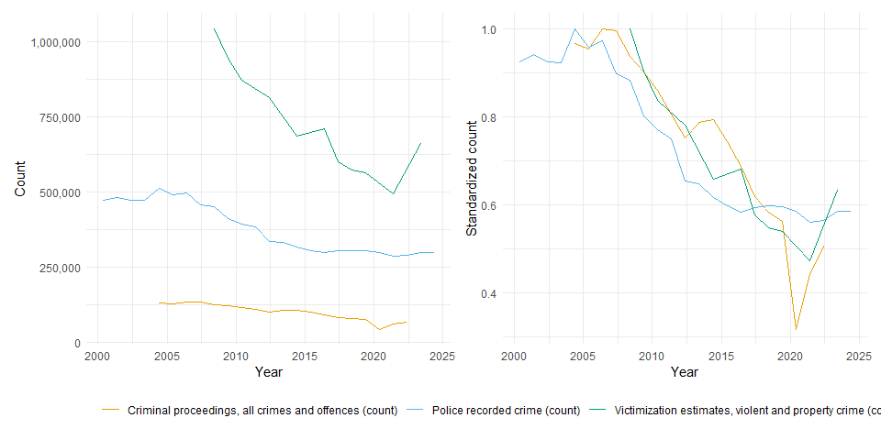

## The overall reconviction rate is falling

## A gap in the crime drop

There has been *a lot* written about the causes of the crime drop (Farrell, Tilley, and Tseloni 2014; Tonry 2014; Ball et al. 2023). Crime drop research has seen many (how many) papers published describing change over time in empirical patterns of crime across the globe, from neighbourhood-level analysis (Bannister, Bates, and Kearns 2018) to global (Dijk, Nieuwbeerta, and Joudo Larsen 2022) analysis, with national Atak (2020) and regional analysis (Aebi and Linde 2010) in between. There is a structure common to many of these analysis (including my own previous work on the topic (Matthews and Minton 2018a)): empirical evidence about how patterns of crime have changed is presented, and then are weighed against rival explanations for *why* crime has fallen.

Whilst many studies of the crime drop focus on describing change in recorded crime, victimization or conviction rates, an group of studies have focused on describing changes in the demographics of crime and use these descriptions to build explanations for why there is less crime now than in the past (Matthews and Minton 2018b; Tuttle 2024; Farrell, Laycock, and Tilley 2015). In Scotland, the key finding of past examinations of the changing demographics of crime is that “the crime drop is a *youth* crime drop” (Matthews and Minton 2018b, 300) - the fall in overall convictions overall between 1989 and 2011 primarily reflected lower conviction rates for young people and in fact hid *increases* in conviction rates for those aged 30 to 40. People aged 16-24 have also shown larger falls in victimization in Scotland compared to any other age group (Matthews, McVie, and Norris, n.d.). Preliminary evidence suggests that Scotland may be distinctive in the scale of this youth crime drop compared to other jurisdictions in Northern Europe (Matthews 2023), with Scandinavian countries showing falls in youth crime but to a lesser degree, and other studies focusing on the USA have also shown greater falls in arrests for young people compared to older people over the couse of the crime drop (Farrell, Laycock, and Tilley 2015; Tuttle 2024). Recent studies of the age-crime curve outside the Global North (Kang and Hureau 2022; Steffensmeier, Slepicka, and Schwartz 2025) suggest that the ‘typical’ age-crime curve with a peak in adolescence may itself by typical only within the Global North.

However, with so much focus on the effort to understand - or debunk (see Kotzé 2019) - the crime drop, there has not to our knowledge been any focus on systematically understanding the downstream implications of the crime drop for how we empirically measure the functioning of the justice system. There haven’t - at least as far as I’m aware - been any studies which go on to explore the *consequences* of these changing demographics for the justice system more broadly. One particular area these changing demographics can matter are when measuring CJS ‘performance’. In this paper we will demonstrate that the changing demographics of conviction, and particularly the falling proportion of younger people as part of the population receiving criminal convictions, has further pushed down reconviction rates in a way that has nothing to do with the functioning of the justice system in ‘rehabilitating’ people who have been convicted. This matters because reconviction rates are used as performance measures of the criminal justice system.

# Part Two: Measuring Justice System ‘Performance’

## Reconviction rates as a performance metric

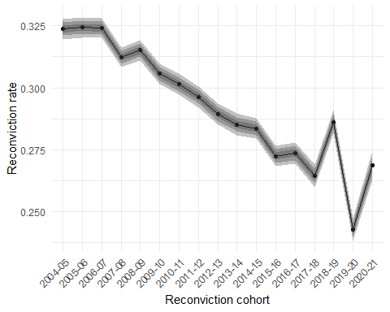

* Move to National Targets under New Labour in 2000s, with goals for reductions in reoffending (see Kirkwood)

In 2007 ‘Reduce overall reconviction rates by 2 percentage points by 2011’ was introduced as a National Indicator. This was revised to ‘Reduce reconviction rates’ in 2012 (West Lothian Council), and then removed following the 2018 National Performance Framework review (SPICe). Whilst not as emphasised in national level performance management, reducing reconviction rates are still widely seen as an important measure of how the criminal justice system is functioning. The Sentencing Council (for England and Wales) says the reconviction rate is a “key metric for evaluating the effectiveness of sentencing” (Gormley, Hamilton, and Belton 2022, p18). In Northern Ireland, NISRA says “The ability to compare and discuss trends in reoffending is important to its usefulness as a performance target within government” (Browne 2024, p19). Scottish Government says “Measuring recidivism is important, as it is one indicator of the effectiveness of the criminal justice system in the rehabilitation of offenders. Reconviction rates are a proxy measure for recidivism” (Scottish Government 2024, p8). The common logic across England and Wales, Scotland and Northern Ireland is that if the aggregate reconviction rate goes down then the criminal justice system is doing a better job at rehabilitating offenders.

However, it’s far from straightforward to use reconviction rates as performance measures. A simple comparison of reconviction rates in different years is a poor performance measure because there could be lots of reasons the overall reconviction rate might fall that aren’t due to how ‘effective’ the justice system is. One possible counfounding factor is that the characteristics of the convicted population are likely to vary over time; as Browne puts it “differences in the offending related characteristics of those included in each cohort make comparing reoffending rates problematic, across both time and jurisdictions.” (Browne 2024, p19). This changing demographic mix can distort comparisons of overall reconviction rates because we can think of the overall reconviction rate as a *weighted* mean of the reconviction rates in different demographic groups, weighted by the relative group size. You can have changes in the rate due to changes in the means or changes in the rates - this phenomenon is known in the statistical literature as the amalgamation paradox (Good and Mittal 1987) or Simpson’s (1951) paradox. Any change in the aggregate reconviction rate will be both due to changes in the prevalence of reconviction amongst demographic groups, but also the mix/composition of those groups who are in each reconviction cohort.

We can describe this situation more formally as:

To use reconviction rates as measures of criminal justice system ‘performance’ you would only want to measure change in the subgroup rates - but change in the overall rate can come from either changes in the subgroup rates *or changes in the subgroup sizes*. This is not just an abstract maths problem. The following example comes from Kirkwood (2008). Comparing reconviciton rates for 1995/96 and 2003/04 leads to the unexpected situtation where reconviction rates in Scotland increased for both men and women, but the overall reconviction rate stayed the same (see Table One). This puzzling situation is explained because of the increasing proportions of women as part of the overall reconvictions cohort. As women consistently had lower reconviction rates than men, the overall reconviction rate was pulled down as women made up a larger proportion of the reconviction cohort.

## The amalgamation paradox in reconviction rates

Table 1: Reconviction rates in Scotland, 1995/6 and 2003/04

|  | Reconviction rate | |  | Proportion of people convicted | |
| --- | --- | --- | --- | --- | --- |
| Sex | 1995/96 | 2003/04 | Change | 1995/96 | 2003/04 |
| Men | 0.46 | 0.47 | Increasing | 0.86 | 0.84 |
| Women | 0.31 | 0.37 | Increasing | 0.14 | 0.16 |
| Total | 0.45 | 0.45 | No change | - | - |
| Source: Kirkwood (2008) | | | | | |

This is situation causes problems if you want to use the overall reconviction rate as a performance measure, and to equate a falling reconviction rate with improved justice system performance:

“If the target for a reduction in the overall reconviction rate is met, and this is mainly due to more people with a lower likelihood of re-offending being brought into the criminal justice system and being convicted, rather than through a reduction in rates of re-offending among those who would normally be brought into the system, this would bring little cause for celebration.” (Kirkwood 2008, p9)

## Standardized reconviction rates as performance indicators

This compositional problem is well known in studies of reconviction rates, particularly those focused on measuring performance. The typical solution adopted is to come up with some counterfactual ‘standardized’ reconviction rate in order to facilitate comparisons across years when measuring performance (Francis, Harman, and Humphreys 2005; Cunliffe and Shepherd 2007; Drake, Aos, and Barnoski 2010). The analysis by Francis, Harman, and Humphreys (2005) and Cunliffe and Shepherd (2007) provide good examples. In Francis, Harman, and Humphreys (2005)’s analysis historic data on a range of demographic, incident, sentence and criminal history are for people convicted in 1998, 1999 and 2000 are used to learn the statistical patterns between these characteristics and the probability that a person would be reconvicted in the next two years. Once learned, these patterns can be used to predict the levels of reconviction for those in new reconviction cohorts, provided the same variables are available, and these individual predictions can be aggregated to form an overall predicted reconviction rate. Cunliffe and Shepherd (2007), who thank two of the authors of Francis, Harman, and Humphreys (2005) in their report, use predicted reconviction rates estimated in a similar way to compare observed reconviction rates in 2004 to an estimated baseline from 2000 to identify whether a target reduction in the overall reconviction rate has been met.

Two features of this approach are noteworthy. First, the comparisons are designed only to be conducted over the short term. Francis, Harman, and Humphreys (2005) say “It is essential that these current predictor models be reviewed periodically … When sufficient time has passed to allow [changes in legislation and sentencing] to feed through the criminal justice system the reconviction predictor model should be remodelled based on the new data.” The precludes examining the type of long-term demographic changes seen over the crime drop, and to date, no studies have assessed the extent to which these long-term demographic changes as reflected in the crime drop can influence aggregate performance measures. Second, These methods typically focus on whether the observed reconviction rate is higher or lower than the standardized rate - the methods do not directly assess the drivers of any change in the observed rate. Their aim is not to identify the relative importance of demographic changes versus change in ‘sub-group’ reconviction rates in producing change in the aggregate rate - it is only to provide a benchmark aggregate rate as a comparison. In this paper we present an alternative approach which allows us to describe the impact of long-term changes in demographics on the overall reconviciton rate in Scotland and to calculate the importance of this change on the trend in the aggregate reconviction rate.

## A word on desistance

Before outlining our method, it is worth pausing to discuss the conceptual limitations of reconviction as a performance measure. Many researchers have expressed discontent as the use of reconvictions indicators. Klingele (2019) advocates for measuring ‘markers of desistance’ instead of a binary reconviction measure, arguing that a binary measure of whether a person was reconvicted or not may hide important signs that a person is moving away from offending; instead we should use measures such as “increasing intervals between offences” or “patterns of de-escalating behaviour” and replace crude indicators with more nuanced quantification of desistance. Using more complicated indicators of ‘desistance’ could also be challenged on conceptual grounds given that many articulations definitions of desistance have been proposed (see e.g. Weaver (2019)), including visions of desistance as a ‘social movement’ (Maruna 2025) rather than something individual focused, as would be the case for Klingele (2019). However, these definition disagreements are not so relevant for our concerns here - the same statistical distortion due to amalgamation bias would occur regardless of the outcome measure used[2].

# Part Three: An alternative approach

## Standardization and decomposition

In contrast to the regression modelling approach used by Francis, Harman, and Humphreys (2005) and Cunliffe and Shepherd (2007), an alternative set of methods have been used by demographers since the 1960s in order to make fair comparisons across countries in measures such as mortality rates and fertility rates (Kitagawa 1964), and to identify how much differences in observed rates are due to morality or fertility per se and how much is due to changes in the underlying demographics of countries. Applied here, these methods of standardization and decomposition can separate out changes in the reconviction rate that are due to demographic change seen over the period of the crime drop from those due to change in the underlying reconviction rate for different population groups. Standardization and decomposition can also separate out the relative importance of different factors in driving aggregate change (e.g. age and sex) over time. In contrast to previous regression-based approaches (Francis, Harman, and Humphreys 2005; Cunliffe and Shepherd 2007; Drake, Aos, and Barnoski 2010), which can correct for the issue of changing ‘offender mix’ can perform standardization, but cannot easily decompose differences in reconviction rates in different years into the effects of demographic change and change in sub-group reconviction rates. Doing so allows us to calculate what proportion of change in the overall reconviction rate over time is due to ‘actual’ changes in reconviction rates amongst different demographic groups, and how much is due to the changing mix of demographic groups over time. Taking Scotland as a case study of the crime drop drop, this gives us the research question the rest of this paper answers: how much of the change in the overall reconviction rate in Scotland between 2004 and 2022 is attributable to changing demographics?

# Research design

## Data

In this paper we analyse data from Scottish ‘reconviciton cohorts’ between 2004/25-2020/21.

// we can actually get back to 1997/98 from earlier reports see <https://www.gov.scot/publications/reconviction-rates-scotland-2018-19-offender-cohort/documents/>

A reconviction cohort is “all offenders who either received a non-custodial conviction or were released from a custodial sentence in a given financial year, from the 1st April to the 31st March the following year” (Scottish Government 2024, p40). These data are made available by Scottish Government as part of their Reconvictions Bulletin (Scottish Government 2024). The reason we focus on these time points is pragmatic: these are the data that are made available with consistently-coded data on demographics (see below), and they offer enough coverage to be able to analyse change over time over a long time period. However, there is nothing particularly special about these time points, and the same approach would work for other time periods and other characteristics. These period exclude the first decade of the crime drop in Scotland through the 1990s, where falls in overall convictions in Scotland showed a different demographic profile to the falls seen from the mid-2000s to early 2010s (Matthews and Minton 2018a). There is also some preliminary evidence that Scotland might be an extreme case here with larger demographic changes than in other countries (Matthews 2023). As a result, the substantive results of this study may not generalize to other jurisdictions or time periods.

// supplementary analysis - look at 2007/08?

## Measures

Our measure of reconviction is the standard measure used by SCottish government - the one-year reconviciton rate. This is defined as the proportion of people in reconviction cohort “who were reconvicted one or more times by a court within [one year] from the date of the index conviction” (Scottish Government 2024, p10). We use this method for sake of comparison with the published statistics - as above the demographic changes are unlikely to be affected by the choice of a particular outcome measure for reconviction, whether it be the one year reconviction rate, two year reconviction rate or average number of reconvictions per member of the cohort.

We decompose the overall reconviction rate by age and sex. Age has a long-standing relationship with criminal conviction in the Global North (Steffensmeier, Slepicka, and Schwartz 2025), including in Scotland (Matthews and Minton 2018a). In this analysis we measure age at the time of sentencing using the following groups: Under 21, 21 to 25, 26 to 30, 31 to 40, over 40. These are the age bands that are made available in the data provided by Scottish Government, with smaller age bands for younger ages to reflect the typical age distribution of people convicted in Scotland (i.e. more younger people). Using age bands can lead to a form of measurement error in the analysis known as ‘age aggregation bias’ (Gelman and Auerbach 2016) where the age distribution *within* age bands may change over time with underlying demographic changes. However this is a limitation that we cannot resolve given the data currently available.

In the reconvictions data provided sex is measured as male or female, and so we also use this classification. (Kirkwood 2008) demonstrated the potential impacts of changes in the mix of men and women making up reconviction cohorts on the overall reconviction rate, and (Matthews and Minton 2018a) showed that men and women in Scotland showed different conviction trends over the first period of the crime drop - although similar trends in the period 2007 onwards. Sex is “generally based on how a person presents and is recorded when a person’s details are entered into the [Criminal Histories System]. It is recorded for operational purposes, such as requirements for searching” (Scottish Government 2024, p44).

## Method

First we use descriptive statistics to chart change over time in the one-year reconviction rate for each age and sex group. We then show the change over time in the relative sizes of the different age and sex groups. Follow these descriptive statistics by presenting the results of a standardization and decomposition analysis which shows what the reconviction rate in Scotland would have been had their only been change in the age structure of the reconviction cohorts, sex structure of the reconviction cohorts and reconviction rates in the reconviction cohorts. Finally, we calculate what percentage of the change in the reconviction rate between 2004/05 and 2021/22 reconviction cohorts is attributable to changes in age structure, sex structure, and reconviction prevalence. For the standardization and decomposition we use the methods described by (Das Gupta 1993) and implemented in the {dasguptr} R package (King and Matthews 2025). The Das Gupta (1993) approach to standardization and decomposition calculates what the reconviction rate ‘would have been’ in each year if each year had the average demographic composition across all years included in the comparison. The differences between these ‘standardized’ rates to the observed rates are then used to calculate how much of the change in the observed rate is due to changes in the underlying reconviction rates for each age group, and how much is due to the change in the mix of the age groups. A brief introduction to the Das Gupta method and how it compares to other methods of decomposition is provided in (King and Matthews 2025), with technical details available at (Das Gupta 1993). This method is a general decomposition method which can be implemented to make comparisons both between small numbers of countries and for time-series comparisons as in our case, where we wish to compare reconviction rates in each year from 2004 to 2022. Because the reconviction rate is a simple outcome measure (it is just the proportion of the reconviction cohort subsequently convicted within a given year) more specialized treatments of decomposition for complex demographic outcomes such as life tables are not required. Unlike analysis based on a statistical model, decomposition results are calculated not estimated - there is no statistical uncertainty in the results, and so no requirement for p-values or statistical significance testing. However, it is possible to assess a plausible range of uncertainty in the analysis using bootstrapping, and in this analysis we present simulation intervals for the standardization and decomposition produced via bootstrapping. All code and data used in the analysis are available online at //insert link here.

# Results

## Change in reconviciton rate by age group

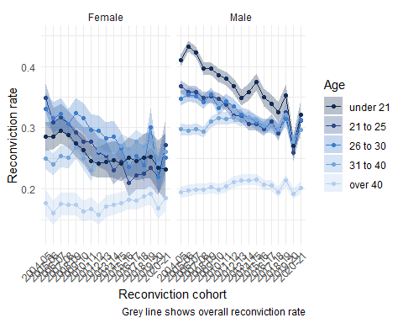

Figure One shows the one-year reconviction rate for each age and sex group. Overall reconviction rates tend to be lowest for the oldest age group, with the over 40 group consistently having the lowest conviction rate over the period analysed. For men, at the start of the observation period those under 21 have the highest reconviction rate - but this group also shows the most marked decline in reconvictions. By the 2020/21 cohort the reconviction rate for the youngest men is very similar to the 21 to 25, 26 to 30 and 31 to 40 age groups. For women there is a less clear cut age pattern - women under 21 have lower reconviction rates than women age 21 to 25 and women age 26 to 30 in 2004/05, and have the second lowest (after women over age 40) in the 2020/21 cohort. In general, those with the highest reconviction rates in the earlier reconviction cohorts also show the largest declines in reconviction rates, meaning that the reconviction rates by age and sex are more similar for the 2020/21 reconviction cohorts than for the 2004/05 cohorts. // quantify this somehow?

## Change in the relative sizes of age group

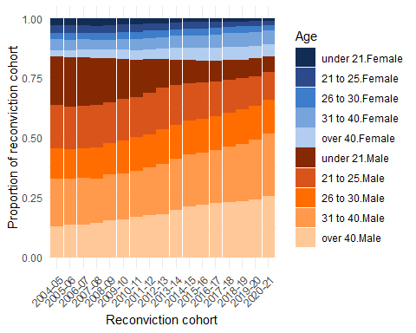

Figure Two shows the proportions of each age and sex combination comprising each reconviciton cohort. The proportions for men are shown in orange and those for women are shown in blue, and for both sexes ligher colours represent older people. Overall there is not much change in the mix of men and women in the reconviction cohorts. However, there is a substantial change in the age distribution of the cohorts. In the 2004/05 cohort men under 21 made up more than 20% people, down to less than 7% in the 2021/21 cohort. In contrast, men aged over 40 made up less than 13% of the 2004/05 cohort, but more than 25% of the 2020/21 cohort. The same pattern is seen for women but at a smaller scale - in the 2004/05 cohort women age under 21 made up around 3% of the cohort, down to around 1% of the 2020/21 cohort whilst women aged over 40 went from comprising around 2% of the 2004/05 cohort to 5% of the 2020/21 cohort.

// put in tables here

## Changing demographic mix

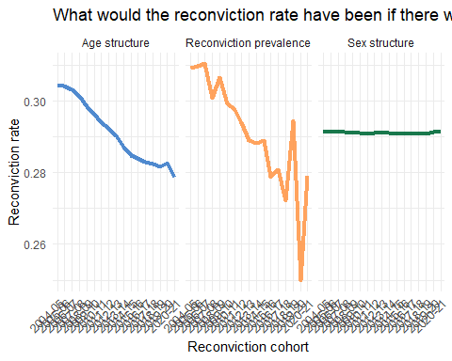

Figure Three combines shows standardized reconviction rates reflecting what reconviction rates in Scotland would have been, all else equal, if there was only change in, respectively, age structure, reconviction prevalence and sex structure[3]. The rightmost panel shows that reconviction rates would have changed very little if it was only sex structure that had changed between reconviction cohorts. The leftmost panel shows that if only age structure had changed then conviction rates would have fallen from just over 30% to around 28% from the 2004/05 to 2020/21 cohorts. This change is reasonably steady across the reconviction cohorts, with s a slight speak in the 2019/20 cohort - likely an effect of Covid. Reflecting the falls in age and sex group reconviction rates seen in Figure One, the middle panel shows that if only the prevalence of reconviction had changed then the aggregate reconviction rate would have fallen from around 31% in 2004/05 to just under 28% in the 2020/21 cohort. This trend is more jumpy than that for age-structure, with a sharp increase for the 2018/19 cohort and then a sharp drop for the 2019/20 cohort. The latter is presumably explained as an effect of Covid, and the reduced capacity of courts during the pandemic, although the increase in the reconviction rate for the 2018/19 cohort is unlikely to be affected by the pandemic as only a week an a half of the one-year follow-up period was affected by lockdown court closures .

## How much change in the reconviction rate is due to demographic mix?

Table 1: Standardization and Decomposition of reconviction rates in Scotland

| Impact of... | Reconviction cohort | |  |  |
| --- | --- | --- | --- | --- |
| 2004-05 | 2020-21 | Difference in rates | % of crude difference |
| Age | 0.31 | 0.28 | -0.03 | 49.06 |
| Sex | 0.29 | 0.29 | 0.00 | -0.22 |
| Reconviction | 0.31 | 0.28 | -0.03 | 51.16 |
| Crude rate | 0.32 | 0.27 | -0.06 | 100.00 |
| Data from Scottish Government (2024). Calculations authors' own. | | | | |

Table One shows a decomposition of the effects of changes in age structure, sex structure and reconviction prevalence between the 2004/05 and 2020/21 reconviction cohorts. The first column shows the three standardized reconvictions rates and the observed/‘crude’ reconviction rate for the 2004/05 conviction cohort, the second column shows the same rates for the 2020/21 cohort. The third column shows the difference between the standardized rates between the two chorots, and the last column expresses this difference as a percentage. It is this last column which shows the relative impact of the different factors on the overall reconviction rate in Scotland - almost half of the fall in the aggregate reconviction rate (49%) between the 2004/05 and 2020/21 cohorts is attributable to changes in the age structure of the reconviction cohorts. This is very close to the change attributable to falls in the age-sex-group reconviction rates itself (51%). The small changes in sex structure actually had a negligible impact on the overall reconviction rate.

## Analysis

* Young people used to have the highest reconviction rate of all age groups, but this is has fallen
* Those over 40 have consistently lower reconviction rates, but these have not fallen
* Young people also used to make up more of the reconviction cohorts
* In terms of the overall reconviction rate, a group of people with high levels of reconviction have been replaced by people with lower levels of reconviction

## Analysis

* We can attribute about 49% of the fall in the reconvictions rate in Scotland between 2004/05-2020/21 to demographic change in the population of people convicted, rather than falls in the reconviction rate *per se*.
* If you want to use the reconviction rate as a measure of sentencing effectiveness or similar, you would think the justice system is doing about twice as a good a job as it is
* In an optimistic reading the change in the mix of people being reconvicted could still be due to criminal justice practices (e.g. more diversion from prosecution for young people), but *is not attributable to the ‘effectiveness’ of the criminal justice system in rehabilitating offenders* - it is purely due to changes in the demographic mix of people being convicted in the first place
* An alternative perspective: the criminal justice system is benefiting from the impacts of wider societal change where young people are less likely to be involved in offending, as well as lots of other ‘risky’ behaviours (Ball et al. 2023)

## Limitations

* Coarse age categories could underplay the impact of changing age mix as a form of ‘measurement error’ (I think?)
* There might be other demographic or offence characteristics we are interested in (ethnicity; type of offence; type of sentence etc etc)
* The time periods selected are arbitrary and due to data availability
* Both of these would be resolvable with access to the underlying Scottish Offenders Index data

## In summary

* The crime drop in Scotland has led to a profound shift in the demographics of the people coming through the criminal justice system
* This shift is so pronounced that it affects our capacity to understand the ‘effectiveness’ of punishment through aggregate measures such as the overall reconviction rate
* A perspective which focuses on aggregate measures of the criminal justice *system* rather than the *people involved with the system* will be mislead by measures of system ‘performance’
* There are lots of other possible ways that demographic changes in crime may impact the functioning of the criminal justice system and public perceptions of crime

# Coda

## What do to about this?

* If we wanted to make a ‘so here’s what the Sentencing Council/Scottish Government should do now’ recommendation there are two possible paths:
* Option one: The Sentencing Council/Scottish Government/whoever should abandon a single overall measure and instead should use reconviction rates (or an alternative measure of your choice) for each demographic sub-group as well as overall reconviction rates
* Option two: [see above] should use some standardization and decomposition method to construct an ‘improved’ performance measure
* I don’t think either of these are good recommendations

## Reconviction rates for each group

* Suggesting that policy-makers/whoever analyse trends for all groups runs counter to the logic of quantification - the whole point is to reduce the amount of information required to understand the thing you care about and have an ‘objective’ and apolitical measure (Porter 1996)
* Requiring reconviction rates for pre-defined population groups raises the question of which groups would make the cut, and how they would be defined
* This is famously the paradoxical bit of Simpson’s paradox - the hard part is identifying the subgroups you need to stratify by (Pearl 2014); it is paradoxical because you need to choose what story to tell about the data, not because of anything inherently statistical

## “Following consultation with key users”

* For the same reason a technical ‘fix’ in terms of constructing a standardized reconviction rate would be adding ‘politics’ (in terms of deciding what to standardize by and how) into measuring reconvictions
* Also, in practice there might be limited appetite for an esoteric and tricky to understand measure amongst ‘key users’

In bulletins prior to 2017/18, reoffending figures were provided alongside adjusted reoffending rates for adults and the overall cohort, to help provide an estimate of change in reoffending. Following consultation with key users, the decision was taken to exclude this from future publications to avoid confusion in the interpretation of findings.

(Browne 2024, p19)

* Moreover, as Kitagawa said sixty years ago that no single summary measure - whether it is a standardized rate as we have calculated here, or the overall reconviction rates as currently used - can be a substitute for examining how rates vary across different groups in the population (Kitagawa 1964)

## So what to do?

* If you really want to use reconviction rates as a performance indicator, I would say that measuring reconviction rates for each group that you care about is probably preferable than coming up with a standardized measure
* It is useful information to know if there are groups who are not seeing the same overall decline in reconvictions and whether this is masked by the overall rate

# Thank you!

## Percentage change by group

| category | comp_ce | rate_ce | tot_ce |
| --- | --- | --- | --- |
| gender | | | |
| Female | 2.14 | 3.82 | 5.96 |
| Male | -2.36 | 21.76 | 19.40 |
| age | | | |
| 21 to 25 | 47.26 | 9.39 | 56.66 |
| 26 to 30 | -7.21 | 6.03 | -1.18 |
| 31 to 40 | -37.16 | -0.27 | -37.43 |
| over 40 | -54.01 | -1.54 | -55.55 |
| under 21 | 100.17 | 11.97 | 112.15 |

## References

Aebi, Marcelo F., and Antonia Linde. 2010. “Is There a Crime Drop in Western Europe?” *European Journal on Criminal Policy and Research* 16 (4): 251–77. <https://doi.org/10.1007/s10610-010-9130-y>.

Atak, Kıvanç. 2020. “Beyond the Western Crime Drop: Violence, Property Offences, and the State in Turkey 19902016.” *International Journal of Law, Crime and Justice* 60 (March): 100373. <https://doi.org/10.1016/j.ijlcj.2019.100373>.

Ball, Jude, Richard Grucza, Michael Livingston, Tom ter Bogt, Candace Currie, and Margaretha de Looze. 2023. “The Great Decline in Adolescent Risk Behaviours: Unitary Trend, Separate Trends, or Cascade?” *Social Science & Medicine* 317 (January): 115616. <https://doi.org/10.1016/j.socscimed.2022.115616>.

Bannister, Jon, Ellie Bates, and Ade Kearns. 2018. “Local Variance in the Crime Drop: A Longitudinal Study of Neighbourhoods in Greater Glasgow, Scotland.” *The British Journal of Criminology* 58 (1): 177–99. <https://doi.org/10.1093/bjc/azx022>.

Browne, S. 2024. “Adult and Youth Reoffending in Northern Ireland (2021/22 Cohort).” <https://www.justice-ni.gov.uk/sites/default/files/publications/justice/Adult%20and%20Youth%20Reoffending%20in%20Northern%20Ireland%20%28202122%20Cohort%29.pdf>.

Cunliffe, Jack, and Adrian Shepherd. 2007. “Re-Offending of Adults: Results from the 2004 Cohort.”

Das Gupta, Prithwis. 1993. *Standardization and Decomposition of Rates: A User’s Manual*. 186. US Department of Commerce, Economics and Statistics Administration, Bureau of the Census.

Dijk, Jan van, Paul Nieuwbeerta, and Jacqueline Joudo Larsen. 2022. “Global Crime Patterns: An Analysis of Survey Data from 166 Countries Around the World, 20062019.” *Journal of Quantitative Criminology* 38 (4): 793–827. <https://doi.org/10.1007/s10940-021-09501-0>.

Drake, E. K., S. Aos, and R. Barnoski. 2010. “Washington’s Offender Accountability Act: Final Report on Recidivism Outcomes.” Olympia: Washington State Institute for Public Policy.

Dziwornu, Michael Gameli. 2021. “Crime Drop in Ghana? Some Insights from Crime Patterns and Trends.” *Crime Prevention and Community Safety* 23 (4): 433–49. <https://doi.org/10.1057/s41300-021-00130-0>.

Farrell, Graham, Gloria Laycock, and Nick Tilley. 2015. “Debuts and Legacies: The Crime Drop and the Role of Adolescence-Limited and Persistent Offending.” *Crime Science* 4 (1). <https://doi.org/10.1186/s40163-015-0028-3>.

Farrell, Graham, Nick Tilley, and Andromachi Tseloni. 2014. “Why the Crime Drop?” *Crime and Justice* 43 (1): 421490. <http://www.journals.uchicago.edu/doi/abs/10.1086/678081>.

Francis, Brian, Juliet Harman, and Leslie Humphreys. 2005. “Predicting Reconviction Rates in Northern Ireland.” <https://eprints.lancs.ac.uk/id/eprint/49993/1/francis_predicting_reconviction_rates_in_northern_ireland_7_2005.pdf>.

Gelman, Andrew, and Jonathan Auerbach. 2016. “Age-Aggregation Bias in Mortality Trends.” *Proceedings of the National Academy of Sciences* 113 (7): E816–17. <https://doi.org/10.1073/pnas.1523465113>.

Good, I. J., and Y. Mittal. 1987. “The Amalgamation and Geometry of Two-by-Two Contingency Tables.” *The Annals of Statistics* 15 (2): 694–711. <https://www.jstor.org/stable/2241334>.

Gormley, Jay, Melissa Hamilton, and Ian Belton. 2022. “The Effectiveness of Sentencing Options on Reoffending.” <https://www.sentencingcouncil.org.uk/wp-content/uploads/Effectiveness-of-Sentencing-Options-Review-FINAL.pdf>.

Kang, Byunggu, and David M. Hureau. 2022. “Social Context and the Static and Dynamic AgeCrime Relationship in the Republic of Korea.” *Asian Journal of Criminology*, November. <https://doi.org/10.1007/s11417-022-09391-6>.

King, Josiah, and Ben Matthews. 2025. “DasGuptR: Das Gupta Standardisation and Decomposition.” <https://doi.org/10.32614/CRAN.package.DasGuptR>.

Kirkwood, Steve. 2008. “Evidencing the Impact of Criminal Justice Services on Re-offending.” CJScotland.

Kitagawa, Evelyn M. 1964. “Standardized Comparisons in Population Research.” *Demography* 1 (1): 296. <https://doi.org/10.2307/2060055>.

Klingele, Cecelia. 2019. “Measuring Change.” *The Journal of Criminal Law and Criminology (1973-)* 109 (4): 769–817.

Kotzé, Justin. 2019. *The Myth of the ‘Crime Decline’: Exploring Change and Continuity in Crime and Harm*. Routledge.

Maruna, Shadd. 2025. “Redeeming Desistance: From Individual Journeys to a Social Movement.” *Criminology* n/a (n/a). <https://doi.org/10.1111/1745-9125.12393>.

Matthews, Ben. 2023. “The Age-Crime Curve and the Crime Drop in (Some of) Northern Europe,” June. <https://benmatthewsed.github.io/age_crime_curve_europe/age_crime_curve_europe.html#/title-slide>.

Matthews, Ben, Susan McVie, and Paul Norris. n.d. “Who Benefited Most from the Crime Drop? Measuring Stability and Change in Victimization Inequality Across Different Socio-Demographic Groups.” <https://doi.org/10.31235/osf.io/hmrpg_v1>.

Matthews, Ben, and Jon Minton. 2018a. “Rethinking One of Criminology’s ‘Brute Facts’: The Agecrime Curve and the Crime Drop in Scotland.” *European Journal of Criminology* 15 (3): 296–320. <https://doi.org/10.1177/1477370817731706>.

———. 2018b. “Rethinking One of Criminology’s ‘Brute Facts’: The Age–Crime Curve and the Crime Drop in Scotland.” *European Journal of Criminology* 15 (3): 296–320. <https://doi.org/10.1177/1477370817731706>.

Pearl, Judea. 2014. “Comment: Understanding Simpson’s Paradox.” *The American Statistician* 68 (1): 8–13. <https://www.jstor.org/stable/24591584>.

Porter, Theodore. 1996. *Trust in Numbers*.

Scottish Government. 2024. “Reconviction Rates in Scotland: 2020-21 Offender Cohort.” Scottish Government.

Simpson, E. H. 1951. “The Interpretation of Interaction in Contingency Tables.” *Journal of the Royal Statistical Society: Series B (Methodological)* 13 (2): 238–41. <https://doi.org/10.1111/j.2517-6161.1951.tb00088.x>.

Steffensmeier, Darrell, Jessie Slepicka, and Jennifer Schwartz. 2025. “International and Historical Variation in the AgeCrime Curve.” *Annual Review of Criminology* 8 (Volume 8, 2025): 239–68. <https://doi.org/10.1146/annurev-criminol-111523-122451>.

Tonry, Michael. 2014. “Why Crime Rates Are Falling Throughout the Western World.” *Crime and Justice* 43 (1): 163. <http://www.journals.uchicago.edu/doi/abs/10.1086/678181>.

Tuttle, James. 2024. “The End of the Age-Crime Curve? A Historical Comparison of Male Arrest Rates in the United States, 1985–2019.” *The British Journal of Criminology* 64 (3): 638–55. <https://doi.org/10.1093/bjc/azad049>.

Weaver, Beth. 2019. “Understanding Desistance: A Critical Review of Theories of Desistance.” *Psychology, Crime & Law* 25 (6): 641–58. <https://doi.org/10.1080/1068316X.2018.1560444>.

1. The only area of justice system activity which does not show this decline is imprisonment, where the average daily prison population increased steadily through the 2000s before peaking in the early 2010s and subsequently fluctuated close to this peak.
2. Assuming that any reconviction measure is an equally good (or equally bad) measure across the demographic groups of interest. // Josiah is this right??
3. These are, rather confusingly, created by negation in the standardization - the results showing the reconviction rate if only age structure had changed is strictly speaking a prevalnence-and-sex-structure standardized reconviction rate.