Phantasy Star V Manual
Jason D. Ralphs

Yes, I know, this game is a beast when it comes to size. But, when you have a graphical RPG with 3 different terrain types, 14 different monster types, 7 different towns, and 5 different players, it’s big.

Battle Screen:
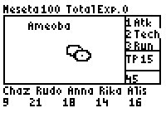
Press 1 to attack.
Press 2 to use a technique.
Press 3 to attempt to run.

Technique Points
Enemy Hit Points
Player Hit Points.

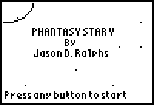

Press any button to start the game.

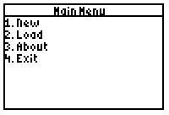
Press 1 to start a new game, 2 to load a game, 3 to see the about screen, and 4 to exit game.

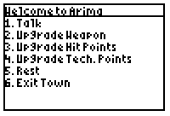
The town, in the town press 1 to talk, press 2 to upgrade weapons, press 3 to add hit points to any character, press 4 to upgrade Tech. Points, press 5 to rest, or press 6 to leave the town.

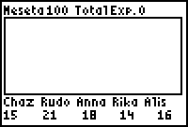
Main Screen: Press up, down, left, or right to move. Press 2nd for a menu. Press 2-9 for screenshots. Press CLEAR to reset game. Press Y=, WINDOW, ZOOM, TRACE, or GRAPH to get info on players.

