Fraction Calculator Add-on Ti-83+
User Guide
By Jason D. Ralphs
(2001)

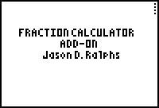
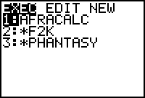
This program is called “AFRACALC.8XP”, I don’t think anyone really needs instructions on how to get it to the calculator, so, I’ll skip that. First, after you get the program onto the calculator, run it . After you do this for the first time you should get the startup screen to the far left. This screen will only appear once, unless you delete some of your variables. Then you get a screen that looks just like your home screen. You will be able to perform most operations there. You can type in either decimals or fractions. It will convert and simplify both as shown in the pictures below.
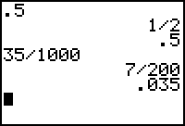
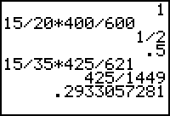
This program does not convert improper fractions into proper fractions, though. If you type in a decimal, it will display both the decimal you typed in and the fraction equivelent to that decimal. And there are NO menus or secret functions to browse through. I believe that this program would be most useful in physics, chemistry, Algebra 1, or any other class that you use fractions in. A note: the program with the name “PHANTASY” is soon to be released, all you sega fans, its what you’ve been waiting for. It is named “Phantasy Star V” right now, I don’t know if I’ll stick with that or not, but… Check out the “Phantasy.doc” for more information, and screenshots. Send any questions or comments to Jason Ralphs, Elgenio14@hotmail.com. This program is MirageOs compatable and you press “ON” to exit. Thank you.

